Express.js
Complete Tutorial Guide

Source: TutorialsPoint.com/expressjs

Generated: March 2026

Table of Contents
1. ExpressJS - Home
2. ExpressJS - Overview
3. ExpressJS - Environment
4. ExpressJS - Installation
5. ExpressJS - Hello World
6. ExpressJS - Routing
7. ExpressJS - HTTP Methods
8. ExpressJS - URL Building
9. ExpressJS - Middleware
10. ExpressJS - Templating
11. ExpressJS - Static Files
12. ExpressJS - Form Data
13. ExpressJS - Database
14. ExpressJS - Cookies
15. ExpressJS - Sessions
16. ExpressJS - Authentication
17. ExpressJS - RESTful APIs
18. ExpressJS - Scaffolding
19. ExpressJS - Serving Dynamic Content
20. ExpressJS - Handling File Uploads
21. ExpressJS - Internationalization(i18n)
22. ExpressJS - Security Practices
23. ExpressJS - Rate Limiting
24. ExpressJS - Slowing Down Responses
25. ExpressJS - Error handling
26. ExpressJS - Debugging
27. ExpressJS - Best Practices
28. ExpressJS - Resources
29. ExpressJS - Quick Guide
30. ExpressJS - Cheatsheet
31. ExpressJS - Useful Resources
32. ExpressJS - Discussion

ExpressJS - Home
Source: https://www.tutorialspoint.com/expressjs/index.htm


ExpressJS Tutorial

ExpressJS Tutorial
Express is a minimal and flexible Node.js web application framework that provides a robust set of features for web and mobile applications. It is an open source framework developed and maintained by the Node.js foundation.

What is Express.js?
Express provides a minimal interface to build our applications. It provides us the tools that are required to build our app. It is flexible as there are numerous modules available on npm, which can be directly plugged into Express.

Why Learn Express.js?
Express Framework unlike its competitors like Rails and Django, which have an opinionated way of building applications, has no "best way" to do something. It is very flexible and pluggable. It uses Pug, a template language for writing HTML templates.

How to Install Express.js?
Express requires Node.JS and NPM to be installed first. Different operating systems required different steps to install Node.js, please follow the provided methods according to your installed operating system.
- Node.js Installation on Windows
- Node.js Installation on Linux - Ubuntu
Once node is installed, you can run the following npm command inside the Node project where package.json is residing.
npm install --save express
To make our development process a lot easier, we will install a tool from npm, nodemon. This tool restarts our server as soon as we make a change in any of our files, otherwise we need to restart the server manually after each file modification. To install nodemon, use the following command −
npm install -g nodemon

Example of Express.js Application
Once express set up is complete, we can start developing our first app using Express. Create a new file calledindex.jsand type the following in it.
var express = require('express');
var app = express();
app.get('/', function(req, res){
res.send("Hello world!");
});
app.listen(3000);
Save the file, go to your terminal and type the following.
nodemon index.js
This will start the server. To test this app, open your browser and go tohttp://localhost:3000and a message will be displayed as in the following screenshot.
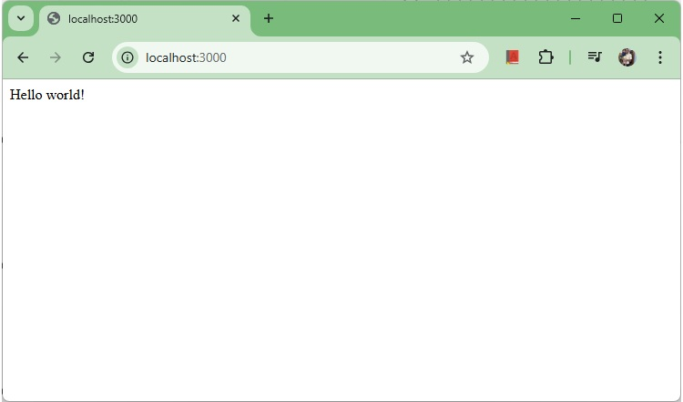
Hello world

Prerequisites to Learn Express.js
Before proceeding with this tutorial, you should have a basic understanding ofJavaScript. As we are going to develop web-based applications using Express.js and Node.js, it will be good if you have some understanding of other web technologies such asHTML,CSS,AJAX, etc.

Getting Started with Express.js
Considering NodeJS as base environement, before going deep into expressjs you should familiar with fundamentals of nodejs like environment setup, REPL terminal, NPM, Callbacks, Events, Objects, etc.
ExpressJS - OverviewExpressJS - EnvironmentExpressJS - Hello WorldExpressJS - RoutingExpressJS - HTTP MethodsExpressJS - URL BuildingExpressJS - MiddlewareExpressJS - TemplatingExpressJS - Static FilesExpressJS - Form Data
- ExpressJS - Database
- ExpressJS - Cookies
- ExpressJS - Sessions
- ExpressJS - Authentication
- ExpressJS - RESTful APIs
- ExpressJS - Scaffolding
- ExpressJS - Error handling
- ExpressJS - Debugging
- ExpressJS - Best Practices
- ExpressJS - Resources

Express.js Jobs and Salary
Express.js. is a popular tool for almost any kind of project. After Learning Express.js you can get job on different job profiles.
- Express.js Developer - Salary ranges in between 1.2 Lakhs to 12.6 Lakhs with an average annual salary of 5.7 Lakhs.
- Express.js Backend Developer - Salary ranges in between 1.2 Lakhs to 11.0 Lakhs with an average annual salary of 4.7 Lakhs.

ExpressJS - Overview
Source: https://www.tutorialspoint.com/expressjs/expressjs_overview.htm

ExpressJS - Overview
ExpressJS is a web application framework that provides you with a simple API to build websites, web apps and back ends. With ExpressJS, you need not worry about low level protocols, processes, etc.

What is Express?
Express provides a minimal interface to build our applications. It provides us the tools that are required to build our app. It is flexible as there are numerous modules available onnpm, which can be directly plugged into Express.
Express was developed byTJ Holowaychukand is maintained by theNode.jsfoundation and numerous open source contributors.

Why Express?
Unlike its competitors like Rails and Django, which have an opinionated way of building applications, Express has no "best way" to do something. It is very flexible and pluggable.

Features of ExpressJS
Following are the salient features of ExpressJS making it a default choice among web application developers.
- Minimalistic Design− ExpressJS is an unopinionated. ExpressJS framework is highly flexible with a simple, minimalistic design principles. We can quickly setup server, define routes and start handling http requests with very few lines of code.
- Middleware/Routing− ExpressJS provides clear options for Routes with support for all kind of HTTP methods like POST, GET, PUT etc.
- Flexibility− There is no prerequisites or any format to follow in order to use ExpressJS. If we know NodeJS, we can write code as per our preference.
- Templating− ExpressJS supports various templating engines like PUG, Jade or EJS to generate HTML content on the fly.
- Static File Serve− ExpressJS supports static files like images/css/javascript from a folder seemlessly.
- NodeJS Based− Core functionalities of asynchronous programming and event driven programming features of NodeJS can be integrated with ExpressJS easily.

Applications of ExpressJS
Following are the salient features of ExpressJS making it a default choice among web application developers.
- Support RESTful APIs− REST Architecture is very powerful style to enable communication of front-end with backend. ExpressJS supports RESTful APIs by design.
- Support for Real Time Applications− Event Driven Programming helps to create chat, parallel collaborative editing tools etc. ExpressJS integrates with Node and supports Event Driven Programming seemlessly.
- Support for Single Page Applications(SPA)− SPA and RESTFul APIs allows Express Based application to update content dynamically enriching user experience.

ExpressJS vs Django vs Ruby on Rails
Sr.No. | Feature | ExpressJS | Django | Ruby on Rails
1 | Language | JavaScript | Python | Ruby
2 | Flexibility | Highly flexible. Unopinionated by design. | Moderate. Opinionated by design. | Low. Highly opinionated.
3 | Performance | Highly performant | Moderate | Moderate

Pug
Pug (earlier known as Jade) is a terse language for writing HTML templates. It −
- Produces HTML
- Supports dynamic code
- Supports reusability (DRY)
It is one of the most popular template language used with Express.

MongoDB and Mongoose
MongoDB is an open-source, document database designed for ease of development and scaling. This database is also used to store data.
Mongoose is a client API fornode.jswhich makes it easy to access our database from our Express application.

ExpressJS - Environment
Source: https://www.tutorialspoint.com/expressjs/expressjs_environment.htm

ExpressJS - Environment Setup
ExpressJS is a NodeJS based application framework. In case to start with Express, we need to set up environment for Node.js, this section will guide you. Node.js can be installed on different OS platforms such as Windows, Linux, Mac OS X, etc. You need the following tools on your computer −
- The Node.js binary installer
- Node Package Manager (NPM)
- IDE or Text Editor

Node Installation Steps
Binaries for various OS platforms are available on the downloads page of the official website of Node.js. Visithttps://nodejs.org/en/downloadto get the list.
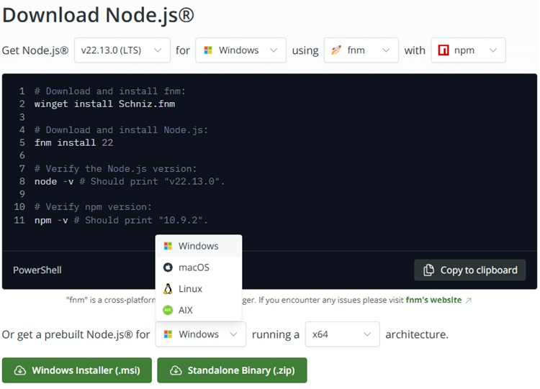
Official Website
This page shows command line as well as installers as well as ZIP archives for Windows, macOS installer as well as tar archives and binaries for Linux OS on x64 and ARM architecture are available.

Installation on Windows
Assuming that you are working with Windows 10/Windows 11 powered computer, download the 64-bit installer for Windows:https://nodejs.org/dist/v22.13.0/node-v22.13.0-x64.msi, and start the installation by double-clicking the downloaded file.
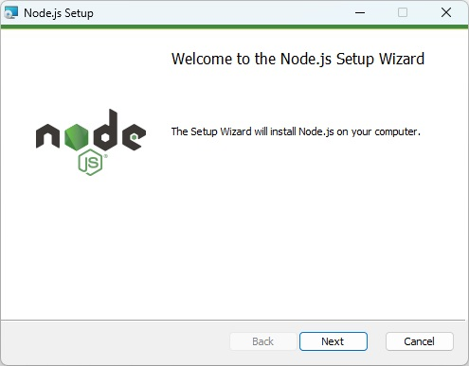
Nodejs Setup Wizard
The installation takes you through a few steps of the installation wizard. It also adds the installation directory of Node.js executable to the system path.
To verify if Node.js has been successfully installed, open the command prompt and type node -v. If Node.js is installed successfully then it will display the version of the Node.js installed on your machine, as shown below.
Microsoft Windows [Version 10.0.26100.2894]
(c) Microsoft Corporation. All rights reserved.
C:\Users\Tutorialspoint>node -v
v22.13.0
C:\Users\Tutorialspoint>

Installation on Ubuntu Linux
First, download the tar file corresponding to Linux binary (https://nodejs.org/dist/v22.13.0/node-v22.13.0-linux-x64.tar.xz) and then, extract the binary using the tar command −
tar -xf node-v22.13.0-linux-x64.tar.gz
Move the extracted files to the installation directory /usr/local/node-v22.13.0.
sudo mv node-<version> /usr/local/node-v22.13.0
Create a symlink to the executable in /usr/bin directory.
sudo ln -s /usr/local/node-v22.13.0/bin/node /usr/bin/node
You can now verify the correct installation with the following command −
node -v
Using Ubuntu package manager
Refresh your local package index first by the following command −
sudo apt update
Then install Node.js −
sudo apt install nodejs
As in above case, verify the installation
node -v
NPM (Node Package Manager) is included in Node.js binaries from its official website since Node version 0.6.0., so you are not required to install it separately.
You can use any text editor available in your OS (notepad in Windows, vi or nano in Ubuntu) to key-in and save the Node.js script. However, it is recommended that you use a suitable IDE for the purpose as it has several features such as syntax highlighting etc. VS Code is a popular source-code editor, which has out of the box support for JavaScript (and hence Node.js), which is highly recommended.
You can verify the version of NPM using following command
npm -v
10.9.2

Postman Installation Steps
Postman is a API, Application Programming Interface, Testing tool. We'll use it to test our REST APIs developed during Express JS tutorial. Please follow thePostman Environment Setup.

ExpressJS - Installation
Source: https://www.tutorialspoint.com/expressjs/expressjs_installation.htm

ExpressJS - Installation
In this chapter, we will learn how to start developing and using the Express Framework. To start with, you should have the Node and the npm (node package manager) installed. If you dont already have these, go to theExpressJS Environment Setupchapter to install node on your local system. Confirm that node and npm are installed by running the following commands in your terminal.
node -v
v22.13.0
npm -v
10.9.2
Now that we have Node andnpmset up, let us understand whatnpmis and how to use it.

Node Package Manager(npm)
npm is the package manager for node. The npm Registry is a public collection of packages of open-source code for Node.js, front-end web apps, mobile apps, robots, routers, and countless other needs of the JavaScript community. npm allows us to access all these packages and install them locally. You can browse through the list of packages available on npm atnpmJS.

How to use npm?
There are two ways to install a package using npm: globally and locally.
- Globally− This method is generally used to install development tools and CLI based packages. To install a package globally, use the following code.
npm install -g <package-name>
- Locally− This method is generally used to install frameworks and libraries. A locally installed package can be used only within the directory it is installed. To install a package locally, use the same command as above without the-gflag.
npm install <package-name>
Whenever we create a project using npm, we need to provide apackage.jsonfile, which has all the details about our project. npm makes it easy for us to set up this file. Let us set up our development project.
Step 1− Start your terminal/cmd, create a new folder named hello-world and cd (create directory) into it −
E:\Dev>mkdir hello-world
E:\Dev>cd hello-world
E:\Dev\hello-world>
Step 2− Now to create the package.json file using npm, use the following code.
E:\Dev\hello-world>npm init
It will ask you for the following information.
E:\Dev\hello-world>npm init
Just keep pressing enter, and enter your name at the author name field.
E:\Dev\hello-world>npm init
This utility will walk you through creating a package.json file.
It only covers the most common items, and tries to guess sensible defaults.
See `npm help init` for definitive documentation on these fields
and exactly what they do.
Use `npm install ` afterwards to install a package and
save it as a dependency in the package.json file.
Press ^C at any time to quit.
package name: (hello-world)
version: (1.0.0)
description:
entry point: (index.js)
test command:
git repository:
keywords:
author: 'MAHESH PARASHAR'
license: (ISC)
About to write to E:\Dev\hello-world\package.json:
{
"name": "hello-world",
"version": "1.0.0",
"main": "index.js",
"scripts": {
"test": "echo \"Error: no test specified\" && exit 1"
},
"author": "'MAHESH PARASHAR'",
"license": "ISC",
"description": ""
}
Is this OK? (yes)
npm notice
npm notice New major version of npm available! 10.9.2 -> 11.0.0
npm notice Changelog: https://github.com/npm/cli/releases/tag/v11.0.0
npm notice To update run: npm install -g npm@11.0.0
npm notice
E:\Dev\hello-world>
Step 3− Now we have our package.json file set up, we will further install Express. To install Express and add it to our package.json file, use the following command −
E:\Dev\hello-world>npm install --save express
added 69 packages, and audited 70 packages in 4s
14 packages are looking for funding
run `npm fund` for details
found 0 vulnerabilities
Tip− The --saveflag can be replaced by the-Sflag. This flag ensures that Express is added as a dependency to ourpackage.jsonfile. This has an advantage, the next time we need to install all the dependencies of our project we can just run the commandnpm installand it will find the dependencies in this file and install them for us.
This is all we need to start development using the Express framework. To make our development process a lot easier, we will install a tool from npm, nodemon. This tool restarts our server as soon as we make a change in any of our files, otherwise we need to restart the server manually after each file modification. To install nodemon, use the following command −
E:\Dev\hello-world>npm install -g nodemon
added 29 packages in 2s
4 packages are looking for funding
run `npm fund` for details
You can now start working on Express.

ExpressJS - Hello World
Source: https://www.tutorialspoint.com/expressjs/expressjs_hello_world.htm

ExpressJS - Hello World!
We have set up the development inExpressJS Installation, now it is time to start developing our first app using Express. Create a new file calledindex.jsin hello-world directory and type the following in it.

index.js
var express = require('express');
var app = express();
app.get('/', function(req, res){
res.send("Hello world!");
});
app.listen(3000);
Save the file, go to your terminal and type the following.
E:\Dev\hello-world>nodemon index.js
[nodemon] 3.1.9
[nodemon] to restart at any time, enter `rs`
[nodemon] watching path(s): *.*
[nodemon] watching extensions: js,mjs,cjs,json
[nodemon] starting `node index.js`
This will start the server. To test this app, open your browser and go tohttp://localhost:3000and a message will be displayed as in the following screenshot.

Hello world
Now update the file index.js to return a different message.
var express = require('express');
var app = express();
app.get('/', function(req, res){
res.send("Welcome to tutorialspoint!");
});
app.listen(3000);
Save the file, go to your terminal and check the server status. It automatically restarted.
E:\Dev\hello-world>nodemon index.js
[nodemon] 3.1.9
[nodemon] to restart at any time, enter `rs`
[nodemon] watching path(s): *.*
[nodemon] watching extensions: js,mjs,cjs,json
[nodemon] starting `node index.js`
[nodemon] restarting due to changes...
[nodemon] starting `node index.js`
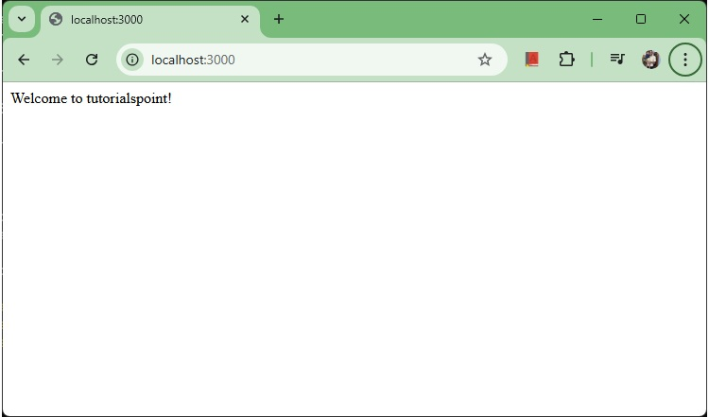
Welcome Message

How the App Works?
The first line imports Express in our file, we have access to it through the variable Express. We use it to create an application and assign it to var app.

app.get(route, callback)
This function tells what to do when agetrequest at the given route is called. The callback function has 2 parameters,request(req)andresponse(res). The requestobject(req)represents the HTTP request and has properties for the request query string, parameters, body, HTTP headers, etc. Similarly, the response object represents the HTTP response that the Express app sends when it receives an HTTP request.

res.send()
This function takes an object as input and it sends this to the requesting client. Here we are sending the string"Hello World!".

app.listen(port, [host], [backlog], [callback]])
This function binds and listens for connections on the specified host and port. Port is the only required parameter here.
S.No. | Argument & Description
1 | portA port number on which the server should accept incoming requests.
2 | hostName of the domain. You need to set it when you deploy your apps to the cloud.
3 | backlogThe maximum number of queued pending connections. The default is 511.
4 | callbackAn asynchronous function that is called when the server starts listening for requests.

ExpressJS - Routing
Source: https://www.tutorialspoint.com/expressjs/expressjs_routing.htm

ExpressJS - Routing
Web frameworks provide resources such as HTML pages, scripts, images, etc. at different routes.
The following function is used to define routes in an Express application −

app.method(path, handler)
This METHOD can be applied to any one of the HTTP verbs get, set, put, delete. An alternate method also exists, which executes independent of the request type.
Path is the route at which the request will run.
Handler is a callback function that executes when a matching request type is found on the relevant route. For example,

index.js
var express = require('express');
var app = express();
app.get('/hello', function(req, res){
res.send("Hello World!");
});
app.listen(3000);
If we run our application and go tolocalhost:3000/hello, the server receives a get request at route"/hello", our Express app executes thecallbackfunction attached to this route and sends"Hello World!"as the response.
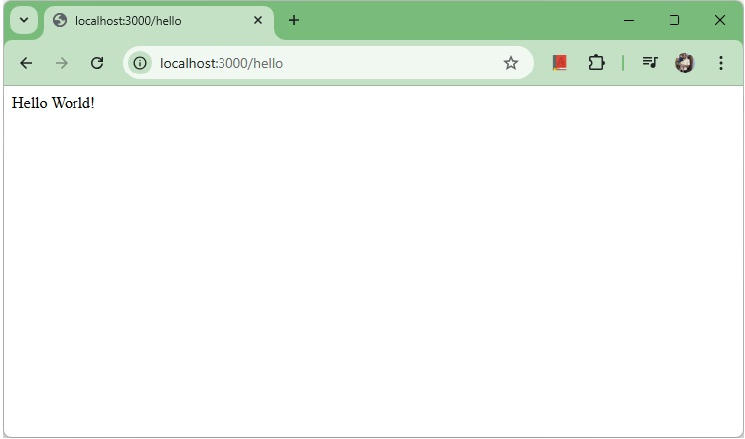
Hello
We can also have multiple different methods at the same route. For example,

index.js
var express = require('express');
var app = express();
app.get('/hello', function(req, res){
res.send("Hello World!");
});
app.post('/hello', function(req, res){
res.send("You just called the post method at '/hello'!\n");
});
app.listen(3000);
To test this request, open postman. Now hit the below URL's in POSTMAN application and you can see the output−
POST Requesthttp://localhost:3000/hello
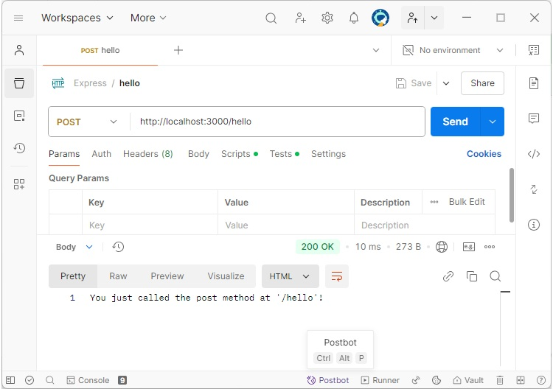
POST request
A special method,all, is provided by Express to handle all types of http methods at a particular route using the same function. To use this method, try the following.
app.all('/test', function(req, res){
res.send("HTTP method doesn't have any effect on this route!");
});
This method is generally used for defining middleware, which we'll discuss in the middleware chapter.

Routers
Defining routes like above is very tedious to maintain. To separate the routes from our mainindex.jsfile, we will useExpress.Router. Create a new file calledthings.jsand type the following in it.

things.js
var express = require('express');
var router = express.Router();
router.get('/', function(req, res){
res.send('GET route on things.');
});
router.post('/', function(req, res){
res.send('POST route on things.');
});
//export this router to use in our index.js
module.exports = router;
Now to use this router in ourindex.js, type in the following before theapp.listenfunction call.
var express = require('Express');
var app = express();
var things = require('./things.js');
app.get('/hello', function(req, res){
res.send("Hello World!");
});
//both index.js and things.js should be in same directory
app.use('/things', things);
app.listen(3000);
Theapp.usefunction call on route'/things'attaches thethingsrouter with this route. Now whatever requests our app gets at the '/things', will be handled by our things.js router. The'/'route in things.js is actually a subroute of '/things'. Visit localhost:3000/things/ and you will see the following output.
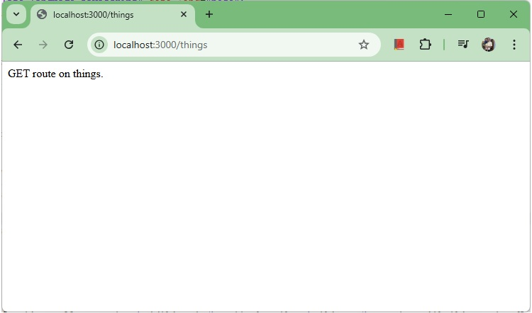
Router Things
Routers are very helpful in separating concerns and keep relevant portions of our code together. They help in building maintainable code. You should define your routes relating to an entity in a single file and include it using the above method in yourindex.jsfile.

ExpressJS - HTTP Methods
Source: https://www.tutorialspoint.com/expressjs/expressjs_http_methods.htm

ExpressJS - HTTP Methods
The HTTP method is supplied in the request and specifies the operation that the client has requested. The following table lists the most used HTTP methods −
S.No. | Method & Description
1 | GETThe GET method requests a representation of the specified resource. Requests using GET should only retrieve data and should have no other effect.
2 | POSTThe POST method requests that the server accept the data enclosed in the request as a new object/entity of the resource identified by the URI.
3 | PUTThe PUT method requests that the server accept the data enclosed in the request as a modification to existing object identified by the URI. If it does not exist then the PUT method should create one.
4 | DELETEThe DELETE method requests that the server delete the specified resource.
These are the most common HTTP methods. To learn more about the methods, visithttp://www.tutorialspoint.com/http/http_methods.htm.

Example
Create a new file calledindex.jsin hello-world directory and type the following in it.

index.js
var express = require('express');
var app = express();
app.get('/', function(req, res){
res.send("GET Request!");
});
app.post('/', function(req, res){
res.send("POST Request!");
});
app.put('/', function(req, res){
res.send("PUT Request!");
});
app.delete('/', function(req, res){
res.send("DELETE Request!");
});
app.listen(3000);
Save the file, go to your terminal and type the following.
E:\Dev\hello-world>nodemon index.js
[nodemon] 3.1.9
[nodemon] to restart at any time, enter `rs`
[nodemon] watching path(s): *.*
[nodemon] watching extensions: js,mjs,cjs,json
[nodemon] starting `node index.js`
This will start the server. To test this app, open your browser and go tohttp://localhost:3000and a message will be displayed as in the following screenshot.
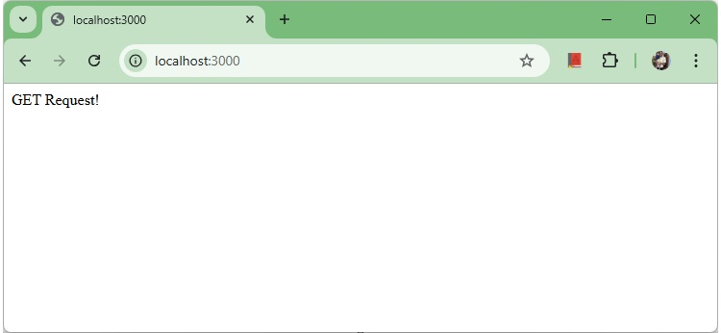
GET Request
To test other requests, open postman. Now hit the below URL's in POSTMAN application and you can see the output−
POST Requesthttp://localhost:3000/
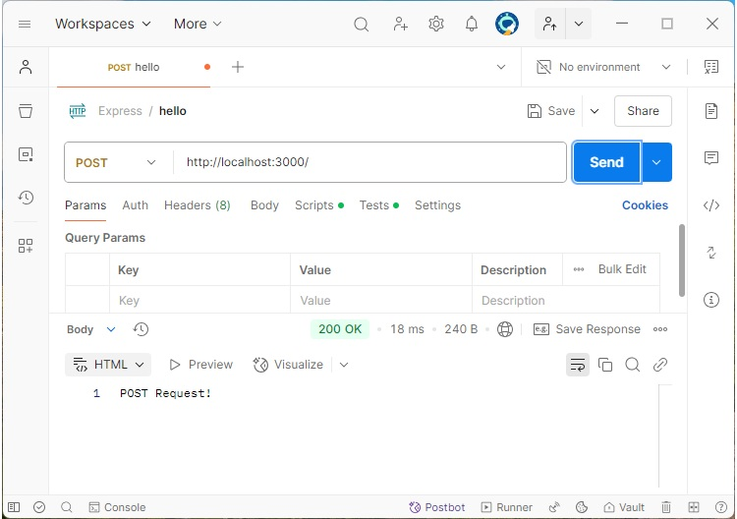
POST request
Similary you can test the other urls.
PUT Requesthttp://localhost:3000/
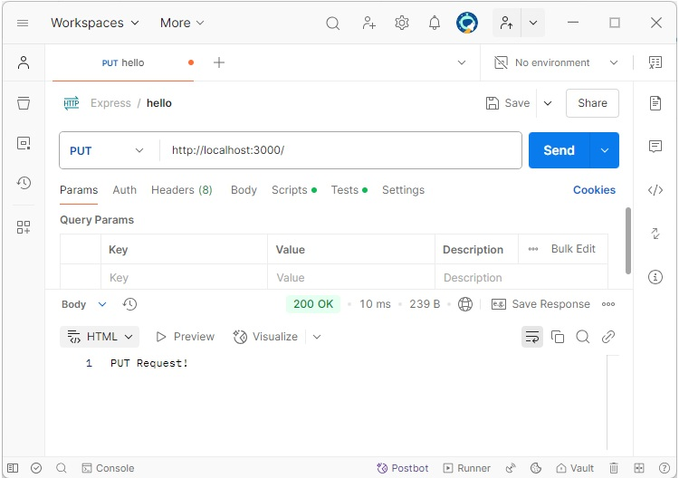
PUT request
DELETE Requesthttp://localhost:3000/
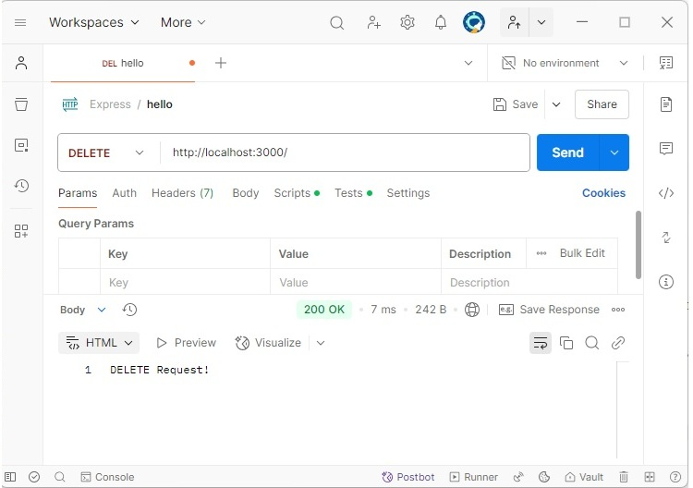
DELETE request

ExpressJS - URL Building
Source: https://www.tutorialspoint.com/expressjs/expressjs_url_building.htm

ExpressJS - URL Building
We can now define routes, but those are static or fixed. To use the dynamic routes, we SHOULD provide different types of routes. Using dynamic routes allows us to pass parameters and process based on them.
Here is an example of a dynamic route −

index.js
var express = require('express');
var app = express();
app.get('/:id', function(req, res){
res.send('The id you specified is ' + req.params.id);
});
app.listen(3000);

Output
To test this go tohttp://localhost:3000/123. The following response will be displayed.
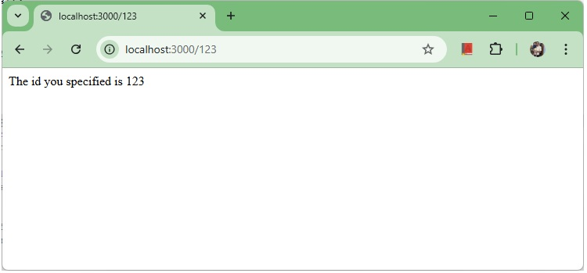
URL Building 1
You can replace '123' in the URL with anything else and the change will reflect in the response. A more complex example of the above is −

index.js
var express = require('express');
var app = express();
app.get('/things/:name/:id', function(req, res) {
res.send('id: ' + req.params.id + ' and name: ' + req.params.name);
});
app.listen(3000);

Output
To test the above code, go tohttp://localhost:3000/things/tutorialspoint/12345.
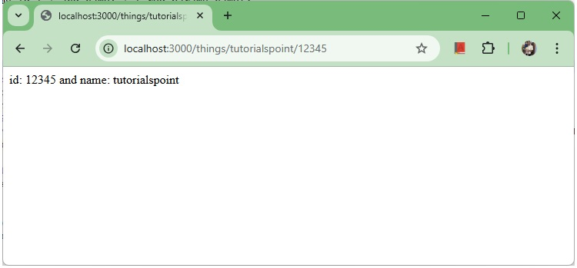
URL Building 2
You can use thereq.paramsobject to access all the parameters you pass in the url. Note that the above 2 are different paths. They will never overlap. Also if you want to execute code when you get'/things'then you need to define it separately.

Pattern Matched Routes
You can also useregexto restrict URL parameter matching. Let us assume you need theidto be a 5-digit long number. You can use the following route definition −

index.js
var express = require('express');
var app = express();
app.get('/things/:id([0-9]{5})', function(req, res){
res.send('id: ' + req.params.id);
});
app.listen(3000);
Note that this willonlymatch the requests that have a 5-digit longid. You can use more complex regexes to match/validate your routes. If none of your routes match the request, you'll get a"Cannot GET <your-request-route>"message as response. This message be replaced by a 404 not found page using this simple route −

index.js
var express = require('express');
var app = express();
//Other routes here
app.get('*', function(req, res){
res.send('Sorry, this is an invalid URL.');
});
app.listen(3000);
Important− This should be placed after all your routes, as Express matches routes from start to end of theindex.jsfile, including the external routers you required.

Output
For example, if we define the same routes as above, on requesting with a valid URL, the following output is displayed. −
Go tohttp://localhost:3000/things/tutorialspoint/12345.
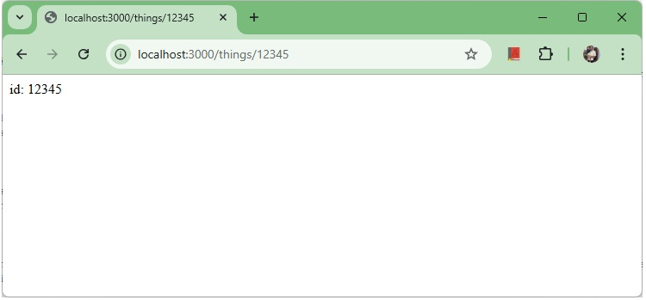
Correct regex
While for an incorrect URL request, the following output is displayed.
Go tohttp://localhost:3000/things/tutorialspoint/id/12345.
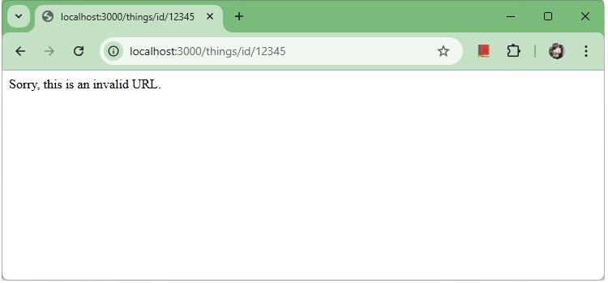
Invalid regex(404)

ExpressJS - Middleware
Source: https://www.tutorialspoint.com/expressjs/expressjs_middleware.htm

ExpressJS - Middleware
Middleware functions are functions that have access to therequest object (req), theresponse object (res), and the next middleware function in the applications request-response cycle. These functions are used to modifyreqandresobjects for tasks like parsing request bodies, adding response headers, etc.
Here is a simple example of a middleware function in action −

index.js
var express = require('express');
var app = express();
// Simple request time logger
app.use(function(req, res, next){
console.log("A new request received at " + Date().now());
// This function call is very important. It tells that more processing is
// required for the current request and is in the next middleware
// function route handler.
next();
});
app.listen(3000);

Output
Now openlocalhost:3000.
The above middleware is called for every request on the server. So after every request, we will get the following message in the console of nodemon −
A new request received at 1737448050745
To restrict it to a specific route (and all its subroutes), provide that route as the first argument ofapp.use(). For Example,
var express = require('express');
var app = express();
//Middleware function to log request protocol
app.use('/things', function(req, res, next){
console.log("A request for things received at " + Date.now());
next();
});
// Route handler that sends the response
app.get('/things', function(req, res){
res.send('Things');
});
app.listen(3000);
Now whenever you request any subroute of '/things', only then it will log the time.

Output
Now openhttp://localhost:3000/things/id/12345.
The above middleware is called for every request on the server. So after every request, we will get the following message in the console of nodemon −
A request for things received at 1737448162008

Order of Middleware Calls
One of the most important things about middleware in Express is the order in which they are written/included in your file; the order in which they are executed, given that the route matches also needs to be considered.
For example, in the following code snippet, the first function executes first, then the route handler and then the end function. This example summarizes how to use middleware before and after route handler; also how a route handler can be used as a middleware itself.
var express = require('express');
var app = express();
// First middleware before response is sent
app.use(function(req, res, next){
console.log("Start");
next();
});
// Route handler
app.get('/', function(req, res, next){
res.send("Middle");
next();
});
app.use('/', function(req, res){
console.log('End');
});
app.listen(3000);
When we visit '/' after running this code, we receive the response asMiddleand on our console −
Start
End
The following diagram summarizes what we have learnt about middleware −
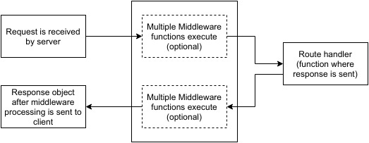
Middleware
Now that we have covered how to create our own middleware, let us discuss some of the most commonly used community created middleware.

Third Party Middleware
A list of Third party middleware for Express is availablehere. Following are some of the most commonly used middleware; we will also learn how to use/mount these −

body-parser
This is used to parse the body of requests which have payloads attached to them. To mount body parser, we need to install it.
E:\Dev\hello-world>npm install --save body-parser
up to date, audited 70 packages in 3s
14 packages are looking for funding
run `npm fund` for details
found 0 vulnerabilities
To mount the body-parser, include the following lines in your index.js −
var bodyParser = require('body-parser');
//To parse URL encoded data
app.use(bodyParser.urlencoded({ extended: false }))
//To parse json data
app.use(bodyParser.json())
To view all available options for body-parser, visit its github page.

cookie-parser
It parsesCookieheader and populate req.cookies with an object keyed by cookie names. To mount cookie parser, we need to install it.
E:\Dev\hello-world>npm install --save cookie-parser
added 2 packages, and audited 72 packages in 1s
14 packages are looking for funding
run `npm fund` for details
found 0 vulnerabilities
To mount it, include the following lines in your index.js −
var cookieParser = require('cookie-parser');
app.use(cookieParser())

express-session
It creates a session middleware with the given options. We will discuss its usage in the Sessions section.
We have many other third party middleware in ExpressJS. However, we have discussed only a few important ones here.

ExpressJS - Templating
Source: https://www.tutorialspoint.com/expressjs/expressjs_templating.htm

ExpressJS - Templating
Pug is a templating engine for Express. Templating engines are used to remove the cluttering of our server code with HTML, concatenating strings wildly to existing HTML templates. Pug is a very powerful templating engine which has a variety of features includingfilters, includes, inheritance, interpolation, etc. There is a lot of ground to cover on this.
To use Pug with Express, we need to install it,
E:\Dev\hello-world>npm install --save pug
added 38 packages, and audited 110 packages in 6s
19 packages are looking for funding
run `npm fund` for details
found 0 vulnerabilities
Now that Pug is installed, set it as the templating engine for your app. Youdon'tneed to 'require' it. Add the following code to yourindex.jsfile.
app.set('view engine', 'pug');
app.set('views','./views');
Now index.js should look like this.

index.js
var express = require('express');
var app = express();
app.set('view engine', 'pug');
app.set('views','./views');
app.listen(3000);
Now create a new directory called views. Inside that create a file calledfirst_view.pug, and enter the following data in it.
doctype html
html
head
title = "Hello Pug"
body
p.greetings#people Hello World!
To run this page, add the following route to your app −
app.get('/first_template', function(req, res){
res.render('first_view');
});
Now index.js should look like this.

index.js
var express = require('express');
var app = express();
app.set('view engine', 'pug');
app.set('views','./views');
app.get('/first_template', function(req, res){
res.render('first_view');
});
app.listen(3000);
Save the file, go to your terminal and type the following.
E:\Dev\hello-world>nodemon index.js
[nodemon] 3.1.9
[nodemon] to restart at any time, enter `rs`
[nodemon] watching path(s): *.*
[nodemon] watching extensions: js,mjs,cjs,json
[nodemon] starting `node index.js`
This will start the server. To test this app, open your browser and go tohttp://localhost:3000/first_template.
You will get the output as −
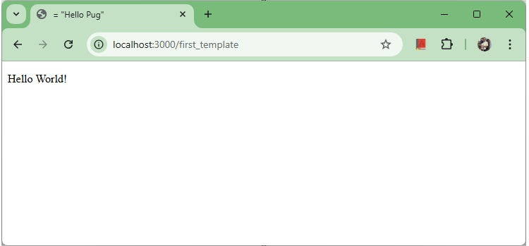
First Template of PUG
Pug converts this very simple looking markup to html. We dont need to keep track of closing our tags, no need to use class and id keywords, rather use '.' and'#'to define them. The above code first gets converted to −
<!DOCTYPE html>
<html>
<head>
<title>Hello Pug</title>
</head>
<body>
<p class = "greetings" id = "people">Hello World!</p>
</body>
</html>
Pug is capable of doing much more than simplifying HTML markup.

Important Features of Pug
Let us now explore a few important features of Pug.

Simple Tags
Tags are nested according to their indentation. Like in the above example,<title>was indented within the<head>tag, so it was inside it. But the<body>tag was on the same indentation, so it was a sibling of the<head>tag.
We dont need to close tags, as soon as Pug encounters the next tag on same or outer indentation level, it closes the tag for us.
To put text inside of a tag, we have 3 methods −
- Space seperated
h1 Welcome to Pug
- Piped text
div
| To insert multiline text,
| You can use the pipe operator.
- Block of text
div.
But that gets tedious if you have a lot of text.
You can use "." at the end of tag to denote block of text.
To put tags inside this block, simply enter tag in a new line and
indent it accordingly.

Comments
Pug uses the same syntax asJavaScript(//)for creating comments. These comments are converted to the html comments(<!--comment-->). For example,
//This is a Pug comment
This comment gets converted to the following.
<!--This is a Pug comment-->

Attributes
To define attributes, we use a comma separated list of attributes, in parenthesis. Class and ID attributes have special representations. The following line of code covers defining attributes, classes and id for a given html tag.
div.container.column.main#division(width = "100", height = "100")
This line of code, gets converted to the following. −
<div class = "container column main" id = "division" width = "100" height = "100"></div>

Passing Values to Templates
When we render a Pug template, we can actually pass it a value from our route handler, which we can then use in our template. Create a new route handler with the following.
var express = require('express');
var app = express();
app.set('view engine', 'pug');
app.set('views','./views');
app.get('/dynamic_view', function(req, res){
res.render('dynamic', {
name: "TutorialsPoint",
url:"http://www.tutorialspoint.com"
});
});
app.listen(3000);
And create a new view file in views directory, calleddynamic.pug, with the following code −
html
head
title=name
body
h1=name
a(href = url) URL
Openlocalhost:3000/dynamic_viewin your browser; You should get the following output −
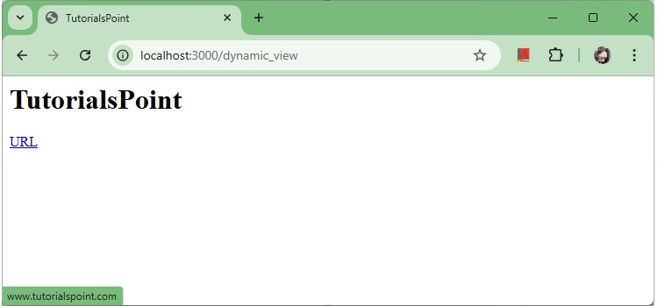
Variables in template
We can also use these passed variables within text. To insert passed variables in between text of a tag, we use#{variableName}syntax. For example, in the above example, if we wanted to put Greetings from TutorialsPoint, then we could have done the following.

dyanamic.pug
html
head
title = name
body
h1 Greetings from #{name}
a(href = url) URL
This method of using values is calledinterpolation. The above code will display the following output. −
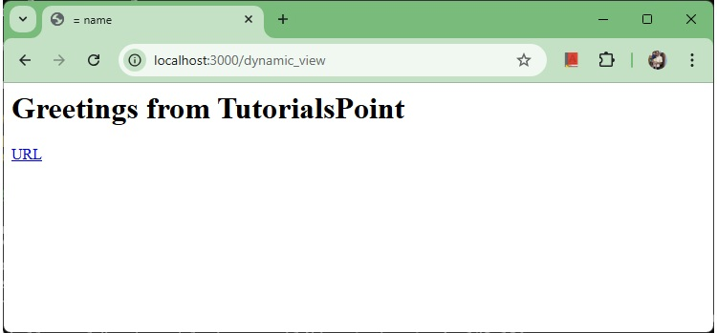
Templating Inter

Conditionals
We can use conditional statements and looping constructs as well.
Consider the following −
If a User is logged in, the page should display"Hi, User"and if not, then the"Login/Sign Up"link. To achieve this, we can define a simple template like −

dyanamic.pug
html
head
title Simple template
body
if(user)
h1 Hi, #{user.name}
else
a(href = "/sign_up") Sign Up
When we render this using our routes, we can pass an object as in the following program −
res.render('/dynamic',{
user: {name: "Ayush", age: "20"}
});

index.js
var express = require('express');
var app = express();
app.set('view engine', 'pug');
app.set('views','./views');
app.get('/dynamic_view', function(req, res){
res.render('dynamic', {
user: {name: "Ayush", age: "20"}
});
});
app.listen(3000);
You will receive a message −Hi, Ayush. But if we dont pass any object or pass one with no user key, then we will get a signup link.

Include and Components
Pug provides a very intuitive way to create components for a web page. For example, if you see a news website, the header with logo and categories is always fixed. Instead of copying that to every view we create, we can use theincludefeature. Following example shows how we can use this feature −
Create 3 views with the following code −
header.pug
div.header.
I'm the header for this website.
content.pug
html
head
title Simple template
body
include ./header.pug
h3 I'm the main content
include ./footer.pug
footer.pug
div.footer.
I'm the footer for this website.
Create a route for this as follows −

index.js
var express = require('express');
var app = express();
app.set('view engine', 'pug');
app.set('views','./views');
app.get('/components', function(req, res){
res.render('content');
});
app.listen(3000);
Go to localhost:3000/components, you will receive the following output −
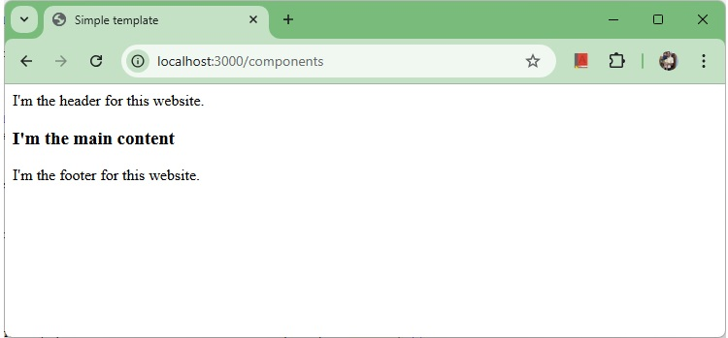
templating components
includecan also be used to include plaintext, css and JavaScript.
There are many more features of Pug. But those are out of the scope for this tutorial. You can further explore Pug.

ExpressJS - Static Files
Source: https://www.tutorialspoint.com/expressjs/expressjs_static_files.htm

ExpressJS - Serving Static Files
Static files are files that clients download as they are from the server. Create a new directory,public. Express, by default does not allow you to serve static files. You need to enable it using the following built-in middleware.
app.use(express.static('public'));
Note− Express looks up the files relative to the static directory, so the name of the static directory is not part of the URL.
Note that the root route is now set to your public dir, so all static files you load will be considering public as root. To test that this is working fine, add any image file in your newpublicdir and change its name to "testimage.jpg". In your views, create a new view and include this file like −

static_files.pug
html
head
body
h3 Testing static file serving:
img(src = "/testimage.jpg", alt = "Testing Image")

index.js
var express = require('express');
var app = express();
app.use(express.static('public'));
app.set('view engine', 'pug');
app.set('views','./views');
app.get('/static_files', function(req, res){
res.render('static_files');
});
app.listen(3000);
You should get the following output −
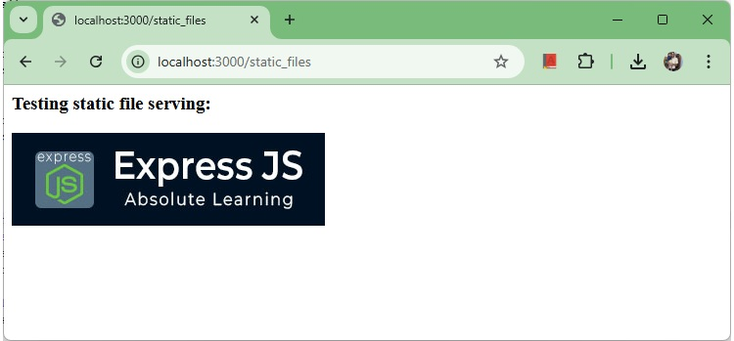
Static Files Example

Multiple Static Directories
We can also set multiple static assets directories using the following program −

index.js
var express = require('express');
var app = express();
app.use(express.static('public'));
app.use(express.static('images'));
app.listen(3000);

Virtual Path Prefix
We can also provide a path prefix for serving static files. For example, if you want to provide a path prefix like'/static', you need to include the following code in yourindex.jsfile −

index.js
var express = require('express');
var app = express();
app.use('/static', express.static('public'));
app.listen(3000);
Now whenever you need to include a file, for example, a script file called main.js residing in your public directory, use the following script tag −
<script src = "/static/main.js" />
This technique can come in handy when providing multiple directories as static files. These prefixes can help distinguish between multiple directories.

ExpressJS - Form Data
Source: https://www.tutorialspoint.com/expressjs/expressjs_form_data.htm

ExpressJS - Form Data
Forms are an integral part of the web. Almost every website we visit offers us forms that submit or fetch some information for us. To get started with forms, we will first install thebody-parser(for parsing JSON and url-encoded data) and multer(for parsing multipart/form data) middleware.
To install thebody-parserandmulter, go to your terminal and use −
E:\Dev\hello-world>npm install --save body-parser multer
added 18 packages, and audited 128 packages in 1s
20 packages are looking for funding
run `npm fund` for details
found 0 vulnerabilities
Replace yourindex.jsfile contents with the following code −

index.js
var express = require('express');
var bodyParser = require('body-parser');
var multer = require('multer');
var upload = multer();
var app = express();
app.get('/', function(req, res){
res.render('form');
});
app.set('view engine', 'pug');
app.set('views', './views');
// for parsing application/json
app.use(bodyParser.json());
// for parsing application/xwww-
app.use(bodyParser.urlencoded({ extended: true }));
//form-urlencoded
// for parsing multipart/form-data
app.use(upload.array());
app.use(express.static('public'));
app.post('/', function(req, res){
console.log(req.body);
res.send("recieved your request!");
});
app.listen(3000);
After importing the body parser and multer, we will use thebody-parserfor parsing json and x-www-form-urlencoded header requests, while we will usemulterfor parsing multipart/form-data.
Let us create an html form to test this out. Create a new view calledform.pugwith the following code −

form.pug
html
head
title Form Tester
body
form(action = "/", method = "POST")
div
label(for = "say") Say:
input(name = "say" value = "Hi")
br
div
label(for = "to") To:
input(name = "to" value = "Express forms")
br
button(type = "submit") Send my greetings
Run your server using the following.
E:\Dev\hello-world>nodemon index.js
[nodemon] 3.1.9
[nodemon] to restart at any time, enter `rs`
[nodemon] watching path(s): *.*
[nodemon] watching extensions: js,mjs,cjs,json
[nodemon] starting `node index.js`
Now go to localhost:3000/ and fill the form as you like, and submit it.
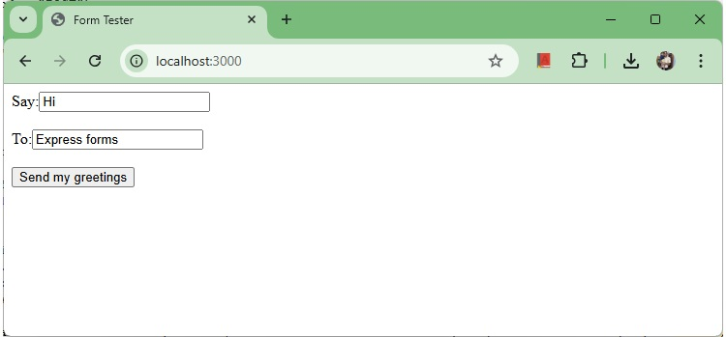
form submission
The following response will be displayed −
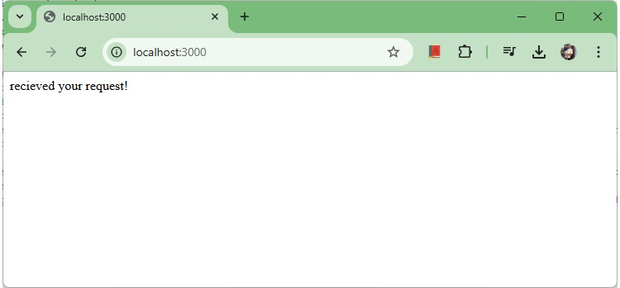
Response to form submission
Have a look at your console; it will show you the body of your request as a JavaScript object as in the following screenshot −
E:\Dev\hello-world>nodemon index.js
[nodemon] 3.1.9
[nodemon] to restart at any time, enter `rs`
[nodemon] watching path(s): *.*
[nodemon] watching extensions: js,mjs,cjs,json
[nodemon] starting `node index.js`
{ say: 'Hi', to: 'Express forms' }
Thereq.bodyobject contains your parsed request body. To use fields from that object, just use them like normal JS objects.
This is the most recommended way to send a request. There are many other ways, but those are irrelevant to cover here, because our Express app will handle all those requests in the same way. To read more about different ways to make a request, have a look atthispage.

ExpressJS - Database
Source: https://www.tutorialspoint.com/expressjs/expressjs_database.htm

ExpressJS - Database
We keep receiving requests, but end up not storing them anywhere. We need a Database to store the data. For this, we will make use of the NoSQL database calledMongoDB.
To install and read about Mongo, followthis link.
In order to use Mongo with Express, we need a client API for node. There are multiple options for us, but for this tutorial, we will stick tomongoose. Mongoose is used fordocument Modelingin Node for MongoDB. For document modeling, we create aModel(much like aclassin document oriented programming), and then we producedocumentsusing this Model (like we createdocuments of a classin OOP). All our processing will be done on these "documents", then finally, we will write these documents in our database.

Setting up Mongoose
Now that you have installed Mongo, let us install Mongoose, the same way we have been installing our other node packages −
npm install --save mongoose
Before we start using mongoose, we have to create a database using the Mongo shell. To create a new database, open your terminal and enter "mongo". A Mongo shell will start, enter the following code −
use my_db
A new database will be created for you. Whenever you open up the mongo shell, it will default to "test" db and you will have to change to your database using the same command as above.
To use Mongoose, we will require it in ourindex.jsfile and then connect to themongodbservice running onmongodb://localhost.
var mongoose = require('mongoose');
mongoose.connect('mongodb://localhost/my_db');
Now our app is connected to our database, let us create a new Model. This model will act as a collection in our database. To create a new Model, use the following code, before defining any route −
var personSchema = mongoose.Schema({
name: String,
age: Number,
nationality: String
});
var Person = mongoose.model("Person", personSchema);
The above code defines the schema for a person and is used to create a Mongoose ModePerson.

Saving Documents
Now, we will create a new html form; this form will help you get the details of a person and save it to our database. To create the form, create a new view file calledperson.pugin views directory with the following content −
html
head
title Person
body
form(action = "/person", method = "POST")
div
label(for = "name") Name:
input(name = "name")
br
div
label(for = "age") Age:
input(name = "age")
br
div
label(for = "nationality") Nationality:
input(name = "nationality")
br
button(type = "submit") Create new person
Also add anew get routeinindex.jsto render this document −
app.get('/person', function(req, res){
res.render('person');
});
Go to "localhost:3000/person" to check if the form is displaying the correct output. Note that this is just the UI, it is not working yet.
We will now define a post route handler at'/person'which will handle this request
app.post('/person', function(req, res){
var personInfo = req.body; //Get the parsed information
if(!personInfo.name || !personInfo.age || !personInfo.nationality){
res.render('show_message', {
message: "Sorry, you provided worng info", type: "error"});
} else {
var newPerson = new Person({
name: personInfo.name,
age: personInfo.age,
nationality: personInfo.nationality
});
newPerson.save(function(err, Person){
if(err)
res.render('show_message', {message: "Database error", type: "error"});
else
res.render('show_message', {
message: "New person added", type: "success", person: personInfo});
});
}
});
In the above code, if we receive any empty field or do not receive any field, we will send an error response. But if we receive a well-formed document, then we create anewPersondocument from Person model and save it to our DB using thenewPerson.save()function. This is defined in Mongoose and accepts a callback as argument. This callback has 2 arguments error and response. These arguments will render theshow_messageview.
To show the response from this route, we will also need to create ashow_messageview. Create a new view with the following code −
html
head
title Person
body
if(type == "error")
h3(style = "color:red") #{message}
else
h3 New person,
name: #{person.name},
age: #{person.age} and
nationality: #{person.nationality} added!
We will receive the following response on successfully submitting theform(show_message.pug)−
New Person, name: Robert, Age: 20 and nationality: Indian added!
We now have an interface to createpersons.

Retrieving Documents
Mongoose provides a lot of functions for retrieving documents, we will focus on 3 of those. All these functions also take a callback as the last parameter, and just like the save function, their arguments are error and response. The three functions are as follows −

Model.find(conditions, callback)
This function finds all the documents matching the fields in conditions object. Same operators used in Mongo also work in mongoose. For example,
Person.find(function(err, response){
console.log(response);
});
This will fetch all the documents from the person's collection.
Person.find({name: "Ayush", age: 20},
function(err, response){
console.log(response);
});
This will fetch all documents where field name is "Ayush" and age is 20.
We can also provide projection we need, i.e., the fields we need. For example, if we want only thenamesof people whosenationalityis"Indian", we use −
Person.find({nationality: "Indian"}, "name", function(err, response){
console.log(response);
});

Model.findOne(conditions, callback)
This function always fetches a single, most relevant document. It has the same exact arguments asModel.find().

Model.findById(id, callback)
This function takes in the_id(defined by mongo) as the first argument, an optional projection string and a callback to handle the response. For example,
Person.findById("507f1f77bcf86cd799439011", function(err, response){
console.log(response);
});
Let us now create a route to view all people records −
var express = require('express');
var app = express();
var mongoose = require('mongoose');
mongoose.connect('mongodb://localhost/my_db');
var personSchema = mongoose.Schema({
name: String,
age: Number,
nationality: String
});
var Person = mongoose.model("Person", personSchema);
app.get('/people', function(req, res){
Person.find(function(err, response){
res.json(response);
});
});
app.listen(3000);

Updating Documents
Mongoose provides 3 functions to update documents. The functions are described below −

Model.update(condition, updates, callback)
This function takes a conditions and updates an object as input and applies the changes to all the documents matching the conditions in the collection. For example, following code will update the nationality "American" in all Person documents −
Person.update({age: 25}, {nationality: "American"}, function(err, response){
console.log(response);
});

Model.findOneAndUpdate(condition, updates, callback)
It finds one document based on the query and updates that according to the second argument. It also takes a callback as last argument. Let us perform the following example to understand the function
Person.findOneAndUpdate({name: "Ayush"}, {age: 40}, function(err, response) {
console.log(response);
});

Model.findByIdAndUpdate(id, updates, callback)
This function updates a single document identified by its id. For example,
Person.findByIdAndUpdate("507f1f77bcf86cd799439011", {name: "James"},
function(err, response){
console.log(response);
});
Let us now create a route to update people. This will be aPUTroute with the id as a parameter and details in the payload.
var express = require('express');
var app = express();
var mongoose = require('mongoose');
mongoose.connect('mongodb://localhost/my_db');
var personSchema = mongoose.Schema({
name: String,
age: Number,
nationality: String
});
var Person = mongoose.model("Person", personSchema);
app.put('/people/:id', function(req, res){
Person.findByIdAndUpdate(req.params.id, req.body, function(err, response){
if(err) res.json({message: "Error in updating person with id " + req.params.id});
res.json(response);
});
});
app.listen(3000);
To test this route, enter the following in your terminal (replace the id with an id from your createdpeople) −
curl -X PUT --data "name = James&age = 20&nationality = American
"http://localhost:3000/people/507f1f77bcf86cd799439011
This will update the document associated with the id provided in the route with the above details.

Deleting Documents
We have coveredCreate, ReadandUpdate, now we will see how Mongoose can be used toDeletedocuments. We have 3 functions here, exactly like update.

Model.remove(condition, [callback])
This function takes a condition object as input and removes all documents matching the conditions. For example, if we need to remove all people aged 20, use the following syntax −
Person.remove({age:20});

Model.findOneAndRemove(condition, [callback])
This functions removes asingle, most relevant document according to conditions object. Let us execute the following code to understand the same.
Person.findOneAndRemove({name: "Robert"});

Model.findByIdAndRemove(id, [callback])
This function removes a single document identified by its id. For example,
Person.findByIdAndRemove("507f1f77bcf86cd799439011");
Let us now create a route to delete people from our database.
var express = require('express');
var app = express();
var mongoose = require('mongoose');
mongoose.connect('mongodb://localhost/my_db');
var personSchema = mongoose.Schema({
name: String,
age: Number,
nationality: String
});
var Person = mongoose.model("Person", personSchema);
app.delete('/people/:id', function(req, res){
Person.findByIdAndRemove(req.params.id, function(err, response){
if(err) res.json({message: "Error in deleting record id " + req.params.id});
else res.json({message: "Person with id " + req.params.id + " removed."});
});
});
app.listen(3000);
To check the output, use the following curl command −
curl -X DELETE http://localhost:3000/people/507f1f77bcf86cd799439011
This will remove the person with given id producing the following message −
{message: "Person with id 507f1f77bcf86cd799439011 removed."}
This wraps up how we can create simple CRUD applications using MongoDB, Mongoose and Express. To explore Mongoose further, read theAPI docs.

ExpressJS - Cookies
Source: https://www.tutorialspoint.com/expressjs/expressjs_cookies.htm

ExpressJS - Cookies
Cookies are simple, small files/data that are sent to client with a server request and stored on the client side. Every time the user loads the website back, this cookie is sent with the request. This helps us keep track of the users actions.
The following are the numerous uses of the HTTP Cookies −
- Session management
- Personalization(Recommendation systems)
- User tracking
To use cookies with Express, we need the cookie-parser middleware. To install it, use the following code −
E:\Dev\hello-world>npm install --save cookie-parser
up to date, audited 128 packages in 2s
20 packages are looking for funding
run `npm fund` for details
found 0 vulnerabilities
Now to use cookies with Express, we will require thecookie-parser. cookie-parser is a middleware whichparses cookies attached to the client request object. To use it, we will require it in ourindex.jsfile; this can be used the same way as we use other middleware. Here, we will use the following code.
var cookieParser = require('cookie-parser');
app.use(cookieParser());
cookie-parser parses Cookie header and populatesreq.cookieswith an object keyed by the cookie names. To set a new cookie, let us define a new route in your Express app like −

index.js
var express = require('express');
var app = express();
var cookieParser = require('cookie-parser');
app.use(cookieParser());
app.get('/', function(req, res){
res.cookie('name', 'express').send('cookie set'); //Sets name = express
});
app.listen(3000);
To check if your cookie is set or not, just go to your browser, fire up the console, and enter −
console.log(document.cookie);
You will get the output like (you may have more cookies set maybe due to extensions in your browser) −
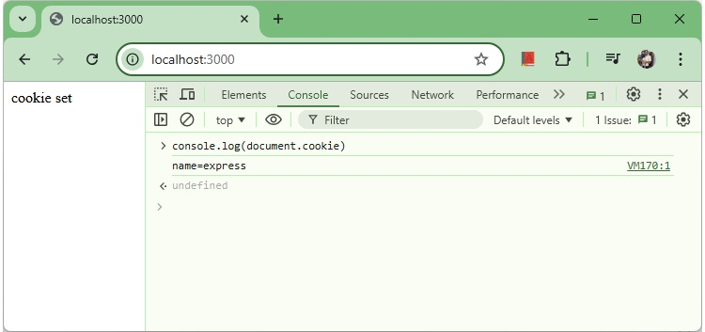
Cookie
The browser also sends back cookies every time it queries the server. To view cookies from your server, on the server console in a route, add the following code to that route.
console.log('Cookies: ', req.cookies);
Next time you send a request to this route, you will receive the following output.
Cookies: { name: 'express' }

Adding Cookies with Expiration Time
You can add cookies that expire. To add a cookie that expires, just pass an object with property 'expire' set to the time when you want it to expire. For example,
//Expires after 360000 ms from the time it is set.
res.cookie(name, 'value', {expire: 360000 + Date.now()});
Another way to set expiration time is using'maxAge'property. Using this property, we can provide relative time instead of absolute time. Following is an example of this method.
//This cookie also expires after 360000 ms from the time it is set.
res.cookie(name, 'value', {maxAge: 360000});

Deleting Existing Cookies
To delete a cookie, use the clearCookie function. For example, if you need to clear a cookie namedfoo, use the following code.

index.js
var express = require('express');
var app = express();
app.get('/clear_cookie_foo', function(req, res){
res.clearCookie('foo');
res.send('cookie foo cleared');
});
app.listen(3000);
In the next chapter, we will see how to use cookies to manage sessions.

ExpressJS - Sessions
Source: https://www.tutorialspoint.com/expressjs/expressjs_sessions.htm

ExpressJS - Sessions
HTTP is stateless; in order to associate a request to any other request, you need a way to store user data between HTTP requests. Cookies and URL parameters are both suitable ways to transport data between the client and the server. But they are both readable and on the client side. Sessions solve exactly this problem. You assign the client an ID and it makes all further requests using that ID. Information associated with the client is stored on the server linked to this ID.
We will need theExpress-session, so install it using the following code.
E:\Dev\hello-world>npm install --save express-session
added 6 packages, and audited 134 packages in 1s
20 packages are looking for funding
run `npm fund` for details
found 0 vulnerabilities
We will put thesessionandcookie-parsermiddleware in place. In this example, we will use the default store for storing sessions, i.e., MemoryStore. Never use this in production environments. The session middleware handles all things for us, i.e., creating the session, setting the session cookie and creating the session object inreqobject.

Checking page views using Session
Whenever we make a request from the same client again, we will have their session information stored with us (given that the server was not restarted). We can add more properties to the session object. In the following example, we will create a view counter for a client.

index.js
var express = require('express');
var cookieParser = require('cookie-parser');
var session = require('express-session');
var app = express();
app.use(cookieParser());
app.use(session({
secret: 'sample-secret',
resave: false,
saveUninitialized: false
}));
app.get('/', function(req, res){
if(req.session.page_views){
req.session.page_views++;
res.send("You visited this page " + req.session.page_views + " times");
} else {
req.session.page_views = 1;
res.send("Welcome to this page for the first time!");
}
});
app.listen(3000);

Explanation
What the above code does is, when a user visits the site, it creates a new session for the user and assigns them a cookie. Next time the user comes, the cookie is checked and thepage_viewsession variable is updated accordingly.
Now if you run the app and go tolocalhost:3000, the following output will be displayed.
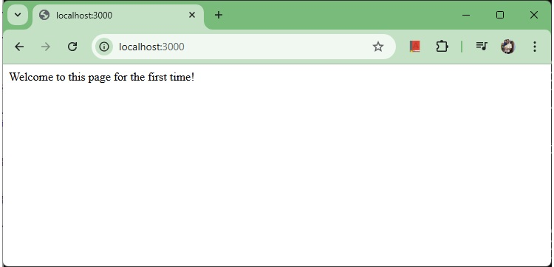
First visit
If you revisit the page, the page counter will increase. The page in the following screenshot was refreshed 5 times.
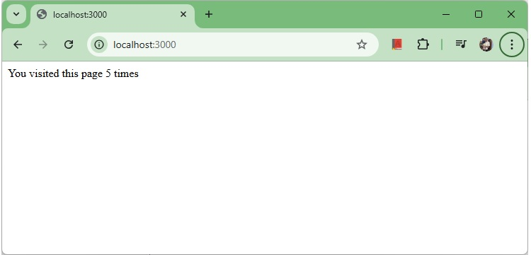
Fifth visit

ExpressJS - Authentication
Source: https://www.tutorialspoint.com/expressjs/expressjs_authentication.htm

ExpressJS - Authentication
Authentication is a process in which the credentials provided are compared to those on file in a database of authorized users' information on a local operating system or within an authentication server. If the credentials match, the process is completed and the user is granted authorization for access.
For us to create an authentication system, we will need to create a sign up page and a user-password store. The following code creates an account for us and stores it in memory. This is just for the purpose of demo; it is recommended that a persistent storage (database or files) is always used to store user information.

index.js
var express = require('express');
var app = express();
var bodyParser = require('body-parser');
var multer = require('multer');
var upload = multer();
var session = require('express-session');
var cookieParser = require('cookie-parser');
app.set('view engine', 'pug');
app.set('views','./views');
app.use(bodyParser.json());
app.use(bodyParser.urlencoded({ extended: true }));
app.use(upload.array());
app.use(cookieParser());
app.use(session({
secret: 'sample-secret',
resave: false,
saveUninitialized: false
}));
var Users = [];
app.get('/signup', function(req, res){
res.render('signup');
});
app.post('/signup', function(req, res){
if(!req.body.id || !req.body.password){
res.status("400");
res.send("Invalid details!");
} else {
Users.filter(function(user){
if(user.id === req.body.id){
res.render('signup', {
message: "User Already Exists! Login or choose another user id"});
}
});
var newUser = {id: req.body.id, password: req.body.password};
Users.push(newUser);
req.session.user = newUser;
res.redirect('/protected_page');
}
});
app.listen(3000);
Now for the signup form, create a new view calledsignup.pug.

signup.pug
html
head
title Signup
body
if(message)
h4 #{message}
form(action = "/signup" method = "POST")
input(name = "id" type = "text" required placeholder = "User ID")
input(name = "password" type = "password" required placeholder = "Password")
button(type = "Submit") Sign me up!
Check if this page loads by visiting localhost:3000/signup.
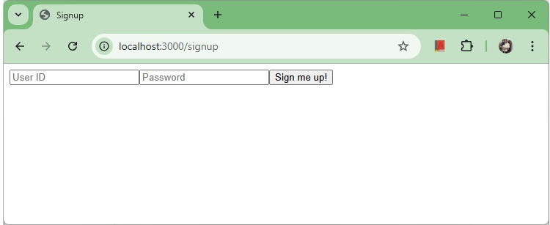
Signup form
We have set the required attribute for both fields, so HTML5 enabled browsers will not let us submit this form until we provide both id and password. If someone tries to register using a curl request without a User ID or Password, an error will be displayed. Create a new file calledprotected_page.pugin views with the following content −
html
head
title Protected page
body
div Hey #{id}, How are you doing today?
div Want to log out?
button(onclick='logout()') Logout
This page should only be visible if the user has just signed up or logged in. Let us now define its route and also routes to log in and log out −

index.js
var express = require('express');
var app = express();
var bodyParser = require('body-parser');
var multer = require('multer');
var upload = multer();
var session = require('express-session');
var cookieParser = require('cookie-parser');
app.set('view engine', 'pug');
app.set('views','./views');
app.use(bodyParser.json());
app.use(bodyParser.urlencoded({ extended: true }));
app.use(upload.array());
app.use(cookieParser());
app.use(session({
secret: 'sample-secret',
resave: false,
saveUninitialized: false
}));
var Users = [];
app.get('/signup', function(req, res){
res.render('signup');
});
app.post('/signup', function(req, res){
if(!req.body.id || !req.body.password){
res.status("400");
res.send("Invalid details!");
} else {
Users.filter(function(user){
if(user.id === req.body.id){
res.render('signup', {
message: "User Already Exists! Login or choose another user id"});
}
});
var newUser = {id: req.body.id, password: req.body.password};
Users.push(newUser);
req.session.user = newUser;
res.redirect('/protected_page');
}
});
function checkSignIn(req, res, next){
if(req.session.user){
next(); //If session exists, proceed to page
} else {
var err = new Error("Not logged in!");
console.log(req.session.user);
next(err); //Error, trying to access unauthorized page!
}
}
app.get('/protected_page', checkSignIn, function(req, res){
res.render('protected_page', {id: req.session.user.id})
});
app.get('/login', function(req, res){
res.render('login');
});
app.post('/login', function(req, res){
console.log(Users);
if(!req.body.id || !req.body.password){
res.render('login', {message: "Please enter both id and password"});
} else {
Users.filter(function(user){
if(user.id === req.body.id && user.password === req.body.password){
req.session.user = user;
res.redirect('/protected_page');
}
});
res.render('login', {message: "Invalid credentials!"});
}
});
app.get('/logout', function(req, res){
req.session.destroy(function(){
console.log("user logged out.")
});
res.redirect('/login');
});
app.use('/protected_page', function(err, req, res, next){
console.log(err);
//User should be authenticated! Redirect him to log in.
res.redirect('/login');
});
app.listen(3000);
We have created a middleware functioncheckSignInto check if the user is signed in. Theprotected_pageuses this function. To log the user out, we destroy the session.
Let us now create the login page. Name the view aslogin.pugand enter the contents −
html
head
title Signup
body
if(message)
h4 #{message}
form(action = "/login" method = "POST")
input(name = "id" type = "text" required placeholder = "User ID")
input(name = "password" type = "password" required placeholder = "Password")
button(type = "Submit") Log in
Our simple authentication application is now complete; let us now test the application. Run the app usingnodemon index.js, and proceed to localhost:3000/signup.
Enter a Username and a password and click sign up. You will be redirected to theprotected_pageif details are valid/unique −
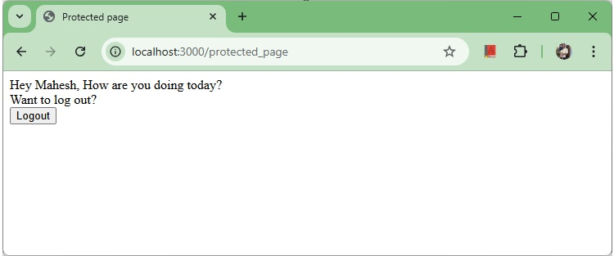
Protected page
Now log out of the app. This will redirect us to the login page −
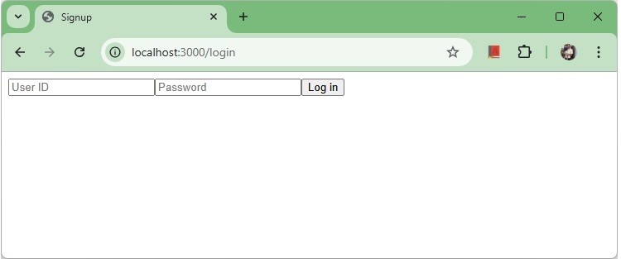
Auth login
This route is protected such that if an unauthenticated person tries to visit it, he will be redirected to our login page. This was all about basic user authentication. It is always recommended that we use a persistent session system and use hashes for password transport. There are much better ways to authenticate users now, leveraging JSON tokens.

ExpressJS - RESTful APIs
Source: https://www.tutorialspoint.com/expressjs/expressjs_restful_apis.htm

ExpressJS - RESTFul APIs
An API is always needed to create mobile applications, single page applications, use AJAX calls and provide data to clients. An popular architectural style of how to structure and name these APIs and the endpoints is calledREST(Representational Transfer State).HTTP 1.1was designed keeping REST principles in mind. REST was introduced byRoy Fieldingin 2000 in his Paper Fielding Dissertations.
RESTful URIs and methods provide us with almost all information we need to process a request. The table given below summarizes how the various verbs should be used and how URIs should be named. We will be creating a movies API towards the end; let us now discuss how it will be structured.
Method | URI | Details | Function
GET | /movies | Safe, cachable | Gets the list of all movies and their details
GET | /movies/1234 | Safe, cachable | Gets the details of Movie id 1234
POST | /movies | N/A | Creates a new movie with the details provided. Response contains the URI for this newly created resource.
PUT | /movies/1234 | Idempotent | Modifies movie id 1234(creates one if it doesn't already exist). Response contains the URI for this newly created resource.
DELETE | /movies/1234 | Idempotent | Movie id 1234 should be deleted, if it exists. Response should contain the status of the request.
DELETE or PUT | /movies | Invalid | Should be invalid.DELETEandPUTshould specify which resource they are working on.
Let us now create this API in Express. We will be using JSON as our transport data format as it is easy to work with in JavaScript and has other benefits. Replace yourindex.jsfile with themovies.jsfile as in the following program.

index.js
var express = require('express');
var bodyParser = require('body-parser');
var multer = require('multer');
var upload = multer();
var app = express();
app.use(cookieParser());
app.use(bodyParser.json());
app.use(bodyParser.urlencoded({ extended: true }));
app.use(upload.array());
//Require the Router we defined in movies.js
var movies = require('./movies.js');
//Use the Router on the sub route /movies
app.use('/movies', movies);
app.listen(3000);
Now that we have our application set up, let us concentrate on creating the API.
Start by setting up the movies.js file. We are not using a database to store the movies but are storing them in memory; so every time the server restarts, the movies added by us will vanish. This can easily be mimicked using a database or a file (using node fs module).
Once you import Express then, create a Router and export it usingmodule.exports−

movies.js
var express = require('express');
var router = express.Router();
var movies = [
{id: 101, name: "Fight Club", year: 1999, rating: 8.1},
{id: 102, name: "Inception", year: 2010, rating: 8.7},
{id: 103, name: "The Dark Knight", year: 2008, rating: 9},
{id: 104, name: "12 Angry Men", year: 1957, rating: 8.9}
];
//Routes will go here
module.exports = router;

GET routes
Let us define the GET route for getting all the movies −
router.get('/', function(req, res){
res.json(movies);
});
To test out if this is working fine, run your app, then open your terminal and enter −
curl -i -H "Accept: application/json" -H "Content-Type: application/json" -X GET
localhost:3000/movies
The following response will be displayed −
[{"id":101,"name":"Fight Club","year":1999,"rating":8.1},
{"id":102,"name":"Inception","year":2010,"rating":8.7},
{"id":103,"name":"The Dark Knight","year":2008,"rating":9},
{"id":104,"name":"12 Angry Men","year":1957,"rating":8.9}]
We have a route to get all the movies. Let us now create a route to get a specific movie by its id.
router.get('/:id([0-9]{3,})', function(req, res){
var currMovie = movies.filter(function(movie){
if(movie.id == req.params.id){
return true;
}
});
if(currMovie.length == 1){
res.json(currMovie[0])
} else {
res.status(404);//Set status to 404 as movie was not found
res.json({message: "Not Found"});
}
});
This will get us the movies according to the id that we provided. To check the output, use the following command in your terminal −
curl -i -H "Accept: application/json" -H "Content-Type: application/json" -X GET
localhost:3000/movies/101
You'll get the following response −
{"id":101,"name":"Fight Club","year":1999,"rating":8.1}
If you visit an invalid route, it will produce acannot GET errorwhile if you visit a valid route with an id that doesnt exist, it will produce a 404 error.
We are done with the GET routes, let us now move on to thePOSTroute.

POST route
Use the following route to handle thePOSTeddata −
router.post('/', function(req, res){
//Check if all fields are provided and are valid:
if(!req.body.name ||
!req.body.year.toString().match(/^[0-9]{4}$/g) ||
!req.body.rating.toString().match(/^[0-9]\.[0-9]$/g)){
res.status(400);
res.json({message: "Bad Request"});
} else {
var newId = movies[movies.length-1].id+1;
movies.push({
id: newId,
name: req.body.name,
year: req.body.year,
rating: req.body.rating
});
res.json({message: "New movie created.", location: "/movies/" + newId});
}
});
This will create a new movie and store it in the movies variable. To check this route, enter the following code in your terminal −
curl -X POST --data "name = Toy%20story&year = 1995&rating = 8.5" http://localhost:3000/movies
The following response will be displayed −
{"message":"New movie created.","location":"/movies/105"}
To test if this was added to the movies object, Run the get request for/movies/105again. The following response will be displayed −
{"id":105,"name":"Toy story","year":"1995","rating":"8.5"}
Let us move on to create the PUT and DELETE routes.

PUT route
The PUT route is almost the same as the POST route. We will be specifying the id for the object that'll be updated/created. Create the route in the following way.
router.put('/:id', function(req, res){
//Check if all fields are provided and are valid:
if(!req.body.name ||
!req.body.year.toString().match(/^[0-9]{4}$/g) ||
!req.body.rating.toString().match(/^[0-9]\.[0-9]$/g) ||
!req.params.id.toString().match(/^[0-9]{3,}$/g)){
res.status(400);
res.json({message: "Bad Request"});
} else {
//Gets us the index of movie with given id.
var updateIndex = movies.map(function(movie){
return movie.id;
}).indexOf(parseInt(req.params.id));
if(updateIndex === -1){
//Movie not found, create new
movies.push({
id: req.params.id,
name: req.body.name,
year: req.body.year,
rating: req.body.rating
});
res.json({message: "New movie created.", location: "/movies/" + req.params.id});
} else {
//Update existing movie
movies[updateIndex] = {
id: req.params.id,
name: req.body.name,
year: req.body.year,
rating: req.body.rating
};
res.json({message: "Movie id " + req.params.id + " updated.",
location: "/movies/" + req.params.id});
}
}
});
This route will perform the function specified in the above table. It will update the object with new details if it exists. If it doesn't exist, it will create a new object. To check the route, use the following curl command. This will update an existing movie. To create a new Movie, just change the id to a non-existing id.
curl -X PUT --data "name = Toy%20story&year = 1995&rating = 8.5"
http://localhost:3000/movies/101
Response
{"message":"Movie id 101 updated.","location":"/movies/101"}

DELETE route
Use the following code to create a delete route. −
router.delete('/:id', function(req, res){
var removeIndex = movies.map(function(movie){
return movie.id;
}).indexOf(req.params.id); //Gets us the index of movie with given id.
if(removeIndex === -1){
res.json({message: "Not found"});
} else {
movies.splice(removeIndex, 1);
res.send({message: "Movie id " + req.params.id + " removed."});
}
});
Check the route in the same way as we checked the other routes. On successful deletion(for example id 105), you will get the following output −
{message: "Movie id 105 removed."}
Finally, ourmovies.jsfile will look like the following.
var express = require('express');
var router = express.Router();
var movies = [
{id: 101, name: "Fight Club", year: 1999, rating: 8.1},
{id: 102, name: "Inception", year: 2010, rating: 8.7},
{id: 103, name: "The Dark Knight", year: 2008, rating: 9},
{id: 104, name: "12 Angry Men", year: 1957, rating: 8.9}
];
router.get('/:id([0-9]{3,})', function(req, res){
var currMovie = movies.filter(function(movie){
if(movie.id == req.params.id){
return true;
}
});
if(currMovie.length == 1){
res.json(currMovie[0])
} else {
res.status(404); //Set status to 404 as movie was not found
res.json({message: "Not Found"});
}
});
router.post('/', function(req, res){
//Check if all fields are provided and are valid:
if(!req.body.name ||
!req.body.year.toString().match(/^[0-9]{4}$/g) ||
!req.body.rating.toString().match(/^[0-9]\.[0-9]$/g)){
res.status(400);
res.json({message: "Bad Request"});
} else {
var newId = movies[movies.length-1].id+1;
movies.push({
id: newId,
name: req.body.name,
year: req.body.year,
rating: req.body.rating
});
res.json({message: "New movie created.", location: "/movies/" + newId});
}
});
router.put('/:id', function(req, res) {
//Check if all fields are provided and are valid:
if(!req.body.name ||
!req.body.year.toString().match(/^[0-9]{4}$/g) ||
!req.body.rating.toString().match(/^[0-9]\.[0-9]$/g) ||
!req.params.id.toString().match(/^[0-9]{3,}$/g)){
res.status(400);
res.json({message: "Bad Request"});
} else {
//Gets us the index of movie with given id.
var updateIndex = movies.map(function(movie){
return movie.id;
}).indexOf(parseInt(req.params.id));
if(updateIndex === -1){
//Movie not found, create new
movies.push({
id: req.params.id,
name: req.body.name,
year: req.body.year,
rating: req.body.rating
});
res.json({
message: "New movie created.", location: "/movies/" + req.params.id});
} else {
//Update existing movie
movies[updateIndex] = {
id: req.params.id,
name: req.body.name,
year: req.body.year,
rating: req.body.rating
};
res.json({message: "Movie id " + req.params.id + " updated.",
location: "/movies/" + req.params.id});
}
}
});
router.delete('/:id', function(req, res){
var removeIndex = movies.map(function(movie){
return movie.id;
}).indexOf(req.params.id); //Gets us the index of movie with given id.
if(removeIndex === -1){
res.json({message: "Not found"});
} else {
movies.splice(removeIndex, 1);
res.send({message: "Movie id " + req.params.id + " removed."});
}
});
module.exports = router;
This completes our REST API. Now you can create much more complex applications using this simple architectural style and Express.

ExpressJS - Scaffolding
Source: https://www.tutorialspoint.com/expressjs/expressjs_scaffolding.htm

ExpressJS - Scaffolding
Scaffolding allows us to easily create askeleton for a web application. We manually create our public directory, add middleware, create separate route files, etc. A scaffolding tool sets up all these things for us so that we can directly get started with building our application.
We can useexpress-generatorto create application skeleton easily −
npx install express-generator
npx is available node 8.2.0 onwards. In case of earlier version, we can use npm as follows:
npm install -g express-generator
express
Once express-generator is installed, then run the command as follows and it will create a skeleton project as shown below−
E:\Dev\express-apps>npx express-generator
warning: the default view engine will not be jade in future releases
warning: use `--view=jade' or `--help' for additional options
create : public\
create : public\javascripts\
create : public\images\
create : public\stylesheets\
create : public\stylesheets\style.css
create : routes\
create : routes\index.js
create : routes\users.js
create : views\
create : views\error.jade
create : views\index.jade
create : views\layout.jade
create : app.js
create : package.json
create : bin\
create : bin\www
install dependencies:
> npm install
run the app:
> SET DEBUG=express-apps:* & npm start
Now to install dependencies, run following command.
E:\Dev\express-apps>npm install
This will install the relevant dependencies and project is ready to start development with.

ExpressJS - Serving Dynamic Content
Source: https://www.tutorialspoint.com/expressjs/expressjs_serving_dynamic_content.htm

ExpressJS - Serving Dynamic Content
In Express JS, we can use templating engines like PUG, EJS, Handlebars, Mustache and many more to render dynamic content in an HTML Page. Template engines make life easier by separating HTML from data and logic. We can reuse template components and layouts. We're using PUG as template engine to render a dynamic content in a page. For details on how to install PUG templating engine, you can refer toExpressJS - Templating.
Apart from PUG as templating engine, we need other libraries useful in html handling.
To installpug, thebody-parserandmulter, go to your terminal and use −
E:\Dev\hello-world>npm install --save pug body-parser multer
added 37 packages, and audited 128 packages in 1s
20 packages are looking for funding
run `npm fund` for details
found 0 vulnerabilities
Replace yourindex.jsfile contents with the following code −

index.js
var express = require('express');
var bodyParser = require('body-parser');
var app = express();
app.set('view engine', 'pug');
app.set('views', './views');
// for parsing application/json
app.use(bodyParser.json());
// for parsing application/xwww-
app.use(bodyParser.urlencoded({ extended: true }));
app.use(express.static('public'));
app.get('/', function(req, res){
res.render('form');
});
// handle form submission
app.post('/', function(req, res){
// read the number entered by the user
const number = parseInt(req.body.number);
// compute square of the number
const square = Math.pow(number, 2);
// return the result
res.render('form', { result: square });
});
app.listen(3000);
After importing the body parser and multer, we can use thebody-parserfor parsing json and x-www-form-urlencoded header requests, while we will usemulterfor parsing multipart/form-data.
Let us create an html form to test this out. Create a new view calledform.pugwith the following code −

form.pug
html
head
title Dynamic Content
body
form(action = "/", method = "POST")
div
label(for = "number") Enter Number:
input(name = "number" value = "10")
br
button(type = "submit") Calculate
if(result)
h3 Square of Number: #{result}
Run your server using the following.
E:\Dev\hello-world>nodemon index.js
[nodemon] 3.1.9
[nodemon] to restart at any time, enter `rs`
[nodemon] watching path(s): *.*
[nodemon] watching extensions: js,mjs,cjs,json
[nodemon] starting `node index.js`
Now go to localhost:3000/ and fill the number in the form as you like, and submit it.
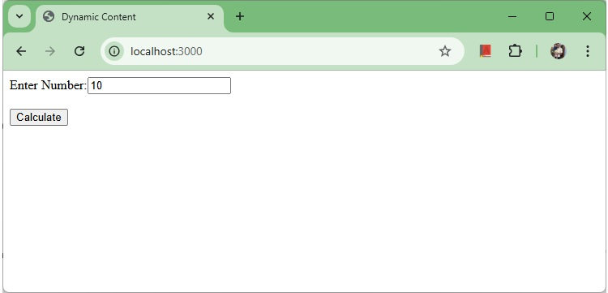
form submission
The following response will be displayed −
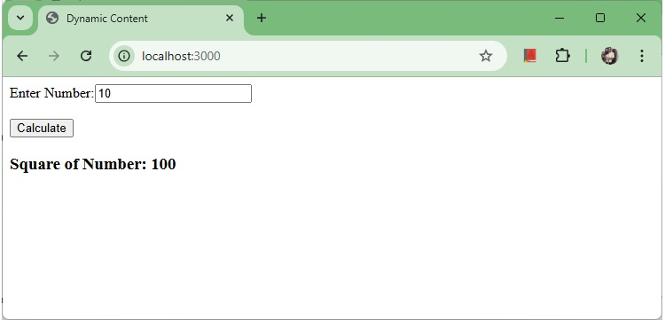
Response to form submission
Here we can check the result computed on node server on our page as a dynamic content using PUG template.

ExpressJS - Handling File Uploads
Source: https://www.tutorialspoint.com/expressjs/expressjs_handling_file_uploads.htm

ExpressJS - Handling File Uploads
It is a very common requirement where we need to upload file to the server. We can achieve the same functionality in express usingmulterlibrary.multeris a middleware especially to handlemultipart/form-data, primarily used to handle uploaded files.

Installing multer
We can use the following command to installmulterusing npm.
npm install --save multer

Usage
multer adds a file or files object to the request object. Using file object, we can retrieve the file details and using files, we can retrieve details of multiple files uploaded.

Handle single file upload
// upload a single file
app.post('/uploadFile', upload.single('uploadedFile'), function (req, res, next) {
// req.file is the `uploadedFile` file
const title = req.file.title;
const file = req.file;
const fileName = req.file.originalname;
console.log(fileName + " saved in " + os.tmpdir());
console.log(file);
res.sendStatus(200);
})

Handle multiple files upload
// upload multiple files
app.post('/uploadFiles', upload.array('uploadedFiles', 12), function (req, res, next) {
// req.files is the array of 'uploadedFiles' files
const files = req.files;
console.log("Files uploaded in " + os.tmpdir());
console.log(files);
res.sendStatus(200);
})

Example - Uploading a file to the server

Install required libraries if not present
Install thebody-parserandmulter, go to your terminal and use −
E:\Dev\hello-world>npm install --save body-parser multer
added 18 packages, and audited 128 packages in 1s
20 packages are looking for funding
run `npm fund` for details
found 0 vulnerabilities
Replace yourindex.jsfile contents with the following code −

index.js
const express = require('express')
const multer = require('multer')
const os = require('os');
// set the temp directory to upload a file
const upload = multer({ dest: os.tmpdir() })
const app = express()
// upload a single file
app.post('/uploadFile', upload.single('uploadedFile'), function (req, res, next) {
// req.file is the `uploadedFile` file
const file = req.file;
const fileName = req.file.originalname;
console.log(fileName + " saved in " + os.tmpdir());
console.log(file);
res.sendStatus(200);
})
// upload multiple files
app.post('/uploadFiles', upload.array('uploadedFiles', 12), function (req, res, next) {
// req.files is the array of 'uploadedFiles' files
const files = req.files;
console.log("Files uploaded in " + os.tmpdir());
console.log(files);
res.sendStatus(200);
})
app.listen(3000);

Run your server
Run the server using following command.
E:\Dev\hello-world>nodemon index.js
[nodemon] 3.1.9
[nodemon] to restart at any time, enter `rs`
[nodemon] watching path(s): *.*
[nodemon] watching extensions: js,mjs,cjs,json
[nodemon] starting `node index.js`
Now go to postman and make a POST request with a file. The following response will be displayed −
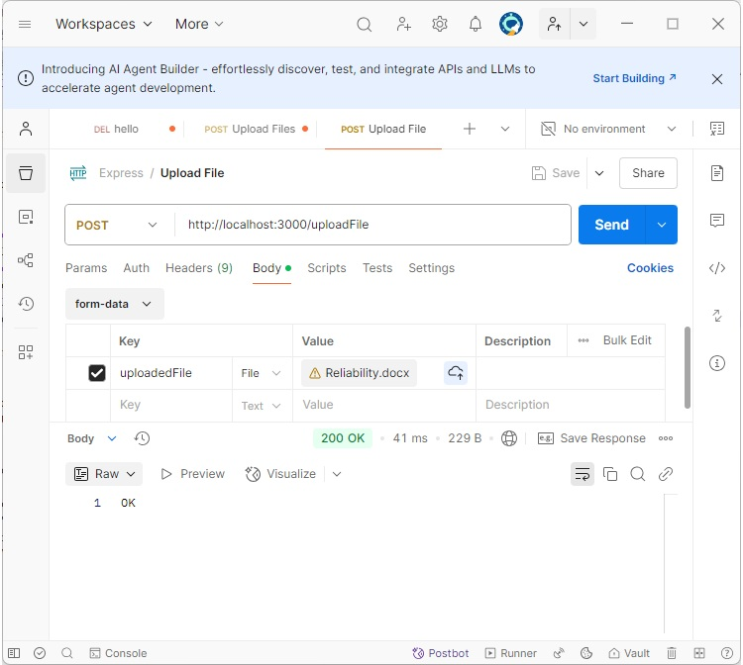
Response to file upload
Have a look at your console; it will show you the body of your request as a JavaScript object as following −
E:\Dev\hello-world>nodemon index.js
[nodemon] 3.1.9
[nodemon] to restart at any time, enter `rs`
[nodemon] watching path(s): *.*
[nodemon] watching extensions: js,mjs,cjs,json
[nodemon] starting `node index.js`
Reliability.docx saved in C:\Users\TUTORI~1\AppData\Local\Temp
{
fieldname: 'uploadedFile',
originalname: 'Reliability.docx',
encoding: '7bit',
mimetype: 'application/vnd.openxmlformats-officedocument.wordprocessingml.document',
destination: 'C:\\Users\\TUTORI~1\\AppData\\Local\\Temp',
filename: '438bf0d2a7fe973cf49b28443db7c2f1',
path: 'C:\\Users\\TUTORI~1\\AppData\\Local\\Temp\\438bf0d2a7fe973cf49b28443db7c2f1',
size: 21279
}
Thereq.fileobject contains uploaded file data. Uploaded file is present in the temporary directory.

ExpressJS - Internationalization(i18n)
Source: https://www.tutorialspoint.com/expressjs/expressjs_internationalization_i18n.htm

ExpressJS - Internationalization
Internationalization or I18N refers to the ability of an Application to serve users in multiple and different languages. We can implement internationalization in express js easily using following modules−
- i18next− core framework for Internationalization.
- i18next-express-middleware− middleware to detect user language and provide i18n functionality to express routes and requests.
- i18next-node-fs-backend− backend to load messages from file system.

Installing i18n modules
We can use the following command to install above i18n modules using npm.
npm install --save i18next i18next-http-middleware i18next-fs-backend

Creating Translation files
Let's us create two translation files, one for default local english and one for french. We'll store a sample message as Hello! in both languages.

Folder Structure
locales
en
translation.json
fr
translation.json

en - translation.json
{
"welcome": "Welcome to tutorialspoint!",
"greeting": "Hello {{name}}!"
}

fr - translation.json
{
"welcome": "Bienvenue sur tutorielspoint!",
"greeting": "Bonjour {{name}}!"
}

Initialize i18n and use
const i18next = require('i18next');
const Backend = require('i18next-fs-backend');
const middleware = require('i18next-http-middleware');
i18next
.use(Backend)
.use(middleware.LanguageDetector)
.init({
fallbackLng: 'en', // Default language
backend: {
loadPath: './locales/{{lng}}/translation.json'
},
detection: {
// Order and types of detection
order: ['querystring', 'cookie', 'header'],
lookupQuerystring: 'lng',
lookupCookie: 'i18next',
caches: ['cookie']
},
interpolation: {
escapeValue: false // React already handles escaping
}
});
app.use(middleware.handle(i18next));

Explanation
- use(Backend)− usei18next-fs-backendas backend to read translatio files from file system.
- use(middleware.LanguageDetector)− allows application to decide language based on Accept-Language header sent by consumer.
- fallbackLng− default language as english if no translation found for a key.
- loadPath− load translation files from relevant language folder identified by {{lng}} attribute.
- app.use(i18nextMiddleware.handle(i18next))− directs express to use i18next middleware.

t function
i18next-express-middlewareprovides express request a translation functiont.tfunction looks for the key in the messages loaded by i18n and returns the corresponding language translation.

Define express routes and usetfunction
app.get('/', (req, res) => {
res.status(200);
res.send(req.t('welcome')); // Uses the appropriate translation
});
app.get('/greet/:name', (req, res) => {
res.status(200);
res.send(req.t('greeting', { name: req.params.name }));
});
app.listen(3000);

Example Usage
- English− http://localhost:3000/
- French− http://localhost:3000/?lng=fr

Complete Example - Internationalization
Following is the complete code of index.js

index.js
var express = require('express');
const i18next = require('i18next');
const Backend = require('i18next-fs-backend');
const middleware = require('i18next-http-middleware');
var app = express();
i18next
.use(Backend)
.use(middleware.LanguageDetector)
.init({
fallbackLng: 'en', // Default language
backend: {
loadPath: './locales/{{lng}}/translation.json'
},
detection: {
// Order and types of detection
order: ['querystring', 'cookie', 'header'],
lookupQuerystring: 'lng',
lookupCookie: 'i18next',
caches: ['cookie']
},
interpolation: {
escapeValue: false // React already handles escaping
}
});
app.use(middleware.handle(i18next));
app.get('/', (req, res) => {
res.status(200);
res.send(req.t('welcome')); // Uses the appropriate translation
});
app.get('/greet/:name', (req, res) => {
res.status(200);
res.send(req.t('greeting', { name: req.params.name }));
});
app.listen(3000);

Output
In browser, open http://localhost:3000/ to use english based translation file.
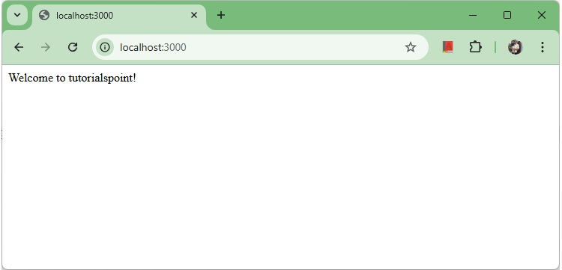
English Locale
http://localhost:3000/greet/mahesh
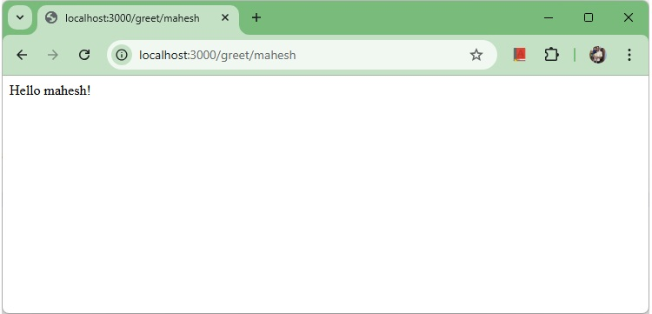
English Locale
In browser, open http://localhost:3000/?lng=fr to use french based translation file.
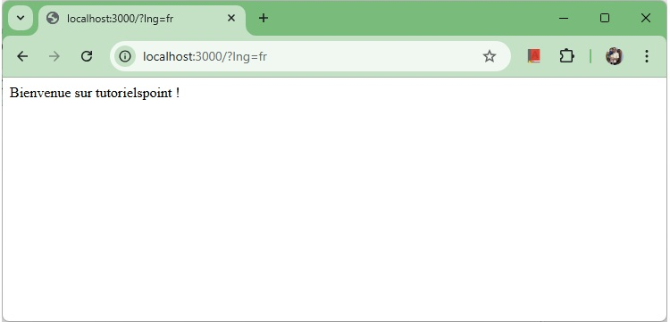
French Locale
http://localhost:3000/greet/mahesh?lng=fr
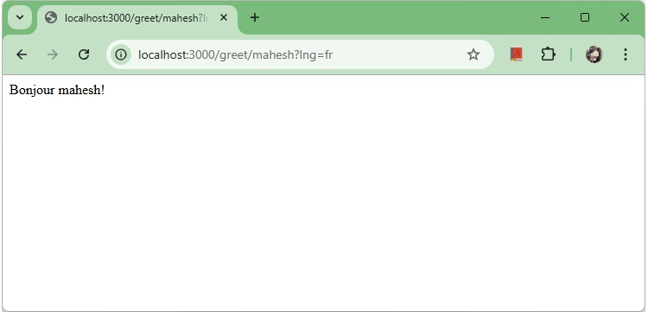
French Locale

ExpressJS - Security Practices
Source: https://www.tutorialspoint.com/expressjs/expressjs_security_practices.htm

ExpressJS - Security Practices
ExpressJS is an unopinionated. ExpressJS framework is highly flexible with a simple, minimalistic design principles. We can quickly setup server, define routes and start handling http requests with very few lines of code. It is very important to secure our server in production. Following are the security best practices for an Express Application one should consider while running application in production.

Use latest stable version of Express
We should never use deprecated or vulnerable versions of express in production. You can followOfficial Express Security Updates Pageto ensure if any listed vulnerable express version is being used. Express 2.x and 3.x are no longer maintained and there is no new security patch or performance fix is planned for them. You can move to express 4.x or the latest stable version.

User Inputs should be sanitized
All types of user inputs should be validated and handled. Sanitizing user input helps preventing injection attacks.
const express = require('express');
const app = express();
const { body, validationResult } = require('express-validator');
app.post('/login',
body('username').isAlphanumeric(),
body('email').isEmail(),
(req, res) => {
const errors = validationResult(req);
if (!errors.isEmpty()) {
return res.status(400).json({ errors: errors.array() });
}
// if there is no error, proceed
});

Use helmet to secure express apps
Helmet is a security library and can protect app from well known vulnerabilities by setting http-headers appropriately. helmet is a collectio of middleware functions to set security related http response headers.
- helmet.contentSecurityPolicy− Sets Content-Security-Policy header to prevent cross-site scripting attacks.
- helmet.hsts− Sets Strict-Transport-Security to ensure https based secure connections to the server.
- helmet.frameguard− Sets X-Frame-Options to provideClickjackingprotection

Install helmet
npm install --save helmet

Use helmet
const helmet = require('helmet');
const app = require('express')();
app.use(helmet());

Use Secure Dependencies Only
Use npm to analyze the dependency tree and figure out any vulnerable dependency.
npm audit

Use Snyk
Snyk is a better alternative to check vulnerabilities againstSnyk's open source vulnerability database.
Install snyk.
npm install -g snyk
test application for vulnerabilities.
synk test

Rate Limiting
Rate limiting limits the number of requests that a user can make within given time frame. This helps to prevent brute force attacks.
Useexpress-rate-limitmiddleware.
const rateLimit = require('express-rate-limit');
const limiter = rateLimit({
windowMs: 15 * 60 * 1000,
max: 100,
});
app.use(limiter);

Use HTTPS
HTTPS is a secure connection protocol over http. Http traffic can be intercepted. Use https module to read SSL/TLS certificates to make a secure server.
const https = require('https');
const fs = require('fs');
const app = require('express')();
const options = {
key: fs.readFileSync('key.pem'),
cert: fs.readFileSync('cert.pem')
};
https.createServer(options, app).listen(443);

Use Secure and HTTP Only Cookies
During session management, always set cookies as secure and http-only to prevent client side scripts to access your cookies.
const session = require('express-session');
app.use(session({
secret: 'secret-code',
cookie: {
secure: true,
httpOnly: true,
},
// ...
}));

Error handling
Always handle error and return user a custom message instead of default error handling. Middleware should manage errors properly and avoid revealing stack trace to the users.
app.use((err, req, res, next) => {
console.error(err.stack);
res.status(500).send('Server Error!');
});
Apart from these security practices, you should follow best coding practices as specified by your organization. Ensure code reviews, monitorings, reviews processes are followed properly.

ExpressJS - Rate Limiting
Source: https://www.tutorialspoint.com/expressjs/expressjs_rate_limiting.htm

ExpressJS - Rate Limiting
Rate Limiting is a security measure which helps maintaining the stability, security and performance of a web application. For example, consider the
following scenarios:
- Too many requests− if a server receives 100 request in a time span of 1 second which it is not capable to handle, then performance will be deteriorated.
- Brute Force Attack− If 100 requests comes from a single user in a very little timespan, it may be the case of brute-force attack.

Usingexpress-rate-limitdependency
In express applications, we can use express-rate-limit as a dependency to implement rate limiting. express-rate-limit middleware controls the rate of incoming requests to an express application. Following are two important parameters of express-rate-limit.
- windowMs− Time in milliseconds. Rate limits applies during this time. For example, to define a window of 10 minutes, we can set windowMs as 10 * 60 * 1000.
- max− Maximum number of requests allowed from a single IP address within the time window. If more requests come, then rate limit will be triggered.

Installingexpress-rate-limitdependency
We can use the following command to install above express-rate-limit dependency using npm.
npm install express-rate-limit

Initialize express-rate-limit and use
var express = require('express');
const rateLimit = require("express-rate-limit");
var app = express();
// configure rate limiter with a time window of 10 minutes
// and maximum 3 requests
const limiter = rateLimit({
windowMs: 10 * 60 * 1000,
max: 3,
});
app.use(limiter);
app.get('/', function(req, res){
res.send("Hello world!");
});
app.listen(3000);
Save the file, go to your terminal and type the following.
nodemon index.js
[nodemon] 3.1.9
[nodemon] to restart at any time, enter `rs`
[nodemon] watching path(s): *.*
[nodemon] watching extensions: js,mjs,cjs,json
[nodemon] starting `node index.js`
This will start the server. To test this app, open your browser and go tohttp://localhost:3000and a message will be displayed as in the following screenshot.

Hello world
Now refresh the page 4 times, browser will show the error message.
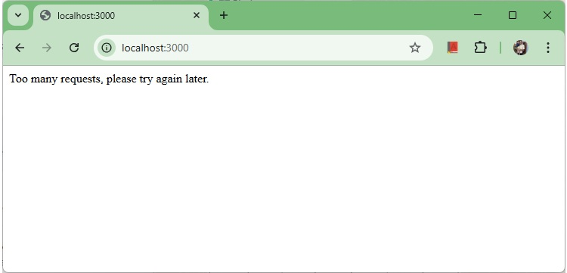
Error Rate Limit

ExpressJS - Slowing Down Responses
Source: https://www.tutorialspoint.com/expressjs/expressjs_slowing_down.htm

ExpressJS - Slowing Down Responses
Slowing Down responses is a technique deployed by websites to control response delivery time. For example, a software download website wants to delay a response. A slow down mechanism prevents a program to use system resources excessively and unintentionally use network resources.
Combining slow down response with rate limiting is a key to make a website stronger and more resillient. We can useexpress-slow-downmiddleware to achieve the same.

Usingexpress-slow-downdependency
In express applications, we can use express-slow-down as a dependency to implement slow down. express-slow-down middleware controls the response time of an express application. Following are the three important parameters of express-slow-down.
- windowMs− Time in milliseconds. Slow down applies during this time. For example, to define a window of 10 minutes, we can set windowMs as 10 * 60 * 1000.
- delayAfter− Maximum number of requests to go with full speed within the time window. If more requests come, then responses will be delayed.
- delayMS− Delay in response time in milliseconds.

Installingexpress-slow-downdependency
We can use the following command to install above express--slow-down dependency using npm.
npm install express-slow-down

Initialize express-slow-down and use
var express = require('express');
const rateLimit = require("express-slow-down");
var app = express();
// configure slow limiter with a time window of 10 minutes
// and maximum 3 requests
const limiter = slowDown({
windowMs: 10 * 60 * 1000, // 10 minutes
delayAfter: 3, // allows 3 requests per 10 minutes
delayMs: (hits) => hits * 100, // Add 100 ms of delay to every request after 3rd request
});
app.use(limiter);
app.get('/', function(req, res){
res.send("Hello world!");
});
app.listen(3000);
Save the file, go to your terminal and type the following.
nodemon index.js
[nodemon] 3.1.9
[nodemon] to restart at any time, enter `rs`
[nodemon] watching path(s): *.*
[nodemon] watching extensions: js,mjs,cjs,json
[nodemon] starting `node index.js`
This will start the server. To test this app, open your browser and go tohttp://localhost:3000and a message will be displayed as in the following screenshot.
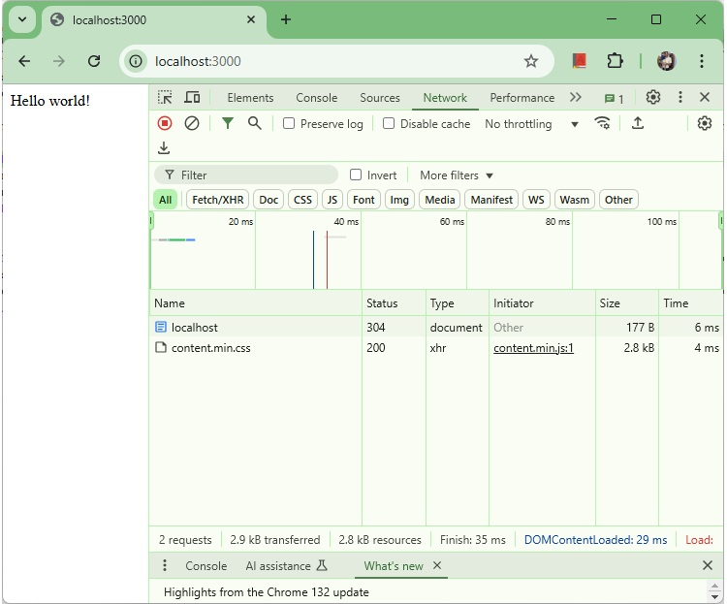
Hello world
Here we can see the response time is nearly 5 ms
Now refresh the page 4 times, browser will start loading the page after delayed time.
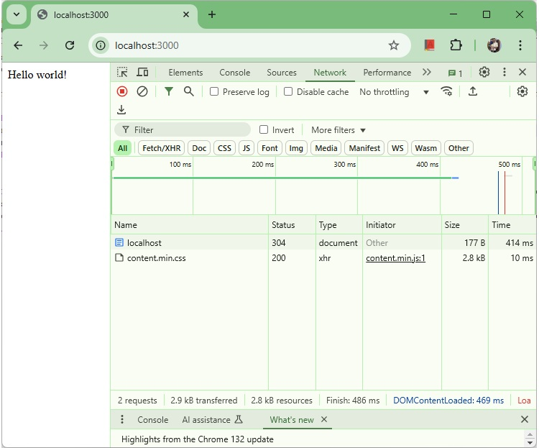
Slow Down
Here we can see the response time is delayed by 400 ms (4th hits * 100ms).

Explanation
In app, we've importedexpress-slow-downand created a limiter with a time window of 10 minutes and maximum 3 requests allowed per single ip address. Then usingapp.use(limiter)
Now if a client makes more than 3 requests within a timeframe of 10 minutes then slow down limiter will trigger and browser will receive response with delay in multiple of 100ms with the number of hits.

ExpressJS - Error handling
Source: https://www.tutorialspoint.com/expressjs/expressjs_error_handling.htm

ExpressJS - Error Handling
Error handling in Express is done using middleware. But this middleware has special properties. The error handling middleware are defined in the same way as other middleware functions, except that error-handling functionsMUST have four argumentsinstead of threeerr, req, res, next. For example, to send a response on any error, we can use −
app.use(function(err, req, res, next) {
console.error(err.stack);
res.status(500).send('Something broke!');
});
Till now we were handling errors in the routes itself. The error handling middleware allows us to separate our error logic and send responses accordingly. The next() method we discussed in middleware takes us to nextmiddleware/route handler.
For error handling, we have thenext(err)function. A call to this function skips all middleware and matches us to the next error handler for that route. Let us understand this through an example.

index.js
var express = require('express');
var app = express();
app.get('/', function(req, res){
//Create an error and pass it to the next function
var err = new Error("Something went wrong");
next(err);
});
/*
* other route handlers and middleware here
* ....
*/
//An error handling middleware
app.use(function(err, req, res, next) {
res.status(500);
res.send("Oops, something went wrong.")
});
app.listen(3000);

Output
This error handling middleware can be strategically placed after routes or contain conditions to detect error types and respond to the clients accordingly. The above program will display the following output.
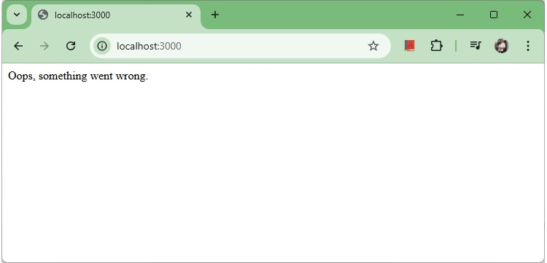
Error handling

ExpressJS - Debugging
Source: https://www.tutorialspoint.com/expressjs/expressjs_debugging.htm

ExpressJS - Debugging
Express uses theDebugmodule to internally log information about route matching, middleware functions, application mode, etc.

Install debug module
E:\Dev\hello-world>npm install debug
added 10 packages, removed 1 package, changed 2 packages, and audited 143 packages in 3s
20 packages are looking for funding
run `npm fund` for details
found 0 vulnerabilities
To see all internal logs used in Express, set the DEBUG environment variable toExpress:*when starting the app −
E:\Dev\hello-world>set DEBUG=express:*
E:\Dev\hello-world>nodemon index.js
The following output will be displayed.
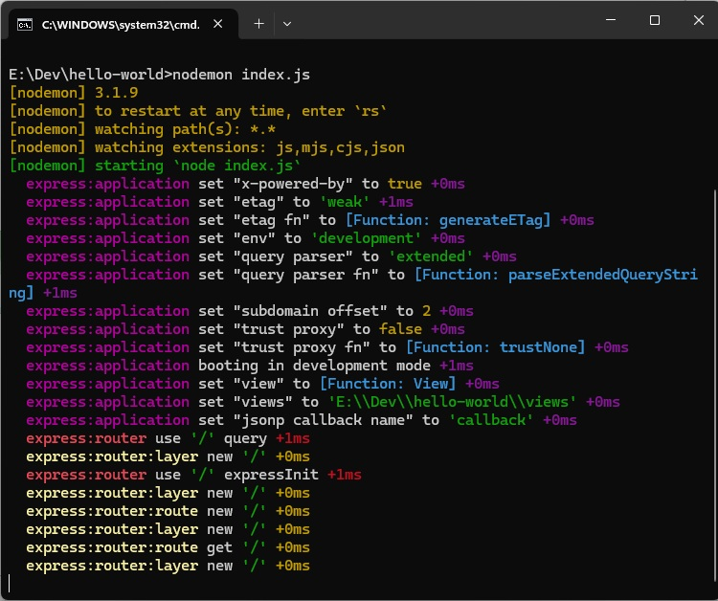
Debug log
These logs are very helpful when a component of your app is not functioning right. This verbose output might be a little overwhelming. You can also restrict the DEBUG variable to specific area to be logged. For example, if you wish to restrict the logger to application and router, you can use the following code.
DEBUG = express:application,express:router node index.js
Debug is turned off by default and is automatically turned on in production environment. Debug can also be extended to meet your needs, you can read more about it atits npm page.

ExpressJS - Best Practices
Source: https://www.tutorialspoint.com/expressjs/expressjs_best_practices.htm

ExpressJS - Best Practices
Unlike Django and Rails which have a defined way of doing things, file structure, etc., Express does not follow a defined way. This means you can structure the application the way you like. But as your application grows in size, it is very difficult to maintain it if it doesn't have a well-defined structure. In this chapter, we will look at the generally used directory structures and separation of concerns to build our applications.
First, we will discuss the best practices for creating node and Express applications.
- Always begin a node project usingnpm init.
- Always install dependencies with a--saveor--save-dev. This will ensure that if you move to a different platform, you can just runnpm installto install all dependencies.
- Stick with lowercase file names and camelCase variables. If you look at any npm module, its named in lowercase and separated with dashes. Whenever you require these modules, use camelCase.
- Dont push node_modules to your repositories. Instead npm installs everything on development machines.
- Use aconfigfile to store variables
- Group and isolate routes to their own file. For example, take the CRUD operations in the movies example we saw in the REST API page.

Directory Structure
Let us now discuss the Express Directory Structure.

Websites
Express does not have a community defined structure for creating applications. The following is a majorly used project structure for a website.
test-project/
node_modules/
config/
db.js //Database connection and configuration
credentials.js //Passwords/API keys for external services used by your app
config.js //Other environment variables
models/ //For mongoose schemas
users.js
things.js
routes/ //All routes for different entities in different files
users.js
things.js
views/
index.pug
404.pug
...
public/ //All static content being served
images/
css/
javascript/
app.js
routes.js //Require all routes in this and then require this file in
app.js
package.json
There are other approaches to build websites with Express as well. You can build a website using the MVC design pattern. For more information, you can visit the following links.
https://code.tutsplus.com/tutorials/build-a-complete-mvc-website-with-expressjs--net-34168
and,
https://www.terlici.com/2014/08/25/best-practices-express-structure.html.

RESTful APIs
APIs are simpler to design; they don't need a public or a views directory. Use the following structure to build APIs −
test-project/
node_modules/
config/
db.js //Database connection and configuration
credentials.js //Passwords/API keys for external services used by your app
models/ //For mongoose schemas
users.js
things.js
routes/ //All routes for different entities in different files
users.js
things.js
app.js
routes.js //Require all routes in this and then require this file in
app.js
package.json
You can also use ayeoman generatorto get a similar structure.

ExpressJS - Resources
Source: https://www.tutorialspoint.com/expressjs/expressjs_resources.htm

ExpressJS - Resources
This chapter lists down the various resources we used for this tutorial.
- The most important link is of course the Express API docs −https://expressjs.com/en/4x/api.html
- The guides provided on the Express website on different aspects are also quite helpful −RoutingMiddlewareError HandlingDebugging
- A list of mostly used middleware with Express is available athttps://expressjs.com/en/resources/middleware.html
- These blogs with Express tips and tricks may prove helpful −https://derickbailey.com/categories/tips-and-tricks/https://scotch.io/tutorials/learn-to-use-the-new-router-in+-expressjs-4
- Application structure −https://www.terlici.com/2014/08/25/best-practices-express-structure.html
- RESTful APIs −https://www.thepolyglotdeveloper.com/2015/10/create-a-simple-restful-api-with-node-js/https://scotch.io/tutorials/build-a-restful-api-using-node-and-express-4https://devcenter.heroku.com/articles/mean-apps-restful-apihttp://cwbuecheler.com/web/tutorials/2014/restful-web-app-node-express-mongodb/
- For advanced authentication, use PassportJS −http://passportjs.org

ExpressJS - Quick Guide
Source: https://www.tutorialspoint.com/expressjs/expressjs_quick_guide.htm

ExpressJS - Quick Guide

ExpressJS - Overview
ExpressJS is a web application framework that provides you with a simple API to build websites, web apps and back ends. With ExpressJS, you need not worry about low level protocols, processes, etc.

What is Express?
Express provides a minimal interface to build our applications. It provides us the tools that are required to build our app. It is flexible as there are numerous modules available onnpm, which can be directly plugged into Express.
Express was developed byTJ Holowaychukand is maintained by theNode.jsfoundation and numerous open source contributors.

Why Express?
Unlike its competitors like Rails and Django, which have an opinionated way of building applications, Express has no "best way" to do something. It is very flexible and pluggable.

Features of ExpressJS
Following are the salient features of ExpressJS making it a default choice among web application developers.
- Minimalistic Design− ExpressJS is an unopinionated. ExpressJS framework is highly flexible with a simple, minimalistic design principles. We can quickly setup server, define routes and start handling http requests with very few lines of code.
- Middleware/Routing− ExpressJS provides clear options for Routes with support for all kind of HTTP methods like POST, GET, PUT etc.
- Flexibility− There is no prerequisites or any format to follow in order to use ExpressJS. If we know NodeJS, we can write code as per our preference.
- Templating− ExpressJS supports various templating engines like PUG, Jade or EJS to generate HTML content on the fly.
- Static File Serve− ExpressJS supports static files like images/css/javascript from a folder seemlessly.
- NodeJS Based− Core functionalities of asynchronous programming and event driven programming features of NodeJS can be integrated with ExpressJS easily.

Applications of ExpressJS
Following are the salient features of ExpressJS making it a default choice among web application developers.
- Support RESTful APIs− REST Architecture is very powerful style to enable communication of front-end with backend. ExpressJS supports RESTful APIs by design.
- Support for Real Time Applications− Event Driven Programming helps to create chat, parallel collaborative editing tools etc. ExpressJS integrates with Node and supports Event Driven Programming seemlessly.
- Support for Single Page Applications(SPA)− SPA and RESTFul APIs allows Express Based application to update content dynamically enriching user experience.

ExpressJS vs Django vs Ruby on Rails
Sr.No. | Feature | ExpressJS | Django | Ruby on Rails
1 | Language | JavaScript | Python | Ruby
2 | Flexibility | Highly flexible. Unopinionated by design. | Moderate. Opinionated by design. | Low. Highly opinionated.
3 | Performance | Highly performant | Moderate | Moderate

Pug
Pug (earlier known as Jade) is a terse language for writing HTML templates. It −
- Produces HTML
- Supports dynamic code
- Supports reusability (DRY)
It is one of the most popular template language used with Express.

MongoDB and Mongoose
MongoDB is an open-source, document database designed for ease of development and scaling. This database is also used to store data.
Mongoose is a client API fornode.jswhich makes it easy to access our database from our Express application.

ExpressJS - Environment Setup
ExpressJS is a NodeJS based application framework. In case to start with Express, we need to set up environment for Node.js, this section will guide you. Node.js can be installed on different OS platforms such as Windows, Linux, Mac OS X, etc. You need the following tools on your computer −
- The Node.js binary installer
- Node Package Manager (NPM)
- IDE or Text Editor

Node Installation Steps
Binaries for various OS platforms are available on the downloads page of the official website of Node.js. Visithttps://nodejs.org/en/downloadto get the list.

Official Website
This page shows command line as well as installers as well as ZIP archives for Windows, macOS installer as well as tar archives and binaries for Linux OS on x64 and ARM architecture are available.

Installation on Windows
Assuming that you are working with Windows 10/Windows 11 powered computer, download the 64-bit installer for Windows:https://nodejs.org/dist/v22.13.0/node-v22.13.0-x64.msi, and start the installation by double-clicking the downloaded file.

Nodejs Setup Wizard
The installation takes you through a few steps of the installation wizard. It also adds the installation directory of Node.js executable to the system path.
To verify if Node.js has been successfully installed, open the command prompt and type node -v. If Node.js is installed successfully then it will display the version of the Node.js installed on your machine, as shown below.
Microsoft Windows [Version 10.0.26100.2894]
(c) Microsoft Corporation. All rights reserved.
C:\Users\Tutorialspoint>node -v
v22.13.0
C:\Users\Tutorialspoint>

Installation on Ubuntu Linux
First, download the tar file corresponding to Linux binary (https://nodejs.org/dist/v22.13.0/node-v22.13.0-linux-x64.tar.xz) and then, extract the binary using the tar command −
tar -xf node-v22.13.0-linux-x64.tar.gz
Move the extracted files to the installation directory /usr/local/node-v22.13.0.
sudo mv node-<version> /usr/local/node-v22.13.0
Create a symlink to the executable in /usr/bin directory.
sudo ln -s /usr/local/node-v22.13.0/bin/node /usr/bin/node
You can now verify the correct installation with the following command −
node -v
Using Ubuntu package manager
Refresh your local package index first by the following command −
sudo apt update
Then install Node.js −
sudo apt install nodejs
As in above case, verify the installation
node -v
NPM (Node Package Manager) is included in Node.js binaries from its official website since Node version 0.6.0., so you are not required to install it separately.
You can use any text editor available in your OS (notepad in Windows, vi or nano in Ubuntu) to key-in and save the Node.js script. However, it is recommended that you use a suitable IDE for the purpose as it has several features such as syntax highlighting etc. VS Code is a popular source-code editor, which has out of the box support for JavaScript (and hence Node.js), which is highly recommended.
You can verify the version of NPM using following command
npm -v
10.9.2

Postman Installation Steps
Postman is a API, Application Programming Interface, Testing tool. We'll use it to test our REST APIs developed during Express JS tutorial. Please follow thePostman Environment Setup.

ExpressJS - Hello World!
We have set up the development inExpressJS Installation, now it is time to start developing our first app using Express. Create a new file calledindex.jsin hello-world directory and type the following in it.

index.js
var express = require('express');
var app = express();
app.get('/', function(req, res){
res.send("Hello world!");
});
app.listen(3000);
Save the file, go to your terminal and type the following.
E:\Dev\hello-world>nodemon index.js
[nodemon] 3.1.9
[nodemon] to restart at any time, enter `rs`
[nodemon] watching path(s): *.*
[nodemon] watching extensions: js,mjs,cjs,json
[nodemon] starting `node index.js`
This will start the server. To test this app, open your browser and go tohttp://localhost:3000and a message will be displayed as in the following screenshot.

Hello world
Now update the file index.js to return a different message.
var express = require('express');
var app = express();
app.get('/', function(req, res){
res.send("Welcome to tutorialspoint!");
});
app.listen(3000);
Save the file, go to your terminal and check the server status. It automatically restarted.
E:\Dev\hello-world>nodemon index.js
[nodemon] 3.1.9
[nodemon] to restart at any time, enter `rs`
[nodemon] watching path(s): *.*
[nodemon] watching extensions: js,mjs,cjs,json
[nodemon] starting `node index.js`
[nodemon] restarting due to changes...
[nodemon] starting `node index.js`

Welcome Message

How the App Works?
The first line imports Express in our file, we have access to it through the variable Express. We use it to create an application and assign it to var app.

app.get(route, callback)
This function tells what to do when agetrequest at the given route is called. The callback function has 2 parameters,request(req)andresponse(res). The requestobject(req)represents the HTTP request and has properties for the request query string, parameters, body, HTTP headers, etc. Similarly, the response object represents the HTTP response that the Express app sends when it receives an HTTP request.

res.send()
This function takes an object as input and it sends this to the requesting client. Here we are sending the string"Hello World!".

app.listen(port, [host], [backlog], [callback]])
This function binds and listens for connections on the specified host and port. Port is the only required parameter here.
S.No. | Argument & Description
1 | portA port number on which the server should accept incoming requests.
2 | hostName of the domain. You need to set it when you deploy your apps to the cloud.
3 | backlogThe maximum number of queued pending connections. The default is 511.
4 | callbackAn asynchronous function that is called when the server starts listening for requests.

ExpressJS - Routing
Web frameworks provide resources such as HTML pages, scripts, images, etc. at different routes.
The following function is used to define routes in an Express application −

app.method(path, handler)
This METHOD can be applied to any one of the HTTP verbs get, set, put, delete. An alternate method also exists, which executes independent of the request type.
Path is the route at which the request will run.
Handler is a callback function that executes when a matching request type is found on the relevant route. For example,

index.js
var express = require('express');
var app = express();
app.get('/hello', function(req, res){
res.send("Hello World!");
});
app.listen(3000);
If we run our application and go tolocalhost:3000/hello, the server receives a get request at route"/hello", our Express app executes thecallbackfunction attached to this route and sends"Hello World!"as the response.

Hello
We can also have multiple different methods at the same route. For example,

index.js
var express = require('express');
var app = express();
app.get('/hello', function(req, res){
res.send("Hello World!");
});
app.post('/hello', function(req, res){
res.send("You just called the post method at '/hello'!\n");
});
app.listen(3000);
To test this request, open postman. Now hit the below URL's in POSTMAN application and you can see the output−
POST Requesthttp://localhost:3000/hello

POST request
A special method,all, is provided by Express to handle all types of http methods at a particular route using the same function. To use this method, try the following.
app.all('/test', function(req, res){
res.send("HTTP method doesn't have any effect on this route!");
});
This method is generally used for defining middleware, which we'll discuss in the middleware chapter.

Routers
Defining routes like above is very tedious to maintain. To separate the routes from our mainindex.jsfile, we will useExpress.Router. Create a new file calledthings.jsand type the following in it.

things.js
var express = require('express');
var router = express.Router();
router.get('/', function(req, res){
res.send('GET route on things.');
});
router.post('/', function(req, res){
res.send('POST route on things.');
});
//export this router to use in our index.js
module.exports = router;
Now to use this router in ourindex.js, type in the following before theapp.listenfunction call.
var express = require('Express');
var app = express();
var things = require('./things.js');
app.get('/hello', function(req, res){
res.send("Hello World!");
});
//both index.js and things.js should be in same directory
app.use('/things', things);
app.listen(3000);
Theapp.usefunction call on route'/things'attaches thethingsrouter with this route. Now whatever requests our app gets at the '/things', will be handled by our things.js router. The'/'route in things.js is actually a subroute of '/things'. Visit localhost:3000/things/ and you will see the following output.

Router Things
Routers are very helpful in separating concerns and keep relevant portions of our code together. They help in building maintainable code. You should define your routes relating to an entity in a single file and include it using the above method in yourindex.jsfile.

ExpressJS - HTTP Methods
The HTTP method is supplied in the request and specifies the operation that the client has requested. The following table lists the most used HTTP methods −
S.No. | Method & Description
1 | GETThe GET method requests a representation of the specified resource. Requests using GET should only retrieve data and should have no other effect.
2 | POSTThe POST method requests that the server accept the data enclosed in the request as a new object/entity of the resource identified by the URI.
3 | PUTThe PUT method requests that the server accept the data enclosed in the request as a modification to existing object identified by the URI. If it does not exist then the PUT method should create one.
4 | DELETEThe DELETE method requests that the server delete the specified resource.
These are the most common HTTP methods. To learn more about the methods, visithttp://www.tutorialspoint.com/http/http_methods.htm.

Example
Create a new file calledindex.jsin hello-world directory and type the following in it.

index.js
var express = require('express');
var app = express();
app.get('/', function(req, res){
res.send("GET Request!");
});
app.post('/', function(req, res){
res.send("POST Request!");
});
app.put('/', function(req, res){
res.send("PUT Request!");
});
app.delete('/', function(req, res){
res.send("DELETE Request!");
});
app.listen(3000);
Save the file, go to your terminal and type the following.
E:\Dev\hello-world>nodemon index.js
[nodemon] 3.1.9
[nodemon] to restart at any time, enter `rs`
[nodemon] watching path(s): *.*
[nodemon] watching extensions: js,mjs,cjs,json
[nodemon] starting `node index.js`
This will start the server. To test this app, open your browser and go tohttp://localhost:3000and a message will be displayed as in the following screenshot.

GET Request
To test other requests, open postman. Now hit the below URL's in POSTMAN application and you can see the output−
POST Requesthttp://localhost:3000/

POST request
Similary you can test the other urls.
PUT Requesthttp://localhost:3000/

PUT request
DELETE Requesthttp://localhost:3000/

DELETE request

ExpressJS - URL Building
We can now define routes, but those are static or fixed. To use the dynamic routes, we SHOULD provide different types of routes. Using dynamic routes allows us to pass parameters and process based on them.
Here is an example of a dynamic route −

index.js
var express = require('express');
var app = express();
app.get('/:id', function(req, res){
res.send('The id you specified is ' + req.params.id);
});
app.listen(3000);

Output
To test this go tohttp://localhost:3000/123. The following response will be displayed.

URL Building 1
You can replace '123' in the URL with anything else and the change will reflect in the response. A more complex example of the above is −

index.js
var express = require('express');
var app = express();
app.get('/things/:name/:id', function(req, res) {
res.send('id: ' + req.params.id + ' and name: ' + req.params.name);
});
app.listen(3000);

Output
To test the above code, go tohttp://localhost:3000/things/tutorialspoint/12345.

URL Building 2
You can use thereq.paramsobject to access all the parameters you pass in the url. Note that the above 2 are different paths. They will never overlap. Also if you want to execute code when you get'/things'then you need to define it separately.

Pattern Matched Routes
You can also useregexto restrict URL parameter matching. Let us assume you need theidto be a 5-digit long number. You can use the following route definition −

index.js
var express = require('express');
var app = express();
app.get('/things/:id([0-9]{5})', function(req, res){
res.send('id: ' + req.params.id);
});
app.listen(3000);
Note that this willonlymatch the requests that have a 5-digit longid. You can use more complex regexes to match/validate your routes. If none of your routes match the request, you'll get a"Cannot GET <your-request-route>"message as response. This message be replaced by a 404 not found page using this simple route −

index.js
var express = require('express');
var app = express();
//Other routes here
app.get('*', function(req, res){
res.send('Sorry, this is an invalid URL.');
});
app.listen(3000);
Important− This should be placed after all your routes, as Express matches routes from start to end of theindex.jsfile, including the external routers you required.

Output
For example, if we define the same routes as above, on requesting with a valid URL, the following output is displayed. −
Go tohttp://localhost:3000/things/tutorialspoint/12345.

Correct regex
While for an incorrect URL request, the following output is displayed.
Go tohttp://localhost:3000/things/tutorialspoint/id/12345.

Invalid regex(404)

ExpressJS - Middleware
Middleware functions are functions that have access to therequest object (req), theresponse object (res), and the next middleware function in the applications request-response cycle. These functions are used to modifyreqandresobjects for tasks like parsing request bodies, adding response headers, etc.
Here is a simple example of a middleware function in action −

index.js
var express = require('express');
var app = express();
// Simple request time logger
app.use(function(req, res, next){
console.log("A new request received at " + Date().now());
// This function call is very important. It tells that more processing is
// required for the current request and is in the next middleware
// function route handler.
next();
});
app.listen(3000);

Output
Now openlocalhost:3000.
The above middleware is called for every request on the server. So after every request, we will get the following message in the console of nodemon −
A new request received at 1737448050745
To restrict it to a specific route (and all its subroutes), provide that route as the first argument ofapp.use(). For Example,
var express = require('express');
var app = express();
//Middleware function to log request protocol
app.use('/things', function(req, res, next){
console.log("A request for things received at " + Date.now());
next();
});
// Route handler that sends the response
app.get('/things', function(req, res){
res.send('Things');
});
app.listen(3000);
Now whenever you request any subroute of '/things', only then it will log the time.

Output
Now openhttp://localhost:3000/things/id/12345.
The above middleware is called for every request on the server. So after every request, we will get the following message in the console of nodemon −
A request for things received at 1737448162008

Order of Middleware Calls
One of the most important things about middleware in Express is the order in which they are written/included in your file; the order in which they are executed, given that the route matches also needs to be considered.
For example, in the following code snippet, the first function executes first, then the route handler and then the end function. This example summarizes how to use middleware before and after route handler; also how a route handler can be used as a middleware itself.
var express = require('express');
var app = express();
// First middleware before response is sent
app.use(function(req, res, next){
console.log("Start");
next();
});
// Route handler
app.get('/', function(req, res, next){
res.send("Middle");
next();
});
app.use('/', function(req, res){
console.log('End');
});
app.listen(3000);
When we visit '/' after running this code, we receive the response asMiddleand on our console −
Start
End
The following diagram summarizes what we have learnt about middleware −

Middleware
Now that we have covered how to create our own middleware, let us discuss some of the most commonly used community created middleware.

Third Party Middleware
A list of Third party middleware for Express is availablehere. Following are some of the most commonly used middleware; we will also learn how to use/mount these −

body-parser
This is used to parse the body of requests which have payloads attached to them. To mount body parser, we need to install it.
E:\Dev\hello-world>npm install --save body-parser
up to date, audited 70 packages in 3s
14 packages are looking for funding
run `npm fund` for details
found 0 vulnerabilities
To mount the body-parser, include the following lines in your index.js −
var bodyParser = require('body-parser');
//To parse URL encoded data
app.use(bodyParser.urlencoded({ extended: false }))
//To parse json data
app.use(bodyParser.json())
To view all available options for body-parser, visit its github page.

cookie-parser
It parsesCookieheader and populate req.cookies with an object keyed by cookie names. To mount cookie parser, we need to install it.
E:\Dev\hello-world>npm install --save cookie-parser
added 2 packages, and audited 72 packages in 1s
14 packages are looking for funding
run `npm fund` for details
found 0 vulnerabilities
To mount it, include the following lines in your index.js −
var cookieParser = require('cookie-parser');
app.use(cookieParser())

express-session
It creates a session middleware with the given options. We will discuss its usage in the Sessions section.
We have many other third party middleware in ExpressJS. However, we have discussed only a few important ones here.

ExpressJS - Templating
Pug is a templating engine for Express. Templating engines are used to remove the cluttering of our server code with HTML, concatenating strings wildly to existing HTML templates. Pug is a very powerful templating engine which has a variety of features includingfilters, includes, inheritance, interpolation, etc. There is a lot of ground to cover on this.
To use Pug with Express, we need to install it,
E:\Dev\hello-world>npm install --save pug
added 38 packages, and audited 110 packages in 6s
19 packages are looking for funding
run `npm fund` for details
found 0 vulnerabilities
Now that Pug is installed, set it as the templating engine for your app. Youdon'tneed to 'require' it. Add the following code to yourindex.jsfile.
app.set('view engine', 'pug');
app.set('views','./views');
Now index.js should look like this.

index.js
var express = require('express');
var app = express();
app.set('view engine', 'pug');
app.set('views','./views');
app.listen(3000);
Now create a new directory called views. Inside that create a file calledfirst_view.pug, and enter the following data in it.
doctype html
html
head
title = "Hello Pug"
body
p.greetings#people Hello World!
To run this page, add the following route to your app −
app.get('/first_template', function(req, res){
res.render('first_view');
});
Now index.js should look like this.

index.js
var express = require('express');
var app = express();
app.set('view engine', 'pug');
app.set('views','./views');
app.get('/first_template', function(req, res){
res.render('first_view');
});
app.listen(3000);
Save the file, go to your terminal and type the following.
E:\Dev\hello-world>nodemon index.js
[nodemon] 3.1.9
[nodemon] to restart at any time, enter `rs`
[nodemon] watching path(s): *.*
[nodemon] watching extensions: js,mjs,cjs,json
[nodemon] starting `node index.js`
This will start the server. To test this app, open your browser and go tohttp://localhost:3000/first_template.
You will get the output as −

First Template of PUG
Pug converts this very simple looking markup to html. We dont need to keep track of closing our tags, no need to use class and id keywords, rather use '.' and'#'to define them. The above code first gets converted to −
<!DOCTYPE html>
<html>
<head>
<title>Hello Pug</title>
</head>
<body>
<p class = "greetings" id = "people">Hello World!</p>
</body>
</html>
Pug is capable of doing much more than simplifying HTML markup.

Important Features of Pug
Let us now explore a few important features of Pug.

Simple Tags
Tags are nested according to their indentation. Like in the above example,<title>was indented within the<head>tag, so it was inside it. But the<body>tag was on the same indentation, so it was a sibling of the<head>tag.
We dont need to close tags, as soon as Pug encounters the next tag on same or outer indentation level, it closes the tag for us.
To put text inside of a tag, we have 3 methods −
- Space seperated
h1 Welcome to Pug
- Piped text
div
| To insert multiline text,
| You can use the pipe operator.
- Block of text
div.
But that gets tedious if you have a lot of text.
You can use "." at the end of tag to denote block of text.
To put tags inside this block, simply enter tag in a new line and
indent it accordingly.

Comments
Pug uses the same syntax asJavaScript(//)for creating comments. These comments are converted to the html comments(<!--comment-->). For example,
//This is a Pug comment
This comment gets converted to the following.
<!--This is a Pug comment-->

Attributes
To define attributes, we use a comma separated list of attributes, in parenthesis. Class and ID attributes have special representations. The following line of code covers defining attributes, classes and id for a given html tag.
div.container.column.main#division(width = "100", height = "100")
This line of code, gets converted to the following. −
<div class = "container column main" id = "division" width = "100" height = "100"></div>

Passing Values to Templates
When we render a Pug template, we can actually pass it a value from our route handler, which we can then use in our template. Create a new route handler with the following.
var express = require('express');
var app = express();
app.set('view engine', 'pug');
app.set('views','./views');
app.get('/dynamic_view', function(req, res){
res.render('dynamic', {
name: "TutorialsPoint",
url:"http://www.tutorialspoint.com"
});
});
app.listen(3000);
And create a new view file in views directory, calleddynamic.pug, with the following code −
html
head
title=name
body
h1=name
a(href = url) URL
Openlocalhost:3000/dynamic_viewin your browser; You should get the following output −

Variables in template
We can also use these passed variables within text. To insert passed variables in between text of a tag, we use#{variableName}syntax. For example, in the above example, if we wanted to put Greetings from TutorialsPoint, then we could have done the following.

dyanamic.pug
html
head
title = name
body
h1 Greetings from #{name}
a(href = url) URL
This method of using values is calledinterpolation. The above code will display the following output. −

Templating Inter

Conditionals
We can use conditional statements and looping constructs as well.
Consider the following −
If a User is logged in, the page should display"Hi, User"and if not, then the"Login/Sign Up"link. To achieve this, we can define a simple template like −

dyanamic.pug
html
head
title Simple template
body
if(user)
h1 Hi, #{user.name}
else
a(href = "/sign_up") Sign Up
When we render this using our routes, we can pass an object as in the following program −
res.render('/dynamic',{
user: {name: "Ayush", age: "20"}
});

index.js
var express = require('express');
var app = express();
app.set('view engine', 'pug');
app.set('views','./views');
app.get('/dynamic_view', function(req, res){
res.render('dynamic', {
user: {name: "Ayush", age: "20"}
});
});
app.listen(3000);
You will receive a message −Hi, Ayush. But if we dont pass any object or pass one with no user key, then we will get a signup link.

Include and Components
Pug provides a very intuitive way to create components for a web page. For example, if you see a news website, the header with logo and categories is always fixed. Instead of copying that to every view we create, we can use theincludefeature. Following example shows how we can use this feature −
Create 3 views with the following code −
header.pug
div.header.
I'm the header for this website.
content.pug
html
head
title Simple template
body
include ./header.pug
h3 I'm the main content
include ./footer.pug
footer.pug
div.footer.
I'm the footer for this website.
Create a route for this as follows −

index.js
var express = require('express');
var app = express();
app.set('view engine', 'pug');
app.set('views','./views');
app.get('/components', function(req, res){
res.render('content');
});
app.listen(3000);
Go to localhost:3000/components, you will receive the following output −

templating components
includecan also be used to include plaintext, css and JavaScript.
There are many more features of Pug. But those are out of the scope for this tutorial. You can further explore Pug.

ExpressJS - Serving Static Files
Static files are files that clients download as they are from the server. Create a new directory,public. Express, by default does not allow you to serve static files. You need to enable it using the following built-in middleware.
app.use(express.static('public'));
Note− Express looks up the files relative to the static directory, so the name of the static directory is not part of the URL.
Note that the root route is now set to your public dir, so all static files you load will be considering public as root. To test that this is working fine, add any image file in your newpublicdir and change its name to "testimage.jpg". In your views, create a new view and include this file like −

static_files.pug
html
head
body
h3 Testing static file serving:
img(src = "/testimage.jpg", alt = "Testing Image")

index.js
var express = require('express');
var app = express();
app.use(express.static('public'));
app.set('view engine', 'pug');
app.set('views','./views');
app.get('/static_files', function(req, res){
res.render('static_files');
});
app.listen(3000);
You should get the following output −

Static Files Example

Multiple Static Directories
We can also set multiple static assets directories using the following program −

index.js
var express = require('express');
var app = express();
app.use(express.static('public'));
app.use(express.static('images'));
app.listen(3000);

Virtual Path Prefix
We can also provide a path prefix for serving static files. For example, if you want to provide a path prefix like'/static', you need to include the following code in yourindex.jsfile −

index.js
var express = require('express');
var app = express();
app.use('/static', express.static('public'));
app.listen(3000);
Now whenever you need to include a file, for example, a script file called main.js residing in your public directory, use the following script tag −
<script src = "/static/main.js" />
This technique can come in handy when providing multiple directories as static files. These prefixes can help distinguish between multiple directories.

ExpressJS - Form Data
Forms are an integral part of the web. Almost every website we visit offers us forms that submit or fetch some information for us. To get started with forms, we will first install thebody-parser(for parsing JSON and url-encoded data) and multer(for parsing multipart/form data) middleware.
To install thebody-parserandmulter, go to your terminal and use −
E:\Dev\hello-world>npm install --save body-parser multer
added 18 packages, and audited 128 packages in 1s
20 packages are looking for funding
run `npm fund` for details
found 0 vulnerabilities
Replace yourindex.jsfile contents with the following code −

index.js
var express = require('express');
var bodyParser = require('body-parser');
var multer = require('multer');
var upload = multer();
var app = express();
app.get('/', function(req, res){
res.render('form');
});
app.set('view engine', 'pug');
app.set('views', './views');
// for parsing application/json
app.use(bodyParser.json());
// for parsing application/xwww-
app.use(bodyParser.urlencoded({ extended: true }));
//form-urlencoded
// for parsing multipart/form-data
app.use(upload.array());
app.use(express.static('public'));
app.post('/', function(req, res){
console.log(req.body);
res.send("recieved your request!");
});
app.listen(3000);
After importing the body parser and multer, we will use thebody-parserfor parsing json and x-www-form-urlencoded header requests, while we will usemulterfor parsing multipart/form-data.
Let us create an html form to test this out. Create a new view calledform.pugwith the following code −

form.pug
html
head
title Form Tester
body
form(action = "/", method = "POST")
div
label(for = "say") Say:
input(name = "say" value = "Hi")
br
div
label(for = "to") To:
input(name = "to" value = "Express forms")
br
button(type = "submit") Send my greetings
Run your server using the following.
E:\Dev\hello-world>nodemon index.js
[nodemon] 3.1.9
[nodemon] to restart at any time, enter `rs`
[nodemon] watching path(s): *.*
[nodemon] watching extensions: js,mjs,cjs,json
[nodemon] starting `node index.js`
Now go to localhost:3000/ and fill the form as you like, and submit it.

form submission
The following response will be displayed −

Response to form submission
Have a look at your console; it will show you the body of your request as a JavaScript object as in the following screenshot −
E:\Dev\hello-world>nodemon index.js
[nodemon] 3.1.9
[nodemon] to restart at any time, enter `rs`
[nodemon] watching path(s): *.*
[nodemon] watching extensions: js,mjs,cjs,json
[nodemon] starting `node index.js`
{ say: 'Hi', to: 'Express forms' }
Thereq.bodyobject contains your parsed request body. To use fields from that object, just use them like normal JS objects.
This is the most recommended way to send a request. There are many other ways, but those are irrelevant to cover here, because our Express app will handle all those requests in the same way. To read more about different ways to make a request, have a look atthispage.

ExpressJS - Database
We keep receiving requests, but end up not storing them anywhere. We need a Database to store the data. For this, we will make use of the NoSQL database calledMongoDB.
To install and read about Mongo, followthis link.
In order to use Mongo with Express, we need a client API for node. There are multiple options for us, but for this tutorial, we will stick tomongoose. Mongoose is used fordocument Modelingin Node for MongoDB. For document modeling, we create aModel(much like aclassin document oriented programming), and then we producedocumentsusing this Model (like we createdocuments of a classin OOP). All our processing will be done on these "documents", then finally, we will write these documents in our database.

Setting up Mongoose
Now that you have installed Mongo, let us install Mongoose, the same way we have been installing our other node packages −
npm install --save mongoose
Before we start using mongoose, we have to create a database using the Mongo shell. To create a new database, open your terminal and enter "mongo". A Mongo shell will start, enter the following code −
use my_db
A new database will be created for you. Whenever you open up the mongo shell, it will default to "test" db and you will have to change to your database using the same command as above.
To use Mongoose, we will require it in ourindex.jsfile and then connect to themongodbservice running onmongodb://localhost.
var mongoose = require('mongoose');
mongoose.connect('mongodb://localhost/my_db');
Now our app is connected to our database, let us create a new Model. This model will act as a collection in our database. To create a new Model, use the following code, before defining any route −
var personSchema = mongoose.Schema({
name: String,
age: Number,
nationality: String
});
var Person = mongoose.model("Person", personSchema);
The above code defines the schema for a person and is used to create a Mongoose ModePerson.

Saving Documents
Now, we will create a new html form; this form will help you get the details of a person and save it to our database. To create the form, create a new view file calledperson.pugin views directory with the following content −
html
head
title Person
body
form(action = "/person", method = "POST")
div
label(for = "name") Name:
input(name = "name")
br
div
label(for = "age") Age:
input(name = "age")
br
div
label(for = "nationality") Nationality:
input(name = "nationality")
br
button(type = "submit") Create new person
Also add anew get routeinindex.jsto render this document −
app.get('/person', function(req, res){
res.render('person');
});
Go to "localhost:3000/person" to check if the form is displaying the correct output. Note that this is just the UI, it is not working yet.
We will now define a post route handler at'/person'which will handle this request
app.post('/person', function(req, res){
var personInfo = req.body; //Get the parsed information
if(!personInfo.name || !personInfo.age || !personInfo.nationality){
res.render('show_message', {
message: "Sorry, you provided worng info", type: "error"});
} else {
var newPerson = new Person({
name: personInfo.name,
age: personInfo.age,
nationality: personInfo.nationality
});
newPerson.save(function(err, Person){
if(err)
res.render('show_message', {message: "Database error", type: "error"});
else
res.render('show_message', {
message: "New person added", type: "success", person: personInfo});
});
}
});
In the above code, if we receive any empty field or do not receive any field, we will send an error response. But if we receive a well-formed document, then we create anewPersondocument from Person model and save it to our DB using thenewPerson.save()function. This is defined in Mongoose and accepts a callback as argument. This callback has 2 arguments error and response. These arguments will render theshow_messageview.
To show the response from this route, we will also need to create ashow_messageview. Create a new view with the following code −
html
head
title Person
body
if(type == "error")
h3(style = "color:red") #{message}
else
h3 New person,
name: #{person.name},
age: #{person.age} and
nationality: #{person.nationality} added!
We will receive the following response on successfully submitting theform(show_message.pug)−
New Person, name: Robert, Age: 20 and nationality: Indian added!
We now have an interface to createpersons.

Retrieving Documents
Mongoose provides a lot of functions for retrieving documents, we will focus on 3 of those. All these functions also take a callback as the last parameter, and just like the save function, their arguments are error and response. The three functions are as follows −

Model.find(conditions, callback)
This function finds all the documents matching the fields in conditions object. Same operators used in Mongo also work in mongoose. For example,
Person.find(function(err, response){
console.log(response);
});
This will fetch all the documents from the person's collection.
Person.find({name: "Ayush", age: 20},
function(err, response){
console.log(response);
});
This will fetch all documents where field name is "Ayush" and age is 20.
We can also provide projection we need, i.e., the fields we need. For example, if we want only thenamesof people whosenationalityis"Indian", we use −
Person.find({nationality: "Indian"}, "name", function(err, response){
console.log(response);
});

Model.findOne(conditions, callback)
This function always fetches a single, most relevant document. It has the same exact arguments asModel.find().

Model.findById(id, callback)
This function takes in the_id(defined by mongo) as the first argument, an optional projection string and a callback to handle the response. For example,
Person.findById("507f1f77bcf86cd799439011", function(err, response){
console.log(response);
});
Let us now create a route to view all people records −
var express = require('express');
var app = express();
var mongoose = require('mongoose');
mongoose.connect('mongodb://localhost/my_db');
var personSchema = mongoose.Schema({
name: String,
age: Number,
nationality: String
});
var Person = mongoose.model("Person", personSchema);
app.get('/people', function(req, res){
Person.find(function(err, response){
res.json(response);
});
});
app.listen(3000);

Updating Documents
Mongoose provides 3 functions to update documents. The functions are described below −

Model.update(condition, updates, callback)
This function takes a conditions and updates an object as input and applies the changes to all the documents matching the conditions in the collection. For example, following code will update the nationality "American" in all Person documents −
Person.update({age: 25}, {nationality: "American"}, function(err, response){
console.log(response);
});

Model.findOneAndUpdate(condition, updates, callback)
It finds one document based on the query and updates that according to the second argument. It also takes a callback as last argument. Let us perform the following example to understand the function
Person.findOneAndUpdate({name: "Ayush"}, {age: 40}, function(err, response) {
console.log(response);
});

Model.findByIdAndUpdate(id, updates, callback)
This function updates a single document identified by its id. For example,
Person.findByIdAndUpdate("507f1f77bcf86cd799439011", {name: "James"},
function(err, response){
console.log(response);
});
Let us now create a route to update people. This will be aPUTroute with the id as a parameter and details in the payload.
var express = require('express');
var app = express();
var mongoose = require('mongoose');
mongoose.connect('mongodb://localhost/my_db');
var personSchema = mongoose.Schema({
name: String,
age: Number,
nationality: String
});
var Person = mongoose.model("Person", personSchema);
app.put('/people/:id', function(req, res){
Person.findByIdAndUpdate(req.params.id, req.body, function(err, response){
if(err) res.json({message: "Error in updating person with id " + req.params.id});
res.json(response);
});
});
app.listen(3000);
To test this route, enter the following in your terminal (replace the id with an id from your createdpeople) −
curl -X PUT --data "name = James&age = 20&nationality = American
"http://localhost:3000/people/507f1f77bcf86cd799439011
This will update the document associated with the id provided in the route with the above details.

Deleting Documents
We have coveredCreate, ReadandUpdate, now we will see how Mongoose can be used toDeletedocuments. We have 3 functions here, exactly like update.

Model.remove(condition, [callback])
This function takes a condition object as input and removes all documents matching the conditions. For example, if we need to remove all people aged 20, use the following syntax −
Person.remove({age:20});

Model.findOneAndRemove(condition, [callback])
This functions removes asingle, most relevant document according to conditions object. Let us execute the following code to understand the same.
Person.findOneAndRemove({name: "Robert"});

Model.findByIdAndRemove(id, [callback])
This function removes a single document identified by its id. For example,
Person.findByIdAndRemove("507f1f77bcf86cd799439011");
Let us now create a route to delete people from our database.
var express = require('express');
var app = express();
var mongoose = require('mongoose');
mongoose.connect('mongodb://localhost/my_db');
var personSchema = mongoose.Schema({
name: String,
age: Number,
nationality: String
});
var Person = mongoose.model("Person", personSchema);
app.delete('/people/:id', function(req, res){
Person.findByIdAndRemove(req.params.id, function(err, response){
if(err) res.json({message: "Error in deleting record id " + req.params.id});
else res.json({message: "Person with id " + req.params.id + " removed."});
});
});
app.listen(3000);
To check the output, use the following curl command −
curl -X DELETE http://localhost:3000/people/507f1f77bcf86cd799439011
This will remove the person with given id producing the following message −
{message: "Person with id 507f1f77bcf86cd799439011 removed."}
This wraps up how we can create simple CRUD applications using MongoDB, Mongoose and Express. To explore Mongoose further, read theAPI docs.

ExpressJS - Cookies
Cookies are simple, small files/data that are sent to client with a server request and stored on the client side. Every time the user loads the website back, this cookie is sent with the request. This helps us keep track of the users actions.
The following are the numerous uses of the HTTP Cookies −
- Session management
- Personalization(Recommendation systems)
- User tracking
To use cookies with Express, we need the cookie-parser middleware. To install it, use the following code −
E:\Dev\hello-world>npm install --save cookie-parser
up to date, audited 128 packages in 2s
20 packages are looking for funding
run `npm fund` for details
found 0 vulnerabilities
Now to use cookies with Express, we will require thecookie-parser. cookie-parser is a middleware whichparses cookies attached to the client request object. To use it, we will require it in ourindex.jsfile; this can be used the same way as we use other middleware. Here, we will use the following code.
var cookieParser = require('cookie-parser');
app.use(cookieParser());
cookie-parser parses Cookie header and populatesreq.cookieswith an object keyed by the cookie names. To set a new cookie, let us define a new route in your Express app like −

index.js
var express = require('express');
var app = express();
var cookieParser = require('cookie-parser');
app.use(cookieParser());
app.get('/', function(req, res){
res.cookie('name', 'express').send('cookie set'); //Sets name = express
});
app.listen(3000);
To check if your cookie is set or not, just go to your browser, fire up the console, and enter −
console.log(document.cookie);
You will get the output like (you may have more cookies set maybe due to extensions in your browser) −

Cookie
The browser also sends back cookies every time it queries the server. To view cookies from your server, on the server console in a route, add the following code to that route.
console.log('Cookies: ', req.cookies);
Next time you send a request to this route, you will receive the following output.
Cookies: { name: 'express' }

Adding Cookies with Expiration Time
You can add cookies that expire. To add a cookie that expires, just pass an object with property 'expire' set to the time when you want it to expire. For example,
//Expires after 360000 ms from the time it is set.
res.cookie(name, 'value', {expire: 360000 + Date.now()});
Another way to set expiration time is using'maxAge'property. Using this property, we can provide relative time instead of absolute time. Following is an example of this method.
//This cookie also expires after 360000 ms from the time it is set.
res.cookie(name, 'value', {maxAge: 360000});

Deleting Existing Cookies
To delete a cookie, use the clearCookie function. For example, if you need to clear a cookie namedfoo, use the following code.

index.js
var express = require('express');
var app = express();
app.get('/clear_cookie_foo', function(req, res){
res.clearCookie('foo');
res.send('cookie foo cleared');
});
app.listen(3000);
In the next chapter, we will see how to use cookies to manage sessions.

ExpressJS - Sessions
HTTP is stateless; in order to associate a request to any other request, you need a way to store user data between HTTP requests. Cookies and URL parameters are both suitable ways to transport data between the client and the server. But they are both readable and on the client side. Sessions solve exactly this problem. You assign the client an ID and it makes all further requests using that ID. Information associated with the client is stored on the server linked to this ID.
We will need theExpress-session, so install it using the following code.
E:\Dev\hello-world>npm install --save express-session
added 6 packages, and audited 134 packages in 1s
20 packages are looking for funding
run `npm fund` for details
found 0 vulnerabilities
We will put thesessionandcookie-parsermiddleware in place. In this example, we will use the default store for storing sessions, i.e., MemoryStore. Never use this in production environments. The session middleware handles all things for us, i.e., creating the session, setting the session cookie and creating the session object inreqobject.

Checking page views using Session
Whenever we make a request from the same client again, we will have their session information stored with us (given that the server was not restarted). We can add more properties to the session object. In the following example, we will create a view counter for a client.

index.js
var express = require('express');
var cookieParser = require('cookie-parser');
var session = require('express-session');
var app = express();
app.use(cookieParser());
app.use(session({
secret: 'sample-secret',
resave: false,
saveUninitialized: false
}));
app.get('/', function(req, res){
if(req.session.page_views){
req.session.page_views++;
res.send("You visited this page " + req.session.page_views + " times");
} else {
req.session.page_views = 1;
res.send("Welcome to this page for the first time!");
}
});
app.listen(3000);

Explanation
What the above code does is, when a user visits the site, it creates a new session for the user and assigns them a cookie. Next time the user comes, the cookie is checked and thepage_viewsession variable is updated accordingly.
Now if you run the app and go tolocalhost:3000, the following output will be displayed.

First visit
If you revisit the page, the page counter will increase. The page in the following screenshot was refreshed 5 times.

Fifth visit

ExpressJS - Authentication
Authentication is a process in which the credentials provided are compared to those on file in a database of authorized users' information on a local operating system or within an authentication server. If the credentials match, the process is completed and the user is granted authorization for access.
For us to create an authentication system, we will need to create a sign up page and a user-password store. The following code creates an account for us and stores it in memory. This is just for the purpose of demo; it is recommended that a persistent storage (database or files) is always used to store user information.

index.js
var express = require('express');
var app = express();
var bodyParser = require('body-parser');
var multer = require('multer');
var upload = multer();
var session = require('express-session');
var cookieParser = require('cookie-parser');
app.set('view engine', 'pug');
app.set('views','./views');
app.use(bodyParser.json());
app.use(bodyParser.urlencoded({ extended: true }));
app.use(upload.array());
app.use(cookieParser());
app.use(session({
secret: 'sample-secret',
resave: false,
saveUninitialized: false
}));
var Users = [];
app.get('/signup', function(req, res){
res.render('signup');
});
app.post('/signup', function(req, res){
if(!req.body.id || !req.body.password){
res.status("400");
res.send("Invalid details!");
} else {
Users.filter(function(user){
if(user.id === req.body.id){
res.render('signup', {
message: "User Already Exists! Login or choose another user id"});
}
});
var newUser = {id: req.body.id, password: req.body.password};
Users.push(newUser);
req.session.user = newUser;
res.redirect('/protected_page');
}
});
app.listen(3000);
Now for the signup form, create a new view calledsignup.pug.

signup.pug
html
head
title Signup
body
if(message)
h4 #{message}
form(action = "/signup" method = "POST")
input(name = "id" type = "text" required placeholder = "User ID")
input(name = "password" type = "password" required placeholder = "Password")
button(type = "Submit") Sign me up!
Check if this page loads by visiting localhost:3000/signup.

Signup form
We have set the required attribute for both fields, so HTML5 enabled browsers will not let us submit this form until we provide both id and password. If someone tries to register using a curl request without a User ID or Password, an error will be displayed. Create a new file calledprotected_page.pugin views with the following content −
html
head
title Protected page
body
div Hey #{id}, How are you doing today?
div Want to log out?
button(onclick='logout()') Logout
This page should only be visible if the user has just signed up or logged in. Let us now define its route and also routes to log in and log out −

index.js
var express = require('express');
var app = express();
var bodyParser = require('body-parser');
var multer = require('multer');
var upload = multer();
var session = require('express-session');
var cookieParser = require('cookie-parser');
app.set('view engine', 'pug');
app.set('views','./views');
app.use(bodyParser.json());
app.use(bodyParser.urlencoded({ extended: true }));
app.use(upload.array());
app.use(cookieParser());
app.use(session({
secret: 'sample-secret',
resave: false,
saveUninitialized: false
}));
var Users = [];
app.get('/signup', function(req, res){
res.render('signup');
});
app.post('/signup', function(req, res){
if(!req.body.id || !req.body.password){
res.status("400");
res.send("Invalid details!");
} else {
Users.filter(function(user){
if(user.id === req.body.id){
res.render('signup', {
message: "User Already Exists! Login or choose another user id"});
}
});
var newUser = {id: req.body.id, password: req.body.password};
Users.push(newUser);
req.session.user = newUser;
res.redirect('/protected_page');
}
});
function checkSignIn(req, res, next){
if(req.session.user){
next(); //If session exists, proceed to page
} else {
var err = new Error("Not logged in!");
console.log(req.session.user);
next(err); //Error, trying to access unauthorized page!
}
}
app.get('/protected_page', checkSignIn, function(req, res){
res.render('protected_page', {id: req.session.user.id})
});
app.get('/login', function(req, res){
res.render('login');
});
app.post('/login', function(req, res){
console.log(Users);
if(!req.body.id || !req.body.password){
res.render('login', {message: "Please enter both id and password"});
} else {
Users.filter(function(user){
if(user.id === req.body.id && user.password === req.body.password){
req.session.user = user;
res.redirect('/protected_page');
}
});
res.render('login', {message: "Invalid credentials!"});
}
});
app.get('/logout', function(req, res){
req.session.destroy(function(){
console.log("user logged out.")
});
res.redirect('/login');
});
app.use('/protected_page', function(err, req, res, next){
console.log(err);
//User should be authenticated! Redirect him to log in.
res.redirect('/login');
});
app.listen(3000);
We have created a middleware functioncheckSignInto check if the user is signed in. Theprotected_pageuses this function. To log the user out, we destroy the session.
Let us now create the login page. Name the view aslogin.pugand enter the contents −
html
head
title Signup
body
if(message)
h4 #{message}
form(action = "/login" method = "POST")
input(name = "id" type = "text" required placeholder = "User ID")
input(name = "password" type = "password" required placeholder = "Password")
button(type = "Submit") Log in
Our simple authentication application is now complete; let us now test the application. Run the app usingnodemon index.js, and proceed to localhost:3000/signup.
Enter a Username and a password and click sign up. You will be redirected to theprotected_pageif details are valid/unique −

Protected page
Now log out of the app. This will redirect us to the login page −

Auth login
This route is protected such that if an unauthenticated person tries to visit it, he will be redirected to our login page. This was all about basic user authentication. It is always recommended that we use a persistent session system and use hashes for password transport. There are much better ways to authenticate users now, leveraging JSON tokens.

ExpressJS - RESTFul APIs
An API is always needed to create mobile applications, single page applications, use AJAX calls and provide data to clients. An popular architectural style of how to structure and name these APIs and the endpoints is calledREST(Representational Transfer State).HTTP 1.1was designed keeping REST principles in mind. REST was introduced byRoy Fieldingin 2000 in his Paper Fielding Dissertations.
RESTful URIs and methods provide us with almost all information we need to process a request. The table given below summarizes how the various verbs should be used and how URIs should be named. We will be creating a movies API towards the end; let us now discuss how it will be structured.
Method | URI | Details | Function
GET | /movies | Safe, cachable | Gets the list of all movies and their details
GET | /movies/1234 | Safe, cachable | Gets the details of Movie id 1234
POST | /movies | N/A | Creates a new movie with the details provided. Response contains the URI for this newly created resource.
PUT | /movies/1234 | Idempotent | Modifies movie id 1234(creates one if it doesn't already exist). Response contains the URI for this newly created resource.
DELETE | /movies/1234 | Idempotent | Movie id 1234 should be deleted, if it exists. Response should contain the status of the request.
DELETE or PUT | /movies | Invalid | Should be invalid.DELETEandPUTshould specify which resource they are working on.
Let us now create this API in Express. We will be using JSON as our transport data format as it is easy to work with in JavaScript and has other benefits. Replace yourindex.jsfile with themovies.jsfile as in the following program.

index.js
var express = require('express');
var bodyParser = require('body-parser');
var multer = require('multer');
var upload = multer();
var app = express();
app.use(cookieParser());
app.use(bodyParser.json());
app.use(bodyParser.urlencoded({ extended: true }));
app.use(upload.array());
//Require the Router we defined in movies.js
var movies = require('./movies.js');
//Use the Router on the sub route /movies
app.use('/movies', movies);
app.listen(3000);
Now that we have our application set up, let us concentrate on creating the API.
Start by setting up the movies.js file. We are not using a database to store the movies but are storing them in memory; so every time the server restarts, the movies added by us will vanish. This can easily be mimicked using a database or a file (using node fs module).
Once you import Express then, create a Router and export it usingmodule.exports−

movies.js
var express = require('express');
var router = express.Router();
var movies = [
{id: 101, name: "Fight Club", year: 1999, rating: 8.1},
{id: 102, name: "Inception", year: 2010, rating: 8.7},
{id: 103, name: "The Dark Knight", year: 2008, rating: 9},
{id: 104, name: "12 Angry Men", year: 1957, rating: 8.9}
];
//Routes will go here
module.exports = router;

GET routes
Let us define the GET route for getting all the movies −
router.get('/', function(req, res){
res.json(movies);
});
To test out if this is working fine, run your app, then open your terminal and enter −
curl -i -H "Accept: application/json" -H "Content-Type: application/json" -X GET
localhost:3000/movies
The following response will be displayed −
[{"id":101,"name":"Fight Club","year":1999,"rating":8.1},
{"id":102,"name":"Inception","year":2010,"rating":8.7},
{"id":103,"name":"The Dark Knight","year":2008,"rating":9},
{"id":104,"name":"12 Angry Men","year":1957,"rating":8.9}]
We have a route to get all the movies. Let us now create a route to get a specific movie by its id.
router.get('/:id([0-9]{3,})', function(req, res){
var currMovie = movies.filter(function(movie){
if(movie.id == req.params.id){
return true;
}
});
if(currMovie.length == 1){
res.json(currMovie[0])
} else {
res.status(404);//Set status to 404 as movie was not found
res.json({message: "Not Found"});
}
});
This will get us the movies according to the id that we provided. To check the output, use the following command in your terminal −
curl -i -H "Accept: application/json" -H "Content-Type: application/json" -X GET
localhost:3000/movies/101
You'll get the following response −
{"id":101,"name":"Fight Club","year":1999,"rating":8.1}
If you visit an invalid route, it will produce acannot GET errorwhile if you visit a valid route with an id that doesnt exist, it will produce a 404 error.
We are done with the GET routes, let us now move on to thePOSTroute.

POST route
Use the following route to handle thePOSTeddata −
router.post('/', function(req, res){
//Check if all fields are provided and are valid:
if(!req.body.name ||
!req.body.year.toString().match(/^[0-9]{4}$/g) ||
!req.body.rating.toString().match(/^[0-9]\.[0-9]$/g)){
res.status(400);
res.json({message: "Bad Request"});
} else {
var newId = movies[movies.length-1].id+1;
movies.push({
id: newId,
name: req.body.name,
year: req.body.year,
rating: req.body.rating
});
res.json({message: "New movie created.", location: "/movies/" + newId});
}
});
This will create a new movie and store it in the movies variable. To check this route, enter the following code in your terminal −
curl -X POST --data "name = Toy%20story&year = 1995&rating = 8.5" http://localhost:3000/movies
The following response will be displayed −
{"message":"New movie created.","location":"/movies/105"}
To test if this was added to the movies object, Run the get request for/movies/105again. The following response will be displayed −
{"id":105,"name":"Toy story","year":"1995","rating":"8.5"}
Let us move on to create the PUT and DELETE routes.

PUT route
The PUT route is almost the same as the POST route. We will be specifying the id for the object that'll be updated/created. Create the route in the following way.
router.put('/:id', function(req, res){
//Check if all fields are provided and are valid:
if(!req.body.name ||
!req.body.year.toString().match(/^[0-9]{4}$/g) ||
!req.body.rating.toString().match(/^[0-9]\.[0-9]$/g) ||
!req.params.id.toString().match(/^[0-9]{3,}$/g)){
res.status(400);
res.json({message: "Bad Request"});
} else {
//Gets us the index of movie with given id.
var updateIndex = movies.map(function(movie){
return movie.id;
}).indexOf(parseInt(req.params.id));
if(updateIndex === -1){
//Movie not found, create new
movies.push({
id: req.params.id,
name: req.body.name,
year: req.body.year,
rating: req.body.rating
});
res.json({message: "New movie created.", location: "/movies/" + req.params.id});
} else {
//Update existing movie
movies[updateIndex] = {
id: req.params.id,
name: req.body.name,
year: req.body.year,
rating: req.body.rating
};
res.json({message: "Movie id " + req.params.id + " updated.",
location: "/movies/" + req.params.id});
}
}
});
This route will perform the function specified in the above table. It will update the object with new details if it exists. If it doesn't exist, it will create a new object. To check the route, use the following curl command. This will update an existing movie. To create a new Movie, just change the id to a non-existing id.
curl -X PUT --data "name = Toy%20story&year = 1995&rating = 8.5"
http://localhost:3000/movies/101
Response
{"message":"Movie id 101 updated.","location":"/movies/101"}

DELETE route
Use the following code to create a delete route. −
router.delete('/:id', function(req, res){
var removeIndex = movies.map(function(movie){
return movie.id;
}).indexOf(req.params.id); //Gets us the index of movie with given id.
if(removeIndex === -1){
res.json({message: "Not found"});
} else {
movies.splice(removeIndex, 1);
res.send({message: "Movie id " + req.params.id + " removed."});
}
});
Check the route in the same way as we checked the other routes. On successful deletion(for example id 105), you will get the following output −
{message: "Movie id 105 removed."}
Finally, ourmovies.jsfile will look like the following.
var express = require('express');
var router = express.Router();
var movies = [
{id: 101, name: "Fight Club", year: 1999, rating: 8.1},
{id: 102, name: "Inception", year: 2010, rating: 8.7},
{id: 103, name: "The Dark Knight", year: 2008, rating: 9},
{id: 104, name: "12 Angry Men", year: 1957, rating: 8.9}
];
router.get('/:id([0-9]{3,})', function(req, res){
var currMovie = movies.filter(function(movie){
if(movie.id == req.params.id){
return true;
}
});
if(currMovie.length == 1){
res.json(currMovie[0])
} else {
res.status(404); //Set status to 404 as movie was not found
res.json({message: "Not Found"});
}
});
router.post('/', function(req, res){
//Check if all fields are provided and are valid:
if(!req.body.name ||
!req.body.year.toString().match(/^[0-9]{4}$/g) ||
!req.body.rating.toString().match(/^[0-9]\.[0-9]$/g)){
res.status(400);
res.json({message: "Bad Request"});
} else {
var newId = movies[movies.length-1].id+1;
movies.push({
id: newId,
name: req.body.name,
year: req.body.year,
rating: req.body.rating
});
res.json({message: "New movie created.", location: "/movies/" + newId});
}
});
router.put('/:id', function(req, res) {
//Check if all fields are provided and are valid:
if(!req.body.name ||
!req.body.year.toString().match(/^[0-9]{4}$/g) ||
!req.body.rating.toString().match(/^[0-9]\.[0-9]$/g) ||
!req.params.id.toString().match(/^[0-9]{3,}$/g)){
res.status(400);
res.json({message: "Bad Request"});
} else {
//Gets us the index of movie with given id.
var updateIndex = movies.map(function(movie){
return movie.id;
}).indexOf(parseInt(req.params.id));
if(updateIndex === -1){
//Movie not found, create new
movies.push({
id: req.params.id,
name: req.body.name,
year: req.body.year,
rating: req.body.rating
});
res.json({
message: "New movie created.", location: "/movies/" + req.params.id});
} else {
//Update existing movie
movies[updateIndex] = {
id: req.params.id,
name: req.body.name,
year: req.body.year,
rating: req.body.rating
};
res.json({message: "Movie id " + req.params.id + " updated.",
location: "/movies/" + req.params.id});
}
}
});
router.delete('/:id', function(req, res){
var removeIndex = movies.map(function(movie){
return movie.id;
}).indexOf(req.params.id); //Gets us the index of movie with given id.
if(removeIndex === -1){
res.json({message: "Not found"});
} else {
movies.splice(removeIndex, 1);
res.send({message: "Movie id " + req.params.id + " removed."});
}
});
module.exports = router;
This completes our REST API. Now you can create much more complex applications using this simple architectural style and Express.

ExpressJS - Scaffolding
Scaffolding allows us to easily create askeleton for a web application. We manually create our public directory, add middleware, create separate route files, etc. A scaffolding tool sets up all these things for us so that we can directly get started with building our application.
We can useexpress-generatorto create application skeleton easily −
npx install express-generator
npx is available node 8.2.0 onwards. In case of earlier version, we can use npm as follows:
npm install -g express-generator
express
Once express-generator is installed, then run the command as follows and it will create a skeleton project as shown below−
E:\Dev\express-apps>npx express-generator
warning: the default view engine will not be jade in future releases
warning: use `--view=jade' or `--help' for additional options
create : public\
create : public\javascripts\
create : public\images\
create : public\stylesheets\
create : public\stylesheets\style.css
create : routes\
create : routes\index.js
create : routes\users.js
create : views\
create : views\error.jade
create : views\index.jade
create : views\layout.jade
create : app.js
create : package.json
create : bin\
create : bin\www
install dependencies:
> npm install
run the app:
> SET DEBUG=express-apps:* & npm start
Now to install dependencies, run following command.
E:\Dev\express-apps>npm install
This will install the relevant dependencies and project is ready to start development with.

ExpressJS - Error Handling
Error handling in Express is done using middleware. But this middleware has special properties. The error handling middleware are defined in the same way as other middleware functions, except that error-handling functionsMUST have four argumentsinstead of threeerr, req, res, next. For example, to send a response on any error, we can use −
app.use(function(err, req, res, next) {
console.error(err.stack);
res.status(500).send('Something broke!');
});
Till now we were handling errors in the routes itself. The error handling middleware allows us to separate our error logic and send responses accordingly. The next() method we discussed in middleware takes us to nextmiddleware/route handler.
For error handling, we have thenext(err)function. A call to this function skips all middleware and matches us to the next error handler for that route. Let us understand this through an example.

index.js
var express = require('express');
var app = express();
app.get('/', function(req, res){
//Create an error and pass it to the next function
var err = new Error("Something went wrong");
next(err);
});
/*
* other route handlers and middleware here
* ....
*/
//An error handling middleware
app.use(function(err, req, res, next) {
res.status(500);
res.send("Oops, something went wrong.")
});
app.listen(3000);

Output
This error handling middleware can be strategically placed after routes or contain conditions to detect error types and respond to the clients accordingly. The above program will display the following output.

Error handling

ExpressJS - Debugging
Express uses theDebugmodule to internally log information about route matching, middleware functions, application mode, etc.

Install debug module
E:\Dev\hello-world>npm install debug
added 10 packages, removed 1 package, changed 2 packages, and audited 143 packages in 3s
20 packages are looking for funding
run `npm fund` for details
found 0 vulnerabilities
To see all internal logs used in Express, set the DEBUG environment variable toExpress:*when starting the app −
E:\Dev\hello-world>set DEBUG=express:*
E:\Dev\hello-world>nodemon index.js
The following output will be displayed.

Debug log
These logs are very helpful when a component of your app is not functioning right. This verbose output might be a little overwhelming. You can also restrict the DEBUG variable to specific area to be logged. For example, if you wish to restrict the logger to application and router, you can use the following code.
DEBUG = express:application,express:router node index.js
Debug is turned off by default and is automatically turned on in production environment. Debug can also be extended to meet your needs, you can read more about it atits npm page.

ExpressJS - Best Practices
Unlike Django and Rails which have a defined way of doing things, file structure, etc., Express does not follow a defined way. This means you can structure the application the way you like. But as your application grows in size, it is very difficult to maintain it if it doesn't have a well-defined structure. In this chapter, we will look at the generally used directory structures and separation of concerns to build our applications.
First, we will discuss the best practices for creating node and Express applications.
- Always begin a node project usingnpm init.
- Always install dependencies with a--saveor--save-dev. This will ensure that if you move to a different platform, you can just runnpm installto install all dependencies.
- Stick with lowercase file names and camelCase variables. If you look at any npm module, its named in lowercase and separated with dashes. Whenever you require these modules, use camelCase.
- Dont push node_modules to your repositories. Instead npm installs everything on development machines.
- Use aconfigfile to store variables
- Group and isolate routes to their own file. For example, take the CRUD operations in the movies example we saw in the REST API page.

Directory Structure
Let us now discuss the Express Directory Structure.

Websites
Express does not have a community defined structure for creating applications. The following is a majorly used project structure for a website.
test-project/
node_modules/
config/
db.js //Database connection and configuration
credentials.js //Passwords/API keys for external services used by your app
config.js //Other environment variables
models/ //For mongoose schemas
users.js
things.js
routes/ //All routes for different entities in different files
users.js
things.js
views/
index.pug
404.pug
...
public/ //All static content being served
images/
css/
javascript/
app.js
routes.js //Require all routes in this and then require this file in
app.js
package.json
There are other approaches to build websites with Express as well. You can build a website using the MVC design pattern. For more information, you can visit the following links.
https://code.tutsplus.com/tutorials/build-a-complete-mvc-website-with-expressjs--net-34168
and,
https://www.terlici.com/2014/08/25/best-practices-express-structure.html.

RESTful APIs
APIs are simpler to design; they don't need a public or a views directory. Use the following structure to build APIs −
test-project/
node_modules/
config/
db.js //Database connection and configuration
credentials.js //Passwords/API keys for external services used by your app
models/ //For mongoose schemas
users.js
things.js
routes/ //All routes for different entities in different files
users.js
things.js
app.js
routes.js //Require all routes in this and then require this file in
app.js
package.json
You can also use ayeoman generatorto get a similar structure.

ExpressJS - Resources
This chapter lists down the various resources we used for this tutorial.
- The most important link is of course the Express API docs −https://expressjs.com/en/4x/api.html
- The guides provided on the Express website on different aspects are also quite helpful −RoutingMiddlewareError HandlingDebugging
- A list of mostly used middleware with Express is available athttps://expressjs.com/en/resources/middleware.html
- These blogs with Express tips and tricks may prove helpful −https://derickbailey.com/categories/tips-and-tricks/https://scotch.io/tutorials/learn-to-use-the-new-router-in+-expressjs-4
- Application structure −https://www.terlici.com/2014/08/25/best-practices-express-structure.html
- RESTful APIs −https://www.thepolyglotdeveloper.com/2015/10/create-a-simple-restful-api-with-node-js/https://scotch.io/tutorials/build-a-restful-api-using-node-and-express-4https://devcenter.heroku.com/articles/mean-apps-restful-apihttp://cwbuecheler.com/web/tutorials/2014/restful-web-app-node-express-mongodb/
- For advanced authentication, use PassportJS −http://passportjs.org

ExpressJS - Serving Dynamic Content
In Express JS, we can use templating engines like PUG, EJS, Handlebars, Mustache and many more to render dynamic content in an HTML Page. Template engines make life easier by separating HTML from data and logic. We can reuse template components and layouts. We're using PUG as template engine to render a dynamic content in a page. For details on how to install PUG templating engine, you can refer toExpressJS - Templating.
Apart from PUG as templating engine, we need other libraries useful in html handling.
To installpug, thebody-parserandmulter, go to your terminal and use −
E:\Dev\hello-world>npm install --save pug body-parser multer
added 37 packages, and audited 128 packages in 1s
20 packages are looking for funding
run `npm fund` for details
found 0 vulnerabilities
Replace yourindex.jsfile contents with the following code −

index.js
var express = require('express');
var bodyParser = require('body-parser');
var app = express();
app.set('view engine', 'pug');
app.set('views', './views');
// for parsing application/json
app.use(bodyParser.json());
// for parsing application/xwww-
app.use(bodyParser.urlencoded({ extended: true }));
app.use(express.static('public'));
app.get('/', function(req, res){
res.render('form');
});
// handle form submission
app.post('/', function(req, res){
// read the number entered by the user
const number = parseInt(req.body.number);
// compute square of the number
const square = Math.pow(number, 2);
// return the result
res.render('form', { result: square });
});
app.listen(3000);
After importing the body parser and multer, we can use thebody-parserfor parsing json and x-www-form-urlencoded header requests, while we will usemulterfor parsing multipart/form-data.
Let us create an html form to test this out. Create a new view calledform.pugwith the following code −

form.pug
html
head
title Dynamic Content
body
form(action = "/", method = "POST")
div
label(for = "number") Enter Number:
input(name = "number" value = "10")
br
button(type = "submit") Calculate
if(result)
h3 Square of Number: #{result}
Run your server using the following.
E:\Dev\hello-world>nodemon index.js
[nodemon] 3.1.9
[nodemon] to restart at any time, enter `rs`
[nodemon] watching path(s): *.*
[nodemon] watching extensions: js,mjs,cjs,json
[nodemon] starting `node index.js`
Now go to localhost:3000/ and fill the number in the form as you like, and submit it.

form submission
The following response will be displayed −

Response to form submission
Here we can check the result computed on node server on our page as a dynamic content using PUG template.

ExpressJS - Handling File Uploads
It is a very common requirement where we need to upload file to the server. We can achieve the same functionality in express usingmulterlibrary.multeris a middleware especially to handlemultipart/form-data, primarily used to handle uploaded files.

Installing multer
We can use the following command to installmulterusing npm.
npm install --save multer

Usage
multer adds a file or files object to the request object. Using file object, we can retrieve the file details and using files, we can retrieve details of multiple files uploaded.

Handle single file upload
// upload a single file
app.post('/uploadFile', upload.single('uploadedFile'), function (req, res, next) {
// req.file is the `uploadedFile` file
const title = req.file.title;
const file = req.file;
const fileName = req.file.originalname;
console.log(fileName + " saved in " + os.tmpdir());
console.log(file);
res.sendStatus(200);
})

Handle multiple files upload
// upload multiple files
app.post('/uploadFiles', upload.array('uploadedFiles', 12), function (req, res, next) {
// req.files is the array of 'uploadedFiles' files
const files = req.files;
console.log("Files uploaded in " + os.tmpdir());
console.log(files);
res.sendStatus(200);
})

Example - Uploading a file to the server

Install required libraries if not present
Install thebody-parserandmulter, go to your terminal and use −
E:\Dev\hello-world>npm install --save body-parser multer
added 18 packages, and audited 128 packages in 1s
20 packages are looking for funding
run `npm fund` for details
found 0 vulnerabilities
Replace yourindex.jsfile contents with the following code −

index.js
const express = require('express')
const multer = require('multer')
const os = require('os');
// set the temp directory to upload a file
const upload = multer({ dest: os.tmpdir() })
const app = express()
// upload a single file
app.post('/uploadFile', upload.single('uploadedFile'), function (req, res, next) {
// req.file is the `uploadedFile` file
const file = req.file;
const fileName = req.file.originalname;
console.log(fileName + " saved in " + os.tmpdir());
console.log(file);
res.sendStatus(200);
})
// upload multiple files
app.post('/uploadFiles', upload.array('uploadedFiles', 12), function (req, res, next) {
// req.files is the array of 'uploadedFiles' files
const files = req.files;
console.log("Files uploaded in " + os.tmpdir());
console.log(files);
res.sendStatus(200);
})
app.listen(3000);

Run your server
Run the server using following command.
E:\Dev\hello-world>nodemon index.js
[nodemon] 3.1.9
[nodemon] to restart at any time, enter `rs`
[nodemon] watching path(s): *.*
[nodemon] watching extensions: js,mjs,cjs,json
[nodemon] starting `node index.js`
Now go to postman and make a POST request with a file. The following response will be displayed −

Response to file upload
Have a look at your console; it will show you the body of your request as a JavaScript object as following −
E:\Dev\hello-world>nodemon index.js
[nodemon] 3.1.9
[nodemon] to restart at any time, enter `rs`
[nodemon] watching path(s): *.*
[nodemon] watching extensions: js,mjs,cjs,json
[nodemon] starting `node index.js`
Reliability.docx saved in C:\Users\TUTORI~1\AppData\Local\Temp
{
fieldname: 'uploadedFile',
originalname: 'Reliability.docx',
encoding: '7bit',
mimetype: 'application/vnd.openxmlformats-officedocument.wordprocessingml.document',
destination: 'C:\\Users\\TUTORI~1\\AppData\\Local\\Temp',
filename: '438bf0d2a7fe973cf49b28443db7c2f1',
path: 'C:\\Users\\TUTORI~1\\AppData\\Local\\Temp\\438bf0d2a7fe973cf49b28443db7c2f1',
size: 21279
}
Thereq.fileobject contains uploaded file data. Uploaded file is present in the temporary directory.

ExpressJS - Security Practices
ExpressJS is an unopinionated. ExpressJS framework is highly flexible with a simple, minimalistic design principles. We can quickly setup server, define routes and start handling http requests with very few lines of code. It is very important to secure our server in production. Following are the security best practices for an Express Application one should consider while running application in production.

Use latest stable version of Express
We should never use deprecated or vulnerable versions of express in production. You can followOfficial Express Security Updates Pageto ensure if any listed vulnerable express version is being used. Express 2.x and 3.x are no longer maintained and there is no new security patch or performance fix is planned for them. You can move to express 4.x or the latest stable version.

User Inputs should be sanitized
All types of user inputs should be validated and handled. Sanitizing user input helps preventing injection attacks.
const express = require('express');
const app = express();
const { body, validationResult } = require('express-validator');
app.post('/login',
body('username').isAlphanumeric(),
body('email').isEmail(),
(req, res) => {
const errors = validationResult(req);
if (!errors.isEmpty()) {
return res.status(400).json({ errors: errors.array() });
}
// if there is no error, proceed
});

Use helmet to secure express apps
Helmet is a security library and can protect app from well known vulnerabilities by setting http-headers appropriately. helmet is a collectio of middleware functions to set security related http response headers.
- helmet.contentSecurityPolicy− Sets Content-Security-Policy header to prevent cross-site scripting attacks.
- helmet.hsts− Sets Strict-Transport-Security to ensure https based secure connections to the server.
- helmet.frameguard− Sets X-Frame-Options to provideClickjackingprotection

Install helmet
npm install --save helmet

Use helmet
const helmet = require('helmet');
const app = require('express')();
app.use(helmet());

Use Secure Dependencies Only
Use npm to analyze the dependency tree and figure out any vulnerable dependency.
npm audit

Use Snyk
Snyk is a better alternative to check vulnerabilities againstSnyk's open source vulnerability database.
Install snyk.
npm install -g snyk
test application for vulnerabilities.
synk test

Rate Limiting
Rate limiting limits the number of requests that a user can make within given time frame. This helps to prevent brute force attacks.
Useexpress-rate-limitmiddleware.
const rateLimit = require('express-rate-limit');
const limiter = rateLimit({
windowMs: 15 * 60 * 1000,
max: 100,
});
app.use(limiter);

Use HTTPS
HTTPS is a secure connection protocol over http. Http traffic can be intercepted. Use https module to read SSL/TLS certificates to make a secure server.
const https = require('https');
const fs = require('fs');
const app = require('express')();
const options = {
key: fs.readFileSync('key.pem'),
cert: fs.readFileSync('cert.pem')
};
https.createServer(options, app).listen(443);

Use Secure and HTTP Only Cookies
During session management, always set cookies as secure and http-only to prevent client side scripts to access your cookies.
const session = require('express-session');
app.use(session({
secret: 'secret-code',
cookie: {
secure: true,
httpOnly: true,
},
// ...
}));

Error handling
Always handle error and return user a custom message instead of default error handling. Middleware should manage errors properly and avoid revealing stack trace to the users.
app.use((err, req, res, next) => {
console.error(err.stack);
res.status(500).send('Server Error!');
});
Apart from these security practices, you should follow best coding practices as specified by your organization. Ensure code reviews, monitorings, reviews processes are followed properly.

ExpressJS - Rate Limiting
Rate Limiting is a security measure which helps maintaining the stability, security and performance of a web application. For example, consider the
following scenarios:
- Too many requests− if a server receives 100 request in a time span of 1 second which it is not capable to handle, then performance will be deteriorated.
- Brute Force Attack− If 100 requests comes from a single user in a very little timespan, it may be the case of brute-force attack.

Usingexpress-rate-limitdependency
In express applications, we can use express-rate-limit as a dependency to implement rate limiting. express-rate-limit middleware controls the rate of incoming requests to an express application. Following are two important parameters of express-rate-limit.
- windowMs− Time in milliseconds. Rate limits applies during this time. For example, to define a window of 10 minutes, we can set windowMs as 10 * 60 * 1000.
- max− Maximum number of requests allowed from a single IP address within the time window. If more requests come, then rate limit will be triggered.

Installingexpress-rate-limitdependency
We can use the following command to install above express-rate-limit dependency using npm.
npm install express-rate-limit

Initialize express-rate-limit and use
var express = require('express');
const rateLimit = require("express-rate-limit");
var app = express();
// configure rate limiter with a time window of 10 minutes
// and maximum 3 requests
const limiter = rateLimit({
windowMs: 10 * 60 * 1000,
max: 3,
});
app.use(limiter);
app.get('/', function(req, res){
res.send("Hello world!");
});
app.listen(3000);
Save the file, go to your terminal and type the following.
nodemon index.js
[nodemon] 3.1.9
[nodemon] to restart at any time, enter `rs`
[nodemon] watching path(s): *.*
[nodemon] watching extensions: js,mjs,cjs,json
[nodemon] starting `node index.js`
This will start the server. To test this app, open your browser and go tohttp://localhost:3000and a message will be displayed as in the following screenshot.

Hello world
Now refresh the page 4 times, browser will show the error message.

Error Rate Limit

Explanation
In app, we've importedexpress-rate-limitand created a limiter with a time window of 10 minutes and maximum 3 requests allowed per single ip address. Then usingapp.use(limiter)
Now if a client makes more than 3 requests within a timeframe of 10 minutes then rate limiter will trigger and browser will receive429 (Too Many Requests)status code until the time window lapses.

ExpressJS - Slowing Down Responses
Slowing Down responses is a technique deployed by websites to control response delivery time. For example, a software download website wants to delay a response. A slow down mechanism prevents a program to use system resources excessively and unintentionally use network resources.
Combining slow down response with rate limiting is a key to make a website stronger and more resillient. We can useexpress-slow-downmiddleware to achieve the same.

Usingexpress-slow-downdependency
In express applications, we can use express-slow-down as a dependency to implement slow down. express-slow-down middleware controls the response time of an express application. Following are the three important parameters of express-slow-down.
- windowMs− Time in milliseconds. Slow down applies during this time. For example, to define a window of 10 minutes, we can set windowMs as 10 * 60 * 1000.
- delayAfter− Maximum number of requests to go with full speed within the time window. If more requests come, then responses will be delayed.
- delayMS− Delay in response time in milliseconds.

Installingexpress-slow-downdependency
We can use the following command to install above express--slow-down dependency using npm.
npm install express-slow-down

Initialize express-slow-down and use
var express = require('express');
const rateLimit = require("express-slow-down");
var app = express();
// configure slow limiter with a time window of 10 minutes
// and maximum 3 requests
const limiter = slowDown({
windowMs: 10 * 60 * 1000, // 10 minutes
delayAfter: 3, // allows 3 requests per 10 minutes
delayMs: (hits) => hits * 100, // Add 100 ms of delay to every request after 3rd request
});
app.use(limiter);
app.get('/', function(req, res){
res.send("Hello world!");
});
app.listen(3000);
Save the file, go to your terminal and type the following.
nodemon index.js
[nodemon] 3.1.9
[nodemon] to restart at any time, enter `rs`
[nodemon] watching path(s): *.*
[nodemon] watching extensions: js,mjs,cjs,json
[nodemon] starting `node index.js`
This will start the server. To test this app, open your browser and go tohttp://localhost:3000and a message will be displayed as in the following screenshot.

Hello world
Here we can see the response time is nearly 5 ms
Now refresh the page 4 times, browser will start loading the page after delayed time.

Slow Down
Here we can see the response time is delayed by 400 ms (4th hits * 100ms).

Explanation
In app, we've importedexpress-slow-downand created a limiter with a time window of 10 minutes and maximum 3 requests allowed per single ip address. Then usingapp.use(limiter)
Now if a client makes more than 3 requests within a timeframe of 10 minutes then slow down limiter will trigger and browser will receive response with delay in multiple of 100ms with the number of hits.

ExpressJS - Cheatsheet
Source: https://www.tutorialspoint.com/expressjs/expressjs_cheatsheet.htm

ExpressJS Cheatsheet
In this cheatsheet, we will cover the essential features and concepts of Express.js, including routing, middleware, request handling, and working with templates. Well also dive into how to set up a basic server, handle different HTTP methods, and manage static files. Whether you're building APIs or web applications, this guide will provide quick references to help you work more efficiently with Express.js.

Table of Contents
- Introduction
- Express.js Basics
- Common CLI Commands
- Routing
- Middleware
- Templates
- Request and Response
- Router
- Application Methods
- Error Handling
- Debugging
- Database Integration
- Authentication
- Security
- Testing
- Deployment

Introduction
Express.jsis a fast, minimalist web framework forNode.js, designed to simplify building web applications and APIs. It provides robust features for handling routes, middleware, and HTTP requests and responses.

Express.js Basics

Create a Project
$ mkdir myapp
$ cd myapp # Enter the directory
$ npm init -y

Install Dependencies
The command installs the express framework, a minimal and flexible web application framework for Node.js.
$ npm install express

Create an Entry File (index.js)
The code creates an entry file index.js that sets up a basic Express server. It listens on port 3000 and responds with "Hello World!" when the root URL (/) is accessed.
const express = require('express');
const app = express();
const port = 3000;
app.get('/', (req, res) => {
res.send('Hello World!');
});
app.listen(port, () => {
console.log(`Listening on port ${port}`);
});

Run the Application
The command node index.js runs the application by executing the index.js file, starting the Express server, which listens on port 3000 and serves responses to incoming requests.
$ node index.js

Common CLI Commands
CLI commandsinclude creating and navigating directories, initializing the project (npm init -y), installing dependencies (npm install express), and running the application (node index.js).

Initialize with Pug Template
The commands initialize an Express app using thePug template engine(express --view=pug myapp), navigate to the app directory (cd myapp), install dependencies (npm install), and start the server (npm start).
$ express --view=pug myapp
$ cd myapp
$ npm install
$ npm start
Option | Explanation
-h, --help | Output usage information
--version | Output version number
-e, --ejs | Add EJS template engine support
--hbs | Add HBS template engine support
--pug | Add Pug template engine support
-v, --view <engine> | Specify a view engine (e.g., ejs, pug)
-c, --css <engine> | Specify a CSS engine (default: CSS)
--git | Add .gitignore
-f, --force | Force creation in non-empty directories

Routing
Routingin Express defines how the application responds to client requests for specific URLs (endpoints) and HTTP methods (e.g., GET, POST).

Basic Routes
Basic routes define handlers for specificHTTP methods:GETserves content (e.g., 'GET request to the homepage'),POSTprocesses submissions, andDELETEremoves resources.
app.get('/', (req, res) => res.send('GET request to the homepage'));
app.post('/', (req, res) => res.send('POST request to the homepage'));
app.delete('/user/:id', (req, res) => res.send(`DELETE user ${req.params.id}`));

Route Middleware
Route middleware in Express allows for pre-processing requests before they reach the route handler.
app.all('/secret', (req, res, next) => {
console.log('Accessing secret section...');
next();
});

Middleware
Middleware functionsare functions that interact with the request object (req), the response object (res), and the next middleware in the application's request-response cycle. They are commonly used to process or modify req and res objects, enabling tasks such as request body parsing, adding response headers, and more.

Global Middleware
Global middleware in Express is applied to all routes and requests. It can be used for logging, authentication, etc.
app.use((req, res, next) => {
console.log('Time:', Date.now());
next();
});

Custom Middleware
Custom middleware in Express allows you to define the processing logic for requests.

Template
Atemplateis a file that defines the structure of a view in an application. In Express, a template engine is used to render dynamic content to the user.

Set View Engine
To configure the application to use a specific template engine, such as Pug, you set the view engine using app.set().
app.set('view engine', 'pug');

Pug Template Example (views/index.pug)
APug templatedefines the structure of an HTML page using variables and dynamic content.
html
head
title= title
body
h1= message

Render Template
Theres.render() methodin Express is used to render a specified template (e.g., index.pug) and pass dynamic data (like title and message) to it.
app.get('/', (req, res) => {
res.render('index', { title: 'Hey', message: 'Hello there!' });
});

Request and Response
Request (req): The object representing the HTTP request, containing details like request headers, query parameters, body, and URL.Response (res): The object used to send the HTTP response back to the client, including status codes, headers, and response body.

Request Object (req)
Property | Explanation
req.params | Route parameters (e.g., /user/:id)
req.query | Query string parameters
req.body | Body of the request (requires parsing)
req.method | HTTP method (GET, POST, etc.)
req.originalUrl | Full URL of the request

Example
app.get('/user/:id', (req, res) => {
res.send(`User ID: ${req.params.id}`);
});

Response Object (res)
Method | Explanation
res.send() | Send a response
res.json() | Send a JSON response
res.render() | Render a template
res.redirect() | Redirect to another URL
res.status() | Set the HTTP status code

Example
app.get('/status', (req, res) => {
res.status(200).json({ status: 'OK' });
});

Router
A router in Express allows you to define route handlers for specific paths, making your application modular.

Create a Router
creates a router for handling the /events route, responding with the text 'Events' when accessed.
const router = express.Router();
router.get('/events', (req, res) => {
res.send('Events');
});
app.use('/api', router);

Application Methods
Method | Explanation
app.use() | Mount middleware functions
app.get() | Handle GET requests
app.post() | Handle POST requests
app.listen() | Bind the application to a port
app.set() | Set application variables
app.engine() | Define a custom template engine

Error Handling
Error handling middlewarein Express catches and processes errors that occur during request processing.
app.use((err, req, res, next) => {
console.error(err.stack);
res.status(500).send('Something broke!');
});

Debugging
Debuggingis achieved in Express using the Debug module to log information like route matching, middleware functions, and application mode.

Run with debug mode
Running with debug mode enables detailed logging for your application.
$ DEBUG=myapp:* npm start

Database integration
Database integration involves connecting a web application to a database system (like Cassandra or MySQL) to store, retrieve, and manage data.

Cassandra Integration
To integrateCassandrawith an Express app, install the Cassandra-driver package. After installation, configure the Cassandra client by specifying contact points (e.g., localhost) and the local data center.
Installation
$ npm install express cassandra-driver
Cassandra
const { Client } = require('cassandra-driver');
const cassandraClient = new Client({
contactPoints: ['localhost'],
localDataCenter: 'datacenter1',
});

MySQL Integration
To integrateMySQLwith an Express app, install the mysql package. This allows you to connect to a MySQL database and execute SQL queries within your application.
Installation
$ npm install express mysql
MySQL
The code establishes a connection to a MySQL database using the mysql package. It connects to a database with the specified credentials (host, user, password)
const mysql = require('mysql');
const db = mysql.createConnection({
host: 'localhost',
user: 'dbuser',
password: 'yourpassword',
database: 'your_database',
});
db.connect((err) => {
if (err) {
console.error('Error connecting to MySQL:', err.message);
} else {
console.log('Connected to MySQL!');
}
});

MongoDB Integration
To integrateMongoDBwith Express, the Mongodb package is installed. After installation, you can connect to MongoDB and interact with the database using its client.

Installation
$ npm install express mongodb

MongoDB
The MongoClient is used to connect to MongoDB via a specified URI (mongodb://localhost:27017). The connection is established asynchronously using await within a try-catch block for error handling.
const { MongoClient } = require('mongodb');
const uri = 'mongodb://localhost:27017'; // Connection URL
const client = new MongoClient(uri);
async function connectToDatabase() {
try {
await client.connect();
console.log('Connected to MongoDB');
return client.db('animals'); // Specify your database
} catch (err) {
console.error('Error connecting to MongoDB:', err.message);
throw err;
}
}

Authentication
Authenticationin an Express app verifies the identity of users, typically through login forms, by comparing credentials with stored data and managing user sessions for access control.

Install Dependencies
$ npm init -y
$ npm install express jsonwebtoken bcryptjs mongoose

Server Setup
Set up the Express server to handle incoming requests, configure middleware for session management, and initialize authentication strategies (e.g., Passport).
const express = require('express');
const app = express();
app.use(express.json());
// Import Routes
const authRoutes = require('./routes/index');
app.use('/api', authRoutes);
const PORT = 3000;
app.listen(PORT, () => console.log(`Server running on http://localhost:${PORT}`));

Routes Setup
Define routes for login, logout, registration, and other user actions, using middleware to authenticate users and manage sessions.
const router = require('express').Router();
const userController = require('../controllers/user');
const { verifyUserToken, IsUser, IsAdmin } = require('../middleware/auth');
// Register, Login, and Protected Routes
router.post('/register', userController.register);
router.post('/login', userController.login);
router.get('/events', verifyUserToken, IsUser, userController.userEvent);
router.get('/special', verifyUserToken, IsAdmin, userController.adminEvent);
module.exports = router;

User Registration and Login
User registration and login involve creating routes to allow users to register by providing credentials and login in using those credentials, often with session management to maintain the user state.
const bcrypt = require('bcryptjs');
const jwt = require('jsonwebtoken');
const User = require('../models/User'); // Assuming User model exists
// Register User
exports.register = async (req, res) => {
const hashedPassword = await bcrypt.hash(req.body.password, 10);
const newUser = new User({
email: req.body.email,
name: req.body.name,
password: hashedPassword,
});
newUser.save()
.then(user => {
const token = jwt.sign({ id: user._id }, 'yourSecretKey');
res.status(200).send({ token });
})
.catch(err => res.status(500).send(err));
};
// Login User
exports.login = async (req, res) => {
const user = await User.findOne({ email: req.body.email });
if (!user) return res.status(400).send('User not found');
const isMatch = await bcrypt.compare(req.body.password, user.password);
if (!isMatch) return res.status(400).send('Invalid password');
const token = jwt.sign({ id: user._id }, 'yourSecretKey');
res.status(200).send({ token });
};

Authentication Middleware
Authentication middleware checks if the user is authenticated before granting access to certain routes, typically using session data or tokens to verify the user's identity.
const jwt = require('jsonwebtoken');
// Verify Token
exports.verifyUserToken = (req, res, next) => {
const token = req.headers.authorization && req.headers.authorization.split(' ')[1];
if (!token) return res.status(401).send('Access Denied');
jwt.verify(token, 'yourSecretKey', (err, user) => {
if (err) return res.status(400).send('Invalid Token');
req.user = user;
next();
});
};
// Role-Based Authorization
exports.IsUser = (req, res, next) => {
if (req.user.user_type_id === 0) return next();
res.status(401).send('Unauthorized');
};
exports.IsAdmin = (req, res, next) => {
if (req.user.user_type_id === 1) return next();
res.status(401).send('Unauthorized');
};

Security
Security in web applications involves implementing measures like encryption, session management, and middleware to protect data and prevent vulnerabilities such as unauthorized access and attacks.

Install Helmet.js
Helmet.jsis a security middleware that helps secure Express apps by setting HTTP headers to protect against common security vulnerabilities.
$ npm install helmet

Server Setup with Helmet.js
Helmet.js is integrated into the Express app to set secure HTTP headers and protect the app from common web vulnerabilities by adding middleware.
const express = require('express');
const helmet = require('helmet');
const app = express();
// Security Middleware
app.use(helmet()); // Automatically adds multiple security-related HTTP headers
app.get('/', (req, res) => {
res.send('Hello, secure world!');
});
const port = 3000;
app.listen(port, () => {
console.log(`Server running securely on http://localhost:${port}`);
});

Install tiny-csrf
tiny-csrf is a library used to generate and verifyCSRF (Cross-Site Request Forgery)using its tokens to prevent malicious requests.
npm install tiny-csrf

CSRF Middleware
CSRF middleware generates a token and ensures that incoming requests contain a valid token to prevent CSRF attacks.
const TinyCSRF = require("tiny-csrf");
const csrfMiddleware = TinyCSRF(process.env.CSRF_SECRET, ["POST", "PUT", "DELETE", "PATCH"], {
getTokenFromRequest: (req) => req.cookies['csrf'],
secure: true,
maxAge: 3600
});

Generate and Send CSRF Token
CSRF tokens are generated and sent to the client, typically via cookies or embedded in forms, to be included in future requests to verify their authenticity.
const csrfTokenRoute = (req, res) => {
const csrfToken = req.csrfToken();
res.cookie('csrf', csrfToken, {
httpOnly: false,
secure: true,
sameSite: 'Strict'
});
res.json({ csrfToken });
};

Apply CSRF Middleware and Route
CSRF middleware is applied to routes that modify data, ensuring each request has a valid CSRF token to prevent malicious form submissions.
app.use(csrfMiddleware); // Apply middleware globally
app.get('/csrf-token', csrfTokenRoute); // Route to get CSRF token

Testing

Unit Tests
Unit tests ensure individual components or functions of your application work as expected by testing them in isolation.
Install Mocha, Chai, and Supertest
Mochais a test framework, Chai provides assertion functions, and Supertest allows for HTTP assertions in integration tests for your Express app.
npm install mocha chai supertest
GreetingService.js
GreetingService provides a method to generate greeting messages, and the Express router uses this service to handle HTTP requests, sending a greeting message back to the client.
class GreetingService {
greet(name) {
return `Hello, ${name}!`;
}
}
module.exports = GreetingService;
routes.js
const express = require('express');
const GreetingService = require('./GreetingService');
const router = express.Router();
const greetingService = new GreetingService();
router.get('/greet/:name', (req, res) => {
const { name } = req.params;
const greetingMessage = greetingService.greet(name);
res.send({ message: greetingMessage });
});
module.exports = router;

routes.test.js
The code tests an Express app using Mocha, Chai, and Supertest, checking that a GET request to the /greet/:name route responds with a 200 status and a message containing the correct greeting.
const { expect } = require('chai');
const request = require('supertest');
const express = require('express');
const routes = require('../routes');
describe('Express App', () => {
const app = express();
app.use('/', routes);
it('should respond with a greeting message', async () => {
const response = await request(app).get('/greet/John');
expect(response.status).to.equal(200);
expect(response.body).to.have.property('message');
expect(response.body.message).to.equal('Hello, John!');
});
});

Integration Tests in Express.js
Install Chai-Http
npm install chai-http
Integration Test
const chai = require('chai');
const chaiHttp = require('chai-http');
const app = require('../app');
chai.use(chaiHttp);
const expect = chai.expect;
describe('Integration Tests for User Management', () => {
it('should create a new user', (done) => {
chai.request(app)
.post('/api/users')
.send({ username: 'braveknight', password: 'secret' })
.end((err, res) => {
expect(res).to.have.status(201);
expect(res.body).to.have.property('userId');
done();
});
});
it('should retrieve user information', (done) => {
chai.request(app)
.get('/api/users/braveknight')
.end((err, res) => {
expect(res).to.have.status(200);
expect(res.body.username).to.equal('braveknight');
done();
});
});
});

Deployment (Vercel)
Vercel is a cloud platform for static sites and serverless functions. It simplifies the deployment process for web applications.

Create a New Project
Create a new project directory and initialize it for deployment using Vercel.
mkdir new-express-projectcd new-express-project npm init -y

Install Express.js
Install Express.js in the project to set up the server framework.
npm install express

Set Up Express.js App
Set up an Express app by creating a basic app.js file to handle incoming HTTP requests.
const express = require("express");
const app = express();
app.get("/", (req, res) => res.send("Express on Vercel"));
module.exports = app;

Create vercel.json
Create a vercel.json configuration file to define deployment settings such as build options and routes.
{
"version": 2,
"rewrites": [
{ "source": "/(.*)", "destination": "/api" }
]
}

Run Locally Using Vercel CLI
Use the Vercel CLI to run your app locally before deploying it.
Install Vercel CLI
Install the Vercel CLI globally to interact with the Vercel platform -g vercel.
npm install -g vercel
Login to Vercel
Log in to Vercel through the CLI to link your project with your Vercel account vercel login.
vercel login
Run your app locally
Use the Vercel CLI to run your application locally for testing before deployment.
vercel dev

Deploy to Vercel
Deploy your app to Vercel by running the deploy command Vercel.
vercel

Promote to Production
Promote your app to production after successful deployment, making it live for the public.
vercel --prod

ExpressJS - Useful Resources
Source: https://www.tutorialspoint.com/expressjs/expressjs_useful_resources.htm

ExpressJS - Useful Resources
The following resources contain additional information on ExpressJS. Please use them to get more in-depth knowledge on this topic.

ExpressJS - Discussion
Source: https://www.tutorialspoint.com/expressjs/expressjs_discussion.htm

Discuss ExpressJS
Express is a minimal and flexible Node.js web application framework that provides a robust set of features for web and mobile applications. It is an open source framework developed and maintained by the Node.js foundation.

