23CCE381
OPEN LAB – 1
VITAL MONITORING SMART GLOVE

TEAM MEMBERS
Mugilan S S –(CB.EN.U4CCE23026)
Veankata Krishnan S M – (CB.EN.U4CCE23042)
Kushal R V – (CB.EN.U4CCE23065)

RESULTS

- Wokwi Simulation Output
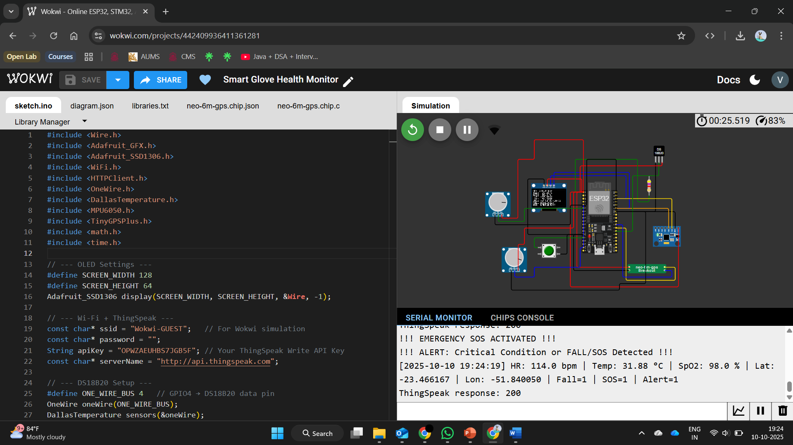

- ThingSpeak Channel Outputs
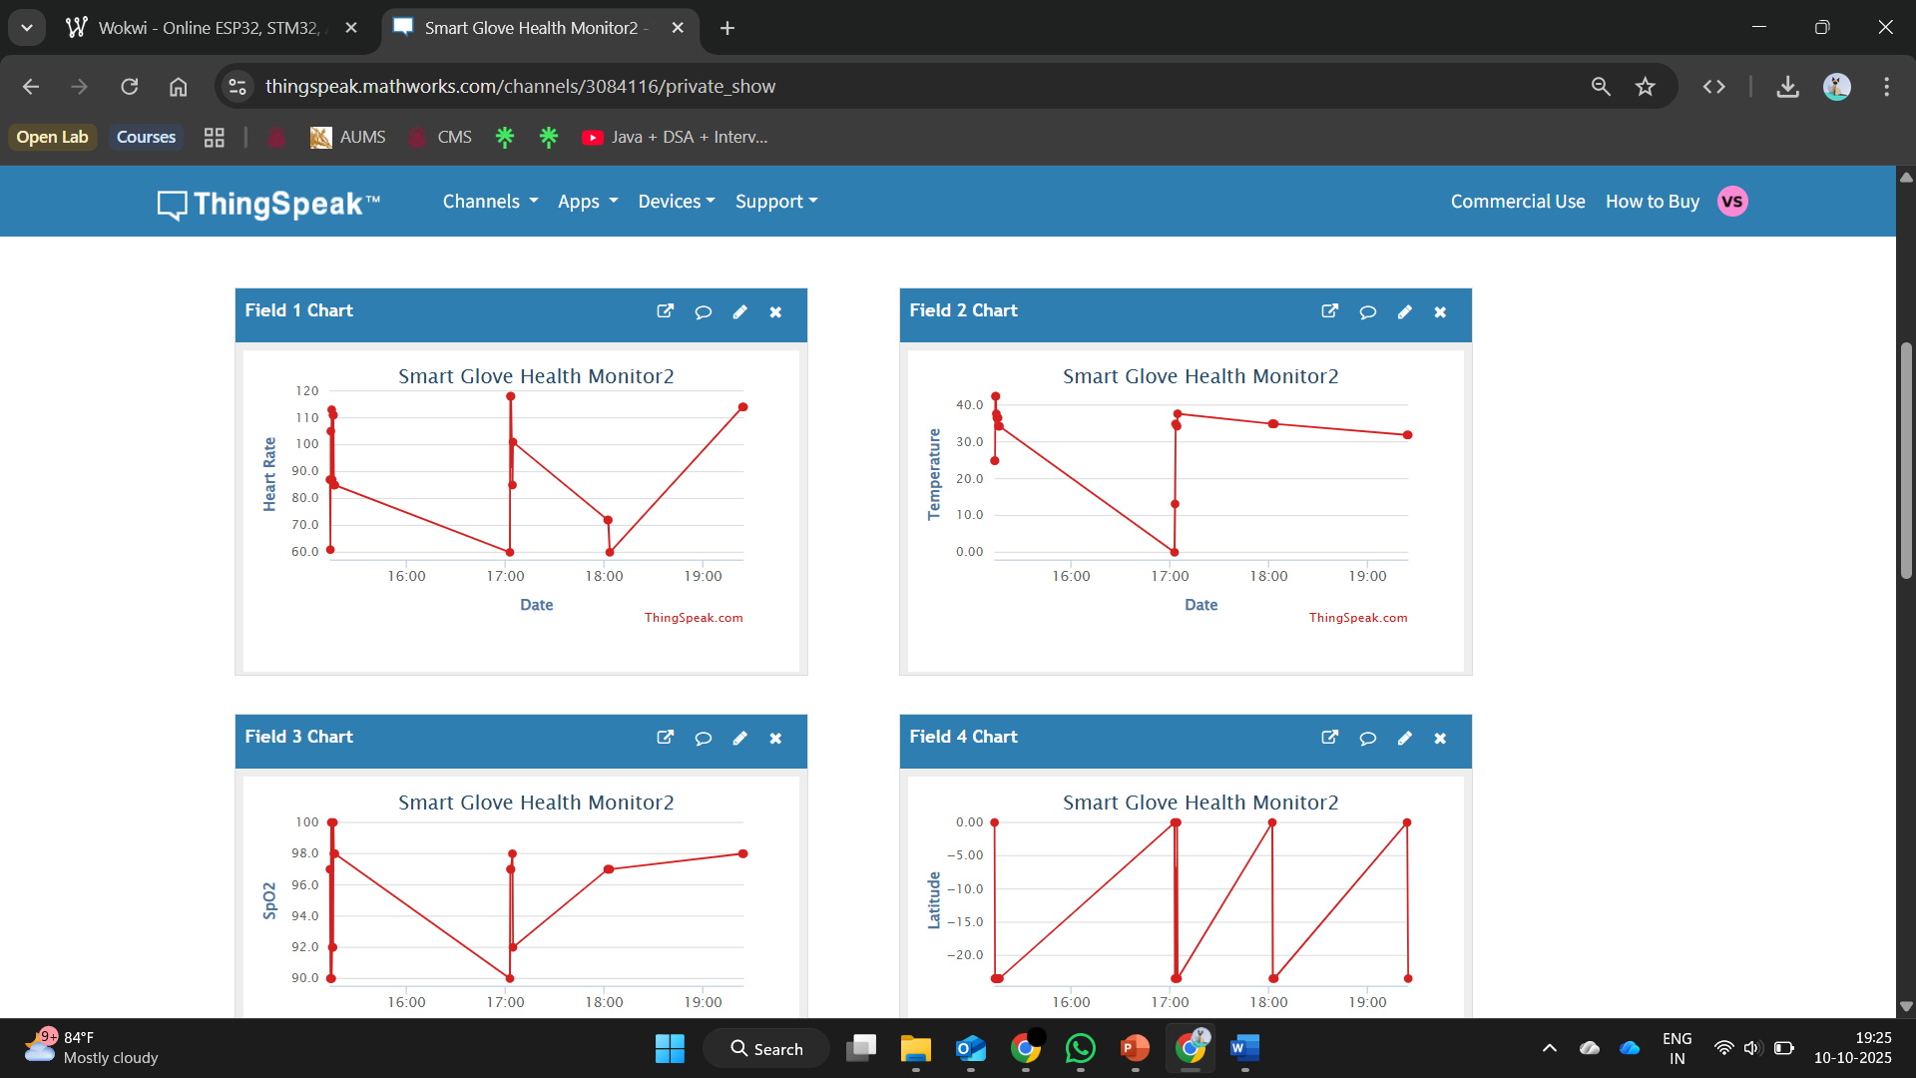

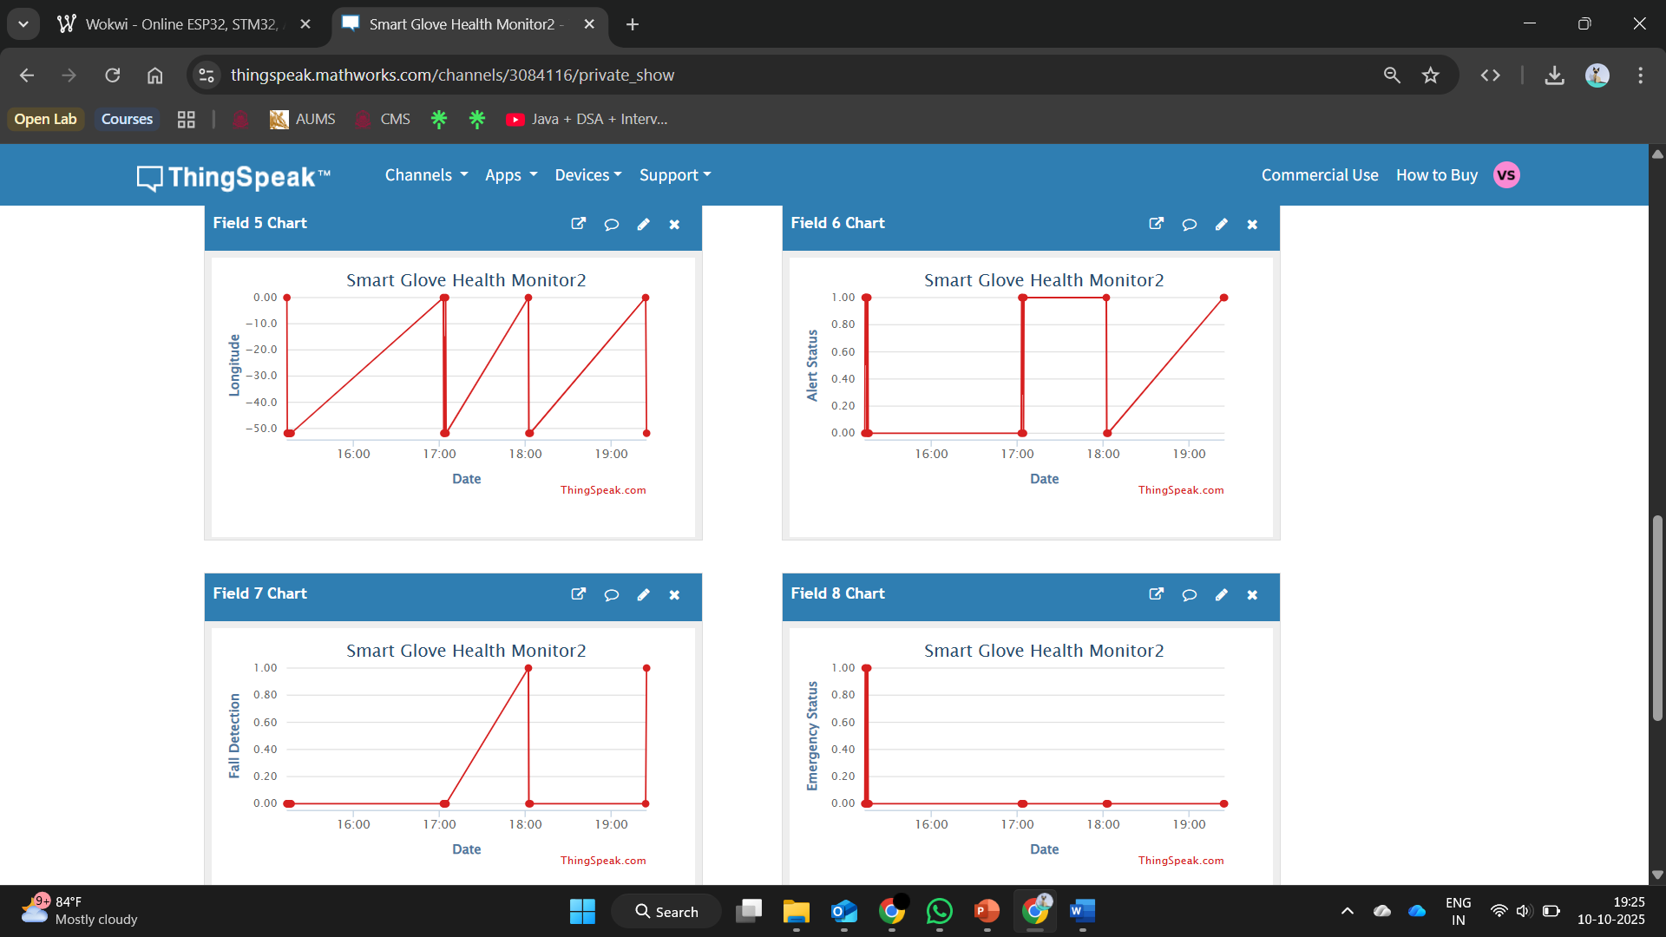

3. Circuit Diagram
