Week 11 · Day 2
IMAGES, PATHS & SEMANTIC HTML | GUIDED CODING LAB
Name / Team: Anna Marie Botas Date: 10/20/26
Existing repository / project folder: ____________________________________________________
MISSION Continue your existing Lakbay Batangas Tours index.html. Add a real local image with helpful text, a visible caption and creator/license credit, then improve the page’s semantic structure. No CSS or JavaScript.
THE BROWSER RESULT YOU ARE WORKING TOWARD
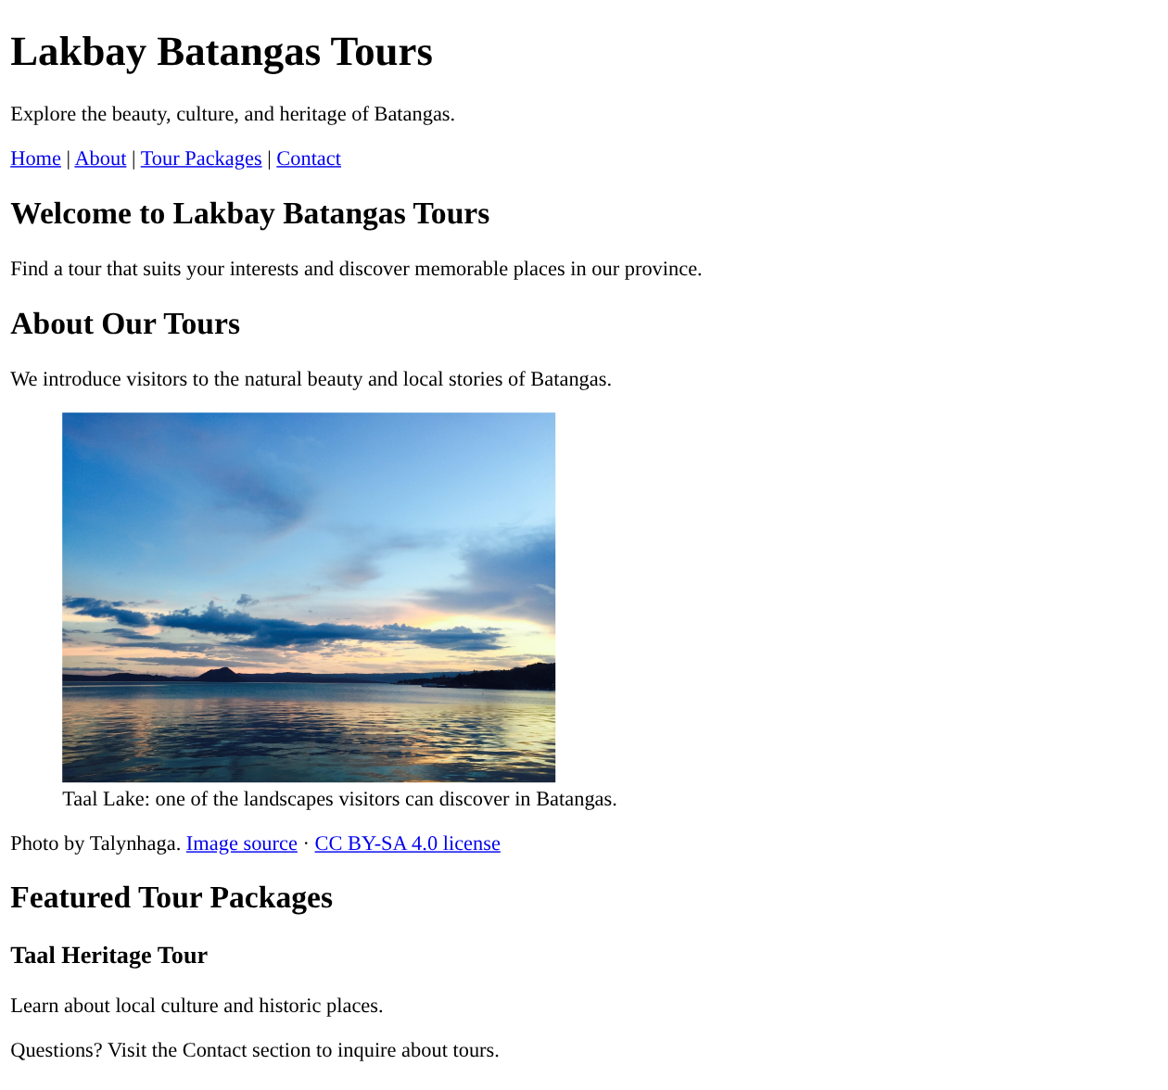
REFERENCE OUTPUT — actual unstyled HTML rendered in a browser. Your existing header and content may differ; focus on the About image, caption, credit, headings and page structure.

LAB PREPARATION • APPROXIMATELY 15 MINUTES

Start with the existing project — do not restart it
1. Open your ORIGINAL Lakbay Batangas Tours folder and inspect index.html. Save a copy or commit your latest working changes before editing. Do not delete your .git folder.
2. Copy the supplied photo into assets/ and place ASSET_CREDIT.txt in the project folder. The paths must match the real files.
lakbay-batangas-tours/
├── index.html
├── ASSET_CREDIT.txt
└── assets/
└── taal-lake.jpg

3. Run git status and note any uncommitted changes. Do not pull, reset or force-push to solve unrelated Git problems during this activity.

Checkpoint 1 — Make the local image appear
Inside the existing About section, type an image element. Replace both TODO values. Check the preview before continuing.
<img
src="TODO: relative path to supplied JPEG"
alt="TODO: what the photo communicates"
width="380"
height="285">

HINT The image file is inside assets, beside index.html. Use a relative file path, not C:\Users\... or an image copied from a search result.
☐ The image loads after I save index.html and refresh the browser.
☐ My alt text describes the scene meaningfully rather than repeating a filename.

Checkpoint 2 — Give the image a visible caption
Group your working image with a figure and figcaption. The text inside figcaption should tell visitors what they are seeing.
<figure>
<!-- Move your working <img> element here -->
<figcaption>TODO: a clear visitor-friendly caption</figcaption>
</figure>

Test: deliberately rename the image path for one refresh. Confirm that the alternative text can communicate the image’s purpose, then restore the correct path.
My screenshot filename for Checkpoints 1–2: __________________________________________
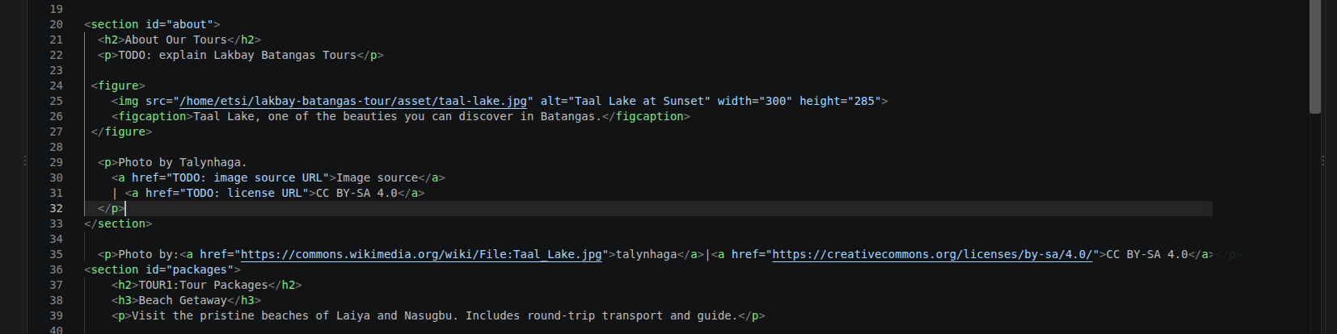
BUILDING THE PAGE • APPROXIMATELY 35 MINUTES

Checkpoint 3 — Build one meaningful About section
Use the code scaffold below in your existing About section. Replace the TODO placeholders with real HTML and your own approved site description. Do not paste a second <main> into an existing <main>.
<section id="about">
<h2>About Our Tours</h2>
<p>TODO: explain Lakbay Batangas Tours</p>

<!-- TODO: insert your <figure> from Checkpoint 2 -->

<p>Photo by Talynhaga.
<a href="TODO: image source URL">Image source</a>
| <a href="TODO: license URL">CC BY-SA 4.0</a>
</p>
</section>

Use the creator, source, and license URLs recorded in ASSET_CREDIT.txt. These are different from the image’s alt text and visible caption.

Checkpoint 4 — Improve semantic page structure
Inspect your current index.html and use the correct structural elements for content that already exists. Keep only one page-level main element.
Current content | Element to check or use | Your result
Site title and opening content | <header> | / checked
Links between page sections | <nav> | /checked
Unique central webpage content | <main> | / checked
About content with the Taal image | <section id="about"> | / checked
One individual tour description | <article> | / checked
Closing contact and footer information | <footer> | / checked

Checkpoint 5 — Verify your existing navigation
Click About from the navigation menu. It should move the browser to the element with id="about". Check another existing internal link. Do not change IDs without updating their links.
☐ About and at least one other internal navigation link work in the browser.
☐ The page still contains the Day 1 headings, lists and required approved content.

DEBUG, TEST AND SUBMIT • APPROXIMATELY 30 MINUTES

Coding challenge — repair this broken fragment
Find at least FOUR problems. Fix this fragment in a separate temporary editor tab, then apply the relevant lessons to your real index.html. Do not replace your project file with the fragment.
<section id="about">
<h2>About Our Tours</h2>
<figure>
<img src="asset/taal.jpg" alt="" width="380" height="285">
</figure>
<figcaption>Taal Lake in Batangas</figcaption>
</section>

Four repairs I made:
1. fix the image src path to point correctly to assets/taal-lake.jpeg
2.wrapped the image and caption inside proper <figure>and <figcaption>tags
3. added correct links for images source and license using<a>tags
4. link the navigation to the section using the correct href=#about” attribute

Browser test record — use the expected-output picture
Test / expected outcome | Pass / Fix | Observed result or correction
Taal Lake photo displays from assets/ | pass | Image loads correctly from the proper asset/ folder path
Caption appears directly below photo | pass | <figcaption> is properly nested inside <figure> and displays beneath the image
Creator, image source and license appear | pass | Attribution details are visible as required
About navigation scrolls to the section | pass | link targeting #about works and scrolls to this section
Photo loads with internet disconnected | pass | Uses relative local path assets/taal.jpg; loads offline without external connection
One tour description has clear structure | pass | Heading–paragraph layout is readable and well-organized

Save a meaningful Git checkpoint
After the browser checks pass, run these commands in the ORIGINAL repository. Only push if a remote is already configured and your trainer has approved the normal workflow.
git status
git diff --check
git add index.html assets/taal-lake.jpg ASSET_CREDIT.txt
git commit -m "Add local tour image and semantic HTML"
git log -1 --oneline
git push # only if the remote and branch are set correctly

Commit hash (short): a1b2c3 GitHub update: ☑ verified ☐ pending

What to submit
Updated index.html, assets/taal-lake.jpg, ASSET_CREDIT.txt, one browser screenshot compared with the reference preview, your test record, and Git evidence. If Git fails, record the exact error and keep your local work.
Remember: This is a classroom HTML lab. No CSS, JavaScript, booking, payment or real inquiry processing is expected yet.

