|  |  |  |
| --- | --- | --- |
| Лабораторная работа №4  Методы штрафных и барьерных функций | Ф.И.О. | Бокова Ольга Дмитриевна |
| Группа | ИВТ-363 |
| Преподаватель | Асанова Наталия Васильевна |
| Дата сдачи | 24.11.2022 |

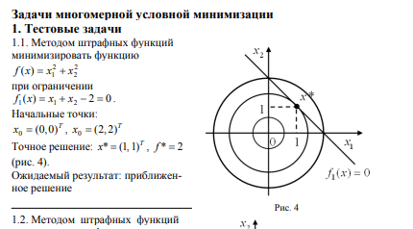

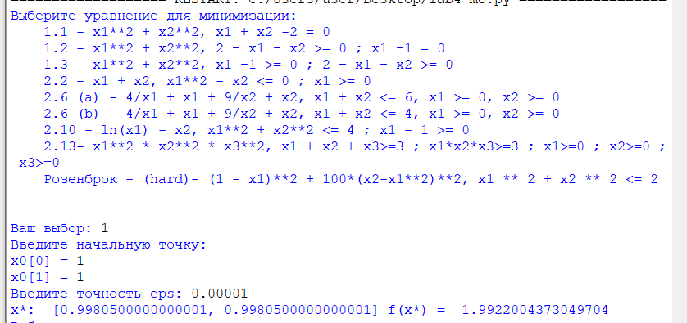

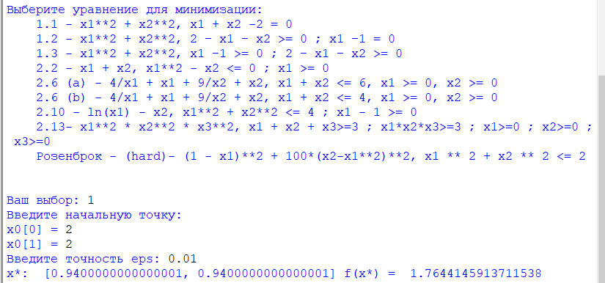

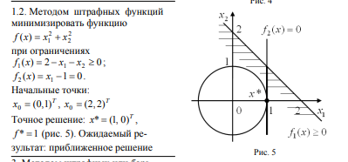

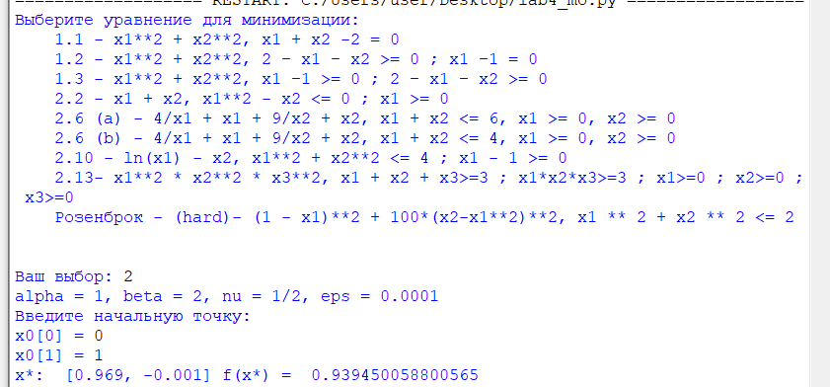

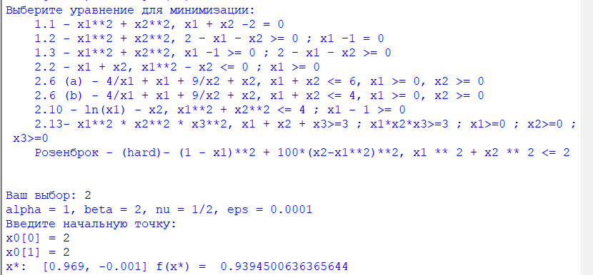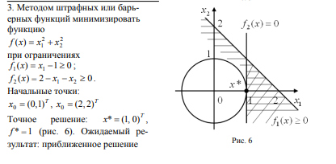

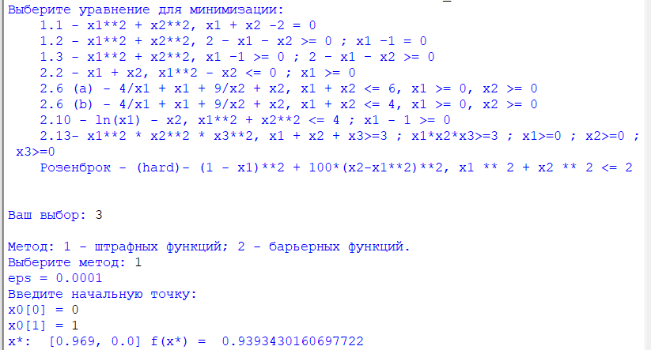

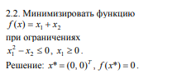

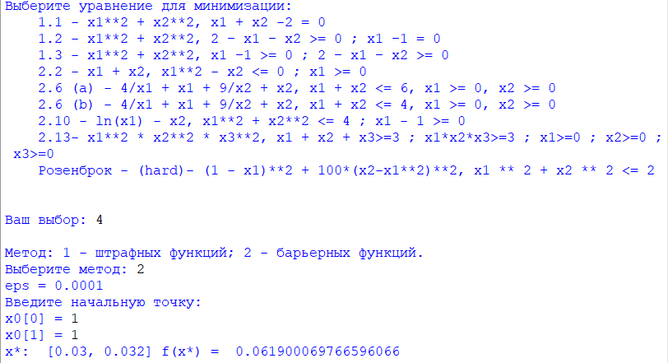

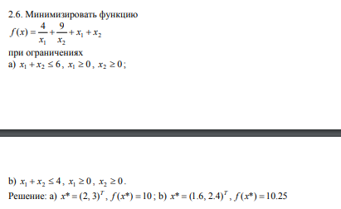

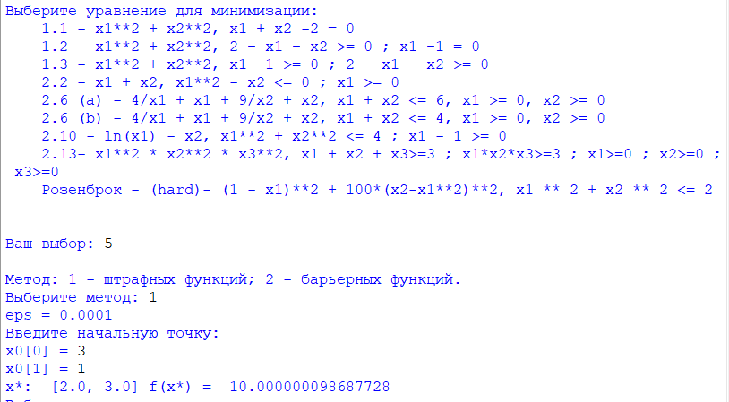

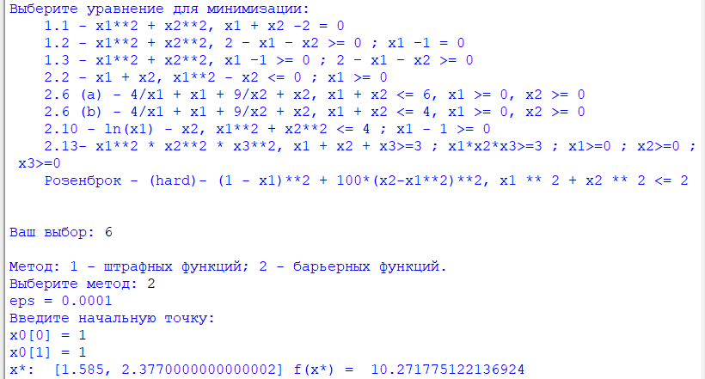

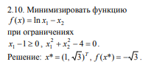

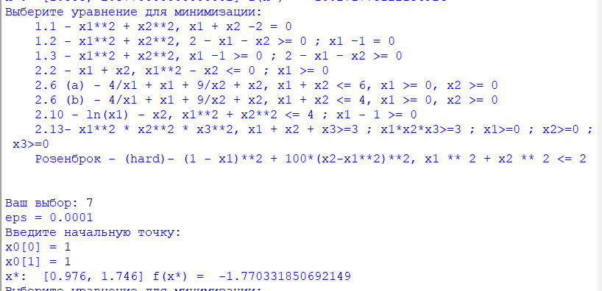

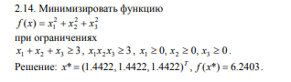

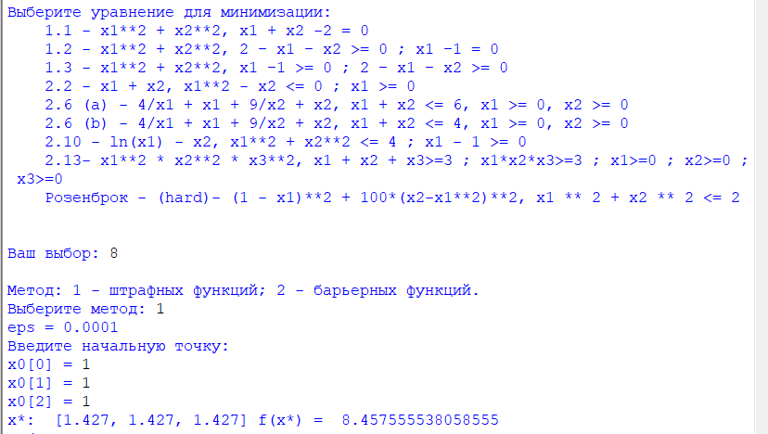

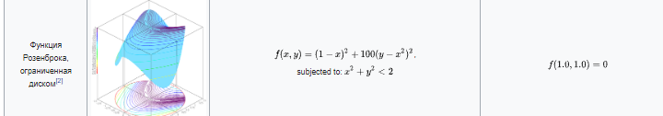

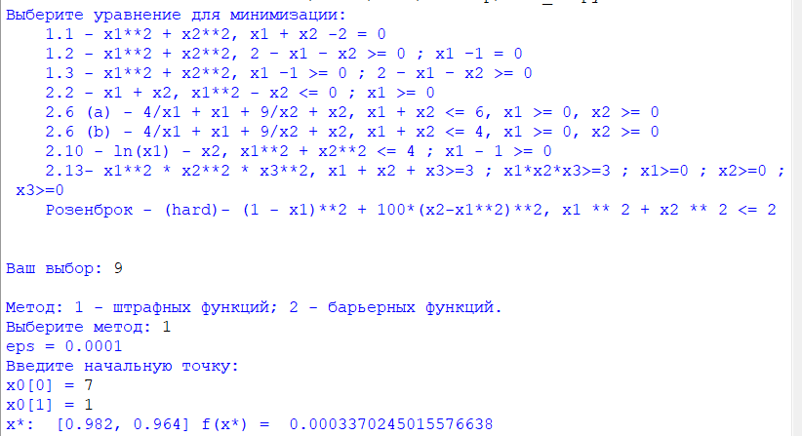

Код программы:

import math

import scipy.optimize as optimize

import numpy as np

from typing import Callable, List

need_to_see_debug_notes = 0

def debug_note(string):

if need_to_see_debug_notes:

print(string)

def error(prompt):

print(prompt)

exit()

def input_value(type_of_data, prompt, restrictions, error_prompt):

i = 0

while True:

value = 0

i += 1

if i > 20:

error("Cлишком много попыток")

if type_of_data == "int" or type_of_data == "integer":

try:

value = int(input(prompt))

except KeyboardInterrupt:

error("Ok...")

except:

print("Неверные данные (должно быть int), повторите попытку")

continue

elif type_of_data == "float":

try:

value = float(input(prompt))

except KeyboardInterrupt:

error("Ok...")

except:

print("Неверные данные (должно быть float), повторите попытку")

continue

elif type_of_data == "bool" or type_of_data == "boolean":

try:

value = bool(input(prompt))

except KeyboardInterrupt:

error("Ok...")

except:

print("Неверные данные (должно быть boolean), повторите попытку")

continue

elif type_of_data == "str" or type_of_data == "string":

try:

value = str(input(prompt))

except KeyboardInterrupt:

error("Ok...")

except:

print("Неверные данные (должно быть string), повторите попытку")

continue

else:

error("Неверные данные")

try:

if restrictions(value):

return value

else:

print(error_prompt)

continue

except KeyboardInterrupt:

error("Ok...")

except:

error("Неправильные ограничения")

def unconditional_optimization(func: Callable[..., float], x_start: List[float], epsilon: float = 0.001):

return optimize.minimize(fun=func, x0 = x_start, method="BFGS", options={'eps': epsilon}).x

def penalty_method(x0, objective_func, alpha_start, beta, eps, rest_eq, rest_not_eq):

alpha = alpha_start

def getAuxilitaryFunctionResult(objective_func, alpha, rest_eq, rest_not_eq, x):

H = 0

for i in rest_eq:

H += pow(abs(i(x)), 2)

for i in rest_not_eq:

H += pow(max(0, i(x)), 2)

return objective_func(x) + alpha * H

xcur = np.array(x0)

xnew = unconditional_optimization(lambda x: getAuxilitaryFunctionResult(objective_func, alpha,

rest_eq, rest_not_eq, x), xcur, eps)

while ((xcur - xnew)**2).sum() > eps:

alpha *= beta

xcur = xnew

xnew = unconditional_optimization(lambda x: getAuxilitaryFunctionResult(objective_func, alpha,

rest_eq, rest_not_eq, x), xcur, eps)

if alpha > 100000:

break

#print("alpha in the end = ", alpha)

return xnew

def barrier_method(x0, objective_func, alpha_start, beta, eps, rest_not_eq):

alpha = alpha_start

def getAuxilitaryFunctionResult(objective_func, alpha, rest_not_eq, x):

H = sum(1 / (0.000000001 + max(0, -i(x))**2) for i in rest_not_eq)

return objective_func(x) + alpha * H

xcur = np.array(x0)

xnew = None

atLeastOnePointFound = False

while not (atLeastOnePointFound and (((xcur - xnew) ** 2).sum() < eps ** 2)):

xtemp = unconditional_optimization(lambda x: getAuxilitaryFunctionResult(objective_func, alpha,

rest_not_eq, x), xcur)

isInside = not any(neq(xtemp) > eps for neq in rest_not_eq)

if (isInside):

if not atLeastOnePointFound:

atLeastOnePointFound = True

else:

xcur = xnew

xnew = xtemp

alpha *= beta

if alpha < 0.00001:

break

#print("alpha in the end = ", alpha)

return xnew

def function_choise(number):

# 3 аргумент - ограничения неравенства

# 4 аргумент - ограничения равенства

if number == 1:

return [lambda x: x[0] ** 2 + x[1] ** 2, 2,

[lambda x: x[0] + x[1] - 2], []]

elif number == 2:

return [lambda x: x[0] ** 2 + x[1] ** 2, 2,

[lambda x: x[0] - 1], [lambda x: x[0] + x[1] - 2]]

elif number == 3:

return [lambda x: x[0] ** 2 + x[1] ** 2, 2,

[], [lambda x: 1 - x[0], lambda x: x[0] + x[1] - 2]]

elif number == 4:

return [lambda x: x[0] + x[1], 2,

[], [lambda x: x[0] ** 2 - x[1], lambda x: -x[0]]]

elif number == 5:

return [lambda x: 4 / x[0] + x[0] + 9 / x[1] + x[1], 2,

[], [lambda x: x[0] + x[1] - 6, lambda x: -x[0], lambda x: -x[1]]]

elif number == 6:

return [lambda x: 4 / x[0] + x[0] + 9 / x[1] + x[1], 2,

[], [lambda x: x[0] + x[1] - 4, lambda x: -x[0], lambda x: -x[1]]]

elif number == 7:

return [lambda x: math.log(abs(x[0])) - x[1], 2,

[lambda x: x[0]**2 + x[1]**2 - 4], [lambda x: 1 - x[0]]]

elif number == 8:

return [lambda x: x[0]**2 * x[1]**2 * x[2]**2, 3,

[],

[lambda x: -x[0], lambda x: -x[1], lambda x: -x[2],

lambda x: 3 - x[0] - x[1] - x[2], lambda x: 3 - x[0] * x[1] * x[2]]]

elif number == 9:

return [lambda x: (1 - x[0]) ** 2 + 100 * (x[1] - x[0] ** 2) ** 2, 2,

[],

[lambda x: x[0] ** 2 + x[1] ** 2 - 2]]

def main():

print("""Выберите уравнение для минимизации:

1.1 - x1**2 + x2**2, x1 + x2 -2 = 0

1.2 - x1**2 + x2**2, 2 − x1 − x2 >= 0 ; x1 −1 = 0

1.3 - x1**2 + x2**2, x1 −1 >= 0 ; 2 − x1 − x2 >= 0

2.2 - x1 + x2, x1**2 - x2 <= 0 ; x1 >= 0

2.6 (a) - 4/x1 + x1 + 9/x2 + x2, x1 + x2 <= 6, x1 >= 0, x2 >= 0

2.6 (b) - 4/x1 + x1 + 9/x2 + x2, x1 + x2 <= 4, x1 >= 0, x2 >= 0

2.10 - ln(x1) - x2, x1**2 + x2**2 <= 4 ; x1 - 1 >= 0

2.13- x1**2 * x2**2 * x3**2, x1 + x2 + x3>=3 ; x1*x2*x3>=3 ; x1>=0 ; x2>=0 ; x3>=0

Розенброк - (hard)- (1 - x1)**2 + 100*(x2-x1**2)**2, x1 ** 2 + x2 ** 2 <= 2

""")

function_number = input_value("int", "Ваш выбор: ", lambda x: 1 <= x <= 9, "Вы ввели неверный номер уравнения")

function, dimensions_num, restrictions_of_equality, restrictions_of_non_equality = function_choise(function_number)

if len(restrictions_of_equality) == 0:

print('\nMетод: 1 - штрафных функций; 2 - барьерных функций.')

method = input_value("int", "Выберите метод: ", lambda x: 1 <= x <= 2, "Вы ввели неверный номер метода")

else:

method = 1

alpha_start = 1

beta = 2

eps = 0.001

print("eps = 0.0001")

print("Введите начальную точку:")

start_point = [input_value("float", "x0[" + str(i) + "] = ", lambda x: True, "Неверные данные")

for i in range(dimensions_num)]

while any(i(start_point) > eps for i in restrictions_of_non_equality) and method == 2:

print("Начальная точка не подходит для барьерного метода. Попробуйте снова:")

start_point = [input_value("float", "x0[" + str(i) + "] = ", lambda x: True, "Неверные данные")

for i in range(dimensions_num)]

# Вызов методов

result = []

if method == 1:

result = penalty_method(start_point, function, alpha_start, beta, eps,

restrictions_of_equality, restrictions_of_non_equality)

else:

result = barrier_method(start_point, function, alpha_start, 1 / beta, eps, restrictions_of_non_equality)

# Отформатированный вывод результата

result_output = [round(i / eps) * eps for i in result]

print("x*: ", result_output, "f(x*) = ", function(result))

return 0

while True:

main()