Guide M1: CentOS Installation

Conditions
Let’s assume that we have a new VM created with CentOS profile in VirtualBox and with the following parameters:
- 1 CPU;
- 1024 MB RAM;
- 16 GB HDD with Dynamic Size (or Thin) space policy;
- 1 Network Adapter connected in NAT mode;
- All other virtual hardware and setting with their default values;
For the installation we will use the minimal installation media (CentOS-7-x86_64-Minimal-1810.iso).

Installation Steps
Power on the machine and after a while we will be presented with the following screen:
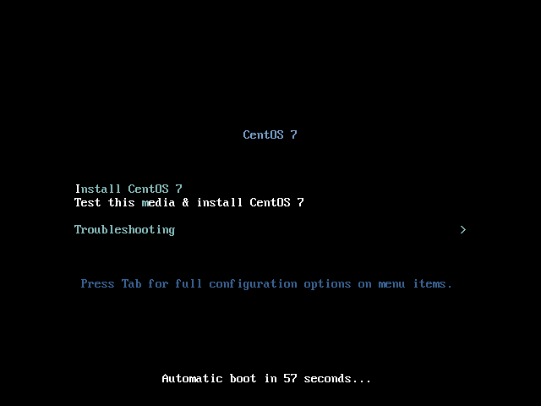
Here, we can use the arrow keys to move the selection up and down. We must select the first option:
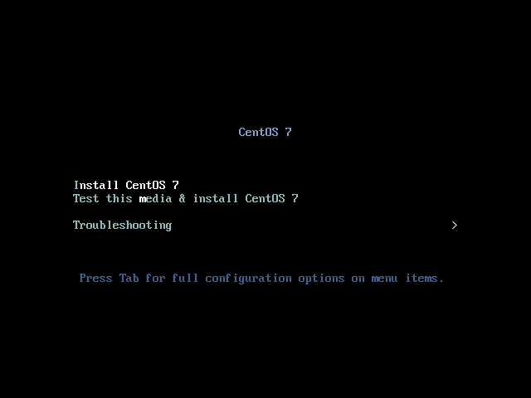
Then hit the Enter key. The VM screen will resize and flicker. Some text messages will start appearing on the screen:
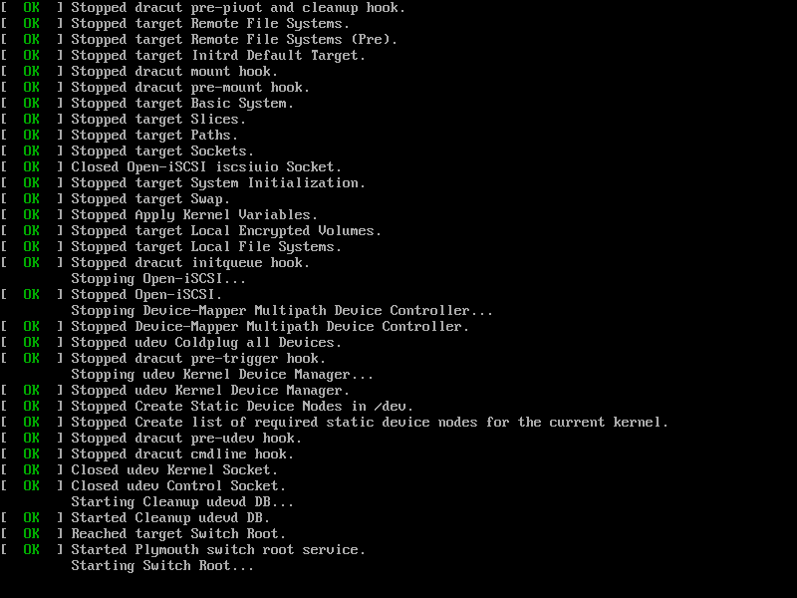
After a while we will be presented with the welcome screen of the setup program. Here we can select a language to be used during the installation process. Let’s accept the default settings (English) and click on Continue:
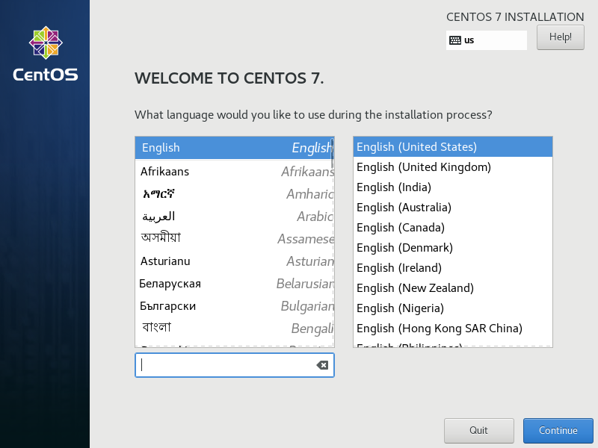
On the next screen, we can adjust settings in three directions localization (time zone, keyboard layout and language), software (installation media and software selection) and system (installation destination, kdump and network):
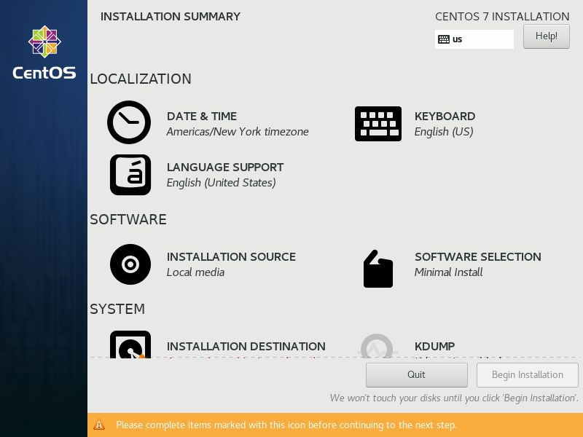
Click on DATE & TIME to adjust the time zone:
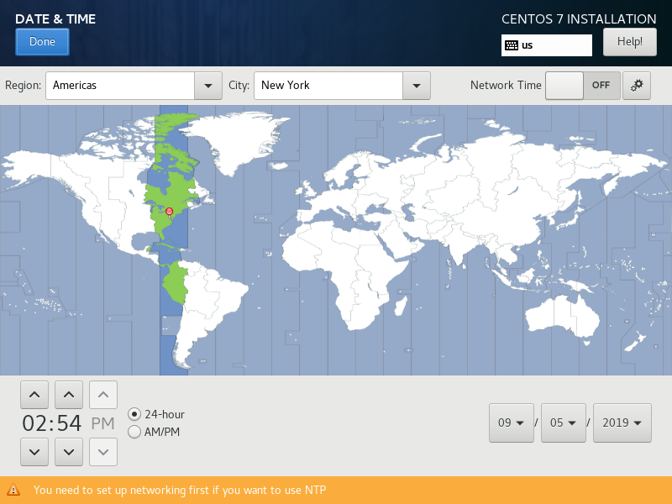
For Region select Europe and for City select Sofia. This can be achieved by using the drop-down lists or by clicking on the map:
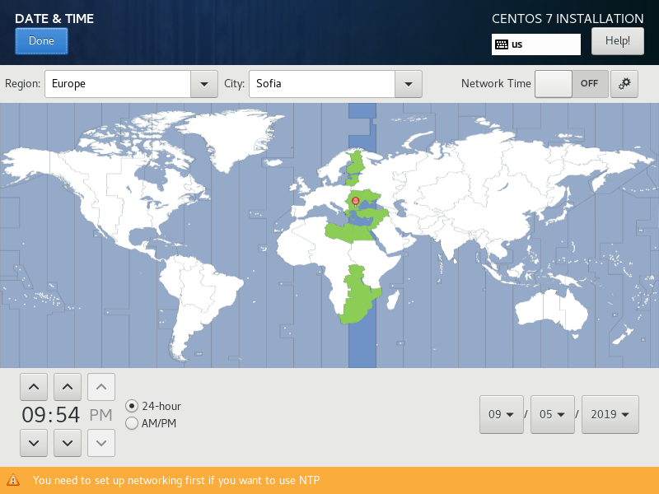
Click on Done. Then click on INSTALLATION DESTINATION option to confirm the target drive:
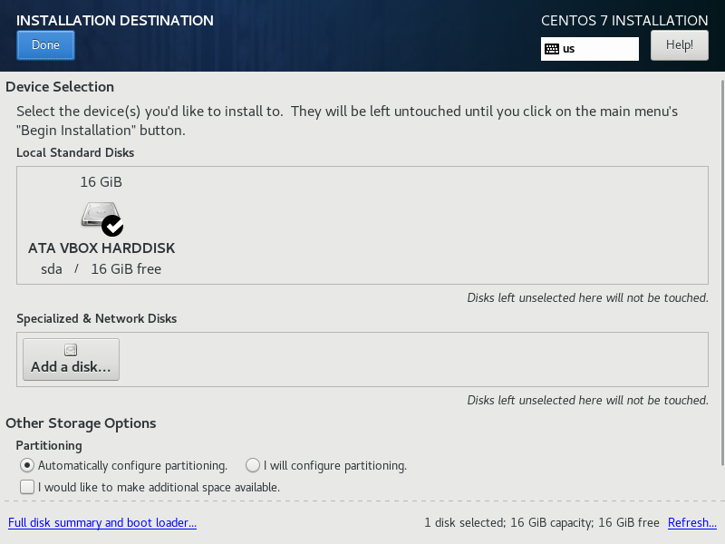
Here, if we had a bigger disk or multiple disks, we could choose a drive or how a drive to be utilized by the new OS. Click on Done to return to the main menu and then select KDUMP:
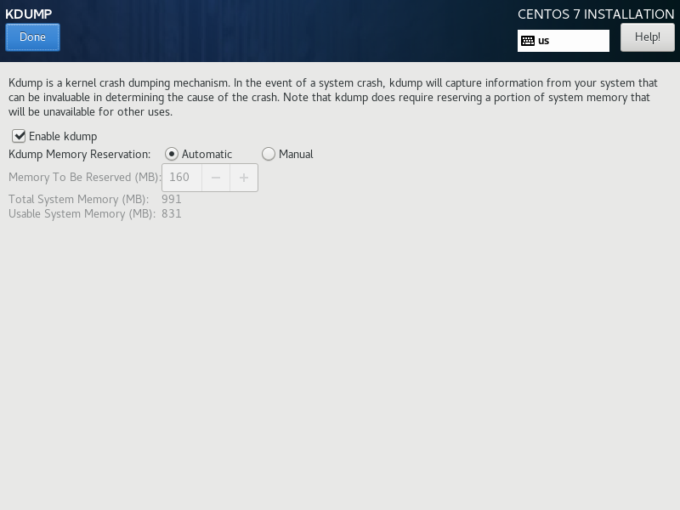
Turn off the Enable kdump to save some memory as we are tight on resources and working in a lab environment:
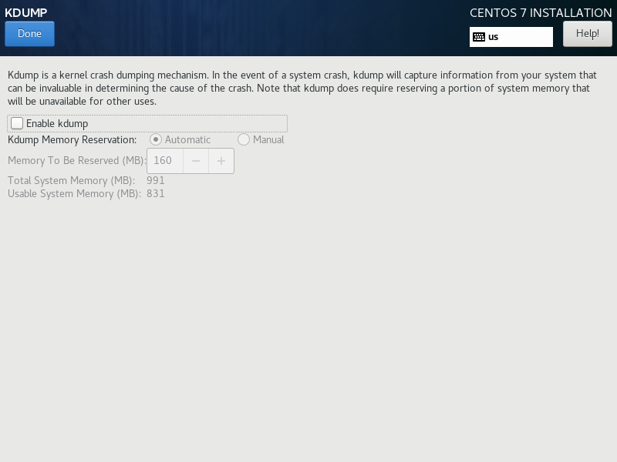
Confirm with Done.
Select NETWORK & HOST NAME from the list of options in the main menu:
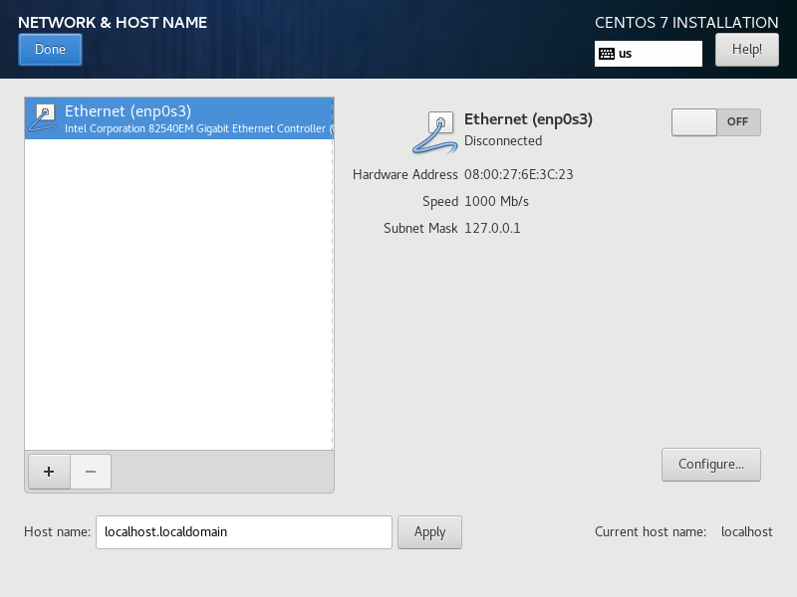
Turn on the network adapter connection, enter custom value in the Host name field and then click on Apply:
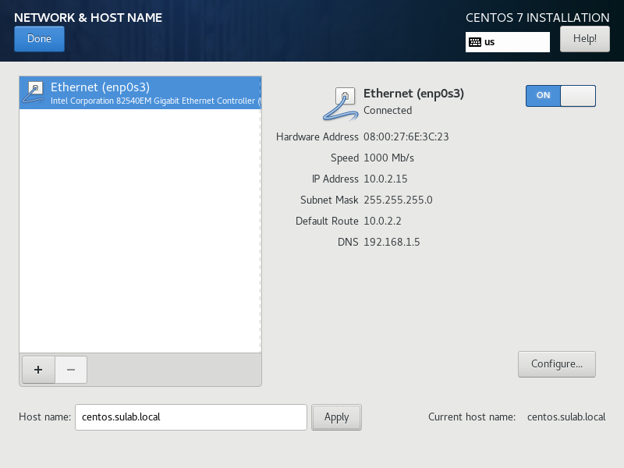
Please note that if we do not turn on the network connection here, when booted our machine won’t connect to the network automatically.
Click on Done to return to the main menu.
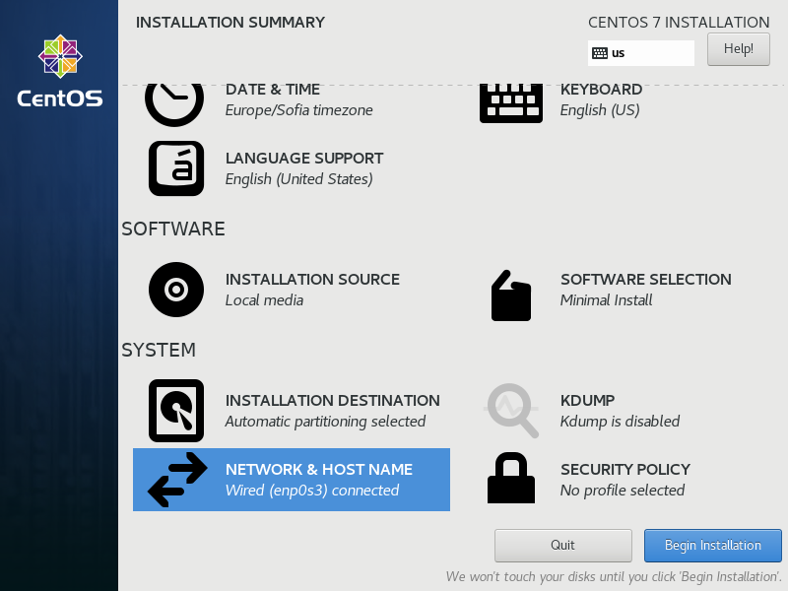
We are ready with the basic configuration and can proceed further. Click the Begin Installation button.
On the next screen, while the OS is being installed, we can set the password for the root user and create additional user:
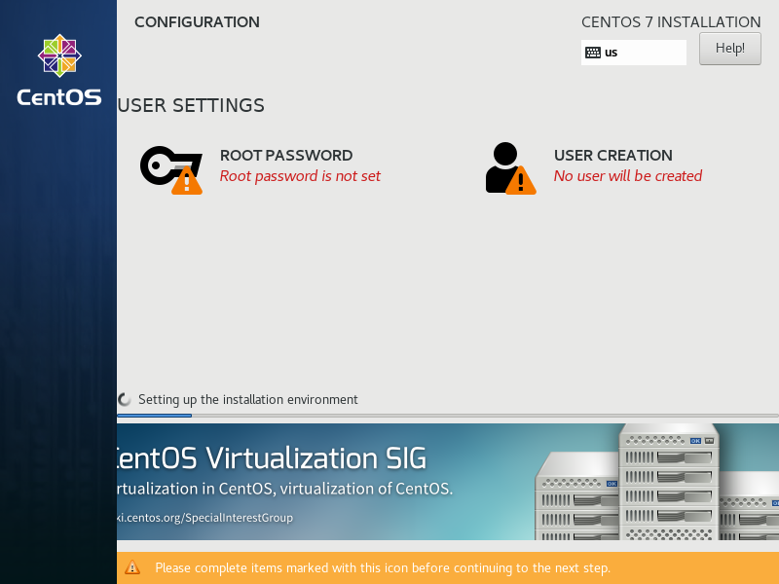
Click on ROOT PASSWORD option:
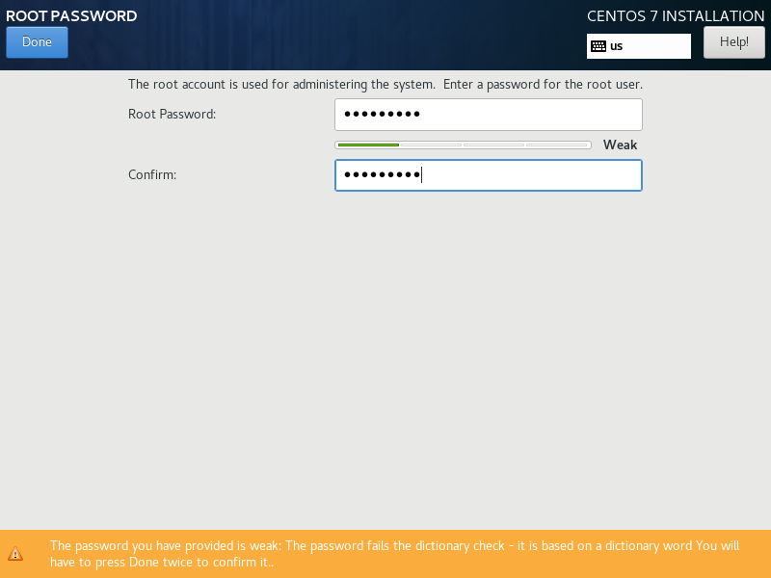
Then enter a password. For example, enter Password1. Please note that if the password is assessed as week, the Done button must be clicked twice. Now, let’s click on Done to return to the main menu and then click on USER CREATION to create one additional user:
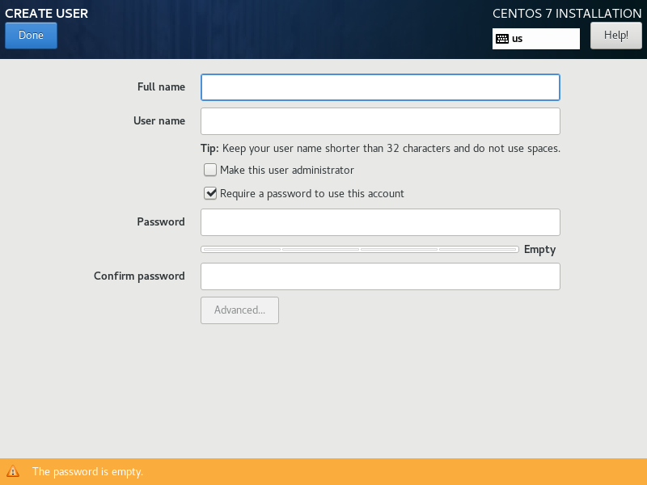
Fill in the needed information. Do not forget to tick the Make this user administrator option:
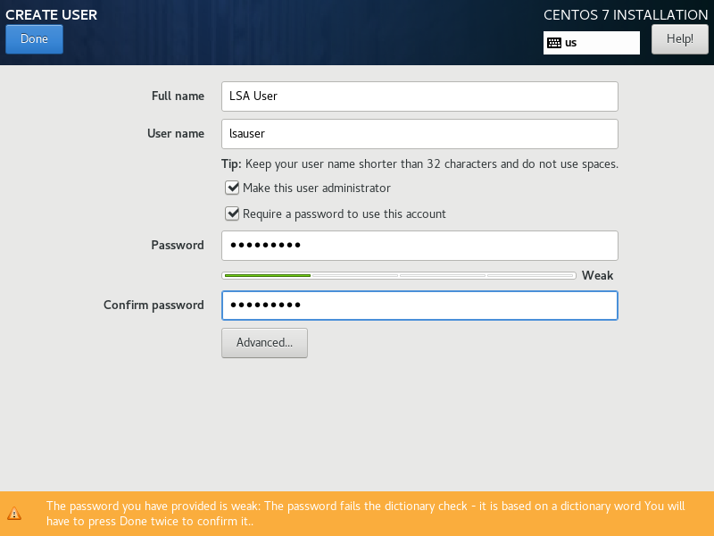
And again, if the password is weak, we must click on Done twice to return to the main menu. Now click on Done.
After a while the installation will end, and we will be asked to reboot the machine:
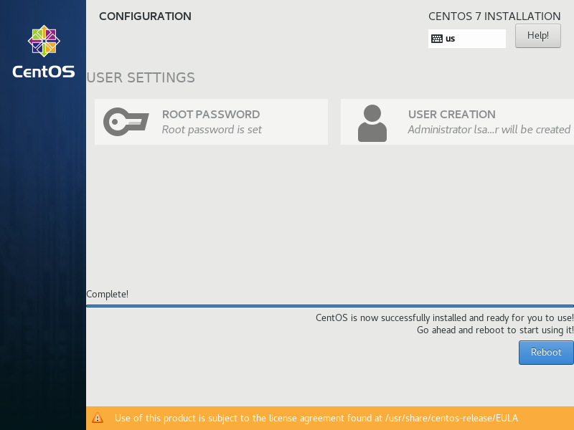
Click on Reboot button to do what asked.
Once the machine is booted, we will be prompted with a menu to choose what to be loaded. This is the Boot manager:
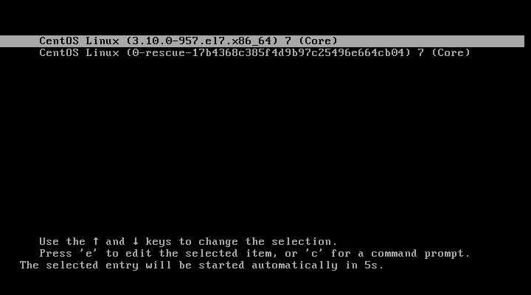
There is option selected by default. We have 10 seconds to change the selection if we want, which we do not, at least not now. Once the time passes or the Enter key is hit, the control is transferred to the OS behind the option selected.
We will be presented with a progress bar of the loading process:

When the loading process is done, we will be presented with the login screen:
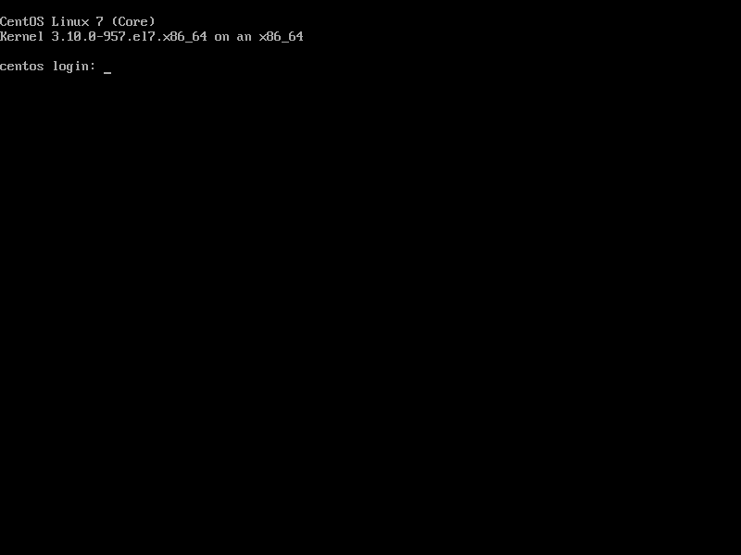
Only one last thing must be done in order to be able to access the VM via SSH. We must create a port forwarding rule. Go to the machine settings and select Network, then on the Adapter 1 section click on Advanced:
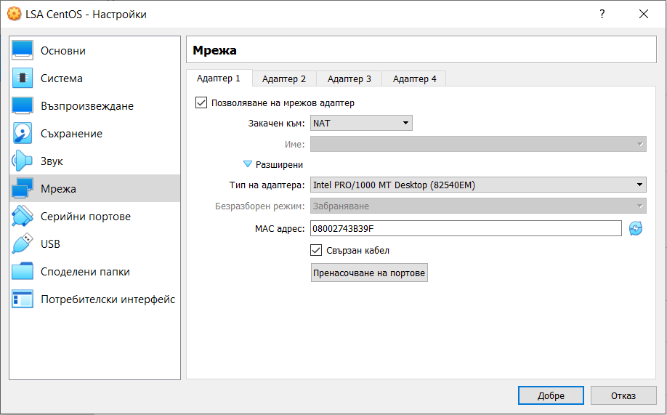
In order to create the rule, we must click on the Port forwarding button. Then we can add a rule with the following sample content:
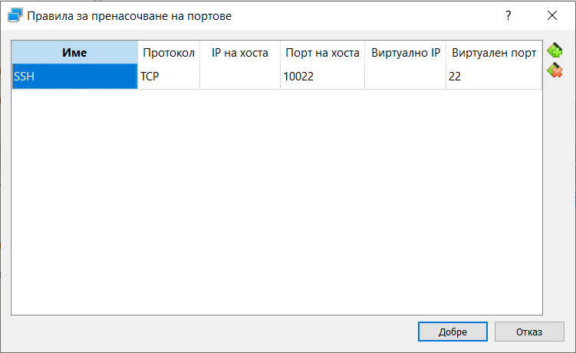
We have to confirm with the OK button.
Please note that the protocol for the SSH service is TCP and the default port on which it operates is 22.
For the Host port we can choose any arbitrary number above 1024 but in general it is safer to put something above 10000. No matter what our choice is, this should be a free port on our host machine. Again, it is safer one host port to be part of one rule for one VM.
Now when using a command line SSH client, the command should look like:
$ ssh -p 10022 lsauser@localhost
And if we use the SCP utility to transfer files via SSH, the command should look like:
$ scp -P 10022 lsauser@localhost:/home/lsauser/some-file.txt .
Please note that port number and user should match what we entered during the installation.

