Guide M1: Ubuntu Installation

Conditions
Let’s assume that we have a new VM created with Ubuntu profile in VirtualBox and with the following parameters:
- 1 CPU;
- 1024 MB RAM;
- 16 GB HDD with Dynamic Size (or Thin) space policy;
- 1 Network Adapter connected in NAT mode;
- All other virtual hardware and setting with their default values;
For the installation we will use the minimal installation media (ubuntu-19.04-live-server-amd64.iso).

Installation Steps
Power on the machine and after a while we will be presented with the following screen:

Here, we can wait few seconds or hit a key which will give us the opportunity to change few setup options. If we don’t do anything, the VM screen will resize and flicker. Some text messages will start appearing on the screen:
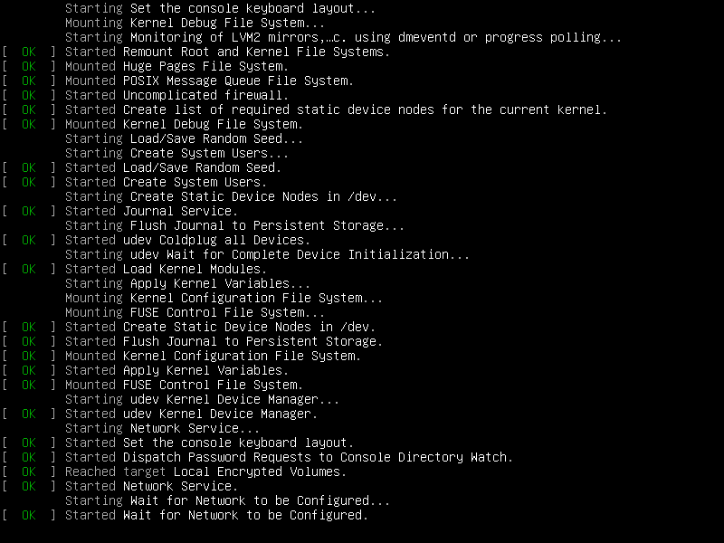
After a while we will be presented with the welcome screen of the setup program. Here we can select a language to be used during the installation process:
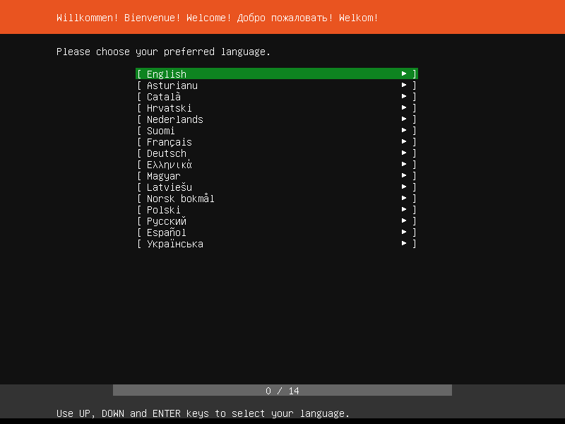
Let’s accept the default settings (English) and hit the Enter key. On the next screen, we will be asked if we want to update the installer first or not:
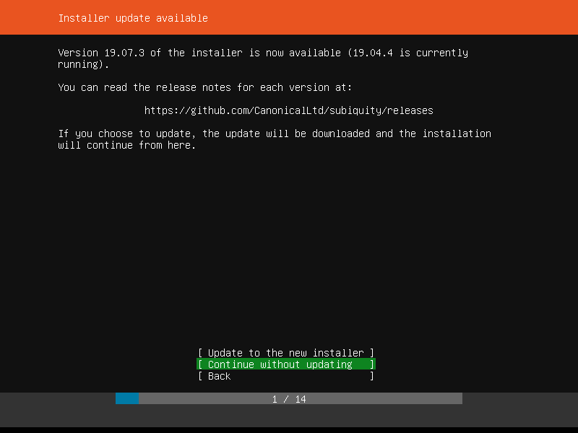
Select Continue without updating using the arrow keys or the Tab key and then hit Enter.
On the next screen we must configure the keyboard layout and variant:
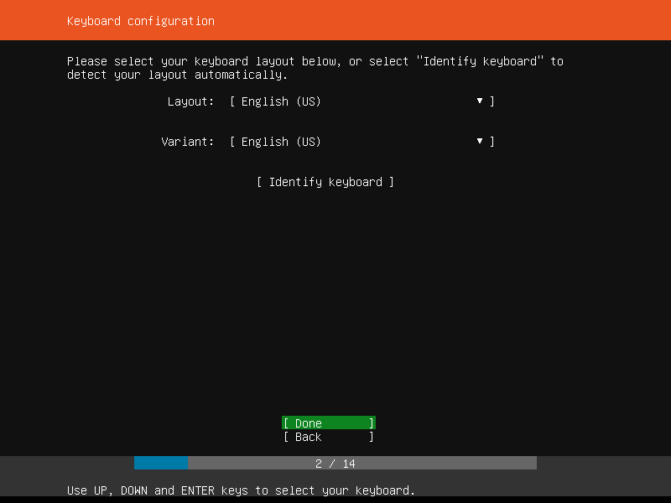
Accept the default values, select Done and hit the Enter key.
On the next screen select the Install Ubuntu option and hit the Enter key to continue:
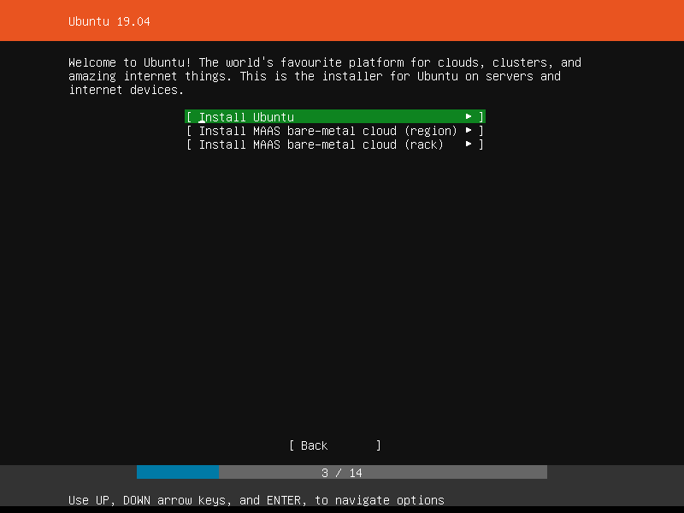
Then we will be presented with the network configuration window. We can safely accept the proposed values, select Done and hit the Enter key:
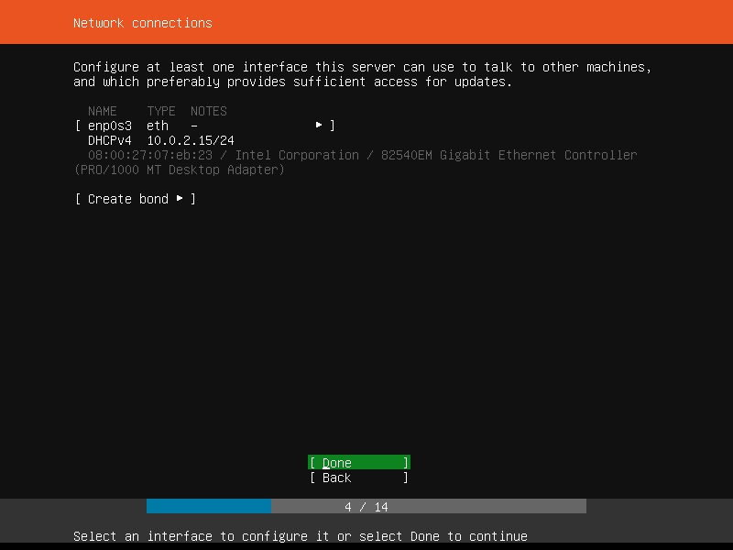
On the proxy screen, in we do not work behind a proxy, we do not have to do anything, just select Done and hit the Enter key to continue:
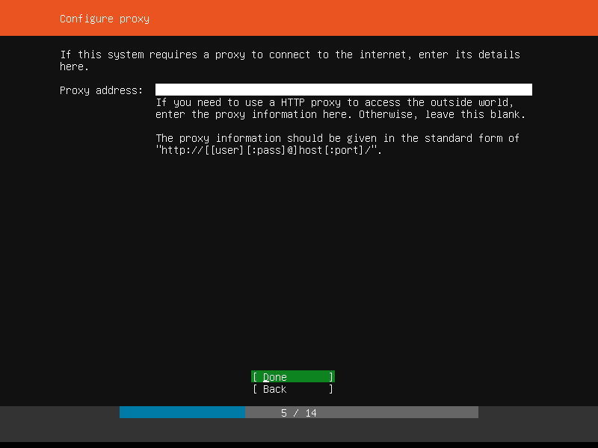
Next step allows us to specify a mirror. We can accept the proposed one, select Done and hit the Enter key:
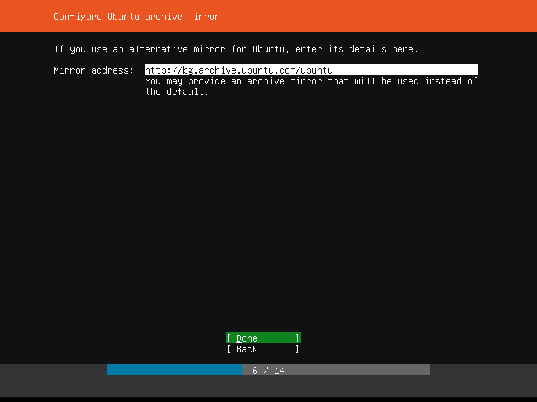
Here, if we can modify the behavior regarding the hard disk usage and utilization. Let’s select the Use An Entire Disk option and then hit the Enter key:
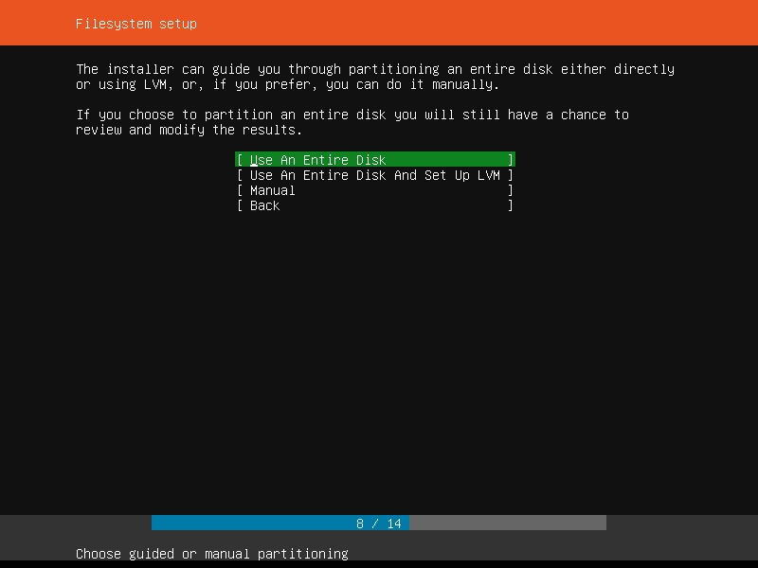
We have only one disk available, so must just hit the Enter key to go on to the next step:
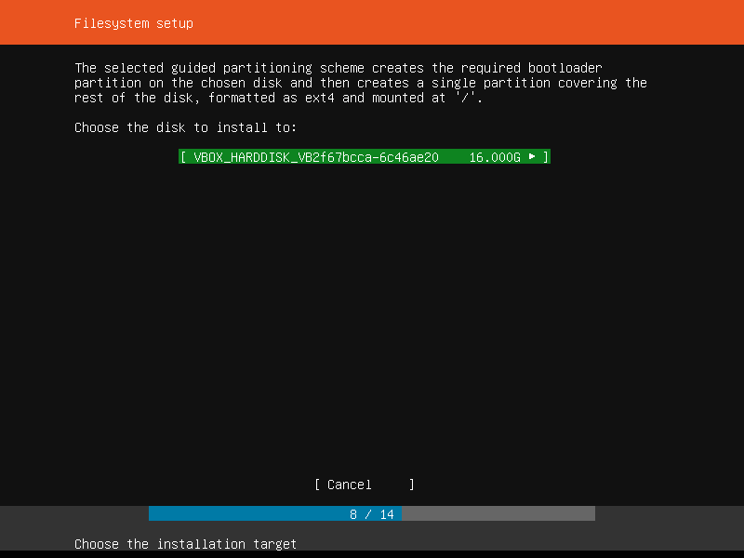
We are presented with an interface that allows us to modify the partitioning scheme of the disk:
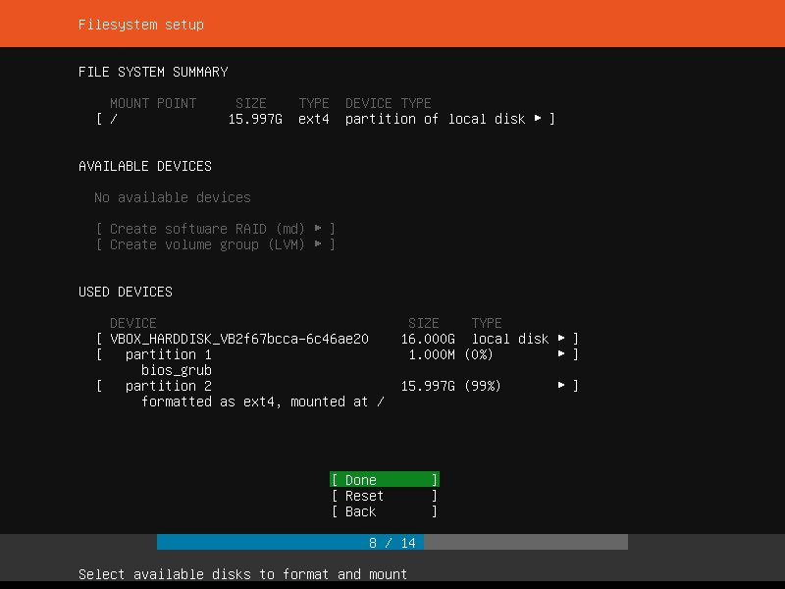
Let’s accept the proposed, select Done and hit the Enter key. Then we will be asked if we are sure that we want to apply the changes to disk:
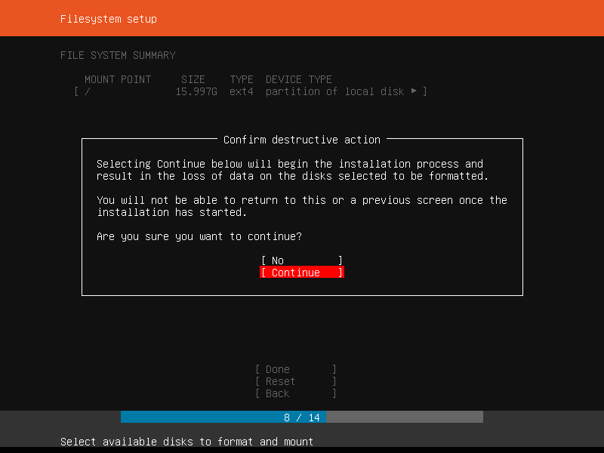
Select the Continue option and hit the Enter key. The actual installation process begins in the background. Meanwhile we are presented with an interface to create a local user and specify the machine name:
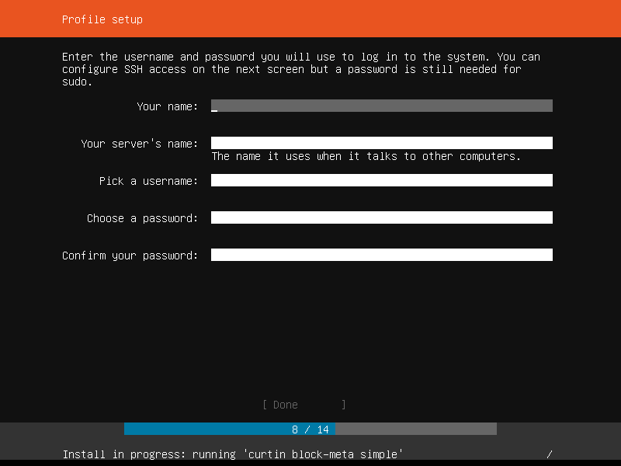

Fill in the needed information:
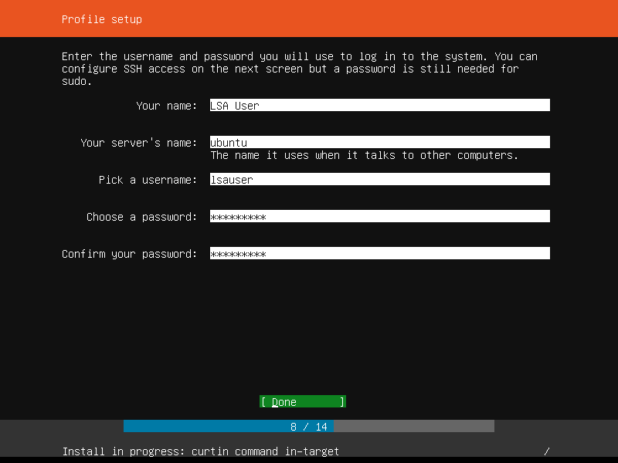
Then select Done and hit the Enter key.
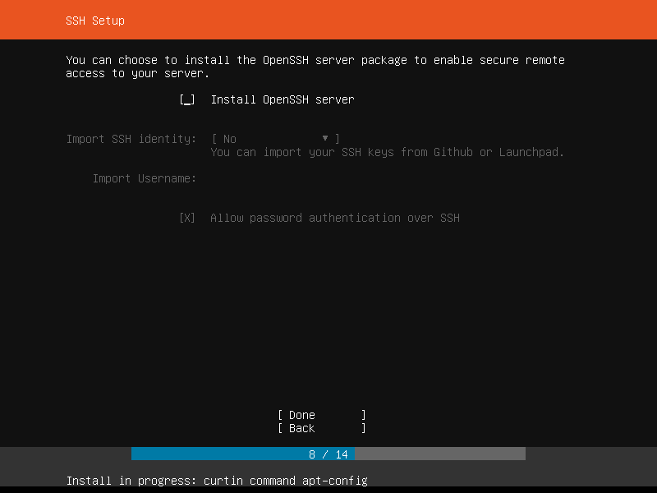
Next, we can choose to install an SSH server which is exactly what we want and need. Select the Install OpenSSH server option.

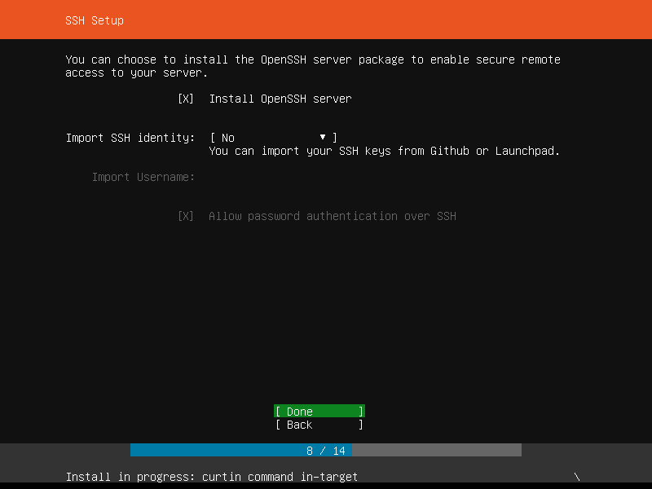
Then select Done and hit the Enter key.
On the next screen, we can select one or more of the proposed prepackaged application to be added to our installation. Currently, we do not want any of those, so we will select Done and then hit the Enter key.
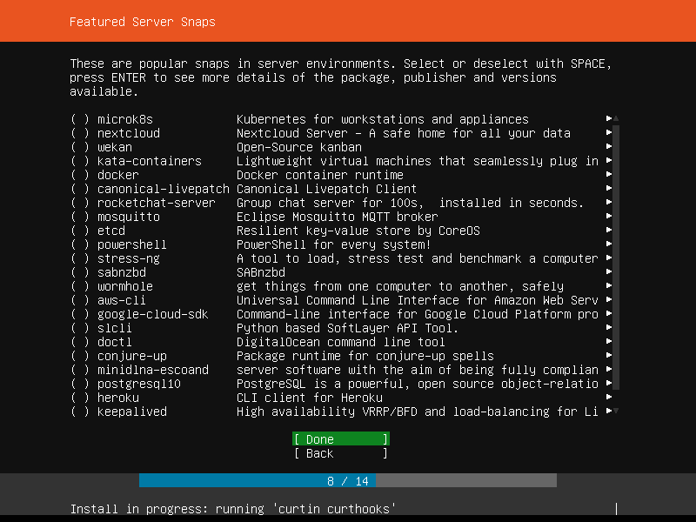

Next screen allows us to monitor the installation progress:
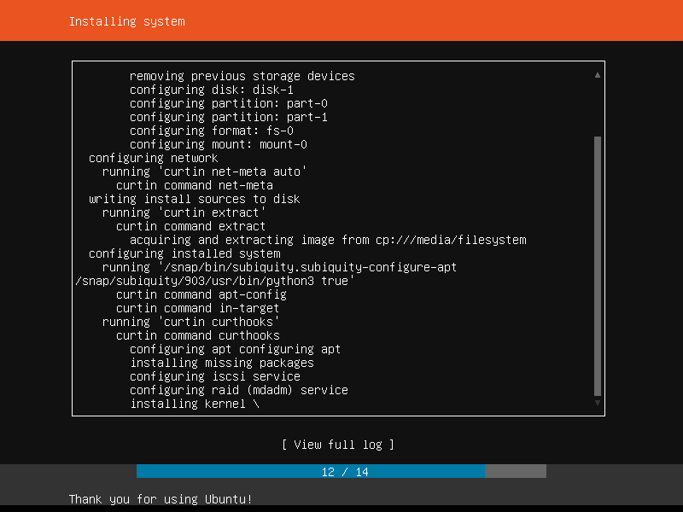
Once the actual installation finishes and option to Cancel update and reboot will appear and it will be selected by default:
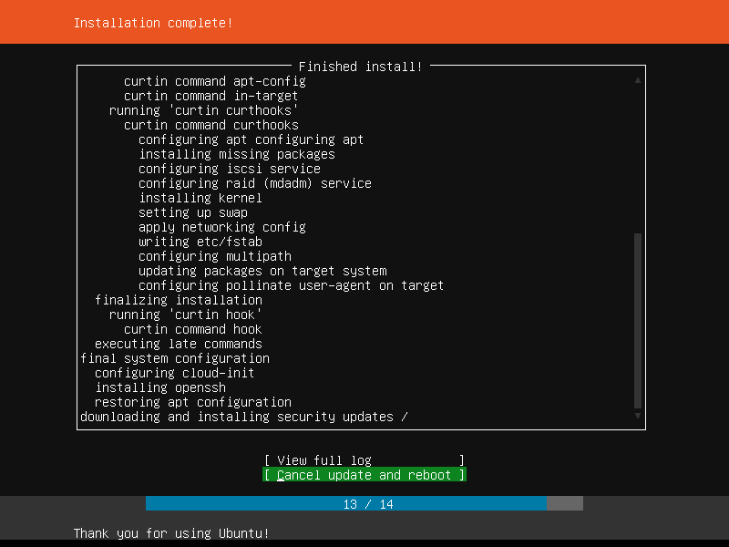
Now, we can hit the Enter key to interrupt the process and reboot or wait a while for the machine to be updated. Let’s wait some time. Once the update process is finished the option will change to Reboot:
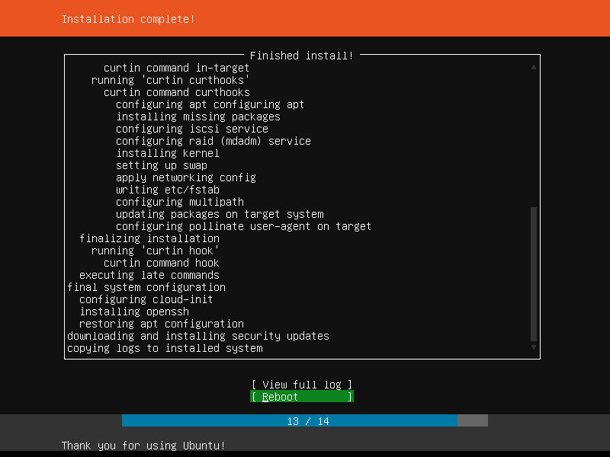
Now, we can hit the Enter key to reboot the system.
The screen will flicker, and text will show up. The installer will try to unmount or eject the installation media. We can check if the media is successfully removed from the machine and if not, remove it manually. Then we must hit the Enter key:
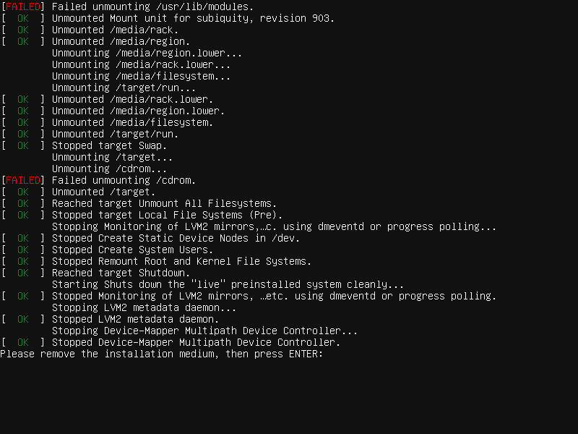

The system will reboot. During the loading process we will observe multiple lines of text (diagnostic or status messages) appearing on the screen:
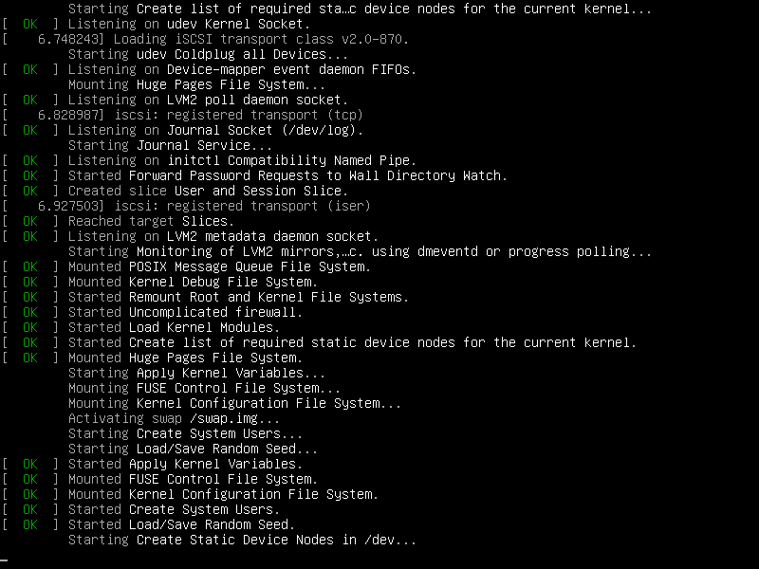
When the loading process is done, we will be presented with the login screen:
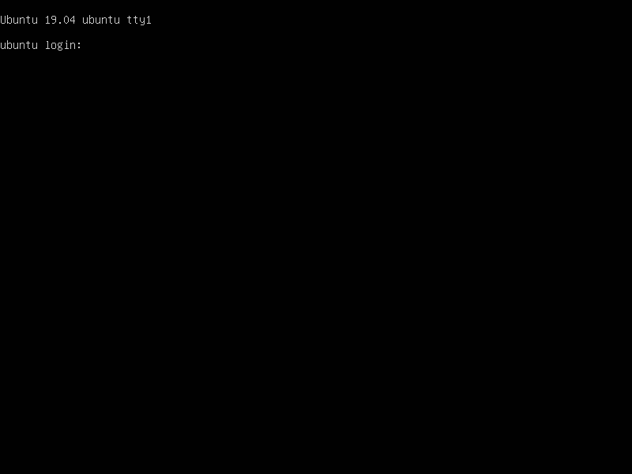
Only one last thing must be done in order to be able to access the VM via SSH. We must create a port forwarding rule. Go to the machine settings and select Network, then on the Adapter 1 section click on Advanced:
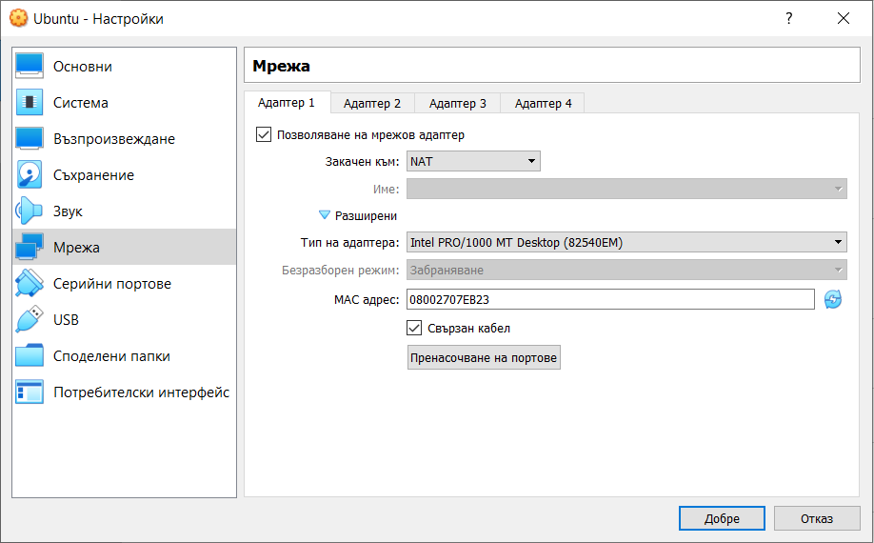
In order to create the rule, we must click on the Port forwarding button. Then we can add a rule with the following sample content:
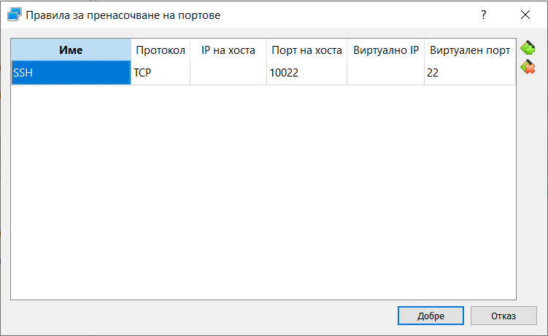
We have to confirm with the OK button.
Please note that the protocol for the SSH service is TCP and the default port on which it operates is 22.
For the Host port we can choose any arbitrary number above 1024 but in general it is safer to put something above 10000. No matter what our choice is, this should be a free port on our host machine. Again, it is safer one host port to be part of one rule for one VM.
Now when using a command line SSH client, the command should look like:
$ ssh -p 10022 lsauser@localhost
And if we use the SCP utility to transfer files via SSH, the command should look like:
$ scp -P 10022 lsauser@localhost:/home/lsauser/some-file.txt .
Please note that port number and user should match what we entered during the installation.

