Guide M1: openSUSE Installation

Conditions
Let’s assume that we have a new VM created with openSUSE profile in VirtualBox and with the following parameters:
- 1 CPU;
- 1024 MB RAM;
- 16 GB HDD with Dynamic Size (or Thin) space policy;
- 1 Network Adapter connected in NAT mode;
- All other virtual hardware and setting with their default values;
For the installation we will use the minimal installation media (openSUSE-Leap-15.1-DVD-x86_64.iso).

Installation Steps
Power on the machine and after a while we will be presented with the initial screen. Here, we can use the arrow keys to move the selection up and down. We must select the second option:
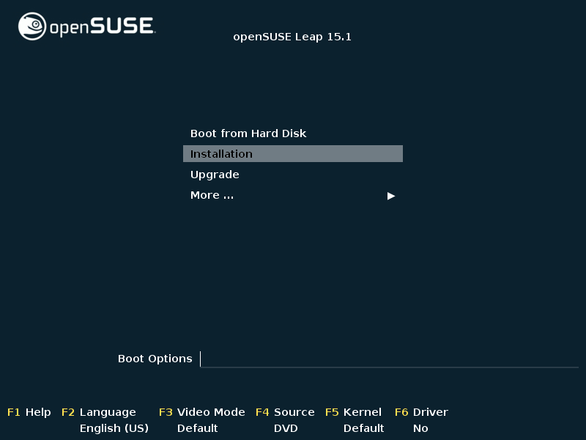

Then hit the Enter key. The VM screen will resize and flicker. Some text messages will start appearing on the screen:
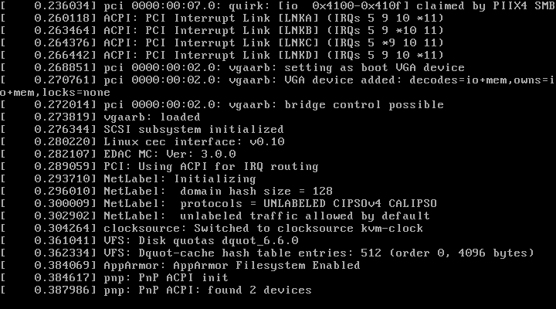

After a while the screen will change to a progress bar showing the loading progression:


Then a graphical part of the setup program will be shown. It will go through the first few steps automatically and will stop on the screen for choosing language, keyboard and license agreement:
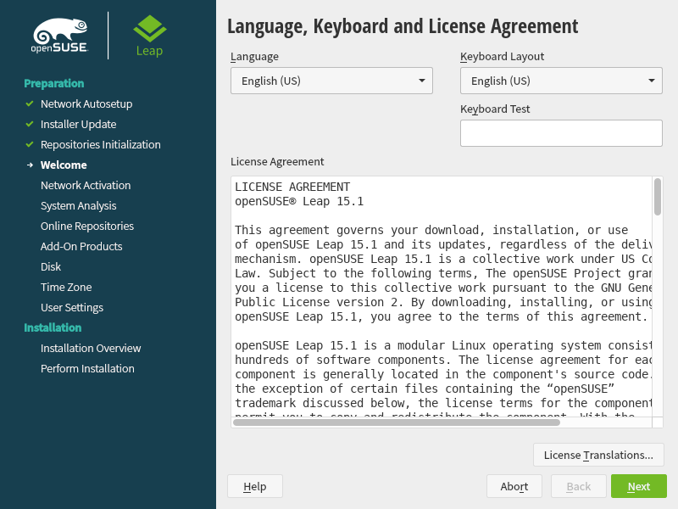
Let’s accept the default language and keyboard (English) and click on the Next button to continue.
Next the setup program will go through the Network Activation and System Analysis steps and will stop on the Online Repositories step with the following question:
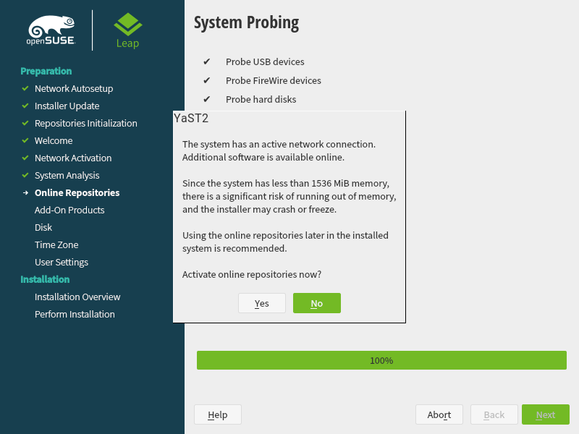
We are being asked if we want to activate the online repositories now. Normally we would like to activate them but with our current setup – having only 1 GB of memory, this is not a good idea as it might affect the system stability and we may end up with frozen system. Click on the No button:
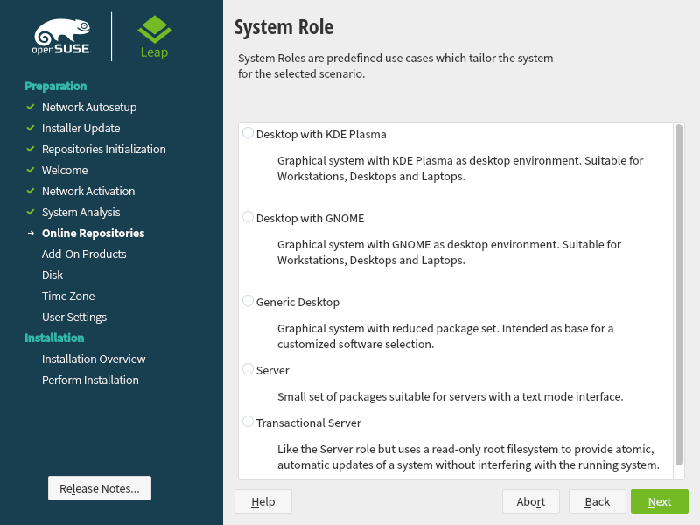
Next, we must choose a profile (role) for our system. Let’s select Server and click on Next.
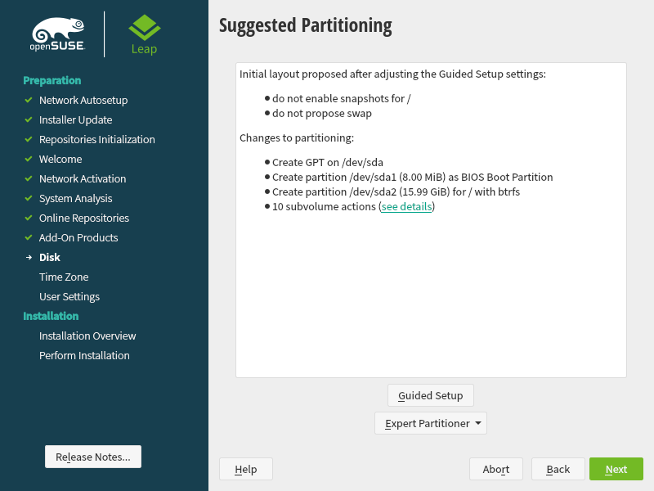
Our next step is to configure the disk layout (partitioning) of our installation. Normally, we would accept the default setup, but as we are tight on resources let’s change it. Click on Guided Setup button:
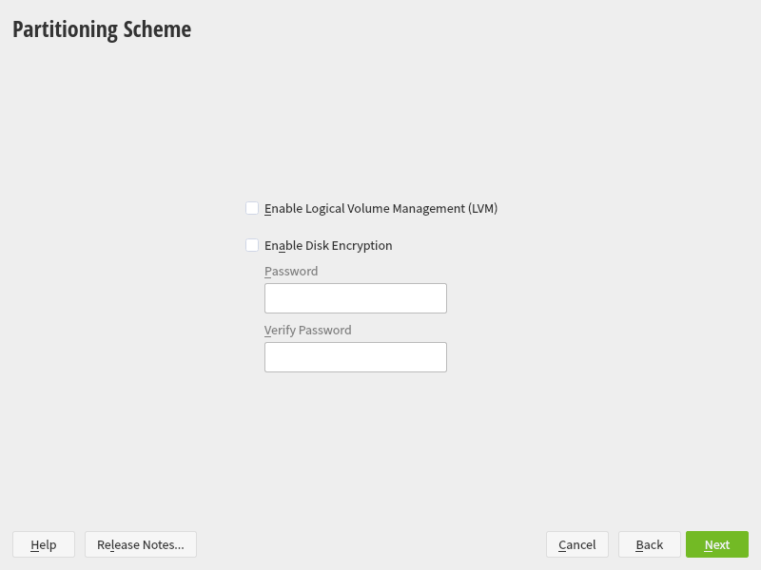
On the Partitioning Scheme step we won’t do any changes. Click Next.
Next, we must change the default file system which normally is BtrFS to something else:
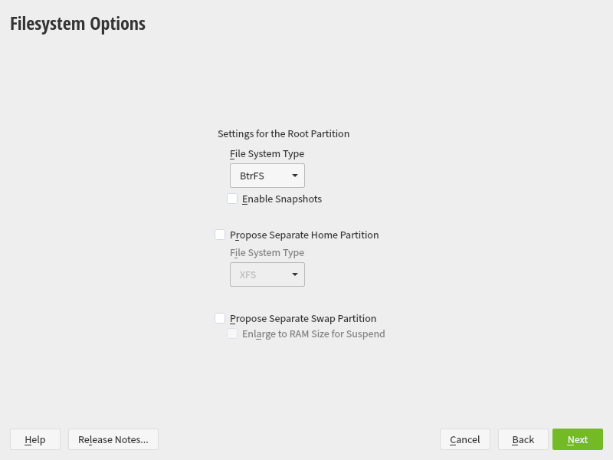
In the drop-down menu select XFS or Ext4. Let it be XFS this time:
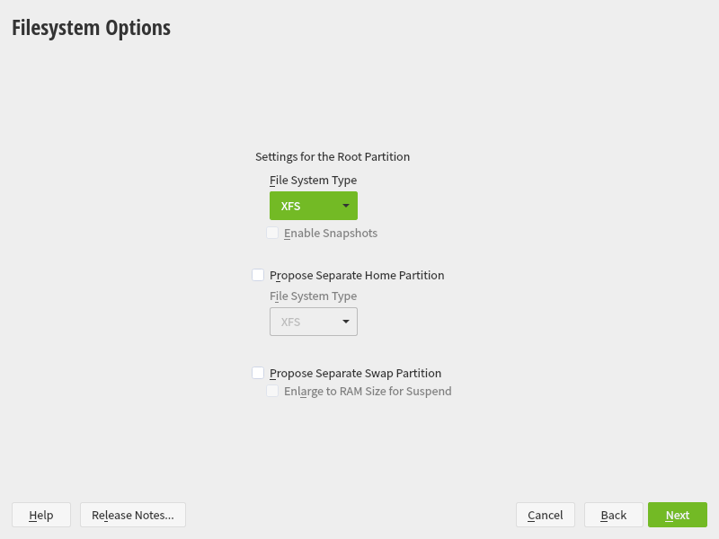
Confirm with the Next button. Now the partitioning summary will show the result of the changes we made:
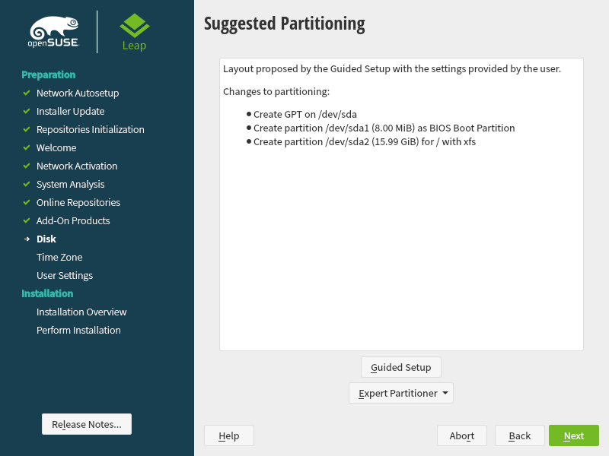
Click Next to move on the next step.
We are prompted with an interface for Clock and Time Zone settings:
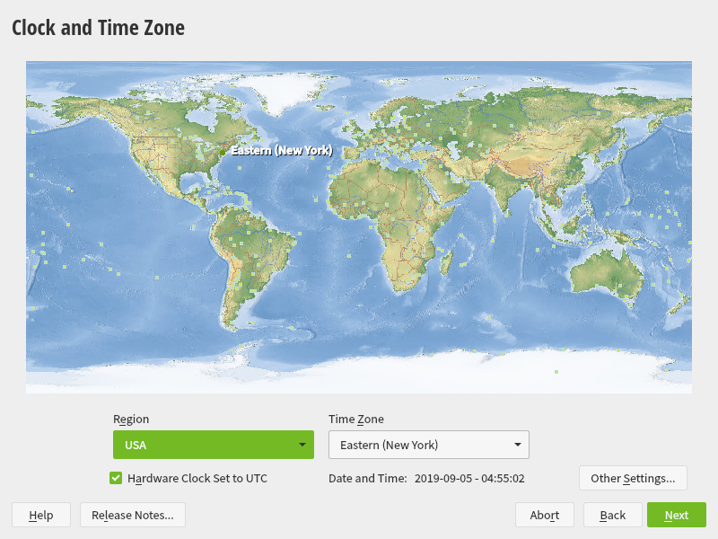
For Region select Europe and for Time Zone select Bulgaria. This can be achieved by using the drop-down lists or by clicking on the map:
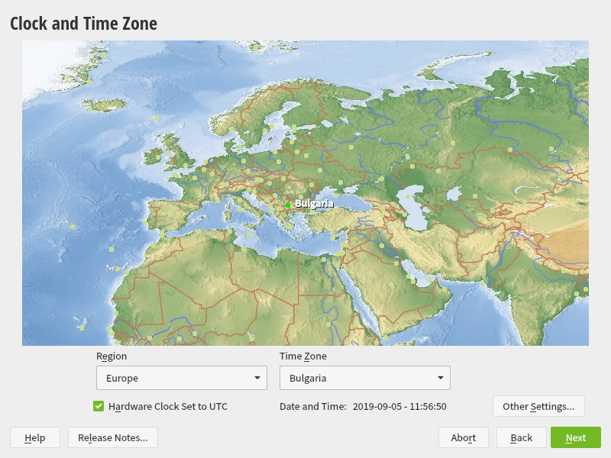
Click on Next to confirm.
Next step of the installation process is about creating a Local User:
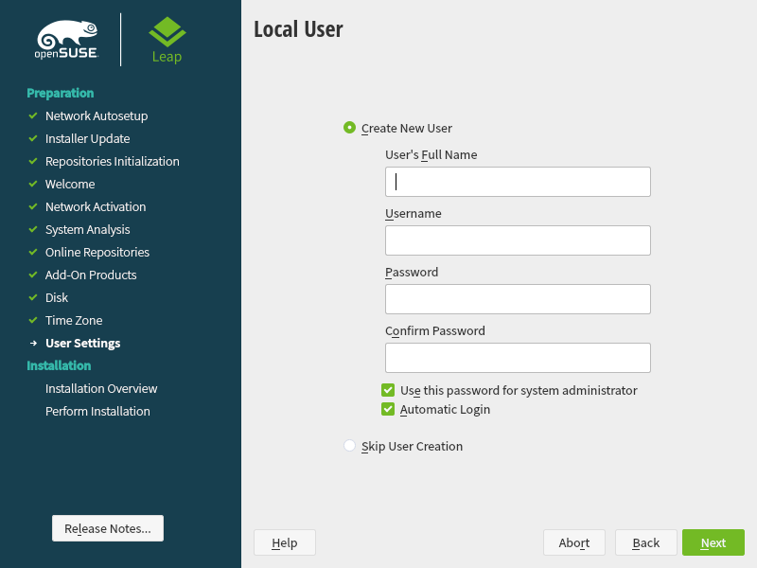
We can skip this step by selecting the Skip User Creation, but this will leave us with only the root user. Because working with the root user is not considered a good practice, we will create a local user. For example, we can enter the following:
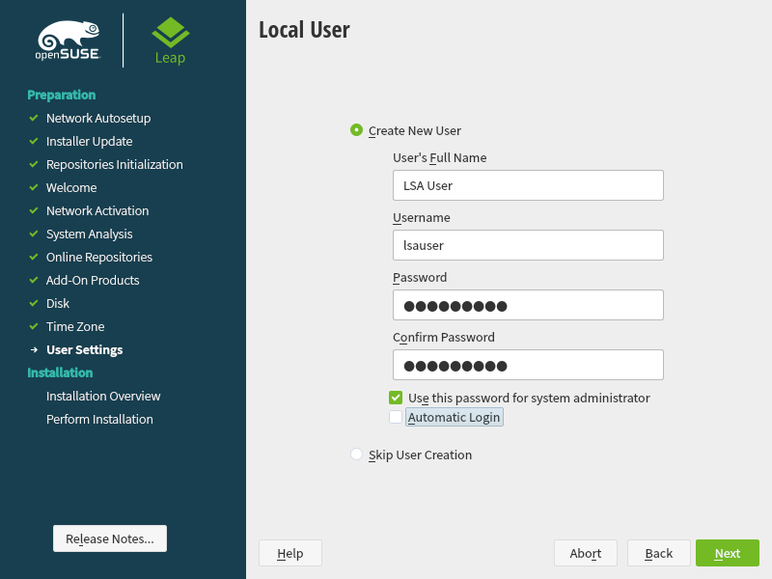
Unselect the Automatic Login option and click on Next.
If we entered a simple password, or a password based on a dictionary (well-known) word, we will be prompted:
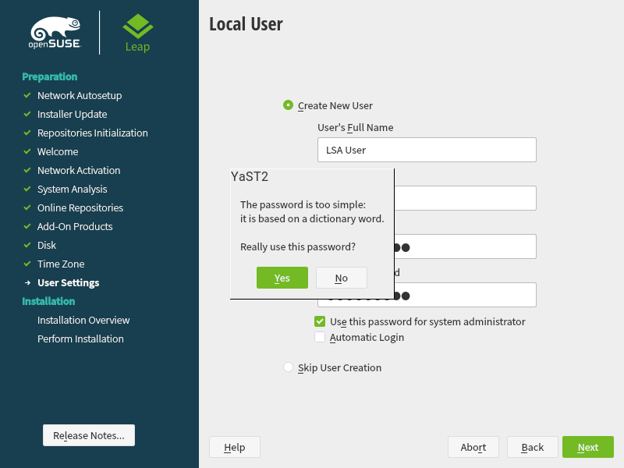
Confirm with Yes. Next, we are presented with the Installation Settings window. Here, we can modify the software selection, security, network configuration and other things:
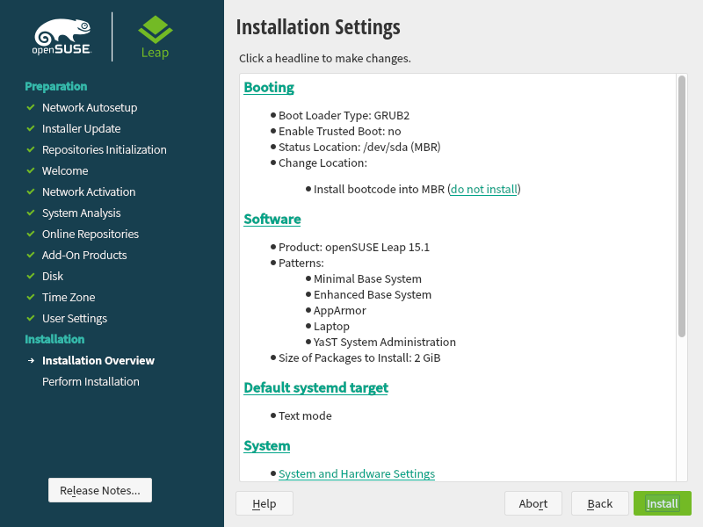
We will accept everything as it is and will click on Install. Then we will be asked for confirmation:
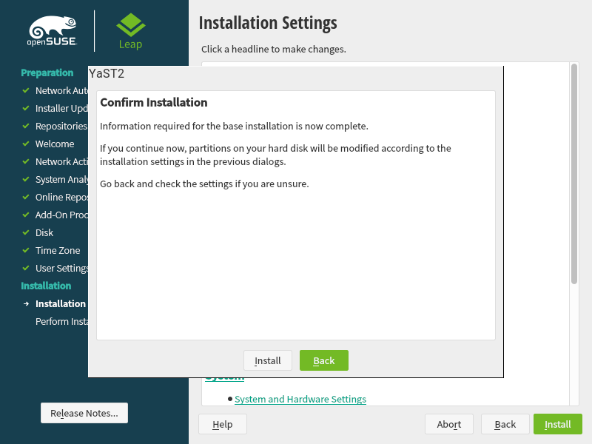
Click on the Install button. Now we can watch the installation progress:
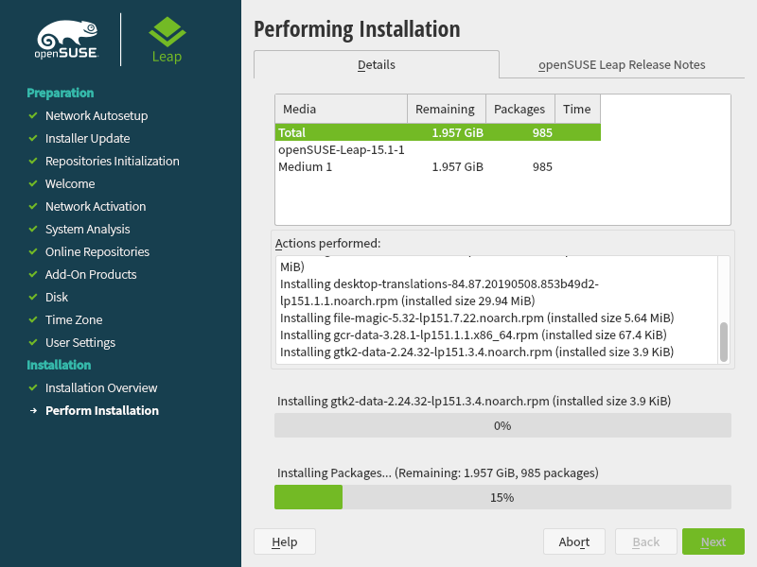

After a while the installation will end, and we will be prompted with dialog box to restart the system. It will wait for 10 seconds and if we do not take any action, the system will restart:
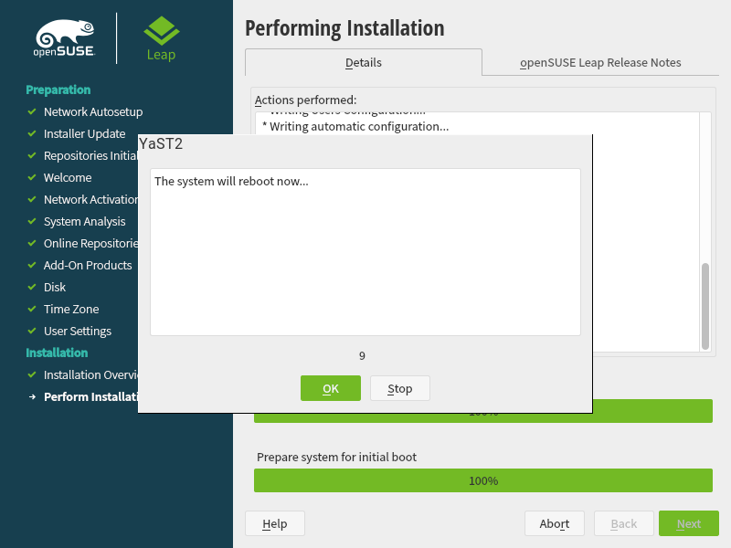
If the installation media is still attached to the VM, we will see the same screen as in the beginning of the process:
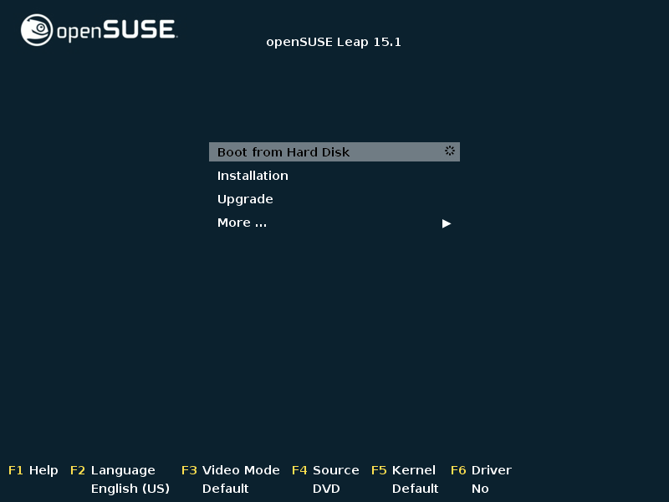
This time, we can either wait, or hit the Enter key in order to boot from the hard disk of the VM. If the installation media was removed before the restart, or the Boot from Hard Disk was initiated we will see this screen, which is the boot manager, showing possible boot options:
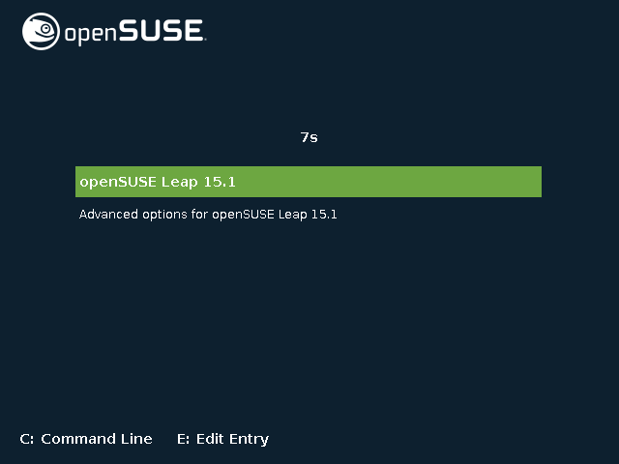
There is option selected by default. We have 8 seconds to change the selection if we want, which we do not, at least not now. Once the time passes or the Enter key is hit, the control is transferred to the OS behind the option selected. We will be presented with a progress bar of the loading process:

When the loading process is done, we will be presented with the login screen:
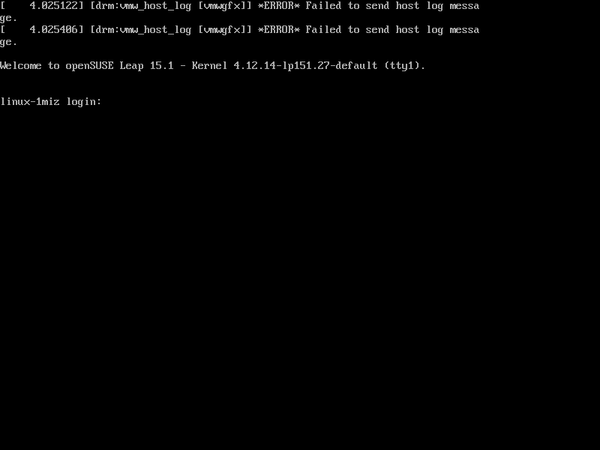
Only one last thing must be done in order to be able to access the VM via SSH. We must create a port forwarding rule. Go to the machine settings and select Network, then on the Adapter 1 section click on Advanced:
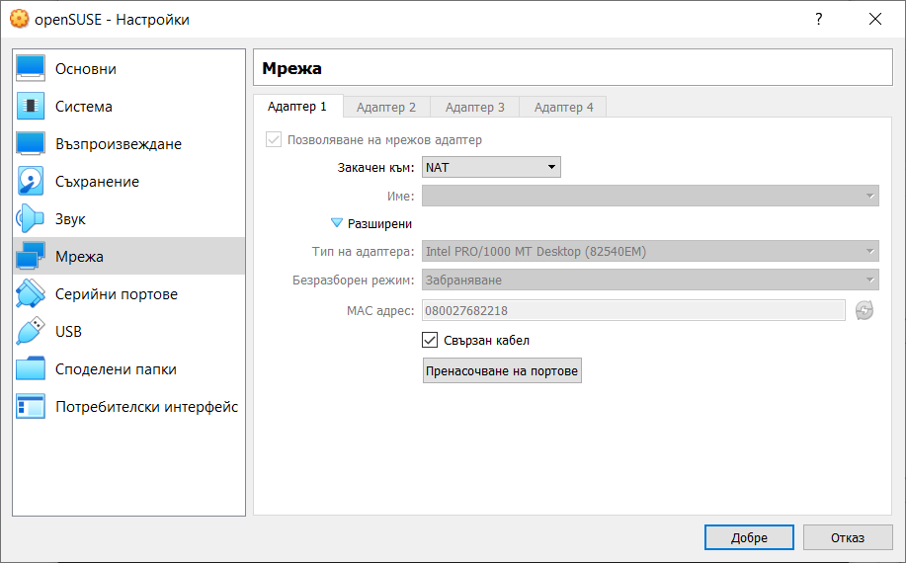
In order to create the rule, we must click on the Port forwarding button. Then we can add a rule with the following sample content:
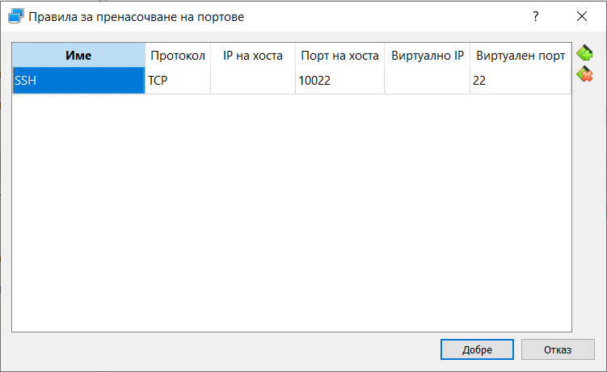
We have to confirm with the OK button.
Please note that the protocol for the SSH service is TCP and the default port on which it operates is 22.
For the Host port we can choose any arbitrary number above 1024 but in general it is safer to put something above 10000. No matter what our choice is, this should be a free port on our host machine. Again, it is safer one host port to be part of one rule for one VM.
Now when using a command line SSH client, the command should look like:
$ ssh -p 10022 lsauser@localhost
And if we use the SCP utility to transfer files via SSH, the command should look like:
$ scp -P 10022 lsauser@localhost:/home/lsauser/some-file.txt .
Please note that port number and user should match what we entered during the installation.

