Homework M4: Network. Software. Services
For a successful completion of the tasks you should have at least one server and one client configured according to the class practice. Should you have any questions about its setup, do not hesitate to contact me or your colleagues.
You must create a small environment, separate from the one you are working in class. The environment should consist of one VM (name it rila.lsa.lab) with two network adapters and another one (name it pirin.lsa.lab) with just one network adapter. More or less the environment should look like this:
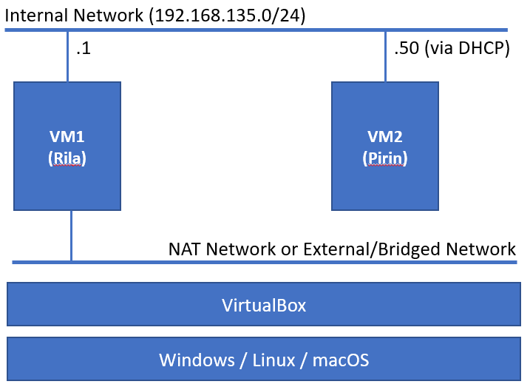
Pick two different (from different families) distributions.
The following tasks must be performed on the Rila host:
- Set one of the network cards with static IP 192.168.135.1/24 (and in the same virtual network as the only card of the other VM).
- Install and configure DHCP with range from 192.168.135.50 – 192.168.135.99
- SSH service installed and running
- Firewall up and running, and allowing SSH connections
- Enabled NAT functionality, so the internal station can have access to Internet
The following tasks must be performed on the Pirin host:
- Make sure that the network adapter is set to get its IP address via DHCP
- Installed and running FTP server
- SSH service installed and running
- Firewall up and running, and allowing SSH and FTP connections
- Access to Internet (for example ping to distrowatch.com)

Proof
Upload a document (txt, doc, docx, pdf) containing the commands that you executed in order to accomplish the above tasks.

