53. 有關 Campylobacter infection，下列何者為非？
A. 在先進國家，Campylobacter infection 最常見在幼兒時期與年輕的成人 (15–44 歲)。
B. Campylobacter 造成急性腸炎，平均潛伏期 3 天。三分之一的病人可能先有發燒、頭痛、頭暈與肌肉痠痛；1–3 天後出現絞痛合併水瀉，較少見有黏液血絲便。
C. 感染後可能出現 erythema nodosum 的皮膚病灶。
D. 培養 Campylobacter 需使用特殊培養基，例如 CAMPY-agar，生長環境 5–10% oxygen、1–10% carbon dioxide、with some hydrogen，C. jejuni 在 37°C 生長最好。
E. 使用抗生素治療建議用在有血便、高燒、病情嚴重與免疫抑制或有 underlying diseases 的兒童，首選藥物為 azithromycin。

答案：D

- 正確
Mandell, Douglas, and Bennett's Principles and Practice of Infectious Diseases, Tenth Edition, Chapter 221 p. 2641：
Based on current estimates, there are probably more than 2 million Campylobacter infections annually in the United States, although there is great geographic variability in incidence rates, even within the United States. Population-based studies show peak incidence in children younger than 1 year and in people 15 to 29 years old.
- 正確
Uptodate - Campylobacter jejuni infection：
Incubation period — The typical incubation period is three days (range one to seven days)
A prodromal period occurs in about one-third of cases; manifestations include high fever accompanied by rigors, generalized aches, dizziness, and delirium. It may last for one day (rarely two or three days) prior to onset of gastrointestinal symptoms.
Signs and symptoms of intestinal infection include abrupt onset of abdominal pain, cramping, diarrhea, and fever. In about 15 percent of patients, bloody stools are observed on the second or third day of diarrhea.
- 正確，過去有多篇文獻報導：
Campylobacter enteritis and erythema nodosum. Lancet. 1982;1(8286):1409.
Campylobacter colitis associated with erythema nodosum. BMJ. 1982;285(6346):937.
- 錯誤
Uptodate - Campylobacter jejuni infection & Mandell, Douglas, and Bennett's Principles and Practice of Infectious Diseases, Tenth Edition, Chapter 221 p. 2639：
Ideally, culture is performed using selective media, such as CAMPY-agar and incubation in a gas mixture of 5 to 10 percent oxygen, 1 to 10 percent carbon dioxide, ideally some hydrogen and are thus considered microaerophilic. All campylobacters grow at 37°C; however, C. jejuni grows best at 42°C. Because C. jejuni is the most common enteric pathogen of humans, many laboratories have used incubation at 42°C for optimal isolation.
- 正確
Uptodate - Campylobacter jejuni infection：
We suggest antibiotic therapy for patients with severe disease or at risk for severe disease. Patients with severe disease include those with bloody stools, high fever, extraintestinal infection, worsening or relapsing symptoms, or symptoms lasting longer than one week. Patients at risk for severe disease include those who are pregnant, immunocompromised, or ≥70 years of age. For patients with Campylobacter infection who warrant treatment, we suggest azithromycin.

54. 有關人類乳突病毒 (human papillomavirus, HPV) 描述，下列何者為非？
- 人類乳突病毒感染造成生殖道疣，其中 90% 是由 types 6 和 11 造成。
- 子宮頸癌約 70% 由高危險型 Types 16 和 18 造成；另外 types 31, 33, 45, 52, 和 58 也是高危險型，造成約 20% 的子宮頸癌。
- 將近 90% 男性的肛門癌由 type 52 和 58 造成，所以建議男性也應施打人類乳突病毒疫苗。
- 人類乳突病毒疫苗 Gardasil-9 含九個型別，分別是 6, 11, 16, 18, 31, 33, 45, 52, 和 58，而人類乳突病毒疫苗 Gardasil 可預防四種型別的人類乳突病毒感染 (6, 11, 16, 和 18)。
- 若在 9 到 14 歲之間施打，須施打三劑；若在 15 歲之後施打只須施打兩劑。
A. 1+3+5
B. 2+4
C. 2+3+4
D. 3+4
E. 3+5
答案：E

Mandell, Douglas, and Bennett's Principles and Practice of Infectious Diseases, Tenth Edition, Chapter 143 p. 1916：
- HPV types 1, 2, and 4 are the most common types found in cutaneous warts.
- HPV types 6 and 11 account for most genital warts.
- HPV types 16 and 18 cause the great majority of cancers of the anogenital tract and oropharynx and are defined as high-risk oncogenic.

- 正確
- 正確
The distribution and differential risks of human papillomavirus genotypes in cervical preinvasive lesions: A Taiwan Cooperative Oncologic Group Study. Int J Gynecol Cancer. 2006;16(5):1801-1808.
在台灣有子宮頸癌的病患中，有HPV16及18型的佔所有子宮頸癌病患的71.4%，HPV52及58型佔有28.5%，比例與全球流行病學相近。
- 錯誤，多數仍為Type 16、18

擷取自台大醫院藥劑部的整理：
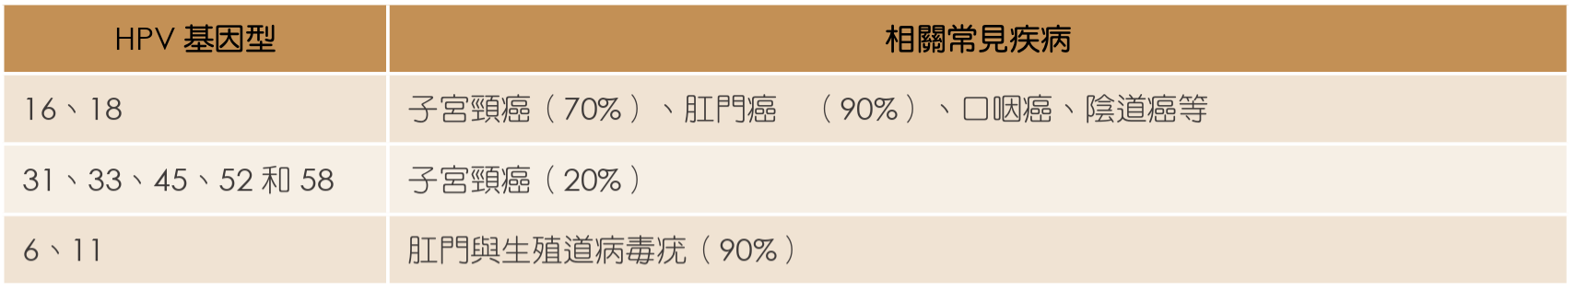
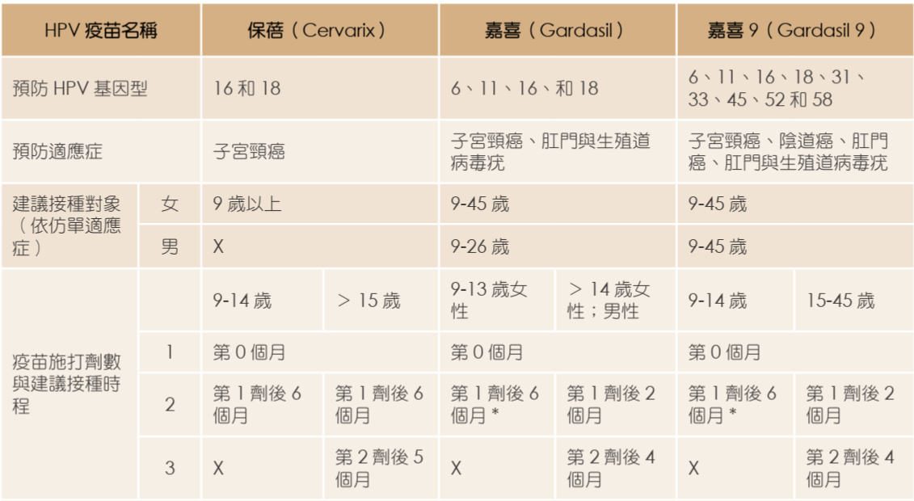
- 正確
- 錯誤，相反

55. 有關 Pharyngoconjunctival fever 的描述，以下何者不正確？
A. 臨床特徵包括高燒、咽喉炎、非膿性結膜炎、耳前與頸部淋巴腺炎等
B. 最常見的病原是 adenoviruses，偶爾 enteroviruses 感染也會有類似的表現
C. 標準的治療是 penicillin 使用 7 天，因為常常會合併 group A Streptococcus 感染
D. 傳染力強，有時會透過未過濾當消毒的游泳池爆發流行
E. 腺病毒引起的 pharyngoconjunctival fever 有時可併發肺炎，特別是在年幼的兒童或免疫系統較弱的患者中

答案：C

Mandell, Douglas, and Bennett's Principles and Practice of Infectious Diseases, Tenth Edition, Chapter 142 p. 1910-1911：
Pharyngoconjunctival fever is a common syndrome consisting of benign follicular conjunctivitis, fever, pharyngitis, and cervical adenitis, commonly caused by adenovirus types 3 and 7. It is a common sporadic illness in children and has also been associated with outbreaks in children’s summer camps, swimming pools, and lakes.
Several adenovirus types, including 1 to 5, 7, 14, and 21, can cause pneumonia in children and may occasionally result in sequelae such as bronchiectasis. Certain
subgroup B adenoviruses (3, 7, 14, and 21) have been associated with severe and complicated pneumonias, particularly in infants. Adenoviruses have also been identified as the cause of community-acquired pneumonia (CAP) in children, with up to 15% of children younger than 5 years with CAP requiring hospitalization.

- 正確
- 正確
急性出血性結膜炎：致病病毒為克沙奇病毒A24型、腸病毒70型以及腺狀病毒。症狀呈現眼腫痛、分泌物增加、結膜炎下出血等，發病快，持續數天(通常不超過一週)。
- 錯誤
Pharyngoconjunctival fever主要由腺病毒引起，不建議使用抗生素治療，除非有明確證據顯示合併細菌性感染（如GAS咽炎），否則抗生素無效且不應濫用。目前沒有任何學會或臨床指引建議對咽結膜熱常規使用青黴素。
- 正確
- 正確

56. 有一3個月大嬰兒因發燒、活動力下降、與抽筋等症狀前來就醫。抽血發現白血球上升、CRP上升，腦脊髓液檢查發現白血球增加(pleocytosis) ，且90%是segmented neutrophils，另於Gram stain發現有Gram(+) coccus。以下敘述何者為真？
A. 最可能是Haemophilus influenzae或Streptococcus pneumoniae腦膜炎
B. 起始經驗性用藥使用Vancomycin加Ceftriaxone是合理的，但知道是Gram(+)以後，就可以把ceftriaxone停掉
C. 若培養確認是Streptococcus pneumoniae，應注意Penicillin MIC。若Penicillin MIC為0.12μg/mL，則可以繼續使用penicillin治療
D. 類固醇在兒童Streptococcus pneumoniae腦膜炎的角色仍不明確
E. 接種卡介苗是預防肺炎鏈球菌感染最有效的方法

答案：D
詳解：
- 題幹敘述提及Gram stain發現有Gram(+) coccus，而Haemophilus influenzae是Gram(-) bacillus，故本選項錯誤
- 知道是Gram(+)以後，就可以把ceftriaxone停掉這句話是錯誤的。
2016 ESCMID guideline: diagnosis and treatment of acute bacterial meningitis. http://dx.doi.org/10.1016/j.cmi.2016.01.007
各年齡層細菌性腦膜炎經驗性抗生素選擇，依各地區Streptococcus pneumoniae對penicillin抗藥狀況提供選擇建議
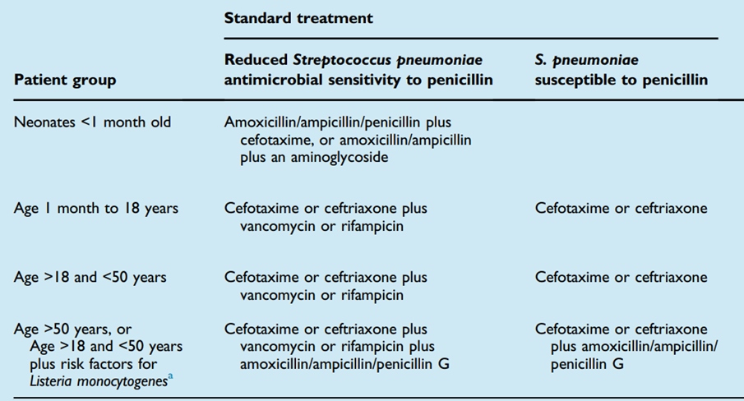
針對特定細菌腦膜炎的抗生素治療
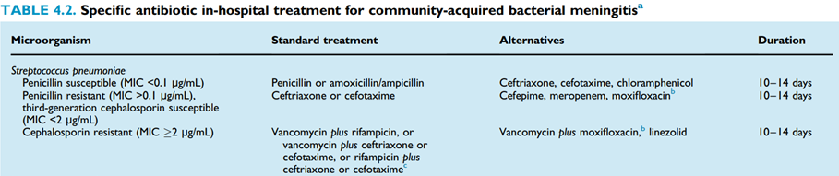
Mandell, Douglas, and Bennett's Principles and Practice of Infectious Diseases, ninth Edition, Chapter 87 p. 1211：
Penicillin can never be recommended as empirical therapy in patients with suspected pneumococcal meningitis. As an empirical regimen, the combination of vancomycin plus a third-generation cephalosporin (either cefotaxime or ceftriaxone) is recommended, although UK and ESCMID guidelines recommend use of a third-generation cephalosporin alone in countries where the prevalence of cephalosporin-resistant pneumococcus is <1%.
The concomitant administration of dexamethasone and the subsequent decreased inflammation and poor entry of vancomycin into CSF may have contributed to negative outcome. Data supports the concept that vancomycin should not be used alone for the treatment of pneumococcal meningitis.
Third-generation cephalosporins have been considered the treatment of choice in pneumococcal meningitis caused by strains that are of intermediate susceptibility to penicillin.
- CLSI M100 ED35關於Streptococcus MIC判讀標準如下：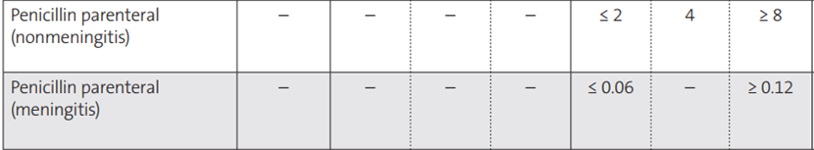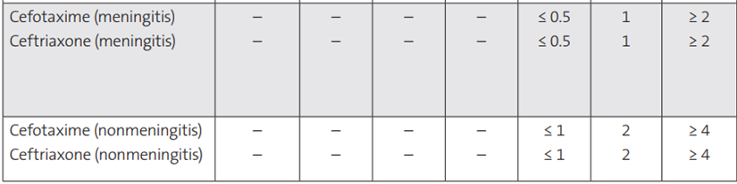
SANFORD GUIDE Antimicrobial Therapy:
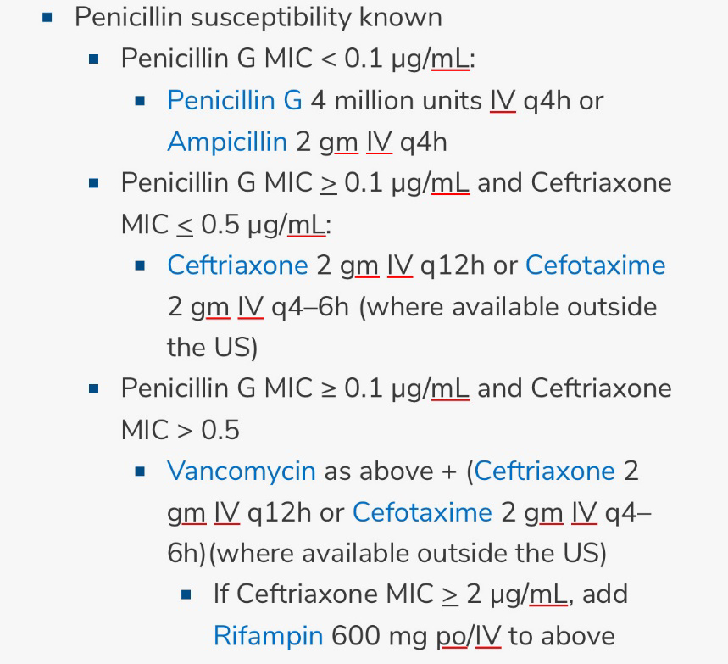
- 正確
Mandell, Douglas, and Bennett's Principles and Practice of Infectious Diseases, ninth Edition, Chapter 87 p. 1207：
A retrospective, nonrandomized study of children with pneumococcal meningitis, published after the meta-analysis, demonstrated that the use of adjunctive dexamethasone was not associated with a beneficial effect, although the dexamethasone was administered before or within 1 hour of the first dose of antibiotic and the children in the dexamethasone group had a higher severity of illness. In addition, in a published double-blind, placebo-controlled trial of adjunctive dexamethasone in Malawi, the overall number of deaths in the two treatment groups was similar (31% in each group), as was the frequency of neurologic sequelae.
Nelson Textbook of Pediatrics, 21 edition, chapter 621, corticosteroid part:
Pediatric data regarding benefits, if any, of corticosteroids in the treatment of meningitis caused by other bacteria remain inconclusive.
- 卡介苗針對的是disseminated TB與TB meningitis，對象並不是肺炎鏈球菌。此處應更正為PCV13/PCV15/PCV20。PPV23不適用於孩童。肺炎鏈球菌腦膜炎屬於侵襲性肺炎鏈球菌感染，為第四類法定傳染病，應於一周內通報。
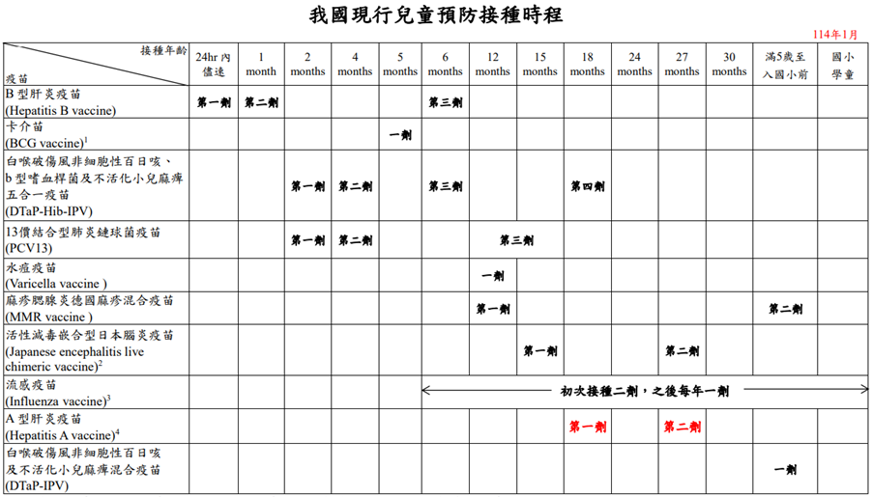

57. 當新生兒或早產兒COVID-19確診需要非侵襲性呼吸治療時，哪一種方法通常較為優先考慮，因為他能提供較為穩定的PEEP？
A. High flow nasal cannula oxygen(HFNC)
B. Continuous positive airway pressure(CPAP)
C. Non-rebreathing mask(NRM, 高流速氧氣設備)
D. Bi-level positive airway pressure(BIPAP)
E. 甦醒球擠壓換氣(Ambu bagging)
答案：B
詳解：
新生兒或早產兒最常使用的非侵襲性呼吸器為HFNC/CPAP。
臺灣兒科醫學會、臺灣新生兒科醫學會、臺灣兒童感染症醫學會共識發表。對於確診/懷疑COVID-19母親之新生兒的照護注意事項第一版。
鼻式持續性氣道正壓/非侵襲性正壓換氣（NCPAP/NIPPV）：依呼吸治療常規流程處置，建議使用拋棄護措施時，以置放氣管內管連接呼吸器照護，也是合理可接受的選擇。式管路，並於管路吐氣端加裝過濾器，照護時醫護人員要穿著完整裝備（包含N95、護目鏡），並維持室內換氣良好、鼻管適當密合、環境適當消毒。若裝備不足或無法信賴防
避免使用加濕加熱高流量氧氣鼻管（Heated humidified high flow nasal cannula, HHHFNC）。

58. 有關Haemophilus influenzae的敘述，以下何者正確？
A. 在有效的Hib接合型疫苗問世以前，non typeable Haemophilus influenzae是兒童嚴重Haemophilus influenzae感染的主要型別
B. 侵襲性Haemophilus influenzae感染，主要發生在5-15歲的兒童與青少年
C. 大部分ampicillin-resistant Haemophilus influenzae是經由分泌β-lactamase產生抗藥性。但是近年有 β-lactamase-negative ampicillin-resistant Haemophilus influenzae，其機轉是透過penicillin binding protein的突變
D. 近年的研究發現dexamethasone並不能減少Haemophilus influenzae meningitis造成的聽力異常
E. Haemophilus influenzae的治療，首選用藥是macrolide類抗生素

答案：C
詳解：
- Haemophilus influenzae type b為Hib疫苗問世之前兒童嚴重Haemophilus influenzae感染的主要型別
Mandell, Douglas, and Bennett's Principles and Practice of Infectious Diseases, ninth Edition, Chapter 225 p. 2744：
Before the widespread use of conjugate vaccines, type b strains colonized the nasopharynx of children at a rate of 2% to 4%. The rate of nasopharyngeal colonization by type b strains has decreased substantially with the use of conjugate vaccines to prevent invasive infections caused by H. influenzae type b.
- 台灣侵襲性Haemophilus influenzae感染主要發生在5歲以下孩童
CDC 侵襲性b型嗜血桿菌感染症防治工作手冊_1070911.pdf
侵襲性B型嗜血桿菌感染症屬於第三類法定傳染病，應於一周內通報。
由Hib引起之侵襲性疾病好發於3個月至3歲之嬰幼兒，很少發生於5歲以上的兒童，超過一半以上的病例為1歲以下的嬰兒，而引起急性會厭炎的好發年齡在2～4歲小孩。
- 正確
Mandell, Douglas, and Bennett's Principles and Practice of Infectious Diseases, ninth Edition, Chapter 225 p. 2748：
Overall, approximately 30% of nontypeable strains produce β-lactamase. Mutations in the fts1 gene, which codes for penicillin-binding protein 3, is a more recently recognized mechanism of resistance in H. influenzae and H. haemolyticus isolates. This mechanism is common in Japan and increasing in prevalence in Europe. Although it is still uncommon in the United States, careful vigilance will be important.
- 教科書結論使用dexamethasone治療Haemophilus influezae type b meningitis可以減少聽力損失
Mandell, Douglas, and Bennett's Principles and Practice of Infectious Diseases, ninth Edition, Chapter 87 p. 1207：
One meta-analysis of these clinical studies confirmed the benefit of adjunctive dexamethasone (0.15 mg/kg every 6 hours for 2–4 days) for H. influenzae type b meningitis and, if begun with or before parenteral antimicrobial therapy, suggests benefit for pneumococcal meningitis in childhood. Evidence of clinical benefit was strongest for improved hearing outcomes.
Nelson Textbook of Pediatrics, 21 edition, chapter 621, corticosteroid part:
In a Cochrane review of using steroids in meningitis treatment, steroids reduced hearing loss in children with meningitis due to H. influenzae type b but not due to other pathogens.
- Macrolide並非首選，台灣兒童感染症醫學會兒童社區肺炎處置建議將其列為alternative treatment。
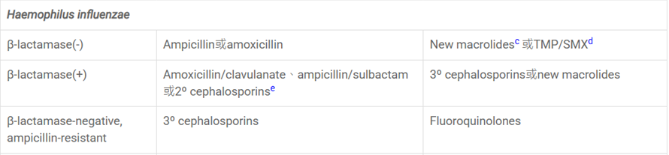
熱病關於Haemophilus influenzae Primary regimens的建議：
