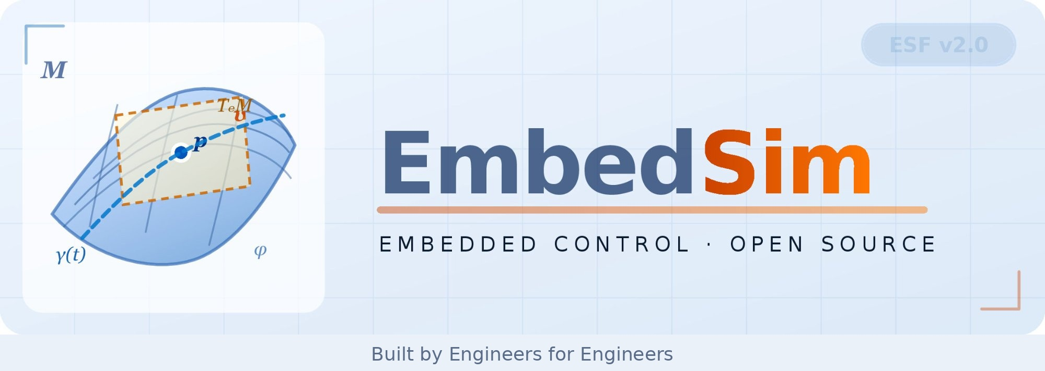
EmbedSim Thesis Guide for AI Students
Fast Read

Abstract
This document introduces an AI-focused thesis project based on the EmbedSim motor simulation framework. The goal is not to learn motor control in depth, but to apply Artificial Intelligence techniques to optimize a real-world dynamic system. Students will explore optimization, surrogate modeling, and data-driven decision-making.

1. Introduction

Modern engineering systems are complex and nonlinear. Traditional methods struggle to optimize them efficiently. Artificial Intelligence provides tools to explore, learn, and optimize such systems. This thesis uses a motor simulation as a case study to demonstrate how AI can be applied to real-world control problems.

2. Problem Formulation

The system is a simulation of a motor controller. The controller is defined by three parameters (gains). Each set of parameters produces a measurable performance score (cost). The objective is to minimize this cost using intelligent search strategies.

3. Why AI is Needed

Each simulation run is computationally expensive. Exhaustive search is not feasible. AI methods allow us to learn from a small number of simulations and predict outcomes for new parameter sets. This dramatically reduces computation time while improving results.

4. System Overview

The system consists of:
– A simulation environment (motor + noise + load)
– A controller with 3 tunable parameters
– A cost function measuring performance
– An AI tuner that searches for optimal parameters

5. Baseline Method

The baseline tuner uses:
– Latin Hypercube Sampling (exploration)
– Neural Network surrogate model (learning)
– Gradient-based optimization (search)
– Final verification using simulation

6. Student Tasks

Students are expected to:
– Run and understand the baseline system
– Modify one component (sampling, model, or cost function)
– Evaluate improvements quantitatively
– Document results and reasoning

7. Possible Improvements

A) Replace random sampling with Bayesian Optimization
B) Improve neural network architecture or training
C) Add robustness across different operating conditions
D) Extend cost function to include transient behavior

8. Evaluation Metrics

Performance is evaluated using:
– Speed accuracy
– Energy efficiency (current usage)
– Noise robustness
– Stability under disturbances

9. Expected Outcomes

Students will produce:
– Improved tuning algorithm
– Comparative results (baseline vs improved)
– Visualizations (plots, convergence curves)
– A written thesis explaining the approach

10. Learning Outcomes

Students will gain experience in:
– Optimization of real systems
– Machine learning for regression
– Working with simulations
– Engineering problem-solving

11. Conclusion

This project bridges AI and engineering. It provides a practical way to apply AI methods to physical systems, preparing students for modern interdisciplinary challenges.

EmbedSim · Embedded Control · Open Source · github.com/vectorsim/embed_sim_project

