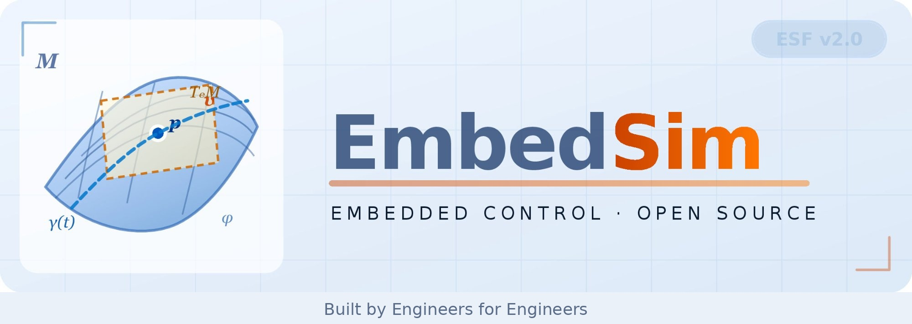
5-Phase SRM Drive · Tuk-Tuk Feasibility Study
Student Lab Guide · Fast Read · OpenModelica + EmbedSim

Motor | 5-Phase 10/8 SRM — no rare-earth magnets
Vehicle | GVW 637 kg │ target 45 km/h
Power | 4.5 kW peak │ 48 V DC bus (touch-safe LiFePO₄)
Sensor | Resolver → RDC → angle & speed feedback
Plant | OpenModelica model exported as FMU 2.0
Simulation | EmbedSim Python framework (FmuBlock + VectorBlocks)
Controllers | PI (baseline) → Sliding Mode → Differential Flatness
Code output | MISRA C:2012 generated by EmbedSim CodeGen
Process | V-Model development lifecycle

Abstract
Build and simulate a complete SRM motor drive for a Sri Lankan three-wheeler. Labs 0–6 take you from a hand-calculation feasibility study through OpenModelica physical modelling, FMU export, EmbedSim closed-loop simulation, PI and sliding-mode controllers, and V-Model traceability to embedded C code generation on AURIX TC3xx.

Lab 0 Feasibility Study — Does an SRM Work for a Tuk-Tuk?

Before any design: derive minimum motor power and torque from real vehicle data. This is the System Requirements level of the V-Model. Every number is traceable to a physical constraint.

Three resistive forces to calculate:
– F_roll = C_rr × m × g (rolling resistance — constant with speed)
– F_aero = 0.5 × ρ × CₙA × v² (aerodynamic drag — grows as v²)
– F_grade = m × g × sin(arctan(i)) (hill climb — grade i = 0.15 for 15%)
– F_accel = m × a (Newton’s second law for the acceleration phase)

Four operating conditions to verify (worst-case for each):
– Cruise at 45 km/h flat: F_roll + F_aero(45) → motor shaft torque T_m = T_wheel ÷ (G × η)
– Hill climb at 20 km/h (15% grade): F_roll + F_grade
– Acceleration 0–40 km/h flat: F_roll + F_accel
– Worst case — acceleration on hill: F_roll + F_grade + F_accel

Motor speed at 45 km/h: n_motor = v_max × G ÷ (2π × r_w) × 60 ≈ 2400 RPM. Feasibility passes if cruise and hill-climb power each stay under 4.5 kW individually. Output: a requirements table that becomes the acceptance criteria for Labs 1–5.

BG What Is a Switched Reluctance Motor?

No magnets, no rotor windings — just shaped steel. Torque is produced because magnetic flux always takes the path of least reluctance. When a stator coil fires, the nearest rotor tooth is pulled toward alignment. Five phases, always at least one producing torque — no dead spots.

Phase voltage equation: v = R·i + L(θ)·(di/dt) + i·(dL/dθ)·ω
Phase torque equation: T = 0.5 · i² · dL/dθ (positive when inductance is rising)
Key insight: torque ∝ i². Double the current → four times the torque, but also four times the copper loss. The controller must switch phases at the right angles to keep torque positive and avoid demagnetising during the falling-inductance region.

Lab 1 Build the OpenModelica Phase Model

Build a single SRM phase model in OMEdit. Key parameters: R = 0.045 Ω, L_unaligned = 0.9 mH, L_aligned = 4.5 mH, Nr = 8 rotor poles.

– Task 1.1 — Create SRM_Phase model; declare R, Lu, La, Nr as parameters with SI units
– Task 1.2 — Add inductanceProfile() function: piecewise-linear triangular L(θ) with 8 peaks per revolution (one per rotor pole). Plot L vs θ: should show 8 identical triangles between 0.9 mH and 4.5 mH
– Task 1.3 — Write the phase voltage ODE: v = R·i + L·der(i) + i·(dL/dθ)·ω. Use finite-difference for dL/dθ. Verify: step 48 V at θ = 0.3 rad, ω = 0 → current rises from 0 A

Lab 2 Assemble the Full Motor and Export as FMU

Connect 5 phase models to a rotor mechanics block and export the complete plant as FMU 2.0 for EmbedSim.

– Task 2.1 — Build SRM_Rotor: J·dω/dt = T_net − B·ω, dθ/dt = ω. Parameters: J = 0.010 kg·m², B = 0.002 N·m·s/rad
– Task 2.2 — Assemble SRM_Plant_10_8: 5 phase instances + 1 rotor. Phase angle offsets: 0, 2π/5, 4π/5, 6π/5, 8π/5. Sum all phase torques − T_load to drive rotor
– Task 2.3 — Export FMU 2.0 Co-Simulation from OMEdit. Unzip and verify v_in, T_load, omega_out, theta_out, i_out appear in modelDescription.xml

Lab 3 Open-Loop Test in EmbedSim

Run the plant open-loop with a fixed voltage pattern before adding a controller. FmuBlock wraps the OpenModelica FMU so it behaves like any other EmbedSim block.

– Task 3.1 — Set up EmbedSim project: FmuBlock(‘SRM_Plant_10_8.fmu’, dt=50e-6), SimulationEngine, SimulationLogger
– Task 3.2 — Apply fixed-angle commutation: excitation window 0–0.26 rad, freewheeling 0.26–0.38 rad, demagnetise −0 V otherwise. V_dc = 48 V, T_load = 5 N·m. Expected: 150–200 rad/s (1400–1900 RPM) within 1 s, current pulses 30–50 A
– Task 3.3 — Plot omega_out, all 5 phase currents. Compute torque ripple = (T_max − T_min) / T_mean × 100%. Record — compare to closed-loop result in Lab 5

Lab 4 Add a PI Speed Controller

PI control law: u(t) = Kp·e(t) + Ki·∫e(t)dt, where e = ω_ref − ω_meas. Kp gives immediate response; Ki removes steady-state error. Anti-windup freezes the integrator when the output hits the torque clamp — prevents overshoot on large steps.

– Task 4.1 — Implement SRM_PI_SpeedController(Kp, Ki, T_max=25 N·m). Clamp T_ref to [0, T_max]. Anti-windup: undo last integration step when output is clamped
– Task 4.2 — Wire closed loop: plant.omega_out → pi.omega_meas, pi.T_ref → commutation → plant.v_in. Set ω_ref = 2400 RPM, T_load = 8 N·m
– Task 4.3 — Tune gains. Target: settling < 1.5 s, overshoot < 10%, zero steady-state error. With Kp = 0.05, Ki = 0.5: expect settling ≈ 1.2 s, overshoot ≈ 8%

Lab 5 Sliding Mode Controller and Comparison

Sliding surface: s = eω + c·∫eω dt. The controller switches to push the system onto s = 0 and keep it there. A boundary layer (sat function) smooths the switching to reduce chattering. More robust to load disturbances than PI.

– Task 5.1 — Implement SRM_SMC_SpeedController(J, B, c=20, Ksw=5, phi=0.05). T_eq = feedforward term (J·ω_ref_dot + B·ω + T_load_est). T_sw = −Ksw·sat(s/phi)
– Task 5.2 — Run 3 scenarios with both PI and SMC:
Scenario A — speed step 0 → 2400 RPM, constant load 8 N·m. Measure: rise time, overshoot, settling time
Scenario B — load step 8 → 18 N·m at t = 2 s (tuk-tuk hits a hill). Measure: speed dip (RPM), recovery time
Scenario C — phase 3 dead (v_in[2] = 0). Measure: achieved steady-state speed, torque ripple increase
– Task 5.3 — Reflection: Why does SRM produce torque ripple? What happens with Ksw too small / too large? Effect of missing anti-windup? Resolver resolution at 2400 RPM?
Typical results: SMC gives 30–50% faster disturbance recovery in Scenario B, maintains speed within 50 RPM in Scenario C (PI may drop 150–200 RPM). PI generally has less overshoot in Scenario A with careful tuning.

Lab 6 The V-Model — Where Does Your Simulation Fit?

No simulation in this lab. Map every file you created onto the V-Model — the engineering process standard used in automotive development (ISO 26262, AUTOSAR).

– System level: Lab 0 power worksheet = left side (requirement derivation). Physical tuk-tuk road test = right side (acceptance test)
– Module level: SRM_Phase.mo, SRM_Plant_10_8.mo = left (plant model). Open-loop commutation test = right (first plant verification)
– Component level: PI/SMC gain tuning table = right (controller parameter verification)
– Code level: embedsim_step.c from CodeGen = left (implementation). MISRA checker run = right (code verification)

Task 6.1: Trace two Scenario A/B/C results back to a Lab 0 system requirement. State pass/fail. If fail: identify which block or gain to change.
Task 6.2: List 5 missing verification activities before hardware installation (thermal testing, EMC, resolver calibration, fail-safe behaviour, road test on Sri Lankan roads).
Task 6.3: Why is the FMU plant excluded from CodeGen? What replaces it on AURIX TC3xx? What happens if the C code takes 60 µs when the ISR period is 50 µs?

REF Quick Reference — Key Numbers and Code Patterns

Key numbers to memorise:
– DC bus: 48 V (touch-safe LiFePO₄) │ Peak phase current: 80 A │ Continuous: 45 A RMS
– L_aligned = 4.5 mH │ L_unaligned = 0.9 mH │ Rated speed = 2400 RPM = 251 rad/s
– Rotor pole pitch = 45° (0.785 rad) │ Phase offset = 72° (1.257 rad) │ FMU step = 50 µs
– Vehicle load at 45 km/h ≈ 12 N·m motor shaft torque (GVW 637 kg, flat road)

EmbedSim patterns:
– Load FMU: plant = FmuBlock(‘motor.fmu’, dt=DT)
– Connect blocks: topo.connect(blockA, ‘out_name’, blockB, ‘in_name’)
– Run: engine = SimulationEngine(topo, logger, dt, t_end); engine.run()
– Clip value: x = np.clip(x, lo, hi) │ SMC sat: s/phi if abs(s)<phi else np.sign(s)

OpenModelica patterns:
– Parameter: parameter Real Kp = 1.0 "Description [unit]";
– ODE: J * der(omega) = T_net; // J·dω/dt = T
– Export: FMI → Export FMU → Co-Simulation 2.0 │ Validate: unzip → modelDescription.xml

EmbedSim · Embedded Control · Open Source · github.com/vectorsim/embed_sim_project

