EmbedSim
Framework for Embedded Control Engineers

A Beginner's Guide
Introduction · Motivation · Conceptual Architecture

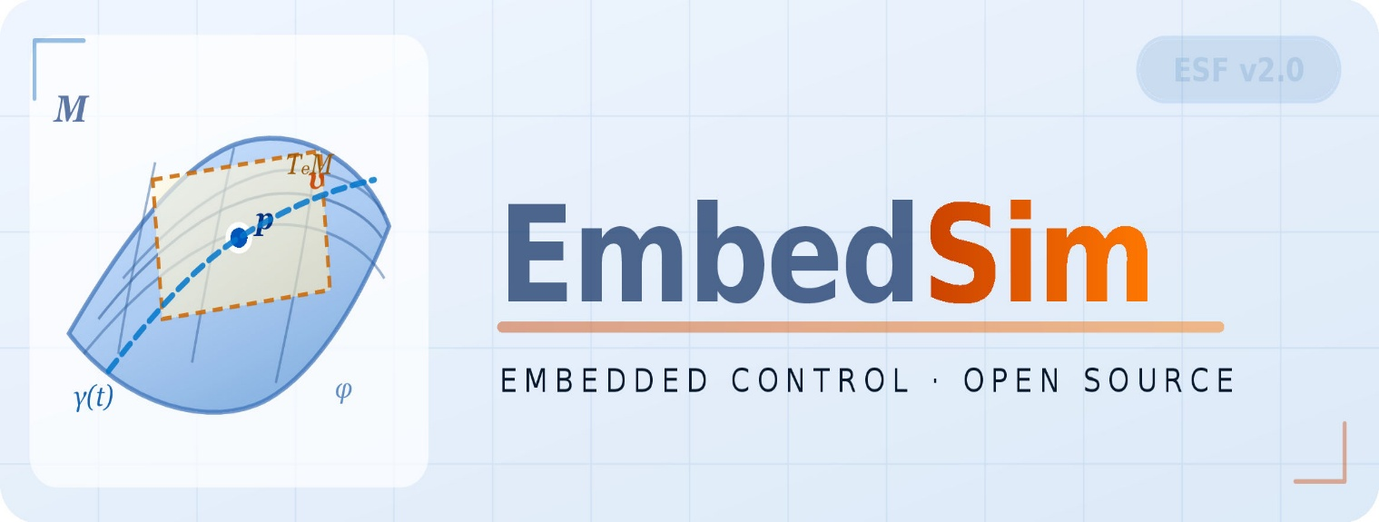

https://github.com/vectorsim/embed_sim_project

1 What is EmbedSim?
EmbedSim is an open-source Python framework that lets you design, simulate, and generate production C code for embedded control systems — all from a single, readable Python script. Think of it as a lightweight, programmer-friendly alternative to MATLAB/Simulink, built specifically for the constraints of 32-bit microcontrollers such as the Infineon AURIX TriCore and ARM Cortex-M4.

💡 | If you have ever written a block diagram on paper and then manually translated it into C code, EmbedSim automates exactly that pipeline.

With EmbedSim you can:
- Connect signal-processing blocks using a clean >> operator — just like Simulink's wire connections.
- Simulate the resulting system in Python with float32 precision, matching typical MCU arithmetic.
- Automatically emit embedsim_loop.c and embedsim_loop.h — ready-to-compile C source — with one function call.
- Gradually accelerate hot blocks using compiled Cython wrappers, without touching the rest of your Python model.
- Import Modelica/FMU plant models alongside your custom blocks through first-class FMU co-simulation support.

EmbedSim in One Picture
The workflow follows a natural left-to-right pipeline:

Python Model (block diagram) | → | Simulation (float32, RK4) | → | Code Generator (embedsim_gen/) | → | MCU Target (AURIX / Cortex-M4) | → | ASIL-D Compliant C

2 Motivation — Why EmbedSim Exists

The Problem with Today's Toolchains
Embedded control engineers working on motor drives, power converters, or automotive ECUs face a painful choice:

Approach | What's Good | What's Painful
MATLAB / Simulink | Industry standard, huge library, autocoding | Expensive licence, closed ecosystem, black-box codegen
Hand-written C | Full control, zero overhead | No simulation, error-prone, slow iteration
Pure Python (scipy) | Free, flexible, great for analysis | Cannot generate MCU code, float64 everywhere, no block-diagram structure
EmbedSim | Free & open-source, block diagrams in Python, MCU-grade codegen | Younger ecosystem, community-driven

Design Principles
EmbedSim was designed around five non-negotiable principles that every line of the framework upholds:

MCU Parity First
Default precision is float32 — the native type on most 32-bit controllers. Float64 is opt-in, not the default. This means simulation results match MCU behaviour by design, not by accident.

Dual Backend from Day One
Every block runs in pure Python for fast development and testing, and can be switched to a compiled Cython/C backend for production benchmarking — with a single flag at construction time.

Block Diagram as Code
The >> connection operator turns a Python script into an executable block diagram. Topology is explicit, readable, and version-controllable — no hidden wires in a proprietary binary.

Code Generation, Not an Afterthought
C code emission is a first-class feature. The code generator walks the same block graph used for simulation, ensuring that what you simulate is exactly what runs on hardware.

Open & Affordable
MATLAB Simulink with Embedded Coder costs thousands of dollars per seat per year. EmbedSim is MIT-licensed. An engineer in Colombo or Jaffna can use the full toolchain on a laptop.

3 Conceptual Architecture
EmbedSim is organised into four conceptual layers. Each layer has a single responsibility, and they compose cleanly — you can use layer 1 alone for pure Python simulation, or add all four layers for full MCU code generation.

# | Layer | Responsibility
1 | Signal Layer | VectorSignal — the float32 data packet flowing between blocks.
2 | Block Layer | VectorBlock — the universal base class. All processing, dynamics, sources, and sinks inherit from here.
3 | Simulation Layer | EmbedSim — the topological executor. Discovers block order, drives time, integrates state.
4 | CodeGen Layer | LoopGenerator + PYXInspector — walks the graph, inspects .pyx files, emits embedsim_loop.c/.h.

Layer 1 — The Signal: VectorSignal
A VectorSignal is simply a named NumPy array. It is the currency that blocks exchange. Wrapping the array in a named object gives every value a human-readable label for debugging and plotting.
from embedsim.core_blocks import VectorSignal

# A 3-phase current measurement (float32 by default)
i_abc = VectorSignal([2.1, -1.0, -1.1], name='i_abc')

# Double precision override for a precision-critical calculation
from embedsim.core_blocks import VectorSignal
angle = VectorSignal([0.0], name='theta', dtype=np.float64)

Layer 2 — The Block: VectorBlock
VectorBlock is the universal base class. Every element in a simulation — sources, gains, integrators, Clarke transforms, PI controllers, FMU wrappers, sinks — is a VectorBlock subclass.
A block exposes exactly three methods that subclasses override:

Method | Purpose
compute_py(t, dt, inputs) | Pure Python logic — always implement this first.
compute_c(t, dt, inputs) | Cython/C accelerated path — implement once performance matters.
_load_wrapper() | Imports the compiled .pyx extension into self._wrapper.

The >> operator wires blocks together in a single line:
# Connect a sine source → Clarke transform → Park transform → PI controller → sink
source >> clarke >> park >> pi_ctrl >> sink

# Fan-out: one source feeds two blocks
source >> clarke
source >> observer

Layer 3 — The Simulation Engine: EmbedSim
EmbedSim takes a list of sink blocks and discovers the full execution graph by walking backwards through input connections. It then:
- Runs a Depth-First Search to establish a topologically sorted execution order.
- Detects and breaks algebraic loops using VectorDelayEnhanced / LoopBreaker blocks.
- Steps forward in time using either Euler or RK4 integration.
- Calls each block's compute() in the correct order at every time step.

from embedsim import EmbedSim

sim = EmbedSim(sinks=[sink], dt=1e-4, t_end=0.1, solver='rk4')
sim.run()

Layer 4 — Code Generation: LoopGenerator & PYXInspector
When you are ready to deploy to hardware, CodeGenerator walks the same block graph and emits C source files. Two components collaborate:

PYXInspector
A static analyser that reads .pyx Cython wrapper files and extracts the C function signatures — number of inputs, number of outputs, required C source files. It populates block metadata (NUM_INPUTS, OUTPUT_SIZE, C_SOURCES, C_HEADERS) automatically via the __init_subclass__ hook in VectorBlock. No manual annotation required.

LoopGenerator
Walks the topologically sorted block list and calls _emit_block() for each block, producing a single embedsim_loop.c file containing a step() function that mirrors exactly what the Python simulation does — including register (state) variables, input wiring, and output forwarding.
from embedsim.code_generator import CodeGenerator

gen = CodeGenerator(sinks=[sink])
gen.generate_loop() # writes embedsim_gen/embedsim_loop.c
# embedsim_gen/embedsim_loop.h

How the Layers Interact — A Complete Example
The following sketch shows how all four layers combine for a simple gain-and-sum simulation:
import numpy as np
from embedsim.core_blocks import VectorSignal
from embedsim.source_blocks import SineSource
from embedsim.processing_blocks import VectorGain, VectorSum
from embedsim.dynamic_blocks import VectorEnd
from embedsim import EmbedSim
from embedsim.code_generator import CodeGenerator

# ── Layer 2: define blocks ──────────────────────────────────────────────
source = SineSource('sine', freq=50.0, amplitude=1.0)
gain = VectorGain('K', gain=2.0)
summer = VectorSum('add', signs=[1, -1])
sink = VectorEnd('output')

# ── Layer 2: wire the diagram with >> ───────────────────────────────────
source >> gain >> summer
source >> summer # second input to summer
summer >> sink

# ── Layer 3: simulate ────────────────────────────────────────────────────
sim = EmbedSim(sinks=[sink], dt=1e-4, t_end=0.02, solver='euler')
sim.run()

# ── Layer 4: generate C code ─────────────────────────────────────────────
gen = CodeGenerator(sinks=[sink])
gen.generate_loop() # → embedsim_gen/embedsim_loop.c

4 Key Abstractions — Quick Reference
Concept | One-liner
VectorSignal | A named float32 NumPy array — the data packet between blocks.
VectorBlock | Abstract base class for every element in the diagram.
compute_py() | Your Python-side block logic. Always implement this first.
compute_c() | Cython-accelerated path. Flip use_c_backend=True to activate.
>> operator | Connects block A's output to block B's input list.
EmbedSim | The time-stepping engine. Owns topology sort, RK4, loop detection.
VectorEnd | Sink block. Records a signal's time history for plotting.
CodeGenerator | Emits embedsim_loop.c / .h from the same graph used for simulation.
PYXInspector | Parses .pyx files to auto-populate C metadata on block classes.
PYX_FILE | Class attribute pointing to a block's .pyx wrapper. Triggers auto-inspection.
C_INPUT_MAP | Dict mapping input port indices to named C register variables.
use_c_backend | Constructor flag: False = Python (default), True = compiled C.
DEFAULT_DTYPE | Module-level dtype (float32). Change once to switch the whole framework.

📌 | Tip for beginners: start with use_c_backend=False and DEFAULT_DTYPE=np.float32. Only add C backends after you have verified the Python model is correct.

5 Next Steps
Now that you understand what EmbedSim is and how it is structured, here is a recommended learning path:

Step 1 — Run the PMSM FOC simulation
Open pmsm_foc_pwm_smc.py and run it. Watch the motor speed converge to the reference. Plot the outputs with plot_helper.

Step 2 — Trace one block end-to-end
Pick VectorGain. Read compute_py(). Connect it to a SineSource and a VectorEnd. Run a 1-second simulation. Verify the output is 2× the input.

Step 3 — Read the topology printer
Call topology_printer.print_topology(sinks=[...]) on your small model. See how EmbedSim discovers and labels the block graph.

Step 4 — Generate C code
On your small model, call CodeGenerator(...).generate_loop(). Open embedsim_gen/embedsim_loop.c and read the step() function line by line.

Step 5 — Add a new block
Write a VectorSaturation wrapper subclass with a PYX_FILE. Add C_INPUT_MAP and watch PYXInspector populate NUM_INPUTS automatically.

Step 6 — Build for hardware
Take the generated .c and .h files, drop them into your AURIX or Cortex-M4 project, wire to your ADC/PWM ISR, and compile with TASKING or GCC.

🚀 | EmbedSim is designed so that each layer can be adopted independently. You do not need to use code generation to benefit from block-diagram simulation, and you do not need to use Cython to benefit from code generation.

