Atomberg Video Support
A self-owned, real-time video support platform

What it is
Atomberg Video Support lets a customer and a support agent talk over live video, right in the browser. The special part: the video and audio do not go through any outside service. They travel through our own server. We built and own the whole pipeline end to end.

How it works
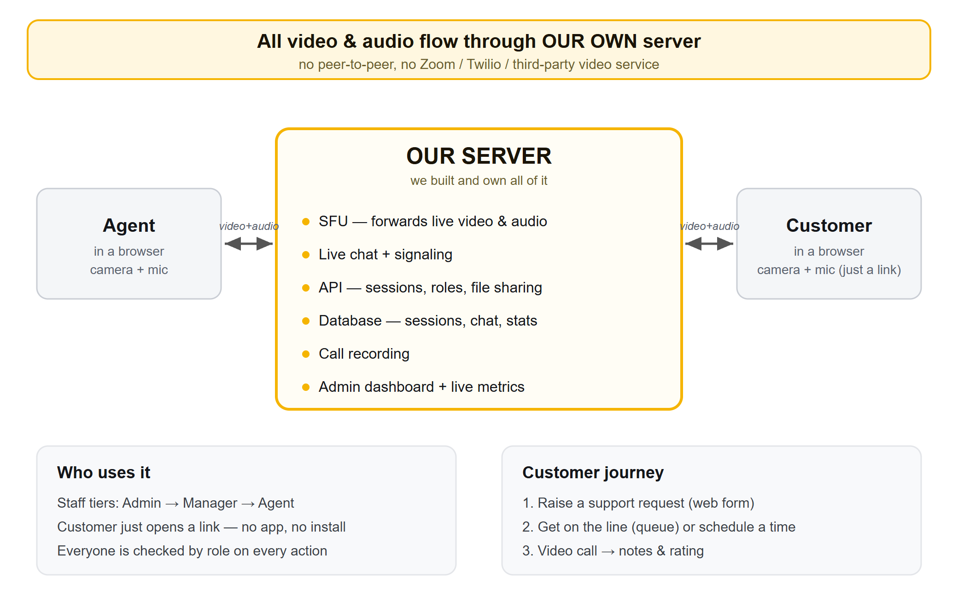
In one line: each person opens one connection to our server. The server receives both camera feeds and forwards them to the other side. The two people never connect directly to each other, and no third-party video tool is involved.
- One server does everything: forwards the video/audio, carries the live chat, runs the API, stores the data, and records the call.
- Customers need no app and no account — they just click a link and allow camera/mic.
- It is plain JavaScript/TypeScript with no special hardware, so it runs almost anywhere.

Why this wins
- Self-owned media: the core challenge was routing video through our own server (an "SFU"), not a hosted API. That is exactly what this does — and we can prove the video flows through the server.
- A complete support product, not a toy: public request form, auto-routing to the least-busy manager, a live queue, scheduling, the call, then agent notes and a customer rating.
- Real organisation: three staff tiers (Admin / Manager / Agent) with a task pool — managers post work, agents pick it up — plus per-agent and per-manager performance stats.
- All the bonus features: call recording, in-call file sharing, automatic reconnect, live chat, and an admin dashboard with real-time metrics.
- Built securely: token-based login, hashed passwords, role checks on every action, and time-limited invite links for customers.
- Clean, professional interface — calm cream-and-yellow theme, no clutter.
- Shipped: the code is on GitHub and the app is deployed on Google Cloud Run. The design doc also explains how it would scale to many users.

Login credentials
Use these demo accounts to sign in. Staff sign in at the /login page; customers never need an account.
Role | Username | Password | What they can do
Admin | admin | admin123 | The single master account. Adds/removes managers, sees everything, live metrics.
Manager | manager | manager123 | Runs an agent team: adds/removes agents, posts tasks, sees performance reports.
Agent | agent | agent123 | Picks up customer requests from the queue and runs the video call.
Customer | (no login) | (no login) | Joins by the invite link from their request — no account needed.

Try it
Live (deployed): https://atombergvideo-150175342104.asia-south1.run.app
Source code: https://github.com/vecvedant/Atomberg-Grand-Finale
Note for the live video demo: the cloud link shows the full app — sign-in, request form, dashboards, chat. For the actual camera-to-camera call, run it locally (npm install, npm run seed, npm start, then open two browser windows), because cloud serverless hosting does not pass the type of network traffic live video needs.

