CSE1007 code evidence
CSE1007 Java Programming. These four screenshots are the running UPI Offline Mesh demo. Each one is labeled with the file, the line range, and the syllabus topics visible in that range.

1. Gossip round
src/main/java/com/demo/upimesh/service/MeshSimulatorService.java
Lines 92–137
Topics covered
- Module 1 — Loops and the enhanced for. Nested for loops walk the phones. for (boolean canHear : topology.neighbours(from)) walks one row of the neighbour table.
- Module 2 — MeshDevice is the phone type. packet.nextHop() uses the Hop inner class of MeshPacket to copy the packet and drop the TTL.
- Module 3 — The method is synchronized. It creates one Thread per phone, starts it, and join()s it. inbox.take() is how the main thread receives what the phone threads send. try/catch handles InterruptedException.
- Module 4 — Map and List hold the snapshot and the outgoing copies. PacketInbox<Delivery> is the generic inbox.
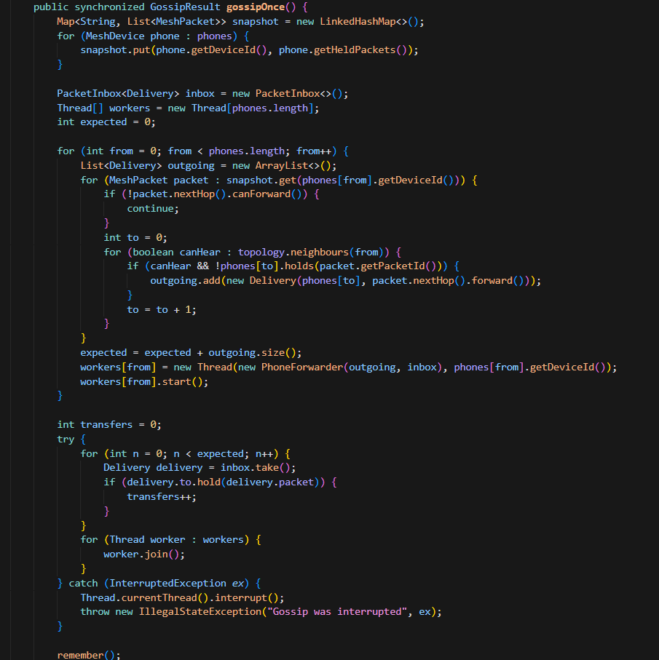

2. Ledger transfer
src/main/java/com/demo/upimesh/jdbc/JdbcLedger.java
Lines 74–127
Topics covered
- Module 3 — try, catch, and finally. throw new UnknownAccountException and throw new DuplicatePacketException are the user-defined exceptions. The finally block rolls back when commit did not happen, then closes the connection. Object.finalize() is named in the comment as the obsolete alternative.
- Module 5 — JDBC. getConnection(), setAutoCommit(false), commit(), rollback(), and close() wrap the debit, the credit, and the ledger insert in one transaction.
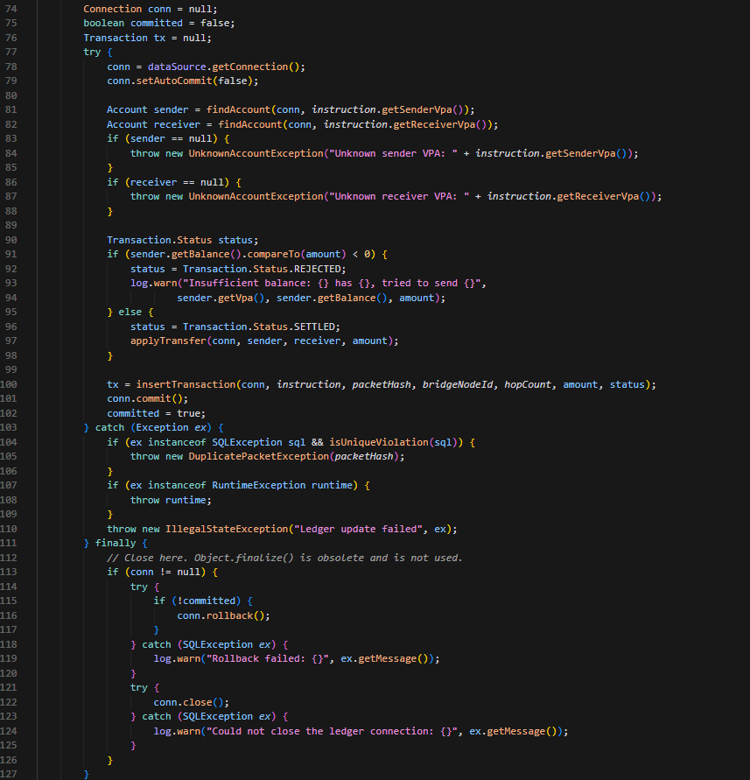

3. Ledger servlet
src/main/java/com/demo/upimesh/web/LedgerServlet.java
Lines 51–80
Topics covered
- Module 6 — Servlet lifecycle. init() and destroy() log start and stop. doGet reads the request, opens an HttpSession, and forwards the response to the JSP.
- Module 6 — Session tracking. visitCount and lastOutcome are stored on the session.
- Module 7 — The same method builds the LedgerPage bean and forwards to /WEB-INF/jsp/ledger.jsp, which reads that bean with jsp:useBean.
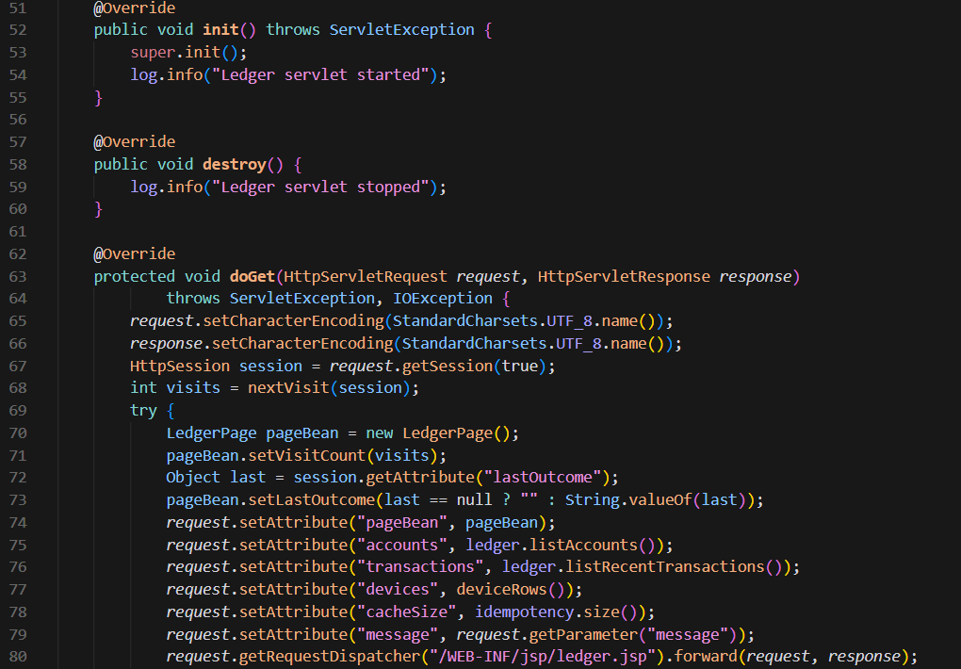

4. JavaFX menu
src/main/java/com/demo/upimesh/fx/UpiMeshFxApplication.java
Lines 86–105
Topics covered
- Module 5 — JavaFX menus and events. MenuBar, Menu, and MenuItem. setOnAction handles Gossip, Flush, Reset, and About. About opens an Alert.
