DB Design Document
Status: source of truth for all database work on the IMGC lender portal.
Last revised: 28 September 2026.
Target platform: PostgreSQL 16 or later.
Aligned to the Phase 1 (MVP) component stack: Azure Database for PostgreSQL 16, Microsoft Entra
ID for sign-in, Azure Blob Storage with pre-signed URLs, Kafka on Azure Event Hubs and Azure
Service Bus for events, Azure Managed Redis for token caching, and Azure Monitor / Application
Insights for tracing. Decisions are recorded in A.11 and applied throughout.
This document has two parts.
- Part A — Target production schema. The relational design the application moves to. This is
the authority: migrations, ORM models, queries and reviews follow it, and any change to the
database starts by changing this document.
- Part B — Current state and the mapping to it. What the code stores today (one JSON document)
and how each part of it lands in Part A. This is the migration contract.
Everything in Part B is read from the code. Everything in Part A is a design decision derived from
that code. Where the code does not settle a question, it is marked Not confirmed and listed in
section A.12 rather than guessed at.

Part A — Target production schema

A.1 Conventions
These apply to every table below; they are not repeated per table.
Rule | Decision
Naming | snake_case; tables plural (claims), columns singular (claim_no)
Primary keys | id uuid PRIMARY KEY DEFAULT gen_random_uuid() (pgcrypto)
Business keys | Separate from the PK and unique in their own right (accounts.loan_no, claims.claim_no)
Timestamps | timestamptz, never timestamp; created_at timestamptz NOT NULL DEFAULT now()
Dates without time | date (e.g. sanction_date, a payment date entered by a person)
Money | numeric(15,2), rupees. Never float
Actor columns | Always a pair: *_by_user_id uuid REFERENCES users(id) plus *_by_name text — the id for joins, the name captured at the time so history survives a rename
Enumerations | Native Postgres ENUM types (section A.3)
Deletes | No hard deletes of business records. Withdrawal is is_active = false; replacement is superseded_at
FK behaviour | ON DELETE RESTRICT by default; ON DELETE CASCADE only for rows that cannot exist alone (child lists, history)
Row versioning | updated_at timestamptz NOT NULL DEFAULT now(), maintained by a trigger, on every mutable table

A.2 Table inventory
28 tables in seven groups.
# | Table | Group | Purpose
1 | lender_orgs | Identity | A lender institution — the tenant boundary
2 | lender_org_contacts | Identity | Stakeholder mailboxes per lender
3 | users | Identity | IMGC staff and lender users
4 | user_password_history | Identity | Previous password hashes, so a reset cannot reuse one
5 | auth_otps | Identity | One-time sign-in codes for lender users
6 | accounts | Loan | The loan/application a claim is made against
7 | account_push_recipients | Loan | Extra mailboxes pinned to one account
8 | pas_values | Loan | Values pushed in from PAS
9 | claims | Claim | A claim against an account
10 | claim_field_values | Claim | Config-defined form values for a claim
11 | claim_status_history | Claim | Every status transition, append-only
12 | claim_decisions | Claim | The approved / ineligible outcome
13 | claim_queries | Claim | A query IMGC raises and the lender's response
14 | claim_query_documents | Claim | Documents a query asks for
15 | claim_documents | Document | One checklist row on a claim
16 | document_files | Document | An uploaded file version
17 | document_reviews | Document | IMGC's accept/reject decisions, append-only
18 | document_waivers | Document | A request to proceed without a document, and its decision
19 | document_retention_holds | Document | Reinstatement requests and archive flags on rejected material
20 | claim_document_specs | Configuration | The default checklist per claim type
21 | lender_document_requirements | Configuration | Per-lender checklist that replaces the default
22 | remarks | Collaboration | Free-text remarks at account, claim or document level
23 | notifications | Collaboration | One message, with its recipients
24 | notification_recipients | Collaboration | To/CC and read state per address
25 | audit_events | Collaboration | Append-only activity log
26 | event_outbox | Platform | Events awaiting publication to Kafka / Service Bus
27 | processed_events | Platform | Events already consumed, so a redelivery cannot double-apply
28 | pas_push_events | Platform | Every loan pushed in by PAS, and what became of it

A.3 Enumerations
Native enum types, created before the tables. Values are exactly those the code uses today
(src/server/mock/types.ts).
CREATE TYPE user_role AS ENUM ('IMGC', 'LENDER');
CREATE TYPE actor_role AS ENUM ('IMGC', 'LENDER', 'SYSTEM');
CREATE TYPE claim_type AS ENUM ('INITIAL', 'SUBSEQUENT');
CREATE TYPE claim_status AS ENUM (
'NOT_STARTED', 'DRAFT', 'INITIATED', 'QUERY_INITIATED', 'UNDER_REVIEW',
'QUERY_UNDER_REVIEW', 'APPROVED', 'INELIGIBLE'
);
CREATE TYPE document_status AS ENUM (
'NOT_REQUESTED', 'PENDING_UPLOAD', 'UNDER_REVIEW', 'APPROVED',
'REJECTED', 'REUPLOAD_REQUIRED', 'WAIVER_REQUESTED', 'WAIVED'
);
CREATE TYPE review_decision AS ENUM ('APPROVED', 'REJECTED', 'REUPLOAD_REQUESTED');
CREATE TYPE waiver_status AS ENUM ('REQUESTED', 'APPROVED', 'DENIED');
CREATE TYPE reinstate_status AS ENUM ('REQUESTED', 'APPROVED', 'DENIED');
CREATE TYPE added_by AS ENUM ('SYSTEM', 'IMGC', 'LENDER');
CREATE TYPE priority AS ENUM ('LOW', 'NORMAL', 'HIGH', 'URGENT');
CREATE TYPE property_status AS ENUM ('UNDER_CONSTRUCTION', 'READY_TO_MOVE');
CREATE TYPE recipient_kind AS ENUM ('TO', 'CC');
CREATE TYPE upload_state AS ENUM ('PENDING', 'COMMITTED', 'ORPHANED');

`claim_status` holds the eight live statuses and nothing else. The values the prototype
accumulated — SUBMITTED, QUERY_RAISED, DOCUMENTS_RESUBMITTED, CLOSED,
REFUND_RECEIVED_BY_IMGC and REJECTED — are not carried into production. Each is folded into
a live status by the migration (B.2), so no legacy value survives to be written by accident.
Two points of vocabulary:
- `INELIGIBLE` replaces `REJECTED`. It is already what the application shows a user
(StatusPill maps REJECTED to "Ineligible"); the column now says the same thing.
- `NOT_STARTED` is a real stored status, not a display trick. Today it is inferred from a draft
with no progress (claimStatusDisplay); storing it means the grid, the filter and the database
agree without that inference.
There is no `party` enum. Who holds a claim is derived from its status, never stored — A.11.

A.4 DDL — identity and loan
CREATE TABLE lender_orgs (
id uuid PRIMARY KEY DEFAULT gen_random_uuid(),
name text NOT NULL,
email_domain citext NOT NULL UNIQUE, -- the only lender-scoping key
logo_url text,
is_active boolean NOT NULL DEFAULT true,
created_at timestamptz NOT NULL DEFAULT now(),
updated_at timestamptz NOT NULL DEFAULT now()
);

CREATE TABLE lender_org_contacts (
id uuid PRIMARY KEY DEFAULT gen_random_uuid(),
lender_org_id uuid NOT NULL REFERENCES lender_orgs(id) ON DELETE CASCADE,
email citext NOT NULL,
created_at timestamptz NOT NULL DEFAULT now(),
UNIQUE (lender_org_id, email)
);

CREATE TABLE users (
id uuid PRIMARY KEY DEFAULT gen_random_uuid(),
role user_role NOT NULL,
is_admin boolean NOT NULL DEFAULT false,
name text NOT NULL,
email citext NOT NULL UNIQUE,
employee_id text UNIQUE, -- IMGC staff only
-- Entra ID is the way in (A.11 decision 13). The object id is the identity, not the email:
-- an address can be reassigned, the object id cannot.
entra_object_id uuid UNIQUE,
user_principal_name citext,
identity_provider text NOT NULL DEFAULT 'ENTRA_ID', -- 'ENTRA_ID' | 'LOCAL' (fallback)
invited_at timestamptz, -- external-identity onboarding for lender users
activated_at timestamptz,
password_hash text, -- fallback sign-in only; empty under Entra
phone text,
lender_org_id uuid REFERENCES lender_orgs(id) ON DELETE RESTRICT,
is_active boolean NOT NULL DEFAULT true,
-- Password policy — IMGC staff only; lender users sign in with a one-time code.
password_changed_at timestamptz,
must_change_password boolean NOT NULL DEFAULT false,
failed_attempts smallint NOT NULL DEFAULT 0,
last_failed_at timestamptz,
locked_until timestamptz,
last_login_at timestamptz,
created_at timestamptz NOT NULL DEFAULT now(),
created_by_user_id uuid REFERENCES users(id),
updated_at timestamptz NOT NULL DEFAULT now(),
-- A lender user belongs to a lender; IMGC staff never do.
CONSTRAINT users_scope_ck CHECK (
(role = 'LENDER' AND lender_org_id IS NOT NULL AND employee_id IS NULL)
OR (role = 'IMGC' AND lender_org_id IS NULL)
)
);

-- Previous password hashes, so a reset cannot reuse one. Never read for authentication.
CREATE TABLE user_password_history (
id uuid PRIMARY KEY DEFAULT gen_random_uuid(),
user_id uuid NOT NULL REFERENCES users(id) ON DELETE CASCADE,
password_hash text NOT NULL,
changed_at timestamptz NOT NULL DEFAULT now()
);
CREATE INDEX user_password_history_user_idx ON user_password_history (user_id, changed_at DESC);

CREATE TABLE auth_otps (
id uuid PRIMARY KEY DEFAULT gen_random_uuid(),
email citext NOT NULL,
code_hash text NOT NULL,
salt text NOT NULL,
expires_at timestamptz NOT NULL,
attempts smallint NOT NULL DEFAULT 0,
consumed_at timestamptz,
created_at timestamptz NOT NULL DEFAULT now()
);
CREATE INDEX auth_otps_email_idx ON auth_otps (email, expires_at DESC);

CREATE TABLE accounts (
id uuid PRIMARY KEY DEFAULT gen_random_uuid(),
loan_no text NOT NULL UNIQUE,
borrower_name text NOT NULL,
lender_org_id uuid NOT NULL REFERENCES lender_orgs(id) ON DELETE RESTRICT,
assigned_user_id uuid REFERENCES users(id) ON DELETE SET NULL,
product text NOT NULL,
region text NOT NULL,
branch text NOT NULL,
application_date date NOT NULL,
loan_amount numeric(15,2) NOT NULL CHECK (loan_amount >= 0),
outstanding_amount numeric(15,2) NOT NULL CHECK (outstanding_amount >= 0),
sanction_date date NOT NULL,
disbursement_date date NOT NULL,
tenure_months integer NOT NULL CHECK (tenure_months > 0),
property_type text NOT NULL,
property_status_label text NOT NULL,
property_status_at_disbursal property_status NOT NULL,
stage text NOT NULL,
claim_status claim_status NOT NULL,
is_npa boolean NOT NULL DEFAULT false,
is_written_off boolean NOT NULL DEFAULT false,
dpd integer, -- NULL ≠ 0: unknown, not "zero days past due"
submitted_at timestamptz,
last_activity_at timestamptz,
-- Where the loan came from, so a PAS-pushed field is distinguishable from a portal entry.
source_system text NOT NULL DEFAULT 'PAS',
pas_last_synced_at timestamptz,
created_at timestamptz NOT NULL DEFAULT now(),
updated_at timestamptz NOT NULL DEFAULT now()
);
CREATE INDEX accounts_lender_idx ON accounts (lender_org_id, claim_status);
CREATE INDEX accounts_assigned_idx ON accounts (assigned_user_id);
CREATE INDEX accounts_activity_idx ON accounts (last_activity_at DESC NULLS LAST);

CREATE TABLE account_push_recipients (
id uuid PRIMARY KEY DEFAULT gen_random_uuid(),
account_id uuid NOT NULL REFERENCES accounts(id) ON DELETE CASCADE,
email citext NOT NULL,
created_at timestamptz NOT NULL DEFAULT now(),
UNIQUE (account_id, email)
);

CREATE TABLE pas_values (
id uuid PRIMARY KEY DEFAULT gen_random_uuid(),
account_id uuid NOT NULL REFERENCES accounts(id) ON DELETE CASCADE,
key text NOT NULL,
label text NOT NULL,
value text NOT NULL,
source text NOT NULL DEFAULT 'PAS',
updated_at timestamptz NOT NULL DEFAULT now(),
updated_by_name text NOT NULL,
UNIQUE (account_id, key)
);

`accounts.claim_status` is a denormalised summary of the account's live claim, kept because
every grid filters and sorts on it. The claim remains the authority; a trigger or the service layer
keeps this column in step. A deliberate duplication, recorded here so it is never mistaken for one.

A.5 DDL — claim
CREATE TABLE claims (
id uuid PRIMARY KEY DEFAULT gen_random_uuid(),
claim_no text NOT NULL UNIQUE,
account_id uuid NOT NULL REFERENCES accounts(id) ON DELETE RESTRICT,
claim_type claim_type NOT NULL,
status claim_status NOT NULL,
draft_saved boolean NOT NULL DEFAULT false,
created_by_user_id uuid NOT NULL REFERENCES users(id),
created_by_name text NOT NULL,
created_at timestamptz NOT NULL DEFAULT now(),
submitted_at timestamptz,
last_updated_at timestamptz NOT NULL DEFAULT now(),
-- Only one live claim per account; terminal ones may accumulate.
CONSTRAINT claims_account_live_uq EXCLUDE (account_id WITH =)
WHERE (status NOT IN ('APPROVED','INELIGIBLE'))
);
CREATE INDEX claims_account_idx ON claims (account_id, status);
CREATE INDEX claims_status_idx ON claims (status, last_updated_at DESC);

CREATE TABLE claim_field_values (
claim_id uuid NOT NULL REFERENCES claims(id) ON DELETE CASCADE,
field_id text NOT NULL, -- matches a claimConfig field id
value text NOT NULL,
updated_at timestamptz NOT NULL DEFAULT now(),
PRIMARY KEY (claim_id, field_id)
);

CREATE TABLE claim_status_history (
id uuid PRIMARY KEY DEFAULT gen_random_uuid(),
claim_id uuid NOT NULL REFERENCES claims(id) ON DELETE CASCADE,
status claim_status NOT NULL,
changed_at timestamptz NOT NULL DEFAULT now(),
actor_user_id uuid REFERENCES users(id), -- NULL when actor_role = 'SYSTEM'
actor_name text NOT NULL,
actor_role actor_role NOT NULL,
note text
);
CREATE INDEX claim_status_history_claim_idx ON claim_status_history (claim_id, changed_at);

CREATE TABLE claim_decisions (
claim_id uuid PRIMARY KEY REFERENCES claims(id) ON DELETE CASCADE,
outcome claim_status NOT NULL
CHECK (outcome IN ('APPROVED','INELIGIBLE')),
decided_by_user_id uuid NOT NULL REFERENCES users(id),
decided_by_name text NOT NULL,
decided_at timestamptz NOT NULL DEFAULT now(),
remarks text NOT NULL
);

CREATE TABLE claim_queries (
id uuid PRIMARY KEY DEFAULT gen_random_uuid(),
claim_id uuid NOT NULL REFERENCES claims(id) ON DELETE CASCADE,
reason text NOT NULL,
remarks text NOT NULL DEFAULT '',
raised_by_user_id uuid NOT NULL REFERENCES users(id),
raised_by_name text NOT NULL,
raised_at timestamptz NOT NULL DEFAULT now(),
due_date date,
responded_at timestamptz,
responded_by_user_id uuid REFERENCES users(id),
responded_by_name text,
response_remarks text,
CONSTRAINT claim_queries_response_ck CHECK (
(responded_at IS NULL AND responded_by_user_id IS NULL)
OR (responded_at IS NOT NULL AND responded_by_user_id IS NOT NULL)
)
);
CREATE INDEX claim_queries_open_idx ON claim_queries (claim_id) WHERE responded_at IS NULL;

-- Which documents a query asks for. Today the code stores document NAMES; a real reference is
-- half the reason for moving to a relational store.
CREATE TABLE claim_query_documents (
query_id uuid NOT NULL REFERENCES claim_queries(id) ON DELETE CASCADE,
claim_document_id uuid NOT NULL REFERENCES claim_documents(id) ON DELETE CASCADE,
PRIMARY KEY (query_id, claim_document_id)
);

A.6 DDL — documents
CREATE TABLE claim_documents (
id uuid PRIMARY KEY DEFAULT gen_random_uuid(),
claim_id uuid NOT NULL REFERENCES claims(id) ON DELETE CASCADE,
account_id uuid NOT NULL REFERENCES accounts(id) ON DELETE RESTRICT, -- denormalised for lender scoping
spec_slug text, -- ties back to the configured document
name text NOT NULL,
category text,
description text,
is_required boolean NOT NULL,
is_conditional boolean NOT NULL DEFAULT false,
condition_reason text,
allows_multiple boolean NOT NULL DEFAULT false,
status document_status NOT NULL DEFAULT 'PENDING_UPLOAD',
added_by added_by NOT NULL,
added_by_name text,
priority priority,
due_date date,
requirement_remarks text,
reference_no text, -- "AD-001" for lender-added documents
display_order integer NOT NULL DEFAULT 0,
is_active boolean NOT NULL DEFAULT true, -- false = withdrawn
current_file_id uuid REFERENCES document_files(id) ON DELETE SET NULL,
created_at timestamptz NOT NULL DEFAULT now(),
updated_at timestamptz NOT NULL DEFAULT now()
);
CREATE INDEX claim_documents_claim_idx ON claim_documents (claim_id, display_order);
CREATE INDEX claim_documents_status_idx ON claim_documents (status) WHERE is_active;

CREATE TABLE document_files (
id uuid PRIMARY KEY DEFAULT gen_random_uuid(),
claim_document_id uuid NOT NULL REFERENCES claim_documents(id) ON DELETE CASCADE,
version integer NOT NULL CHECK (version >= 1),
original_name text NOT NULL,
-- Azure Blob Storage (A.11 decision 14). The blob is addressed by container + key; the
-- pre-signed URL that reaches it is minted per request and never stored.
storage_provider text NOT NULL DEFAULT 'AZURE_BLOB',
storage_container text NOT NULL,
storage_key text NOT NULL, -- blob name within the container
storage_etag text, -- Azure's ETag, to spot a blob changed underneath us
stored_path text NOT NULL, -- provider-neutral locator, derived from the two above
size_bytes bigint NOT NULL CHECK (size_bytes > 0),
mime_type text NOT NULL,
checksum_sha256 text,
document_number text,
document_date date,
upload_remarks text,
uploaded_by_user_id uuid NOT NULL REFERENCES users(id),
uploaded_by_name text NOT NULL,
uploaded_by_role user_role NOT NULL,
uploaded_at timestamptz NOT NULL DEFAULT now(),
superseded_at timestamptz,
superseded_reason text,
is_pending_save boolean NOT NULL DEFAULT false, -- draft upload not yet kept by Save Draft
-- The browser uploads straight to Azure, so the row exists before the blob is known to be there.
upload_state upload_state NOT NULL DEFAULT 'PENDING',
upload_expires_at timestamptz, -- when the issued URL dies; a sweep cleans up after
committed_at timestamptz, -- server verified size + checksum against the blob
-- Retention spans two systems: the row is marked, then the blob delete is confirmed.
deleted_at timestamptz,
purge_confirmed_at timestamptz,
UNIQUE (claim_document_id, version),
UNIQUE (storage_container, storage_key)
);
CREATE INDEX document_files_orphan_idx ON document_files (upload_expires_at)
WHERE upload_state = 'PENDING';
CREATE INDEX document_files_purge_idx ON document_files (deleted_at)
WHERE deleted_at IS NOT NULL AND purge_confirmed_at IS NULL;
CREATE INDEX document_files_live_idx ON document_files (claim_document_id)
WHERE superseded_at IS NULL;

-- Append-only. An "undo" writes nothing away: it stamps undone_at, and the document's status is
-- derived from the live decisions (deriveDocumentStatus today).
CREATE TABLE document_reviews (
id uuid PRIMARY KEY DEFAULT gen_random_uuid(),
claim_document_id uuid NOT NULL REFERENCES claim_documents(id) ON DELETE CASCADE,
document_file_id uuid REFERENCES document_files(id) ON DELETE CASCADE, -- NULL = document-level (legacy)
decision review_decision NOT NULL,
remarks text NOT NULL, -- mandatory for REJECTED / REUPLOAD_REQUESTED
against_version integer, -- the file version judged
decided_by_user_id uuid NOT NULL REFERENCES users(id),
decided_by_name text NOT NULL,
decided_at timestamptz NOT NULL DEFAULT now(),
undone_at timestamptz,
undone_by_user_id uuid REFERENCES users(id),
CONSTRAINT document_reviews_remarks_ck
CHECK (decision = 'APPROVED' OR length(btrim(remarks)) > 0)
);
CREATE INDEX document_reviews_file_idx ON document_reviews (document_file_id, decided_at DESC);
CREATE INDEX document_reviews_live_idx ON document_reviews (claim_document_id)
WHERE undone_at IS NULL;

CREATE TABLE document_waivers (
id uuid PRIMARY KEY DEFAULT gen_random_uuid(),
claim_document_id uuid NOT NULL REFERENCES claim_documents(id) ON DELETE CASCADE,
status waiver_status NOT NULL DEFAULT 'REQUESTED',
reason text NOT NULL,
requested_by_user_id uuid NOT NULL REFERENCES users(id),
requested_by_name text NOT NULL,
requested_at timestamptz NOT NULL DEFAULT now(),
decided_by_user_id uuid REFERENCES users(id),
decided_by_name text,
decided_at timestamptz,
decision_remarks text,
CONSTRAINT document_waivers_decision_ck CHECK (
(status = 'REQUESTED' AND decided_at IS NULL)
OR (status <> 'REQUESTED' AND decided_at IS NOT NULL)
),
CONSTRAINT document_waivers_denial_ck
CHECK (status <> 'DENIED' OR length(btrim(coalesce(decision_remarks,''))) > 0)
);
-- One open request at a time per document.
CREATE UNIQUE INDEX document_waivers_open_uq ON document_waivers (claim_document_id)
WHERE status = 'REQUESTED';

-- Retention: a rejected file is purged after its window unless held or archived.
CREATE TABLE document_retention_holds (
id uuid PRIMARY KEY DEFAULT gen_random_uuid(),
document_review_id uuid NOT NULL REFERENCES document_reviews(id) ON DELETE CASCADE,
reinstate_status reinstate_status,
requested_by_user_id uuid REFERENCES users(id),
requested_by_name text,
requested_at timestamptz,
decided_by_user_id uuid REFERENCES users(id),
decided_by_name text,
decided_at timestamptz,
note text,
archived_at timestamptz, -- archived = never purged
archived_by_name text,
UNIQUE (document_review_id)
);

A.7 DDL — configuration
-- The built-in checklist a claim type ships with (today in src/config/claimConfig.ts).
CREATE TABLE claim_document_specs (
id uuid PRIMARY KEY DEFAULT gen_random_uuid(),
claim_type claim_type NOT NULL,
slug text NOT NULL,
name text NOT NULL,
category text NOT NULL,
description text,
is_required boolean NOT NULL,
allows_multiple boolean NOT NULL DEFAULT false,
condition_field text, -- conditional rule: field / operator / value
condition_operator text,
condition_value text,
display_order integer NOT NULL,
is_active boolean NOT NULL DEFAULT true,
UNIQUE (claim_type, slug)
);

-- A lender with rows here gets exactly this list instead of the default.
CREATE TABLE lender_document_requirements (
id uuid PRIMARY KEY DEFAULT gen_random_uuid(),
lender_org_id uuid NOT NULL REFERENCES lender_orgs(id) ON DELETE CASCADE,
slug text NOT NULL,
name text NOT NULL,
category text NOT NULL,
description text,
is_required boolean NOT NULL,
display_order integer NOT NULL,
created_at timestamptz NOT NULL DEFAULT now(),
updated_at timestamptz NOT NULL DEFAULT now(),
UNIQUE (lender_org_id, slug)
);

A.8 DDL — collaboration
CREATE TABLE remarks (
id uuid PRIMARY KEY DEFAULT gen_random_uuid(),
account_id uuid NOT NULL REFERENCES accounts(id) ON DELETE CASCADE,
claim_id uuid REFERENCES claims(id) ON DELETE CASCADE,
claim_document_id uuid REFERENCES claim_documents(id) ON DELETE CASCADE,
source text, -- e.g. 'CLAIM_INITIATION'
body text NOT NULL,
author_user_id uuid NOT NULL REFERENCES users(id),
author_name text NOT NULL,
author_role user_role NOT NULL,
created_at timestamptz NOT NULL DEFAULT now()
);
CREATE INDEX remarks_account_idx ON remarks (account_id, created_at DESC);

CREATE TABLE notifications (
id uuid PRIMARY KEY DEFAULT gen_random_uuid(),
event text NOT NULL,
subject text NOT NULL,
body text NOT NULL,
account_id uuid REFERENCES accounts(id) ON DELETE SET NULL,
claim_id uuid REFERENCES claims(id) ON DELETE SET NULL,
sent_at timestamptz NOT NULL DEFAULT now(),
-- Email is delivered for real (A.11): QUEUED → SENT → DELIVERED, or BOUNCED / FAILED.
delivery_status text NOT NULL DEFAULT 'QUEUED',
provider_message_id text,
sent_to_provider_at timestamptz,
delivered_at timestamptz,
bounced_at timestamptz,
bounce_type text, -- hard / soft, as the provider reports it
delivery_error text,
trace_id text
);
CREATE INDEX notifications_bounced_idx ON notifications (bounced_at) WHERE bounced_at IS NOT NULL;
CREATE INDEX notifications_account_idx ON notifications (account_id, sent_at DESC);

-- To/CC, and who has read it. Replaces three string arrays.
CREATE TABLE notification_recipients (
id uuid PRIMARY KEY DEFAULT gen_random_uuid(),
notification_id uuid NOT NULL REFERENCES notifications(id) ON DELETE CASCADE,
email citext NOT NULL,
kind recipient_kind NOT NULL,
recipient_role user_role,
read_at timestamptz,
UNIQUE (notification_id, email, kind)
);

CREATE TABLE audit_events (
id uuid PRIMARY KEY DEFAULT gen_random_uuid(),
account_id uuid REFERENCES accounts(id) ON DELETE SET NULL,
claim_id uuid REFERENCES claims(id) ON DELETE SET NULL,
occurred_at timestamptz NOT NULL DEFAULT now(),
actor_user_id uuid REFERENCES users(id),
actor_name text NOT NULL,
actor_role actor_role NOT NULL,
event_type text NOT NULL,
summary text NOT NULL,
meta jsonb NOT NULL DEFAULT '{}'::jsonb,
-- "Trace ID and Span ID visible across all layers" — including the row the request produced.
trace_id text,
span_id text
);
CREATE INDEX audit_events_account_idx ON audit_events (account_id, occurred_at DESC);
CREATE INDEX audit_events_type_idx ON audit_events (event_type, occurred_at DESC);

audit_events.event_type stays text rather than an enum: the list grows with every feature, and
a new event should not need a schema migration. meta is jsonb for the same reason.

A.8a DDL — platform
These three tables exist because of the Phase 1 stack: Kafka on Event Hubs and Service Bus for
events, and the PAS Push API for loan intake.
-- Transactional outbox. An event is written in the same transaction as the business change it
-- describes, then relayed to Kafka / Service Bus. Without this, a crash between the commit and
-- the publish loses the event with no trace.
CREATE TABLE event_outbox (
id bigserial PRIMARY KEY,
aggregate_type text NOT NULL, -- 'claim', 'claim_document', 'account'
aggregate_id uuid NOT NULL,
event_type text NOT NULL, -- 'ClaimSubmitted', 'DocumentRejected', …
payload jsonb NOT NULL,
occurred_at timestamptz NOT NULL DEFAULT now(),
published_at timestamptz,
attempts smallint NOT NULL DEFAULT 0,
last_error text,
trace_id text
);
CREATE INDEX event_outbox_unpublished_idx ON event_outbox (occurred_at)
WHERE published_at IS NULL;

-- Consumer side: at-least-once delivery means the same event can arrive twice.
CREATE TABLE processed_events (
consumer text NOT NULL, -- which service consumed it
event_id text NOT NULL, -- the broker's message id
processed_at timestamptz NOT NULL DEFAULT now(),
PRIMARY KEY (consumer, event_id)
);

-- Every loan PAS pushes in, and what became of it. The payload is kept as received, so a dispute
-- about what was sent is settled by the record rather than by memory.
CREATE TABLE pas_push_events (
id uuid PRIMARY KEY DEFAULT gen_random_uuid(),
idempotency_key text NOT NULL UNIQUE, -- a retry cannot create a second account
received_at timestamptz NOT NULL DEFAULT now(),
loan_no text NOT NULL, -- as sent, before any matching
payload jsonb NOT NULL,
status text NOT NULL DEFAULT 'RECEIVED', -- RECEIVED | APPLIED | REJECTED
account_id uuid REFERENCES accounts(id) ON DELETE SET NULL,
error text,
processed_at timestamptz,
trace_id text
);
CREATE INDEX pas_push_events_loan_idx ON pas_push_events (loan_no, received_at DESC);
CREATE INDEX pas_push_events_status_idx ON pas_push_events (status) WHERE status <> 'APPLIED';

The outbox is deliberately bigserial rather than uuid: the relay reads it in insertion order,
and a monotonic key is what makes that cheap.

A.9 ERD — target schema
The whole schema on one page is a wall chart, not a diagram anyone reads. It is drawn here as
eight views of five or six tables each, plus a map. Every view is generated from the same
master ERD, so no view can show a column or a relationship the schema does not have.
How to read a view. Tables the view is about are drawn in full. A table shown only for
context carries its key columns and a note saying which view holds its detail — follow the link
under the diagram to get there.

A.9.0 Map — how the views connect

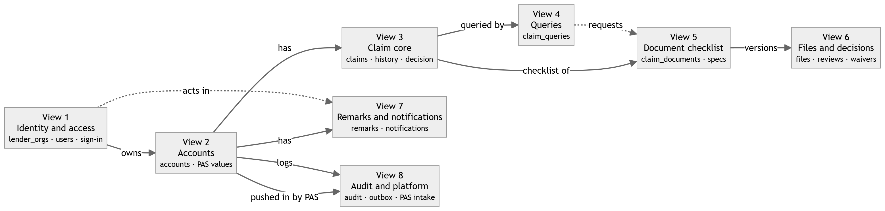

View | Tables in full | Jump
1. Identity and access | lender_orgs, lender_org_contacts, users, user_password_history, auth_otps | open
2. Accounts (the loan) | accounts, account_push_recipients, pas_values | open
3. Claim core | claims, claim_field_values, claim_status_history, claim_decisions | open
4. Queries | claim_queries, claim_query_documents | open
5. The document checklist | claim_documents, claim_document_specs, lender_document_requirements | open
6. Files, decisions and retention | document_files, document_reviews, document_waivers, document_retention_holds | open
7. Remarks and notifications | remarks, notifications, notification_recipients | open
8. Audit, events and PAS intake | audit_events, event_outbox, processed_events, pas_push_events | open

View 1 — Identity and access
Who the portal knows: the lender institutions, their people, and how those people sign in.
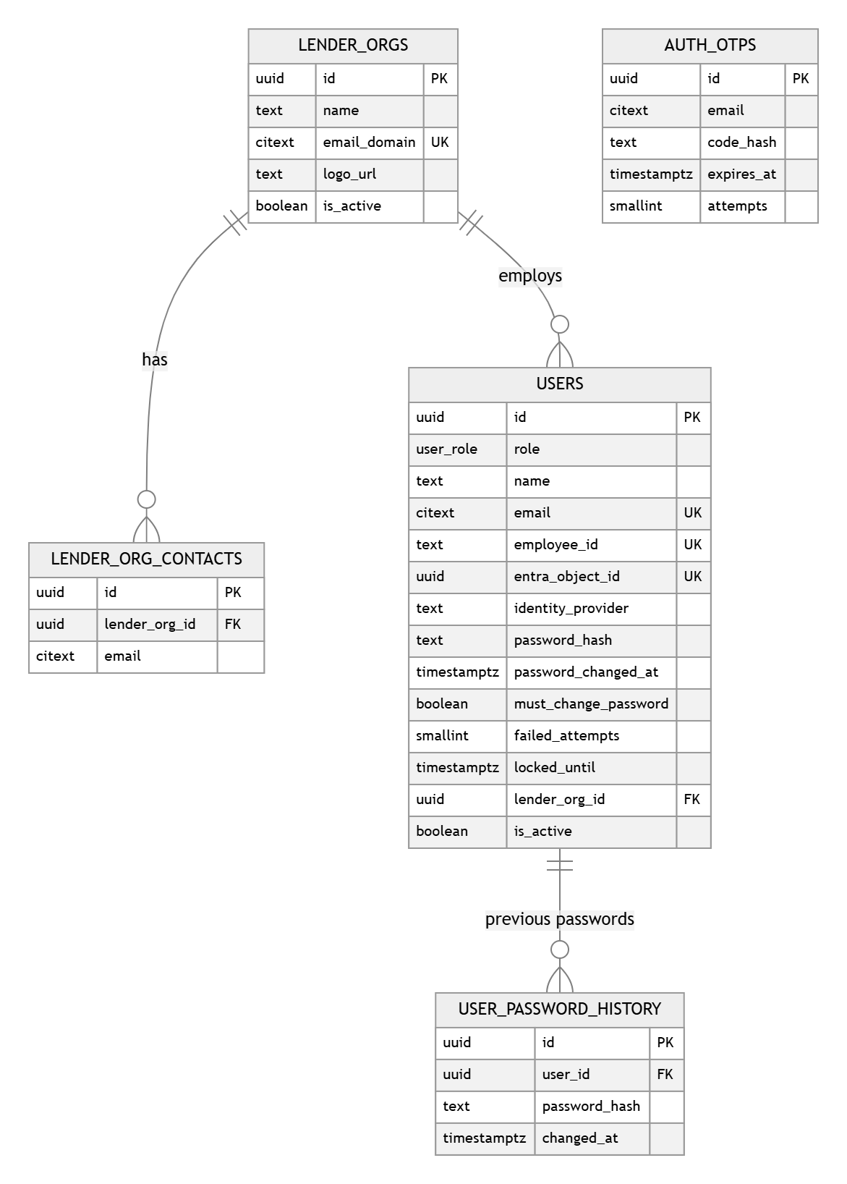
Goes on to: accounts (owns) → View 2: Accounts (the loan) · lender_document_requirements (configures) → View 5: The document checklist · document_files (uploads) → View 6: Files, decisions and retention · document_reviews (decides) → View 6: Files, decisions and retention · remarks (writes) → View 7: Remarks and notifications · audit_events (acts) → View 8: Audit, events and PAS intake
↑ Back to the map

View 2 — Accounts (the loan)
The loan a claim is made against, the mailboxes pinned to it, and the values PAS pushes in.
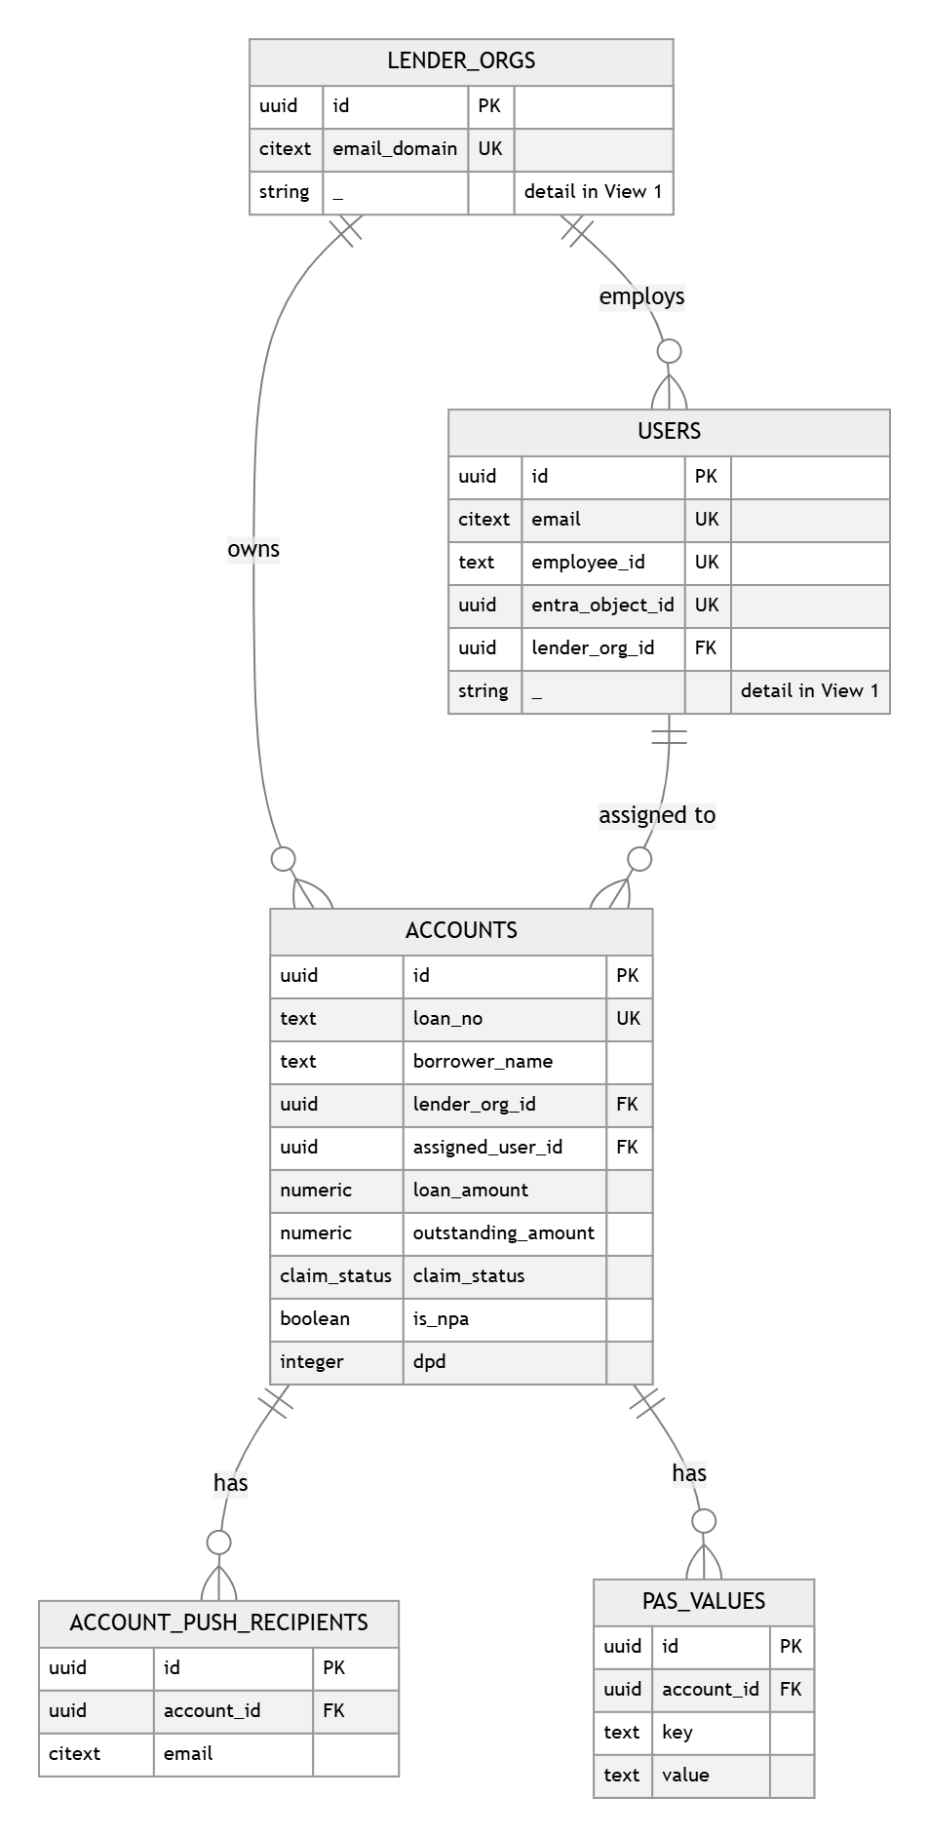
Goes on to: lender_orgs (owns) → View 1: Identity and access · users (assigned to) → View 1: Identity and access · claims (has) → View 3: Claim core · remarks (has) → View 7: Remarks and notifications · audit_events (logs) → View 8: Audit, events and PAS intake · notifications (about) → View 7: Remarks and notifications · pas_push_events (pushed in by PAS) → View 8: Audit, events and PAS intake
↑ Back to the map

View 3 — Claim core
A claim, the form values captured on it, every status it has passed through, and its outcome.

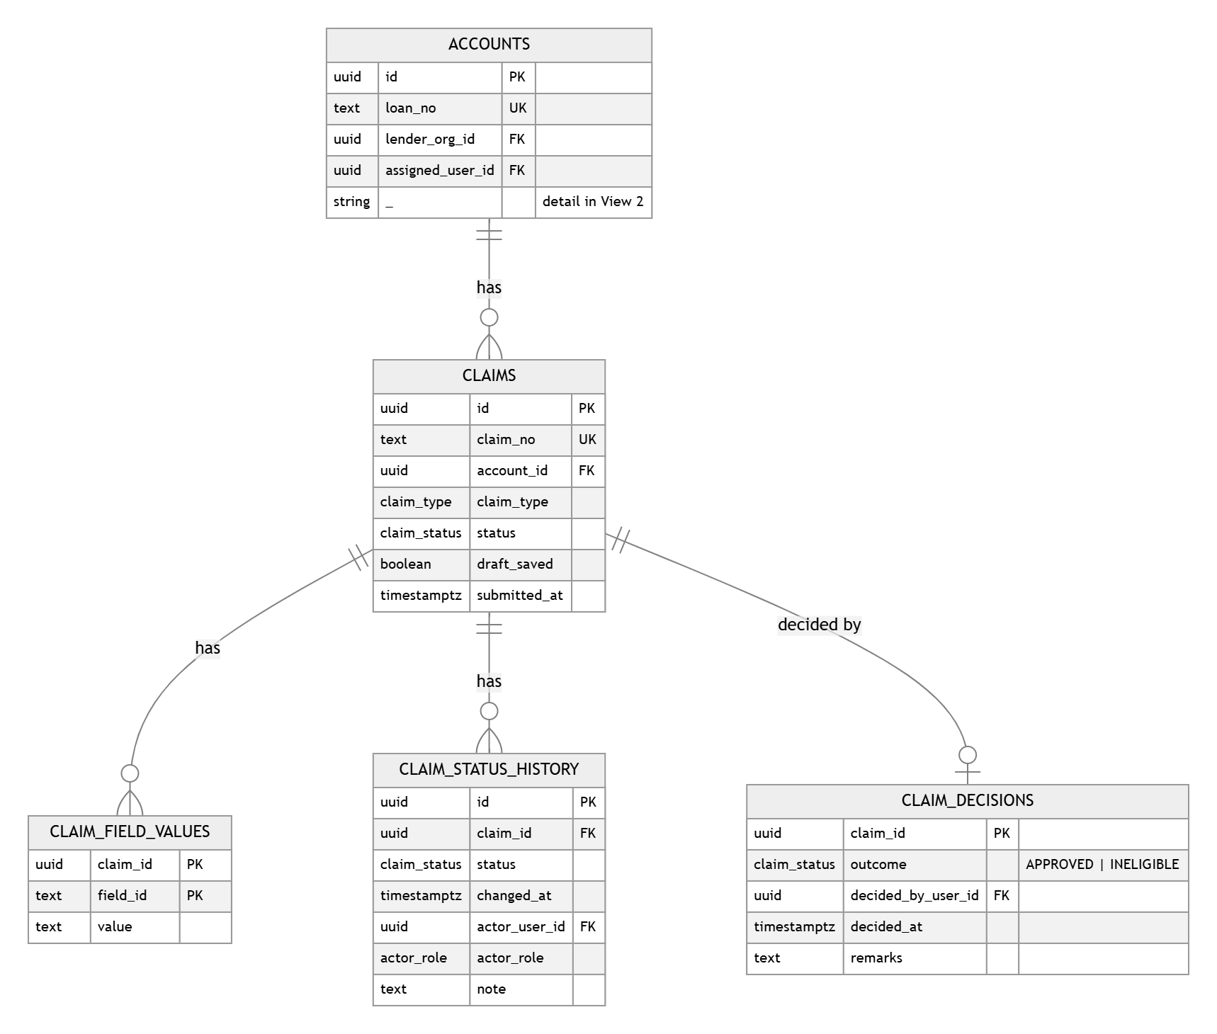

Goes on to: accounts (has) → View 2: Accounts (the loan) · claim_queries (queried by) → View 4: Queries · claim_documents (checklist of) → View 5: The document checklist
↑ Back to the map

View 4 — Queries
A query IMGC raises against a claim, the lender's response, and the documents it asks for.
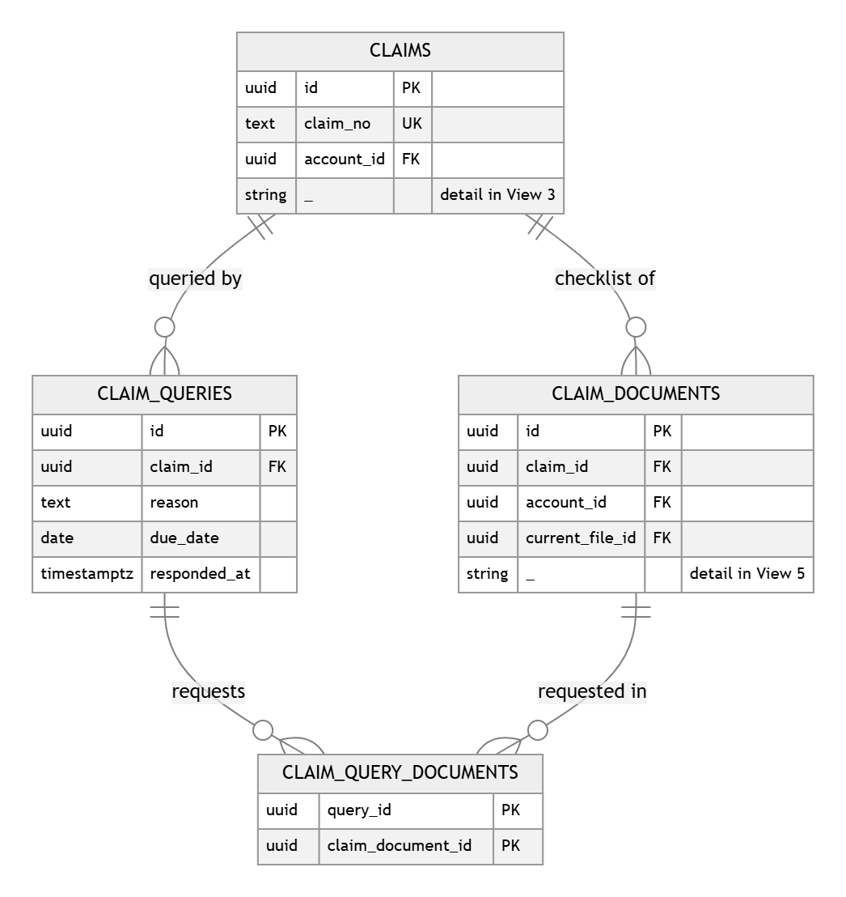
Goes on to: claims (queried by) → View 3: Claim core · claim_documents (requested in) → View 5: The document checklist
↑ Back to the map

View 5 — The document checklist
What a claim must produce: the configured defaults, the per-lender list that replaces them, and the rows a claim ends up with.
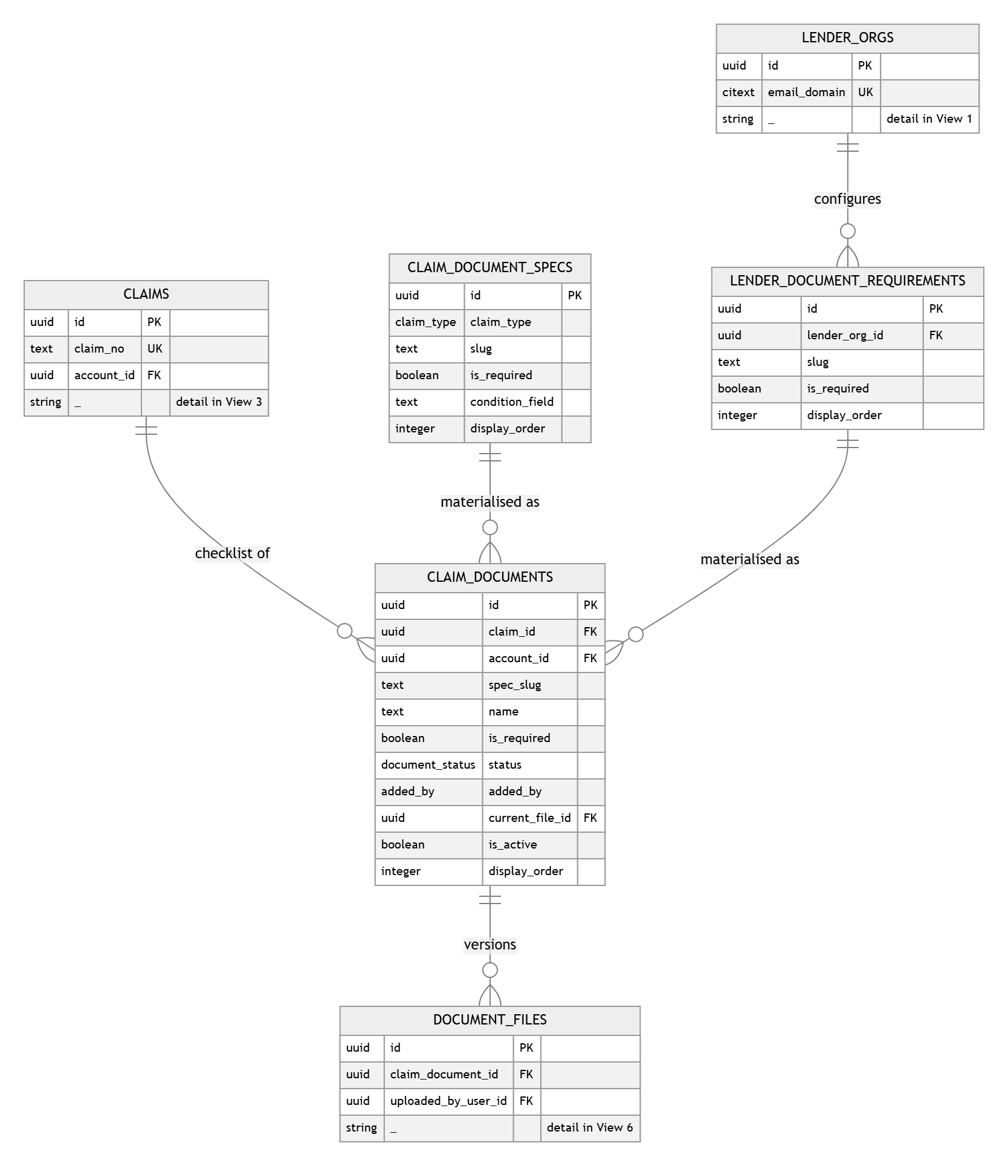
Goes on to: lender_orgs (configures) → View 1: Identity and access · claims (checklist of) → View 3: Claim core · claim_query_documents (requested in) → View 4: Queries · document_files (versions) → View 6: Files, decisions and retention · document_reviews (decided by) → View 6: Files, decisions and retention · document_waivers (waived by) → View 6: Files, decisions and retention · remarks (has) → View 7: Remarks and notifications
↑ Back to the map

View 6 — Files, decisions and retention
What was uploaded, what IMGC decided about it, what was waived instead, and what stops a rejected file being purged.
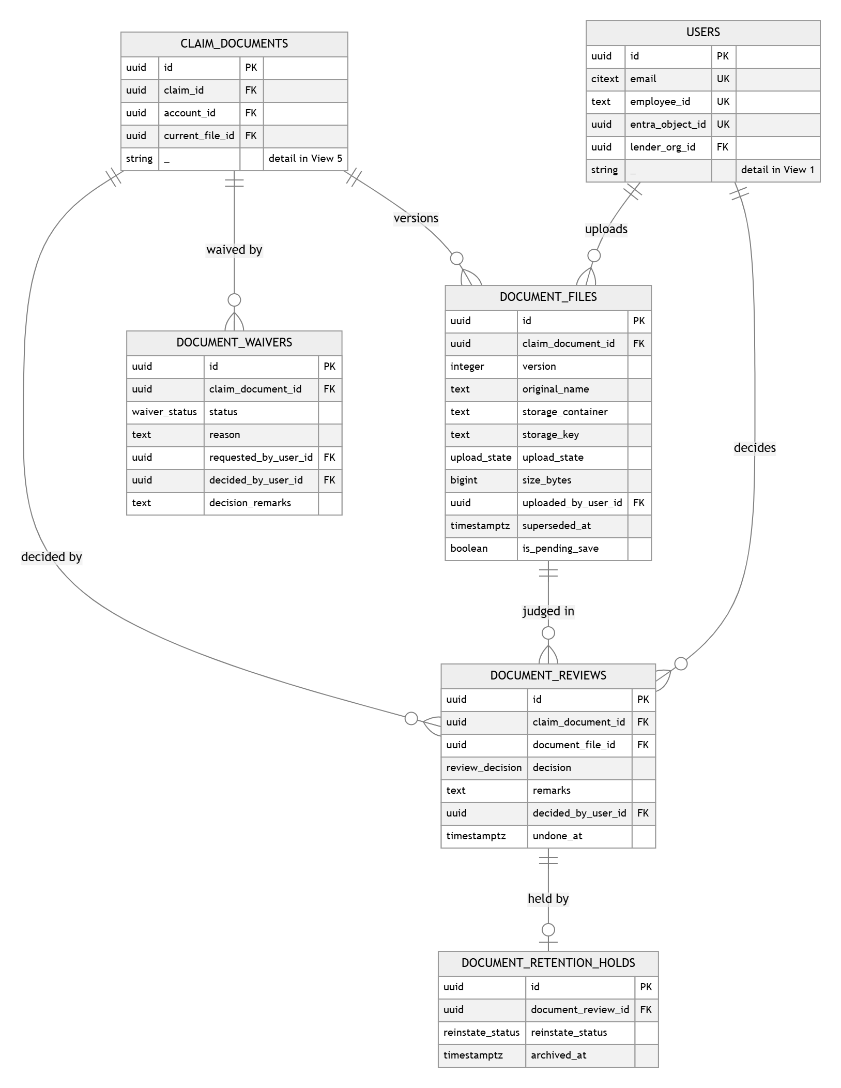
Goes on to: claim_documents (versions) → View 5: The document checklist · users (uploads) → View 1: Identity and access
↑ Back to the map

View 7 — Remarks and notifications
What people wrote, and who was told about it.
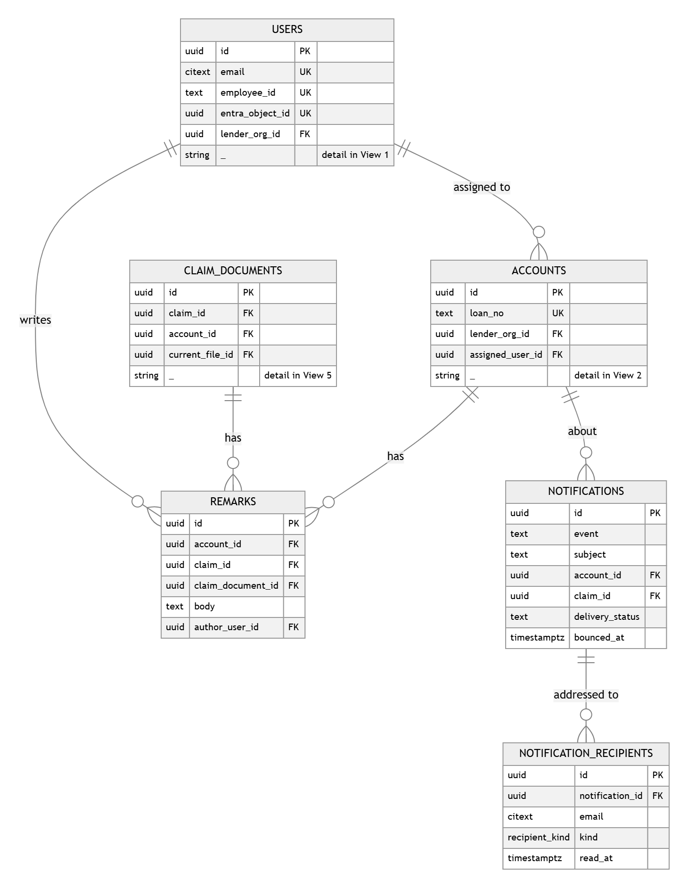
Goes on to: accounts (has) → View 2: Accounts (the loan) · claim_documents (has) → View 5: The document checklist · users (writes) → View 1: Identity and access
↑ Back to the map

View 8 — Audit, events and PAS intake
What the system recorded, the outbox feeding Kafka and Service Bus, the consumer's ledger, and every loan PAS pushes in.

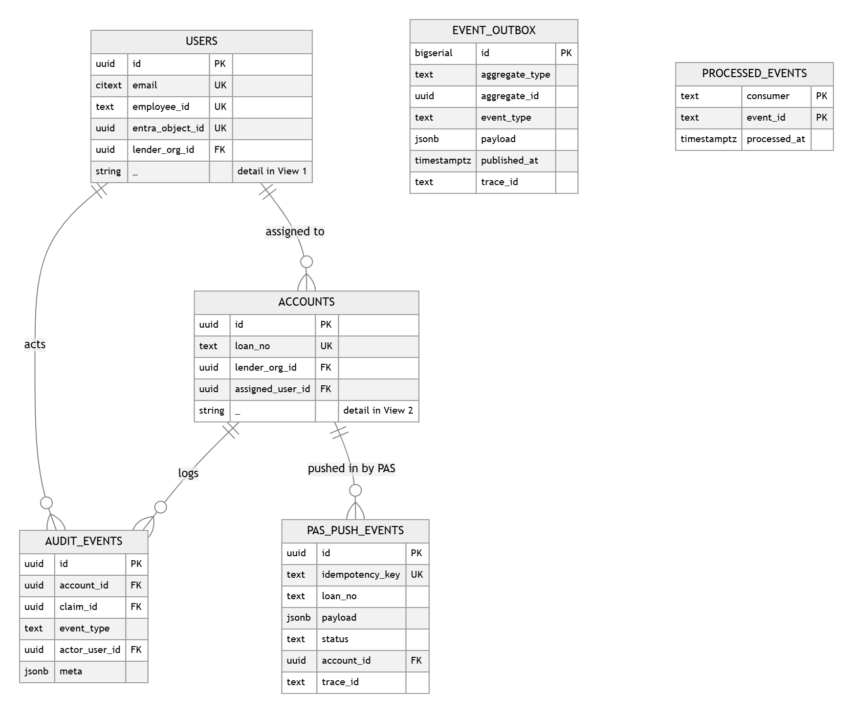

Goes on to: accounts (logs) → View 2: Accounts (the loan) · users (acts) → View 1: Identity and access
↑ Back to the map

A.10 UML — domain model
Aggregates and their behaviour, as the service layer sees them.
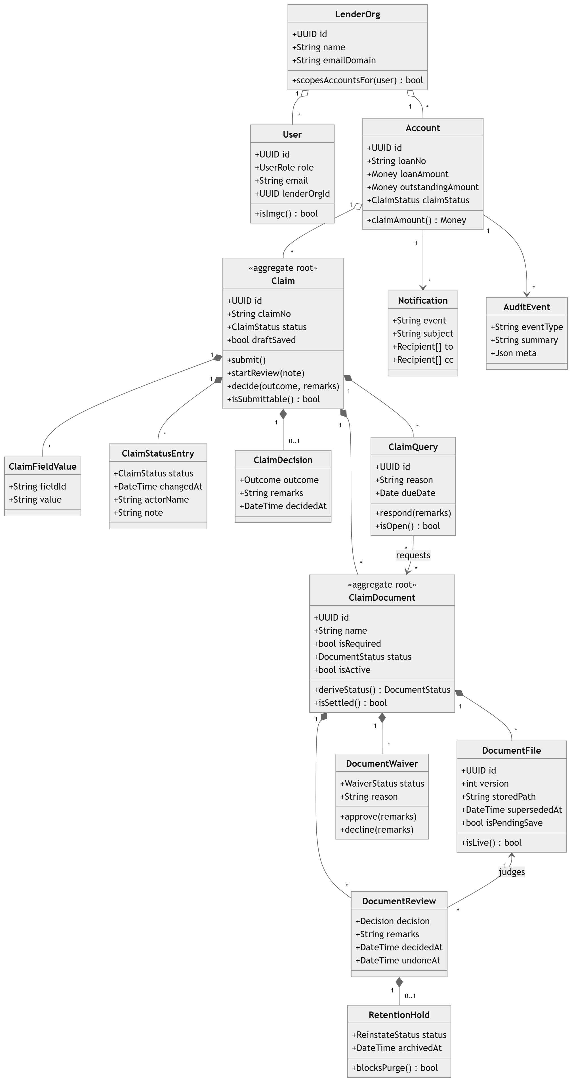
Invariants the schema enforces, or the service must:
- A document's status is derived, never set directly. claim_documents.status follows from
its live files' reviews and any approved waiver (deriveDocumentStatus today).
- A claim is submittable when every active required document is APPROVED, WAIVED, or has an
open waiver request.
- Review can start only when every active required document is APPROVED or WAIVED.
- One live claim per account — the exclusion constraint on claims.
- One open waiver per document — the partial unique index.
- A rejection and a declined waiver both need a remark — check constraints.
- Lender scoping is by accounts.lender_org_id against the user's lender_org_id, never from
anything the client sends.

A.11 Decisions taken
Settled on 28 September 2026. These are decisions, not proposals; the DDL above already reflects
them.
1. Single tenant. This is not a multi-tenant application. **One database, one deployment, no
tenant column and no per-tenant database.** Lenders are data inside it (lender_orgs), not
tenants: a lender sees only their own accounts because accounts.lender_org_id matches their
user's lender, which is ordinary row filtering. The multi-tenant machinery in the application
template (host-based tenant resolution) is not used by the database design.
Row-level security is still worth adding on accounts, claims, claim_documents,
document_files, remarks and notifications, keyed on the session's lender — as a second line
behind the service checks, not as tenancy.
2. Retention stays fixed at 90 days. A constant in code, not a settings table. A rejected
document is purged 90 days after its rejection unless a document_retention_holds row blocks it.
If it ever becomes per-lender policy, it becomes a column on lender_orgs, not a new table.
3. The refund module is withdrawn. Its UI was removed on 24 September 2026 and it is not
coming back, so **no claim_refund_receipts table ships and no REFUND_RECEIVED_BY_IMGC status
exists** — not even as a legacy value. A claim ends at APPROVED or INELIGIBLE.
3a. Eight claim statuses, and no others.
NOT_STARTED · DRAFT · INITIATED · QUERY_INITIATED · UNDER_REVIEW ·
QUERY_UNDER_REVIEW · APPROVED · INELIGIBLE
These are the statuses the application actually uses, so they are the whole enum. The prototype's
extra values are folded in by the migration and then gone (B.2): REJECTED becomes INELIGIBLE,
which is the label users already see; SUBMITTED becomes INITIATED; QUERY_RAISED becomes
QUERY_INITIATED; DOCUMENTS_RESUBMITTED becomes QUERY_UNDER_REVIEW; CLOSED and
REFUND_RECEIVED_BY_IMGC become APPROVED, which is the decision underneath each of them.
NOT_STARTED becomes a stored value rather than something inferred from an empty draft, so the
grid, the filter and the database give the same answer.
4. The claim amount stays computed. 20% of loan_amount (CLAIM_AMOUNT_RATE in
src/config/claimConfig.ts). Not stored, so changing the rate can never leave stale rows
behind. Every screen and export derives it the same way.
5. INITIAL claims only, for now. claim_document_specs is seeded for INITIAL. The
claim_type enum keeps SUBSEQUENT so adding it later is data, not a migration, but nothing is
seeded or tested for it.
6. Email is delivered for real, and bounces are recorded. notifications carries the
provider's message id and the delivery lifecycle: QUEUED → SENT → DELIVERED, or BOUNCED /
FAILED, with bounce_type as the provider reports it. A failure never loses the notification —
the row stays and the portal still shows it. The provider itself is a deployment choice, not a
schema one.
7. Ownership is derived, not stored. Analysed in the code before deciding. Today the
bucket field is written at eight transition points and read in only three places: the dashboard's
"loans with IMGC" tile, the bucket-shift audit event and its notification. Both grids **already
ignore it** and derive the owner from the claim's status (ownerForStatus in
src/config/claimOwner.ts, added 23 September 2026).
Two sources for one fact is exactly how they drift, and the status is the one that decides what the
user sees. So: no `current_party` column on `accounts` or `claims`. The rule lives in one
place:
Status | Owner
Not started, Draft, Query Initiated, Query Under Review | Lender
Initiated, Under Review, Approved, Rejected | IMGC

The dashboard tile counts claims whose status maps to IMGC. The bucket-shift audit event and its
notification stay — a handover is still worth recording — but they are raised from the status
transition rather than from a stored column.
8. Actor fields carry both an id and a name. Analysed in the code before deciding. Today's
JSON is inconsistent: DocumentReview.by and FileReview.by hold a user id alongside
byName, while Rejection.by, Reinstate.requestedBy, Reinstate.decidedBy, the waiver's by
and decidedBy, and both archived.by fields hold a display name only, and
PasValue.updatedBy can be the literal "PAS".
Every actor in the target schema is therefore a pair — *_by_user_id for joins and
*_by_name captured at the time — so history reads correctly after someone is renamed or
deactivated. The migration resolves today's name-only fields against users.name; anything
ambiguous or unmatched is reported and loaded with the id left null, never guessed.
9. IMGC staff have a password policy, enforced in the database's shape. Lender users are
unaffected — they sign in with a one-time code, and auth_otps already limits that with
attempts and expires_at.
users carries the state the policy needs:
Column | Purpose
password_changed_at | When the password was last set — drives expiry
must_change_password | Forces a change at next sign-in (new account, admin reset)
failed_attempts | Consecutive failures; reset to 0 on success
last_failed_at | When the last failure was, so a stale count can age out
locked_until | Set when the limit is reached; sign-in refused until it passes
last_login_at | Last successful sign-in, for dormant-account review

user_password_history keeps previous hashes so a reset cannot reuse one. It is never read to
authenticate — only to refuse a repeat.
The numbers are application settings rather than schema, and these are the proposed defaults,
for confirmation: expire after 90 days; lock for 30 minutes after 5 consecutive failures;
refuse the last 5 passwords; minimum 12 characters. Changing any of them is configuration, not a
migration.
13. Microsoft Entra ID is how people sign in; the database holds no secrets by default. IMGC
staff and lender users (as external identities) authenticate against Entra, and every call carries
a signed token the service validates. users therefore stores who someone is, not how they
prove it: entra_object_id is the identity key, because an email address can be reassigned and an
object id cannot.
Local password sign-in is kept for now, as a fallback. password_hash, the policy columns and
user_password_history all stay, and auth_otps stays with them, but identity_provider says
which route an account actually uses, and it defaults to ENTRA_ID. The fallback exists so the
portal is not locked out during Entra onboarding; once every account is federated, those columns
and both tables can be dropped in one migration. Password expiry, lockout and reuse rules are
Entra's policy for federated accounts, and only apply to the fallback.
No session table. Tokens are validated per call and cached in Azure Managed Redis. Sessions
never reach Postgres.
14. Documents live in Azure Blob Storage, reached by short-lived pre-signed URLs. The blob is
addressed by storage_container + storage_key; the SAS URL itself is minted per request and
never stored — it is a credential, and it would be stale before it was read. Storage account
keys live in Key Vault, not here.
Because the browser uploads straight to Azure, a file row exists before the blob is known to
have arrived. upload_state carries that: PENDING when the URL is issued, COMMITTED once the
service has verified the blob's size and checksum, ORPHANED when it never arrived. And because
retention now spans two systems, a purge marks deleted_at, deletes the blob, then sets
purge_confirmed_at — a failed blob delete stays visible instead of quietly leaving data in Azure.
15. Events are published through a transactional outbox. Kafka on Event Hubs and Service Bus
carry the audit and integration events. A business change and its event are written in **one
transaction** to event_outbox, and a relay publishes from there. Consumers record what they have
handled in processed_events, because at-least-once delivery means the same message can arrive
twice. Without both, a crash between commit and publish loses an audit event, and a redelivery
applies a decision twice.
16. Trace ids are stored, not only logged. Application Insights requires the trace id and span
id to be visible across all layers, so audit_events, notifications, pas_push_events and
event_outbox each carry trace_id. A support question then moves from a log line to the exact
row it produced.
17. Every PAS push is recorded before it is applied. pas_push_events keeps the payload as
received, with a unique idempotency_key so a retried push cannot create a second account, and a
status of RECEIVED → APPLIED / REJECTED. accounts.source_system and pas_last_synced_at
then say where a loan came from and when it was last refreshed.
18. Files stay in object storage. The database holds the locator and a checksum. No bytea.
19. Migrations are forward-only, run by Flyway or Liquibase from the Spring Boot services,
in version control, named V<n>__description.sql. No schema change reaches an environment any
other way. The database is owned by the services that write it; nothing else runs DDL.
20. Archival. audit_events and notifications grow without limit. Partition by month once
either passes roughly 10 million rows.

A.12 Still open
Nothing. Every question raised in review is settled in A.11.

Part B — Current state and mapping

B.1 How data is stored today
One SQL table, confirmed from src/server/mock/storage.ts:
Table | Column | Key | Notes
imgc_snapshots | name | PK | Row key, namespaced: db, v2:db, dev-ved:db, plus matching …:audit rows
 | version | — | Incremented per write; optimistic concurrency
 | data | — | The entire application database as one JSON document
 | updated_at | — | Write time

Two rows per deployment (SnapshotName = "db" | "audit" in storage.ts): the database, and the
audit log kept apart because it only grows (db.ts).
There are no foreign keys, indexes or constraints today. Every relationship is enforced by
application code doing .find(...) by id. The exact DDL of imgc_snapshots is Not confirmed —
no migration file exists; the table was created by hand.

B.2 Mapping — today's JSON to the target tables
Today (MockDb, types.ts) | Target table(s) | Notes on the move
lenderOrgs[] | lender_orgs + lender_org_contacts | contactEmails[] becomes rows
users[] | users | The role/lender rule becomes a check constraint; entra_object_id is filled by matching each email to Entra and reported where it cannot be matched; password-policy columns start empty, with password_changed_at set to the import date so fallback expiry runs from go-live
(no source) | user_password_history | Starts empty; fills from the first password change after go-live
(no source) | event_outbox, processed_events | Start empty; the relay fills them from go-live
(no source) | pas_push_events | Starts empty; fills from the first PAS push after go-live
otps[] | auth_otps | Gains a surrogate id; consumed becomes consumed_at
accounts[] | accounts + account_push_recipients | pushRecipients[] becomes rows
pasValues[] | pas_values | Unchanged apart from keys
claims[] | claims | Embedded parts split out, below; status remapped — see B.2.1
claims[].fields | claim_field_values | One row per field id
claims[].statusHistory[] | claim_status_history | Same shape
claims[].decision | claim_decisions | 1:1
claims[].refundReceipt | Not migrated | The refund module is withdrawn (A.11 decision 3)
claimQueries[] | claim_queries | Unchanged
claimQueries[].requestedDocuments[] | claim_query_documents | Names become document ids
claimDocuments[] | claim_documents | active → is_active; config fields kept
claimDocuments[].review | document_reviews (file id NULL) | Legacy document-level decisions
claimDocuments[].rejection | document_reviews + document_retention_holds | Reason to the review; reinstatement and archive to the hold
claimDocuments[].rejection.reinstate | document_retention_holds
claimDocuments[].waiver | document_waivers | One row per request, so a later second request is possible
documentFiles[] | document_files | accountId dropped, reachable through the document; storedPath is split into storage_container + storage_key as each blob is copied into Azure, and every imported row lands COMMITTED
documentFiles[].review | document_reviews | The live decision is the newest row with undone_at IS NULL
documentFiles[].reviews[] | document_reviews | Already append-only
documentFiles[].review.archived | document_retention_holds.archived_at
remarks[] | remarks | Unchanged
auditEvents[] (audit snapshot) | audit_events | meta becomes jsonb
notifications[] | notifications + notification_recipients | to[], cc[], unreadFor[] become rows
lenderDocumentRequirements[] | lender_document_requirements | Unchanged
CLAIM_TYPES in src/config/claimConfig.ts | claim_document_specs | A code constant becomes data

B.2.1 Status remapping
Applied to claims.status, accounts.claim_status and every claim_status_history row.
Stored today | Loads as | Why
DRAFT with no progress | NOT_STARTED | What the grid already displays (claimStatusDisplay)
DRAFT with progress | DRAFT | Unchanged
INITIATED | INITIATED | Unchanged
SUBMITTED | INITIATED | Same point in the flow; only INITIATED is written today
QUERY_INITIATED | QUERY_INITIATED | Unchanged
QUERY_RAISED | QUERY_INITIATED | Marked legacy in the code
UNDER_REVIEW | UNDER_REVIEW | Unchanged
QUERY_UNDER_REVIEW | QUERY_UNDER_REVIEW | Unchanged
DOCUMENTS_RESUBMITTED | QUERY_UNDER_REVIEW | The lender has answered; IMGC is reviewing
APPROVED | APPROVED | Unchanged
REJECTED | INELIGIBLE | Rename only — already labelled "Ineligible" in the UI
CLOSED | APPROVED | Closed follows an approval in every path that sets it
REFUND_RECEIVED_BY_IMGC | APPROVED | The decision underneath it; the refund module is gone

Counts per source status are recorded before and after, so a remap that lands in the wrong bucket
is visible rather than silent.
Not migrated: Account.bucket and Claim.bucket. Ownership is derived from status (A.11
decision 7), so there is no column to load them into. The bucket-shift audit events already
recorded keep their value as history.

B.3 Migration approach
- Stand up the schema with the migration tool, on an empty database.
- Seed configuration — claim_document_specs from claimConfig.ts, then lender requirements.
- Import in FK order — lender orgs, users, accounts, claims, claim documents, files, then
reviews, waivers, queries, remarks, notifications, audit events. Keep a map from every old string
id to its new UUID; today's ids are not UUIDs.
- Resolve the loose references — query requestedDocuments names to document ids, and every
name-only actor field to a users.id (A.11 decision 8). Anything unmatched is reported and
loaded with a null id, never guessed and never silently dropped.
- Reconcile — row counts per collection, then spot checks: a claim's document statuses, a
file's review history, an account's audit trail.
- Run both in parallel for one cycle if the volume warrants it, with the JSON snapshot kept
read-only as the rollback.

Change control
This document is the source of truth for database work. A schema change lands here first, in the
same pull request as its migration. Part A carries the DDL; Part B is maintained only while the
migration is in flight, and is removed once the JSON store is retired.

