INITIAL DEVELOPMENT

Project Proposal

This project was designed with students in mind. Every day, countless numbers of students are revising for exams, and thus need to create notes which can be used to revise from.

The goal of this project was to program an application which automatically generates files of research notes for the user when they choose to research a topic.

Design Brief

|  |  |
| --- | --- |
| Must | * Look online for data * Present the text in a file |
| Should | * Have an interactive UI * Summarize any data it finds |
| Could | * Present the data in the UI |

**Written Code visible on github**

EVALUATION OF RESULT

This is my first time working with textRank and the Wikipedia API and I experimented a lot, trying to access data from different places, however, it was often hard to parse the text off different kinds of sites, and so I stuck to using Wikipedia. This is my first ever entry into a hackathon so I find it quite a good solution.

HOW TO USE THE CODE

Step 1:

Install all necessary libraries

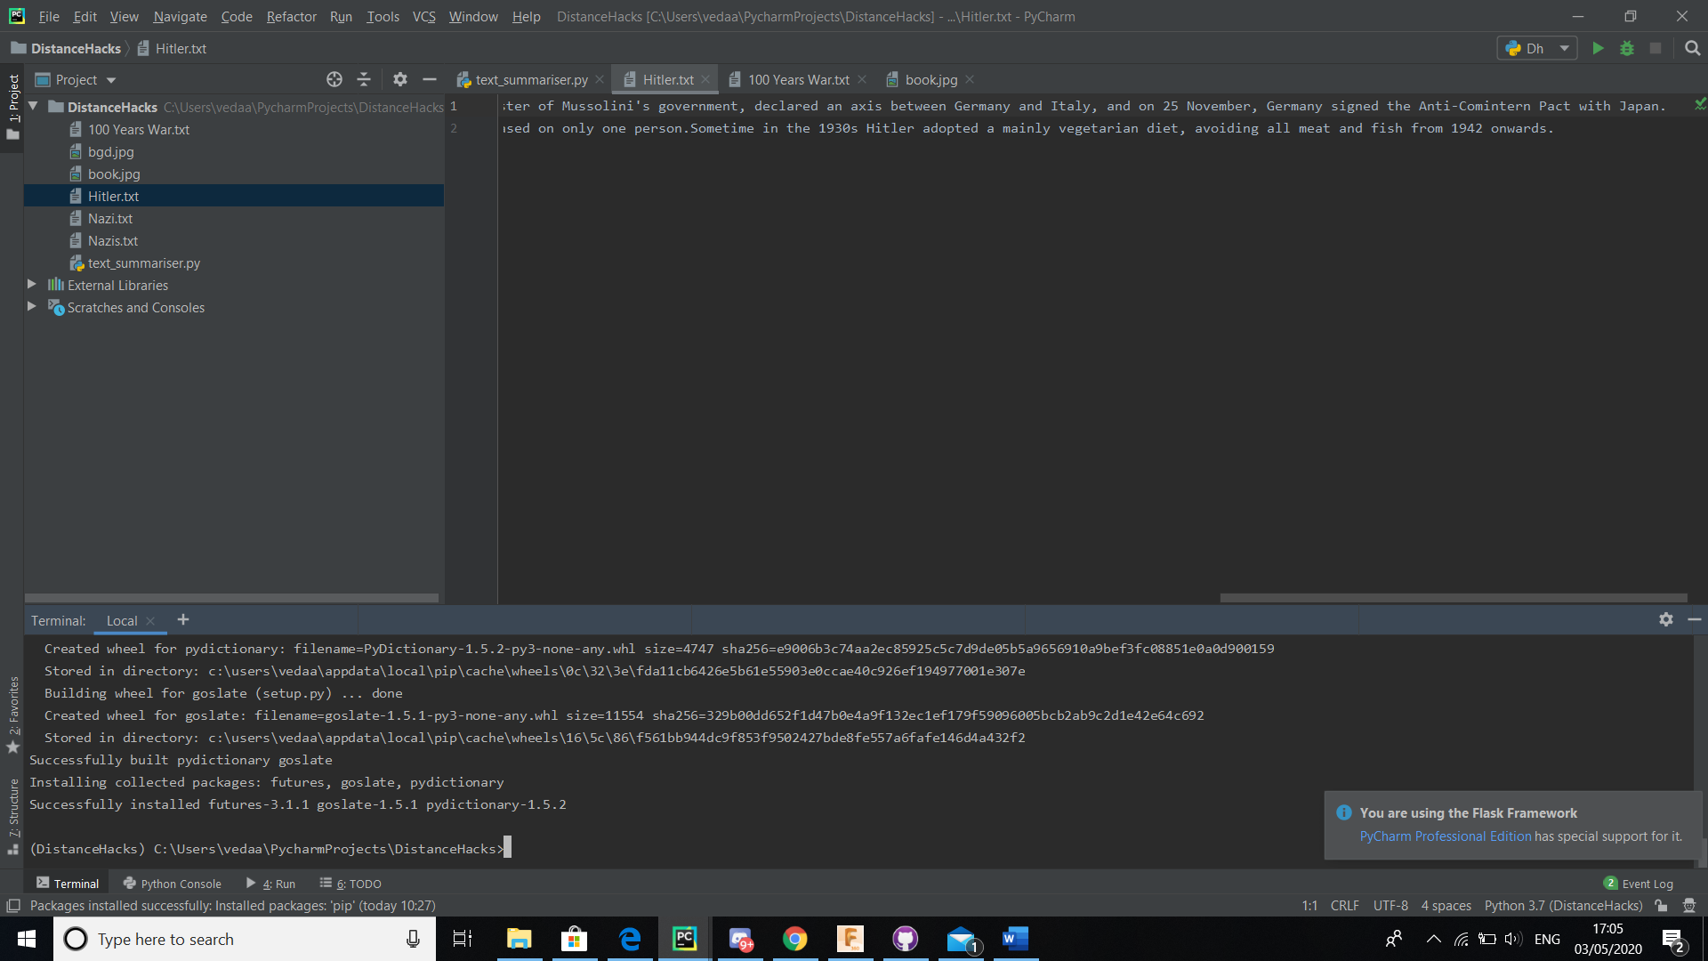

Step 2

Run the code and open the UI

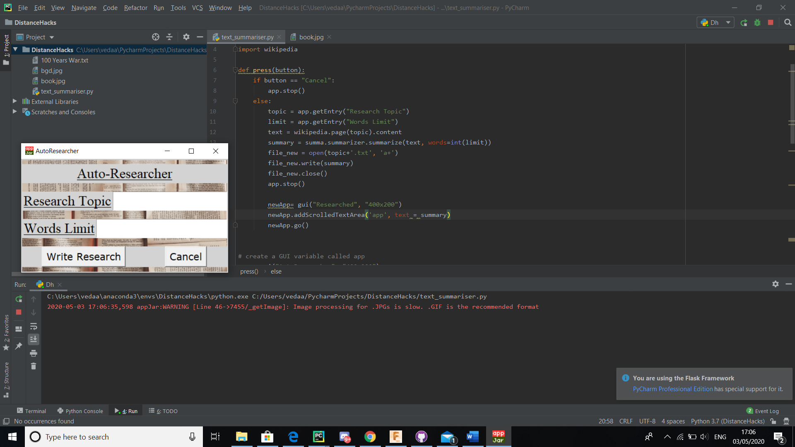

Step 3:

Enter your topic of choice and the maximum words limit. Then click write research



Step 4:

You now have both notes in the UI and in the text file on your topic

