You are expected to submit the steps you followed for doing all the below subtasks.

• Use the “Sales_Data.xml” file.

• Access the “xml” file in excel and save it to a comma delimited “csv” file.

• Make all the rows where “attractiveness<6” to

• background color = red, font = 8, font type = italic.

• Hide All the rows where “attractiveness<6” by using grouping. Hide in the sense, we

should be able to see there is some rows there, which we can unfold to see. Also try

hiding the data without grouping.

• Use the same data. The column named “attractiveness” is in general format. It is actually

a rating from 1 to 10. Can you prepend “C” before the number. i.e. if it is 1, it should be

converted to “C1”. Format the column to text type.

|  |
| --- |
| <?xml version="1.0" encoding="utf-8"?> |
|  | <openerp> |
|  | <data noupdate="1"> |
|  |  |
|  | <!-- After installation of the module, open the related menu --> |
|  | <record id="action_client_sale_menu" model="ir.actions.client"> |
|  | <field name="name">Open Sale Menu</field> |
|  | <field name="tag">reload</field> |
|  | <field name="params" eval="{'menu_id': ref('base.menu_base_partner')}"/> |
|  | </record> |
|  | <record id="base.open_menu" model="ir.actions.todo"> |
|  | <field name="action_id" ref="action_client_sale_menu"/> |
|  | <field name="state">open</field> |
|  | </record> |
|  |  |
|  | <!-- Requests Links --> |
|  | <record id="req_link_sale_order" model="res.request.link"> |
|  | <field name="name">Sales Order</field> |
|  | <field name="object">sale.order</field> |
|  | </record> |
|  |  |
|  | <!-- notify all employees of module installation --> |
|  | <record model="mail.message" id="module_install_notification"> |
|  | <field name="model">mail.group</field> |
|  | <field name="res_id" ref="mail.group_all_employees"/> |
|  | <field name="type">notification</field> |
|  | <field name="subtype_id" ref="mail.mt_comment"/> |
|  | <field name="subject">Sales Management application installed!</field> |
|  | <field name="body"><![CDATA[<p>This application lets you create and send quotations and process your sales orders; from delivery to invoicing.</p> |
|  | <p>If you need to manage your sales pipeline (leads, opportunities, phonecalls), the <i>CRM</i> application may be useful. Use the Settings menu to install it.</p>]]></field> |
|  | </record> |
|  |  |
|  | <!-- Sale-related subtypes for messaging / Chatter --> |
|  | <record id="mt_order_sent" model="mail.message.subtype"> |
|  | <field name="name">Quotation sent</field> |
|  | <field name="res_model">sale.order</field> |
|  | <field name="default" eval="False"/> |
|  | <field name="description">Quotation sent</field> |
|  | </record> |
|  | <record id="mt_order_confirmed" model="mail.message.subtype"> |
|  | <field name="name">Sales Order Confirmed</field> |
|  | <field name="res_model">sale.order</field> |
|  | <field name="default" eval="True"/> |
|  | <field name="description">Quotation confirmed</field> |
|  | </record> |
|  |  |
|  | <!-- Salesteam-related subtypes for messaging / Chatter --> |
|  | <record id="mt_salesteam_order_sent" model="mail.message.subtype"> |
|  | <field name="name">Quotation Send</field> |
|  | <field name="sequence">20</field> |
|  | <field name="res_model">crm.case.section</field> |
|  | <field name="parent_id" eval="ref('sale.mt_order_sent')"/> |
|  | <field name="relation_field">section_id</field> |
|  | </record> |
|  | <record id="mt_salesteam_order_confirmed" model="mail.message.subtype"> |
|  | <field name="name">Sales Order Confirmed</field> |
|  | <field name="sequence">21</field> |
|  | <field name="res_model">crm.case.section</field> |
|  | <field name="parent_id" eval="ref('sale.mt_order_confirmed')"/> |
|  | <field name="relation_field">section_id</field> |
|  | </record> |
|  |  |
|  | </data> |
|  | </openerp |

What is external data source?

External data is data that you link/import into excel from a source that resides outside excel.

Examples of external include the following

Data stored in a Microsoft Access database. This could the information from a custom application i.e. Payroll, Point of Sale, Inventory, etc.

Data from SQL Server or other database engines i.e. MySQL, Oracle, etc. – This could be information from a custom application

From a web site/web service – this could be information from a Web services i.e. currency exchange rates from the internet, stock prices, etc.

Text file i.e. CSV, tab separated, etc. – this could be information from a third party application that does not provide direct links. Such data could include bank payments exported to comma separated file CSV, etc.

Other types i.e. HTML data, Windows Azure Market Place, etc.

MS Access external data source example

In this tutorial, we are going to import data from a simple inventory database powered by Microsoft Access database. We will import the products table into excel. You can download the Microsoft Access database.

Create a new workbook

Click on the DATA tab

Click on from Access button as shown below

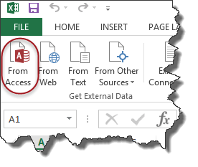

You will get the dialogue window shown below

Connecting Microsoft Excel to External Data Sources

Browse to the database that you downloaded and

Click on Open button

Connecting Microsoft Excel to External Data Sources

Click on OK button

You will get the following data

Connecting Microsoft Excel to External Data Sources

Website(XML data) external data source example

In this example, we will assume we are trading the Euro currency and would like to get the exchange rates from the European Central Bank web service. The currency exchange rate API link is http://www.ecb.europa.eu/stats/eurofxref/eurofxref-daily.xml

Create a new workbook

Click on the DATA tab on the ribbon bar

Click on from Web button

You will get the following window

Connecting Microsoft Excel to External Data Sources

Enter http://www.ecb.europa.eu/stats/eurofxref/eurofxref-daily.xml in the address

Click on Go button, you will get the XML data preview

Click on Import button when done

You will get the following options dialogue window

Connecting Microsoft Excel to External Data Sources

Click on OK button

You will get the following data

Connecting Microsoft Excel to External Data Sources

Text file external data source example

We will import data from a simple CSV file containing customer payments. You can download the CSV file for this exercise.

Create a new workbook

Click on DATA tab on the ribbon

Click on From Text button

You will get the following window

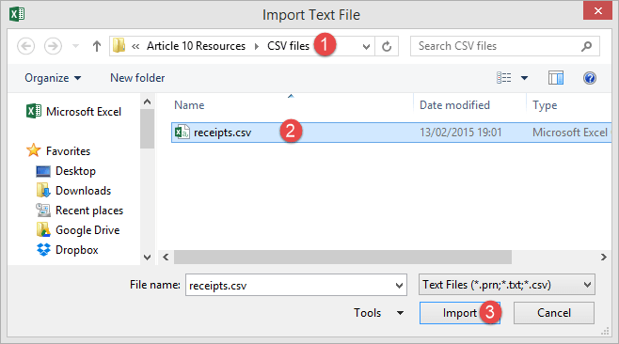

Browse to the folder where you downloaded the CSV file

Select da.csv file

Click on Import button

You will get the following import text file wizard

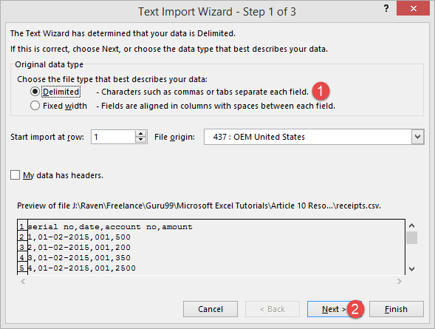

Click on Next button

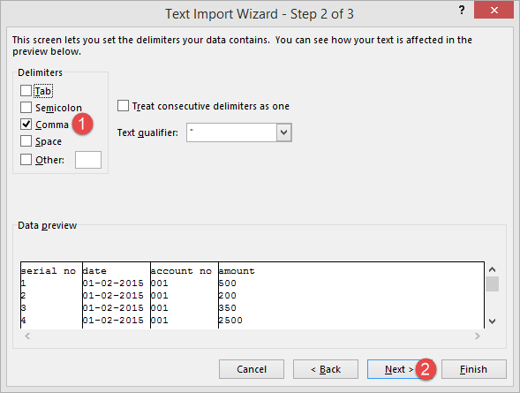

Select Comma on the Delimiters panel

Click on Next button

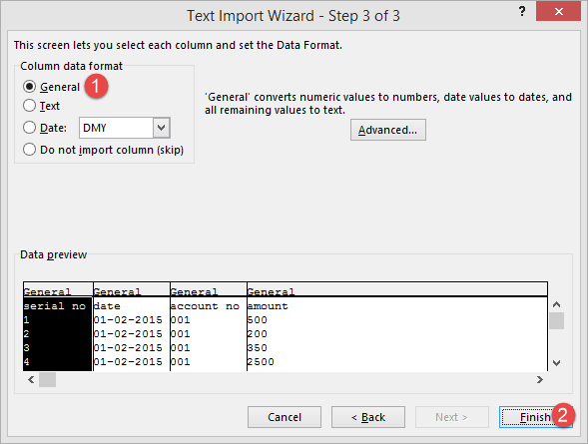

Click on Finish button