library(RcmdrPlugin.IPSUR)

data(RcmdrTestDrive)

Perform the below operations:

1. Compute the measures of central tendency for salary and reduction which variable has highest center?

Summary(RcmdrTestDrive)

>c(mean(before),median(before))

>c(mean(after),median(after))

1. Which measure of center is more appropriate for before and after?

The boxplot of before

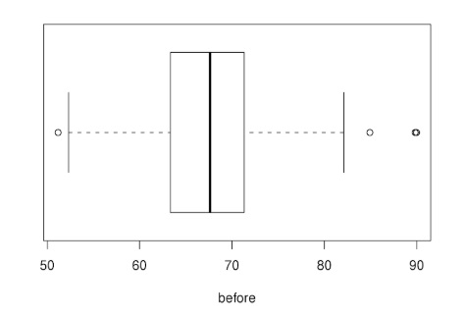

We want to watch out for extreme values or large departures from symmetry. If the distribution is fairly symmetric then the mean and median should be approximately the same. But if the distribution is highly skewed with extreme values then we should be sceptical of the sample mean, and fall back to the median which is resistant to extremes. By design, the before variable is set up to have a fairly symmetric distribution.

A boxplot of after

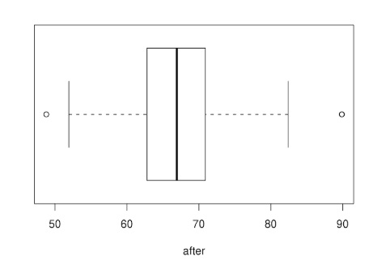

The same remarks apply to the after variable. The after variable has designed to be left-skewed.. thus, the median would likely be a good choice for this variable.