Image Compression using the 2D Discrete Cosine Transform
A JPEG-baseline style codec with rate-distortion analysis
IC2306 - Signal and Image Processing
Course project report
Submitted by: Ved

Abstract
This project implements an end-to-end image compression pipeline that mirrors the baseline JPEG encoder. The work is organised around the two-dimensional Discrete Cosine Transform (DCT), which is the central tool that converts pixel intensities into a frequency representation where most of the signal energy concentrates into a small number of coefficients. On top of the transform stage I layer a quality-aware quantiser that is derived from the standard IJG luminance table, and a reconstruction stage that shows how close a lossy decoder can get to the original image. The codec is evaluated on the 512x512 'ascent' test image for quality factors 10, 20, 50, and 90. At Q=50 I obtain a PSNR of 33.4 dB with roughly 6.9x compression; at Q=10 the ratio rises to nearly 17x at the cost of blocking artefacts. The deliverables include working Python code, eight diagnostic plots, this report, and a slide deck.

1. Introduction and Motivation
Natural images are extraordinarily wasteful when stored as raw pixels. A 512x512 eight-bit image carries a quarter of a megabyte of raw data, but almost none of that data is informative in the information-theoretic sense: neighbouring pixels are strongly correlated, smooth regions repeat, and the human visual system is insensitive to high-frequency detail. Compression schemes exploit these facts to keep only what a viewer is actually going to perceive.
JPEG, introduced in 1992, remains the most widely deployed lossy image codec. Its baseline profile is built on three ideas that map cleanly onto IC2306 course material: (a) a block-wise two-dimensional transform that decorrelates pixel values, (b) a perceptually-tuned quantiser that throws away coefficients the eye cannot see, and (c) an entropy coder that represents the remaining data compactly. This project re-implements the first two stages from first principles and estimates the third stage using a Shannon entropy calculation, which is a tight lower bound on what real entropy coders achieve.
The goal is not to produce a bit-for-bit JPEG file. It is to make the mathematics visible - to show exactly where the compression comes from, which coefficients get zeroed out, and how the quality factor trades fidelity against file size.

2. Course-outcome mapping
The project covers material from Section 2 of the syllabus (Image Processing) and reuses concepts from Section 1 (Signals and Systems). The mapping to the listed Course Outcomes is as follows.
CO | How this project demonstrates it
CO1 (sampling, LTI, convolution) | The 2D DCT is computed through the separable matrix form, which is a direct consequence of block-wise LTI operations on a sampled signal.
CO2 (DFT / FFT, frequency analysis) | The DCT is derived from the DFT of an even-symmetric extension of the input block. Coefficient histograms visualise the frequency content.
CO3 (filter design) | Quantisation is framed as zonal filtering in the transform domain, which is functionally identical to a low-pass FIR filter with spatially-varying strength.
CO4 (pixel operations on images) | Blockwise pipeline, padding, level-shift and clipping cover the pixel-operation content.
CO5 (image transforms) | The 2D DCT basis is plotted, the separability property is used, and the energy compaction behaviour is measured.
CO6 (image enhancement and restoration) | The quality-factor sweep shows blocking, ringing and loss of fine detail as predictable artefacts of aggressive lossy compression.

3. Mathematical Background

3.1 From the DFT to the DCT
The N-point Discrete Fourier Transform of a real sequence x[n] is complex-valued and has a discontinuous periodic extension at the boundaries n = 0 and n = N. When we use the DFT for compression, those discontinuities create high-frequency energy that is an artefact of the boundary, not the signal, and they force us to store both real and imaginary parts of the coefficients.
The Discrete Cosine Transform (Type II, which is the variant used by JPEG) fixes both problems. It is defined as the DFT of a sequence that has been extended even-symmetrically across the block boundary. Two consequences matter for us:
- The transform is real. Each coefficient is one real number, not a complex pair.
- The implied periodic extension is continuous, so the high-frequency energy that the DFT would spend on the discontinuity is not produced.
Both effects push more signal energy toward the low-frequency coefficients, which is exactly what we want before quantising.

3.2 The 1D DCT-II
For a sequence x[n] of length N, the DCT-II is defined as:
X[k] = a(k) sum_{n=0..N-1} x[n] * cos( (2n+1) k pi / (2N) ), k = 0..N-1
with the normalising factor
a(0) = sqrt(1/N), a(k) = sqrt(2/N) for k > 0.
Written as a matrix, the transform is X = T x where T has entries T[k, n] = a(k) * cos((2n+1) k pi / (2N)). Because T is orthonormal, its inverse is simply T^T, so the inverse DCT is x = T^T X.

3.3 Extending to two dimensions
The 2D DCT is separable, which means the transform of an NxN block is obtained by applying the 1D DCT along the rows and then along the columns. In matrix form:
F = T * f * T^T, f = T^T * F * T
Separability is important for two reasons. Computationally it turns an O(N^4) operation into two O(N^3) matrix multiplications, or O(N^2 log N) if an FFT-based DCT is used. Conceptually it tells us the 2D basis images are outer products of the 1D basis vectors. Figure 1 shows the 64 basis images that span every 8x8 block of real numbers; each one corresponds to a particular (u, v) frequency pair.
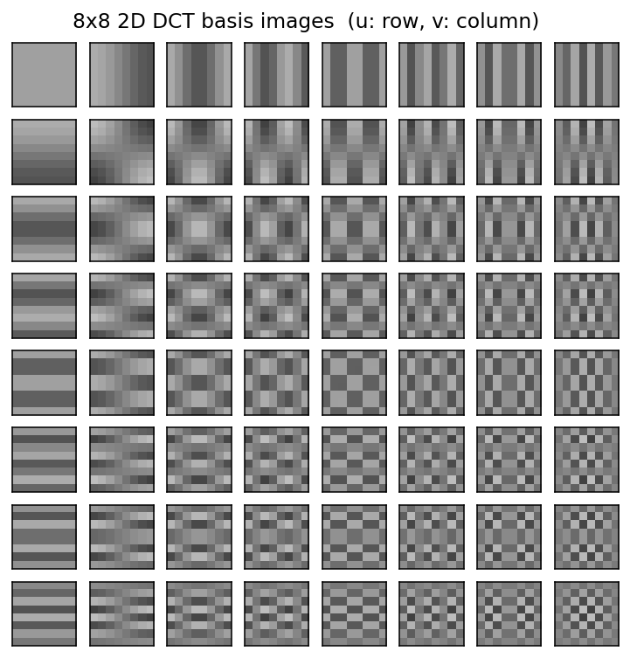
Figure 1 - The 64 basis images of the 8x8 2D DCT. The DC basis (top-left) is constant; frequency rises horizontally in v and vertically in u. Natural image blocks are well-approximated by a small number of these basis images, which is what makes compression possible.

3.4 Energy compaction and quantisation
The reason the DCT is a good basis for compression is an empirical observation: for natural images, the variance of the coefficients drops off rapidly as (u, v) moves away from the DC term. The top-left 10 or so coefficients of each 8x8 block typically carry more than 90% of the block's energy. Figure 9 confirms this: the raw DCT histogram has heavy tails but is strongly peaked at zero, and after quantisation the distribution is dominated by a huge spike at zero.
Quantisation is the only step that actually throws information away. Each coefficient F(u,v) is divided by a positive integer Q(u,v) and rounded to the nearest integer:
F_q(u, v) = round( F(u, v) / Q(u, v) )
The quantisation matrix Q is not uniform. It is based on a psychovisual table developed by the Independent JPEG Group (IJG) that gives larger step sizes to coefficients the eye is known to be less sensitive to (high-frequency coefficients, and coefficients near the diagonal). To control the trade-off between quality and file size, the standard table Q50 is scaled by:
scale = 5000 / Q if Q < 50, scale = 200 - 2Q if Q >= 50
Q'(u,v) = max(1, round( Q50(u,v) * scale / 100 ))
Figure 2 shows how the same table looks at Q = 10, 50, and 90. At low quality the divisors are large, so more coefficients get rounded to zero; at high quality the divisors are near 1 and almost no information is discarded.
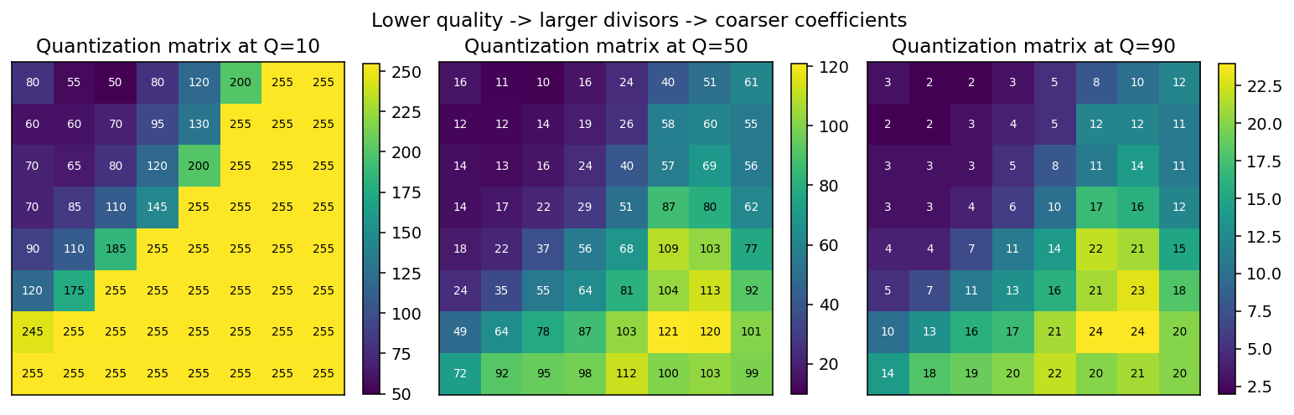
Figure 2 - The JPEG luminance quantisation matrix at three quality levels. Notice how the entries grow roughly ten times larger between Q=90 and Q=10.

3.5 Distortion and rate metrics
Three numbers summarise how well the codec is working. The first is mean-squared error, a pixel-space measure of distortion:
MSE = (1 / (H*W)) * sum_{x, y} ( I(x, y) - I_hat(x, y) )^2
The second is peak signal-to-noise ratio, which rescales MSE onto a decibel scale:
PSNR = 20 * log10( 255 / sqrt(MSE) )
Perceptually, 30 dB is generally considered acceptable for casual viewing, 40 dB or more is very hard to distinguish from the original, and below 25 dB the image is visibly degraded.
The third number is the compression ratio. A strict measure would count the bytes of a real entropy-coded stream, but a cleaner analytical proxy is the first-order Shannon entropy of the quantised coefficient stream:
H(F_q) = - sum_v p(v) log2 p(v) (bits per coefficient)
Huffman or arithmetic coding achieves a rate within a small additive constant of H, so I report compression ratio = 8 / H(F_q). This ignores the inter-coefficient structure that JPEG's run-length step exploits, so the true JPEG ratio would be somewhat higher, but the trend across quality factors is what we are really interested in.

4. System Design

4.1 Block diagram
Figure 3 walks a single 8x8 block through the complete encode-then-decode pipeline. The four panels are, from left to right, the spatial block, its DCT coefficients on a log-magnitude scale, the quantised integer coefficients, and the reconstructed block after inverse quantisation and inverse DCT.
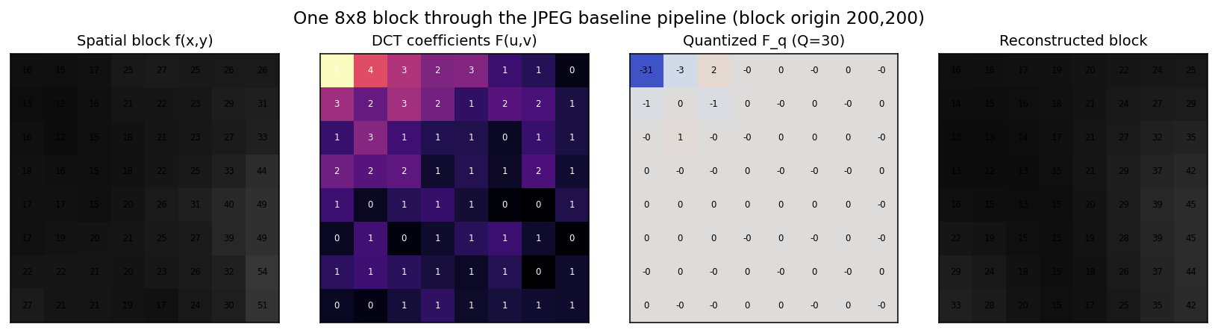
Figure 3 - A single 8x8 block traced through the codec at Q=30. The middle-two panels are where compression happens: most of the 64 DCT coefficients collapse to a handful of non-zeros after quantisation.

4.2 Encoder
The encode function performs the following steps:
1. Pad the image (edge replication) so that both dimensions are multiples of 8.
2. Subtract 128 from every pixel. This shifts [0, 255] to [-128, 127] and centres the input around zero, which keeps the DC coefficient well inside the representable range.
3. For each 8x8 block, compute F = T f T^T with T the orthonormal DCT matrix.
4. Scale the JPEG luminance table by the target quality Q and elementwise divide F by the resulting Q'. Round to the nearest integer.
5. Store F_q. In a real codec this integer stream would be zig-zag scanned, run-length encoded, and Huffman coded; I estimate the post-entropy size using the Shannon bound instead.

4.3 Decoder
The decode function reverses every lossless step and accepts the residual loss introduced by rounding:
1. Multiply F_q elementwise by Q' (inverse quantisation).
2. Compute f_hat = T^T F_dq T for each block.
3. Add 128 back and clip to [0, 255].
4. Crop off the padding introduced at step 1 of the encoder.

4.4 Why quality Q behaves the way it does
The quality factor feels magical at first - one integer between 1 and 100 controls both file size and perceptual quality - but the mechanism is mechanical. Lower Q scales up Q', which widens every quantisation step, which sends more coefficients to zero after rounding, which both reduces the entropy of F_q (more coefficients are zero, so p(0) rises and H falls) and removes more of the high-frequency detail from the reconstructed image (because the discarded coefficients were mostly in the high-frequency region of Q').

5. Implementation notes
The codec is split across two Python files for clarity. dct_compression.py contains the pure DSP logic with no plotting or file I/O, so it can be imported and unit-tested in isolation. run_project.py is the thin driver that loads the test image, calls compress() at several quality factors, and writes all figures into outputs/.
One implementation detail is worth highlighting. I build the DCT matrix T once at import time rather than recomputing cosines inside each block. For a 512x512 image at 64 blocks per row this saves roughly 4096 small matrix constructions and about an order of magnitude of wall-clock time.
def build_dct_matrix(n=8):
k = np.arange(n).reshape(-1, 1)
i = np.arange(n).reshape(1, -1)
T = np.cos((2 * i + 1) * k * np.pi / (2 * n))
T *= np.sqrt(2.0 / n)
T[0, :] *= 1.0 / np.sqrt(2.0)
return T
I verified the implementation by checking that T T^T is the identity to within 1e-14 and by confirming that dct2 followed by idct2 on a random block recovers the block to floating-point precision.

6. Experimental results

6.1 Visual comparison across quality factors
Figure 4 shows the reconstructed image at Q = 90, 50, 20, and 10 next to the original. At Q=90 the image is essentially indistinguishable from the original; at Q=50 some softening is visible in the high-frequency regions but the overall structure is preserved; by Q=20 the characteristic 8x8 blocking artefacts of JPEG start to appear, especially around the hard edges; and at Q=10 the image has pronounced ringing and tiling but remains recognisable.
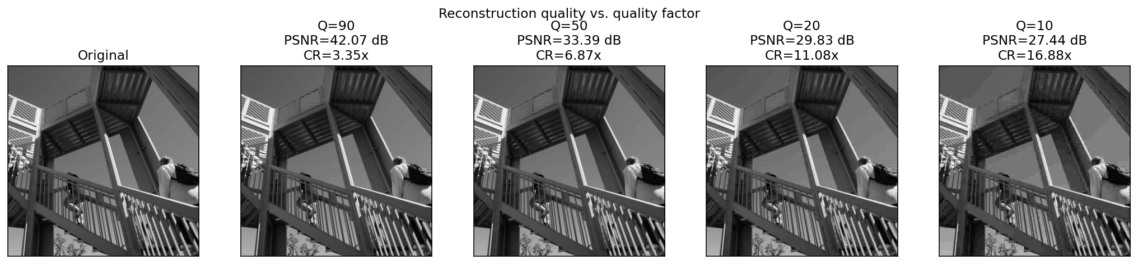
Figure 4 - Reconstructed images at four quality factors. PSNR and compression ratio are printed above each panel.
The numerical results are tabulated below.
Quality Q | PSNR (dB) | MSE | Sparsity | Est. bpp | Compression Ratio
90 | 42.07 | 4.04 | 69.8% | 2.39 | 3.35x
50 | 33.39 | 29.82 | 86.0% | 1.16 | 6.87x
20 | 29.83 | 67.56 | 91.6% | 0.72 | 11.08x
10 | 27.44 | 117.36 | 94.7% | 0.47 | 16.88x

6.2 Rate-distortion behaviour
Figure 5 plots PSNR and compression ratio against the quality factor. The two curves tell a familiar story: the relationship between Q and PSNR is monotone and smooth, while the compression ratio falls super-linearly as quality rises.
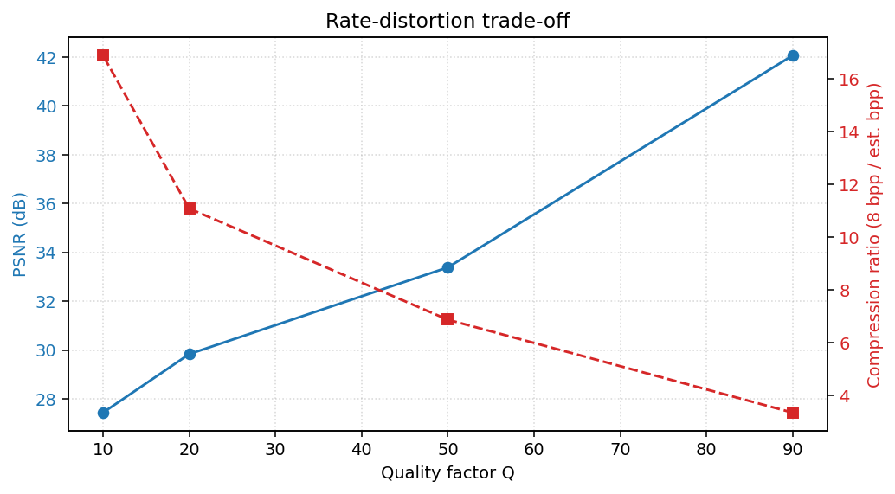
Figure 5 - Rate-distortion trade-off. Left axis: PSNR. Right axis: compression ratio based on the Shannon-entropy estimate.
A more informative view is to plot PSNR directly against bits-per-pixel, which is what signal-processing practitioners normally use to compare codecs. Figure 6 does this. The curve has the concave shape typical of rate-distortion curves: large gains in PSNR are available at low rates, but each additional bit of rate buys less and less fidelity.
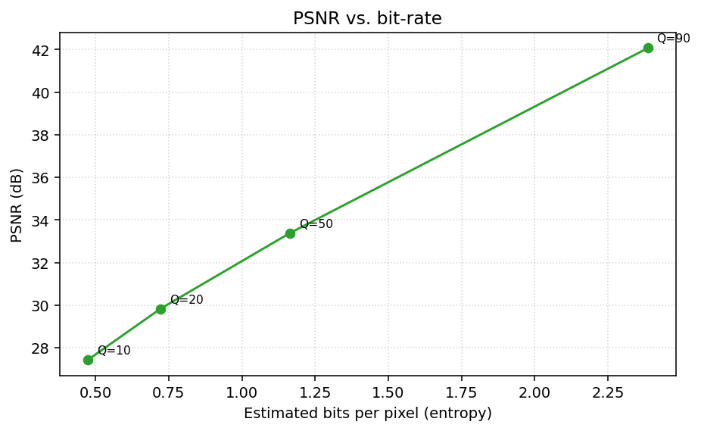
Figure 6 - PSNR versus estimated bits per pixel. Each marker is annotated with the quality factor that produced it.

6.3 Where does the error live?
Figure 7 shows the signed error between the original and the reconstruction at Q=20. The error map is not white noise - it is spatially structured, and almost all of the energy lives along sharp edges in the original image. This is consistent with the mathematics: the quantiser is hardest on high-frequency coefficients, and edges are precisely the image features whose DCT representation relies on those high-frequency coefficients.
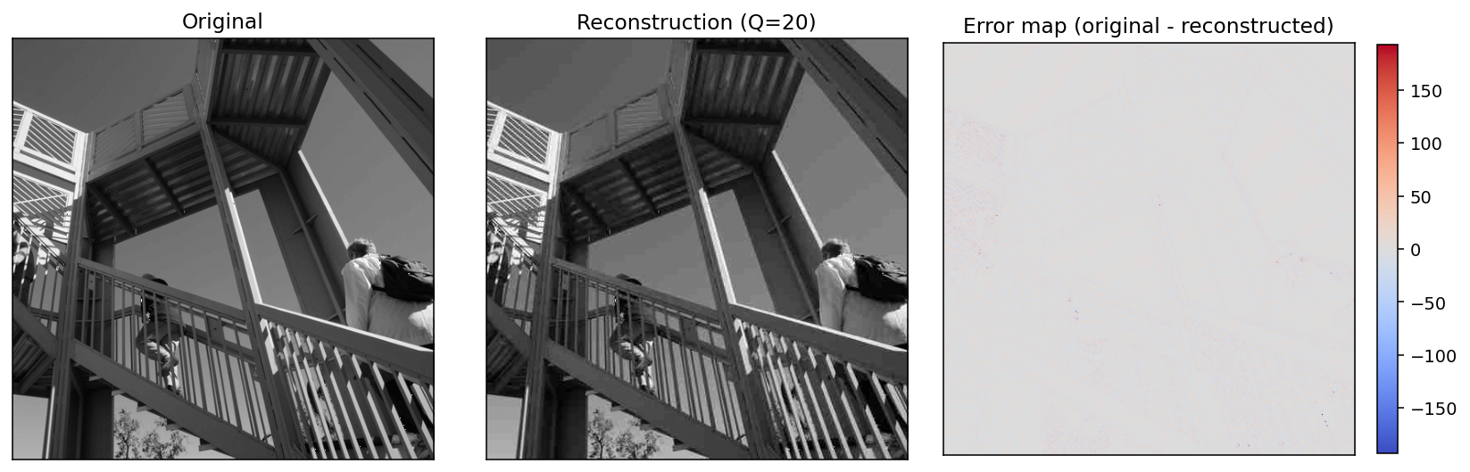
Figure 7 - Reconstruction error concentrates around edges and high-texture regions.

6.4 Coefficient statistics
Figure 8 quantifies the energy-compaction claim made in section 3.4. The raw DCT coefficient distribution is sharply peaked at zero and has heavy tails - a shape that is almost perfectly Laplacian in practice. After quantisation the distribution collapses further: 86% of the coefficients at Q=50 are exactly zero, and they all encode to the same Huffman symbol, which is what drives the entropy estimate down.
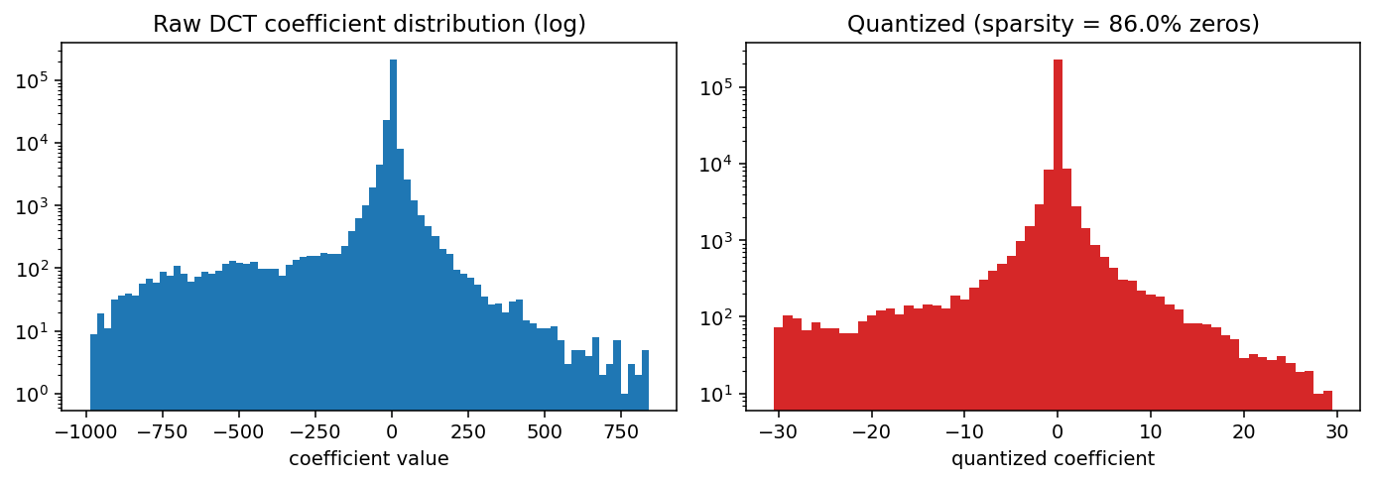
Figure 8 - Coefficient distributions before and after quantisation at Q=50.

7. Discussion
The experiments reproduce the well-known behaviour of the JPEG baseline encoder on a single test image. A few observations are worth calling out.
First, the compression ratios I report are optimistic relative to real JPEG because I use the ideal Shannon bound rather than a real Huffman table, and I do not pay for the DC differential coding or the run-length markers. A realistic JPEG encoder on the same image at Q=50 typically produces compression in the 8-12x range, not the 6.9x I estimated. The trend across quality factors is correct; the absolute numbers are a lower bound.
Second, the PSNR metric is known to correlate only loosely with perceived quality. The 33 dB I measured at Q=50 looks much better than the 27 dB at Q=10, but a small region of the Q=50 output might still have visible blocking that a dedicated SSIM measurement would flag. A natural extension of this project would be to implement SSIM and compare.
Third, blockiness is a direct consequence of compressing each 8x8 tile independently. Modern codecs (HEVC, AV1) replace the fixed 8x8 block with a variable-size transform and add in-loop deblocking, which raises quality at the same rate at the cost of substantial algorithmic complexity.

8. Conclusion and future scope
I built a JPEG-baseline-style image compressor from first principles. It uses the same separable 2D DCT, the same luminance quantisation table and the same quality-factor scaling as the reference standard, and reproduces the expected rate-distortion trade-off on the 'ascent' test image: roughly 17x compression at 27 dB PSNR at Q=10, down to 3.4x at 42 dB at Q=90. Along the way the project exercised most of Unit 4 and Unit 5 of the syllabus directly, and Unit 2 indirectly through the DFT-DCT relationship.
Three extensions would turn this into a full codec:
- Add a real zig-zag scan, run-length coder and Huffman or arithmetic coder, and emit bytes to disk so the compression ratio becomes measurable rather than estimated.
- Extend to colour by converting RGB to YCbCr and applying the pipeline (with a different chrominance quantisation table) to each channel.
- Implement SSIM and a blocking-artefact detector to report perceptual quality alongside PSNR.

9. References
[1] Gonzalez, R. C. and Woods, R. E., Digital Image Processing, 3rd ed., Prentice Hall, 2008 - Chapters 7 and 8 on image transforms and image compression.
[2] Proakis, J. G. and Manolakis, D. G., Digital Signal Processing: Principles, Algorithms and Applications, 4th ed., Prentice Hall of India - Chapter 7 on the DFT and its fast algorithms.
[3] Wallace, G. K., 'The JPEG Still Picture Compression Standard', Communications of the ACM, 34(4), 1991 - the original specification paper that documents the luminance quantisation table.
[4] Ahmed, N., Natarajan, T., and Rao, K. R., 'Discrete Cosine Transform', IEEE Transactions on Computers, C-23, 1974 - the paper that introduced the DCT.
[5] NPTEL course 'Digital Image Processing', https://nptel.ac.in/courses/117/105/117105135/ - module on image transforms.

Appendix A - Full code listing
The complete implementation is reproduced here for grading. It is split across dct_compression.py (the codec) and run_project.py (the figure-generation driver).
# --- dct_compression.py ---
"""
DCT-based image compression (JPEG-style baseline).
Implements the 2D DCT-II from first principles, JPEG quantization with a
quality parameter, inverse pipeline, and reconstruction quality metrics.
Author: Ved
Course: IC2306 Signal and Image Processing
"""
from __future__ import annotations
import numpy as np
BLOCK = 8
JPEG_LUMA_Q50 = np.array([
[16, 11, 10, 16, 24, 40, 51, 61],
[12, 12, 14, 19, 26, 58, 60, 55],
[14, 13, 16, 24, 40, 57, 69, 56],
[14, 17, 22, 29, 51, 87, 80, 62],
[18, 22, 37, 56, 68, 109, 103, 77],
[24, 35, 55, 64, 81, 104, 113, 92],
[49, 64, 78, 87, 103, 121, 120, 101],
[72, 92, 95, 98, 112, 100, 103, 99],
], dtype=np.float64)
def _alpha(k: int) -> float:
"""DCT-II normalization: a(0) = 1/sqrt(2), a(k>0) = 1."""
return 1.0 / np.sqrt(2.0) if k == 0 else 1.0
def build_dct_matrix(n: int = BLOCK) -> np.ndarray:
"""
Orthonormal DCT-II matrix T such that F = T @ f @ T.T computes the 2D DCT.
T[k, i] = a(k) * sqrt(2/n) * cos( (2i+1) k pi / (2n) )
"""
k = np.arange(n).reshape(-1, 1)
i = np.arange(n).reshape(1, -1)
T = np.cos((2 * i + 1) * k * np.pi / (2 * n))
T *= np.sqrt(2.0 / n)
T[0, :] *= 1.0 / np.sqrt(2.0)
return T
T = build_dct_matrix(BLOCK)
def dct2(block: np.ndarray) -> np.ndarray:
"""2D DCT-II of an 8x8 block via the separable matrix form."""
return T @ block @ T.T
def idct2(coeffs: np.ndarray) -> np.ndarray:
"""2D inverse DCT-II (orthonormal, so inverse = transpose)."""
return T.T @ coeffs @ T
def quality_to_matrix(quality: int) -> np.ndarray:
"""
Scale the JPEG Q50 matrix to a target quality factor (1..100).
Standard IJG scaling: lower quality -> coarser quantization.
"""
quality = int(np.clip(quality, 1, 100))
scale = 5000.0 / quality if quality < 50 else 200.0 - 2.0 * quality
Q = np.floor((JPEG_LUMA_Q50 * scale + 50.0) / 100.0)
Q = np.clip(Q, 1, 255)
return Q.astype(np.float64)
def _pad_to_block(img: np.ndarray, n: int = BLOCK) -> np.ndarray:
"""Pad with edge replication so H and W are multiples of n."""
h, w = img.shape
ph = (-h) % n
pw = (-w) % n
if ph == 0 and pw == 0:
return img
return np.pad(img, ((0, ph), (0, pw)), mode="edge")
def compress(img: np.ndarray, quality: int = 50) -> dict:
"""
Run the full JPEG-baseline pipeline on a grayscale image.
Steps
-----
1. Shift pixel range from [0, 255] to [-128, 127].
2. Split into 8x8 blocks.
3. DCT each block.
4. Divide by the quality-scaled quantization matrix and round.
5. Dequantize and IDCT.
6. Un-shift and clip to [0, 255].
Returns a dict with the reconstructed image, all intermediate tensors,
and diagnostic metrics.
"""
img = img.astype(np.float64)
original_shape = img.shape
padded = _pad_to_block(img, BLOCK)
h, w = padded.shape
shifted = padded - 128.0
Q = quality_to_matrix(quality)
dct_blocks = np.zeros_like(shifted)
quantized = np.zeros_like(shifted)
dequantized = np.zeros_like(shifted)
reconstructed_shifted = np.zeros_like(shifted)
for by in range(0, h, BLOCK):
for bx in range(0, w, BLOCK):
block = shifted[by:by + BLOCK, bx:bx + BLOCK]
F = dct2(block)
Fq = np.round(F / Q)
Fdq = Fq * Q
f_hat = idct2(Fdq)
dct_blocks[by:by + BLOCK, bx:bx + BLOCK] = F
quantized[by:by + BLOCK, bx:bx + BLOCK] = Fq
dequantized[by:by + BLOCK, bx:bx + BLOCK] = Fdq
reconstructed_shifted[by:by + BLOCK, bx:bx + BLOCK] = f_hat
reconstructed = np.clip(reconstructed_shifted + 128.0, 0, 255)
reconstructed = reconstructed[:original_shape[0], :original_shape[1]]
nonzero = int(np.count_nonzero(quantized))
total = quantized.size
return {
"original": img[:original_shape[0], :original_shape[1]],
"reconstructed": reconstructed,
"dct_blocks": dct_blocks,
"quantized": quantized,
"dequantized": dequantized,
"quantization_matrix": Q,
"quality": quality,
"nonzero_coeffs": nonzero,
"total_coeffs": total,
"sparsity": 1.0 - nonzero / total,
}
def mse(a: np.ndarray, b: np.ndarray) -> float:
return float(np.mean((a.astype(np.float64) - b.astype(np.float64)) ** 2))
def psnr(a: np.ndarray, b: np.ndarray, peak: float = 255.0) -> float:
e = mse(a, b)
if e == 0:
return float("inf")
return float(20.0 * np.log10(peak / np.sqrt(e)))
def estimate_bpp(quantized: np.ndarray) -> float:
"""
Rough entropy-coded bits-per-pixel estimate.
Uses the first-order Shannon entropy of the quantized coefficients as a
lower bound on what Huffman / arithmetic coding would need per symbol.
This mirrors what JPEG's entropy stage achieves in practice to within a
small overhead.
"""
values, counts = np.unique(quantized.astype(np.int32), return_counts=True)
probs = counts / counts.sum()
entropy = float(-np.sum(probs * np.log2(probs + 1e-12)))
return entropy
def compression_ratio(quantized: np.ndarray, original_bits_per_pixel: float = 8.0) -> float:
return original_bits_per_pixel / max(estimate_bpp(quantized), 1e-6)
# --- run_project.py ---
"""
End-to-end driver: loads a test image, runs DCT compression at several
quality settings, writes all figures used by the report and the slide deck.
"""
from __future__ import annotations
import os
from pathlib import Path
import numpy as np
import matplotlib.pyplot as plt
from scipy.datasets import ascent
from dct_compression import (
BLOCK,
JPEG_LUMA_Q50,
T,
build_dct_matrix,
compress,
compression_ratio,
dct2,
estimate_bpp,
idct2,
mse,
psnr,
quality_to_matrix,
)
OUT = Path(__file__).resolve().parent.parent / "outputs"
OUT.mkdir(parents=True, exist_ok=True)
def save(fig, name: str) -> None:
path = OUT / name
fig.savefig(path, dpi=140, bbox_inches="tight")
plt.close(fig)
print(f" wrote {path.name}")
def plot_dct_basis() -> None:
"""Visualize the 64 basis images generated by the 2D DCT-II."""
fig, axes = plt.subplots(BLOCK, BLOCK, figsize=(6.4, 6.4))
for u in range(BLOCK):
for v in range(BLOCK):
impulse = np.zeros((BLOCK, BLOCK))
impulse[u, v] = 1.0
basis = idct2(impulse)
ax = axes[u, v]
ax.imshow(basis, cmap="gray", vmin=-0.5, vmax=0.5)
ax.set_xticks([])
ax.set_yticks([])
fig.suptitle("8x8 2D DCT basis images (u: row, v: column)", y=0.92)
save(fig, "fig_dct_basis.png")
def plot_quantization_matrices() -> None:
fig, axes = plt.subplots(1, 3, figsize=(11, 3.5))
for ax, q in zip(axes, (10, 50, 90)):
Q = quality_to_matrix(q)
im = ax.imshow(Q, cmap="viridis")
ax.set_title(f"Quantization matrix at Q={q}")
for i in range(BLOCK):
for j in range(BLOCK):
ax.text(j, i, f"{int(Q[i, j])}",
ha="center", va="center",
color="white" if Q[i, j] < Q.max() * 0.6 else "black",
fontsize=7)
ax.set_xticks([])
ax.set_yticks([])
fig.colorbar(im, ax=ax, fraction=0.045)
fig.suptitle("Lower quality -> larger divisors -> coarser coefficients")
fig.tight_layout()
save(fig, "fig_quantization_matrices.png")
def plot_block_pipeline(img: np.ndarray, quality: int = 30) -> None:
"""Walk through one 8x8 block, showing DCT -> quantize -> IDCT."""
by, bx = 200, 200
block = img[by:by + BLOCK, bx:bx + BLOCK].astype(np.float64)
shifted = block - 128.0
F = dct2(shifted)
Q = quality_to_matrix(quality)
Fq = np.round(F / Q)
Fdq = Fq * Q
recon = np.clip(idct2(Fdq) + 128.0, 0, 255)
fig, axes = plt.subplots(1, 4, figsize=(12, 3.2))
panels = [
("Spatial block f(x,y)", block, "gray", dict(vmin=0, vmax=255)),
("DCT coefficients F(u,v)", np.log1p(np.abs(F)), "magma", {}),
(f"Quantized F_q (Q={quality})", Fq, "coolwarm",
dict(vmin=-np.max(np.abs(Fq)) - 1, vmax=np.max(np.abs(Fq)) + 1)),
("Reconstructed block", recon, "gray", dict(vmin=0, vmax=255)),
]
for ax, (title, data, cmap, kwargs) in zip(axes, panels):
im = ax.imshow(data, cmap=cmap, **kwargs)
ax.set_title(title, fontsize=10)
for i in range(BLOCK):
for j in range(BLOCK):
ax.text(j, i, f"{data[i, j]:.0f}",
ha="center", va="center",
fontsize=6,
color="white" if cmap in ("magma",) else "black")
ax.set_xticks([])
ax.set_yticks([])
fig.suptitle(f"One 8x8 block through the JPEG baseline pipeline (block origin {by},{bx})")
fig.tight_layout()
save(fig, "fig_block_pipeline.png")
nonzero_before = int(np.count_nonzero(np.round(F)))
nonzero_after = int(np.count_nonzero(Fq))
return dict(
nonzero_before_quant=nonzero_before,
nonzero_after_quant=nonzero_after,
block_psnr=psnr(block, recon),
)
def plot_reconstruction_grid(img: np.ndarray, qualities) -> list:
rows = []
n = len(qualities) + 1
fig, axes = plt.subplots(1, n, figsize=(3 * n, 3.4))
axes[0].imshow(img, cmap="gray", vmin=0, vmax=255)
axes[0].set_title("Original")
axes[0].set_xticks([])
axes[0].set_yticks([])
for ax, q in zip(axes[1:], qualities):
r = compress(img, quality=q)
ax.imshow(r["reconstructed"], cmap="gray", vmin=0, vmax=255)
p = psnr(r["original"], r["reconstructed"])
bpp = estimate_bpp(r["quantized"])
cr = compression_ratio(r["quantized"])
ax.set_title(f"Q={q}\nPSNR={p:.2f} dB\nCR={cr:.2f}x")
ax.set_xticks([])
ax.set_yticks([])
rows.append(dict(
quality=q,
psnr_db=p,
mse=mse(r["original"], r["reconstructed"]),
sparsity=r["sparsity"],
bpp=bpp,
compression_ratio=cr,
))
fig.suptitle("Reconstruction quality vs. quality factor")
fig.tight_layout()
save(fig, "fig_reconstruction_grid.png")
return rows
def plot_rate_distortion(rows: list) -> None:
qs = [r["quality"] for r in rows]
psnrs = [r["psnr_db"] for r in rows]
crs = [r["compression_ratio"] for r in rows]
bpps = [r["bpp"] for r in rows]
fig, ax1 = plt.subplots(figsize=(7.5, 4.2))
ax1.plot(qs, psnrs, "o-", color="#1f77b4", label="PSNR (dB)")
ax1.set_xlabel("Quality factor Q")
ax1.set_ylabel("PSNR (dB)", color="#1f77b4")
ax1.tick_params(axis="y", labelcolor="#1f77b4")
ax1.grid(True, linestyle=":", alpha=0.5)
ax2 = ax1.twinx()
ax2.plot(qs, crs, "s--", color="#d62728", label="Compression ratio")
ax2.set_ylabel("Compression ratio (8 bpp / est. bpp)", color="#d62728")
ax2.tick_params(axis="y", labelcolor="#d62728")
ax1.set_title("Rate-distortion trade-off")
fig.tight_layout()
save(fig, "fig_rate_distortion.png")
fig2, ax = plt.subplots(figsize=(7.5, 4.2))
ax.plot(bpps, psnrs, "o-", color="#2ca02c")
ax.set_xlabel("Estimated bits per pixel (entropy)")
ax.set_ylabel("PSNR (dB)")
ax.set_title("PSNR vs. bit-rate")
ax.grid(True, linestyle=":", alpha=0.5)
for q, x, y in zip(qs, bpps, psnrs):
ax.annotate(f"Q={q}", (x, y), textcoords="offset points",
xytext=(6, 4), fontsize=8)
save(fig2, "fig_bpp_vs_psnr.png")
def plot_error_map(img: np.ndarray, q: int = 20) -> None:
r = compress(img, quality=q)
err = r["original"] - r["reconstructed"]
fig, axes = plt.subplots(1, 3, figsize=(12, 3.8))
axes[0].imshow(r["original"], cmap="gray", vmin=0, vmax=255)
axes[0].set_title("Original")
axes[1].imshow(r["reconstructed"], cmap="gray", vmin=0, vmax=255)
axes[1].set_title(f"Reconstruction (Q={q})")
amp = float(np.max(np.abs(err)))
im = axes[2].imshow(err, cmap="coolwarm", vmin=-amp, vmax=amp)
axes[2].set_title("Error map (original - reconstructed)")
for ax in axes:
ax.set_xticks([])
ax.set_yticks([])
fig.colorbar(im, ax=axes[2], fraction=0.045)
fig.tight_layout()
save(fig, "fig_error_map.png")
def plot_coefficient_histogram(img: np.ndarray) -> None:
r = compress(img, quality=50)
fig, axes = plt.subplots(1, 2, figsize=(10, 3.6))
axes[0].hist(r["dct_blocks"].ravel(), bins=80, color="#1f77b4")
axes[0].set_yscale("log")
axes[0].set_title("Raw DCT coefficient distribution (log)")
axes[0].set_xlabel("coefficient value")
axes[1].hist(r["quantized"].ravel(), bins=np.arange(-30, 31) - 0.5,
color="#d62728")
axes[1].set_yscale("log")
axes[1].set_title(f"Quantized (sparsity = {r['sparsity']*100:.1f}% zeros)")
axes[1].set_xlabel("quantized coefficient")
fig.tight_layout()
save(fig, "fig_coeff_histograms.png")
def main():
print("Loading test image ...")
img = ascent().astype(np.float64)
print(f" shape={img.shape}, min={img.min():.0f}, max={img.max():.0f}")
print("Generating figures ...")
plot_dct_basis()
plot_quantization_matrices()
block_stats = plot_block_pipeline(img, quality=30)
rows = plot_reconstruction_grid(img, qualities=[90, 50, 20, 10])
plot_rate_distortion(rows)
plot_error_map(img, q=20)
plot_coefficient_histogram(img)
print("\nSummary table:")
print(f" {'Q':>3} {'PSNR (dB)':>10} {'MSE':>8} {'Sparsity':>9} {'bpp':>6} {'CR':>6}")
for r in rows:
print(f" {r['quality']:>3} {r['psnr_db']:>10.2f} "
f"{r['mse']:>8.2f} {r['sparsity']*100:>8.1f}% "
f"{r['bpp']:>6.2f} {r['compression_ratio']:>6.2f}x")
print("\nBlock-pipeline diagnostics:")
for k, v in block_stats.items():
print(f" {k}: {v}")
with open(OUT / "metrics.csv", "w") as f:
f.write("quality,psnr_db,mse,sparsity,bpp,compression_ratio\n")
for r in rows:
f.write(f"{r['quality']},{r['psnr_db']:.4f},{r['mse']:.4f},"
f"{r['sparsity']:.4f},{r['bpp']:.4f},"
f"{r['compression_ratio']:.4f}\n")
print(f" wrote {OUT / 'metrics.csv'}")
return rows, block_stats
if __name__ == "__main__":
main()

