**Review of TCP Congestion Control**

* Connection-oriented, reliable, ordered, byte-stream protocol with explicit flow control.
* Divides data into Sender Maximum Segment Size (SMSS), and labels with sequence numbers to guarantee ordering and reliability.
* When a host receives in-sequence segment, it sends an ACK, if an out-of-sequence segment is received, it send next expected sequence numbers.
* If no ACK received within a timeout, sender transmits again.

**TCP Congestion Control Algorithm**

* The **Slow Start and Congestion Avoidance** which is mentioned in **RFC 2581** algorithm **MUST** be used by TCP sender to control the amount of outstanding data being injected into the network.
* Transmission over network for the very first time or after repairing loss detected by the retransmission timer, TCP implements Slow Start.
* Slow Start is implemented with conjunction to Congestion Avoidance.
* During **Slow Start**, a TCP increments **congestion window** (cnwd) by at most SMSS bytes for each ACK received that cumulatively acknowledges new data.
* During **Congestion Avoidance**, cwnd is incremented by roughly 1 full- sized segment per round-trip time (RTT). Congestion avoidance continues until congestion is detected.

**ACK Division Attack**

* **Savage, Cardwell, Wetherall, and Anderson [SCWA99]** analysed the effect of sending spurious acknowledge. **They developed ACK Division Attack.**
* The discord between the byte granularity of error control and the segment granularity of congestion control leads to vulnerability.
* **The Attack :** When receiving N bytes of data, divide the data into M distinct segment (M<=N) and send acknowledgements for each segment.
* Each ACK is valid since it covers data that was sent and previously unacknowledged. And this leads the sender to grow CWND M times faster than usual.
* In this attack malicious receiver over exploit resources by tricking sender by sending more and more acknowledgements.

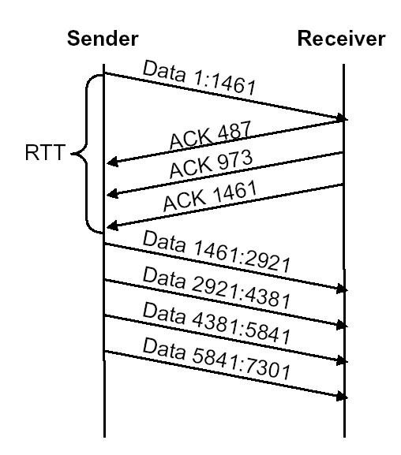

* As seen in the example , after one RTT **cwnd**=4, instead of expected value of2.

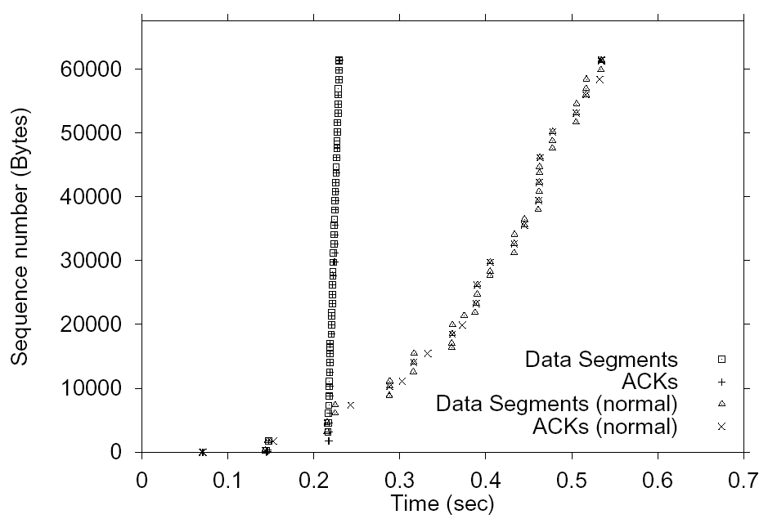

* This attack can convince a TCP sender to send all of its data in send buffer in a single burst.