**Q-1 What is software? What is software engineering?**

**Ans: -**

**Software -** Softwareis a collection of computer programs and related data that provide the instructions for telling a computer what to do and how to do it.

* Software is the language of computer.

**Software engineering -** Software is a systematic approach to design, development, operation and maintenance of a software system.

**Q-2 Explain types of software**

**Ans: -** There are Three type of software.

1. System software / OS (operating system)
2. Application software
3. Programming software
4. **System software:** - It provide the basic functions for computer usage and helps to run the computer hardware and system.

- It is the software used by the computer to translate inputs from various source into a language which a machine can understand.

- Basically, OS coordinates the different hardware components of a computer.

- Ex. Linux, Window, macOS, Android, iOS

1. **Application software: -** It is the general designation of computer programs for performing user tasks.

- 1. Mobile app: This type of application run on mobile. Ex. Instagram, Facebook, etc

- 2. Desktop app: This type of application run 0n a desktop. Ex. Word, PowerPoint, etc

- 3. Web app: This type if application run on a wen browser. Ex. google.com, facebook.com, etc

1. **Programming software: -** It is process of designing, writing, testing, debugging and maintenance the source code of computer programs.

- This software is PA written in a programming language.

- The purpose of programming is to create a program a that exhibits a certain desired behaviour.

- Ex. c++, html, php, etc

**Q-3 What is SDLC? Explain each phase of SDLC**

**Ans:**

**SDLC (Software Development Life Cycle):** SDLC is a structure imposed on the development of a software product that defines the process for planning, designing, implementation, testing, deployment, and ongoing maintenance and support.

1. **Planning phase:**

- SDLC is a structure imposed on the development of a software product that defines the process for planning, implementation, testing, documentation, deployment, and ongoing maintenance and support

SDLC is a structure imposed on the development of a software product that defines the process for planning, implementation, testing, documentation, deployment, and ongoing maintenance and support

1. **Designing phase:**

-During the design phase, lead developers and technical architects create the initial high-level design plan for the software and system. This includes the delivery of requirements used to create the Design Document Specification (DDS). This document details database tables to be added, new transactions to be defined, security processes, as well as hardware and system requirements.

1. **Implementation phase:**

- In this phase, the database admin creates and imports the necessary data into the database. Programming languages are defined by requirements. Developers create the interface as per the coding guidelines and conduct unit testing. This is an important phase for developers. They need to be open-minded and flexible if any changes are introduced by the business analyst.

1. **Testing phase:**

- Testers test the software against the requirements to make sure that the software is solving the needs addressed and outlined during the planning phase. All tests are conducted as functional testing, including unit testing, integration testing, system testing, acceptance testing, and non-functional testing.

1. **Deployment phase:**

- After successful testing, the product is delivered/deployed to the client, and even clients are trained on how to use the product.

1. **Maintenance and support phase:**

- In a post-production, live software environment, the system is in maintenance mode. No matter the number of users, the sophistication of the software and rigorous QA testing, issues will occur. That’s the nature of software with managing data, integration, and security, and real-world usage. Access to knowledgeable, reliable support resources is essential, as is routine maintenance and staying up to date on upgrades.

**Q-4 What is DFD? Create a DFD diagram on Flipkart**

**Ans:**

**Data Flow Diagram (DFD):** DFD is a traditional way to visualize the information flows within a system. A neat and clear DFD can depict a good amount of the system requirements graphically. It can be manual, automated, or a combination of both.

**DFD diagram for Flipkart:**

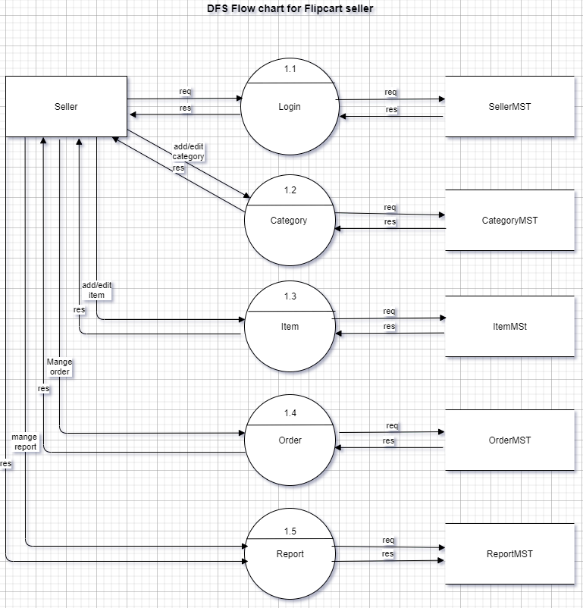

**Q-5 What is Flow chart? Create a flowchart to make addition of two numbers**

**Ans:**

**Flow chart:** A flow chart is a graphical or symbolic representation of a process. Each step in the process is represented by a different symbol and contains a short description of the process step. The flow chart symbols are linked together with arrows showing the process flow direction.

**Flowchart for addition of two numbers:**

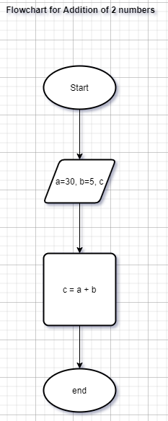

**Q-6 What is Use case Diagram? Create a use-case on bill payment on paytm.**

**Ans:**

**Use case diagram:** A use case diagram is used to represent the dynamic behaviour of a system. It encapsulates the system's functionality by incorporating use cases, actors, and their relationships. It models the tasks, services, and functions required by a system/subsystem of an application. It depicts the high-level functionality of a system and also tells how the user handles a system.

**Use-case on bill payment on paytm:**

