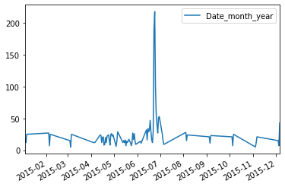

Figure1.1  trend chart for the number of complaints at daily

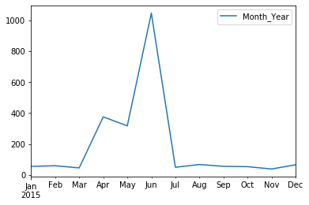

Figure 1.2  trend chart for the number of complaints at monthly 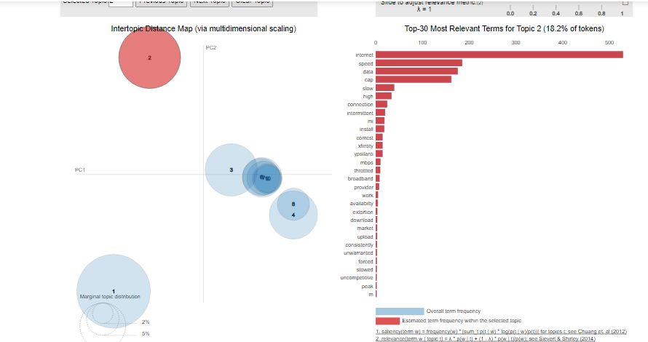

Figure 1.3Topic containing Intenet etc

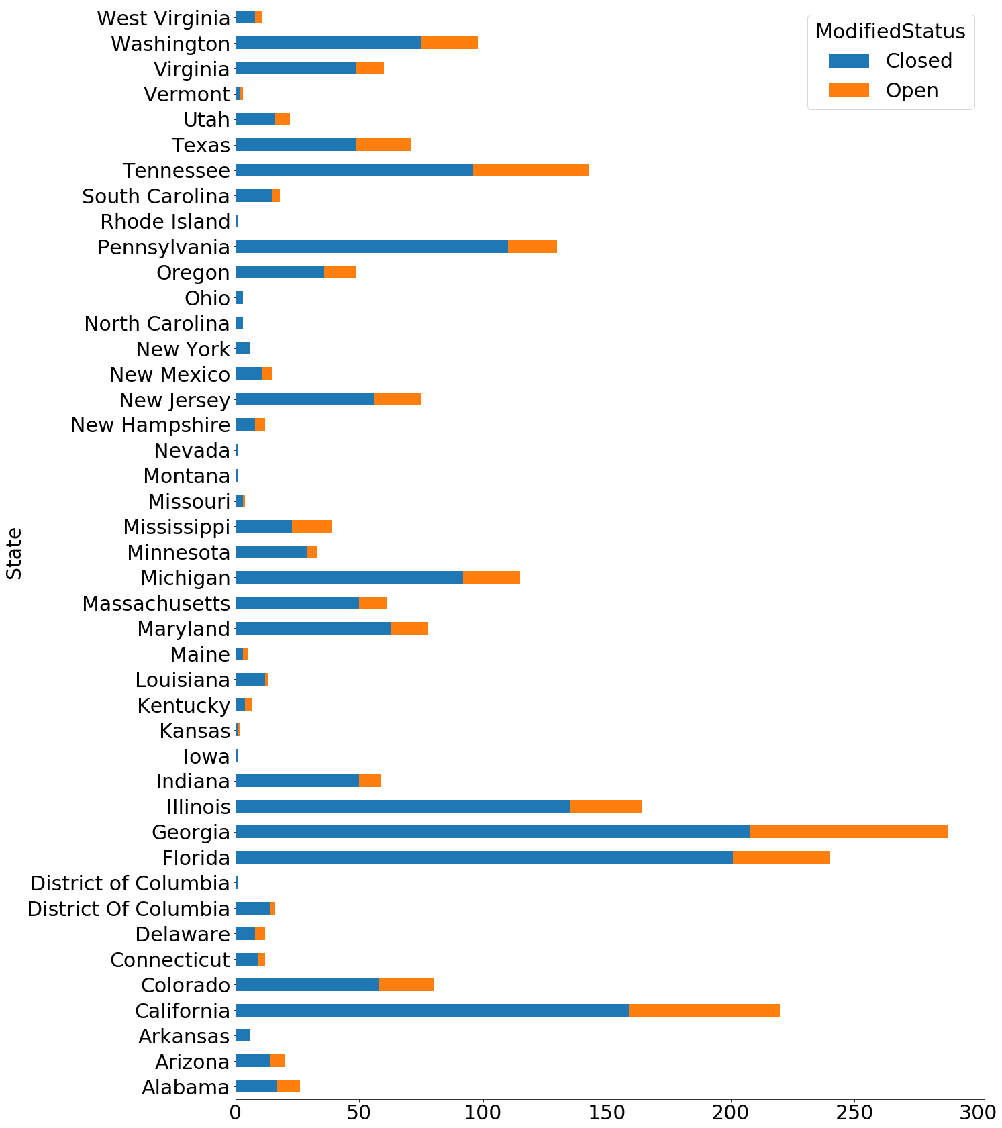

Figure 1.4 state wise statuses of complaints in a stacked bar chart