# Requirement:

Store Analytics wants to forecast the sales for each of their store. The store sales vary based on the temperature, rainfall and other factors. The client wants a system that takes in input the parameters that affect the sales as well as the number of days for which the forecast has to be made.

Also, the system has to be deployed as user interface API for ease of usage.

# Step 1 : Data Import

To start with project first step is to import the data files in MSSQL database.

There are 5 data files: StoreData, GasPrice, SnowFall, RainFall, InterestRate

All data files are imported as five different collections.

**Step 2 : Analyzing data and Deep Learning algorithm**

Once data is imported in database our next step will be to analyze data .

Steps involved for running algorithm:

1. Installing and loading required packages.
2. Fetching data from database into R Studio.
3. Checking data if it is monthly/weekly or daily and merging it one data set.
4. Handle missing values and outliers.
5. Creating lags for Sales variable and appending it to data set.
6. Standardizing Sales variable
7. Split data set into Training and Test data set.
8. Running model with different set of layers and neurons.
9. Predicting Sales on Test data and computing RMSE.

*Sample code used:*

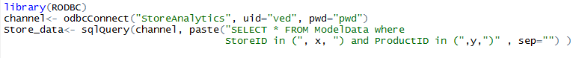

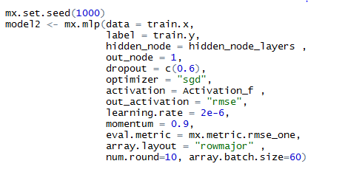

**Step 3 : Save result to MSSQL database**

Once we have forecasted result in a data frame in R, save this data frame to MSSQL database.

**Step 4 : Save result to MySQL database**

Once we have matching result in a data frame in python, save this data frame to mysql database.

*sample code used:*

