**A**

**Project Report**

**On**

**“ZERO INTRUSION**

**PORTABLE SMART SWITCH”**

**Submitted in partial fulfilment of the requirements of the degree of**

**BACHELOR OF SCIENCE**

**(INFORMATION TECHNOLOGY)**

**Designed and developed by**

**Mr. Ved V. Ahinave**

**Mrs. Komal T. Naik**

**Under the guidance of**

**Prof. Rajesh. Maisalge**

**Professor(teacher) in college**



**DEPARTMENT OF INFORMATION TECHNOLOGY**

**NIRANJANA MAJITHIA COLLEGE OF**

**COMMERCE AND SCIENCE**

***Affiliated to university of Mumbai***

MUMBAI, 400067, MAHARASHTRA



2019-2020

**ESPLANADE EDUCATION SOCIETY**

**NIRANJANA MAJITHIA COLLEGE OF**

**COMMERCE AND SCIENCE**

***(Affiliated to University of Mumbai)***



**BSC IT DEPARTMENT-2019-20**



DEPARTMENT OF INFORMATION TECHNOLOGY

**CERTIFICATE**

This is to certify that the work entered in this Project is the original work of **Mr. VED AHINAVE** AND **KOMAL NAIK** of TY B.Sc. IT Roll No.**02** and Roll No. **08** respectively.

University Exam Seat No. ,(Ved Ahinave) Seat No. ,(Komal Naik) We had satisfactorily completed required project for the semester VI of the academic year 2019-20 under the guidance of **Prof. RAJESH MAISALGE** being the partial requirement for the fulfilment of the curriculum of Degree of Bachelor of Science in Information Technology, University of Mumbai.

Place: MUMBAI

Date: 24th OCT,2019

------------------------------- -- -----------------------

External Examiner Internal Examiner/Guide

------------------------------- -- ----------------------

Principal

**ACKNOWLEDGEMENT**

It was highly eventful session at the B.Sc. Information Technology, **NIRANJANA MAJHITHIA COLLEGE** , working with teacher’s community and will probably remain the most memorable experience of my life. Hence this acknowledgement is a humble attempt to honestly thank all of those who were directly or indirectly involved in my project work and was of immense help to me.

I take a rather special privilege of thanking Principal **Mrs. Khushbu Pandya**, Coordinator

**Mrs. Sweta Kumar** for making the resources available within the institute during the project work whenever it was required.

I also humbly thank my project guide **Prof. Rajesh Maisalge** , for his guidance. It was because of his invaluable suggestion, motivation, co-operation and timely help in overcoming problems, that my work on project was successful.

And finally, there was and always will be the love for all the professors and flame-strikers team who have taught us, for what is written in this report has been the fruit of experience that they have taught us.

Thanking All,

**VED AHINAVE**

**and KOMAL NAIK**

**ABSTRACT**

Zero Intrusion portable smart switch is one of the most ambitious and exciting ventures of the IOT technology. IoT growth is now driven by the diminishing price of sensors, public APIs and clear benefits of using connected solutions for business purposes. However, the process of building IoT hardware and software is always associated with certain challenges including technology limitations, project delays, and cost overruns. Discover how development boards for IoT can help you mitigate these risks. They have sensors and actuators which do the actual work of motion. Sensors detect changes in environment like motion, heating, change in direction and actuators are the motors responsible for movement. Prototyping is the process of building IoT hardware (that is, devices enhanced with embedded systems and smart sensors) using numerous off-the-shelf components like circuit boards, sensors, and microcontrollers. Off-the-shelf solutions are freely available to end consumers.

A prototype is by no means a market-ready product; it is a trial version of your connected solution and the proof that your innovative idea can be brought to life. The Internet of Things is developing at a rapid pace, thanks in part to an explosion in the availability of small, inexpensive computing hardware. IoT prototyping kits and development boards combine microcontrollers and processors with wireless chips and other components in a pre-built, ready-to-program package.

**DECLARATION**

I here by declare that the project entitled, “**Zero Intrusion Portable Smart Switch**” done at **Niranjana Majhithia College of Science And Commerce**, has not been in any case duplicated to submit to any other university for theaward of any degree. To the best of my knowledge other than me, no one has submitted to any other university.

The project is done in partial fulfillment of the requirements for the award of degree of

**BACHELOR OF SCIENCE (INFORMATION TECHNOLOGY)** to be submitted

as final semester project as part of our curriculum.

**Name and Signature of the Student**

**TABLE OF CONTENTS**

|  |  |  |  |
| --- | --- | --- | --- |
| **Sr.No** |  | **Contents** | **Pg.No** |
|  |  |  |  |
| **1** |  | **Investigation** |  |
|  |  |  |  |
|  | 1.1 | Project Fixing |  |
|  | 1.2 | Synopsis |  |
|  |  |  |  |
| **2** |  | **ANALYSIS** |  |
|  |  |  |  |
|  | **2.1** | **Project History** |  |
|  | 2.2 | Reqirement Gathering |  |
|  | 2.3 | Objective And Scope of Project |  |
|  | 2.4 | Problems With Existing System |  |
|  | 2.5 | Advantages of Proposed System |  |
|  | 2.6 | Feasibility Study |  |
|  | 2.7 | Cost Benefit Analysis |  |
|  | 2.8 | Requirement Specification |  |
|  | 2.9 | Tools and Technology |  |
|  |  |  |  |
| **3** |  | **DESIGN PHASE** |  |
|  |  |  |  |
|  | 3.1 | Detailed Life Cycle of the Project(Logical Design) |  |
|  | 3.2 | FlowChart |  |
|  | 3.3 | Class Diagram |  |
|  | 3.4 | E-R Diagram |  |
|  | 3.5 | DFD |  |
|  | 3.6 | Activity Diagram |  |
|  | 3.7 | Use Case Diagram |  |
|  | 3.8 | Database Relationship Diagram |  |
|  | 3.9 | Event Table |  |
|  |  |  |  |
| **4** |  | **GUI DESIGN** |  |
|  |  |  |  |
| **5** |  | **REVIEW** |  |
|  | 5.1 | Spiral Binding Submission |  |

**CHAPTER 1**

# **1.INVESTIGATION**

***IoT*** is short for ***I***nternet ***o***f ***T***hings. The Internet of Things refers to the ever-growing network of physical objects that feature an [IP address](https://www.webopedia.com/TERM/I/IP_address.html) for [internet](https://www.webopedia.com/TERM/I/Internet.html) connectivity, and the communication that occurs between these objects and other Internet-enabled devices and systems. The Internet of Things extends internet connectivity beyond traditional devices like [desktop](https://www.webopedia.com/TERM/D/desktop.html) and [laptop computers](https://www.webopedia.com/TERM/L/laptop_computer.html), [smartphones](https://www.webopedia.com/TERM/S/smartphone.html) and [tablets](https://www.webopedia.com/TERM/T/tablet_PC.html) to a diverse range of devices and everyday things that utilize embedded technology to communicate and interact with the external environment, all via the Internet.

Examples of objects that can fall into the scope of Internet of Things include connected security systems, thermostats, cars, electronic appliances, lights in household and commercial environments, alarm clocks, speaker systems, vending machines and more.

You’ve tried everything. You’ve tried throwing socks, you’ve tried reaching extra far, you’ve even tried activating your latent psychic powers, yet the light switch refuses to budge. Of course, you could just get up off your bed and walk all the way across the room, but that would be too much effort for a feeble college student such as yourself. No, what we need right now is a convoluted contraption to turn the switch off from across the room, and with a little bit of coding, you can finally turn that switch on and off from your bed.

We were able to rent all of the electronic parts we needed for free from our university, but if you were to buy the exact parts we used in order to replicate this design, it would be quite expensive. There are much cheaper alternatives available for the cost-conscious college student. The prices listed are the average prices found after some online research.

We came up with a way around this by building a customized acrylic box as a circuit box in which whole circuit is embedded. We can also use this by building 3D printed light switch covers that add servo control. It’s a great solution that it doesn’t require the modification of any mains wiring, and interfaces with the standard switches in the normal way. It makes it a lot safer this way – there are municipal writing codes for a reason. This is a simple servo mount that you can attach to a standard switch plate. Connect the servo to a microcontroller for a quick home automation project.

We wanted to control the light switches in house from smartphone, so [he built a system that incorporates an Arduino, Bluetooth module, and servo to do just that](https://makershare.com/projects/control-switches-bluetooth-and-arduino)! The system has a working range of 30 meters (approximately 10 feet). It’s a nifty little device, and certainly cheaper to build than the smart devices you’ll find online.

The number of connected devices that are in use worldwide now exceeds 17 billion, with the number of IoT devices at 7 billion (that number does not include smartphones, tablets, laptops or fixed line phones). At some point we have all wished to just click our fingers and make our lights turn off, without having to get up and flick the switch.

Whilst you can get expensive light switches which do this, it struck me that with some acrylic customized model and cheap electronics, I could make my own remote control system which I could retrofit onto any standard light switch.

I also think it’s an interesting design challenge which can be approached in many ways, giving plenty of options for inventing and experimenting.

The design itself is pretty simple, it uses two servos – one positioned vertically for each light switch to turn it on and off. I Intentionally chose not to mess with the mains voltage.

# **PROJECT FIXING**

This Instructable is all about one of life's simple actions, flipping a light switch on and off.  
  
As we do it many times a day, so many in fact it came to a point where we asked ourselves "Can't we get an Arduino to do this?". Of course we can, what follows is how we went about doing it.  
  
With the help of some acrylic, nuts and bolts and a small hobby servo we have made a great little switcher (we're calling it our Servo Switcher - (SESW)).  
  
**Features:**

* No need to mess with any high voltage wiring.
* Switch is still operable by hand.
* Easy to make and assemble

**Applications:**

* Simple light switching.
* Can be paired with sensor to make for more complicated applications. (security lights, temperature control on ceiling fans, night lights, the possibilities are endless)
* Wire up a switch to a socket and control anything that has a plug.

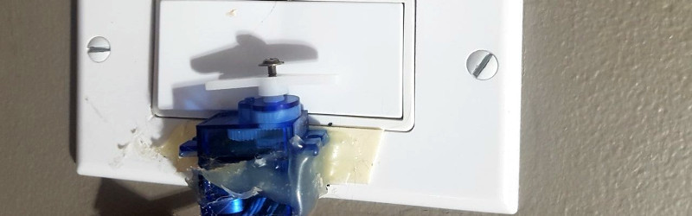

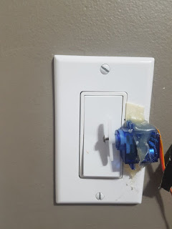 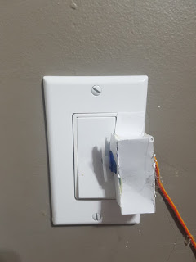

Before After

I also have a switch which allows me to control the light locally, this is using a pull-down resistor and a regular light switch....(This allows me to control the light switch by the door from my chair without interacting with a computer, I've also got a [hacked Dash button](http://guyfromhe.blogspot.ca/2017/02/amazon-dash-button-hacking.html) that will do the same)  
  
You can choose in the code if you want it to toggle every time you flip it, or have one position be on and one position be off, or if you are using a momentary button you can set it up for that so it won't switch twice or you can take the switch out completely if you don't need it.  
There are comments on the lines you need to change for this purpose

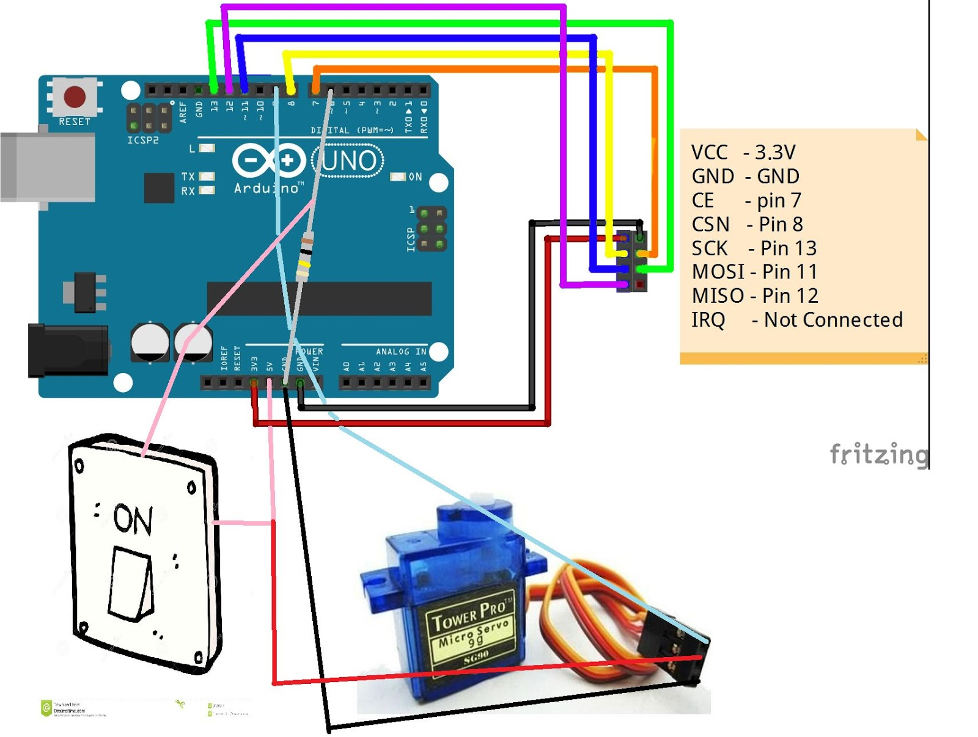

The resistor is connected between GND and pin 6, and the switch is connected to 5v on the Arduino and the leg of the resistor that is connected to pin 6 (not the GND side).  
  
Finally your light switch 'Duino has a servo connected to 5v and GND on the power wires and signal conneced to pin 9.  The servo is then hot glued to the switch plate with the horn perpendicular to the light switch at idle. (with the shaft of the servo lined up about with the center of the switch).

# **1.2 SYNOPSIS**

This is a simple servo mount that you can attach to a standard switch plate. Connect the servo to a microcontroller for a quick home automation project.

What You Need:  
-Micro sized servo (I used cheap SG90 9G micro servos from ebay)  
-Mounting hardware for servo and arm (typically comes with the servo when you buy it)  
-arduino

EXAMPLE ARDUINO CODE:  
-You will need to have the Servo.h library installed  
-Connect servo to Pin 9, GND, and 5V  
-Turns the switch ON right after you connect to power  
-Turns the switch OFF after 5s, ON after 10s, OFF after 15s, ON after 20s, then loops.  
-You can change or add time intervals as needed

POSITIONING*  
-Servo neutral position is 60 degrees  
-Switch ON position is at 100 degrees, and OFF position is at 20 degrees  
-May need to change these numbers depending on you servo.

*When programming the servo, the arm should move about +-40 degrees from the neutral position to turn the switch ON and OFF. Experiment with these numbers for best results.

This switch uses a sg90 servo, an Arduino Uno, and pairs of ATtiny85s with HC-05 Bluetooth modules assembled on protoboards. The customized acrylic board model screws easily on top of a standard light switch cover while still allowing the switch to be flipped the old-fashioned way. It’s also perfect as a temporary solution

A [servomotor](https://en.wikipedia.org/wiki/Servomotor), or servo for short, is a self-contained motor, controller, and reduction gear system in a box. Rather than turning continuously, most of them have a limited range of movement, and are normally configured to move a lever from side to side and hold it in position. If this sounds a lot like the kind of stall-motor we’ve been using to throw turnouts on model railroads for decades, that’s because in some ways it is very similar. There are differences, and two of the most important are economy of scale and how they are controlled.  
  
The newer micro servers are particularly interesting, because they are very compact compared to current motor-based turnout controls, and are thus suitable for more space-constrained environments. And yet they have sufficient power for throwing typical turnouts, as well as being applied for other purposes such as crossing gates (or semaphore signals for that matter). They are also potentially less expensive (if you are willing to work on your own control system; commercial systems are still somewhat expensive).

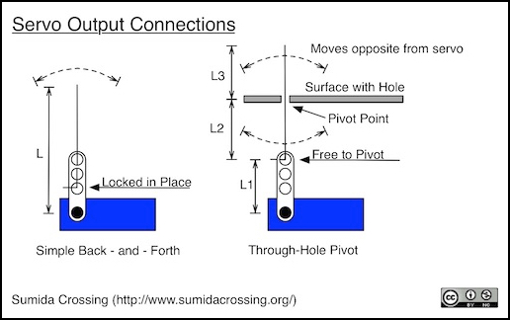

# **2. ANALYSIS**

# **2.1 PROJECT HISTORY**

The first smart homes were ideas, not actual structures. For decades, science fiction has explored the idea of home automation. Prolific writers, such as Ray Bradbury, imagined a future where homes were interactive, and seemingly ran themselves. In Bradbury’s cautionary short story, “There Will Come Soft Rains” he describes an automated home that continues to function even after humans have died out. It’s all well and frightening, until you consider the actual benefits of home automation, and then the idea becomes more comforting than chilling.

Although the idea of home automation has been around for some time, actual smart homes have only existed a short while. This timeline focuses on hardware; meaning actual inventions leading up to the smart homes we know today and can expect from the near future.

**Home automation began** to increase in popularity in the late 1990s and early 2000s as internet technology developed fast and smart **homes** suddenly became a more affordable option. Domestic technology or 'domotics' was a highly discussed topic as domestic appliances were being combined with computers.

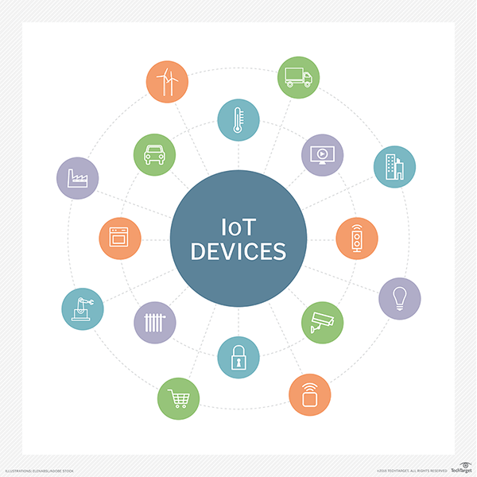

Home automation suffers from [platform fragmentation](https://en.wikipedia.org/wiki/Platform_fragmentation) and lack of [technical standards](https://en.wikipedia.org/wiki/Technical_standard) a situation where the variety of home automation devices, in terms of both hardware variations and differences in the software running on them, makes the task of developing applications that work consistently between different inconsistent technology [ecosystems](https://en.wikipedia.org/wiki/Ecosystem) hard. Customers may hesitate to bet their IoT future on [proprietary software](https://en.wikipedia.org/wiki/Proprietary_software) or hardware devices that use [proprietary protocols](https://en.wikipedia.org/wiki/Proprietary_protocol) that may fade or become difficult to customize and interconnect.

The nature of home automation devices can also be a problem for security, since patches to bugs found in the core operating system often do not reach users of older and lower-price devices. One set of researchers say that the failure of vendors to support older devices with patches and updates leaves more than 87% of active devices vulnerable.

# **2.2 REQUIREMENT GATHERING**

2.2.1 AURDINO UNO

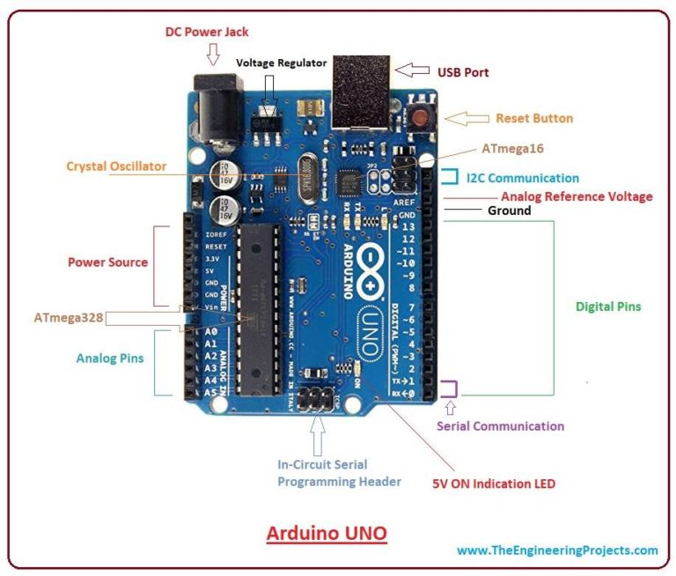

The Arduino Uno is an [open-source](https://en.wikipedia.org/wiki/Open-source) [microcontroller board](https://en.wikipedia.org/wiki/Microcontroller_board) based on the [Microchip](https://en.wikipedia.org/wiki/Microchip_Technology) [ATmega328P](https://en.wikipedia.org/wiki/ATmega328P) microcontroller and developed by [Arduino.cc](https://en.wikipedia.org/wiki/Arduino). The board is equipped with sets of digital and analog [input/output](https://en.wikipedia.org/wiki/Input/output) (I/O) pins that may be interfaced to various [expansion boards](https://en.wikipedia.org/wiki/Expansion_board) (shields) and other circuits. The board has 14 Digital pins, 6 Analog pins, and programmable with the [Arduino IDE](https://en.wikipedia.org/wiki/Arduino#Software) (Integrated Development Environment) via a type B [USB cable](https://en.wikipedia.org/wiki/USB_cable).[]](https://en.wikipedia.org/wiki/Arduino_Uno#cite_note-priceton-4) It can be powered by the USB cable or by an external [9-volt battery](https://en.wikipedia.org/wiki/9-volt_battery), though it accepts voltages between 7 and 20 volts. It is also similar to the [Arduino Nano](https://en.wikipedia.org/wiki/Arduino_Nano) and Leonardo. The hardware reference design is distributed under a [Creative Commons](https://en.wikipedia.org/wiki/Creative_Commons) Attribution Share-Alike 2.5 license and is available on the Arduino website. Layout and production files for some versions of the hardware are also available.

2.2.2 HC-05 BLUETOOTH MODULE

### **HC-05 Default Settings**

Default Bluetooth Name: “HC-05”

Default Password: 1234 or 0000

Default Communication: Slave

Default Mode: Data Mode

Data Mode Baud Rate: 9600, 8, N, 1

Command Mode Baud Rate: 38400, 8, N, 1

Default firmware: LINVOR

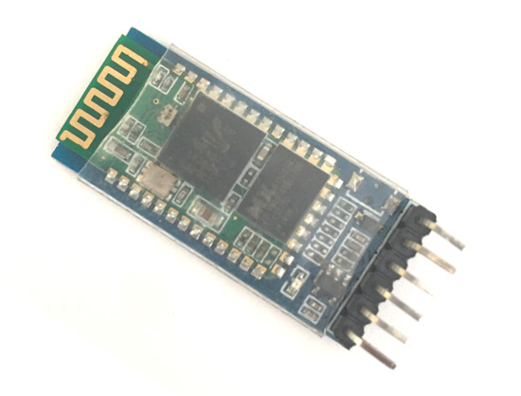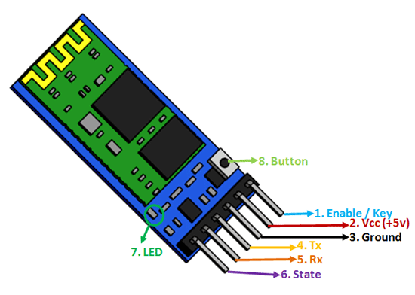

### **HC-05 Technical Specifications**

* Serial Bluetooth module for [Arduino](https://components101.com/microcontrollers/arduino-uno) and other microcontrollers
* Operating Voltage: 4V to 6V (Typically +5V)
* Operating Current: 30mA
* Range: <100m
* Works with Serial communication (USART) and TTL compatible
* Follows IEEE 802.15.1 standardized protocol
* Uses Frequency-Hopping Spread spectrum (FHSS)
* Can operate in Master, Slave or Master/Slave mode
* Can be easily interfaced with Laptop or Mobile phones with Bluetooth
* Supported baud rate: 9600,19200,38400,57600,115200,230400,460800.

 2.2.3 SERVO MOTOR SG-90

### Wire **Configuration**

|  |  |  |
| --- | --- | --- |
| **Wire Number** | **Wire Colour** | **Description** |
| 1 | Brown | Ground wire connected to the ground of system |
| 2 | Red | Powers the motor typically +5V is used |
| 3 | Orange | PWM signal is given in through this wire to drive the motor |

### TowerPro SG-90 Features

* Operating Voltage is +5V typically
* Torque: 2.5kg/cm
* Operating speed is 0.1s/60°
* Gear Type: Plastic
* Rotation : 0°-180°
* Weight of motor : 9gm
* Package includes gear horns and screws

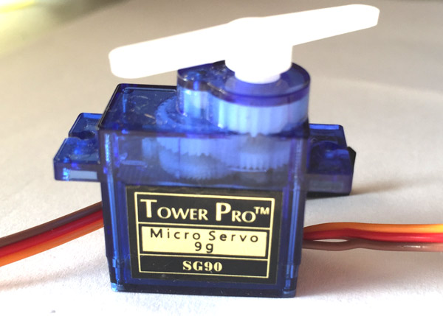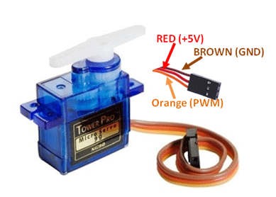

There are lots of servo motors available in the market and each one has its own speciality and applications. The following two paragraphs will help you identify the right type of servo motor for your project/system.

Most of the hobby Servo motors operates from 4.8V to 6.5V, the higher the voltage higher the torque we can achieve, but most commonly they are operated at +5V.  Almost all hobby servo motors can rotate only from 0° to 180° due to their gear arrangement so make sure you project can live with the half circle if no, you can prefer for a 0° to 360° motor or modify the motor to make a full circle. The gears in the motors are easily subjected to wear and tear, so if your application requires stronger and long running motors you can go with metal gears or just stick with normal plastic gear.

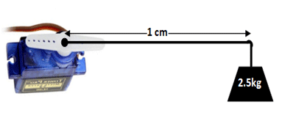

2.2.4 JUMPER WIRES AND SMALL BREADBOARD

**Jumper wires** are simply **wires** that have connector pins at each end, allowing them to be used to connect two points to each other without soldering. **Jumper wires** are typically used with breadboards and other prototyping tools in order to make it easy to change a circuit as needed.

Anatomy of a **Mini Breadboard**. ... The modern **breadboard** is a plug-and-play way to make connections between electronic components. It gets its name from the long-dead practice of using a wooden board ( an actual bread-board if it was handy ) to prototype circuits

**2.2.5 Acrylic - (several options)**

Cut Your Own (Scroll Saw) -- Download the scroll saw pattern (03-(SESW)-Scrollsaw Pattern.pdf) glue it to a piece of 3mm Acrylic, cut and drill

Cut Your Own (Laser Cutter) -- Download (00-SESW-Parts File.eps or .cdr) and cut it on your laser cutter using 3mm acrylic

# **2.3 OBJECTIVES AND SCOPE OF PROJECT**

Home Automation using IOT and Arduino. The main objective of this project is to build a smart home device which can be used to control the home appliances via internet. ... This establishes the internet connection to the system and all the home appliances can in turn be connected and controlled by internet.

 This is a simple servo mount that you can attach to a standard switch plate.

Future scope for the home automation systems involves making homes even smarter. Homes can be interfaced with sensors including motion sensors, light sensors and temperature sensors and provide automated toggling of devices based on conditions.

Future of home automation :

Home of the future is a space for the digital natives. With the invention of lots of automation technologies featuring IOT and AI, home automation has become a reality. One can implement several of their tasks with just a single command of verbal instructions. These technologies can used to build fully functional home automation system and control smart home devices including smart lights, connected thermostats, and appliances.

There are several new technologies which can become a part of home in the near future:

Increased efficiency, control, and customization: Artificial intelligence is set to make you lazy in the near future. Technology will become much more efficient and one will be able to control everything from volume to security from one central place. The devices will work automatically and you don’t need to waste your energy it will act upon user’s preferences. AI would revolutionize home by automatic threat detection and proactive alertness.

Integration of Smart home devices: One can command it to control small things of home through voice and Smartphones. All the tech giants are working in the field of IoT to bring advancements in the home automation devices. In near future, homes will be equipped with such IoT devices which will make your daily lives work faster smoother and more accurate.  
Mark Zuckerberg came up with a goofy proof-of-concept video showing off an idealized version of how his Jarvis system actually works. Google Home, which is Google’s smart speaker loaded with Google Assistant, was updated at last year’s Google I/O with a bunch of new features, including “proactive assistance”, also known as push notifications, hands-free free calling, Spotify, SoundCloud, and Deezer integrations, and more. Also, more recently, Google launched two more Google Home speakers, Home Max and Home Mini.

Smart spaces outside homes: Smart parking through sensors will help to recognize whether the parking is available or not. Camera monitoring can be done and with the help of artificial intelligence and computer vision, both parking facilities and security can be provided. It would be a faster and smoother process and act as a reference for other smart systems to be build accordingly. Streetlights can also be automated through sensors and build for effective use for the people nearby.

Development of smart appliances: The devices which we use to use like television, refrigerator and even the mirror is getting smarter today with evolution of technology. The smart mirror should not only act as a face video but also help to other tasks like listening to music and stuff. Televisions have become part of a centralized entertainment and can also be used for social media. The refrigerator has been upgraded to sense the temperature outside and operate accordingly. The washing machine will wash the clothes according to the clothes material and switch off after drying. They will keep on advancing as the technology evolves.

Personal home delivery: Drones will be used to deliver the packages at the right time. They will replace the normal salesman job. They might also be used for several other tasks like monitoring the weather outside the home, returning something back to a relative’s home nearby and so on. They can also be used for monitoring the traffic in our locality.

One can build several amazing projects using the concepts of home automation. There are several projects already done by developers and available on the Internet. They might help you to start the work with IoT. You can add new skills to own smart device. You can make your smart home device work according to your life works and habits. Even we can build many projects around it by discovering new areas of the internet of things and make the world a smarter place to live in.

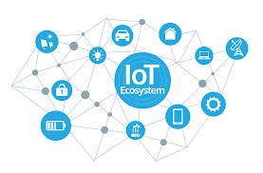

# **2.4 PROBLEMS WITH EXISTING SYSTEMS**

Many **IoT Systems** are poorly designed and implemented, using diverse protocols and technologies that create complex configurations. Lack of mature **IoT** technologies and business processes. Limited guidance for life cycle maintenance and management of **IoT** devices. Limited best practices available for **IoT** developers.

The Internet of Things is a nexus of devices and services that allow for data exchange. These devices range from home appliances— whether furniture, coffee makers, or agricultural machinery— that can be implanted with various software and means of electronic connectivity. To put things into simpler terms, everything and anything can be adjusted to connect to the internet and become part of the web. Thus, this network spans a large number of devices that also includes people and their interactions via the internet.

The idea behind IoT is to create a system that stores all data required by human beings without having a direct hand in collecting it. Research suggests that the impact of IoT on the world will be monumental in upcoming years. The growth in its influence and application can be assessed from consumer patterns for entertainment and media, infrastructure and energy management, agriculture, transportation and even medical care. Given the current trends, the impact of IoT on human life is increasing exponentially and will only continue to rise.

However, questions have emerged simultaneously on the dangers and potential risks of inculcating the IoT into all aspects of human life. Here are some of the problems with the IoT:

1. Security

One of the greatest threats to the IoT comes from the strain put on the global system of information exchange that the IoT relies upon. The Global Risks Report of 2018 highlights the menace of cyber-attacks and the danger to all interconnected enterprises if the IoT is compromised as a result of internal weaknesses. Clouds will be the first to be compromised as security regulations are still not fully developed given how severe the issue. The Annual Economic cost of cybercrime is estimated to be around 1 trillion US dollars, which supersedes costs of natural disasters such as Hurricane Sandy and Katrina.

The recent rise in ransom-ware is expected to pose a serious security threat, for cloud vendors and service providers will be the prime targets. The nature of cloud activity is known for being complex given the numerous clientele and the variations of enterprises it caters to. Therefore, interconnectivity can also serve as a disadvantage to various enterprises if the cloud is compromised.

Security threats also encompass Artificial Intelligence-based devices and services. Experts suggest that malware is now becoming better at evading detection via AI. At a contrast, some argue that AI is limited due to the lack of human intervention in its activities, which also affects its performance when it comes to identifying cause and effect in an investigation. Thus, AI might not be equipped enough yet to deal with the rapidly increasing problems that are facing the cloud and IoT in the face of cyber-attacks.

2. Privacy

Another pressing issue with the IoT is that of user privacy. Not only is hacking a security breach, but also a violation of consumer privacy. A recent study at the University of Glasgow shows that consumers are largely unsatisfied with the lack of privacy the IoT allows them. As users have grown more aware of the extent of cyber-surveillance, they have begun taking their privacy more seriously and thus demand that the ultimate control over their data should remain with them. An increased corporate transparency is needed to ensure that user data is not vulnerable to others.

3. Internet Walls

The risk of losing important data via hacks is a dangerous proposition not just for corporations, but also for nations via cross-border attacks. The World Economic Forum predicts that these attacks will propel nations to create internet walls that will limit the activity of the IoT to particular regions. Moreover, nations will eventually be motivated to protect their economic interests as governments cannot operate freely in a global system of online companies and enterprises. This ultimately compromises the very idea of the IoT as barriers prevent the unregulated exchange of data that many corporations demand. Regulations such as this will also serve as an obstacle to technological advancement by substantially slowing it down.

4. Cloud attacks

Observing the traces of this digital war, it is highly likely that the next potential threats to IoT would be cloud networks. This is because cloud networks have the biggest data stocks to run the IoT. According to recent statistics, the annual economic cost of cybercrime was estimated around $1 trillion in 2017, which is a multiple of 2017’s record-year aggregate cost of almost $300 billion from natural disasters. To comprehend the magnitude of the problem, the World Economic Forum report quotes a study that put forward the takedown of just one cloud provider could cause $50 billion to $120 billion of financial damage.

5. Understanding IoT

Rapid growth in technology has resulted in a limited understanding of the IoT. For consumers to make use of the internet and all that the IoT has to offer, it is essential to work upon their awareness of the changes taking place within IoT to make it more efficient. Not only will the comprehension empower them, it will prepare them mentally and they will possibly be able to find solutions on how to take caution from any of the mentioned problems.

6. Lack of Confidence

According to the latest research report shared by the State of IoT Security, which was released at the end of October, showed the following information:

96 percent of companies and 90 percent of consumers believe there should be IoT security code of practice.

54 percent of consumers possess an average of four IoT devices, but then again only 14 percent consider that they are familiar with IoT device security.

65 percent of consumers are petrified about a hacker monitoring their IoT device, whereas around 60 percent are fretful of their personal or professional data being leaked.

# **2.5 ADVANTAGES OF PROPOSED SYSTEM**

One of the most important part of this project is that it is a portable device which can be attached on any standard switch plate

**The advantages and disadvantages of Internet Of Things (IoT)**

The Internet of Things, called the IoT for short, is a new interconnection of technology heralded as the next industrial revolution—implying radical change, disruption, and an entirely new paradigm for the planet. Specifically, the Internet of Things is an extension of the existing connections between people and computers to include digitally-connected “things.”

These things measure and report data. This data can be simple numbers from a stationary or mobile sensor (such as a temperature sensor), or more complex findings from devices that measure and report multiple data streams at once. These advanced devices can even actuate or effect the data they’re measuring (a connected thermostat is an easy example.).

IOT or Internet of Things is a burning topic these days. Like every fresh concept, the masses are not too familiar with this novel idea. So, what exactly is IOT? Said in the simplest manner, it refers to a virtual internet connection from things, processes, people, animals and almost everything that we see around. It describes a situation where everything in our surrounding environment is made capable of automatically communicating with each other without any inter-human or human-to-machine interaction. Apart from the fact that it is a path-breaking discovery, it can also prove to be extremely beneficial in facilitating our lives to manifolds.

Every new technology faces a million challenges in its initial phases. Internet of Things also poses some grave issues that need to be tackled well in order to utilize its fullest potential. But let’s leave the threats aside for the time being and focus only on the positives in this post.

Before we understand the impact IoT can have on our way of living, it’s important to go through its advantages and disadvantages:

**Advantages**

Here are some advantages of IoT:

Communication

IoT encourages the communication between devices, also famously known as Machine-to-Machine (M2M) communication. Because of this, the physical devices are able to stay connected and hence the total transparency is available with lesser inefficiencies and greater quality.

Automation and Control

Due to physical objects getting connected and controlled digitally and centrally with wireless infrastructure, there is a large amount of automation and control in the workings. Without human intervention, the machines are able to communicate with each other leading to faster and timely output.

Information

It is obvious that having more information helps making better decisions. Whether it is mundane decisions as needing to know what to buy at the grocery store or if your company has enough widgets and supplies, knowledge is power and more knowledge is better.

Monitor

The second most obvious advantage of IoT is monitoring. Knowing the exact quantity of supplies or the air quality in your home, can further provide more information that could not have previously been collected easily. For instance, knowing that you are low on milk or printer ink could save you another trip to the store in the near future. Furthermore, monitoring the expiration of products can and will improve safety.

Time

As hinted in the previous examples, the amount of time saved because of IoT could be quite large. And in today’s modern life, we all could use more time.

Money

**T**he biggest advantage of IoT is saving money. If the price of the tagging and monitoring equipment is less than the amount of money saved, then the Internet of Things will be very widely adopted. IoT fundamentally proves to be very helpful to people in their daily routines by making the appliances communicate to each other in an effective manner thereby saving and conserving energy and cost. Allowing the data to be communicated and shared between devices and then translating it into our required way, it makes our systems efficient.

Automation of daily tasks leads to better monitoring of devices

The IoT allows you to automate and control the tasks that are done on a daily basis, avoiding human intervention. Machine-to-machine communication helps to maintain transparency in the processes. It also leads to uniformity in the tasks. It can also maintain the quality of service. We can also take necessary action in case of emergencies.

Efficient and Saves Time

The machine-to-machine interaction provides better efficiency, hence; accurate results can be obtained fast. This results in saving valuable time. Instead of repeating the same tasks every day, it enables people to do other creative jobs.

Saves Money

Optimum utilization of energy and resources can be achieved by adopting this technology and keeping the devices under surveillance. We can be alerted in case of possible bottlenecks, breakdowns, and damages to the system. Hence, we can save money by using this technology.

Better Quality of Life

All the applications of this technology culminate in increased comfort, convenience, and better management, thereby improving the quality of life.

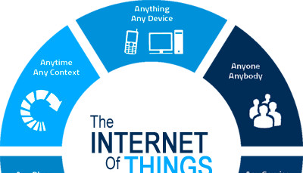

# **2.6 FEASIBILITY STUDY**

I really, really dig the light switch mount plate for an SG90 servo to activate a light switch. I have a bunch of smart bulbs for my other lights, but my kitchen lights are the long, giant, bright bulbs. Phillips' Hues don't really come in that size ;) So I wanted to activate the servo with MQTT (from a RPi running Home Assistant and Mosquitto MQTT server) using a Wemos D1 Mini. I know you're generally supposed to power servos from their own power supply and not the boards, but I figure quick activation are fine. Plus the 5V may be straight from the USB before the regulator for the Wemos D1 Mini, I need to look into it. Regardless, it should be fine. I took the D1 mini case file and combined it with the plate. The thing is not heavy at all, my light switch screws don't even feel the burden. Then I modded the case lid to make room to hide all the wires from the servo and D1 Mini. I also had to trim the press fit sections to be a bit smaller, and the GPIO holes to be a bit wider/longer.

# **2.6 COST BENEFIT ANALYSIS**

IoT is trending. Companies invest in new tech to streamline business processes and cut expenses. Consumers buy wearables and Smart Home appliances to save time and improve the quality of their lives. If you’re set on releasing a smart device or consider optimizing your business workflow with the Internet of Things solutions, you need to get an idea of how much it may cost you to build one. In this article we’ll try to figure out what may constitute the final cost of an IoT solution

INTERNET OF THINGS COST BREAKDOWN

The Internet of Things is the environment where gadgets equipped with smart sensors collect data and exchange it over a network.

Thus, the system operates on three levels:

Hardware (various objects enhanced with firmware/embedded systems and smart sensors).

Infrastructure (a piece of software that receives, analyzes and stores sensor data; it runs in the cloud or on a corporate server).

Apps (applications for smartphones, tablets and PCs that connect hardware to the infrastructure and enable users to manage smart gadgets).

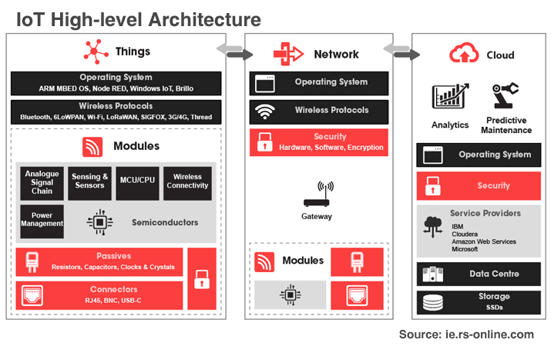Although [IoT potential economic impact](https://www.mckinsey.com/~/media/McKinsey/Business%20Functions/McKinsey%20Digital/Our%20Insights/The%20Internet%20of%20Things%20The%20value%20of%20digitizing%20the%20physical%20world/Unlocking_the_potential_of_the_Internet_of_Things_Executive_summary.ashx) will exceed $ 11 trillion by 2025, the Internet of Things development requires substantial upfront investments. Where does the money go?

Hardware

The price of building a smart gadget may amount to 70-80% of the total IoT cost and depends on the type and complexity of a solution you intend to create.

Hardware Design Stages Influencing IoT Project Costs

Analysis: the phase involves concept development, budget planning, cost optimization and technical requirements specification.

Modelling: engineers and industrial designers create Printed Circuit Board (PCB) layout schemes and visualize the gadget’s interior in 3D CAD.

Prototyping: a hardware device manufacturer creates up to ten PCBs, debugs them and makes corresponding changes to the requirements document.

Testing: successful prototypes are transformed into pre-production models which use different materials for the device case. Various types of tests are then conducted, including climatic, electrical safety, pre-certification and user tests. During this phase, critical errors might be detected, and the prototyping process starts all over again.

Innovative IoT solutions usually go through three to five iterations until they are ready to be passed for mass production. On average, an IoT gadget spends anything between six months and two years in the development stages we’ve mentioned above before finally making it to market.

How much does it cost to develop IoT hardware then – given that you need to invest in research, analyze technical requirements, prototype and test your idea, and, finally, manufacture and market the end product? The honest answer is, “It depends”. A complex Home Automation system which uses machine learning algorithms to identify and remember a home owner’s face and automatically adjusts its settings based on the person’s preferences may cost up to $5 million (hardware and software costs included). The price of building a custom EKG tracker which analyzes the electrical signals of a human body and visualizes sensor data via a mobile app is estimated at only $300 thousand – but there are hidden costs you might overlook.

# **2.7 TOOLS AND TECHNOLOGY**

The whole system is designed in Aurdino IDE. C Language is used for controlling servos in vertical alignment on switch plate and MIT App Inverter is used for interface with android application

Code:

#include <SoftwareSerial.h>

#include <Servo.h>

Servo servo1;

Servo servo2;

int TX = 10;

int RX = 11;

SoftwareSerial HC_06(TX, RX); //Bluetooth TX to 10 and Bluetooth RX to 11.

void setup()

{

servo1.attach(9);

servo2.attach(8);

Serial.begin(9600);

HC_06.begin(9600);

}

void loop()

{

if(HC_06.available()> 0 )

{

int value = HC_06.read();

if(value>=0 && value<=90){

Serial.println(value);

int servo1_position = map(value, 0, 90, 0, 180);

servo1.write(servo1_position);

}

if(value>90 && value<=180){

Serial.println(value);

int servo2_position = map(value, 91, 180, 0, 180);

servo2.write(servo2_position);

}

}

}

# **3. DESIGN PHASE**

# **3.1 DETAILED LIFECYCLE OF PROJECT(Logical Design)**

Creating successful IoT-enabled products and services is not an impossible task; it’s just a challenging one when organizations try to do too much at once, make project commitments without asking the right questions, or do things in the wrong order. To be successful, it’s critical to understand what the entire IoT journey looks like and accurately identify where an organization is in that journey—after all, it’s only possible to know what immediate next steps to take when the final destination is clear.

Because every organization has different levels of experience, actionable market opportunities, or internal resources at their disposal, there is no step-by-step guide to completely avoid this type of dysfunction. However, Exosite has developed the IoT Project Lifecycle framework to provide project stakeholders a holistic overview of the connected-product project lifecycle that greatly increases the chances of success.  The framework breaks the process down into four stages—explore, validate, accelerate, and commercialize—and identifies key objectives and tasks that project teams should focus on in each stage. The IoT Project Lifecycle framework also helps explain how the definition of success changes over time as a project progresses through each lifecycle stage. In this blog, which is the first of several, we’ve provided a high-level overview of each phase.

Stage 1: Explore

Organizations in the midst of the Explore stage are typically looking to build a case around why they should get involved with IoT, including how it may aid in new customer acquisition or uncover new revenue streams. The technical objectives are geared towards identifying gaps in technical capabilities, and the organizational objective in this stage should be to survey the current IoT landscape and identify interest and opportunities throughout the organization. The Explore stage can seem overwhelming for organizations that are new to adopt IoT, but creating a solid business case for why IoT is a value-add, understanding the technical gaps, and knowing who the key players are that will support the effort is crucial to gain traction.

Stage 2: Validate

The second stage is for organizations that are ready to validate both their business case and technical feasibility of a connected product in order to obtain buy-in from organizational stakeholders. The business case is typically validated through a variety of research activities, whereas the technical feasibility of the product concept is proven out as quickly as possible through micro-experiments and the use of low-fidelity demonstrations of connectivity. It is important for organizations in the Validate stage to test their hypothesis with a minimum amount of engineering effort so that the business case for stakeholders is strong enough to justify the IoT investment in order to proceed to the next stage.

Stage 3: Accelerate

Once a product idea has been validated as valuable to the market and technical unknowns have been largely addressed, organizations move into the Accelerate stage, where engineering and development teams off to the races. Organizations in this stage are focusing on the significant resources needed to support connected product development at both the project and organizational level. The technical objectives in this stage should be to align the build, buy, and partner decisions to the company’s core business needs. This is the time to determine who will build it, how to accelerate time-to-market, what processes are needed to support software development, if there are any new roles that need to be added to the organization (e.g., product owner), what services or roles are best provided by a partner, etc. The organizational objective in the Accelerate stage should be to engage stakeholders responsible for the people, processes, and technology to operationalize IoT and reduce risk.

Stage 4: Commercialize

In the final Commercialize stage, organizations should be focused on ensuring all bases are covered from a logistics and operational perspective before, during, and after the launch. This is the stage where an organization is building a production-level connected product with supporting capabilities for commercialization and subsequent iterations. The project team objective is to get the product into the market quickly and make improvements as needed, and the technical objective here is to maintain the product software over time while addressing changes in market needs. The final stage also includes all of the ongoing commitments to software iterations, enhancements, and support. It is crucial in this last stage for organizations to identify successful practices that would enable repeatable IoT development throughout the organization.

Organizations that successfully transition into the world of connected products have a holistic understanding of the IoT journey and are able to pinpoint where they are in that journey. When incorporated into an organization’s IoT strategy, the IoT Project Lifecycle can be used to identify gaps in knowledge, project plans, or business concepts that might otherwise slow project progress or cripple the project completely. As a result, stakeholders and project teams better understand IoT projects and develop a more balanced approach to IoT that is proven to increase the chances of success.

# **3.2 DFD(DATA FLOW DIAGRAM)**

It's easy to understand the flow of data through systems with the right [data flow diagram software](https://www.lucidchart.com/pages/examples/data-flow-diagram). This guide provides everything you need to know about data flow diagrams, including definitions, history, and symbols and notations. You'll learn the different levels of a DFD, the difference between a logical and a physical DFD and tips for making a DFD.

Data flow diagrams were popularized in the late 1970s, arising from the book Structured Design, by computing pioneers Ed Yourdon and Larry Constantine. They based it on the “data flow graph” computation models by David Martin and Gerald Estrin. The structured design concept took off in the software engineering field, and the DFD method took off with it. It became more popular in business circles, as it was applied to business analysis, than in academic circles.

Also contributing were two related concepts:

Object Oriented Analysis and Design (OOAD), put forth by Yourdon and Peter Coad to analyze and design an application or system.

Structured Systems Analysis and Design Method (SSADM), a waterfall method to analyze and design information systems. This rigorous documentation approach contrasts with modern agile approaches such as Scrum and Dynamic Systems Development Method (DSDM.)

# **3.3 ACTIVITY DIAGRAM**

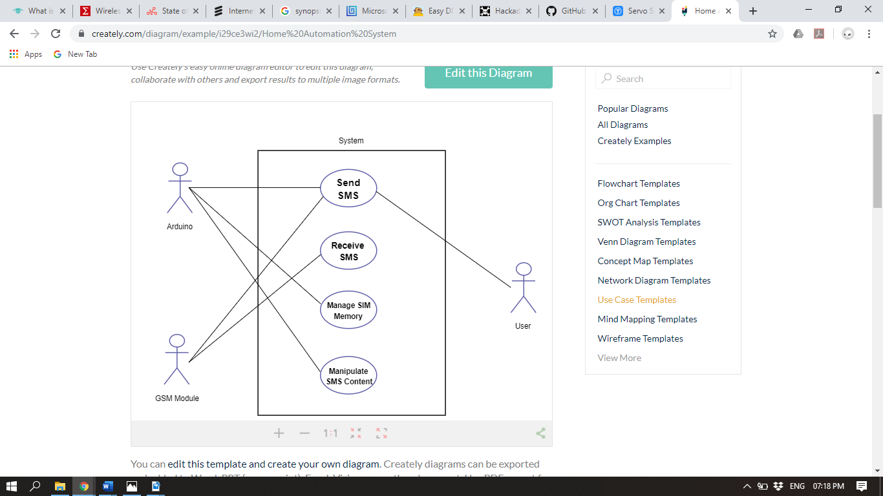

# **4.GUI DESIGN**

GUI design for the project is done in MIT App Inverter for the interface of android application and hence van be controlled wirelessly.

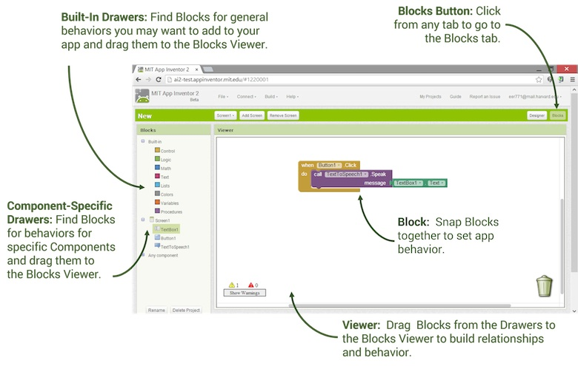

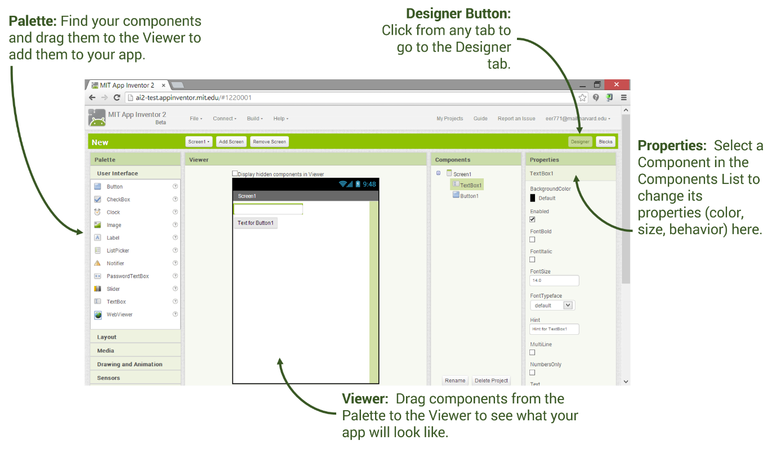

# **5. REVIEW**

