LAB – 2

Sub: DATA200

1. Main Menu:

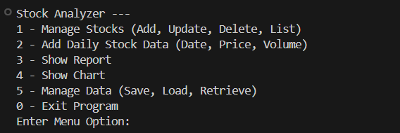

* 1. Manage Stocks (Add, Update, Delete, List)

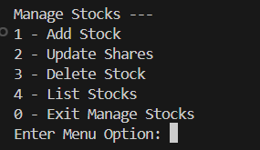

* + 1. Adding a Stock

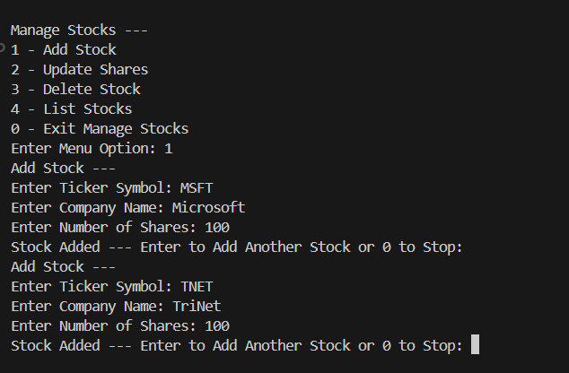

We have added two stocks – MSFT and TNET.  
To confirm if the stocks are being added we need to check if the stocks are being listed.

1.1.4 List the Stocks

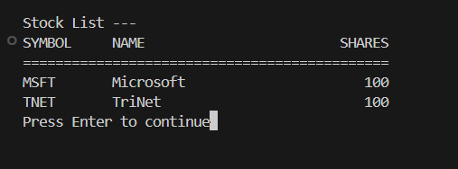

* + 1. Update Stocks

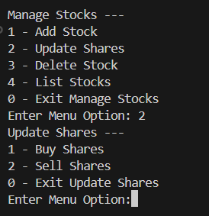

* + - 1. Buy Shares:

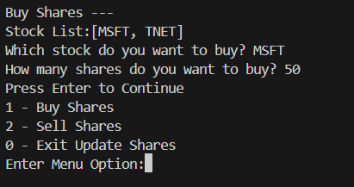

* + - 1. Sell Shares

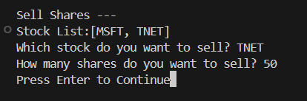

* + 1. List the stocks to confirm the updated list

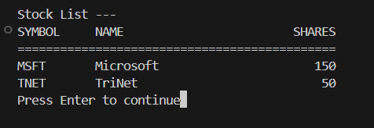

1. Add Daily Stock Data

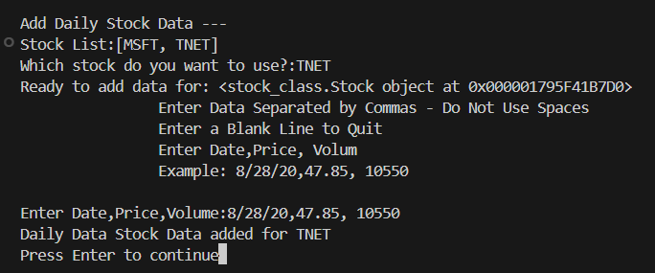

1. Show the Report of the stocks

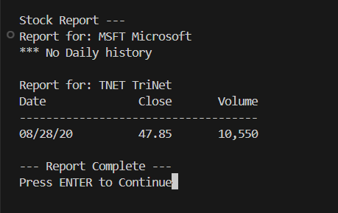

1.1.3 Delete Stock

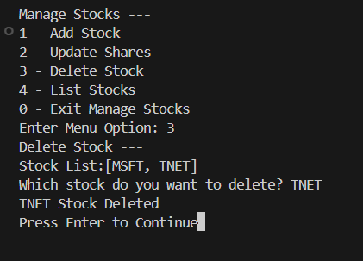

1.1.4 List stock to confirm if the required stock is deleted

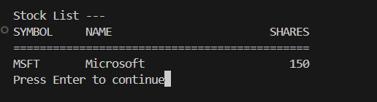

5.Manage Data

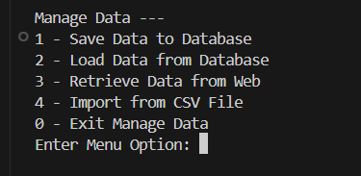

5.3 Retrieve Data from Web (Web Scraping)

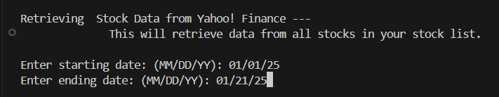

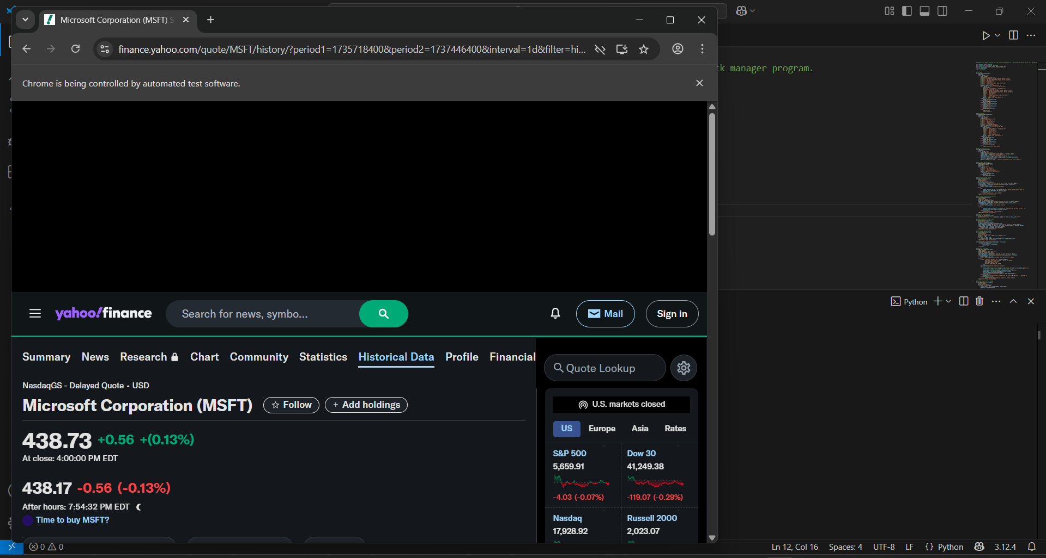

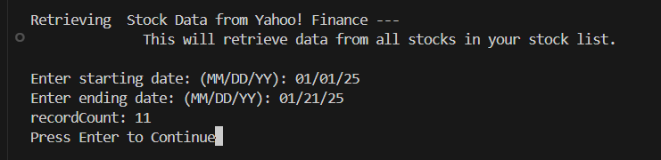

* 1. Saving to database

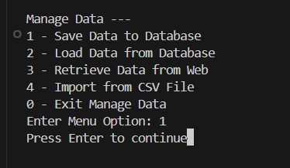

* 1. Load form the database

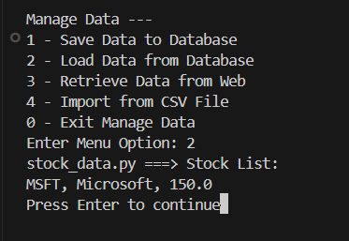

1. Show Chart

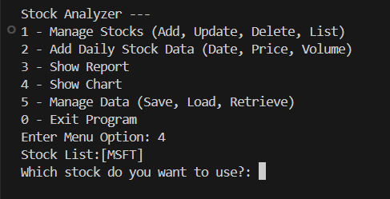

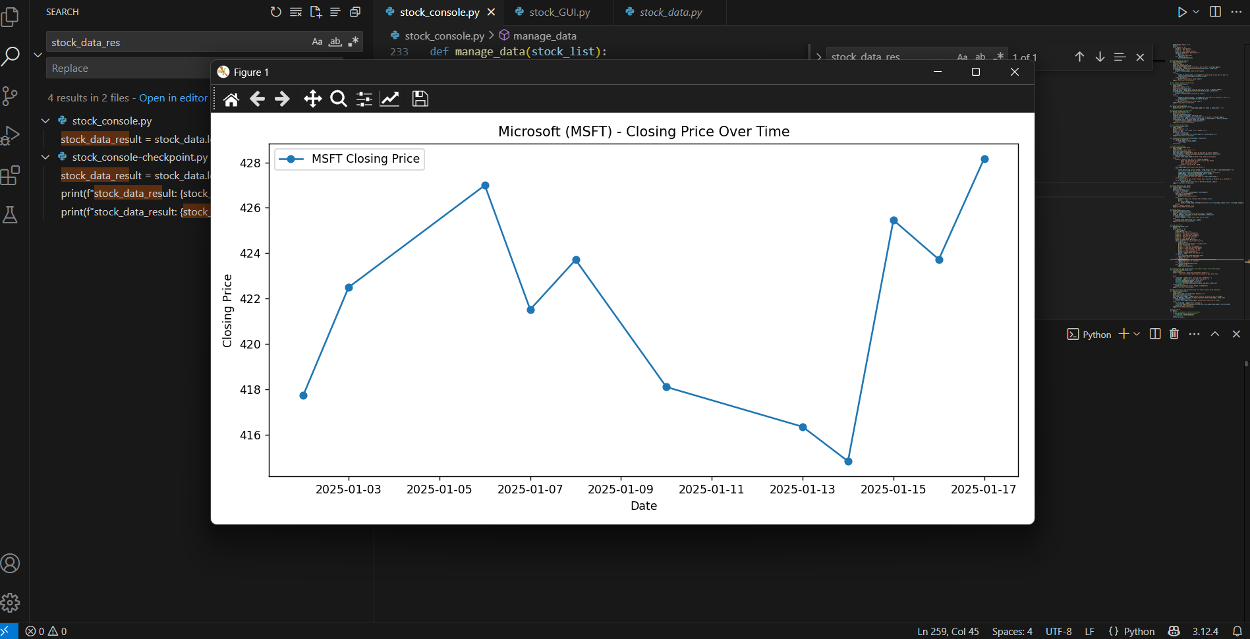

3. Show report

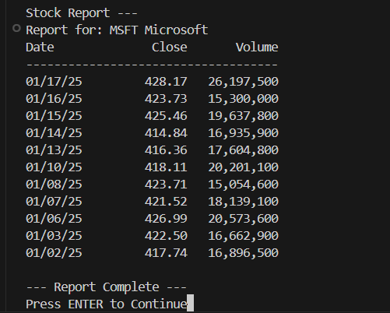

* 1. Import from CSV file

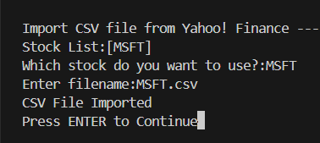

Show report of CSV

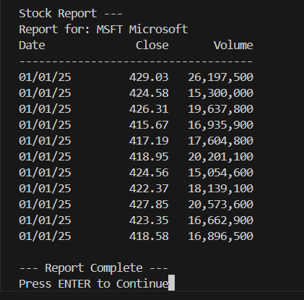

Show chart of CSV

