Accelerating Deep Reinforcement Learning via Imitation Learning
Xiao Lei Zhang
York University
Toronto, Canada
zhang205@cse.yorku.ca
Anish Agarwal
University of Waterloo
Fremont, California
a22agarw@outlook.com

Abstract—This electronic document is a “live” template and already defines the components of your paper [title, text, heads, etc.] in its style sheet. *CRITICAL: Do Not Use Symbols, Special Characters, Footnotes, or Math in Paper Title or Abstract. (Abstract)
Our source code is located at: https://github.com/veda-s4dhak/Cartpole-Imitiation-Learning
Keywords—imitation learning, deep reinforcement learning, deep q-learning, behavioral cloning

Introduction
Imitation learning in deep learning system is focused on modeling the behavior of the expert system or focused on modeling the reward function which best approximates the expert system’s behavior. [needs to be better]

The performance of an imitation learning system alone is limited by the performance of the expert player. In the ideal sense we want systems which can increase the upper bound of performance by going beyond that of an expert system. To achieve this, imitation learning alone is not sufficient. We are bounded by the limits of supervision.

Current fully unsupervised deep learning systems which have performance beyond known expert systems have been designed using reinforcement learning, where machines are learning from direct environment interaction. Deep reinforcement learning however requires quite a bit of training period till the neural network reaches expert level performance [citation]. This is exacerbated in increasingly complex environments.

It seems that there is a mutual advantage to augment reinforcement learning with imitation learning. A reinforcement learning model can accelerate its initial training time by imitating an expert system. An imitation learning model can increase its upper bound and go beyond the expert system by switching to direct environment interaction. In this paper we consider this augmentation. We use traditional imitation learning approaches as a precursor to deep reinforcement learning. A deep neural network first imitates an expert system and then is allowed to reinforce directly through the environment.

This paper investigates this possible symbiosis of imitation learning and deep learning. We first setup the framework of the experiment, followed by the implementation details and concluding with the experimental results.

The variation of imitation learning we are applying is Behavioural Cloning [citation] via Forward Learning [citation].

For both training portions, imitation learning and reinforcement learning a standard Deep Q-Learning model (DQN) is used. The DQN first computes imitation error during the imitation learning portion and subsequently computes the reinforcement error during the reinforcement learning portion.

Framework
The set of initiation learning approaches can be classified into two categories: behavioral cloning and inverse reinforcement learning. Behavioral cloning as the name says focuses on making an deep learning system directly model an expert system. Inverse reinforcement learning on the other hand focuses on making a deep learning system model the reward function which the expert system is trying to optimize.
For the purposes of this experiment, behavioral cloning is preferred. This is because the training environment under consideration in this paper has a well defined reward function and is thus more conducive to behavioral cloning.

Markov Decision Processes
We define the MDP parameters as {S, A, P, R, I}, where:
- S is the set of states
- A is the finite set of actions
- P = P(s, a, s’) is the state transition probability which denotes the probability to transition to state s’ give than the previous state was s and action a was taken.
- R = R(s,a) is the reward in state s given action a was taken
- I is the initial state distribution
Additional parameters are specified as follows:
- N denotes the number of epochs
- T denotes the time horizon
- pi denotes the policy that determines which action is taken at state s
- pi* denotes the experts policy
- pi** denotes the optimal policy
Note: pi* != pi**

Given the above we can make the following conclusions:
- V(pi) = T*Es~dpi[R(s, pi(s))] denotes the total rewards of all trajectories given the initial state I
- V(pi*) - V(pi) denotes the imitation regret
- V(pi**) - V(pi) denotes the reinforcement regret
- V(pi**) - V(pi*) denotes the expert regret
The goal of augmented reinforcement learning is to accelerate reduction of reinforcement regret to the point where it is below expert regret. That is using imitation learning to reach the point where
V(pi**) - V(pi) <= V(pi**) - V(pi*)
as fast as possible.

Imitation Training Methology

For imitation training we use the forward training methodology used by Ross and Bagnell (2010) [2] modified to use a stationary policy. We use a stationary policy since the T is unbounded in the training environment.
The training methodology is summarized as follows:
initialize pi
for I = 1 to T do
Execute trajectories by following pi*
Get dataset D = {states, action} taken by expert at step I
Train classifier with the reward = expert action – user action
end for
return pi

Reinforcement Training Methology

The reinforcement training is similiar to imitation training except that the training classifier uses a reward function directly from the environment rather than the expert player.
initialize pi
for I = 1 to T do
Execute trajectories by following pi*
Get dataset D = {states, action} taken by expert at step I
Train classifier with reward = environment reward
end for
return pi

Implementation
Explain the mechanics of the cartpole project and neural netowork training
A. CartPole-v1
We implement our experiment in CartPole-v1 Gym environment in which a pole is attached by a joint to a cart which is controlled by applying a force of +1 or -1. The pole initially starts upright and the goal is to prevent the pole from falling over. Each episode ends, when the pole is more than theta degrees from the vertical or the cart moves more than 2.4 units away from the center. For this experiment, we set theta to 50 degrees to reduce learning time of each agent.
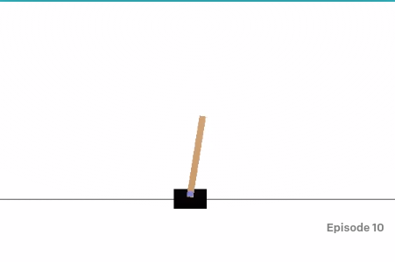
B. Reward Function

C. Model Architecture

1) What is cartpole and why (ease of expert → PID)?
2) Reward function modification
3) Neural Network?
4) How does imitation work?
5) How does RL work?
6) Draw out the neural network
7) What worked in training and what didnt work
Someone should be able to read this and understand our Github project

Results
A. CartPole-v1 with Deep Q Learning
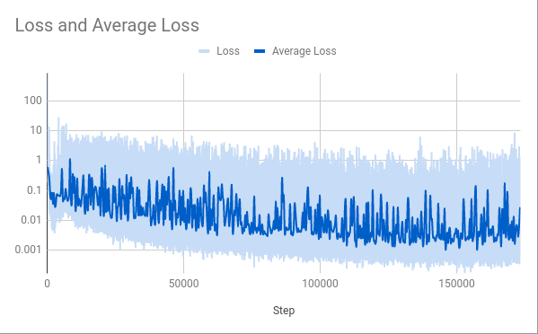

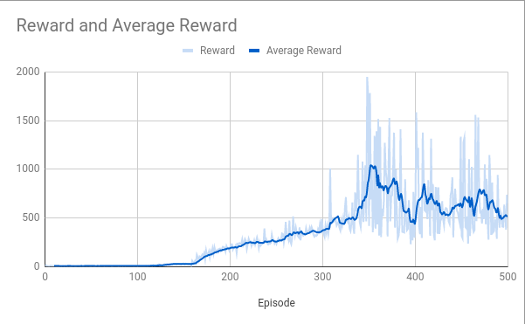
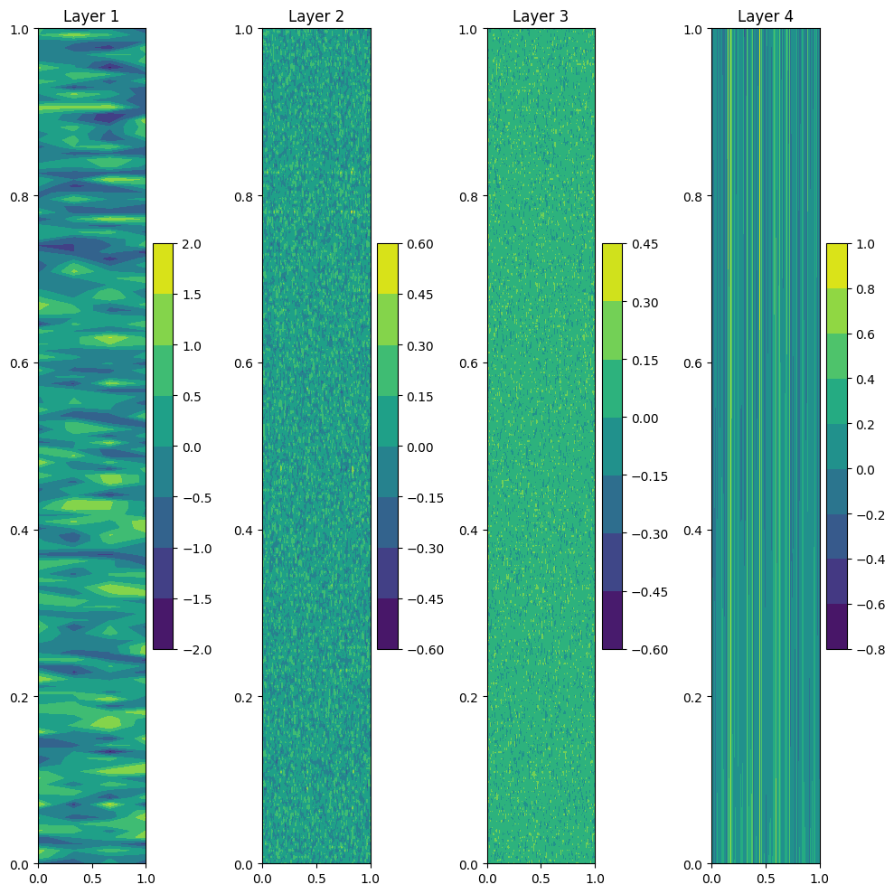
Figure 1. Model Loss and Reward for CartPole-v1 with Deep Q Learning, denoted as RL500.

Figure 2. Model Weights for RL500 Model.
B. Expert Player (PID) with Behavoral Cloning
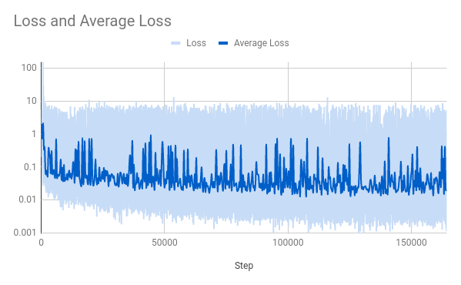
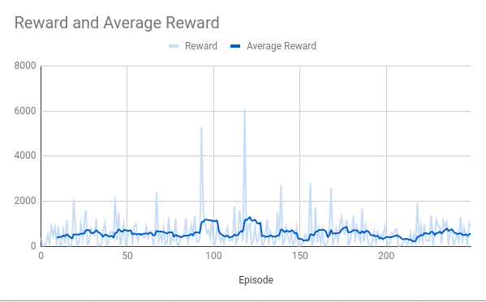
Figure 3. Model Loss and Reward for Behavioral Cloning using PID expert player, denoted as IL250.
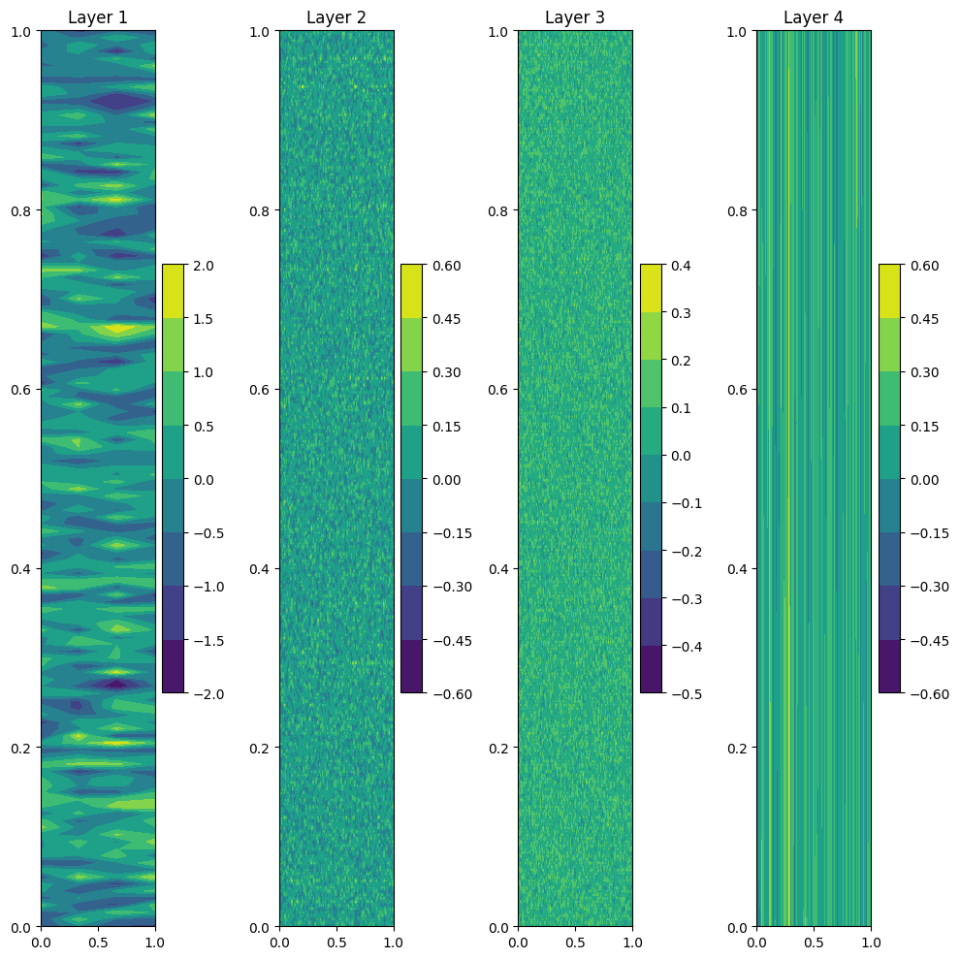

Figure 4. Model Weights for IL250 Model.

C. Deep Reinforcement Learning after Behavioral Cloning
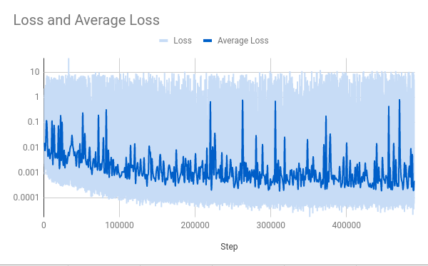

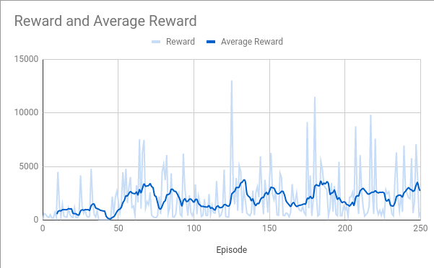

Figure 5. Model Loss and Reward for CartPole-v1 with Deep Q Learning after Behavioral Cloning, denoted as IL250 + RL250.

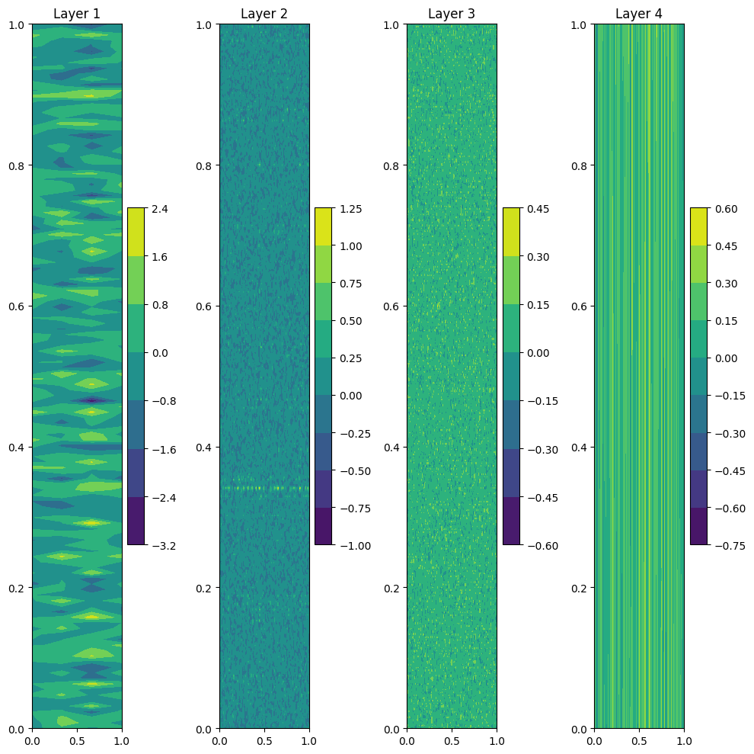

Figure 6. Model Weights for IL250 + RL250 Model.

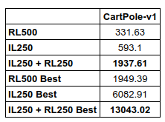

Table 1.Comparison of average reward and best reward for each learning method. Best reward measures the single best performing episode for each learning method.

Conclusion

Acknowledgment
We acknowledge ourselves. We very much thank our selves for self funding our and lives and allowing us to focus in a decidated manner this project. We are gratefull to Anish and Xiao Lei for ther resources to this project. Also shoutout to Geoof Hinton, Ian Goodfellow, Yan Lecun and Demis Hassabis for this inspiration in this field.

References
- G. Eason, B. Noble, and I. N. Sneddon, “On certain integrals of Lipschitz-Hankel type involving products of Bessel functions,” Phil. Trans. Roy. Soc. London, vol. A247, pp. 529–551, April 1955. (references)
- J. Clerk Maxwell, A Treatise on Electricity and Magnetism, 3rd ed., vol. 2. Oxford: Clarendon, 1892, pp.68–73.
- I. S. Jacobs and C. P. Bean, “Fine particles, thin films and exchange anisotropy,” in Magnetism, vol. III, G. T. Rado and H. Suhl, Eds. New York: Academic, 1963, pp. 271–350.
- K. Elissa, “Title of paper if known,” unpublished.
- R. Nicole, “Title of paper with only first word capitalized,” J. Name Stand. Abbrev., in press.
- Y. Yorozu, M. Hirano, K. Oka, and Y. Tagawa, “Electron spectroscopy studies on magneto-optical media and plastic substrate interface,” IEEE Transl. J. Magn. Japan, vol. 2, pp. 740–741, August 1987 [Digests 9th Annual Conf. Magnetics Japan, p. 301, 1982].
- M. Young, The Technical Writer’s Handbook. Mill Valley, CA: University Science, 1989.

