Abstract

Our code is located at: https://github.com/veda-s4dhak/Cartpole-Imitiation-Learning

Introduction
Is the tone of the paper relevant to the target audience?
Do we have to cite our passive claims? (see highlighted)
Imitation Learning Methods (Behavioural Cloning or Inverse Reinforcement Learning)
  - Supervised learning by classification
  - Forward Training: This is what we are doing
  - Searn
  - SMILe
  - RAIL
  - Dagger
  - Dagger with Coaching

Imitation learning research has focused on improved the process of imitation. Within this process of imitation research has focused on modelling the behaviour of the expert system or focused on modelling the reward function which best approximates the expert system’s behaviour.
The performance of an imitation learning system alone is limited by the performance of the expert player. In the ideal sense we want systems who can increase the upper bound of performance by going beyond that of an expert system. To achieve this, imitation learning alone is not sufficient. We are bounded by the limits of supervision.

Current fully unsupervised deep learning systems which have performance beyond known expert systems have been designed using reinforcement learning, where machines are learning from direct environment interaction. Reinforcement learning however requires quite a bit of training period till the neural network reaches expert level performance [citation]. This is exacerbated in increasingly complex environments.

It seems that there is a mutual advantage to augment reinforcement learning with imitation learning. A reinforcement learning model can accelerate its initial training time by imitating an expert system. An imitation learning model can increase its upper bound and go beyond the expert system by switching to direct environment interaction. In this paper we consider this augmentation. We use traditional imitation learning approaches as a precursor to deep reinforcement learning. A deep neural network first imitates an expert system and then is allowed to reinforce directly through the environment.

The variation of imitation learning we are applying is Behavioural Cloning [citation] via Forward Learning [citation]. We use Behavioural Cloning instead of Inverse Reinforcement Learning [citation] since the training model is more transferrable to reinforcement learning. Since the reward function during reinforcement is exactly defined it is not useful to create a prior definition of the reward function. We use forward learning since it generates a non-stationary policy. This is conducive to scenarios where an expert player is readily available.

We use a standard Deep Q-Learning model with a modified error function to first compute imitation error and subsequently compute reinforcement error.

Implementation:

We consider a simple environment CartPole provided by the OpenAI Gym project. The environment is modified to provide an additional interface for imitation learning. We increase the angle threshold to 50 degrees to reduce training time.

The expert system we are using is a standard PID controller. The controller was tuned to provide enough performance to go beyond basic DQN performance but with enough in-stability to reduce training time.

Mathematical Framework:
Cite: Global Overview of Imitation Learning
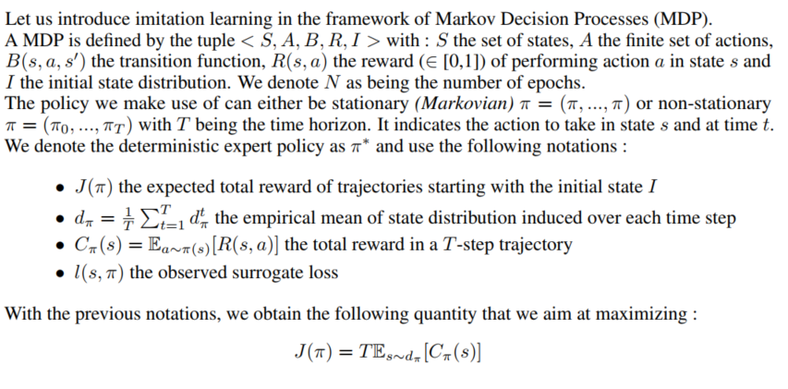
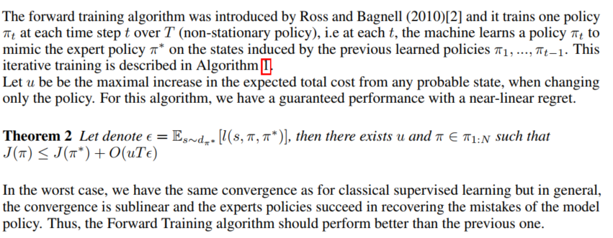

Experimental Results
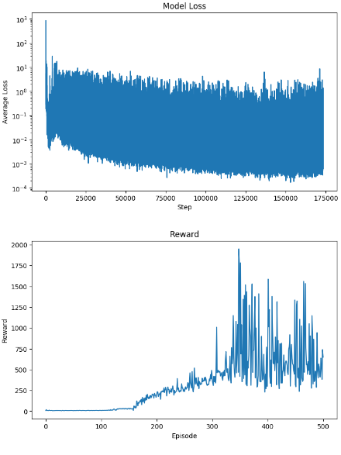
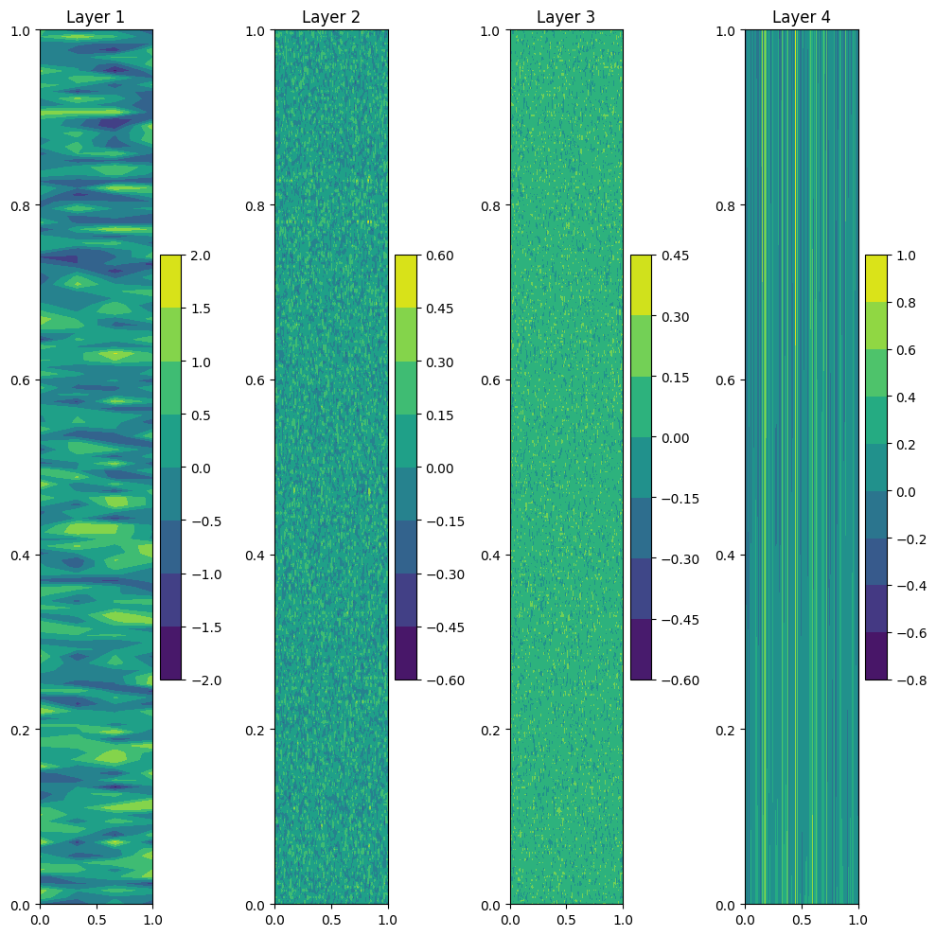

Figure 1. Model Loss and Reward Plots for RL500 Figure 2: Model Weight Plot for RL500

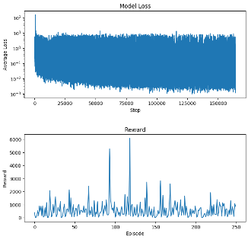
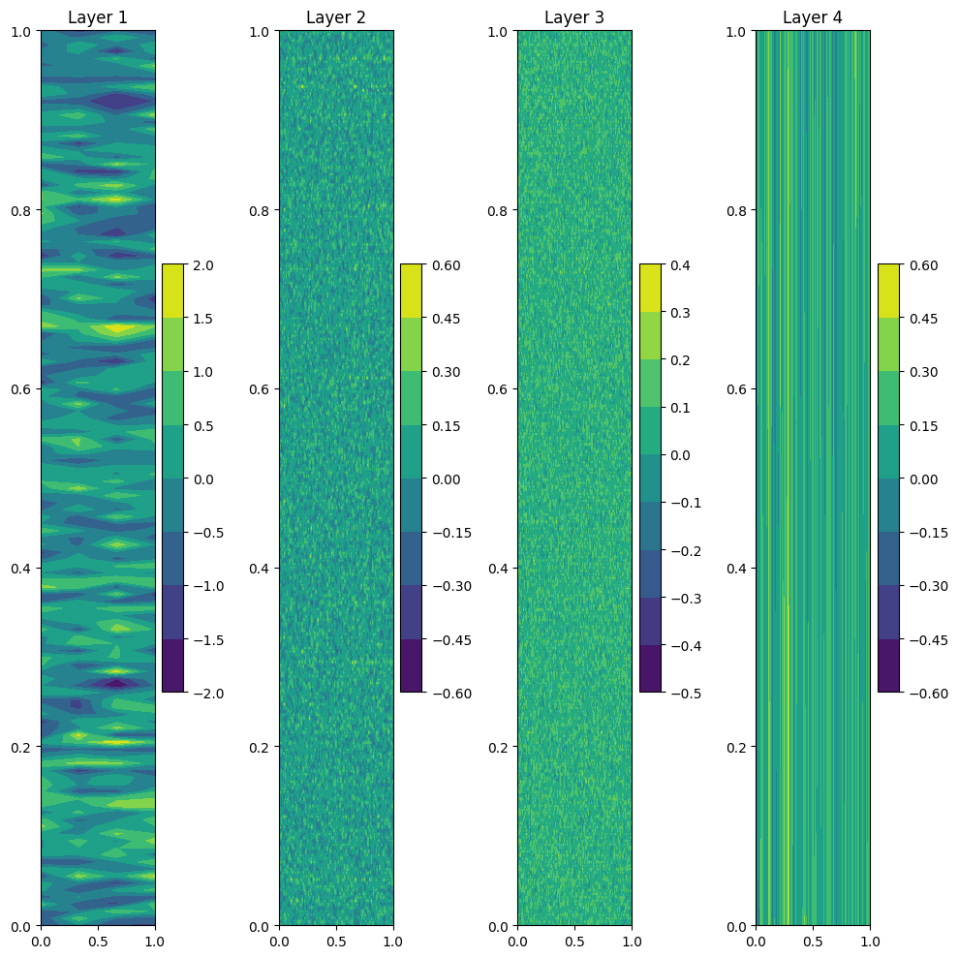

Figure 3. Loss and Reward Plots for IL250 Figure 4: Model Weight Plot for IL250
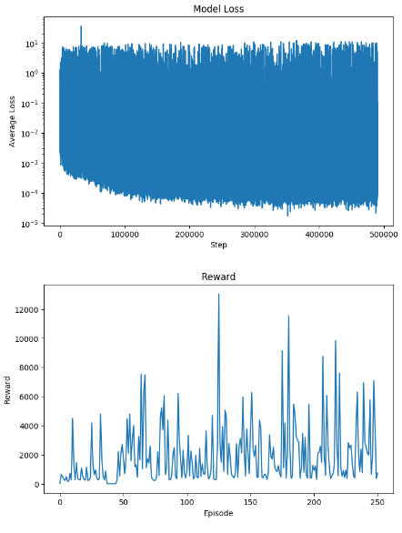
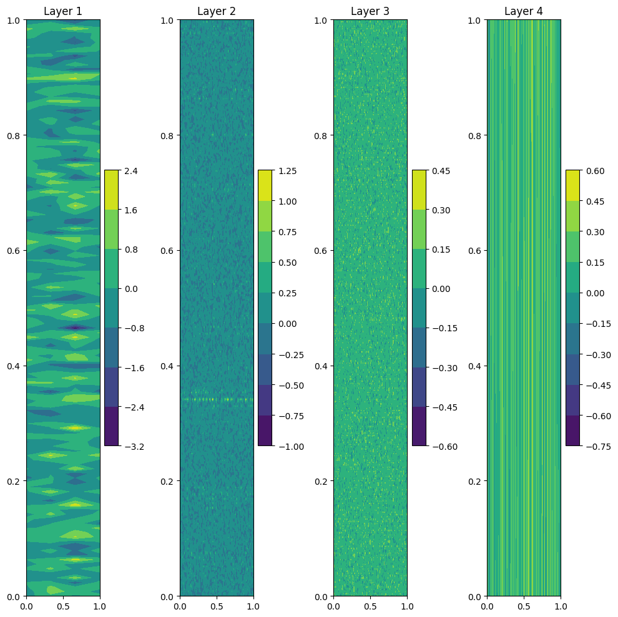

Figure 5. Loss and Reward Plots for IL250-RL250 Figure 6: Model Weight Plot for RL250_IL250

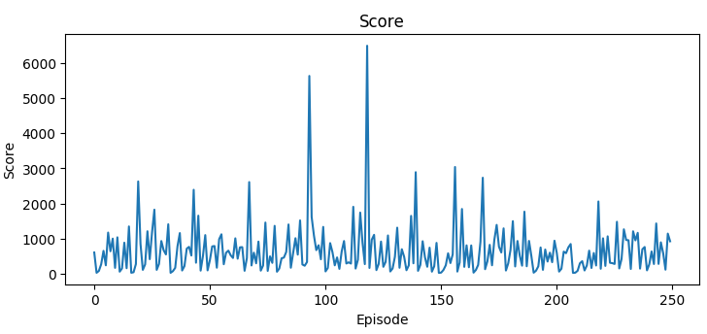

Figure 6. Score Plot for PID250

Conclusion

References
CartPole: https://gym.openai.com/envs/CartPole-v1/

