Forest Fire Montesinho Natural park in Portugal

Team member names

1.Shivani Nalanagula

2.Veda Samskruthi Kancherla

3.Sravani Pasunuri

4.Prathyusha Bathula

5.Poorna Prakash Pulamakula

**Introduction:**

Forest fires are impacting the world like a fish under the water destroying the least left flora and fauna and has became an major consent for all the countries around the world. They have the ability to alter the ecosystem all around the world. This can be occurred naturally or man made fires this can spread swiftly and wild devouring large areas of the forest causing a huge impact on animals, plants and other organisms that are sustaining on the forest. Thoe the effect of forest fires on global warming is minimal but this will slow down the recovery period of the global warming. In order to reduce their potential for destruction and protect the natural heritage of our planet, it is essential to comprehend their causes, dynamics, and ecological implications.

Montesinho Natural Park in Portugal is a pristine sanctuary of biodiversity and natural beauty with rugged mountains, lush and green forest and beautiful villages and landscapes with rich culture heritage and diverse flora and fauna. It is a protected area by the Portugal government offers visitors a glimpse of rich cultural and traditional look. It stands as a testament to Portugal's commitment to conservation and sustainable tourism, inviting adventurers and nature enthusiasts alike to explore its unspoiled charm. Despite of all the efforts put forth by the government the forest fires have destroyed the landscape leading to many forest fires and is a concern for the government to reduce this the government has taken report of every incident in an year our task i to use this data and help the government to identify the patterns of forest fires and help them to take precautions to reduce the number of incidents that are happening in the area.

The indexes used to calculate forest fires are Fire whether index (FWI) or Fire Damage Rating System(FDRS) These are the tools in assessing wildfire risk and behaviour. These values are intern dependent on FFMC,ISI,RH,DC,DMC. Which are derived based on Temperature, Wind, Rain.

**Problem statement:**

Forest fire is a major environment issue that is degrading the quality of air quality we need to reduce the forest fires by taking precautions. Based on FFMC,ISI,RH,DC,DMC indexes we are trying to identify the patterns that are influencing the spread of wild fire.

|  |  |
| --- | --- |
| **Variables** | **Description** |
| Day | Day of the incident |
| Month | Month of the incident |
| FFMC | FFMC index from FWI |
| DMC | DMC index from FWI |
| DC | DC index from FWI |
| ISI | ISI index from FWI |
| Temp | Temperature in the area |
| RH | Relative Humidity |
| Wind | Wind speed Km/H |
| Rain | Rain in MM/M2 |
| Area | Area of spread |

**Source:**

The dataset we chose is from the kaggel.com which Forest Fire Montesinho Natural park in Portugal the link is below. This dataset has helped us in analysing our interested topic.

[**https://www.kaggle.com/datasets/sumitm004/forest-fire-area**](https://www.kaggle.com/datasets/sumitm004/forest-fire-area)

**Project objective :**

Our project objective is the identify the relation between the index’s that are influencing the FWI and provide a visual representation on the important indexes that are contributing to the spread of wild fire. Our goal is to identify the key factors and relating them through visualization for the fire department to be alert in those condition and provide a speed control of the situation and reduce the damage caused by the fire.

**Scope:**

The scope of our project will primarily be the analysis and visualization the FWI indicators for the days the incident has occurred. We are focused on learning the long term trend , effect of temperature and wind speed on cause of forest fire. And also to build a correlation between the DC and DCm indicators. Using all the variables we hope to create a tubule visualization to provide insights into the dynamics of cause of forest fires in Montesinho Natural park , ultimately facilitating informed decision-making and promoting environmental action to protect the natural park.

However we need to understand the limitations of the data, which might significantly affect the work. This limitations can be missing values, possible error in measuring the data for the specific incident. Since we are looking only into the data and details that is recorded on the day the incident has occurred we are blinded by the details of general conditions present in the area. Despite the limitations, we will attempt to make we maximize the usefulness of the available data and address any potential limitations in our visualization and interpretation of in an obvious manner.

**Data Selection:**

We selected this dataset after understanding the interests of all our team members as every one of us wanted to analyse this dataset to explore the answer to the cause of wide fires and be eco friendly and reduce the damage to the environment. The best part was that this dataset was a surveillance which is highly relevant to our team's interest. As this data is recovered from the park data itself we can accurately measure the trends.

The main variables we intended to investigate are depends on temperature wind and air influencing on the indicators such as ISI, DC,DMC, FFMC as these indexes are used to calculate the FWI and identify the cause of the fires. Additionaly we are identifying the corelation and trend between the DC and DMC that are dependent on drought codes and the amount of fry area present in the area. We also analysis the ISI which is the rate of speed at which the fire will spread which is influenced by wind speed. The FFMC will  represents fuel moisture of forest litter fuels under the shade of lush forest.

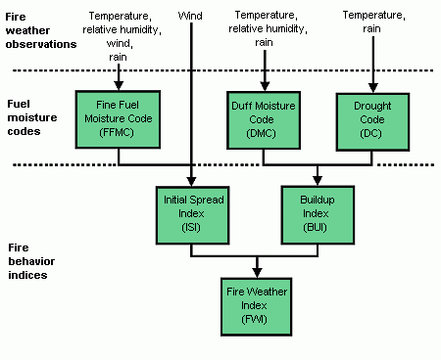

**Justification:**

We chose this dataset because it provides a comprehensive indication of cause of forest fire in the natural park which fits well with the goals of our project to analyze and visualize Environmental damage. Using these datasets, we can examine and identify areas of concern, and make recommendations that can be implemented to reduce forest fires and improve eco system. It can inform evidence-based decision-making and targeted actions to implement preventive measures.

The topics we chose is having an impact on animals, plant and organisms that are effected by the forest fires. Understanding the dynamics of forest fires is important for the forest officers and also the government to safeguard wide spread of the wild fires it is better to be prepared than to be sorry . We also hope to stimulate collaborative efforts to tackle Fires and we hope to create healthy, sustainable forest for the animals that all live there.

**Targeted audience:**

Our main targeted audience are fire department, Forest officers, Activist and natural park authorities for the Montesinho Natural park.

Insights and visualizations can help authorities to make situation based decisions on the conservation of forest that reduces the cause of fires. the public Environmentalists can use graphics to advocate environmentally friendly practices and policies for avoiding the fires. It also help to resistant public access in few areas where there are more suitable conditions for a forest fire to occur.

In addition, academic institutions, researchers, and students interested in environmental science, forest studies can benefit from our Tableau project. Visualization can be a useful educational tool to make people aware of the causes and consequences of forest fires and their causes in space and time, and emphasize the importance of collective action in the environment emphasis on environmental issues.

**Analysis:**

* **Insightful Analysis and Interpretation of the Data:**

The study provides data on long-term fire incidents happening in the natural park area. Several data points such as average ISI , average DC provides a detailed view on the cause of the forest fires notably is that the project includes:

Graphs show the wind speed is one of the major cause for the forest fires. Other insightful analysis comes with the temperature which represents the major reason for the start of the fire along with ISI index which is adding fuel to for the spread of forest fire.

* **Identifying Meaningful Patterns, Trends, and Relationships:**

The data reveal several meaningful things: We can identify the corelation between DC and DCM which are drought code and duff moisture. We can also identify that temperature is also effecting these 2 factores predominately. But the temperature is not effecting the Humidity but in general terms this shouldn’t be the scenario as the temperature increase the humidity should be increased.

* **Well-supported conclusions based on the analysis:**

Our analysis has best output results as the we are able to show the matter of forest fires effectively and the main indicators that are needed to be considered by the forest department in identifying the cause of forest fires. The ISI index, DC Index and DCM Index have clearly show the possible outcome’s of the incidents and precautions needed to be taken in such situations.

Over all we were able to achieve the results we are looking for by using dataset about forest fires.

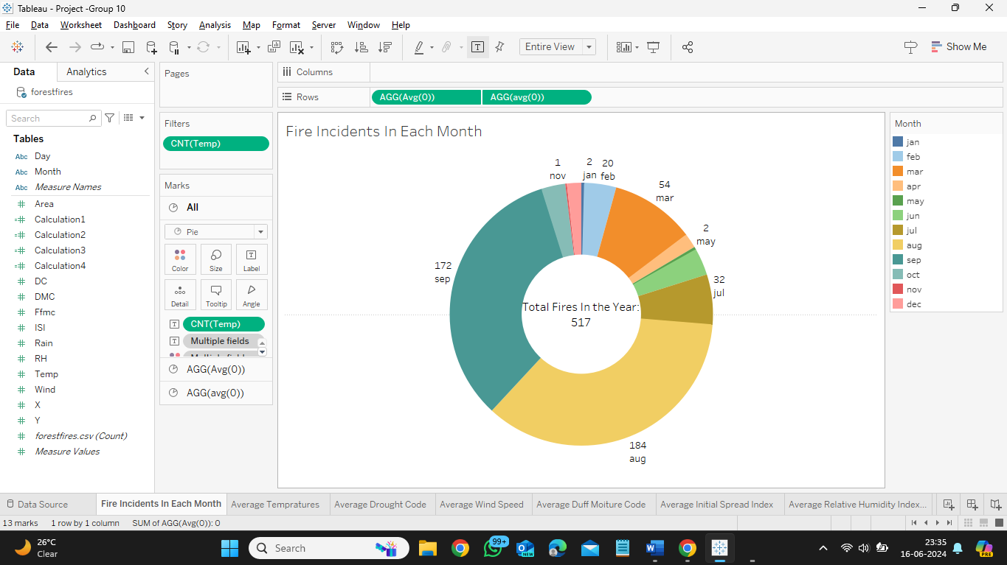

This visualization show’s the total number of incidents of forest fires that have occurred over a period of one year. It also represents the number of incidents that have occurred in each month individually. Helping us further to look into those months with higher incidents by analysing in those months.

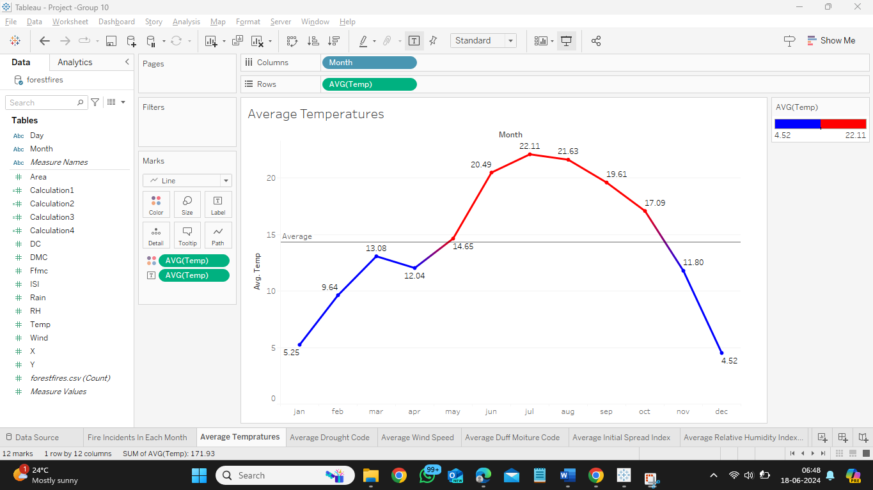

Our line graph here represents the average temperature in each month in that year. The colour difference represent the hottest and coldest month in the year. The visual line show the average temperature though out the year.

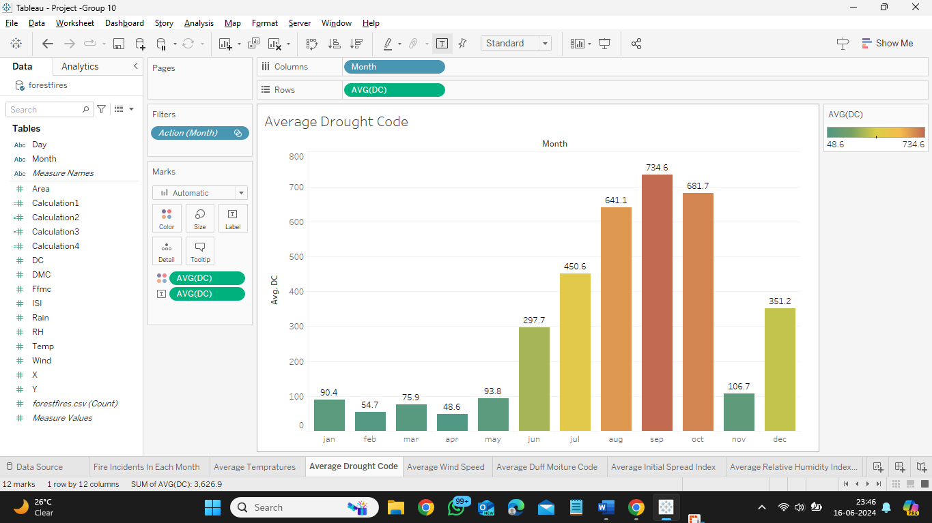

The Bar chat represents average drought code in each month providing us the insights on the indicator that needed to be considered while analysing the incidents.

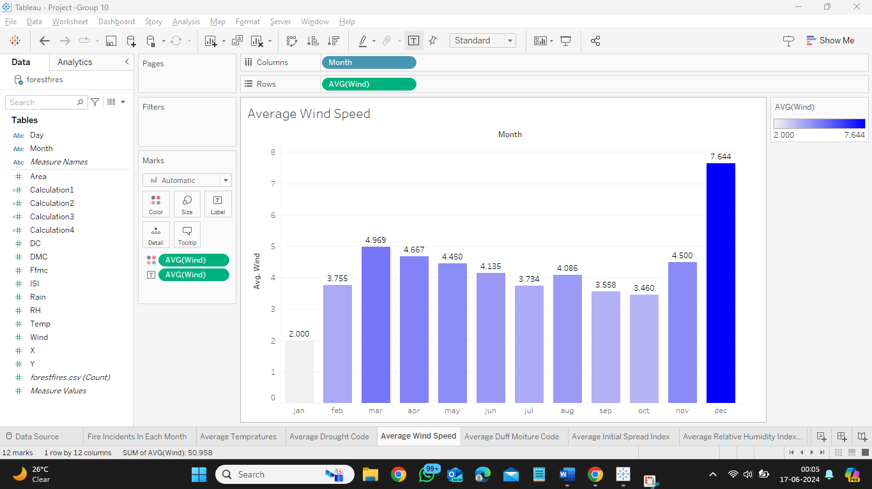

Wind Speed is an another indicator that is very useful for our analysis as it show the rate at which the fire would be spreading in the case the wind speed plays a major role in the cause of the incident. The wind speed is constant for all over the year except for the month of December.

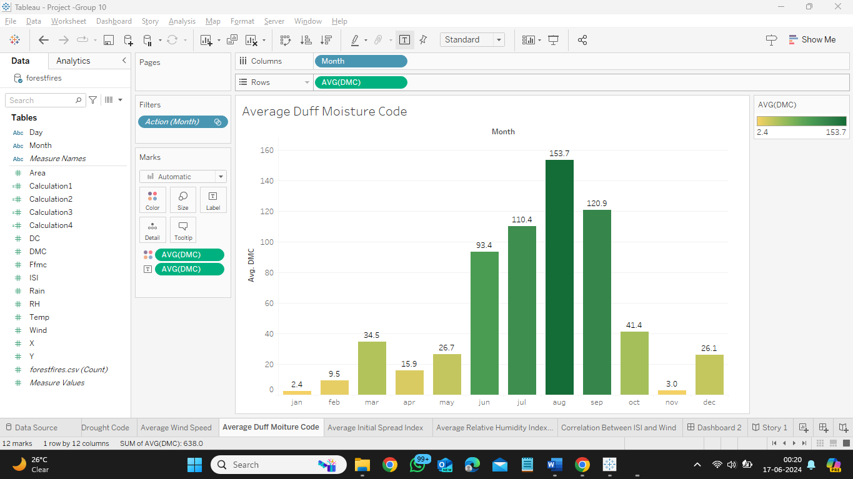

This graph showcase the average Duff moisture code which is another important index for the FWI analysis we can relate this graph with temperature as the graph is looking very similar to the temperature and pose a relationship between these two.

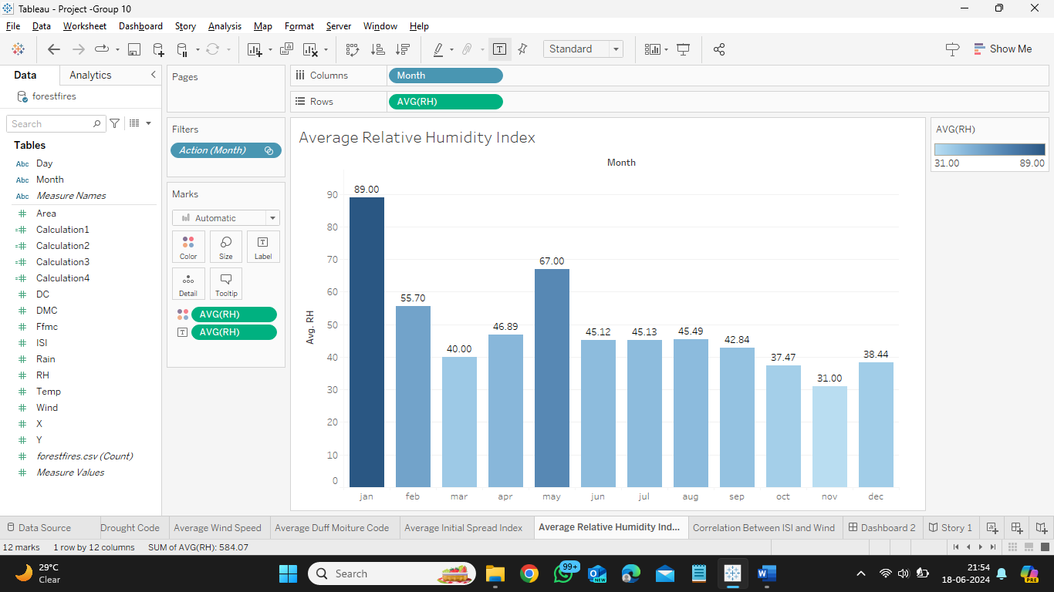

This is another indicator for the analysis of forest fires showing us the average relative humidity in the area on the date of the incident we could read the humidity id relative to the forest fires and the number of incidents are low in those months where the relative humidity is very high.

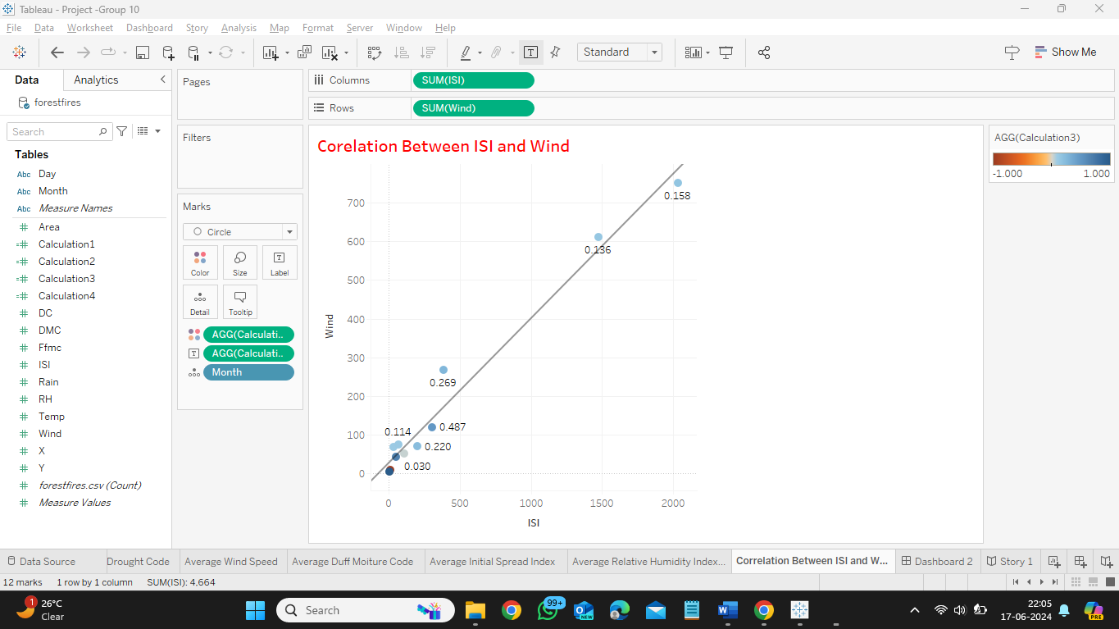

This Graph represents the corelation between the ISI and the wind speed which are two important parameters that determine the spread of the forest fires. We can clearly identify that the relation between wind and ISI is positive which represents the wind and ISI are corelated and is having a positive corelation identified from the positive trend line on the graph. This represents that the wind is effecting the ISI index and can be considered that our analysis are correct.

**Interactivity and Storytelling - Dashboard & Story:**

The dashboard and story provide a detailed and interactive visualization of forest fires in the Montesinho Natural Park in Portugal. We have used attractive colours using which we can easily distinguish between different between the different indicators and can easily identify the relation ship between few of those indicators.

The top section provides the total number of incidents in the year into a pie chart and dividing into each month. The following charts represents the number of incidents in a particular month in each day of the month, Followed by average of Temperature, wind speed and ISI of each day in a month in accordance with the number of incidents that have happened in that year.

Our dashboard is showcasing all the relevant indexes that are resulting in the cause and spread of forest fires here we can observe that the ISI and wind are the main cause of the forest fires though the temperature is adding fuel for the start of the forest fires the wind speed and ISI are an important factors in this case as forest fires as more incidents have occurred in the places where the ISI and wind speed are high.

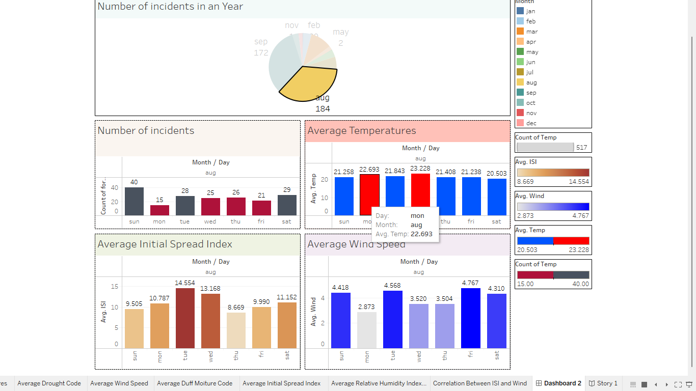

The Story on Forest fires showcases the important parameter that we need to look into while analysing the root cause of forest fires with vibrant colours and along with the number of incidents that are related with those parameters. This helps the stack holders to help them understand the climate better along with the uses of the data to do more research on the forest fires. The story itself can describe all our analysis without looking into other factors with doing any further analysis on the forest fires.

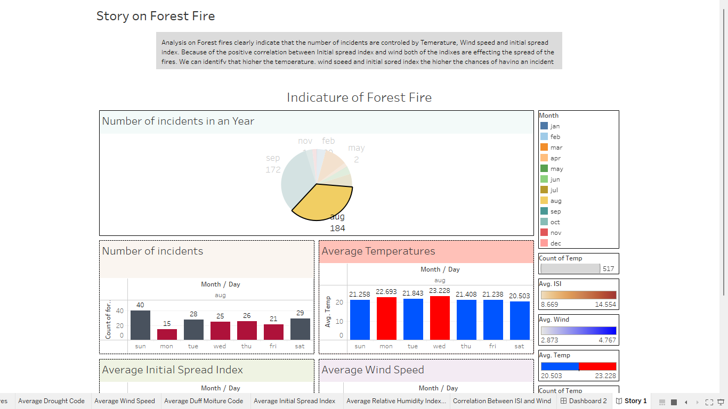

**Challenges for the Project:**

Our potential challenge for the data is the completeness and quality of the data as this is from the raw source we can get the exact values on the incident and potentially the true figure at the time of which the incident happened this is a good data point as analysis could be precise and unto to the point for our analysis. But the dataset don’t contains the readings of tall the days in that year we will not be able to understand the general condition of the area so we will be unable to analysis the general condition of the area which leads to some soft of miss information in analysing the data. To avoid this issue we could use data form other sources for analysing the pattern since the our analysis is providing a fruitful resolution we could use the same and achieve our results.

Another challenge we could face is the limitations of the Tableau software. By using proper tools and techniques we hope to ensure that our Tableau project on forest fires will become a good resource for every individual using it for analysis.

**Business implications:**

From our analysis we could potentially help government, fire fighters, forest officers and NGO’s to take precautionary measures to safeguard the forest area from fires and help them saves animals and other living beings. Government could also bring resolutions to prevent or restrict area to the public which have dangerous.

We could build satellite surveillance on the area with more incidents and do a regular analysis on the areas which could be accessible to the general public helping them the dangers that are present in their camping cites we could use this sites to advantages products that are helpful in such dangerous situation .

**Conclusion:**

In Summary, Our analysis in the tableau about the Forest Fire Montesinho Natural park in Portugal revels the a valuable insight into the patterns of the fires effecting the forest fires in the national park and impact of such fires in the forest area. We intend to create a interactive dashboard that highlights the descriptive analysis of the index related to forest fires, relation between such index and cause of the fire. Our project is aimed to raise the awareness of the forest fires and their impact on the area , providing valuable insights for the stakeholders, government, public and help them to effectively build an network to reduce the forest fires in the natural park.

With regular updating of data and adding additional information about the area we are confident we could overcome the problems and increase the accuracy of the data set. This model could potentially become very useful tool to analysis the forest fires and offer valuable insights in dealing with the fires.

We could build satellite surveillance on the area with more incidents and do a regular analysis on the areas which could be accessible to the general public helping them the dangers that are present in their camping cites we could use this sites to advantages products that are helpful in such dangerous situation .

By using proper analysis we can prevent the fires and reduce the expenditures of fire fighters and forest officers for revenue saving.