CS898BD ASSIGNMENT-2
Q2 REPORT
Experiments on Non-Linear Activation Functions (CIFAR-10)

- Goal (what I tested)
I trained the same 4-layer CNN on CIFAR-10 twice, changing only the hidden-layer activation:
- Model A: ReLU in all hidden layers (no activation on the output layer).
- Model B: Tanh in all hidden layers (no activation on the output layer).
I stopped each training run as soon as the training error ≤ 25% (i.e., training accuracy ≥ 75%).
For both runs I also recorded the time per epoch (seconds) and I plotted both trainings on the same figure.
- Dataset
Dataset: CIFAR-10 (50,000 training images, 10,000 test images; 10 classes; 32×32 RGB).
Preprocessing: Convert to tensor and normalize with the standard CIFAR-10 mean/std:
mean = (0.4914, 0.4822, 0.4465), std = (0.2470, 0.2435, 0.2616).
No data augmentation (to keep the activation comparison as clean as possible).
- Model (same architecture for both runs)
A small 4-layer CNN without BatchNorm/Dropout (so the activation difference shows clearly):
- Block 1: Conv (3→64, 3×3, pad 1) → Activation → Conv (64→64, 3×3, pad 1) → Activation → MaxPool (2×2)
- Block 2: Conv (64→128, 3×3, pad 1) → Activation → Conv (128→128, 3×3, pad 1) → Activation → MaxPool (2×2)
- Head: Flatten → Linear (128×8×8 → 256) → Activation → Linear (256 → 10)
- Output: raw logits (used with CrossEntropyLoss).
- Initialization: Same for both runs (Kaiming/He on weights; bias=0).
Only the word Activation above changes: ReLU or Tanh.

- Training setup (identical across runs except activation)
- Optimizer: SGD (momentum 0.9).
- Batch size: 128.
- Learning rate: tuned per activation for the AlexNet-style comparison
(start ReLU around 0.01, Tanh around 0.001; I kept other settings identical).
- Weight decay: 0.0 (no regularization) for this comparison.
- Epoch cap: 200 (early stopping usually triggers much earlier).
- Seed: 42 (to keep the process reproducible).
Stopping rule: stop immediately when training error ≤ 25%.
- Results
5.1 Early-stop point and final metrics
- ReLU: stopped at epoch 5 (≤25% train error achieved).
- Tanh: stopped at epoch 30 (≤25% train error achieved).
- Epoch multiple: Tanh / ReLU = 30 / 5 = 6×.
Time per epoch is similar across the two runs (same model/data).
Therefore the 6× epoch gap translates directly to ≈6× longer wall-clock time for Tanh to reach the same stopping criterion.
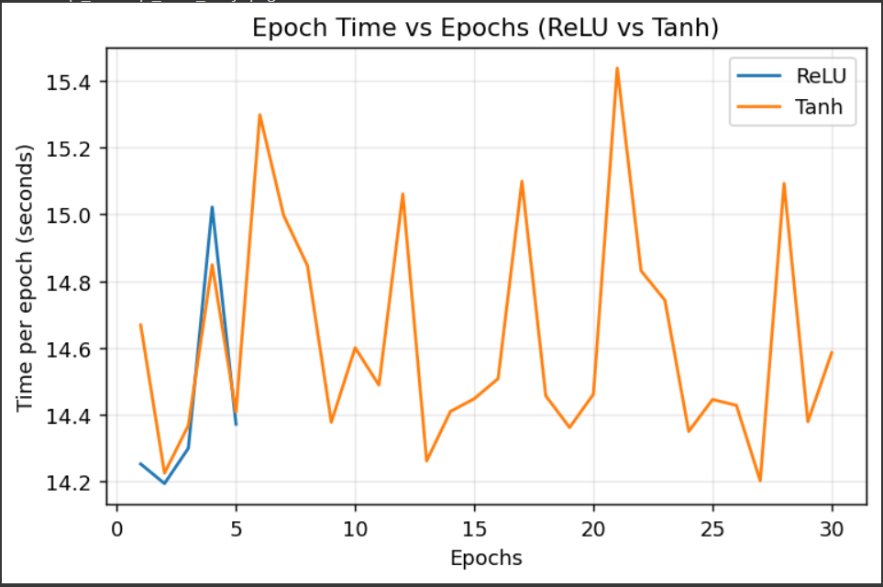
5.2 Figures

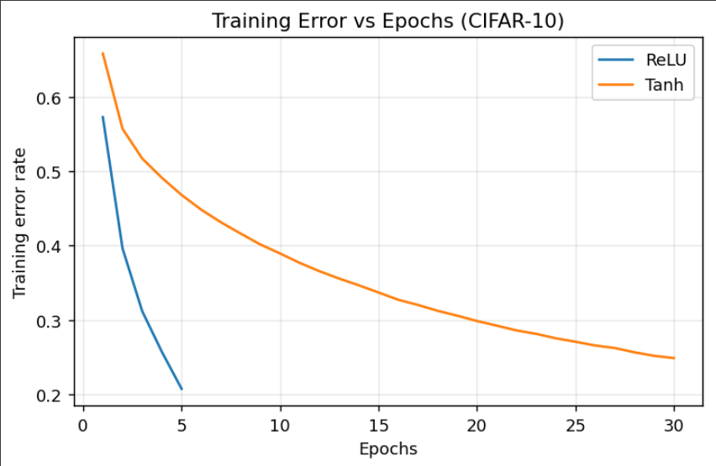
- Observation
- ReLU is non-saturating for positive inputs, which keeps gradients larger and speeds optimization.
- Tanh saturates near −1 and +1; gradients shrink in those regions, slowing learning unless LR is reduced.
- With identical settings (except activation & a tuned LR per activation), ReLU reached ≤25% training error in 5 epochs, while Tanh needed 30 epochs (≈6× more), matching the classic trend.
• Setup to reproduce
- Dataset: CIFAR-10; normalize with mean (0.4914, 0.4822, 0.4465), std (0.2470, 0.2435, 0.2616).
- Model: 4-layer CNN (two 3×3 conv blocks with 64/128 channels + MaxPool; FC-256 → logits-10). No BatchNorm/Dropout.
- Initialization: Kaiming/He for all weights; biases = 0.
- Training: SGD (momentum 0.9), batch size 128, weight decay 0.0.
- Learning rates: ReLU 0.01, Tanh 0.00019 (tuned per activation).
- Seed: 42. Stop when training error ≤ 0.25.
- Outputs: per-epoch CSV logs at q2_runs/<activation>/log.csv; combined figure saved as q2_runs/q2_combined_error_and_time.png.

• Fairness & comparison notes
- Only the hidden activation differs between runs; all other settings are held constant.
- No regularization or augmentation used to isolate activation effects.
- LR is tuned per activation so each model trains as fast as possible.
• Limitations
- Exact epoch multiple can vary with LR choice, seed, and hardware.
- Adding augmentation/BatchNorm/Dropout can change absolute metrics, but the relative trend (ReLU converges faster than Tanh) typically remains.

