

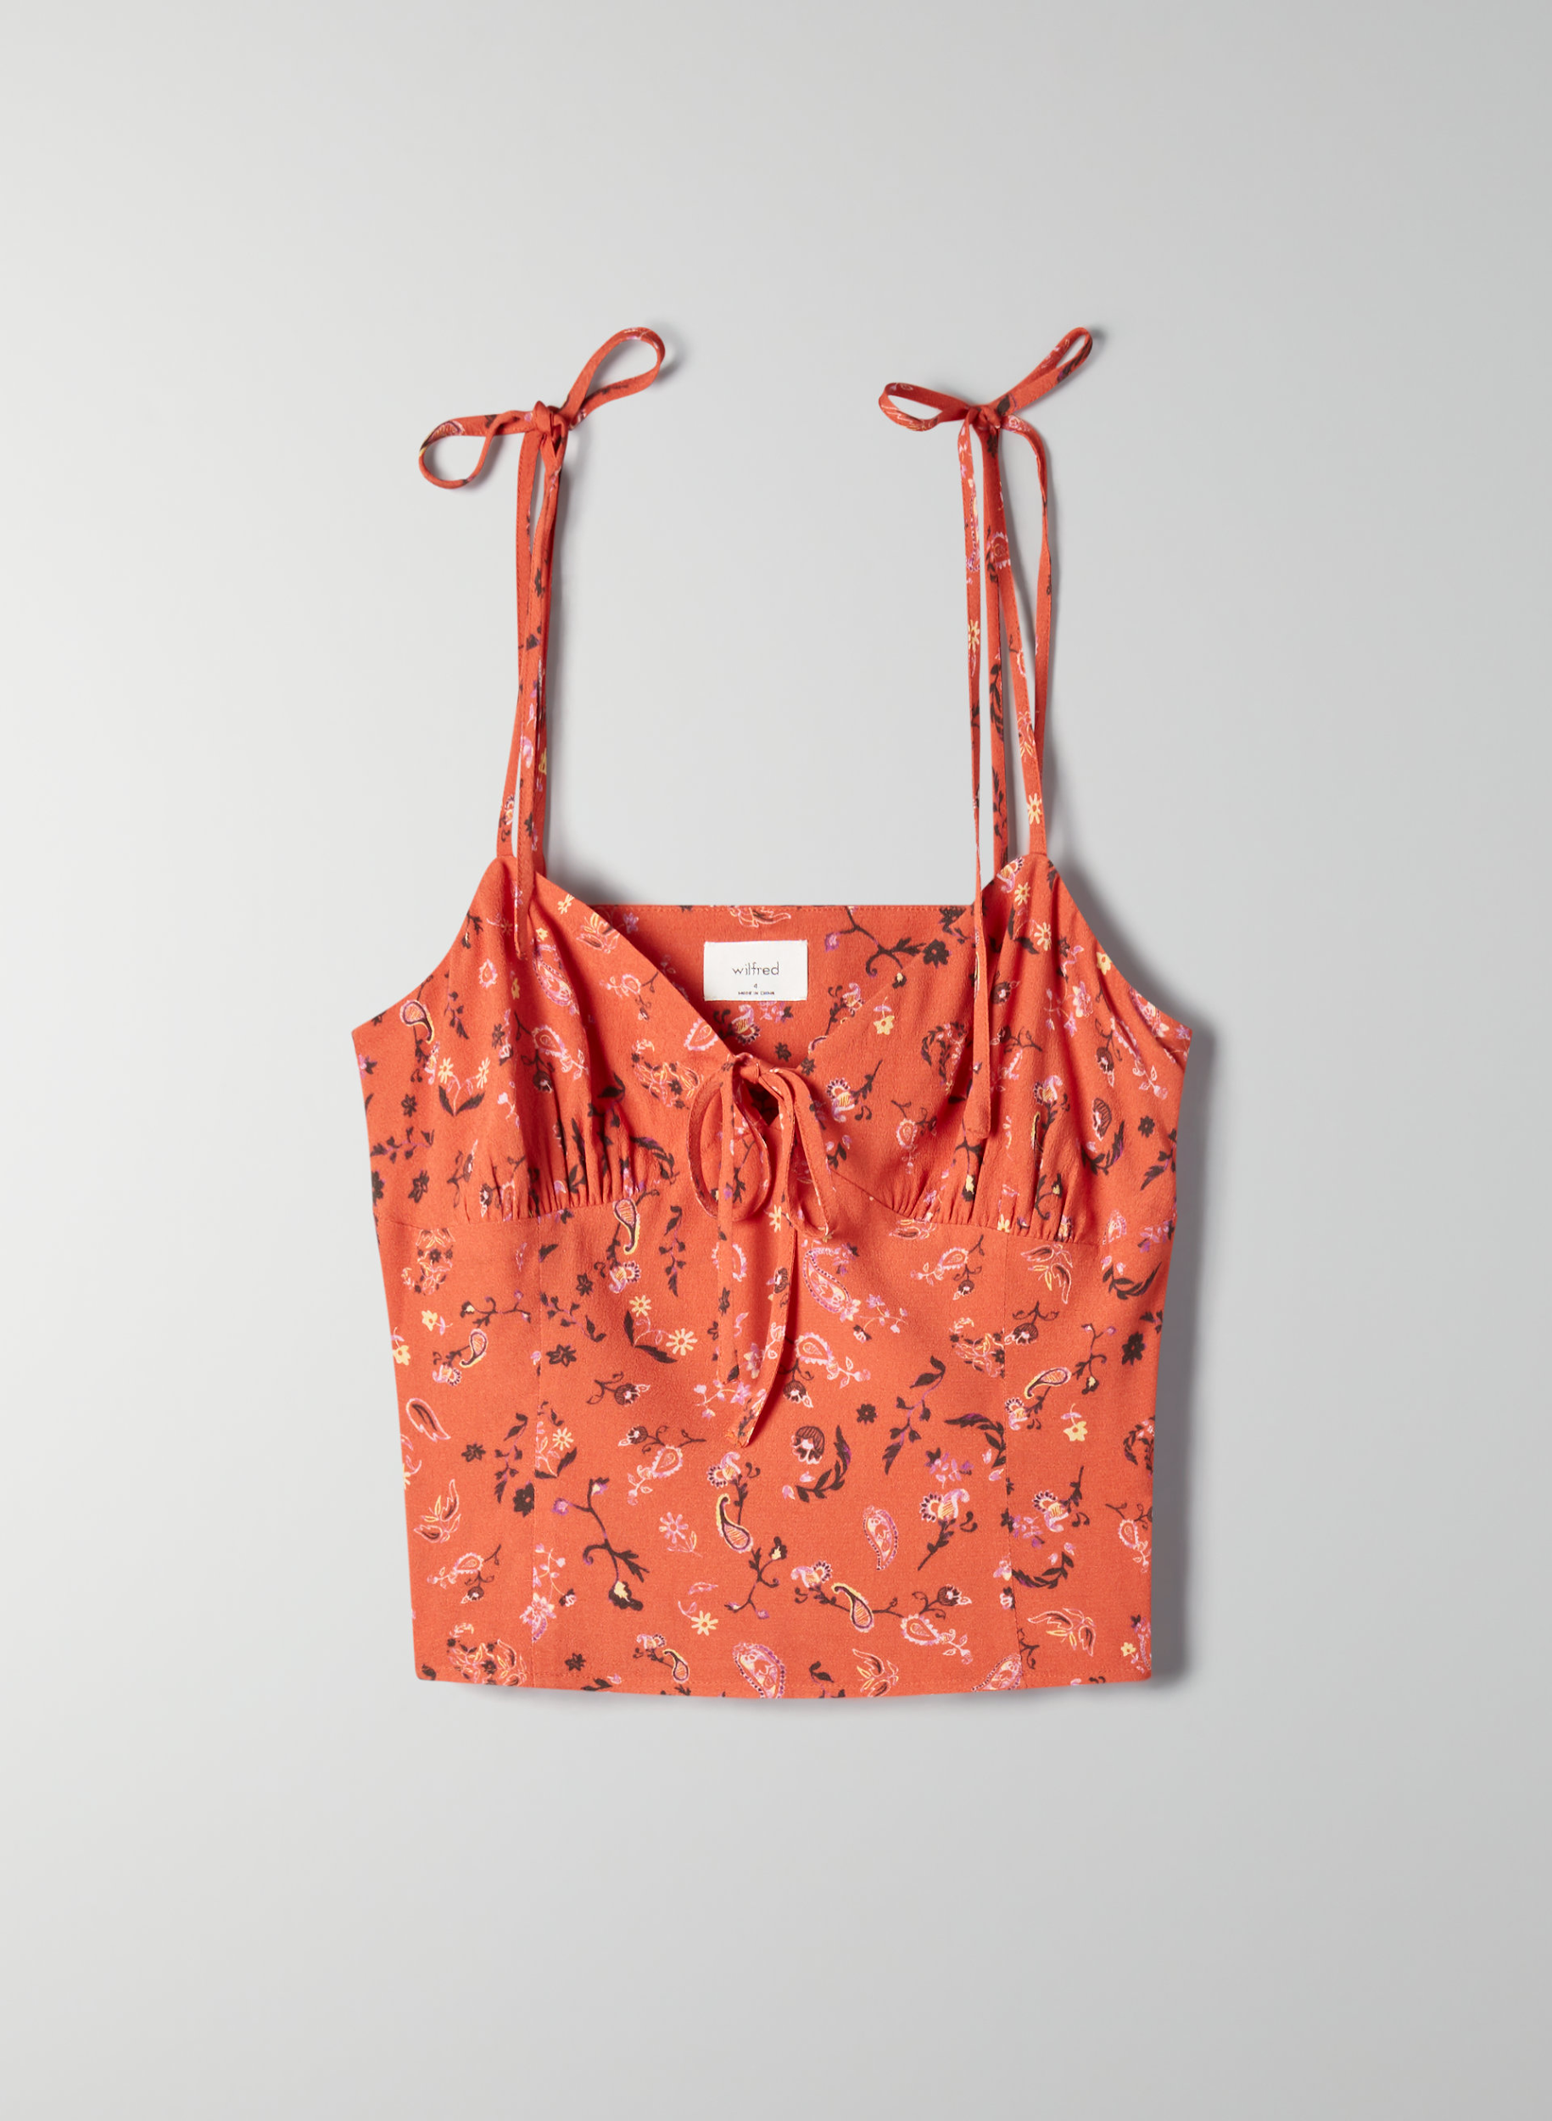Wilfred Heidi Orange tank $26.23 CA

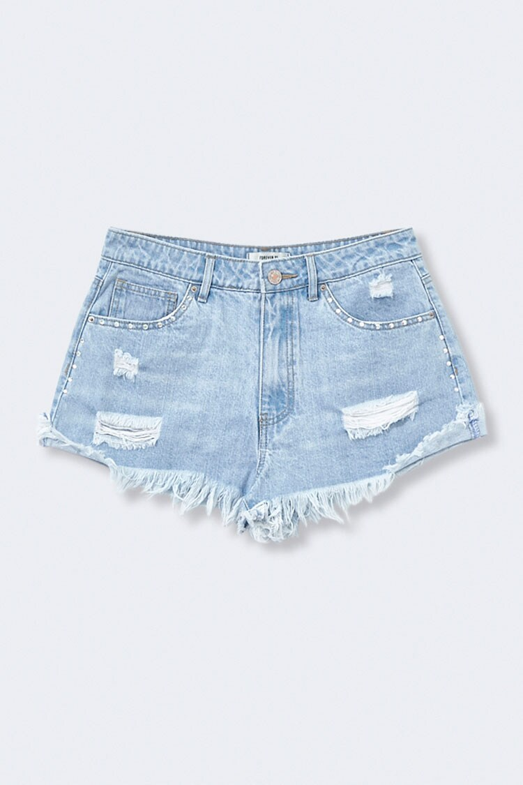Forever 21 Distressed Denim Rhinestone $20.97 CA

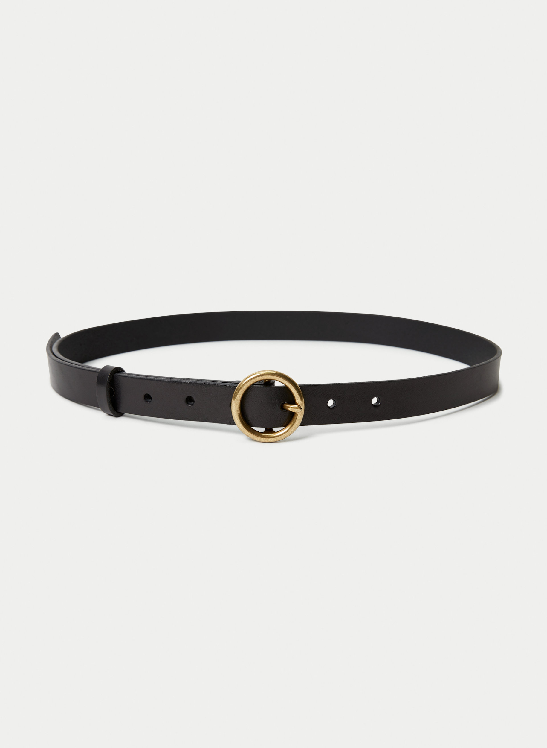Aritzia Auxiliary skinny ring jean belt $50CA

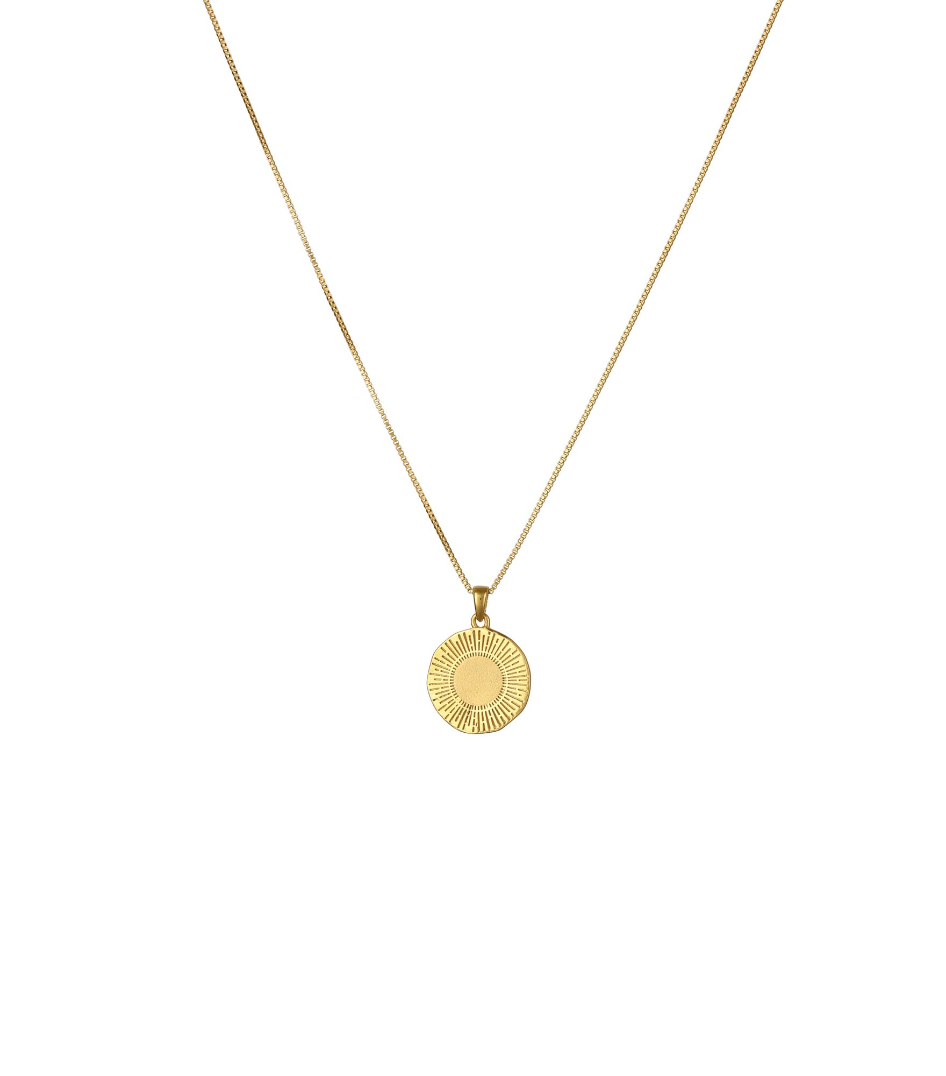Systerp: Sunburst Round Pendant Necklace Gold $122.31 CA