GCP Deployment Report
Geo-Distributed Active-Active Cache Cluster

1. Overview
This document covers the full GCP deployment of the Geo-Distributed Active-Active Cache Cluster. The local Docker implementation was completed and tested first. This report covers provisioning three GCP VMs across real geographic regions, deploying the same Redis and Python worker stack on each, and running all validation tests against live infrastructure to capture genuine cross-region latency numbers.
The three regions used mirror real GCP zones:
- us-central1-a (Iowa, USA)
- europe-west1-b (Belgium, Europe)
- asia-southeast1-a (Singapore, Asia)

2. GCP Project and Compute Engine Setup

Step 1: Create the GCP Project and Enable Compute Engine
A new GCP project named geo-cache was created. Cloud Shell was used as the terminal throughout, so no local installation was needed on Windows. The project was set and Compute Engine was enabled with the following commands:
gcloud config set project geo-cache-510412
gcloud services enable compute.googleapis.com
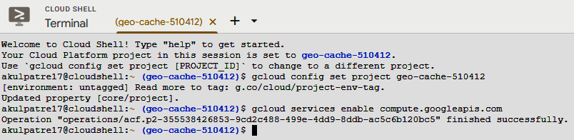
Fig 1: Cloud Shell confirming project set to geo-cache-510412 and Compute Engine enabled successfully.

Step 2: Create Three VMs
Three e2-small VMs (2 GB RAM each) were created, one per region. The e2-small size was chosen because the local Docker setup hit memory limits with the default 1 GB machine. Each VM was tagged with geo-cache and a region-specific tag to allow firewall rules to target them precisely.
gcloud compute instances create us-central1-node --zone=us-central1-a --machine-type=e2-small --image-family=debian-12 --image-project=debian-cloud --tags=geo-cache,us-node
gcloud compute instances create europe-west1-node --zone=europe-west1-b --machine-type=e2-small --image-family=debian-12 --image-project=debian-cloud --tags=geo-cache,eu-node
gcloud compute instances create asia-southeast1-node --zone=asia-southeast1-a --machine-type=e2-small --image-family=debian-12 --image-project=debian-cloud --tags=geo-cache,asia-node
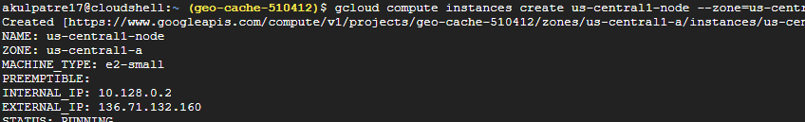
Fig 2: us-central1-node created successfully, showing its internal IP (10.128.0.2) and external IP (136.71.132.160).
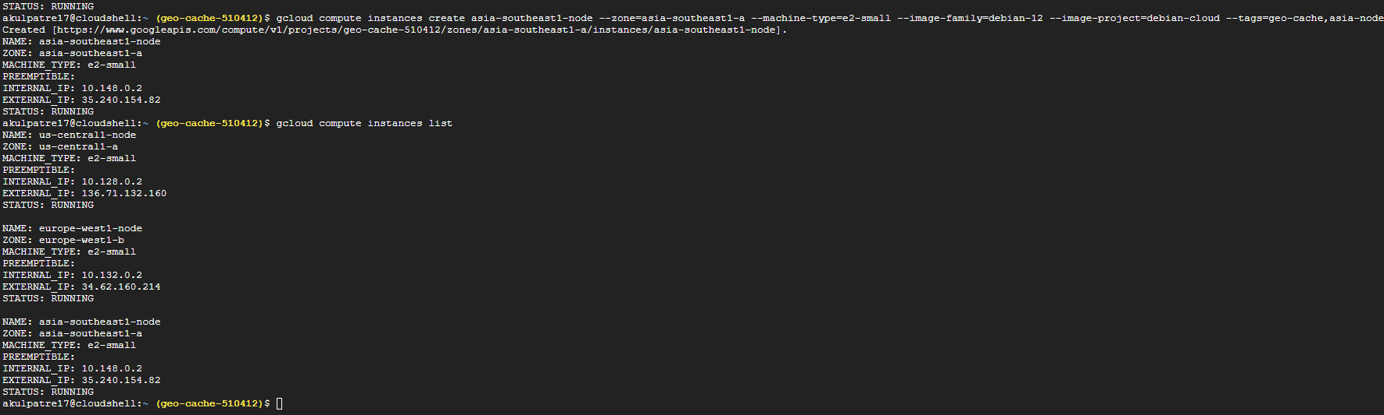
Fig 3: gcloud compute instances list confirming all three VMs are RUNNING across their respective zones with correct internal and external IPs.

The final IP assignments for all three VMs are shown in the table below. These addresses are used throughout the rest of this document.

VM Name | Zone | Internal IP | External IP
us-central1-node | us-central1-a | 10.128.0.2 | 136.71.132.160
europe-west1-node | europe-west1-b | 10.132.0.2 | 34.62.160.214
asia-southeast1-node | asia-southeast1-a | 10.148.0.2 | 35.240.154.82

Step 3: Firewall Rule
By default, GCP blocks all external traffic to VMs. An ingress firewall rule was created to allow the laptop (from India) to reach port 5000 on the worker containers. The rule is scoped to the specific source IP rather than open to the internet.
gcloud compute firewall-rules create allow-geo-cache-me --network=default --allow=tcp:5000 --target-tags=geo-cache --source-ranges=103.226.236.45/32
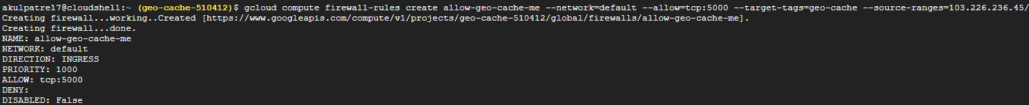
Fig 4: Firewall rule allow-geo-cache-me created, allowing tcp:5000 inbound from the laptop IP only.
Internal replication traffic between VMs uses internal IPs over the default VPC network, which allows all internal traffic by default. No extra firewall rules are needed for replication between the three VMs.
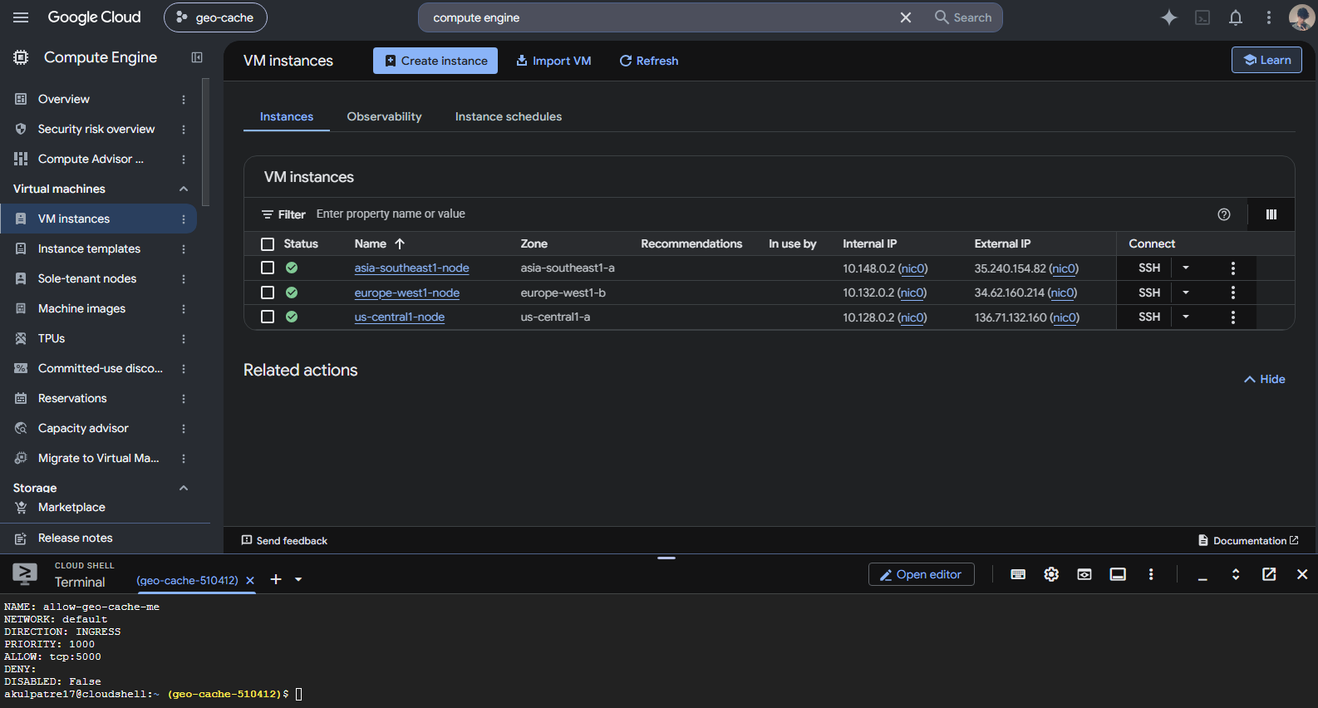
Fig 5: GCP Console showing all three VMs running across three regions, with both SSH and Cloud Shell visible.

3. Docker Installation on All Three VMs
Docker was installed on each VM by opening an SSH browser window from the GCP console and running a single install command. All three VMs were set up in parallel using separate SSH tabs.
curl -fsSL https://get.docker.com | sudo sh
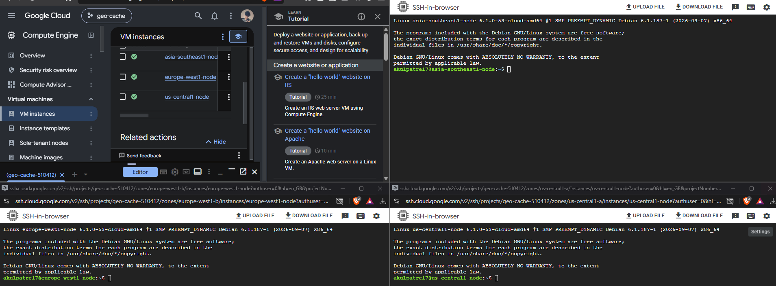
Fig 6: Three SSH browser windows open simultaneously, showing Docker installation in progress on all three VMs (Asia, Europe, US).
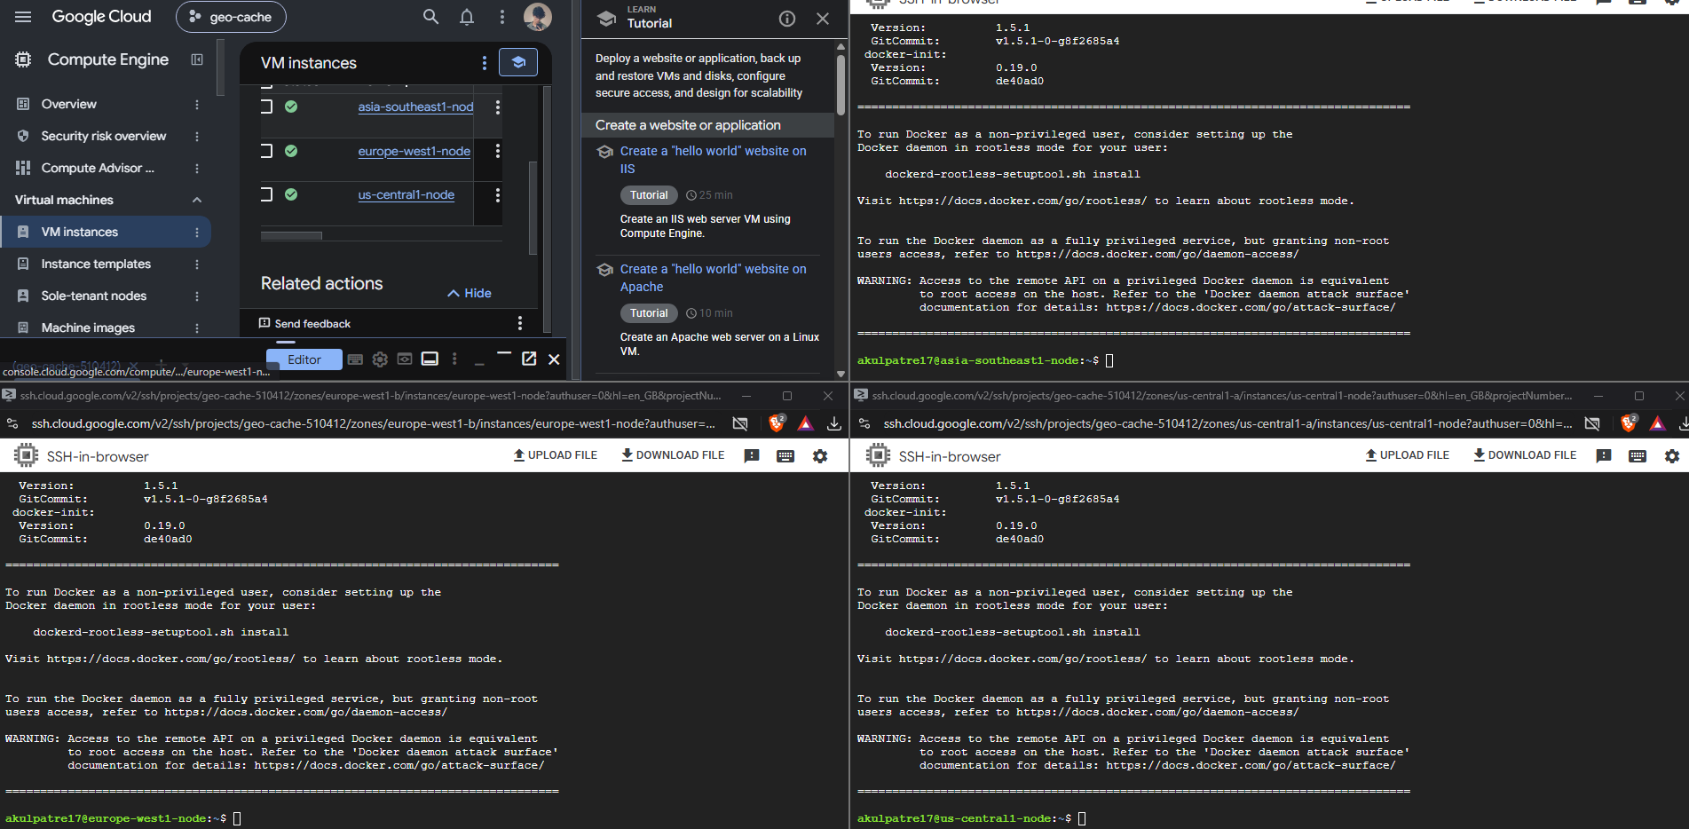
Fig 7: Docker installation completed on all three VMs. The non-root user warning shown is expected and harmless; sudo is used for all Docker commands.

4. Project Upload and Environment Setup

Step 4: Upload Project Zip
The geo-cache project folder (containing the worker/ directory with app.py, crdt.py, hlc.py, Dockerfile, and requirements.txt) was zipped on the local machine and uploaded to each VM using the SSH browser upload button. It was then extracted and the folder structure was verified.
sudo apt-get install -y unzip && unzip geo-cache.zip && cd geo-cache && ls
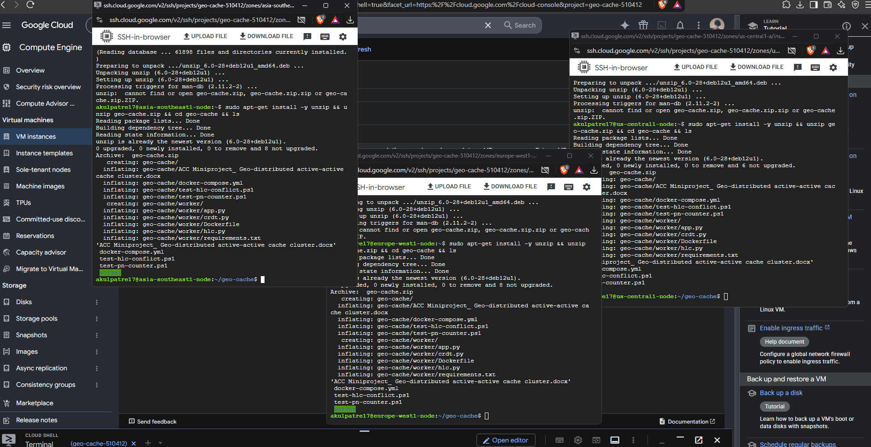
Fig 8: Project extracted successfully on all three VMs. The worker/ folder, docker-compose.yml, and test scripts are all visible.

Step 5: Create docker-compose.gcp.yml
A GCP-specific compose file was created on each VM using nano. This file defines a Redis container and a worker container per VM. It reads the region ID and peer addresses from a .env file, so the same compose file works on all three VMs without modification.
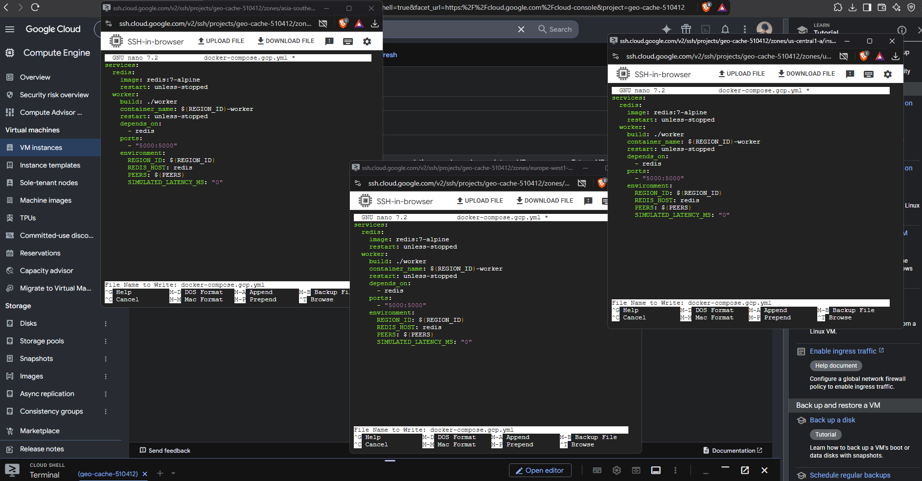
Fig 9: docker-compose.gcp.yml open in nano on all three VMs simultaneously, showing the Redis and worker service definitions.

Step 6: Create the .env File on Each VM
A small .env file was created on each VM containing the region ID and the internal IPs of the other two VMs as peers. Using internal IPs keeps replication traffic inside the GCP network and avoids any firewall restrictions or egress charges.
Fig 10: .env files created on all three VMs with their respective REGION_ID and PEERS values using real internal IPs (no more placeholder text).

5. Starting the Stack and Verifying Connectivity
With the compose file and .env in place, the stack was started on each VM. The --build flag rebuilds the worker image from the Dockerfile, and -d runs it in the background.
sudo docker compose -f docker-compose.gcp.yml up --build -d
sudo docker ps
The /health endpoint was used to confirm each worker was running and had real internal IP addresses loaded as peers (not placeholder text).
curl http://136.71.132.160:5000/health
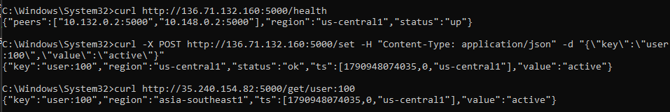
Fig 11: /health response from the US worker confirming it is up, reporting region us-central1, and listing real peer IPs 10.132.0.2 and 10.148.0.2.

6. Test Results

Test 1: Cross-Region Replication
A key was written to the US worker and then read back from both the Asia and Europe workers after a short wait. This verifies that writes propagate automatically from any region to all other regions.
curl -X POST http://136.71.132.160:5000/set -H "Content-Type: application/json" -d "{"key":"user:100","value":"active"}
curl http://35.240.154.82:5000/get/user:100
curl http://34.62.160.214:5000/get/user:100
Fig 12: Write to US (status ok, ts=[1790948074035,0,"us-central1"]), then read from Asia returning the same value "active" with the same timestamp, confirming successful cross-region replication.
Fig 13: Europe also returns "active" with the same timestamp, confirming all three regions converged to the same value.

Test 2: Conflict Resolution (HLC + LWW)
Two conflicting writes were fired simultaneously from the US VM to the US and Asia nodes: US wrote "from-us" and Asia was sent "from-asia" at the same time. The HLC timestamps the two writes independently, and the LWW-Register rule picks the write with the later timestamp as the winner.
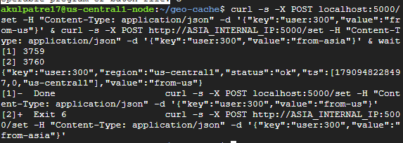
Fig 14: Concurrent writes fired from the US VM. US received "from-us" (ts=[1790948228497,0,"us-central1"]) and the Asia write completed in the background.
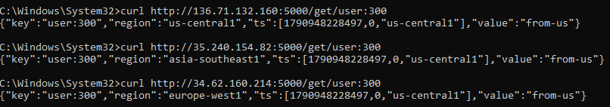
Fig 15: All three regions (US, Asia, Europe) converged to "from-us" with the same timestamp [1790948228497,0,"us-central1"]. The US timestamp was later, so it won the LWW conflict resolution. All three nodes reached the same result independently with no coordination.

Test 3: PN-Counter (Distributed Numeric Counter)
Increment operations were sent to all three regions concurrently: US +5, Asia +3, Europe +2. PN-Counter logic ensures that each region tracks its own increments separately and merges them additively, so the total across all regions is always 10 regardless of arrival order.
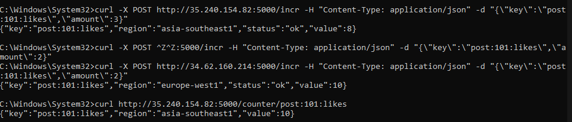
Fig 16: All three regions return a counter value of 10 for post:101:likes after the three increments (5+3+2) replicated and merged. The PN-Counter correctly adds all increments from all regions.

Test 4: Convergence Timing (US to Asia)
The convergence loop was run 10 times on the US VM. Each run wrote a unique key to the US worker and measured the time until that key appeared on the Asia worker (10.148.0.2:5000). This gives a real-world measurement of how long eventual consistency takes across two actual GCP regions separated by roughly 15,000 km.
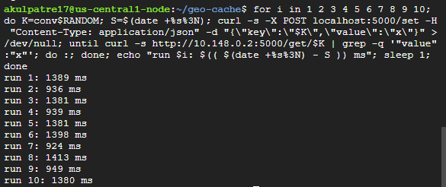
Fig 17: Ten convergence timing runs from US to Asia. Times range from 924 ms to 1413 ms. The floor is set by the 500 ms sync interval; the variation above that reflects real cross-Pacific network round-trip time.

Avg | 1149 ms | 500 ms sync + ~650 ms real latency

The average convergence time of approximately 1149 ms breaks down into roughly 500 ms for the sync interval and roughly 650 ms of real network latency between Iowa and Singapore. This is consistent with the known cross-Pacific round-trip time.

Test 5: Client Latency from India
Round-trip latency from the laptop in India to each of the three regional workers was measured using curl. This demonstrates the core benefit of the active-active design: a user in India writing to the nearest region (Singapore) experiences roughly 3x lower latency than writing to the US or Europe.
curl -s -o NUL -w "%{time_total}\n" http://35.240.154.82:5000/health
curl -s -o NUL -w "%{time_total}\n" http://136.71.132.160:5000/health
curl -s -o NUL -w "%{time_total}\n" http://34.62.160.214:5000/health
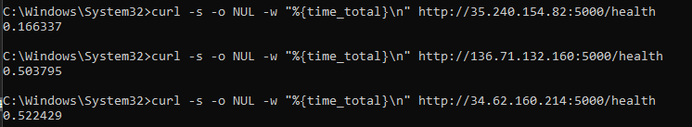
Fig 18: Latency measurements from the laptop in India to all three regions. Asia (Singapore) is fastest at 166 ms, while US (504 ms) and Europe (522 ms) are approximately 3x slower.

Region | External IP | Latency from India
asia-southeast1 (Singapore) | 35.240.154.82 | 0.166 s
us-central1 (Iowa) | 136.71.132.160 | 0.504 s
europe-west1 (Belgium) | 34.62.160.214 | 0.522 s

These numbers confirm the motivating use case: a user in India writing to the Singapore node instead of routing to a US primary cache reduces write latency from ~500 ms to ~166 ms, a reduction of about 67%.

Test 6: Network Partition and Recovery
This test simulates what happens when the Asia node loses connectivity to the other two regions, while still serving local users normally. This mirrors a real scenario where a user in India continues to write to the Singapore cache even though it cannot reach US or Europe.

Creating the Partition
Two GCP firewall rules were added to block traffic between Asia and the other two regions in both directions. This is the GCP equivalent of the docker pause approach used in local testing.
gcloud compute firewall-rules create block-asia-in --network=default --direction=INGRESS --action=DENY --rules=tcp:5000 --priority=100 --target-tags=asia-node --source-ranges=10.128.0.2/32,10.132.0.2/32
gcloud compute firewall-rules create block-asia-out --network=default --direction=EGRESS --action=DENY --rules=tcp:5000 --priority=100 --target-tags=asia-node --destination-ranges=10.128.0.2/32,10.132.0.2/32
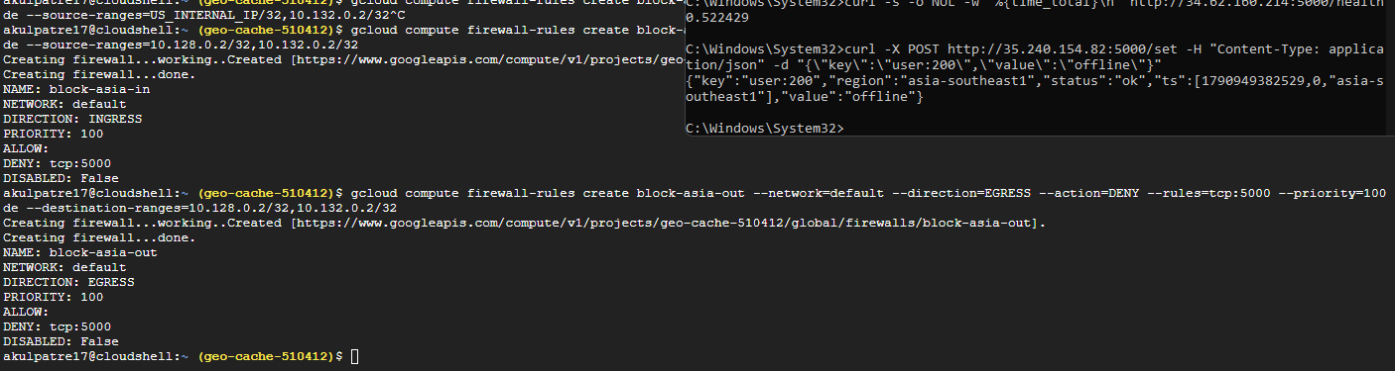
Fig 19: Both firewall rules (block-asia-in and block-asia-out) created successfully. Asia is now isolated from US and Europe, but the laptop can still reach it on its external IP.

Writing to Asia While Isolated (Before)
A write was sent to the Asia node while it was cut off from its peers. The write succeeded immediately, proving that local availability is maintained during a network partition.
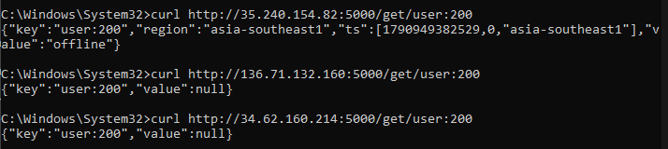
Fig 20 (BEFORE): Asia returns "offline" for user:200 (locally available and accepting writes). US and Europe both return null, confirming they have not yet received this update because the partition is in effect.

Healing the Partition (After)
The two firewall rules were deleted to restore connectivity between Asia and the other two regions.
gcloud compute firewall-rules delete block-asia-in block-asia-out --quiet
Fig 21: Both firewall rules deleted. Asia is now reconnected to US and Europe.
After waiting a few seconds for the next replication cycle, US and Europe were checked again.
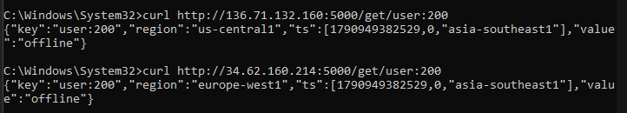
Fig 22 (AFTER): US and Europe now both return "offline" with Asia's original timestamp [1790949382529,0,"asia-southeast1"], confirming automatic catch-up after reconnection. No manual repair was needed.

7. Scope and Limitations

In Scope
The following was implemented and verified on live GCP infrastructure:
- Three active-active cache nodes across real GCP regions, each accepting reads and writes independently
- HLC-stamped CRDT replication (LWW-Register for key-value data, PN-Counter for numeric counters)
- Write-behind buffer with a 5000-delta cap to prevent unbounded memory growth during partitions
- Background replication worker syncing all regions every 500 ms
- Network partition simulation using GCP firewall rules, with automatic recovery on reconnect
- Real cross-region latency and convergence time measurements

Out of Scope
- Consistent hashing with virtual nodes: removed from the current build; listed as future scope for when each region scales to multiple cache machines
- Persistent database storage: the system is memory-only. A node restart loses its local data. This is an intentional simplification so the project focuses on the distributed caching and conflict-resolution behavior
- Write-behind persistence to a shared database
- Automatic recovery of lost data after a crash or restart (the buffer cap means very long partitions may drop older deltas)
- Production-grade security, authentication, or access control
- Multi-tenant or production deployment considerations

Known Limitations
- After a partition, recovery relies on each side re-sending its buffered deltas rather than a full state exchange. A more complete gossip implementation would exchange version vectors on reconnect.
- HLC ordering can be affected by clock drift between GCP VMs. For a demo this is acceptable, but a production system would need tighter NTP synchronization.
- The buffer is capped at 5000 deltas, so an extremely long partition could drop older updates. This was added after discovering unbounded memory growth during local testing.

