NAME : VEDAANT MALIK
ROLLNO:66
BATCH:T13
EXPERIMENT 10

Aim
To create a Dockerfile for a Python Flask web application, build a Docker image, run a container, and implement multiple routes including dynamic routing, forms, calculator functionality, and a JSON API.

Theory
What is Docker?
Docker is a containerization platform that allows developers to package applications along with their dependencies into containers. Containers ensure that the application runs consistently across different environments.

What is a Dockerfile?
A Dockerfile is a text file containing instructions that Docker uses to build an image. Each instruction creates a new layer in the image.
Basic syntax: DIRECTIVE argument
Common directives:
- FROM

- WORKDIR

- RUN

- COPY

- ENV

- CMD

What is Flask?
Flask is a lightweight Python web framework used to build web applications and APIs.

Implementation

Step 1: Create Project Directory
Open Command Prompt and create a new folder:
mkdir flask-docker-app cd flask-docker-app

Step 2: Create Flask Application (app.py)
Create a file named:
app.py
Add the following code:
from flask import Flask, request, jsonify

app = Flask(__name__)

@app.route('/') def home(): return """
<h1>🚀 Welcome to My Advanced Docker Flask App</h1>
<ul>
<li><a href="/hello/Student">Dynamic Hello</a></li>
<li><a href="/calculator">Calculator</a></li>
<li><a href="/form">Form</a></li>
<li><a href="/api/data">JSON API</a></li>
</ul>
"""

@app.route('/hello/<name>') def hello(name):
return f"<h2>Hello, {name}!</h2>"

@app.route('/calculator', methods=['GET', 'POST']) def calculator(): if request.method == 'POST':
num1 = float(request.form['num1']) num2 = float(request.form['num2']) result = num1 + num2 return f"<h2>Result: {result}</h2>"

return """
<form method="POST">
Number 1: <input type="number" name="num1"><br><br>
Number 2: <input type="number" name="num2"><br><br>
<input type="submit" value="Add">
</form>
"""

@app.route('/form', methods=['GET', 'POST']) def form():
if request.method == 'POST':
username = request.form['username'] return f"<h2>Welcome, {username}!</h2>"

return """
<form method="POST">
Enter Name: <input type="text" name="username">
<input type="submit" value="Submit">
</form>
"""

@app.route('/api/data') def api_data(): return jsonify({
"message": "Dockerized Flask App",
"status": "success"
})

if __name__ == '__main__':
app.run(host='0.0.0.0', port=5000)
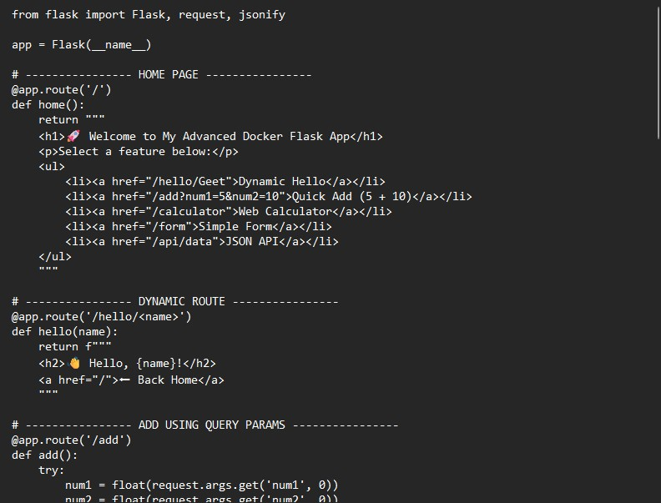

Step 3: Create Dockerfile
Create a file named:
Dockerfile
Add:
FROM python:3.11-slim

WORKDIR /app

RUN pip install flask==2.3

COPY . /app

ENV FLASK_APP=app.py

CMD ["flask", "run", "--host=0.0.0.0", "--port=5000"]

Step 4: Create .dockerignore File
Create file: .dockerignore Add:
Dockerfile
__pycache__

Step 5: Build Docker Image
Run: docker build -t sample-flask-app:v1 .
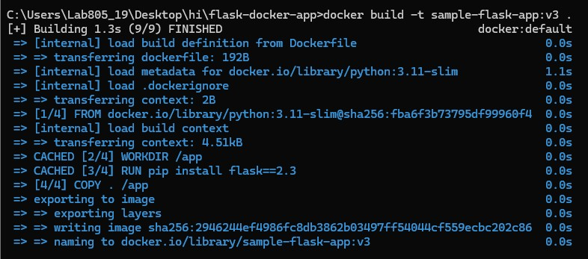

Step 6: Verify Image Creation
docker images

Step 7: Run Docker Container
docker run -d -p 5000:5000 sample-flask-app:v1
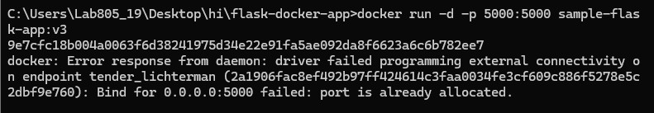

Step 8: Verify Running Container
docker ps
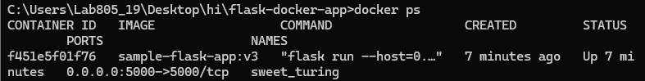

Step 9: Test Application in Browser
Open:
http://localhost:5000
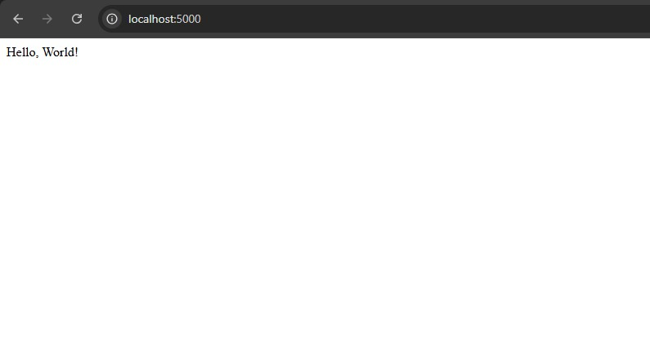
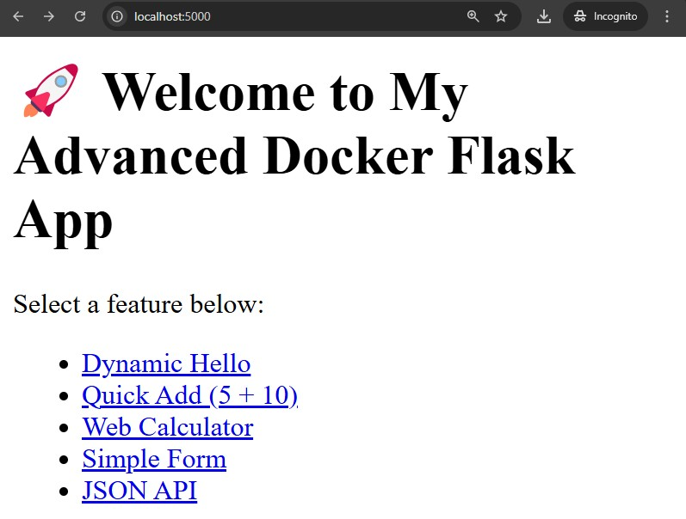
Test additional routes:
http://localhost:5000/hello/YourName

