Top 10 Eigen Faces :

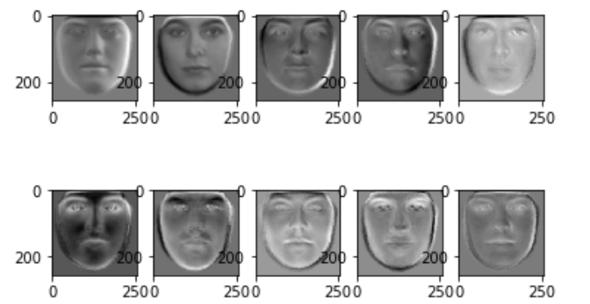

5 testing images and their reconstructed ones.

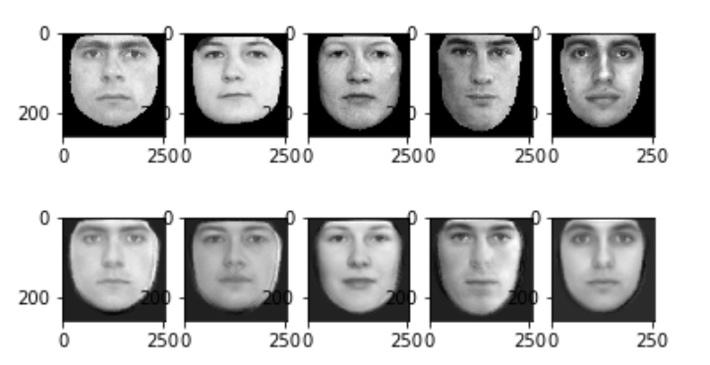

No. of EigenFaces/EigenValues to Reconstruction Error Curve

