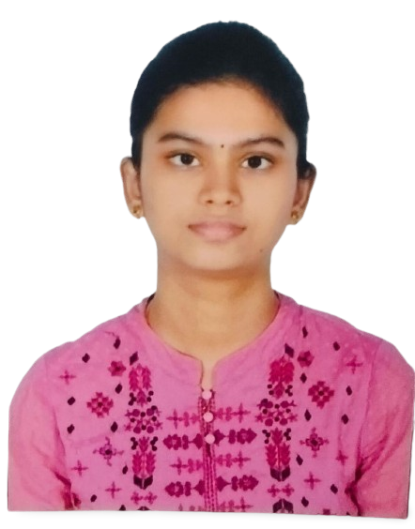

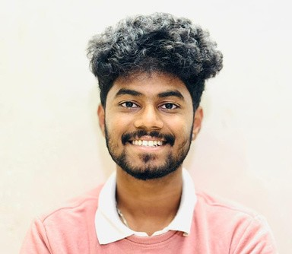

VEDAGNA PARVATHAREDDY

SUMMARY

A proactive and solution-oriented approach to problem-solving drives my work ethic. I believe that collaboration is key to achieving successful outcomes. As a forward-thinking computer science student, I bring a robust set of technical skills, including a strong grasp of requirements gathering and project planning. My effective communication, both verbal and written, combined with excellent organizational abilities, enable me to contribute effectively to team projects and drive them to successful completion.

# EDUCATION

## Vignan Foundation for Science, Technology & Research- Guntur

B. Tech - Computer Science and Engineering

9.1 **CGPA currently**

2022 – 2026

## Sri Chaitanya Bapatla .

Intermediate - MPC 98 **%**

2020 – 2022

## Sri Chaitanya Techno School Bapatla

10th-SSC

99%

2019-2020

# SKILLS

JAVA SQL

Python

C

# CERTIFICATIONS

Certificate of Completion Creating a Website Using Wordpress : Free Hosting & Sub-domain from Coursera.

* Certified in “Preliminary English test (level A2)” at Vignan University conducted by Cambridge University in 2019.

# HOBBIES

Travelling Photography Playing sportsREAL TIME EXPERIENCE

## Have good communication skills and have delivered many presentations at school

## Completed 2 months course in Web Technology in TechnoHacks 1) Created a calculator using HTML. 2) Created a Currency Convertor in HTML. 3) Created a Landpage using css &HTML.

## I have been the volunteer and coordinator for the college level Cultural events .

## 

# CONTACT

+91-8897631186 

 vedagna1424@gmail.com@gmail.com 

Guntur, India.