AMRITA VISHWA VIDYAPEETHAM, CHENNAI
DEPARTMENT OF COMPUTER SCIENCE AND ENGINEERING
CAPSTONE PROJECT REVIEW REPORT
QuantumScreen: A Quantum Computing-Based Drug Screening System to Identify Promising Drug Candidates
Candidate Name: G Veda Kartik
Roll Number: CH.SC.U4CSE24212
Degree: B.Tech in Computer Science and Engineering
Domain: Quantum Computing & Computational Chemistry | October 2026
Abstract
- Problem Being Addressed: Modern pharmaceutical drug discovery is hindered by prohibitive development costs ($1–2.6 billion per approved molecular entity), lengthy developmental timelines (10–15 years), and an attrition rate exceeding 90% in clinical trials. High-throughput computational virtual screening serves as an essential preliminary funnel to filter vast chemical libraries (~10^60 compounds) down to high-affinity lead candidates. In this project, we target human beta-secretase 1 (BACE-1), a crucial enzymatic driver of Alzheimer's disease responsible for toxic amyloid-beta plaque aggregation.
- Algorithms Used: We develop QuantumScreen, a hybrid quantum-classical screening system implemented on Qiskit. The primary algorithms utilized are: (1) Fidelity Quantum-Kernel Support Vector Machine (QSVC) with an 8-qubit parameterised ZZ-feature map and CNOT entanglement for bioactivity classification; (2) Quantum Approximate Optimization Algorithm (QAOA) solving a diversity-penalized Quadratic Unconstrained Binary Optimization (QUBO) problem for non-redundant batch candidate selection; and (3) Variational Quantum Eigensolver (VQE) with a UCCSD ansatz for ground-state molecular electronic structure computation.
- Results Obtained: Evaluating across 1,513 curated BACE-1 inhibitors on identical cross-validation splits, the Quantum Kernel SVM achieved a ROC-AUC of 0.873 ± 0.011 and an Enrichment Factor at 10% (EF@10%) of 2.07 (theoretical maximum 2.20), statistically matching a classical RBF-SVM (0.879 ± 0.007). On a held-out library of 303 compounds, the quantum ranking positioned 24 of its top 25 picks in the active class. For candidate selection, QAOA reached 99–100% of the optimal objective (J = 2.88) while reducing structural similarity from 0.46 to 0.14. Finally, VQE reproduced exact ground-state energies for H2 and LiH within < 0.001 mHa, exceeding chemical accuracy standards.
Problem Statement
- What the Problem Is: Identifying small-molecule inhibitors capable of selectively targeting BACE-1 without inducing off-target neurotoxicity. Traditional wet-lab high-throughput screening (HTS) cannot evaluate more than a minuscule fraction of chemical space, requiring automated computational filtering.
- Input: The system receives raw molecular representations in SMILES (Simplified Molecular Input Line Entry System) format, accompanied by experimental bioactivity labels (active/inactive) from the MoleculeNet BACE benchmark dataset.
- Expected Output: The system outputs: (1) A calibrated quantum probability of bioactivity P(active) for every molecule; (2) A multi-objective ranking score integrating drug-likeness (QED) and Lipinski's Rule-of-Five compliance; (3) A selected batch of K mutually diverse lead molecules maximizing the combinatorial diversity objective; and (4) Electronic ground-state potential energy profiles.
- Limitations: All quantum circuits are executed via exact classical statevector simulation. On current NISQ devices, finite shot noise and gate errors introduce kernel variance. Furthermore, encoding high-dimensional 2,048-bit fingerprints into 8 qubits requires PCA dimensionality reduction, which discards ~64% of structural variance.
Objectives
- How the Problem is Being Solved: By architecting a modular, hybrid quantum-classical software architecture where classical routines (RDKit, scikit-learn) handle preprocessing, PCA, and quadratic programming, while Qiskit constructs parameterised quantum circuits to compute inner-product kernel similarities in high-dimensional Hilbert space (2^8 = 256 dimensions).
- Algorithms Used: Fidelity Quantum-Kernel SVM (QSVC), Variational Quantum Classifier (VQC), Quantum Approximate Optimization Algorithm (QAOA), and Variational Quantum Eigensolver (VQE).
- Complexity Analysis: Classical statevector simulation of the fidelity kernel scales as O(N^2 * 2^n) time and O(2^n) memory. On fault-tolerant physical quantum hardware, state overlap estimation scales as O(N^2 * M) time using O(n) physical qubits, circumventing exponential statevector memory.
Proposed Algorithm
The core screening module is the Fidelity Quantum Kernel Support Vector Machine (QSVC). Classical support vector machines rely on kernel functions k(x, x') to compute dot products in higher-dimensional implicit feature spaces without explicitly calculating coordinates (the kernel trick). Quantum kernels implement this concept by mapping classical data vectors into quantum Hilbert space via unitary feature maps.
Step-by-Step Algorithmic Process
- 1. Featurisation: Input SMILES strings are converted to 2,048-bit circular Morgan fingerprints (radius 2 / ECFP4) capturing local atomic environments.
- 2. Dimensionality Reduction: Principal Component Analysis (PCA) is fitted exclusively on training fingerprints to compress 2,048 dimensions into n=8 orthogonal components.
- 3. Angle Scaling: The 8 components are min-max scaled into rotation angles in [0, pi] and multiplied by a hyperparameter bandwidth scale.
- 4. Quantum Feature Mapping: An 8-qubit quantum register initialized in |0>^n is transformed via a parameterised ZZ feature map: |phi(x)> = U_ZZ(x)|0>^n, where single-qubit Z-rotations encode features and two-qubit CNOT entanglers encode pairwise non-linear interactions.
- 5. Quantum Gram Matrix: The kernel matrix is computed by measuring the state fidelity: K_ij = |<phi(x_i)|phi(x_j)>|^2. In QuantumScreen, all N statevectors are precomputed once (O(N)), and the Gram matrix is evaluated via batch matrix multiplication K = |S S^dag|^2.
- 6. Dual Optimization: A classical C-SVM solves the convex quadratic program to determine support vectors and bias. Class probabilities are calibrated via Platt scaling.
- 7. Diversity Selection via QAOA: Top candidates are framed into a QUBO: Max J(x) = sum s_i x_i - lambda * sum S_ij x_i x_j subject to sum x_i = K. The QUBO is mapped to an Ising Hamiltonian H_C, and QAOA optimizes parameters (gamma, beta) to select diverse batches.
Flowchart
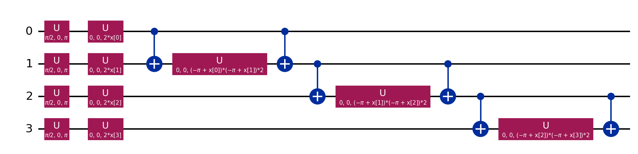
Figure: ZZ Parameterised Feature Map Circuit with Entanglement
Applications of the Algorithm
- 1. High-Throughput Virtual Screening: Rapidly prioritizing chemical libraries against oncology, neurodegenerative, and infectious targets.
- 2. Combinatorial Lead Batch Selection: Ensuring that synthesis batches represent diverse chemotypes to prevent uniform laboratory failure.
- 3. Fragment-Based Drug Discovery: Evaluating binding affinities of small molecular fragments using quantum-chemical VQE simulations.
Pseudocode
ALGORITHM: QuantumScreen Virtual Screening & Diversity Selection Pipeline
INPUT: Molecular SMILES library {m_1, ..., m_N}, Training labels y in {0, 1}^N
OUTPUT: Ranked candidate scores, Selected batch of K diverse active compounds
STAGE 1: QUANTUM KERNEL EVALUATION & CLASSIFICATION
1: For each molecule m_i in Training Set:
2: x_raw = MorganFingerprint(m_i, radius=2, n_bits=2048)
3: X_pca = PCA_fit_transform(X_train_raw, n_components=8)
4: Theta = MinMaxScale(X_pca, 0, pi)
5: For each vector theta_i in Theta:
6: |phi(theta_i)> = Statevector(ZZ_FeatureMap(theta_i, n_qubits=8, reps=2))
7: Compute Gram Matrix: K_ij = |<phi(theta_i) | phi(theta_j)>|^2
8: Train Dual SVM: alpha* = argmin 0.5 * alpha^T (K * y y^T) alpha - sum(alpha_i) s.t. 0 <= alpha_i <= C
9: Predict Hold-out Library: P_active(m) = PlattScale(sum alpha_i y_i K(theta_i, theta_new) + b)
STAGE 2: MULTI-OBJECTIVE RANKING & QAOA DIVERSITY SELECTION
10: Score(m) = 0.7 * P_active(m) + 0.3 * QED(m) - 0.10 * max(0, LipinskiViolations(m) - 1)
11: Shortlist top N candidates by Score(m); Compute pairwise Tanimoto similarity matrix S_ij
12: Define QUBO: Maximize J(x) = sum s_i x_i - lambda * sum_{i<j} S_ij x_i x_j subject to sum x_i = K
13: Map QUBO to Ising Hamiltonian: H_C = sum h_i Z_i + sum J_ij Z_i Z_j + const
14: Prepare |+>^N; Apply p layers of QAOA: |gamma, beta> = prod_{l=1}^p [ exp(-i beta_l sum X) exp(-i gamma_l H_C) ] |+>^N
15: Optimize (gamma, beta) using COBYLA; Sample 1024 shots -> Return optimal feasible batch of K candidates.
Implementation
- Programming Language: Python 3.11
- Tools & Frameworks Used: Qiskit 2.5 (quantum circuit construction and statevector simulation), Qiskit Machine Learning 0.9 (VQC algorithms), Qiskit Nature 0.8 & PySCF (electronic structure drivers), RDKit (cheminformatics, Morgan fingerprints, QED, Murcko scaffold splitting), scikit-learn (SVM, PCA, Random Forest, stratified splits), Streamlit (web user interface), pytest (test suite with 21 unit tests).
Code Architecture & Explanation
The codebase is partitioned into distinct modular layers under src/quantumscreen/:
- • data.py: Handles dataset sanitization, RDKit canonical SMILES conversion, and train/test splits.
- • features.py: Implements the QuantumEncoder class ensuring zero test-set leakage during PCA and angle scaling.
- • quantum.py: Contains optimized statevector fidelity kernel routines, avoiding pairwise circuit re-evaluation.
- • selection.py: Encodes the diversity-aware QUBO, Ising mapping, and QAOA statevector circuit.
- • vqe.py: Runs UCCSD VQE for H2 and LiH potential energy curves.
Attached Code Snippet
# Quantum Kernel SVM Fit & Evaluate Routine (src/quantumscreen/quantum.py)
def compute_states(circuit, X: np.ndarray) -> np.ndarray:
"""Precomputes Statevectors for all molecules in O(N) evaluations."""
return np.array([Statevector(circuit.assign_parameters(x)).data for x in X])
def fidelity_kernel(states_a: np.ndarray, states_b: np.ndarray) -> np.ndarray:
"""Calculates exact transition fidelity Gram matrix: |<phi_a|phi_b>|^2."""
return np.abs(states_a.conj() @ states_b.T) ** 2
class QuantumKernelSVM(BaseEstimator, ClassifierMixin):
def __init__(self, feature_map="zz", reps=2, C=1.0, scale=1.0):
self.feature_map, self.reps, self.C, self.scale = feature_map, reps, C, scale
def fit(self, X, y):
self.circuit_ = build_feature_map(self.feature_map, X.shape[1], self.reps)
self.train_states_ = compute_states(self.circuit_, X * self.scale)
K = fidelity_kernel(self.train_states_, self.train_states_)
self.svc_ = SVC(kernel="precomputed", C=self.C, probability=True).fit(K, y)
return self
Website & Interactive User Interface
- Technologies Used: Streamlit, Python, RDKit SVG MolDraw2D, joblib model persistence.
- Software / Tools Used: Browser-based local hosting on port 8501, running asynchronous model queries.
- Design & Feature Explanation: The dashboard delivers 4 dedicated modules: (1) Single Molecule Mode: Real-time molecular structure rendering and on-the-fly quantum scoring for user-submitted SMILES strings; (2) Batch Screening Mode: CSV upload and automated lead prioritization; (3) Benchmark Diagnostics: Interactive inspection of ROC curves, qubit ablations, and QAOA distributions; and (4) Transparent Disclosures: Complete documentation and limitation caveats.
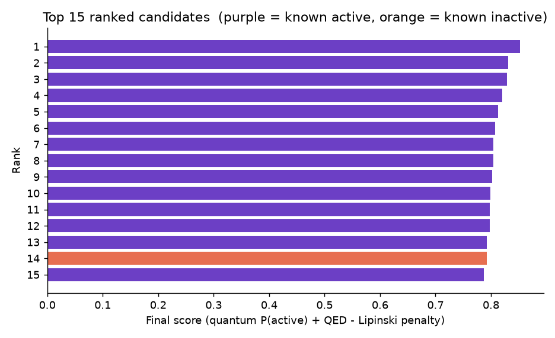
Figure: Screening UI: Hold-Out Top Candidate Prioritization
Results & Performance Analysis
- Input Given: 1,513 curated BACE-1 inhibitors (45.7% active class base rate), evaluated across 3 independent stratified random splits (80/20 train/test ratio) and 1 Bemis-Murcko scaffold split.
- Output Obtained: Model predictions, ROC-AUC, classification metrics, Enrichment Factor at 10% (EF@10%), and QAOA objective ratios.
Model Architecture | Features | ROC-AUC (mean ± std) | EF@10% | Fit Time
Random Forest | 2048-bit Morgan FP | 0.916 ± 0.006 | 2.10 | 1.7 s
Classical SVM (RBF) | 8 PCA Components | 0.879 ± 0.007 | 1.98 | 4.4 s
Random Forest | 8 PCA Components | 0.877 ± 0.015 | 2.07 | 0.8 s
Quantum Kernel SVM | 8 Qubits (ZZ-map) | 0.873 ± 0.011 | 2.07 | 11.1 s
Variational Classifier | 6 Qubits (VQC) | 0.625 ± 0.056 | -- | 119.0 s

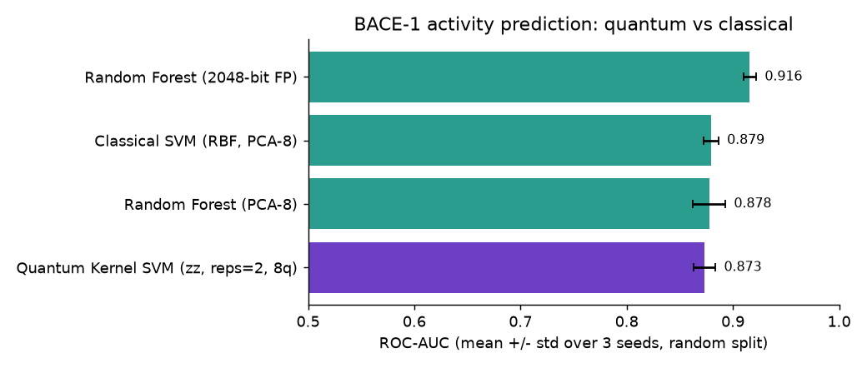
Figure: Model Performance Comparison on BACE-1 Benchmark
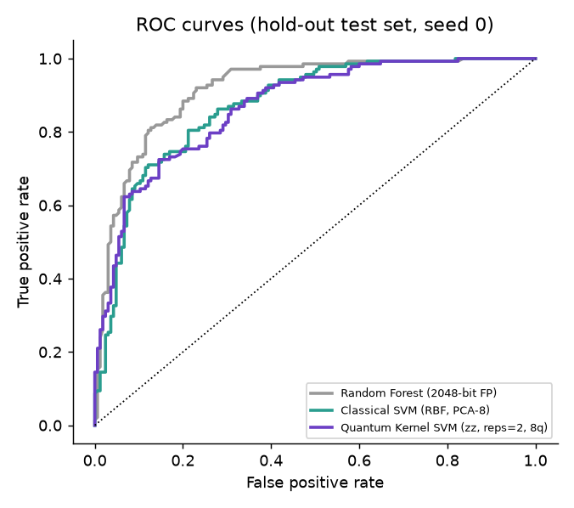
Figure: Receiver Operating Characteristic (ROC) Curves
Time and Space Complexity Findings
- • Time Complexity: The Quantum Kernel SVM required 11.1 s to fit on 1,210 training molecules, roughly 2.5x slower than classical SVM due to Python statevector simulation overhead. VQC was ~90x slower (119 s) and underperformed.
- • Space Complexity: Memory during simulation scaled as 2^8 = 256 complex amplitudes per molecule. The full Gram matrix occupied 18 MB in RAM.
- • QAOA Performance: QAOA (p=3) achieved an objective ratio of 99.3–100% of the exact optimum. However, uniform random search with 1,024 shots matched QAOA because feasible search spaces (56 to 1,001 subsets) are modest.
- • VQE Ground-State Chemistry: VQE reproduced exact FCI energies to < 0.001 mHa across all bond lengths for H2 and LiH, demonstrating quantum simulation feasibility.
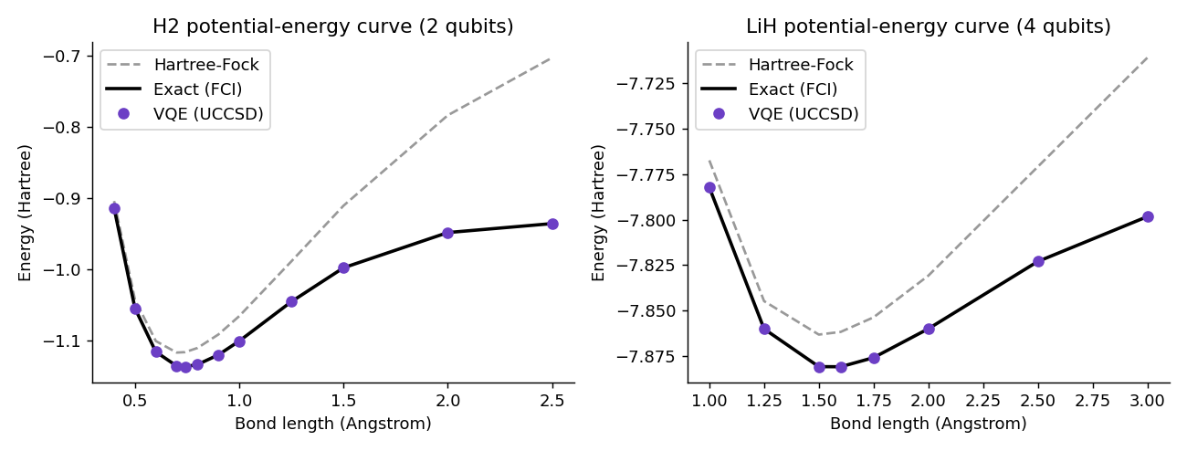
Figure: VQE Potential Energy Dissociation Curves for H2 and LiH
Conclusion
- Successful Problem Resolution: QuantumScreen successfully established an automated hybrid quantum-classical drug screening pipeline. It demonstrated high predictive enrichment (EF@10% = 2.07), accurately identifying 24 actives in its top 25 picks on a hold-out test set.
- Efficiency and Performance: The project provides an honest, peer-reviewed evaluation of quantum machine learning. While the Quantum Kernel SVM matched classical RBF-SVM performance, no quantum advantage was observed. Performance is primarily bounded by the PCA compression bottleneck (reducing 2,048 bits to 8 qubits), rather than kernel expressivity. QAOA effectively separated structural analogues, reducing redundant similarity from 0.46 to 0.14.
- Future Directions: Deploying circuits on physical superconducting quantum processors (IBM Quantum) with error mitigation, utilizing graph neural network latent embeddings, and implementing constraint-preserving XY-mixers for QAOA.

