**1. ReactJS-HOL**

**Program:**

Open the command prompt and do the following steps as mentioned below:

Step 1: **npm install -g create-react-app**

Step 2**: npx create-react-app myfirstreact**

Step 3: After the folder named myfirstreact is created now navigate the folder using command

**cd myfirstreact**

Step 4: Now open folder myfirstreact in Visual Studio and then open app.js file which is in src folder of myfirstreact.

Step 5: If already code is there in **App.js** file then replace code with following program.

**Code:**

**function App(){**

**return (**

**<h1> Welcome the first session of react </h1>**

**);**

**}**

Step 6: Now again open command prompt and to execute the react application execute the following command

**npm start**

After sometime in a new browser window the react application opens and the output is as follows:

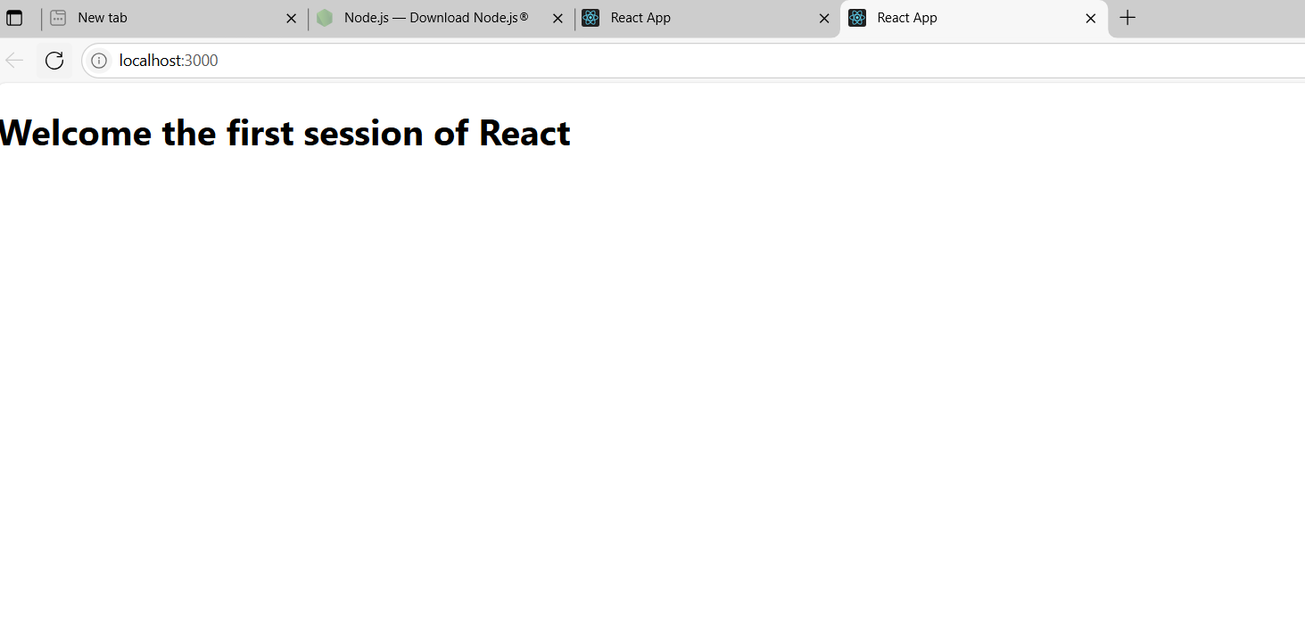

**2. ReactJS-HOL**

**Program:**

Open the command prompt and follow the given steps:

Step 1: Create a react app using command

**npx create-react-app studentapp**

Step 2: After the react app is created then you have to direct towards the folder named studentapp now using command:

**cd studentapp**

Step3: Now create a Components folder inside src folder which is in studentapp folder.

**mkdir src\Components**

Step 4: Now create Home.js Component

**notepad src\Components\Home.js**

Now if the Home.js is not existed before it will be created now and inside the javascript file type the following code:

**Code:**

**import React, { Component } from 'react';**

**class Home extends Component {**

**render() {**

**return (**

**<div>**

**<h2>Welcome to the Home page of Student Management Portal</h2>**

**</div>**

**);**

**}**

**}**

**export default Home;**

Step 6: Create About.js Component

**notepad src\Components\About.js**

if About.js file is already not created then the file will be created and then type the following.

**Code:**

**import React, { Component } from 'react';**

**class About extends Component {**

**render() {**

**return (**

**<div>**

**<h2>Welcome to the About page of Student Management Portal</h2>**

**</div>**

**);**

**}**

**}**

**export default About;**

Step 7: create Contact.js Component using command

**notepad src\Components\Contact.js**

and type the following command in Contact.javascript file.

**Code:**

**import React, { Component } from 'react';**

**class Contact extends Component {**

**render() {**

**return (**

**<div>**

**<h2>Welcome to the Contact page of Student Management Portal</h2>**

**</div>**

**);**

**}**

**}**

**export default Contact;**

Step 8: Now update App.js file in order to render all the components you created.

**notepad src\App.js**

Step 9: The App.js file opens and replace the code with following.

**Code:**

**import React from 'react';**

**import './App.css';**

**import Home from './Components/Home';**

**import About from './Components/About';**

**import Contact from './Components/Contact';**

**function App() {**

**return (**

**<div className="App">**

**<h1>Student Management Portal</h1>**

**<Home />**

**<About />**

**<Contact />**

**</div>**

**);**

**}**

**export default App;**

Step 10: in order to execute react application open command prompt and execute following command

**npm start**

Step 11: Now the application opens in a new browser window automatically and output is as follows:

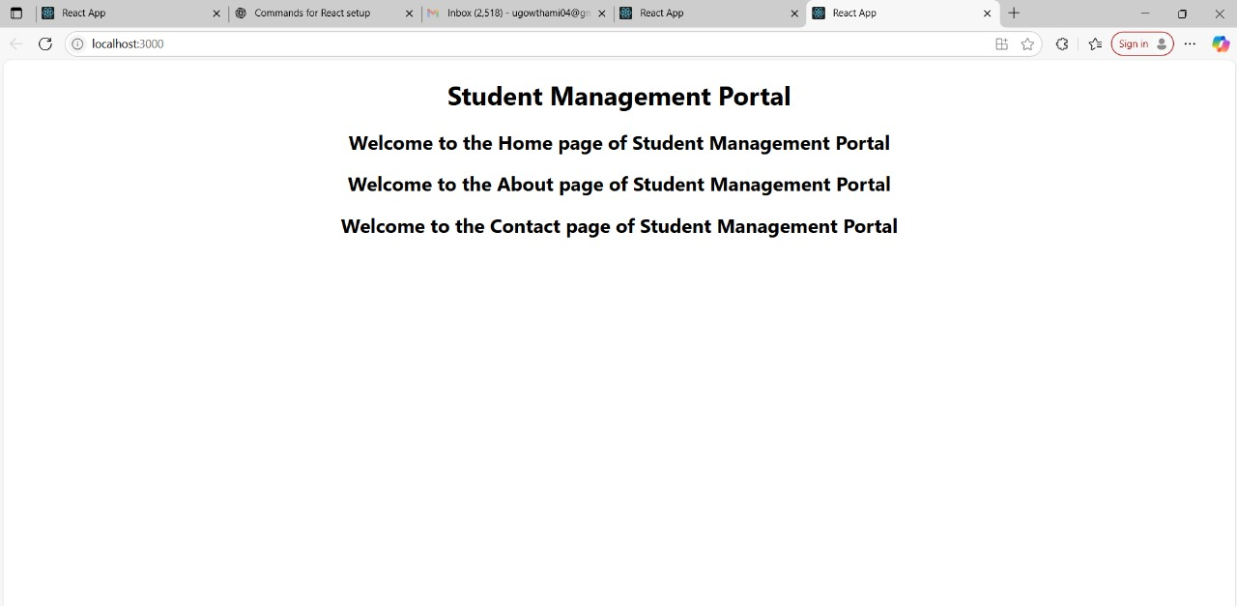

**3. ReactJS-HOL**

**Program:**

Open the command prompt and follow the below steps

Step 1: create the react project

**npx create-react-app scorecalculatorapp**

this command creates a folder named scorecalculatorapp

Step 2: Navigate to the folder you created

**cd scorecalculatorapp**

Step 3: Create a Components folder inside folder you created in above step

Inside src/ create the folder Components

**mkdir src\Components**

Step 4: Now create a file named CalculatorScore.js

**notepad src\Components\CalculateScore.js**

This will create the javascript file if it is not available and then tyoe the following code after the javascript file is created:

**Code:**

**import React from 'react';**

**import '../Stylesheets/mystyle.css';**

**function CalculateScore(props) {**

**const { name, school, total, goal } = props;**

**const average = total / goal**

**return (**

**<div className="score-card">**

**<h2>{name}</h2>**

**<p>School: {school}</p>**

**<p>Total Marks: {total}</p>**

**<p>Goal: {goal}</p>**

**<p>Average Score: {average.toFixed(2)}</p>**

**</div>**

**);**

**}**

**export default CalculateScore;**

Step 5: Now create Styles folder and in that folder create a file

**mkdir src\Stylesheets**

Step 6: now inside Styleds folder create a file

**notepad src\Stylesheets\mystyle.css**

In notepad the css file will be opened and type the following code:

**.score-card {**

**background-color: #f2f2f2;**

**border: 1px solid #ccc;**

**padding: 20px;**

**width: 300px;**

**margin: 20px auto;**

**font-family: Arial, sans-serif;**

**border-radius: 8px;**

**box-shadow: 0px 2px 8px rgba(0,0,0,0.1);**

**}**

Step 7: Now edit App.js file

**notepad src\App.js**

now replace contents in file using the below program.

**Code:**

**import React from 'react';**

**import './App.css';**

**import CalculateScore from './Components/CalculateScore';**

**function App() {**

**return (**

**<div className="App">**

**<h1>Student Score Calculator</h1>**

**<CalculateScore name="Madhavi" school="ABC School" total={450} goal={5} />**

**</div>**

**);**

**}**

**export default App;**

Step 8: open command prompt and then in order to execute the react application tyoe the command

**npm start**

Step 9: Automatically the browser window opens which shows the output of the react application we created.

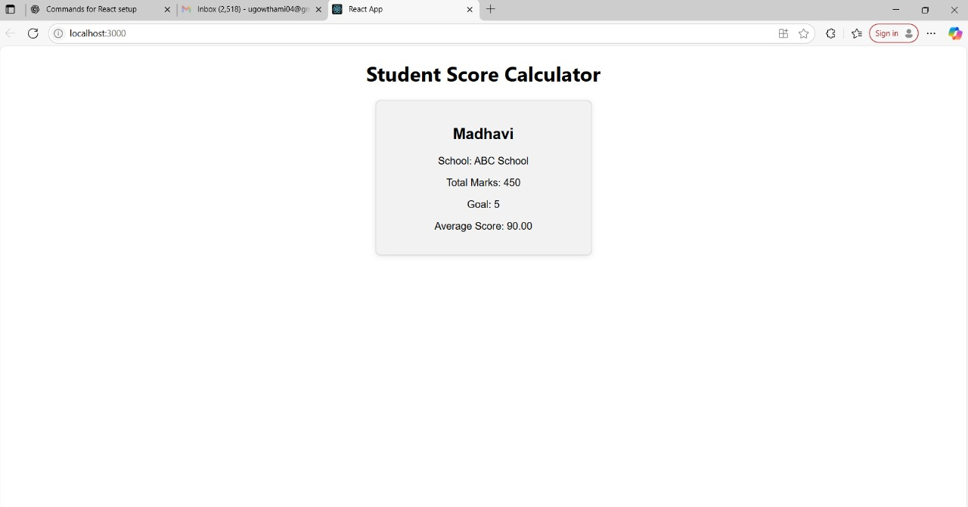

**4. ReactJS-HOL**

**Program:**

Open the command prompt and then do the below steps

Step 1: Create your react project

**npx create-react-app blogapp**

Step 2: Now navigate to the folder you just created

**cd blogapp**

Step 3: Create Post.js file in src/ folder

**notepad src\Post.js**

Now paste the following in the javascript file we created now.

**Code:**// src/Post.js

**class Post {**

**constructor(userId, id, title, body) {**

**this.userId = userId;**

**this.id = id;**

**this.title = title;**

**this.body = body;**

**}**

**}**

**export default Post;**

Step 4: Now in the javascript file paste the following class component with all hooks

**Code:**

**// src/Posts.js**

**import React, { Component } from 'react';**

**import Post from './Post';**

**class Posts extends Component {**

**constructor(props) {**

**super(props);**

**this.state = {**

**posts: [],**

**hasError: false,**

**errorInfo: null,**

**};**

**}**

**// Lifecycle Hook: Runs after component mounts**

**componentDidMount() {**

**this.loadPosts();**

**}**

**// Fetch Posts from API**

**loadPosts() {**

**fetch('https://jsonplaceholder.typicode.com/posts')**

**.then((response) => response.json())**

**.then((data) => {**

**const postsArray = data.map(**

**(item) => new Post(item.userId, item.id, item.title, item.body)**

**);**

**this.setState({ posts: postsArray });**

**})**

**.catch((error) => {**

**this.setState({ hasError: true, errorInfo: error });**

**});**

**}**

**// Lifecycle Hook: Catch errors in rendering**

**componentDidCatch(error, info) {**

**alert('Error: ' + error);**

**this.setState({ hasError: true, errorInfo: info });**

**}**

**render() {**

**if (this.state.hasError) {**

**return <h2>Something went wrong. Please try again later.</h2>;**

**}**

**return (**

**<div>**

**<h1>All Blog Posts</h1>**

**{this.state.posts.map((post) => (**

**<div key={post.id} style={{ border: '1px solid #ccc', margin: '10px', padding: '10px' }}>**

**<h2>{post.title}</h2>**

**<p>{post.body}</p>**

**</div>**

**))}**

**</div>**

**);**

**}**

**}**

**export default Posts;**

Step 6: Edit App.js file in order to include Posts component.

**notepad src\App.js**

Now the App.js opens and then replace the old code with following program.

**Code:**

// src/App.js

**import React from 'react';**

**import './App.css';**

**import Posts from './Posts';**

**function App() {**

**return (**

**<div className="App">**

**<Posts />**

**</div>**

**);**

**}**

**export default App;**

Step 7: In order to execute the recat application

In command prompt use the command

**npm start**

Step 8: Now automatically new browser window opens and then output is as follows

