IT13: ADBMS
Chapter 2:SQL
Practical Assignment 1 Solution Template

Name: Vedang P Gadge
Roll No: 2601058

Practical 1. Implementation of DDL & DML commands in SQL with suitable examples
Create the following tables. (Primary Keys are underlined)
Employee ( emp_id ,emp_name, City, bdate)
Investor ( inv_no, inv_name, inv_date, inv_amt, emp_id)
Create a Primary key constraint on emp_id in the Employee table and inv_no in the Investor table.
Write the SQL query and paste a screenshot of the output below the question.
- Create a database and two tables in it.
CREATE DATABASE practical;

USE practical;

CREATE table Employee(emp_id INT PRIMARY KEY,emp_name VARCHAR(10),
City VARCHAR(10),bdate INT);

CREATE table Investor(inv_no INT PRIMARY KEY,inv_name VARCHAR(10),
inv_date INT,inv_amt INT,emp_id INT);
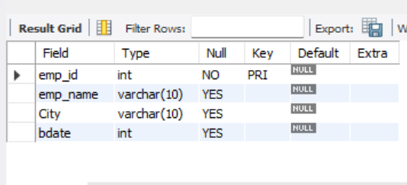
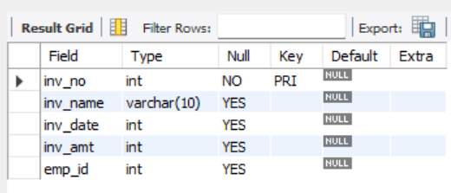
- Insert at least 5 rows into the table.
INSERT INTO Employee VALUES(1,'Rahul','Pune',20-02-2001);
INSERT INTO Employee VALUES(2,'Ram','Mumbai',10-12-1990);
INSERT INTO Employee VALUES(3,'Rajesh','Akola',30-09-1995);
INSERT INTO Employee VALUES(4,'Mahesh','Delhi',25-03-2003);
INSERT INTO Employee VALUES(5,'Jay','Kolhapur',02-05-2002);
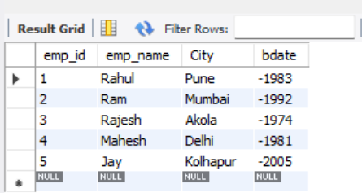
- Display all the information in the Employee table.
DESC Employee;
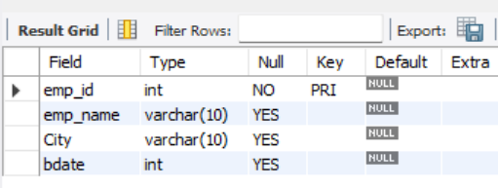
- Add columns ‘Age’ and ‘Salary’ to the Employee table; apply check constraints for (Age<=50 and Salary>=10000).
ALTER TABLE Employee
ADD COLUMN Age INT;

ALTER TABLE Employee
ADD COLUMN Salary INT;

ALTER TABLE Employee
ADD CONSTRAINT chk__age CHECK (age <= 50);

ALTER TABLE Employee
ADD CONSTRAINT chk__salary CHECK (salary >= 10000);
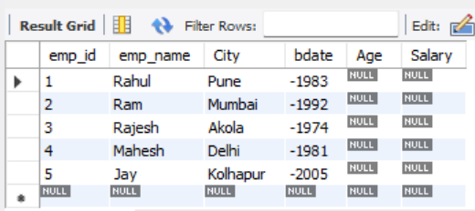
- Add a column ‘Age’ to the Investor table.
ALTER TABLE Investor
ADD COLUMN Age INT;
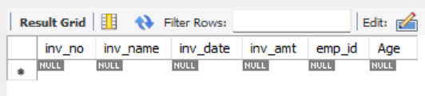
- Change the data type of inv_name from varchar to text in the Investor table.
ALTER TABLE Investor
modify inv_name text;
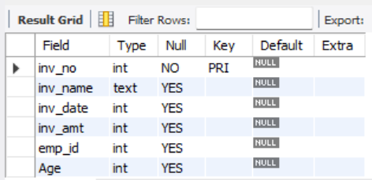
- Change the name of the column/field Emp_id to E_id.
ALTER TABLE Investor
RENAME COLUMN emp_id TO e_id;
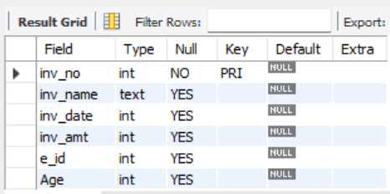
- Update the city of Emp_id-4 to the current city, Nagpur.
UPDATE Employee SET City='Nagpur' WHERE emp_id=4;
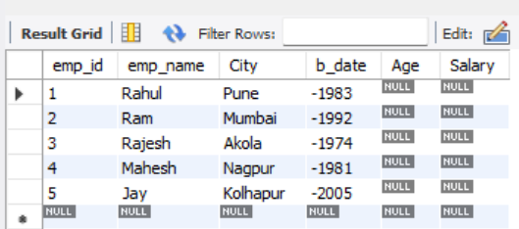
- Delete one record from the Investor table.
DELETE FROM Investor WHERE inv_no=15;
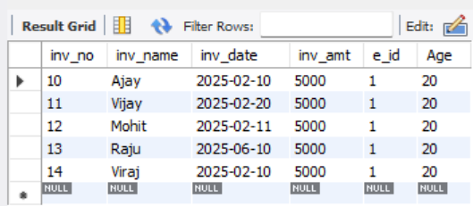
- Drop the column ‘Age’ from the Investor table.
ALTER TABLE Investor
DROP COLUMN Age;
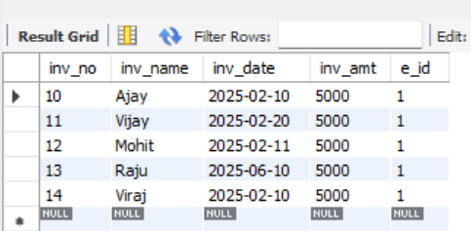
- Drop the CHECK constraint on the ‘Age’ column from the Employee table.
ALTER TABLE Employee
DROP CONSTRAINT chk__age;
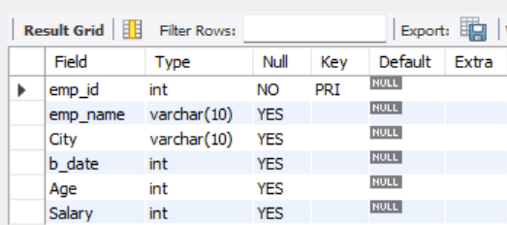
- Create foreign key constraints between the Employee and Investor tables.
ALTER TABLE Investor
ADD FOREIGN KEY(emp_id)
references Employee(emp_id);
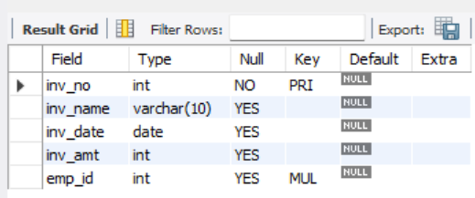
- Display any 4 columns from the Investor table.
SELECT inv_no,inv_name,
inv_date,inv_amt FROM Investor;
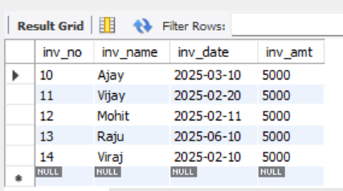
- Rename a table.
rename table Investor to INV;
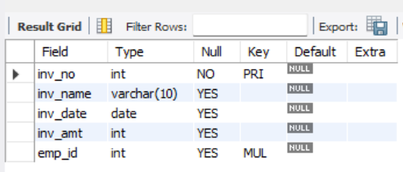
- Delete all the records using the TRUNCATE command.
truncate INV;
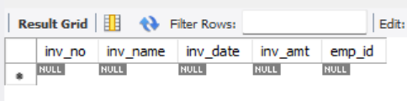

- Drop both tables from the database.
DROP table Employee,INV;
