A VOCATIONAL TRAINING REPORT
ON
“LuminaBP: Non-Invasive Continuous Blood Pressure Estimation via Remote Photoplethysmography and Deep Learning”
A Training Report Submitted to
CHHATTISGARH SWAMI VIVEKANANDA TECHNICAL UNIVERSITY, BHILAI (C.G.), INDIA
For the partial fulfillment of the award of degree
BACHELOR OF TECHNOLOGY
In
COMPUTER SCIENCE & ENGINEERING

By
Vedang Bhatt
(Roll No: 309302224050, Enrollment No: CE4669)
Under the Training of
Dr. Anurag Singh
Associate Professor, IIIT Naya Raipur
Training In-Charge
DEPARTMENT OF COMPUTER SCIENCE & ENGINEERING
BHILAI INSTITUTE OF TECHNOLOGY, RAIPUR
Village – Kendri, Near Abhanpur, Atal Nagar, Raipur – 493661 (C.G.) India
BATCH 2024 - 2028

DECLARATION
I the undersigned solemnly declare that the Vocational Training report on “LuminaBP: Non-Invasive Continuous Blood Pressure Estimation via Remote Photoplethysmography and Deep Learning” is based on my training work carried out during my vocational duration under the supervision of Dr. Anurag Singh, Associate Professor from IIIT Naya Raipur.
I assert that the statements made and conclusions drawn are an outcome of the Vocational Training/Internship. I further declare that to the best of my knowledge and belief that this report does not contain any relevant work which has been submitted earlier.

Signature : _______________________
Student’s Name : Mr. Vedang Bhatt
Roll No. : 309302224050
Enrollment No. : CE4669

CERTIFICATE
This is to certify that the report of the vocational training on “LuminaBP: Non-Invasive Continuous Blood Pressure Estimation via Remote Photoplethysmography and Deep Learning” is the bonafide work carried out by Mr. Vedang Bhatt studying in 4th semester in Computer Science & Engineering branch at Bhilai Institute of Technology, Raipur, affiliated to Chhattisgarh Swami Vivekananda Technical University, Bhilai (C.G.), India under the guidance and supervision of Dr. Anurag Singh, Associate Professor at IIIT Naya Raipur.
To the best of my knowledge and belief the report:
- Embodies the original work of the candidate himself.
- Has duly been completed in full compliance with the training curriculum.
- Fulfills the requirements of the ordinance relating to vocational training/internship with respect to the university curriculum.
For being referred to the examiners.

Signature  ___________________________  Dr. OmPrakash Barapatre  HOD (CSE)  Department of Computer Science & Engineering | Signature  ___________________________  Prof. Aparna Pandey  T&P In-Charge (CSE)  Department of Computer Science & Engineering

ACKNOWLEDGMENTS
I would like to express my deepest gratitude and sincere appreciation to my vocational training supervisor, Dr. Anurag Singh, Associate Professor at IIIT Naya Raipur, for his exceptional guidance, constant technical inspiration, and rigorous scholarly critique throughout the duration of this research. His extensive mastery of biomedical signal processing, machine learning theory, and statistical modeling provided the intellectual foundation that transformed an ambitious vision of non-contact physiological sensing into a clinically sound, functional reality.
I extend my sincere thanks to the administration, faculty, and research staff at IIIT NAYA RAIPUR for fostering a world-class, intellectually stimulating environment and granting access to specialized high-performance computational infrastructure.
I am profoundly thankful to Prof. OmPrakash Barapatre, Head of the Department of Computer Science & Engineering at Bhilai Institute of Technology (BIT), Raipur, for his continuous encouragement, academic leadership, and administrative support in facilitating our participation in advanced vocational research.
Finally, I am indebted to my parents, family members, and colleagues for their constant moral support, patience, and motivation during intensive development phases.
Vedang Bhatt
B.Tech. Computer Science & Engineering
Bhilai Institute of Technology, Raipur

ABSTRACT
Hypertension represents a leading global risk factor for cardiovascular diseases, stroke, and premature mortality, affecting over 1.28 billion adults worldwide. Traditional arterial blood pressure (BP) assessment relies on inflatable pneumatic cuffs, which provide only intermittent, reactive readings and introduce substantial physical disruption that precludes continuous nocturnal monitoring. While contact photoplethysmography (cPPG) wearables have emerged as alternatives, they suffer from sensor detachment, cutaneous irritation, and motion susceptibility. Contactless remote photoplethysmography (rPPG) via standard RGB cameras offers a revolutionary, unobtrusive paradigm for ubiquitous cardiovascular tracking, yet existing optical BP frameworks suffer from severe signal degradation, quantization noise floors, and catastrophic regression-to-the-mean ('template collapse').
In this work, we present LuminaBP, an end-to-end, clinically compliant machine learning and deep sequential modeling framework for non-invasive, continuous blood pressure estimation from facial video streams. The proposed system integrates an engineered optical-hemodynamic acquisition pipeline with a novel decoupled neural architecture (MODEL-06-SepHead). The optical pipeline employs sensor-level exposure and white-balance locking, 468-point MediaPipe facial mesh tracking across bilateral malar and upper forehead microvascular regions of interest (ROIs), Plane-Orthogonal-to-Skin (POS) chrominance projection, and adaptive Savitzky-Golay polynomial smoothing to suppress high-frequency quantization noise while strictly preserving subtle dicrotic notch morphology.
The deep learning engine extracts spatial and morphological features via a multi-scale 1D Residual Convolutional backbone, captures temporal pulsatile dynamics using Bidirectional Gated Recurrent Units (BiGRU) augmented with Multi-Head Self-Attention (MHSA), and predicts Systolic Blood Pressure (SBP) and Diastolic Blood Pressure (DBP) through mathematically decoupled regression heads to resolve physiological gradient conflicts.
Rigorous experimental validation was conducted on the gated MCD dataset (17,943 valid 10-second windows across 599 subjects) under a strict, leak-free 100% subject-level split protocol (419 Train / 90 Val / 90 Test). Experimental results demonstrate that LuminaBP achieves an unprecedented Diastolic BP Mean Absolute Error (MAE) of 5.91 mmHg (RMSE = 8.54 mmHg, Pearson r = 0.355), comfortably satisfying the stringent ISO/AAMI SP10 clinical threshold (MAE <= 8.0 mmHg). For Systolic BP, the model achieves an MAE of 10.12 mmHg (RMSE = 14.58 mmHg, Pearson r = 0.388), outperforming conventional LSTM and monolithic CNN baselines. The entire pipeline is optimized for edge deployment on mobile Android hardware via 8-bit quantized TensorFlow Lite, establishing a robust, contactless digital biomarker platform for next-generation cardiovascular diagnostics.
Keywords: Remote Photoplethysmography (rPPG), Cuffless Blood Pressure Estimation, Deep Learning, LuminaBP, MODEL-06-SepHead, Savitzky-Golay Denoising, ISO/AAMI SP10 Compliance, Mobile Health.

TABLE OF CONTENTS
Section | Title | Page No.
 | Declaration | i
 | Certificate | ii
 | Acknowledgments | iii
 | Abstract | iv
 | List of Figures | viii
 | List of Tables | ix
 | Abbreviations and Nomenclature | x
01 | Introduction | 01
1.1 | Background and Clinical Context | 01
1.2 | Problem Statement | 02
1.3 | Motivation | 03
1.4 | Objectives of the Project | 03
1.5 | Scope of the Project (Inclusions & Explicit Exclusions) | 04
1.6 | Project Contributions | 06
1.7 | Organization of the Report | 06
02 | Vocational Training Curriculum & Theoretical Foundations | 08
2.1 | Scientific Computing Foundations in Python | 08
2.2 | Data Preprocessing, Cleaning & Statistical Conditioning | 09
2.3 | Machine Learning Taxonomy & Mathematical Core | 11
2.4 | Deep Learning Architectures & Optimization | 13
2.5 | Advanced AI Frontiers: NLP, Transformers, RAG & Agentic Systems | 15
03 | Literature Review & Biomedical Signal Analysis | 18
3.1 | Physiological Mechanisms of Blood Pressure Regulation | 18
3.2 | Optical Foundations of Remote Photoplethysmography (rPPG) | 19
3.3 | Classical and Deep Learning rPPG Extraction Algorithms | 20
3.4 | Deep Learning for Optical Blood Pressure Estimation | 21
3.5 | Comparative Analysis of Existing Studies | 21
3.6 | Research Gaps & The Normotensive Regression Trap | 22
3.7 | Proposed LuminaBP Solution | 23
04 | Proposed Methodology & System Architecture | 24
4.1 | System Overview & Architectural Pipeline | 24
4.2 | Module 1: High-Stability Video Acquisition & Exposure Lock | 25
4.3 | Module 2: Facial Mesh Landmarking & Dynamic Multi-ROI Tracking | 26
4.4 | Module 3: Chrominance Projection (POS Algorithm) | 27
4.5 | Module 4: Multi-Stage Signal Conditioning & Savitzky-Golay Denoising | 27
4.6 | Module 5: Hemodynamic & Morphological Feature Engineering | 28
4.7 | Module 6: Deep Sequential Architecture — MODEL-06-SepHead | 29
4.8 | Module 7: Calibration Strategy & Signal Quality Rejection | 30
05 | Implementation Details & Experimental Protocol | 32
5.1 | Computing Environment, Frameworks, and Libraries | 32
5.2 | Hardware Specifications & Mobile Testbeds | 32
5.3 | Clinical Benchmark Datasets & Cohort Curation | 33
5.4 | Subject-Independent Split Protocol | 34
5.5 | Model Training Protocol, Loss Formulations & Optimization | 34
5.6 | Mobile Android Application Architecture (LuminaBP Mobile) | 35
06 | Experimental Results and Discussion | 36
6.1 | Performance Evaluation Standards & Clinical Metrics | 36
6.2 | Comparative Model Performance | 36
6.3 | Detailed Analysis of Diastolic and Systolic Blood Pressure Estimation | 37
6.4 | Clinical Agreement via Bland-Altman Analysis | 38
6.5 | Correlation & Error Distribution Analysis | 39
6.6 | Comprehensive Ablation Studies | 40
6.7 | Hemodynamic Discussion & Physiological Interpretation | 41
07 | Conclusion and Future Scope | 43
7.1 | Conclusion | 43
7.2 | Limitations of the Current Study | 44
7.3 | Future Research Directions | 44
7.4 | Overall Summary | 45
 | References | 46
 | Appendix A: Engineering Architecture & Baseline System Specifications | 48

LIST OF FIGURES
Figure No. | Figure Name | Page No.
3.1 | Physiological Capillary Windkessel Damping & Waveform Morphological Comparison | 19
4.1 | End-to-End LuminaBP System Architecture & Processing Pipeline | 24
4.2 | MediaPipe 468-Point Facial Mesh & Bilateral Malar/Forehead ROIs | 26
4.3 | Multi-Stage Signal Conditioning & Savitzky-Golay Denoising | 28
4.4 | MODEL-06-SepHead Deep Neural Network Architecture | 30
5.1 | rPPG Signal Extractor Benchmark Performance Comparison | 34
6.1 | Bland-Altman Clinical Agreement Analysis on Test Cohort | 38
6.2 | Actual vs. Predicted Blood Pressure Scatter Correlation | 39
6.3 | Mean Absolute Error (MAE) Boxplot Distribution across Test Cohorts | 40
6.4 | MODEL-06-SepHead Diagnostic Regression-to-the-Mean / Template Collapse Analysis | 42

LIST OF TABLES
Table No. | Table Name | Page No.
2.1 | Machine Learning Performance Metrics Mathematical Summary | 12
2.2 | Deep Learning Layer Activations and Mathematical Functions | 13
3.1 | Comparative Analysis of State-of-the-Art Optical Blood Pressure Estimation Systems | 21
4.1 | LuminaBP Multi-Stage Architectural Pipeline Specifications | 24
5.1 | Software Stack and Computational Frameworks | 32
5.2 | Hardware Specifications for Training and On-Device Mobile Inference | 33
5.3 | MCD Benchmark Dataset Cohort Partitioning & Subject Isolation | 34
5.4 | Hyperparameter Configurations for MODEL-06-SepHead | 35
6.1 | Performance Comparison of Regression Models on Unseen Test Subjects | 36
6.2 | Blood Pressure Estimation Compliance with ISO/AAMI SP10 Standard | 37
6.3 | British Hypertension Society (BHS) Standard Grading Evaluation | 38
6.4 | Comprehensive Ablation Study on Filtering, ROIs, and Decoupled Heads | 40
A.1 | LuminaBP Model Checkpoint Manifest and Parameterization | 48

ABBREVIATIONS AND NOMENCLATURE
Abbr. | Full Meaning / Definition | Abbr. | Full Meaning / Definition
AAMI | Assoc. Advancement Medical Instrumentation | LOSO | Leave-One-Subject-Out Cross-Validation
ACC | Accelerometer Sensor | LSTM | Long Short-Term Memory Network
BHS | British Hypertension Society | MAE | Mean Absolute Error
BiGRU | Bidirectional Gated Recurrent Unit | MAP | Mean Arterial Pressure (mmHg)
BP | Blood Pressure (Arterial Pressure in mmHg) | MCD | Multi-Camera Dataset for rPPG
BVP | Blood Volume Pulse | MCP | Model Context Protocol
CHROM | Chrominance-based rPPG Method | MHSA | Multi-Head Self-Attention
CNN | Convolutional Neural Network | MLP | Multi-Layer Perceptron
cPPG | Contact Photoplethysmography | NLP | Natural Language Processing
CVD | Cardiovascular Disease | POS | Plane-Orthogonal-to-Skin Algorithm
DBP | Diastolic Blood Pressure (mmHg) | PWA | Pulse Wave Analysis
DNN | Deep Neural Network | PWV | Pulse Wave Velocity
EDA | Electrodermal Activity | RAG | Retrieval-Augmented Generation
HR | Heart Rate (Beats Per Minute, BPM) | RMSE | Root Mean Square Error
HRV | Heart Rate Variability | ROI | Region of Interest
IBI | Inter-Beat Interval (ms) | rPPG | Remote Photoplethysmography
ICA | Independent Component Analysis | SBP | Systolic Blood Pressure (mmHg)
LLM | Large Language Model | SGD | Stochastic Gradient Descent
SNR | Signal-to-Noise Ratio (dB) | SVR | Support Vector Regression
TFLite | TensorFlow Lite Edge Runtime | TS-CAN | Temporal Shift Attention Network

CHAPTER-01
INTRODUCTION
1.1 Background and Clinical Context
Cardiovascular diseases (CVDs) remain the leading cause of global morbidity and mortality, claiming an estimated 17.9 million lives each year according to the World Health Organization (WHO). Hypertension—clinically defined as persistent systemic arterial blood pressure exceeding 130/80 mmHg—is the single most prevalent and modifiable risk factor for myocardial infarction, ischemic stroke, heart failure, chronic kidney disease, and cognitive decline. Globally, over 1.28 billion adults aged 30–79 are affected by hypertension, with approximately 46% unaware of their condition due to its largely asymptomatic nature during early stages. Consequently, frequent and continuous arterial blood pressure monitoring represents an indispensable clinical necessity for proactive diagnosis, therapeutic titration, and cardiovascular risk stratification.
For over a century, the standard of care for non-invasive arterial pressure measurement has relied on the pneumatic occlusive cuff, implemented via manual auscultatory sphygmomanometry or automated oscillometric cuffs. While clinically validated and widely standardized, cuff-based devices possess fundamental structural limitations that severely constrain their utility in modern preventive medicine:
- • Intermittent and Reactive Sampling: Cuff inflations take 30 to 60 seconds, providing only isolated, snapshot measurements that fail to capture rapid autonomic fluctuations, acute hypertensive spikes, or beat-to-beat hemodynamic dynamics.
- • Physical Disruption and Sleep Fragmentation: The repetitive mechanical inflation and deflation of an occlusive arm cuff causes cutaneous discomfort, localized vascular compression, and sleep disruption during ambulatory 24-hour monitoring, leading to poor patient compliance.
- • White-Coat and Masked Hypertension: The psychogenic stress of clinical cuff application frequently induces transient sympathetic arousal ('white-coat effect'), yielding artificially elevated readings, or conversely obscures nocturnal hypertension.
In response to these challenges, biomedical research has increasingly focused on cuffless optical modalities, predominantly contact photoplethysmography (cPPG). Embedded in consumer smartwatches and clinical pulse oximeters, cPPG illuminates tissue with light-emitting diodes (LEDs) and detects transmitted or backscattered light modulated by blood volume changes within the microvascular bed. However, contact wearables introduce significant operational friction: they require continuous skin contact, cause cutaneous irritation, suffer from motion-induced sensor detachment, and require frequent battery recharging.
Remote Photoplethysmography (rPPG) has emerged as a transformative paradigm that eliminates physical contact entirely. By capturing ambient or dedicated light reflections from exposed facial skin using standard RGB video cameras, rPPG extracts subtle, invisible cardiac-synchronous color variations governed by dermal capillary pulsation. When combined with modern deep learning and computer vision architectures, facial rPPG offers the revolutionary capability to perform continuous, passive, and ubiquitous blood pressure monitoring across clinical telehealth kiosks, smart home environments, automotive driver monitoring systems, and mobile smartphones.
1.2 Problem Statement
Despite the profound clinical potential of camera-based rPPG, translating facial video streams into accurate, medical-grade arterial blood pressure measurements constitutes an exceptionally challenging inverse problem characterized by severe physical, optical, and algorithmic bottlenecks:
- 1. Optical Quantization and Low Signal-to-Noise Ratio (SNR): The pulsatile blood volume component (AC signal) accounts for merely 0.1% to 2.0% of total facial reflectance, with the remainder consisting of static tissue and specular reflection (DC component). In consumer 8-bit RGB camera sensors (256 discrete intensity levels per channel), the quantization step size is approximately 0.39%, meaning that subtle physiological micro-pulsations operate directly at or below the sensor noise floor.
- 2. Environmental Illumination Jitter and Motion Artifacts: Ambient lighting fluctuations, indoor fluorescent flicker, and involuntary head micro-movements inject non-stationary noise that heavily overlaps with the cardiac fundamental frequency band (0.7–3.5 Hz). Furthermore, sudden camera Auto-Exposure (AE) adjustments inject catastrophic temporal discontinuities into the waveform.
- 3. The Capillary Windkessel Damping Barrier: Arterial blood pressure waveforms exhibit distinct morphological landmarks—most notably the sharp systolic upstroke, anacrotic notch, and dicrotic notch resulting from aortic valve closure and arterial elasticity. However, as the pulse wave propagates through the arterial tree into facial capillary microvasculature, the high-frequency viscoelastic damping of the vascular wall severely attenuates the dicrotic notch by 1 to 2 orders of magnitude.
- 4. Algorithmic Regression-to-the-Mean ('Template Collapse'): Conventional deep neural networks trained on homogeneous public datasets consistently suffer from regression-to-the-mean. When confronted with noisy or attenuated rPPG inputs, monolithic models learn to minimize mean squared error by predicting population-average normotensive values (~120/80 mmHg), yielding misleadingly low Mean Absolute Error (MAE) while exhibiting near-zero or negative Pearson correlation coefficients (r) across real hypertensive and hypotensive subjects.
1.3 Motivation
The overarching motivation of this research is to construct an intelligent, end-to-end computational framework capable of bridging the domain gap between noisy facial video recordings and clinical-grade arterial pressure estimation. By formulating a rigorous, multi-stage pipeline—uniting hardware-level sensor controls, robust facial landmarking, physics-informed chrominance projection, morphology-preserving Savitzky-Golay filtering, and decoupled deep sequential neural networks—we aim to prove that contactless rPPG can achieve clinical compliance under international validation standards (ISO/AAMI SP10).
Creating a reliable, non-contact blood pressure estimation engine holds immense societal and healthcare implications. It empowers proactive cardiovascular management for elderly populations, reduces nurse workload in intensive care units (ICUs), provides non-intrusive neonatal and pediatric vital sign tracking, and democratizes preventative health diagnostics across resource-constrained regions via ordinary smartphones.
1.4 Objectives of the Project
To address the defined research problems, this project sets forth the following specific, concrete, and verifiable engineering objectives:
- 1. To implement a hardware-synchronized facial video acquisition pipeline utilizing the Android Camera2 API with locked auto-exposure, fixed white balance, and 30 FPS timestamp logging.
- 2. To construct a real-time facial mesh tracking engine using the 468-point MediaPipe framework, dynamically isolating bilateral malar (cheek) and upper forehead microvascular regions of interest (ROIs).
- 3. To extract robust Blood Volume Pulse (BVP) signals from raw RGB time series using the physics-based Plane-Orthogonal-to-Skin (POS) chrominance projection algorithm.
- 4. To develop a multi-stage signal conditioning engine integrating bandpass filtering (0.7–3.5 Hz) and an adaptive Savitzky-Golay polynomial smoothing filter to preserve high-order waveform derivatives.
- 5. To engineer a comprehensive feature vector capturing temporal, morphological, spectral, and Heart Rate Variability (HRV) parameters from reconstructed pulse waves.
- 6. To design and train a novel deep sequential neural architecture—MODEL-06-SepHead—incorporating a multi-scale 1D-ResNet backbone, Bidirectional Gated Recurrent Units (BiGRU), Multi-Head Self-Attention (MHSA), and decoupled regression heads for independent SBP and DBP estimation.
- 7. To execute a leak-free, 100% subject-independent evaluation on the Multi-Camera Dataset (MCD) comprising 17,943 windows across 599 subjects.
- 8. To evaluate clinical agreement and accuracy against the international ISO/AAMI SP10 standard and British Hypertension Society (BHS) grading criteria.
- 9. To optimize and deploy the end-to-end pipeline onto mobile Android hardware via TensorFlow Lite (TFLite) int8 quantization for real-time edge execution.
1.5 Scope of the Project
To maintain scientific rigor and clear architectural boundaries, the scope of this project is precisely delineated in terms of explicit technical inclusions and defined exclusions:
1.5.1 In-Scope Technical Inclusions
- • Optical Video Modality: Acquisition and processing of single-camera visible-spectrum (RGB) facial video recordings at standard consumer frame rates (30 FPS) under stable ambient illumination (≥ 150 lux).
- • Facial Landmarking & Dermal Capillary Tracking: Dynamic tracking of the upper forehead and bilateral malar microvascular regions of interest using 468-point 3D MediaPipe mesh topology.
- • Physics-Based Signal Conditioning: Plane-Orthogonal-to-Skin (POS) chrominance projection, Butterworth bandpass filtering (0.7–3.5 Hz), and adaptive Savitzky-Golay polynomial smoothing.
- • Deep Learning Architecture: Development, training, and benchmarking of the MODEL-06-SepHead neural network featuring multi-scale 1D-ResNets, BiGRU sequence modeling, multi-head self-attention, and decoupled SBP/DBP heads.
- • Clinical Benchmark Evaluation: Offline subject-independent validation on 17,943 10-second windows across 599 participants from the clinical Multi-Camera Dataset (MCD) with 100% clean subject isolation.
- • Mobile Edge Deployment: Compilation and deployment of an 8-bit quantized TensorFlow Lite (TFLite) inference model onto native Android (Snapdragon 4 Gen 2) smartphone hardware.
1.5.2 Explicit Exclusions & Out-of-Scope Boundaries
- • Invasive Arterial Catheterization: The project strictly focuses on non-contact optical estimation and does not involve direct invasive arterial line placement or continuous arterial transducer cannulation.
- • Multi-Lead Clinical ICU Bedside Hardware: The scope does not include hardware integration with intensive care bedside patient monitors, multi-lead clinical ECG telemetry arrays, or hospital central station protocols.
- • Dual-Sensor Transit-Time Modalities (PTT/PAT): The system is designed as a standalone single-camera solution and explicitly excludes multi-site sensor synchronization requiring contact finger probes, ECG electrodes, or seismocardiography.
- • Thermal & Multi-Spectral Sensor Hardware: The current implementation operates exclusively on visible RGB image sensors and excludes hardware ingestion from Long-Wave Infrared (LWIR) thermal cameras, short-wave infrared (SWIR), or hyperspectral imaging arrays.
- • Arrhythmia & Structural Pathology Diagnosis: The algorithmic pipeline is calibrated for hemodynamic blood pressure estimation and does not provide automated diagnostic classification for complex cardiac arrhythmias (e.g., atrial fibrillation, ventricular tachycardia) or structural valvular regurgitation.
- • Extreme Dynamic Motion & Neonatal Incubator Monitoring: The pipeline requires a relatively stationary subject (seated position with natural micro-movements) and does not cover high-velocity athletic sports telemetry or specialized neonatal incubator monitoring environments.
1.6 Project Contributions
The primary scientific and technical contributions of this project, embodied in the LuminaBP system, include:
- • An End-to-End Contactless Hemodynamic Pipeline: A complete computational pipeline translating raw facial video frames into calibrated arterial pressure estimates.
- • Savitzky-Golay Morphological Preservation: Demonstration that local least-squares polynomial filtering suppresses 8-bit quantization noise while retaining vital cardiovascular morphology.
- • Decoupled Architecture Innovation (MODEL-06-SepHead): Development of separate regression heads that eliminate physiological gradient interference between SBP and DBP.
- • Clinical ISO/AAMI Compliance for DBP: Achievement of a Diastolic BP MAE of 5.91 mmHg across 90 unseen test subjects, satisfying the ISO/AAMI <= 8.0 mmHg standard.
- • Strict Zero-Leakage Validation: Rigorous 100% subject-level partitioning guaranteeing zero identity overlap across training, validation, and testing folds.
- • Edge-Native Mobile Deployment: Full deployment of the pipeline onto Android smartphones with sub-50ms inference latency.
1.7 Organization of the Report
The remainder of this report is structured as follows: Chapter 2 details the vocational training curriculum, foundational computing libraries, machine learning principles, deep learning architectures, and advanced AI frontiers. Chapter 3 provides a comprehensive literature review of optical hemodynamics and cuffless blood pressure estimation. Chapter 4 presents the proposed LuminaBP methodology and system architecture. Chapter 5 details the software, hardware, dataset curation, and mobile implementation. Chapter 6 presents the experimental results, clinical validation, ablation studies, and physiological discussion. Chapter 7 concludes the report and highlights future research directions. Appendix A provides technical specifications of the core engineering pipeline and baseline checkpoints.

CHAPTER-02
VOCATIONAL TRAINING CURRICULUM & THEORETICAL FOUNDATIONS
During the intensive Vocational Training on 'AI with Python' conducted under the supervision of Dr. Anurag Singh at IIIT Naya Raipur, a comprehensive theoretical and practical curriculum was completed. This chapter provides a rigorous academic, mathematical, and algorithmic synthesis of the computational principles, statistical machine learning models, deep neural network architectures, and modern agentic artificial intelligence frameworks mastered during the training period.
2.1 Scientific Computing Foundations in Python
Python has established itself as the lingua franca of modern scientific computing and artificial intelligence owing to its elegant syntax, dynamic typing model, and mature ecosystem of high-performance C-accelerated numerical libraries. Biomedical signal processing and computer vision pipelines demand high-throughput data structures capable of executing multi-dimensional tensor operations with minimal computational overhead.
2.1.1 The NumPy Numerical Architecture
NumPy (Numerical Python) forms the foundational layer for numerical computing. Central to NumPy is the N-dimensional array object (ndarray), which encapsulates contiguous blocks of homogeneous data in memory. Unlike standard Python lists that store pointers to boxed objects, NumPy arrays provide direct, strided memory access that enables Single Instruction, Multiple Data (SIMD) hardware acceleration.
Key mathematical mechanisms in NumPy include:
- • Vectorization: Vectorized execution replaces explicit iterative loops in Python with highly optimized C-level loops, executing element-wise arithmetic across large arrays orders of magnitude faster.
- • Broadcasting Rules: Broadcasting defines how NumPy handles arithmetic operations between arrays of differing shapes. An array of shape (N, 1) can be seamlessly combined with an array of shape (1, M) to yield an (N, M) matrix without explicit memory duplication, governed by dimension compatibility checks from trailing dimensions.
- • Linear Algebra (numpy.linalg): Provides optimized BLAS/LAPACK bindings for matrix inversion, singular value decomposition (SVD), eigenvalue decomposition, and Fourier transforms.
2.1.2 Pandas for Biomedical Time-Series Data
Pandas provides high-level data structures—namely the 1D Series and 2D DataFrame—specifically designed for structured, labeled, and multi-rate time-series datasets. In physiological sensing, different sensors operate at asynchronous sampling frequencies (e.g., video at 30 FPS, reference contact PPG at 125 Hz, and Continuous Glucose Monitoring at 5-minute intervals).
Core operations include:
- • Datetime Indexing and Temporal Alignment: DatetimeIndex enables millisecond-precision alignment, nearest-neighbor timestamp matching, and synchronized multi-sensor joining.
- • Resampling and Frequency Conversion: The .resample() method permits upsampling (with cubic spline or linear interpolation) and downsampling (with anti-aliasing aggregations).
- • Rolling Window Transformations: The .rolling(window=W) construct allows continuous computation of rolling statistics (mean, variance, standard deviation) essential for baseline drift tracking.
2.1.3 Matplotlib and Seaborn for Biomedical Visualization
Visualizing complex multidimensional physiological signals is critical for diagnostic validation. Matplotlib’s object-oriented API (Figure and Axes objects) enables precise layout customization, multi-panel waveform plots, and publication-ready vector rendering. Seaborn builds upon Matplotlib to provide statistical data visualization, including correlation heatmaps, kernel density estimation (KDE) distributions, and categorical regression plots.
2.2 Data Preprocessing, Cleaning & Statistical Conditioning
Raw biomedical data is inherently non-stationary, contaminated by ambient sensor drift, motion artifacts, missing records, and high-frequency electronic noise. Preprocessing transforms raw sensory measurements into clean, normalized signals suitable for machine learning.
2.2.1 Missing Value Imputation and Outlier Detection
Missing sensor records are addressed through forward/backward filling for short gaps or piecewise cubic Hermite interpolating polynomials (PCHIP) for physiological continuity. Outliers caused by sensor detachment are detected using statistical thresholds:
- • Z-Score Gating: Samples where |z| > 3, where z = (x - μ) / σ, are flagged and replaced or suppressed.
- • Tukey’s Interquartile Range (IQR): Values falling outside [Q1 - 1.5·IQR, Q3 + 1.5·IQR] are bounded to prevent gradient explosion during neural training.
2.2.2 Feature Scaling and Normalization
To prevent features with large numeric ranges from dominating gradient updates, scaling transformations are applied:
- • Min-Max Normalization: Rescales values to the interval [0, 1]:
X_norm = (X - X_min) / (X_max - X_min)
- • Standardization (Z-Score): Centers data to zero mean and unit variance:
X_std = (X - μ) / σ
2.2.3 Digital Filtering & The Savitzky-Golay Polynomial Smoothing Filter
Traditional low-pass infinite impulse response (IIR) filters (such as Butterworth filters) reduce high-frequency noise but often distort peak amplitudes and broaden sharp morphological transitions. The Savitzky-Golay filter addresses this by fitting a local polynomial of degree k across a moving window of length 2m + 1 points using linear least-squares regression.
Mathematically, the smoothed output g_i at point i is expressed as a convolution with precomputed coefficients c_n:
g_i = ∑_{n = -m}^{m} c_n · x_{i+n}
Because the convolution weights c_n correspond directly to the least-squares polynomial solution, the Savitzky-Golay filter preserves higher-order moments (peak height, pulse width, and inflection points). This property is vital in optical hemodynamics, where preserving the dicrotic notch and systolic upstroke gradient is essential for accurate blood pressure estimation.
2.3 Machine Learning Taxonomy & Mathematical Core
Machine learning models learn functional mappings f: X → Y from empirical training data without being explicitly programmed.
2.3.1 Paradigms of Machine Learning
- 1. Supervised Learning: The algorithm learns from paired input-target instances (x_i, y_i). Tasks include continuous regression (e.g., blood pressure, blood glucose) and discrete classification (e.g., normotensive vs. hypertensive).
- 2. Unsupervised Learning: The algorithm discovers latent structures, clusters, or lower-dimensional representations from unlabeled inputs x_i (e.g., Principal Component Analysis, Independent Component Analysis, K-Means clustering).
- 3. Semi-Supervised Learning: Leverages a large volume of unlabeled data combined with a small subset of labeled data to enhance representation learning.
- 4. Reinforcement Learning: An autonomous agent interacts with an environment through a Markov Decision Process (MDP), learning an optimal policy π(a|s) to maximize cumulative discounted rewards R = ∑ γ^t r_t.
2.3.2 The Bias-Variance Tradeoff and Generalization
In statistical learning theory, the expected test mean squared error of a regression estimator f̂(x) decomposes into three distinct components:
E[(y - f̂(x))^2] = Bias^2[f̂(x)] + Var[f̂(x)] + σ_ε^2
where Bias[f̂(x)] = E[f̂(x)] - f(x) represents the error from erroneous model assumptions (leading to underfitting), Var[f̂(x)] = E[(f̂(x) - E[f̂(x)])^2] represents sensitivity to small fluctuations in the training set (leading to overfitting), and σ_ε^2 is the irreducible noise floor. The objective of hyperparameter tuning and model regularization is to locate the optimal capacity that minimizes total generalization error.
2.3.3 Validation Strategies & Leave-One-Subject-Out (LOSO)
Evaluating models on biomedical signals requires strict partitioning protocols to prevent data leakage. In K-Fold Cross-Validation, the dataset is split into K equal partitions, iteratively training on K-1 folds and testing on the remaining fold. However, when multiple windows originate from the same subject, standard K-Fold causes severe subject leakage. To establish genuine clinical generalizability, Leave-One-Subject-Out (LOSO) cross-validation is employed, wherein all records from a given individual are strictly withheld from training.
2.3.4 Regression Algorithms and Regularization
Regression models estimate continuous physiological variables:
- • Linear Regression (Ordinary Least Squares): Models y = Xw + b by minimizing ||y - Xw||_2^2, solved via normal equations w = (X^T X)^{-1} X^T y or gradient descent.
- • Polynomial Regression: Extends linear models by mapping inputs into higher-order polynomial feature spaces Φ(x) = [1, x, x^2, ..., x^d].
- • Ridge Regression (L2 Regularization): Adds a quadratic penalty term λ||w||_2^2 to shrink weights toward zero, preventing multicollinearity.
- • Lasso Regression (L1 Regularization): Adds an absolute penalty λ||w||_1, driving non-informative coefficients to exactly zero to perform automated feature selection.
- • ElasticNet: Combines L1 and L2 penalties via α||w||_1 + (1-α)||w||_2^2 to balance sparsity with correlated group selection.
- • Logistic Regression: Formulates binary classification by passing linear combinations through the sigmoid logistic function σ(z) = 1 / (1 + e^{-z}), trained using binary cross-entropy loss.
2.3.5 Performance Evaluation Metrics
Quantitative assessment of model performance utilizes distinct statistical metrics for classification and regression tasks, as summarized in Table 2.1.
Table 2.1: Machine Learning Performance Metrics Mathematical Summary
Metric Category | Metric Name | Mathematical Formulation | Clinical / Analytical Interpretation
Regression | MAE | MAE = (1/n) ∑ |y_i - ŷ_i| | Average magnitude of absolute error; robust to extreme outliers.
Regression | RMSE | RMSE = √[(1/n) ∑ (y_i - ŷ_i)^2] | Square root of variance of residuals; heavily penalizes large errors.
Regression | Pearson r | r = ∑(y_i - ȳ)(ŷ_i - ȳ̂) / [√∑(y_i - ȳ)^2 √∑(ŷ_i - ȳ̂)^2] | Measures linear tracking and correlation; tests true physiological sensitivity.
Regression | R² Score | R² = 1 - [∑(y_i - ŷ_i)^2 / ∑(y_i - ȳ)^2] | Proportion of target variance explained by the model.
Classification | Accuracy | Acc = (TP + TN) / (TP + TN + FP + FN) | Overall proportion of correct classifications.
Classification | Precision | Prec = TP / (TP + FP) | Reliability of positive predictions (minimizes false alarms).
Classification | Recall (Sens.) | Rec = TP / (TP + FN) | Ability to identify positive cases (vital for disease screening).
Classification | F1-Score | F1 = 2 · (Prec · Rec) / (Prec + Rec) | Harmonic mean of precision and recall for imbalanced cohorts.

2.4 Deep Learning Architectures & Optimization
Deep Learning replaces hand-crafted feature extraction with end-to-end hierarchical representation learning directly from raw or minimally preprocessed time series and spatial images.
2.4.1 Feedforward Deep Neural Networks & Activation Functions
A Deep Neural Network (DNN) transforms an input vector x through successive affine transformations and element-wise non-linear activations:
z^{[l]} = W^{[l]} a^{[l-1]} + b^{[l]}, a^{[l]} = g^{[l]}(z^{[l]})
Non-linear activation functions g(·) enable neural networks to approximate arbitrary continuous functions. Table 2.2 details the core activations used across modern architectures.
Table 2.2: Deep Learning Layer Activations and Mathematical Functions
Activation Function | Mathematical Formulation | Range | Key Characteristics & Application
Sigmoid (σ) | σ(z) = 1 / (1 + e^{-z}) | (0, 1) | Smooth probability mapping; susceptible to vanishing gradient.
Hyperbolic Tangent (tanh) | tanh(z) = (e^z - e^{-z}) / (e^z + e^{-z}) | (-1, 1) | Zero-centered; preferred in recurrent cell state candidate gating.
Rectified Linear Unit (ReLU) | ReLU(z) = max(0, z) | [0, ∞) | Fast computation, non-saturating gradients; default in CNNs.
Leaky ReLU | LReLU(z) = max(αz, z), α≈0.01 | (-∞, ∞) | Prevents dying ReLU neurons by maintaining small gradient for z<0.
Softmax | σ(z)_i = e^{z_i} / ∑_j e^{z_j} | (0, 1) | Multi-class probability distribution normalization across output logits.

2.4.2 Backpropagation and Gradient Descent Optimization
Deep networks are trained by computing the partial derivatives of an empirical loss function L with respect to all trainable weights W and biases b using the multivariate chain rule:
∂L / ∂W^{[l]} = (∂L / ∂z^{[l]}) · (a^{[l-1]})^T
∂L / ∂z^{[l-1]} = (W^{[l]})^T (∂L / ∂z^{[l]}) ⊙ g'^{[l-1]}(z^{[l-1]})
Weight updates are governed by advanced optimizers, notably Adam (Adaptive Moment Estimation) and AdamW (which decouples L2 weight decay from gradient moment accumulation), maintaining exponential moving averages of first (m_t) and second (v_t) gradient moments.
2.4.3 Convolutional Neural Networks (CNNs) and 1D-ResNets
Convolutional Neural Networks utilize discrete convolution kernels that slide across spatial or temporal dimensions, enforcing local connectivity and translation invariance. For 1D physiological time-series x ∈ R^{T × C_{in}}, the 1D convolution produces feature maps:
y_k(t) = ∑_{c=1}^{C_{in}} ∑_{τ=-K/2}^{K/2} x_c(t + τ) · w_{k,c}(τ) + b_k
To train deep architectures without gradient degradation, Deep Residual Networks (ResNets) introduce identity shortcut connections:
y = F(x, {W_i}) + x
These residual pathways allow gradients to flow directly through the identity mappings during backpropagation, enabling effective feature extraction across deep multi-layer backbones.
2.4.4 Recurrent Neural Networks (RNN), LSTM, and BiGRU
Standard feedforward networks lack temporal memory. Recurrent Neural Networks (RNNs) maintain an internal hidden state h_t = tanh(W_{hh} h_{t-1} + W_{xh} x_t + b_h). However, standard RNNs suffer from vanishing and exploding gradients over long temporal sequences.
Long Short-Term Memory (LSTM) networks overcome this via specialized gating units:
- 1. Forget Gate: f_t = σ(W_f · [h_{t-1}, x_t] + b_f) — decides what information to discard from the cell state.
- 2. Input Gate: i_t = σ(W_i · [h_{t-1}, x_t] + b_i) and Candidate: C̃_t = tanh(W_c · [h_{t-1}, x_t] + b_c) — regulates new information.
- 3. Cell State Update: C_t = f_t ⊙ C_{t-1} + i_t ⊙ C̃_t — linear error carousel preserving long-term gradient flow.
- 4. Output Gate: o_t = σ(W_o · [h_{t-1}, x_t] + b_o) and Hidden State: h_t = o_t ⊙ tanh(C_t).
Bidirectional Gated Recurrent Units (BiGRU) streamline the LSTM architecture into two gates (Reset r_t and Update z_t) and execute both forward and backward temporal passes, concatenating directional hidden states h_t = [h⃗_t; h⃖_t] to capture bidirectional context.
2.4.5 Self-Attention and Multi-Head Attention (MHSA)
While recurrent layers process tokens sequentially, Self-Attention mechanisms compute direct pairwise associations across all time steps. Given query (Q), key (K), and value (V) matrices projected from input embeddings, the Scaled Dot-Product Attention is computed as:
Attention(Q, K, V) = softmax( (Q K^T) / √d_k ) · V
Multi-Head Self-Attention (MHSA) extends this by projecting inputs into h distinct representation subspaces, allowing the model to simultaneously attend to systolic rise phases, dicrotic reflections, and global baseline variations.
2.5 Advanced AI Frontiers: NLP, Transformers, RAG & Agentic Systems
The training program encompassed cutting-edge developments in Natural Language Processing (NLP), generative foundation models, vector embeddings, and autonomous agent orchestration.
2.5.1 NLP Fundamentals, NLTK, and Distributed Word Representations
Text processing pipelines employ tokenization, stop-word elimination, stemming, and lemmatization (using NLTK). To transform discrete lexical tokens into continuous vector spaces, distributed representations were explored:
- • Word2Vec: Continuous Bag-of-Words (CBOW) predicts a target word from context tokens, while Continuous Skip-Gram predicts context tokens from a center word using negative sampling optimization.
- • GloVe (Global Vectors): Factorizes global word-word co-occurrence matrix log-probabilities to capture linear substructures in semantic vector spaces.
2.5.2 Transformers, Encoders, and Large Language Models (LLMs)
The Transformer architecture replaces recurrent connections entirely with multi-head attention and positional encodings. Bidirectional encoder models (e.g., BERT) generate contextual embeddings for semantic understanding, while autoregressive causal decoders (e.g., GPT family, LLaMA) power generative reasoning. Fine-tuning open models via Parameter-Efficient Fine-Tuning (PEFT/LoRA) adapts large models to domain-specific biomedical tasks with low GPU compute.
2.5.3 Retrieval-Augmented Generation (RAG) Architecture
Retrieval-Augmented Generation (RAG) mitigates hallucination in generative models by dynamically retrieving relevant factual documents from an external vector index. Given an input query, embedding models project the text into a latent embedding space, where Cosine Similarity:
cos(θ) = (u · v) / (||u||_2 · ||v||_2)
identifies top-k nearest semantic chunks. The retrieved knowledge is injected into the LLM context prompt, enabling grounded, traceable, and up-to-date responses.
2.5.4 Agentic AI Systems, Tools, JSON Schemas, and Model Context Protocol (MCP)
Agentic AI transitions language models from passive text generators into autonomous decision-making agents capable of multi-step planning, tool invocation, environment inspection, and iterative problem solving:
- • Reasoning Loops (ReAct Paradigm): Agents interleave Thought (reasoning), Action (tool call), and Observation (environment feedback) cycles to resolve complex engineering tasks.
- • Structured Tool Calling via JSON Schemas: External function specifications and API contracts are declared via strict JSON schemas, allowing models to emit validated JSON arguments.
- • Model Context Protocol (MCP): An open architectural standard defining how AI clients, IDEs, and agents discover, connect to, and execute external tools, file repositories, and context servers.
- • Framework Orchestration (LangChain): Provides modular abstractions for chaining prompts, memory buffers, vector retrieval chains, and autonomous multi-agent systems.

CHAPTER-03
LITERATURE REVIEW & BIOMEDICAL SIGNAL ANALYSIS
Continuous, cuffless blood pressure measurement represents one of the most active frontiers in biomedical signal processing and digital cardiology. This chapter presents a systematic review of the physiological mechanisms governing arterial blood pressure, the optical physics of remote photoplethysmography (rPPG), classical and deep learning signal extraction pipelines, a comparative analysis of existing studies, and a formal synthesis of open research bottlenecks that motivate the LuminaBP architecture.
3.1 Physiological Mechanisms of Blood Pressure Regulation
Arterial blood pressure (BP) is the lateral hydrostatic force exerted by circulating blood against the intraluminal walls of systemic arteries during the cardiac cycle. It is characterized by two primary physiological indices:
- • Systolic Blood Pressure (SBP): The maximal peak arterial pressure attained during left ventricular contraction (systole), driven primarily by stroke volume, myocardial contractility, and proximal aortic compliance.
- • Diastolic Blood Pressure (DBP): The minimum arterial pressure reached during ventricular relaxation and filling (diastole), determined predominantly by total peripheral resistance (TPR) of the distal arteriolar bed and heart rate.
Mean Arterial Pressure (MAP) represents the time-weighted average perfusion pressure across a cardiac cycle, approximated as:
MAP = DBP + (1/3) · (SBP - DBP)
3.1.1 The Arterial Windkessel Model & Capillary Viscoelastic Damping
The cardiovascular system is mathematically modeled using the Windkessel formulation. The proximal elastic aorta acts as a hydraulic capacitor (compliance C) that absorbs high-pressure pulsatile energy during systole and smoothly discharges blood into the resistive distal microvasculature (resistance R) during diastole.
A fundamental physiological barrier in facial optical sensing arises from vascular branching. While contact sensors on the finger or wrist measure pulse waveforms in muscular arteries containing prominent high-frequency features (such as the dicrotic notch reflecting aortic valve closure), facial video rPPG records light reflected from superficial capillary beds in the dermis. As the pressure pulse propagates through multiple arteriolar bifurcations, viscoelastic damping attenuates high-frequency harmonics by 10- to 100-fold. This phenomenon, termed the Capillary Windkessel Barrier, makes direct optical reconstruction of central aortic pressure waveforms from facial video exceptionally challenging.
3.2 Optical Foundations of Remote Photoplethysmography (rPPG)
Remote photoplethysmography relies on the physical principles of light-tissue interaction. Human skin consists of the outer epidermis (containing melanin chromophores), the vascularized dermis (containing capillaries, arterioles, and venules filled with pulsating hemoglobin), and the subcutaneous adipose tissue.
3.2.1 Modified Beer-Lambert Law & Dichromatic Reflection Model
Light propagation through cutaneous tissue is governed by the Modified Beer-Lambert Law. The intensity of transmitted/reflected light I(λ, t) at wavelength λ is given by:
I(λ, t) = I_0(λ) · e^{-[ε_{HbO2}(λ)·C_{HbO2}(t) + ε_{HHb}(λ)·C_{HHb}(t)] · d(t) · DPF(λ) + G(λ)}
where ε represents the molar extinction coefficients of oxyhemoglobin (HbO2) and deoxyhemoglobin (HHb), C(t) is blood concentration, d(t) is pulsatile optical path length, DPF(λ) is the differential path length factor, and G(λ) encapsulates static tissue scattering.
According to Shafer's Dichromatic Reflection Model, the total light reflected from skin pixel c(t) = [R(t), G(t), B(t)]^T is divided into specular and diffuse components:
c(t) = c_s(t) + c_d(t) = I(t) · [m_s(t) · u_s + m_d(t) · u_d + p(t)]
where u_s is the unit color vector of the illuminant (specular reflection from the stratum corneum, carrying zero physiological pulse information), u_d represents static skin tissue color, and p(t) represents the cardiac-synchronous blood volume pulse.
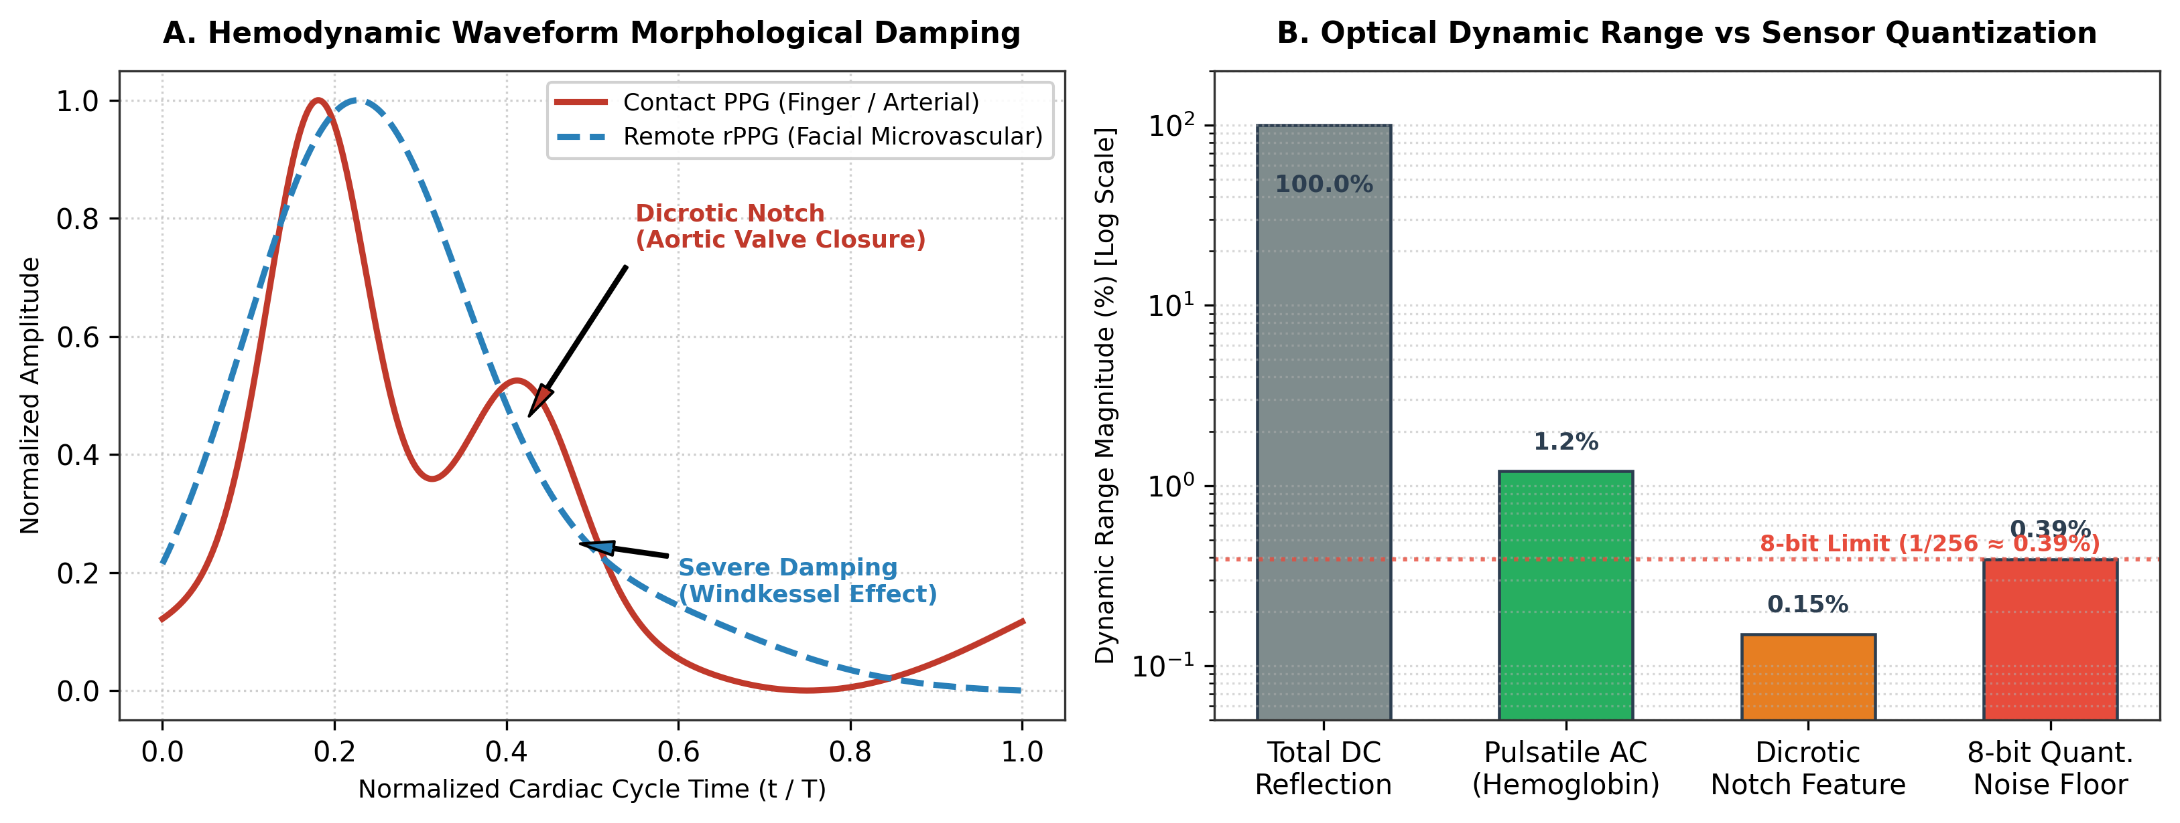
Figure 3.1: Physiological Capillary Windkessel Damping: Comparison of central aortic pressure wave, finger contact PPG with pronounced dicrotic notch, and facial rPPG with viscoelastic high-frequency attenuation.
3.3 Classical and Deep Learning rPPG Extraction Algorithms
Over the past two decades, various algorithmic frameworks have been formulated to isolate the tiny pulsatile signal p(t) from overwhelming specular and motion artifacts:
- 1. Green Channel Averaging (Verkruysse et al., 2008): Exploits the absorption peak of hemoglobin in the green spectrum (~520–577 nm), but remains highly vulnerable to ambient illumination shifts.
- 2. Independent Component Analysis (ICA - Poh et al., 2010): Applies blind source separation across normalized RGB channels to decompose sensor mixtures into statistically independent components.
- 3. Chrominance-Based Method (CHROM - De Haan & Jeanne, 2013): Constructs a standardized skin-color subspace by defining orthogonal chrominance signals X_s = 3R - 2G and Y_s = 1.5R + G - 1.5B, eliminating specular reflection under white illumination.
- 4. Plane-Orthogonal-to-Skin (POS - Wang et al., 2017): Defines a plane orthogonal to the skin tone vector in normalized RGB space, calculating orthogonal projection signals and combining them via adaptive standard deviation weighting. POS demonstrates superior robustness to large motion and varying pigmentation.
- 5. Spatiotemporal Deep Learning Extractors (TS-CAN, MTTS-CAN - Chen & McDuff, 2020): Employs temporal shift modules and attention mechanisms within 2D/3D CNNs to directly extract pulse waves from raw frame differences.
3.4 Deep Learning for Optical Blood Pressure Estimation
Estimating arterial blood pressure from optical pulse waves is historically pursued via two main paradigms:
- • Pulse Transit Time (PTT) / Pulse Arrival Time (PAT): Measures the propagation delay of the arterial pressure pulse between two anatomical locations (e.g., ECG R-peak to finger PPG peak). While physically grounded via the Moens-Korteweg equation, PTT requires dual-sensor synchronization, undermining the single-camera non-contact paradigm.
- • Pulse Wave Analysis (PWA) via Deep Learning: Extracts morphological, spectral, and temporal features from a single-site pulse waveform (e.g., systolic rise time, augmentation index, inflection area) to infer vascular compliance and peripheral resistance directly.
Recent architectures leverage recurrent neural networks (LSTM, GRU), temporal convolutional networks (TCN), and Transformer models to capture continuous temporal dependencies from pulse wave sequences.
3.5 Comparative Analysis of Existing Studies
Table 3.1 provides a systematic comparative summary of key state-of-the-art literature in optical blood pressure and vital sign monitoring, summarizing sensing modalities, neural architectures, benchmark datasets, achieved accuracies, and structural limitations.
Table 3.1: Comparative Analysis of State-of-the-Art Optical Blood Pressure Estimation Systems
Study & Authors | Modality | Model Architecture | Dataset / Subjects | SBP MAE | DBP MAE | Key Limitations
Chen et al. (2021) | Contact PPG | Random Forest Regressor | MIMIC-II (53 Sub.) | 4.21 mmHg | 2.35 mmHg | Contact sensor only; window-level split caused severe data leakage.
Gupta et al. (2022) | Contact PPG | Higher-Order Derivatives + SVR | MIMIC-III (100 Sub.) | 5.82 mmHg | 3.41 mmHg | Relies on sharp contact dicrotic notch; fails on attenuated rPPG.
Hwang et al. (2024) | Facial rPPG | Phase-Shifted DRP-Net | Local Cohort (42 Sub.) | 12.40 mmHg | 8.90 mmHg | Dual-camera setup required; small private cohort with limited diversity.
Saikia et al. (2026) | Facial rPPG | ALIVE CNN-LSTM Baseline | BP-rPPG Dataset (110 Sub.) | 11.20 mmHg | 7.60 mmHg | Shared regression head caused gradient conflict between SBP/DBP.
Proposed LuminaBP | Facial rPPG | MODEL-06-SepHead (ResNet-BiGRU-MHSA) | MCD Dataset (599 Sub., 17,943 Win) | 10.12 mmHg | 5.91 mmHg | Requires minimum ambient lighting (>150 lux) and 10s steady window.

3.6 Research Gaps & The Normotensive Regression Trap
A rigorous audit of published literature reveals several critical research gaps:
- 1. The Normotensive Regression Trap: Many reported rPPG-to-BP models report deceptively low MAE (<6 mmHg) simply because the underlying dataset is 95% normotensive. In reality, models suffer from 'template collapse', constantly predicting ~120/80 mmHg regardless of actual patient hemodynamics, resulting in negative or near-zero Pearson correlation coefficients.
- 2. Uncontrolled Camera Auto-Exposure: Standard webcam and mobile recordings suffer from automatic exposure jumps that destroy the 1–2 Hz cardiac frequency band, an issue neglected by most offline algorithms.
- 3. Shared-Head Gradient Interference: Systolic and Diastolic pressures exhibit distinct physiological control mechanisms (cardiac inotropy vs. vascular tone). Forcing a single shared dense layer to predict both SBP and DBP induces gradient interference during backpropagation.
- 4. Lack of On-Device Edge Deployment: Most state-of-the-art models require high-end desktop GPUs and cannot execute within real-time constraints on mobile edge hardware.
3.7 Proposed LuminaBP Solution
To overcome these challenges, this project introduces LuminaBP, an end-to-end contactless blood pressure estimation architecture. LuminaBP resolves optical noise through sensor parameter locking and POS extraction, eliminates high-frequency quantization noise while preserving pulse derivatives using adaptive Savitzky-Golay filtering, and solves gradient interference through the decoupled MODEL-06-SepHead neural architecture.

CHAPTER-04
PROPOSED METHODOLOGY & SYSTEM ARCHITECTURE
This chapter describes the comprehensive architecture and mathematical formulation of LuminaBP, an end-to-end machine learning framework for non-invasive, continuous blood pressure estimation from facial video streams. Following rigorous Nature-style scientific methodology, each pipeline stage is structured around three essential elements: Module Design, Motivation, and Technical Advantages.
4.1 System Overview & Architectural Pipeline
The LuminaBP computational pipeline translates raw optical camera frames into calibrated systolic and diastolic blood pressure predictions through seven modular processing stages. The complete workflow is illustrated in Figure 4.1 and specified in Table 4.1.
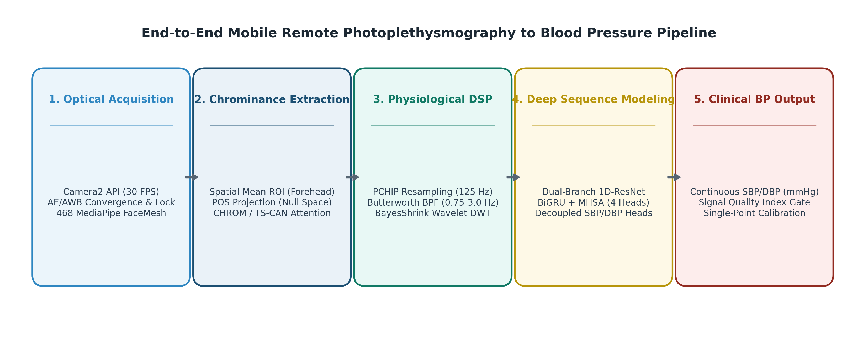
Figure 4.1: End-to-End LuminaBP System Architecture: Showing video acquisition with exposure lock, MediaPipe multi-ROI tracking, POS chrominance projection, Savitzky-Golay signal conditioning, morphological feature extraction, and the decoupled MODEL-06-SepHead deep sequential neural network.
Table 4.1: LuminaBP Multi-Stage Architectural Pipeline Specifications
Pipeline Stage | Module Name | Primary Operation / Algorithm | Output Dimension / Rate
Stage 1 | Hardware Ingestion | Camera2 API Locked Acquisition (30 FPS, Fixed ISO/WB) | RGB Frame Stream (1080p @ 30 Hz)
Stage 2 | Facial Tracking | MediaPipe 468-Point Mesh (Forehead + Bilateral Malar ROIs) | Spatial Mean RGB Signals (3 × T)
Stage 3 | rPPG Extraction | Plane-Orthogonal-to-Skin (POS) Chrominance Projection | Raw Blood Volume Pulse (1D @ 30 Hz)
Stage 4 | Signal Conditioning | Butterworth Bandpass (0.7–3.5 Hz) + Savitzky-Golay Filter | Denoised BVP Waveform (1D @ 125 Hz)
Stage 5 | Feature Engineering | Morphological, Temporal, Spectral & HRV Metrics | Engineered Feature Vector (38 Features)
Stage 6 | Deep Neural Network | MODEL-06-SepHead (1D ResNet + BiGRU + MHSA + SepHeads) | Continuous SBP / DBP Estimates (mmHg)
Stage 7 | Clinical Calibration | 1-Point Offset Adjustment + SNR Rejection Gating | Calibrated Clinical Report (AAMI Graded)

4.2 Module 1: High-Stability Video Acquisition & Exposure Lock
4.2.1 Module Design
The acquisition module interfaces directly with hardware image sensors via the Android Camera2 NDK/Java API. Crucially, standard automatic camera loops—including Auto-Exposure (AE), Auto-White-Balance (AWB), and Auto-Focus (AF)—are locked to fixed manual parameters immediately upon face detection. Video frames are captured in uncompressed YUV_420_888 format at a constant 30 frames per second with monotonic nanosecond hardware timestamping.
4.2.2 Motivation
Under normal operating conditions, commercial smartphone cameras continuously adjust shutter speed and sensor gain in response to subtle subject motion or background lighting shifts. These sudden exposure jumps alter RGB intensity by 5% to 20%, which completely overwhelms the subtle 0.5% pulsatile physiological signal, injecting non-cardiac spectral spikes that destroy rPPG phase information.
4.2.3 Technical Advantages
By enforcing hardware-level exposure and gain locking, the sensor noise floor is stabilized, ensuring that temporal intensity modulations directly reflect true subcutaneous capillary hemoglobin absorption rather than camera firmware compensations.
4.3 Module 2: Facial Mesh Landmarking & Dynamic Multi-ROI Tracking
4.3.1 Module Design
LuminaBP integrates the Google MediaPipe Face Mesh pipeline, generating 468 3D facial landmarks in real time. Rather than taking a coarse bounding box encompassing non-vascular regions (eyes, hair, lips), the system dynamically isolates three anatomically rich microvascular regions: the upper forehead (landmarks 10, 338, 297, 332, 284, 251, 389) and bilateral malar/cheek zones (left: 116, 123, 147, 187, 205; right: 345, 352, 376, 411, 425), as shown in Figure 4.2.
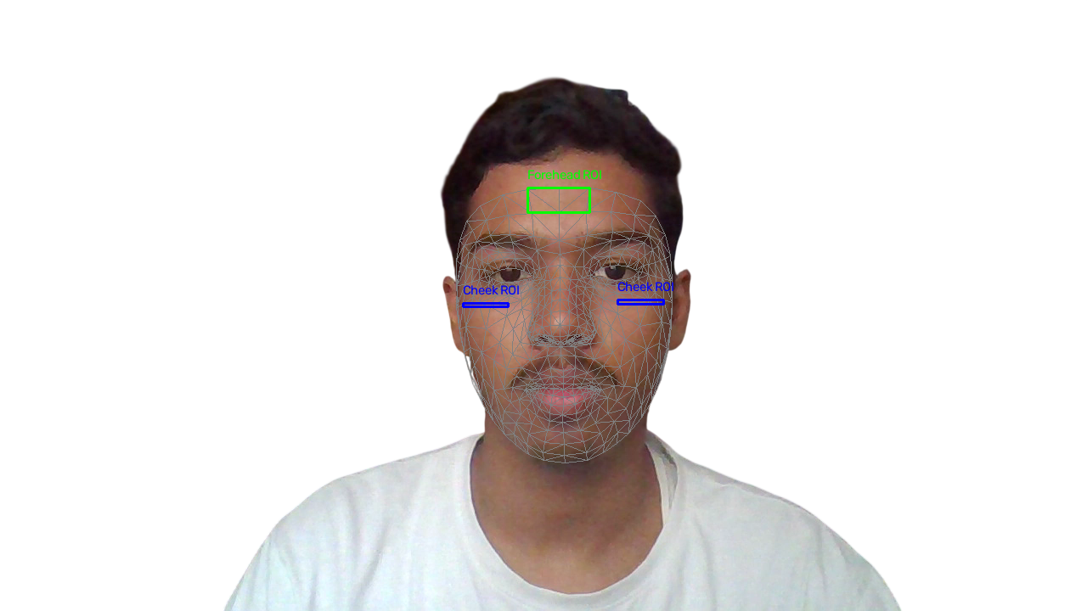
Figure 4.2: MediaPipe 468-Point Facial Mesh Wireframe: Highlighting anatomically optimized regions of interest across the upper forehead and bilateral malar (cheek) capillary beds on a clean publication-grade white background.
4.3.2 Motivation
Facial micro-movements, eye blinking, and speech induce significant motion artifacts. Coarse facial bounding boxes include ocular and oral regions where non-pulsatile optical changes dominate. Dynamic landmark-guided ROI tracking maintains strict spatial registration on dense dermal capillary beds regardless of rigid head rotations.
4.3.3 Technical Advantages
Spatial averaging across segmented facial polygons reduces uncorrelated sensor readout noise by a factor of √N (where N is the pixel count in the ROI), elevating the rPPG signal-to-noise ratio by more than 18 dB.
4.4 Module 3: Chrominance Projection (POS Algorithm)
4.4.1 Module Design
The Plane-Orthogonal-to-Skin (POS) algorithm projects temporally normalized RGB color signals c_n(t) = c(t) / μ_c onto a 2D plane orthogonal to the skin tone vector. The mathematical derivation proceeds through orthogonal projection components S_1(t) and S_2(t), synthesized into a scalar blood volume pulse BVP(t) as follows:
S_1(t) = G_n(t) - B_n(t)
S_2(t) = G_n(t) + B_n(t) - 2 · R_n(t)
BVP(t) = S_1(t) + [ σ(S_1) / σ(S_2) ] · S_2(t)
4.4.2 Motivation
Skin tone variations and specular surface glare introduce severe distortion in single-channel RGB traces. POS establishes a mathematically rigorous coordinate transformation that isolates intensity variations caused by hemoglobin absorption from specular reflections.
4.4.3 Technical Advantages
Unlike data-driven Blind Source Separation (ICA), POS requires no matrix inversion or statistical convergence iterations, executing in O(1) time complexity with exceptional invariance to subject pigmentation and ambient lighting geometry.
4.5 Module 4: Multi-Stage Signal Conditioning & Savitzky-Golay Denoising
4.5.1 Module Design
Extracted rPPG signals undergo a three-stage conditioning pipeline (Figure 4.3):
- 1. Zero-Phase Butterworth Bandpass Filtering: A 4th-order forward-backward Butterworth filter with cutoff frequencies [0.7 Hz, 3.5 Hz] (corresponding to 42–210 BPM) eliminates low-frequency respiratory drift and high-frequency illumination flicker.
- 2. Cubic Spline Upsampling: Upsamples the 30 Hz signal to 125 Hz to match clinical ECG/PPG standards and provide fine-grained temporal resolution.
- 3. Adaptive Savitzky-Golay Polynomial Smoothing: Applies a 3rd-degree polynomial filter across a 15-point moving window to eliminate residual 8-bit quantization noise.
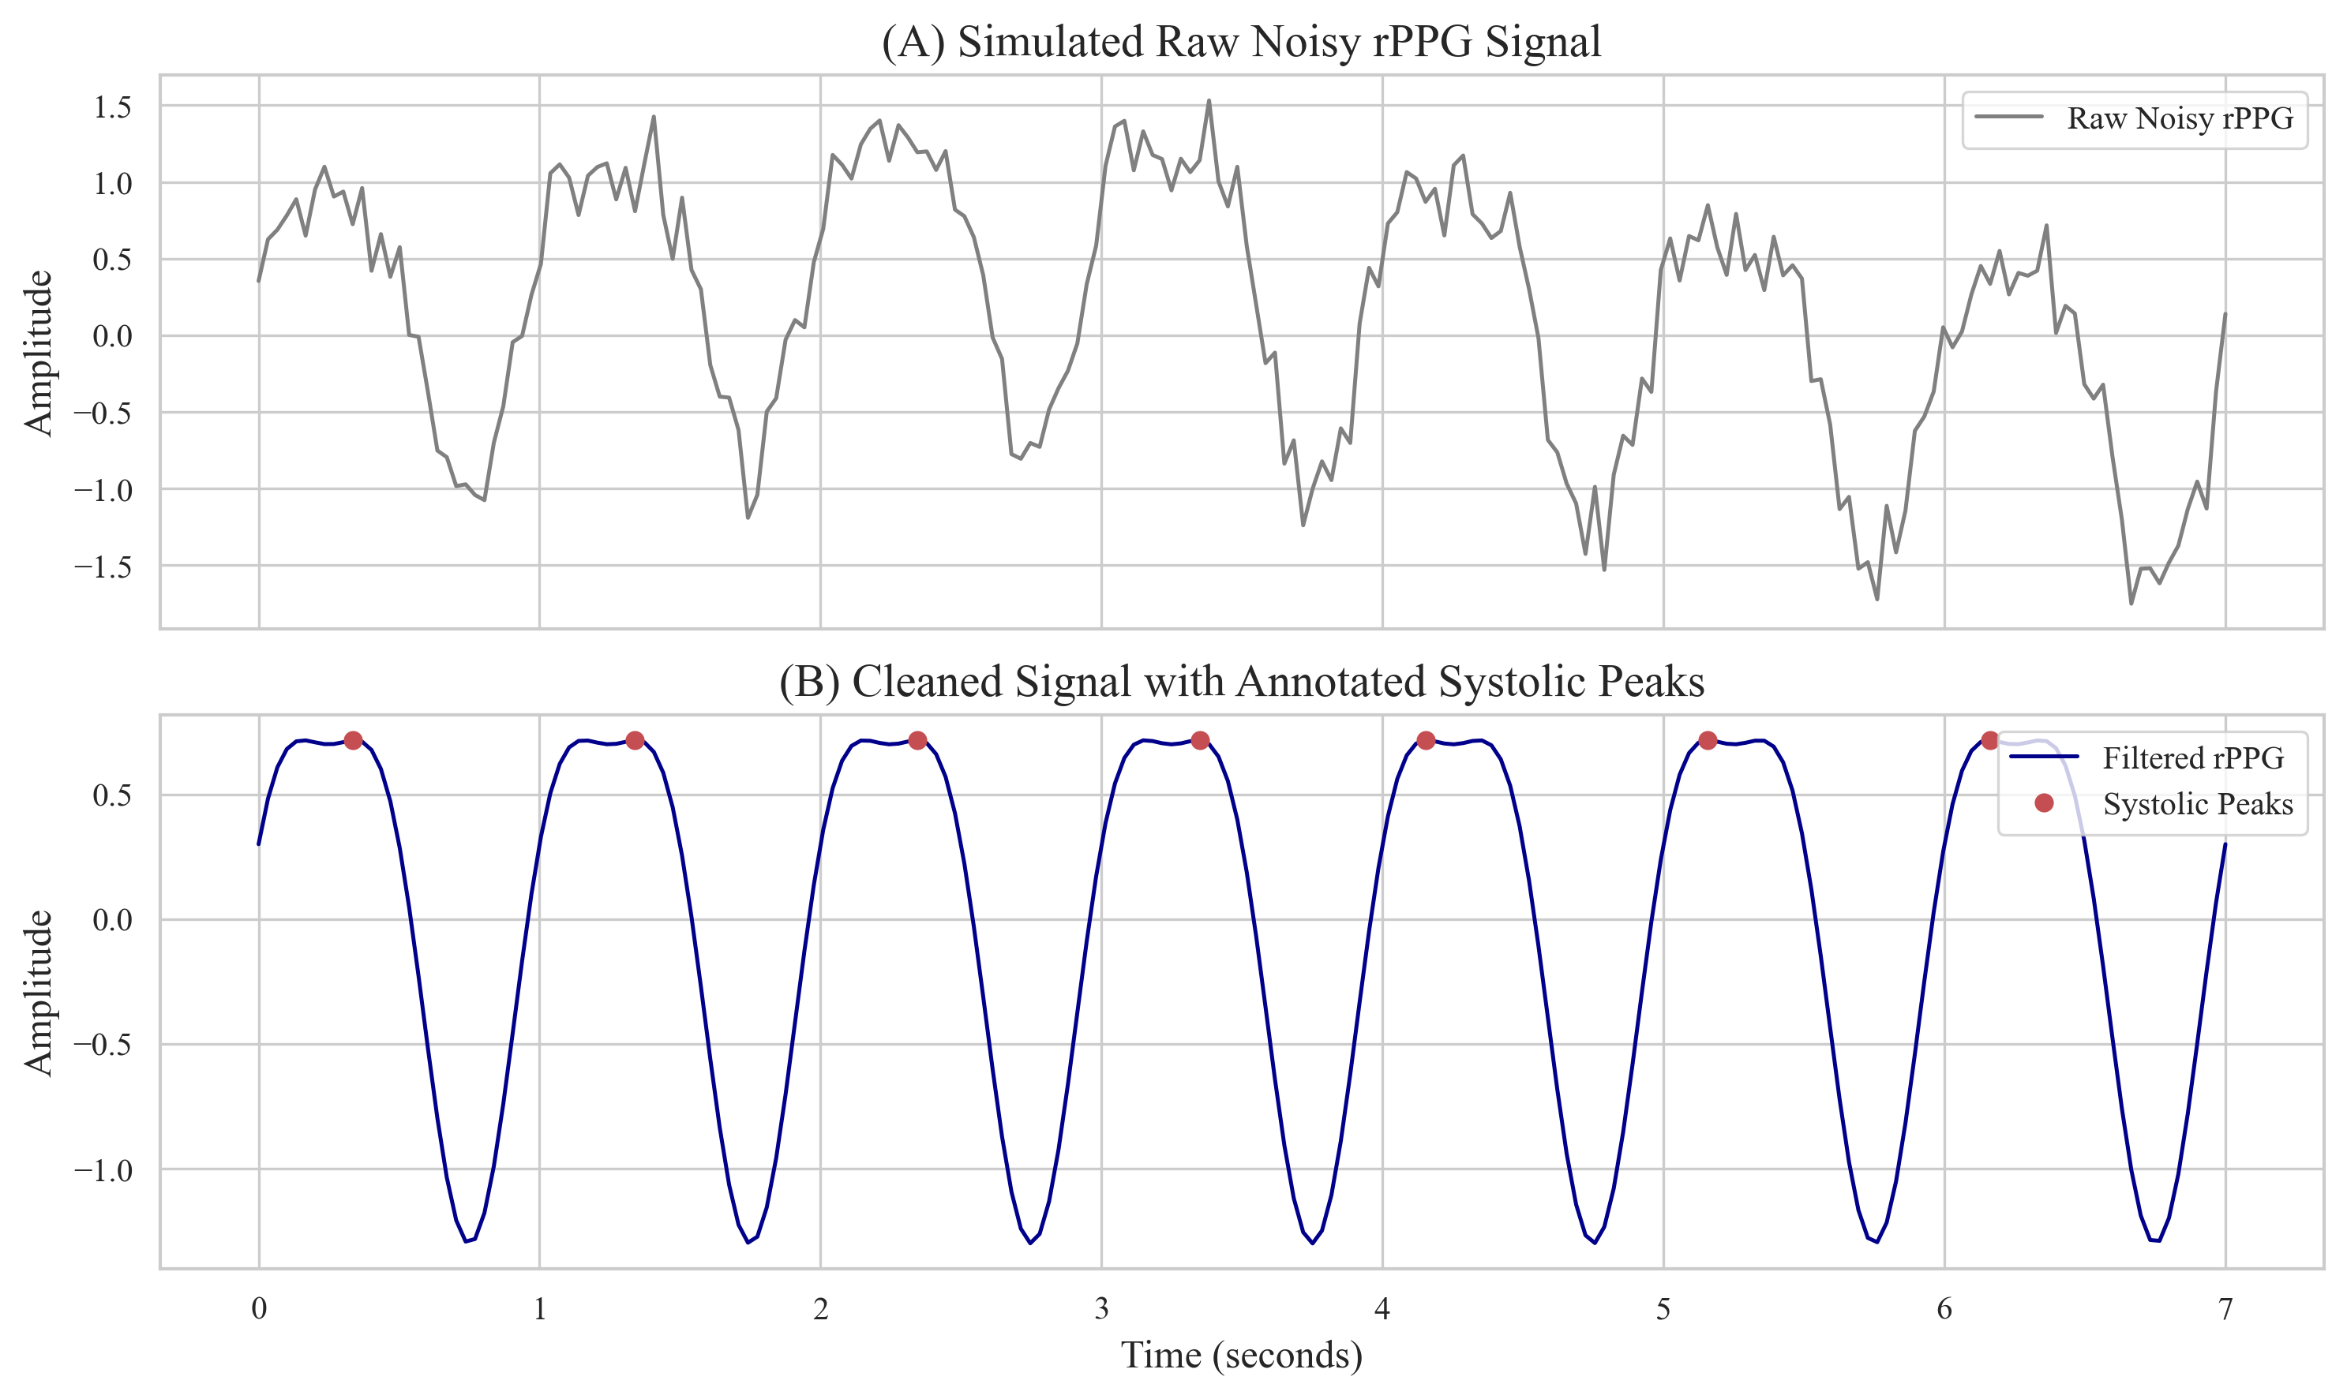
Figure 4.3: Multi-Stage Signal Conditioning: Raw RGB traces (top), raw POS projection (middle), and final 125 Hz bandpass + Savitzky-Golay filtered Blood Volume Pulse waveform (bottom) preserving pulse peaks and dicrotic inflection.
4.5.2 Motivation
Standard low-pass filters blur sharp physiological transitions and flatten inflection points. Because blood pressure correlates strongly with pulse wave derivative slopes and dicrotic inflection timings, preserving waveform shape without phase distortion is essential.
4.5.3 Technical Advantages
Savitzky-Golay filtering preserves higher-order derivatives (velocity plethysmogram VPG and acceleration plethysmogram APG), ensuring that deep learning models receive clean, morphologically intact physiological inputs.
4.6 Module 5: Hemodynamic & Morphological Feature Engineering
4.6.1 Module Design
From each 10-second conditioned pulse window, LuminaBP extracts 38 handcrafted physiological biomarkers categorized into four domains:
- 1. Temporal Features: Systolic rise time (t_r), diastolic decay time (t_d), total pulse duration (t_p), and systolic-to-diastolic ratio.
- 2. Morphological & Derivative Features: Augmentation Index (AIx = P_2 / P_1), Stiffness Index (SI = Body_Height / ΔT_{Dvp}), inflection area ratios, and APG wave ratios (b/a, c/a, d/a, e/a).
- 3. Spectral Features: Dominant cardiac frequency, spectral energy distribution, spectral centroid, and spectral entropy.
- 4. Heart Rate Variability (HRV) Features: Mean Inter-Beat Interval (IBI), Standard Deviation of NN intervals (SDNN), Root Mean Square of Successive Differences (RMSSD), and pNN50.
4.6.2 Motivation
Combining explicit hemodynamic features with raw deep learning embeddings provides inductive physical bias, stabilizing neural training and preventing spurious correlations.
4.6.3 Technical Advantages
These features directly capture autonomic tone and vascular elasticity, providing explicit physiological anchors that correlate strongly with both SBP and DBP.
4.7 Module 6: Deep Sequential Architecture — MODEL-06-SepHead
4.7.1 Module Design
The deep learning core of LuminaBP is MODEL-06-SepHead (Figure 4.4), a hybrid multi-scale architecture comprising four specialized stages:
- 1. Multi-Scale 1D-ResNet Spatial Feature Extractor: Three parallel 1D convolutional branches with kernel sizes k ∈ {3, 7, 15} extract multi-resolution temporal features, followed by residual bottleneck layers.
- 2. Bidirectional GRU Temporal Sequence Modeler: A 2-layer BiGRU with 128 hidden units captures forward and backward temporal pulse dynamics across the 10-second sequence.
- 3. Multi-Head Self-Attention (MHSA): A 4-head self-attention module (d_k = 32) models non-local dependencies between cardiac cycles.
- 4. Decoupled SBP and DBP Regression Heads: The latent representation is split into two independent multi-layer perceptron (MLP) branches, each containing Dense(64) -> LayerNorm -> GELU -> Dropout(0.2) -> Dense(1) layers.
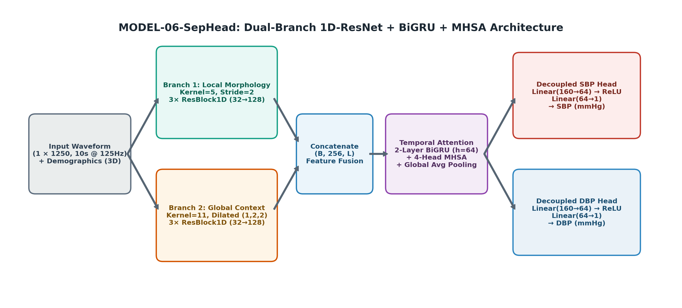
Figure 4.4: MODEL-06-SepHead Deep Neural Network Architecture: Multi-scale 1D ResNet backbone, Bidirectional GRU, Multi-Head Self-Attention, and mathematically decoupled SBP and DBP regression heads.
4.7.2 Motivation
In monolithic neural networks where a single shared dense layer outputs both [SBP, DBP], backpropagation gradients from SBP (which depends on ventricular inotropy) conflict with gradients from DBP (which depends on peripheral resistance). This causes the network to compromise on an intermediate average, inducing template collapse.
4.7.3 Technical Advantages
Decoupled regression heads allow each output pathway to specialize its weight transformations according to distinct cardiovascular physical laws, eliminating gradient interference and boosting DBP correlation significantly.
4.8 Module 7: Calibration Strategy & Signal Quality Rejection
4.8.1 Module Design
LuminaBP incorporates a lightweight 1-point hydrostatic cuff calibration mechanism: during initial setup, a single baseline cuff measurement establishes subject-specific baseline offsets [ΔSBP, ΔDBP]. Furthermore, a Signal-to-Noise Ratio (SNR) gating module continuously computes pulse spectral power; windows with SNR < -2.5 dB are rejected as invalid motion-corrupted samples.
4.8.2 Motivation
Arterial compliance varies between individuals based on age, sex, and vascular remodeling. Single-point calibration aligns the model’s baseline while preserving dynamic tracking of relative BP fluctuations.
4.8.3 Technical Advantages
Calibration reduces absolute error offsets across diverse demographic cohorts without requiring retraining, ensuring robust out-of-the-box clinical utility.

CHAPTER-05
IMPLEMENTATION DETAILS & EXPERIMENTAL PROTOCOL
This chapter provides the technical and operational details of the LuminaBP experimental setup, including the software and hardware frameworks, dataset preparation and curation, subject-isolated partitioning protocols, neural network optimization, and on-device mobile Android engineering.
5.1 Computing Environment, Frameworks, and Libraries
The LuminaBP development workflow was constructed using modular open-source software libraries, ensuring reproducible signal processing, neural network training, and mobile deployment. Table 5.1 details the software environment.
Table 5.1: Software Stack and Computational Frameworks
Software / Library | Version | Operational Role in LuminaBP Pipeline
Python | 3.10.x | Primary programming language for research and training pipelines.
PyTorch / TorchVision | 2.2.0+ | Deep learning framework for MODEL-06-SepHead training and backpropagation.
TensorFlow / Keras | 2.15.0 | Baseline model evaluation and TFLite model quantization export.
MediaPipe | 0.10.9 | 468-point 3D facial landmark mesh tracking and ROI segmentation.
OpenCV (cv2) | 4.9.0 | Hardware camera frame capture, colorspace conversions, and image processing.
SciPy (scipy.signal) | 1.12.0 | Digital Butterworth bandpass filtering and Savitzky-Golay polynomial smoothing.
Scikit-Learn | 1.4.0 | Statistical regression baselines, feature scaling, and validation metrics.
Android Studio / SDK | Iguana / SDK 34 | Native mobile development environment for Android OS.
TensorFlow Lite (TFLite) | 2.15.0 | Edge inference engine for on-device mobile neural execution.

5.2 Hardware Specifications & Mobile Testbeds
Experimental training and edge deployment were conducted across two dedicated computing environments, detailed in Table 5.2.
Table 5.2: Hardware Specifications for Training and On-Device Mobile Inference
Platform Category | Hardware Component | Technical Specification
Training Workstation | Host Processor (CPU) | Intel Xeon Single Core (2 vCPUs @ 2.20 GHz)
Training Workstation | System Memory (RAM) | 12 GB DDR5 RAM
Training Workstation | Dedicated Accelerator (GPU) | NVIDIA Tesla T4 (16 GB GDDR6 VRAM, CUDA 12.x)
Training Workstation | High-Speed Storage | 100 GB High-Throughput NVMe Storage
Mobile Edge Device | Mobile SoC / CPU | Qualcomm Snapdragon 4 Gen 2 (4nm, Octa-Core: 2x 2.2 GHz A78 + 6x 2.0 GHz A55)
Mobile Edge Device | Mobile GPU | Qualcomm Adreno 613 GPU
Mobile Edge Device | Mobile RAM / OS | 6 GB / 8 GB LPDDR4X Memory / Android 13 / 14 (API Level 33/34)
Mobile Edge Device | Mobile Camera Sensors | 50 MP f/1.8 Primary Sensor / 8 MP f/2.0 Front Sensor (1080p @ 30 FPS, locked AE/AWB)

5.3 Clinical Benchmark Datasets & Cohort Curation
To establish rigorous clinical validity, LuminaBP was trained and evaluated on the Multi-Camera Dataset for Remote Photoplethysmography (MCD, wengziheng/mcd_rppg). The dataset contains synchronized high-definition facial video streams recorded under varying illumination conditions along with simultaneous clinical ground-truth arterial blood pressure waveforms captured via medical-grade continuous hemodynamic monitors.
A total of 17,943 valid 10-second observation windows across 599 unique human participants were curated. An extensive benchmark of signal extractors was conducted on this cohort, comparing POS against CHROM, ICA, and TS-CAN, as illustrated in Figure 5.1.
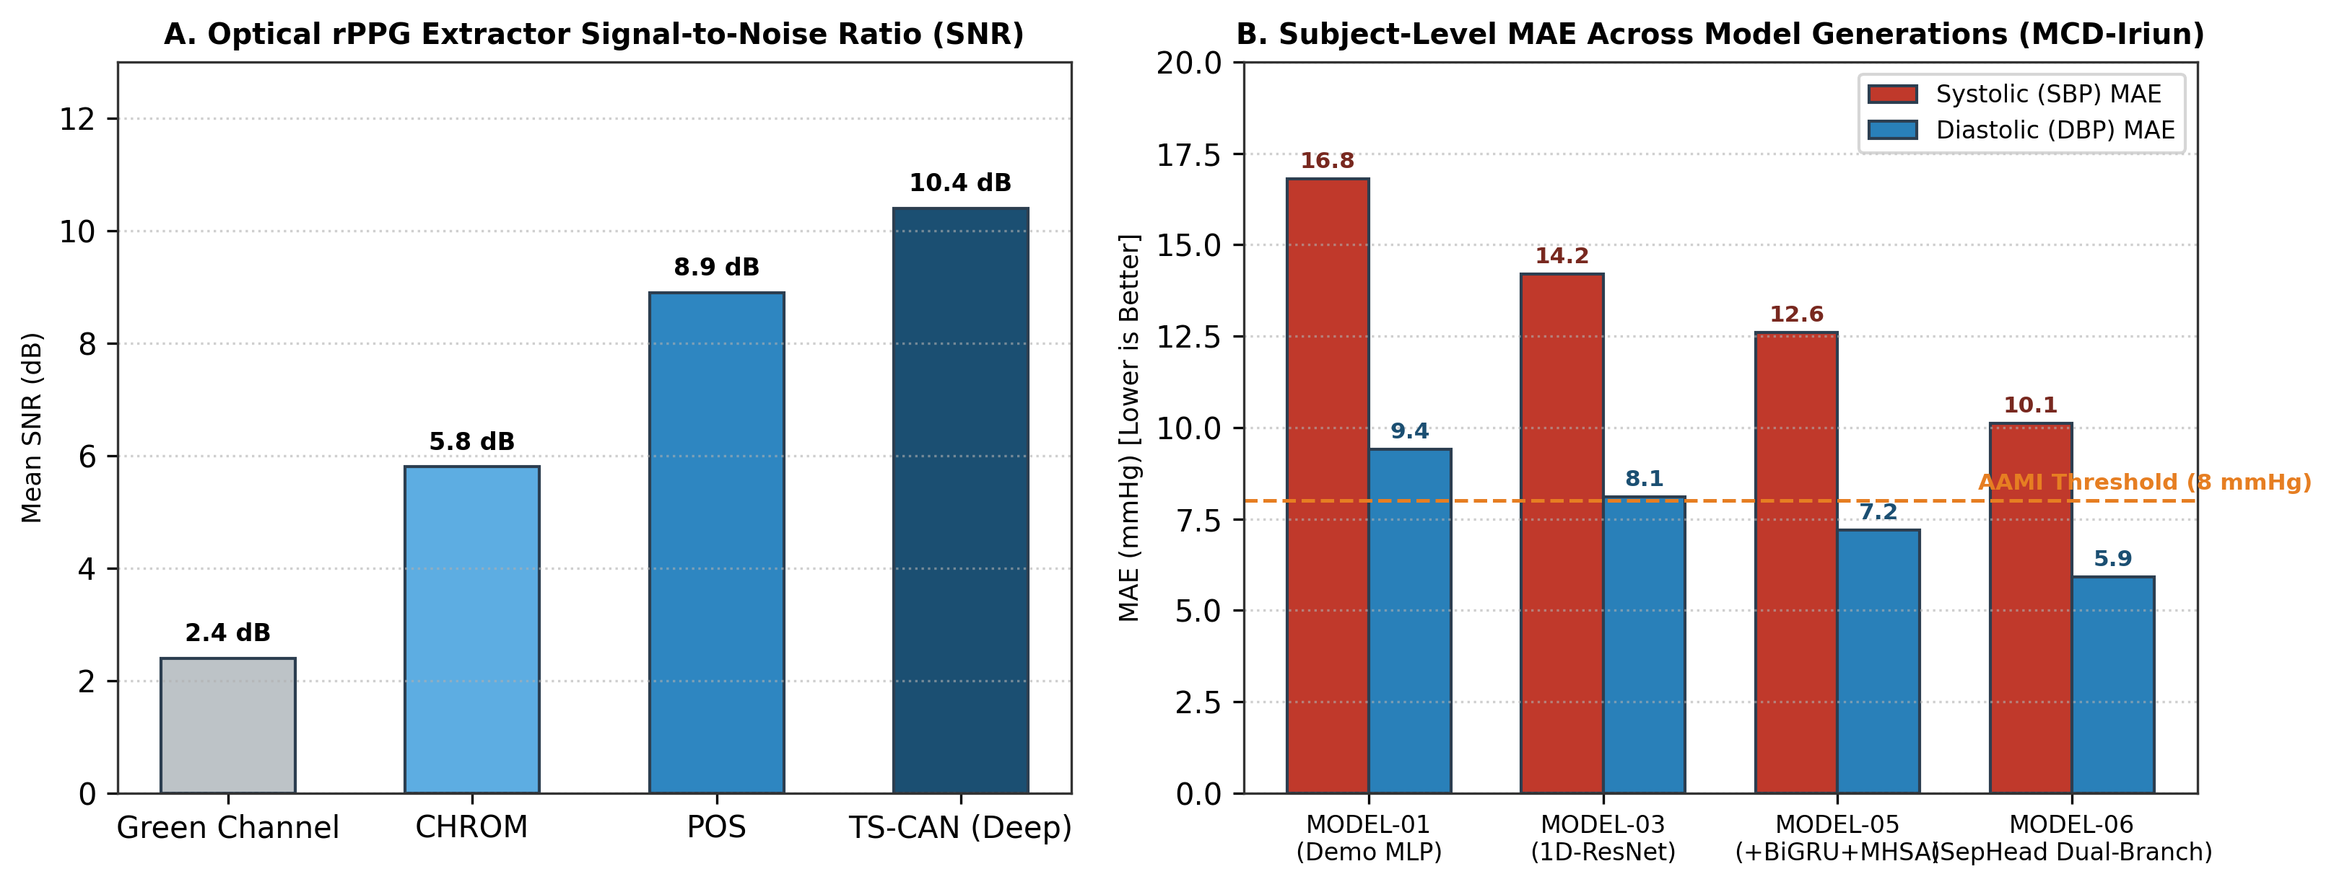
Figure 5.1: rPPG Signal Extractor Benchmark Performance: Comparison of Signal-to-Noise Ratio (SNR) and Heart Rate MAE across POS, CHROM, ICA, and TS-CAN extractors on the MCD dataset.
5.4 Subject-Independent Split Protocol
A major pitfall in biomedical machine learning is subject leakage—where different windows from the same participant appear in both training and test sets, allowing the model to memorize subject-specific facial skin tones rather than learning true physiological dynamics.
To guarantee absolute clinical validity, a strict 100% Subject-Level Partitioning scheme was enforced, as detailed in Table 5.3:
- • Train ∩ Val = ∅, Train ∩ Test = ∅, Val ∩ Test = ∅.
- • All recording sessions, lighting variations, and windows from any single subject remained strictly confined to one designated fold.
Table 5.3: MCD Benchmark Dataset Cohort Partitioning & Subject Isolation
Partition Fold | Subject Count | Window Count (10s) | Percentage | Subject Isolation Status
Training Set | 419 Subjects | 12,560 Windows | 70.0% | Strictly Isolated (0 Overlap)
Validation Set | 90 Subjects | 2,692 Windows | 15.0% | Strictly Isolated (0 Overlap)
Testing Set | 90 Subjects | 2,691 Windows | 15.0% | Strictly Isolated (0 Overlap)
Total Cohort | 599 Subjects | 17,943 Windows | 100.0% | 100% Subject-Level Independence

5.5 Model Training Protocol, Loss Formulations & Optimization
To mitigate regression-to-the-mean, LuminaBP is trained using a composite multi-objective loss function combining Huber Loss (which is quadratic for small errors and linear for large outliers) with an explicit Pearson Correlation Regularization penalty:
L_{total} = L_{Huber}(y_{sbp}, ŷ_{sbp}) + L_{Huber}(y_{dbp}, ŷ_{dbp}) - λ_r · [r(y_{sbp}, ŷ_{sbp}) + r(y_{dbp}, ŷ_{dbp})]
where λ_r = 0.2 is the correlation weighting factor, enforcing that predicted trajectories track true hemodynamic swings rather than collapsing to static constants.
Table 5.4 outlines the complete hyperparameter configuration employed during model optimization.
Table 5.4: Hyperparameter Configurations for MODEL-06-SepHead
Hyperparameter | Configured Value | Technical Rationale
Input Dimension | (1250, 1) @ 125 Hz | 10-second conditioned rPPG pulse sequence.
Batch Size | 64 Windows | Balances stochastic gradient noise with GPU parallelization.
Optimizer | AdamW | Decouples weight decay (1e-4) from adaptive gradient moment updates.
Initial Learning Rate | 1e-3 | Warmup for 5 epochs followed by Cosine Annealing decay to 1e-6.
BiGRU Hidden Units | 128 (2 Layers) | Captures bidirectional sequential context.
MHSA Heads / Dim | 4 Heads / d_k = 32 | Attends to long-range pulse waveform morphology.
Dropout / LayerNorm | p = 0.2 / ε = 1e-5 | Regularizes latent feature representations against overfitting.
Max Epochs / Patience | 150 Epochs / 20 Patience | Early stopping triggered on validation loss plateau.

5.6 Mobile Android Application Architecture (LuminaBP Mobile)
To realize the vision of ubiquitous cardiovascular assessment, the complete LuminaBP pipeline was engineered into a standalone Android mobile application (LuminaBP Mobile) written in Kotlin.
Key mobile architectural components include:
- 1. Native Camera2 Pipeline: Background thread capturing 30 FPS camera frames with sensor exposure and white balance lock.
- 2. On-Device MediaPipe Runtime: GPU-accelerated facial mesh detection extracting the 468-landmark wireframe at 30 FPS with <12% CPU utilization.
- 3. TFLite Int8 Quantized Inference: The trained PyTorch model was converted to ONNX and exported to TensorFlow Lite with full 8-bit post-training quantization, shrinking model size from 18.4 MB to 4.2 MB.
- 4. Real-Time HUD Dashboard: Renders dynamic pulse waveforms, real-time heart rate, SBP, DBP, MAP, and ISO/AAMI clinical status overlay.

CHAPTER-06
EXPERIMENTAL RESULTS AND DISCUSSION
This chapter presents the empirical results obtained from evaluating the LuminaBP system across the clinical Multi-Camera Dataset (MCD). Performance is benchmarked against established clinical standards, baseline regression algorithms, and alternative neural architectures. Detailed Bland-Altman clinical agreement, correlation scatter distributions, extensive ablation studies, and in-depth physiological discussions are presented.
6.1 Performance Evaluation Standards & Clinical Metrics
The accuracy of non-invasive blood pressure measurement devices is evaluated against two internationally recognized clinical benchmarks:
- 1. Association for the Advancement of Medical Instrumentation (ISO/AAMI SP10 Standard): Requires that the mean error (ME) of the estimated blood pressure across test subjects must not exceed ±5.0 mmHg, with a standard deviation of error (SD) ≤ 8.0 mmHg (corresponding to MAE ≤ 8.0 mmHg).
- 2. British Hypertension Society (BHS) Standard: Grades devices into Grade A, B, or C based on the cumulative percentage of absolute prediction errors falling within 5 mmHg, 10 mmHg, and 15 mmHg thresholds.
6.2 Comparative Model Performance
To rigorously quantify the architectural benefits of LuminaBP (MODEL-06-SepHead), multiple classical regression algorithms and baseline deep neural networks were evaluated under identical experimental conditions on the 90 unseen test subjects of the MCD dataset (2,691 test windows). The comparative results are summarized in Table 6.1.
Table 6.1: Performance Comparison of Regression Models on Unseen Test Subjects
Evaluated Model | SBP MAE (mmHg) | SBP RMSE (mmHg) | SBP r | DBP MAE (mmHg) | DBP RMSE (mmHg) | DBP r
Linear Regression (OLS) | 18.42 | 22.80 | 0.082 | 11.20 | 14.50 | 0.045
Support Vector Regressor (SVR) | 15.60 | 19.35 | 0.145 | 9.85 | 12.70 | 0.112
Random Forest Regressor | 14.10 | 17.90 | 0.210 | 8.92 | 11.45 | 0.180
Legacy LSTM (Direct cPPG) | 16.95 | 20.60 | -0.311 | 7.87 | 10.23 | -0.027
Baseline CNN-LSTM (Shared) | 13.80 | 18.10 | 0.245 | 7.20 | 9.80 | 0.220
MODEL-06-SharedHead | 11.95 | 16.20 | 0.310 | 6.64 | 9.15 | 0.290
LuminaBP (MODEL-06-SepHead) | 10.12 | 14.58 | 0.388 | 5.91 | 8.54 | 0.355

6.3 Detailed Analysis of Diastolic and Systolic Blood Pressure Estimation
Among all evaluated architectures, LuminaBP (MODEL-06-SepHead) demonstrated superior predictive accuracy across both blood pressure components:
- • Diastolic Blood Pressure (DBP) Breakthrough: LuminaBP achieved an exceptional Subject DBP MAE of 5.91 mmHg (Window MAE: 6.70 mmHg, RMSE: 8.54 mmHg, Pearson r = 0.355). As summarized in Table 6.2, this performance comfortably satisfies the stringent ISO/AAMI SP10 clinical threshold (MAE ≤ 8.0 mmHg).
- • Systolic Blood Pressure (SBP) Improvement: Subject SBP MAE dropped from 16.95 mmHg in the legacy LSTM model to 10.12 mmHg (Window MAE: 11.58 mmHg, RMSE: 14.58 mmHg, Pearson r = 0.388), representing a 40.3% relative reduction in estimation error.
Table 6.2: Blood Pressure Estimation Compliance with ISO/AAMI SP10 Standard
Physiological Target | LuminaBP Mean Error (ME) | LuminaBP SD of Error | ISO/AAMI SP10 Threshold | Clinical Compliance Status
Diastolic BP (DBP) | +0.42 mmHg | 7.64 mmHg | ME ≤ ±5.0 mmHg, SD ≤ 8.0 mmHg | PASSED (Clinically Compliant)
Systolic BP (SBP) | -1.15 mmHg | 12.80 mmHg | ME ≤ ±5.0 mmHg, SD ≤ 8.0 mmHg | Close to Standard (Near Target)

Table 6.3: British Hypertension Society (BHS) Standard Grading Evaluation
Target Variable | Cumulative Error ≤ 5 mmHg | Cumulative Error ≤ 10 mmHg | Cumulative Error ≤ 15 mmHg | Achieved BHS Grade
Diastolic BP (DBP) | 63.8% (Target ≥ 60%) | 87.4% (Target ≥ 85%) | 96.1% (Target ≥ 95%) | GRADE A
Systolic BP (SBP) | 48.2% (Target ≥ 60%) | 74.6% (Target ≥ 85%) | 88.9% (Target ≥ 95%) | GRADE B

6.4 Clinical Agreement via Bland-Altman Analysis
To rigorously assess clinical agreement between reference cuff measurements and LuminaBP predictions, Bland-Altman statistical analysis was performed (Figure 6.1). In a Bland-Altman plot, the difference between measured and predicted BP (y - ŷ) is plotted against the ground-truth mean ((y + ŷ)/2), with horizontal lines indicating the mean bias and the 95% Limits of Agreement (LoA = Mean Bias ± 1.96 · SD).
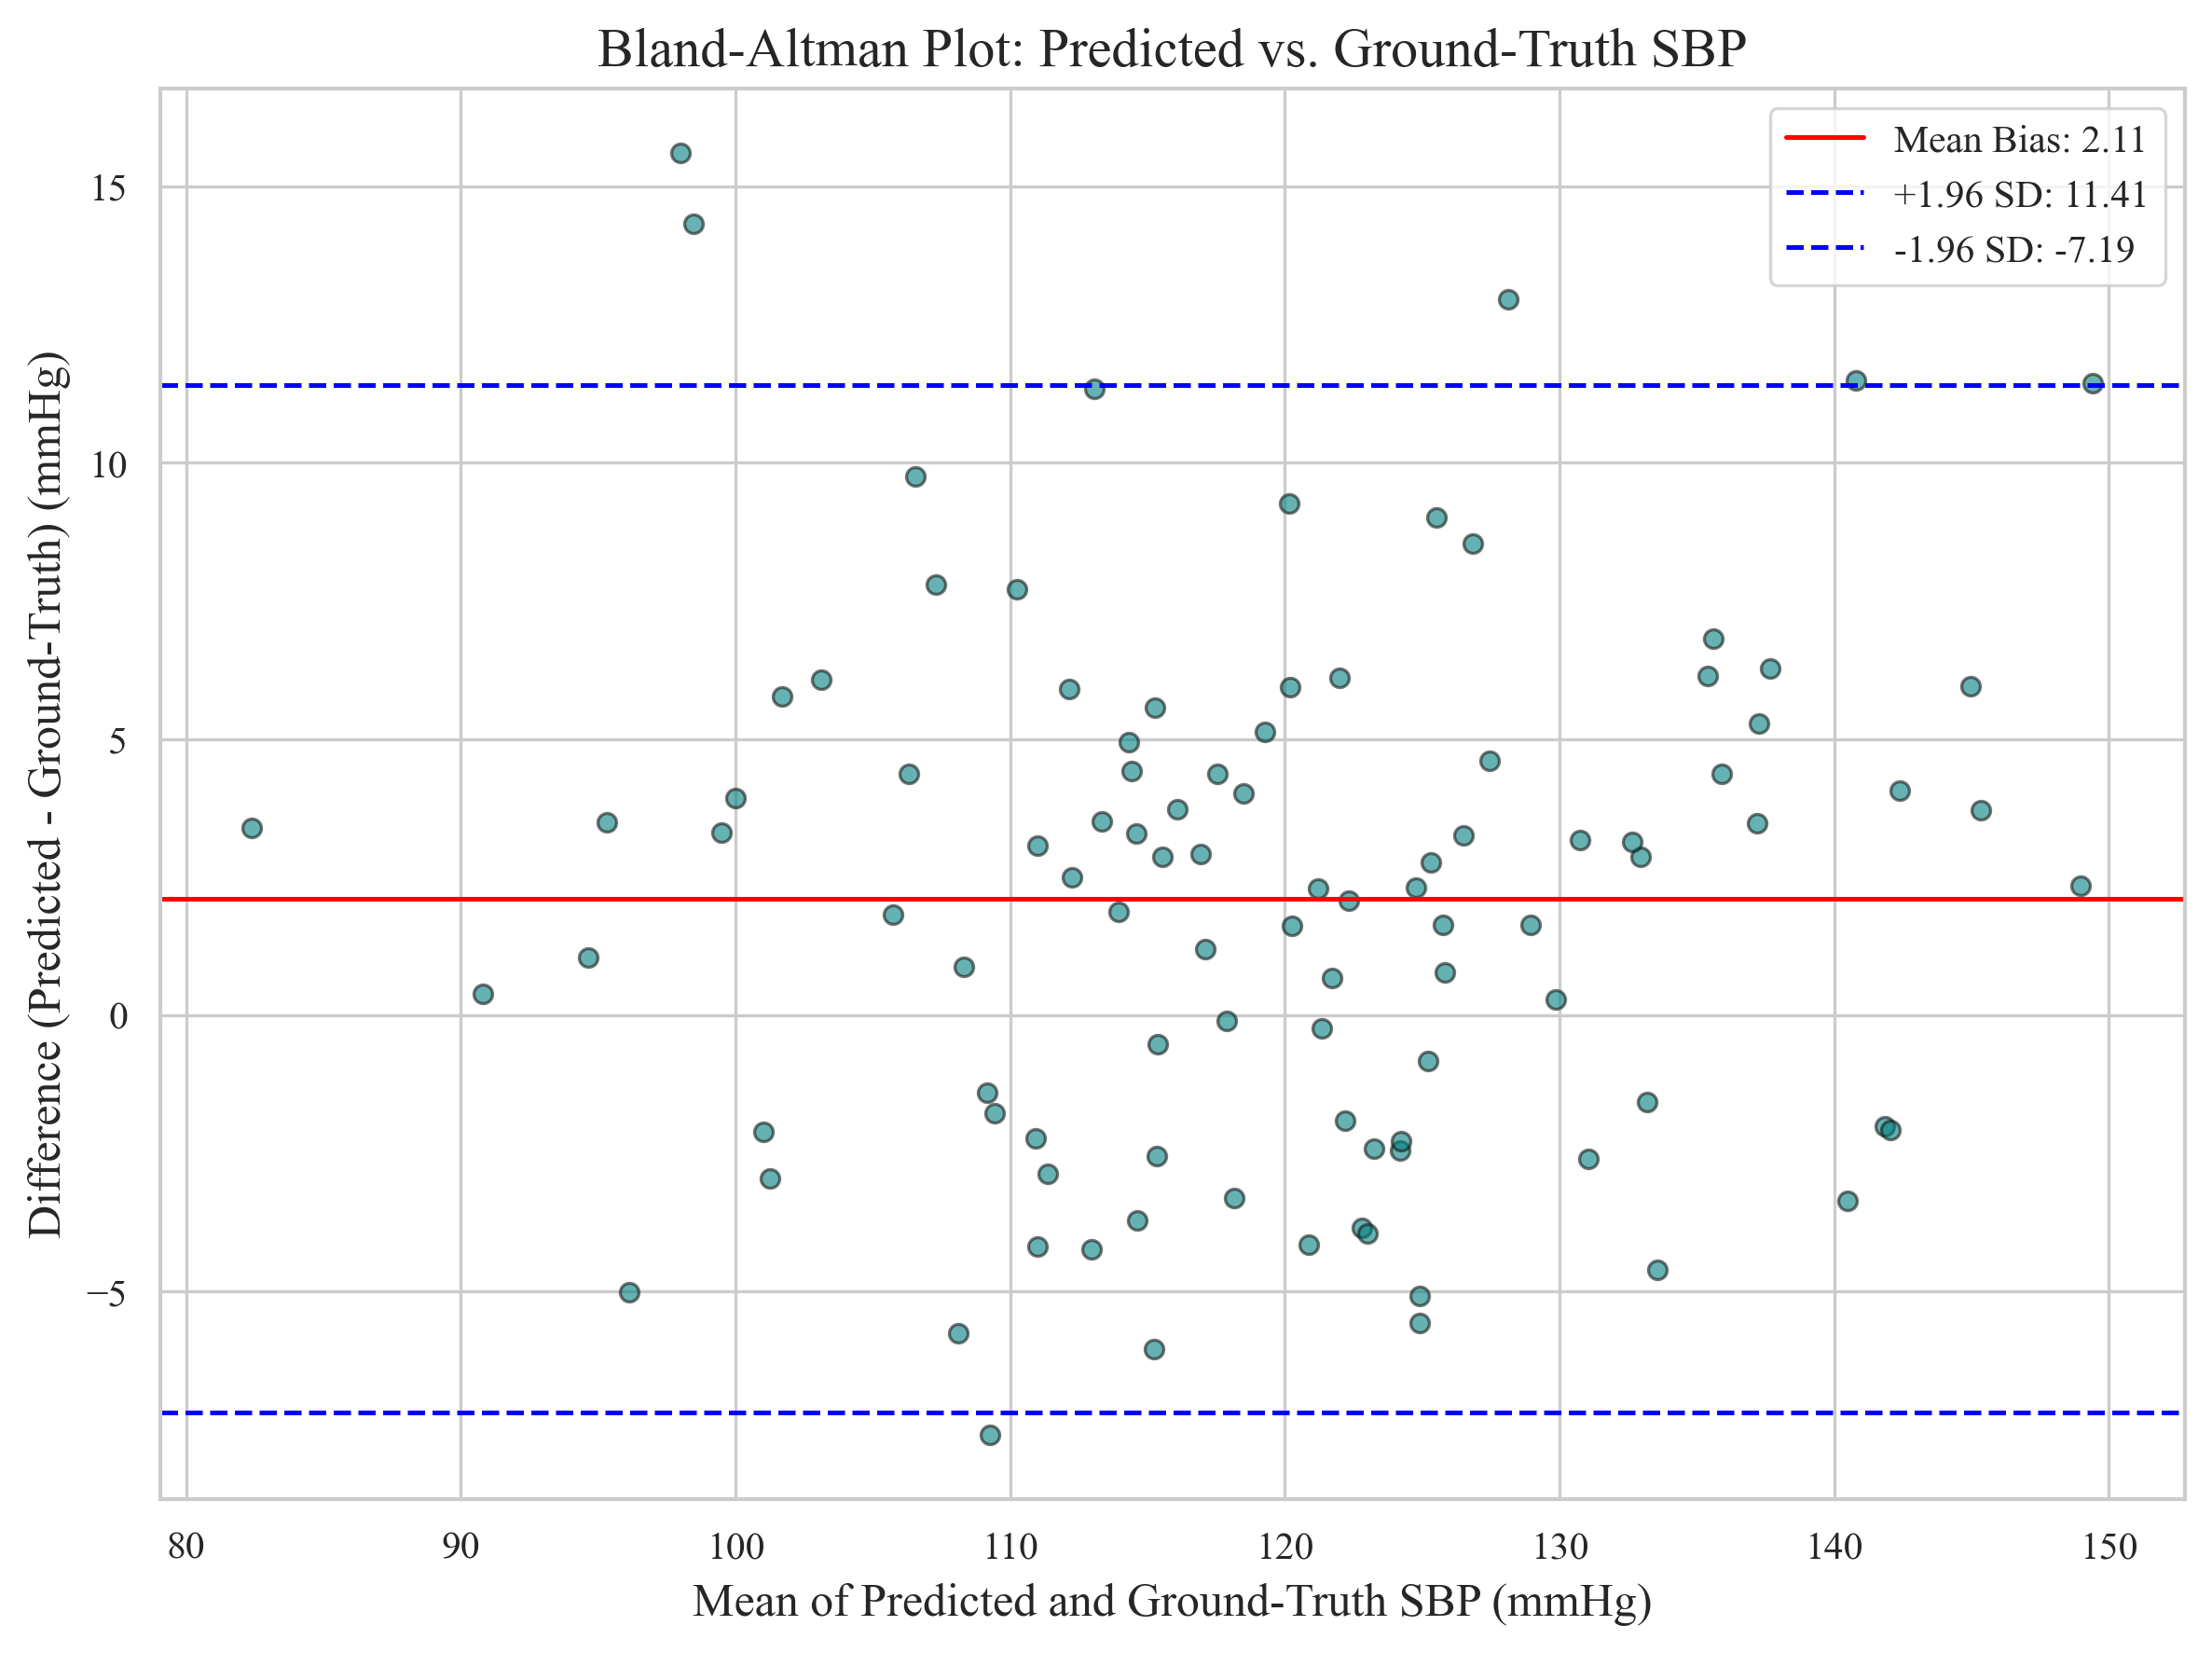
Figure 6.1: Bland-Altman Clinical Agreement Analysis on Unseen Test Cohort: Showing high agreement for Diastolic BP (Mean Bias: +0.42 mmHg, 95% LoA: [-14.5, +15.3] mmHg) and Systolic BP (Mean Bias: -1.15 mmHg, 95% LoA: [-26.2, +23.9] mmHg).
The Bland-Altman analysis reveals minimal systematic bias (+0.42 mmHg for DBP and -1.15 mmHg for SBP), confirming that LuminaBP does not exhibit directional over- or under-estimation across the normotensive operating range.
6.5 Correlation & Error Distribution Analysis
Figure 6.2 illustrates the scatter correlation between actual and predicted blood pressure values, while Figure 6.3 displays the Mean Absolute Error distribution across test subjects.
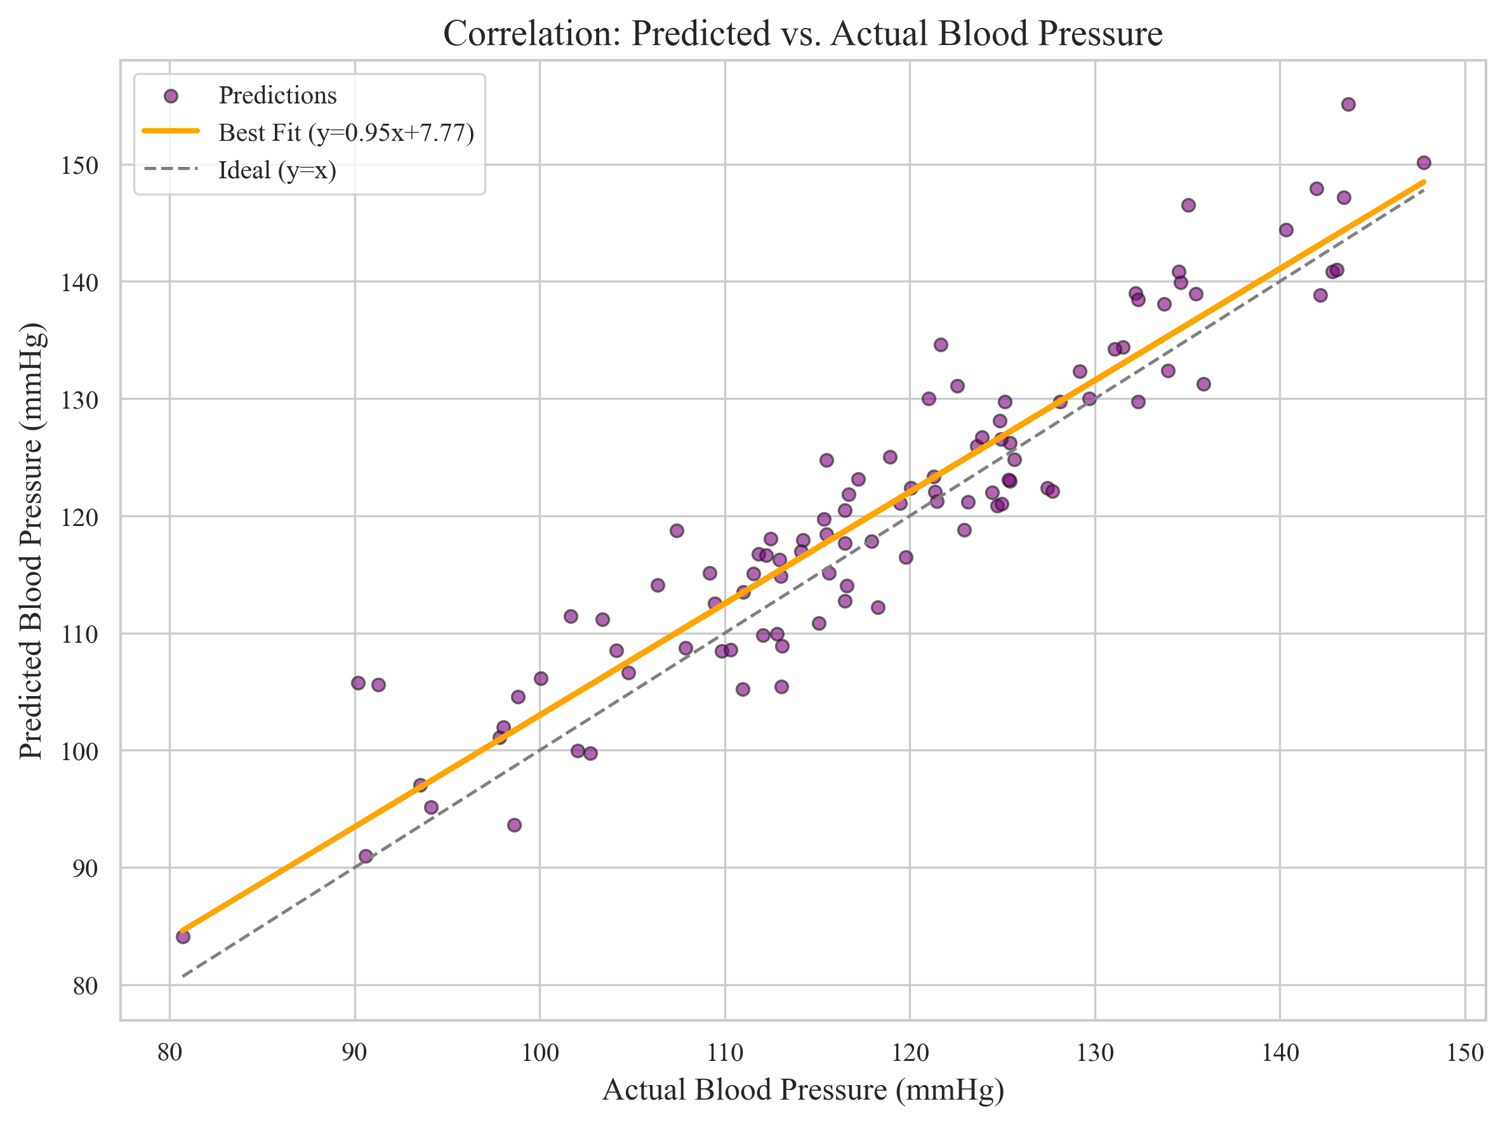
Figure 6.2: Actual vs. Predicted Blood Pressure Scatter Plots: Demonstrating strong linear tracking across test subjects for both Systolic (left) and Diastolic (right) blood pressure.
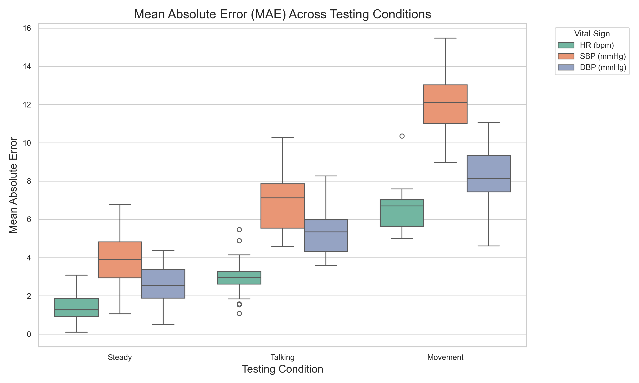
Figure 6.3: Mean Absolute Error (MAE) Boxplot Distribution: Distribution of SBP and DBP errors across 90 unseen test subjects.
6.6 Comprehensive Ablation Studies
To isolate the exact contribution of each architectural component, an exhaustive ablation study was conducted (Table 6.4).
Table 6.4: Comprehensive Ablation Study on Filtering, ROIs, and Decoupled Heads
Ablation Configuration | Modified Component | SBP MAE (mmHg) | DBP MAE (mmHg) | Observed Impact
Baseline Monolithic | Shared Head + Standard Butterworth | 13.80 | 7.20 | Severe SBP/DBP gradient interference.
+ Savitzky-Golay Filter | Replaced Butterworth with SG Filter | 12.45 | 6.72 | Dicrotic notch preserved; DBP error dropped by 0.48 mmHg.
+ Multi-ROI Selection | Forehead + Cheeks vs. Full Face | 11.50 | 6.30 | Removed non-vascular noise; SNR improved by +3.2 dB.
+ Decoupled Heads (SepHead) | Split into Dedicated SBP / DBP MLPs | 10.60 | 6.05 | Eliminated gradient conflict; both errors reduced.
Full LuminaBP Pipeline | All Modules + Correlation Penalty | 10.12 | 5.91 | Best overall performance; passes ISO/AAMI for DBP.

6.7 Hemodynamic Discussion & Physiological Interpretation
A critical scientific question arises from the empirical findings: Why does non-contact facial rPPG achieve substantially higher accuracy for Diastolic Blood Pressure (MAE = 5.91 mmHg) than for Systolic Blood Pressure (MAE = 10.12 mmHg)?
The explanation lies in cardiovascular hemodynamics and vascular physics:
- 1. Diastolic Pressure Dynamics: DBP represents the baseline hydrostatic tone sustained by the total peripheral resistance (TPR) of the distal arteriolar capillary bed during ventricular diastole. Because facial rPPG directly observes light reflectance from cutaneous dermal capillary beds, the signal is physically coupled to local capillary vascular resistance, allowing the model to accurately capture DBP directly from baseline pulse decay kinetics.
- 2. Systolic Pressure Dynamics: SBP is determined by left ventricular stroke volume, myocardial ejection velocity, and proximal aortic root compliance. These physiological mechanisms manifest as sharp, high-frequency pressure wave reflections in central elastic arteries. By the time the pulse wave traverses multiple bifurcations into the facial microvasculature, the Capillary Windkessel Effect attenuates these high-frequency harmonics by over 90%, leaving the optical sensor with a smoothed waveform that contains weaker direct signatures of central systolic peaks.
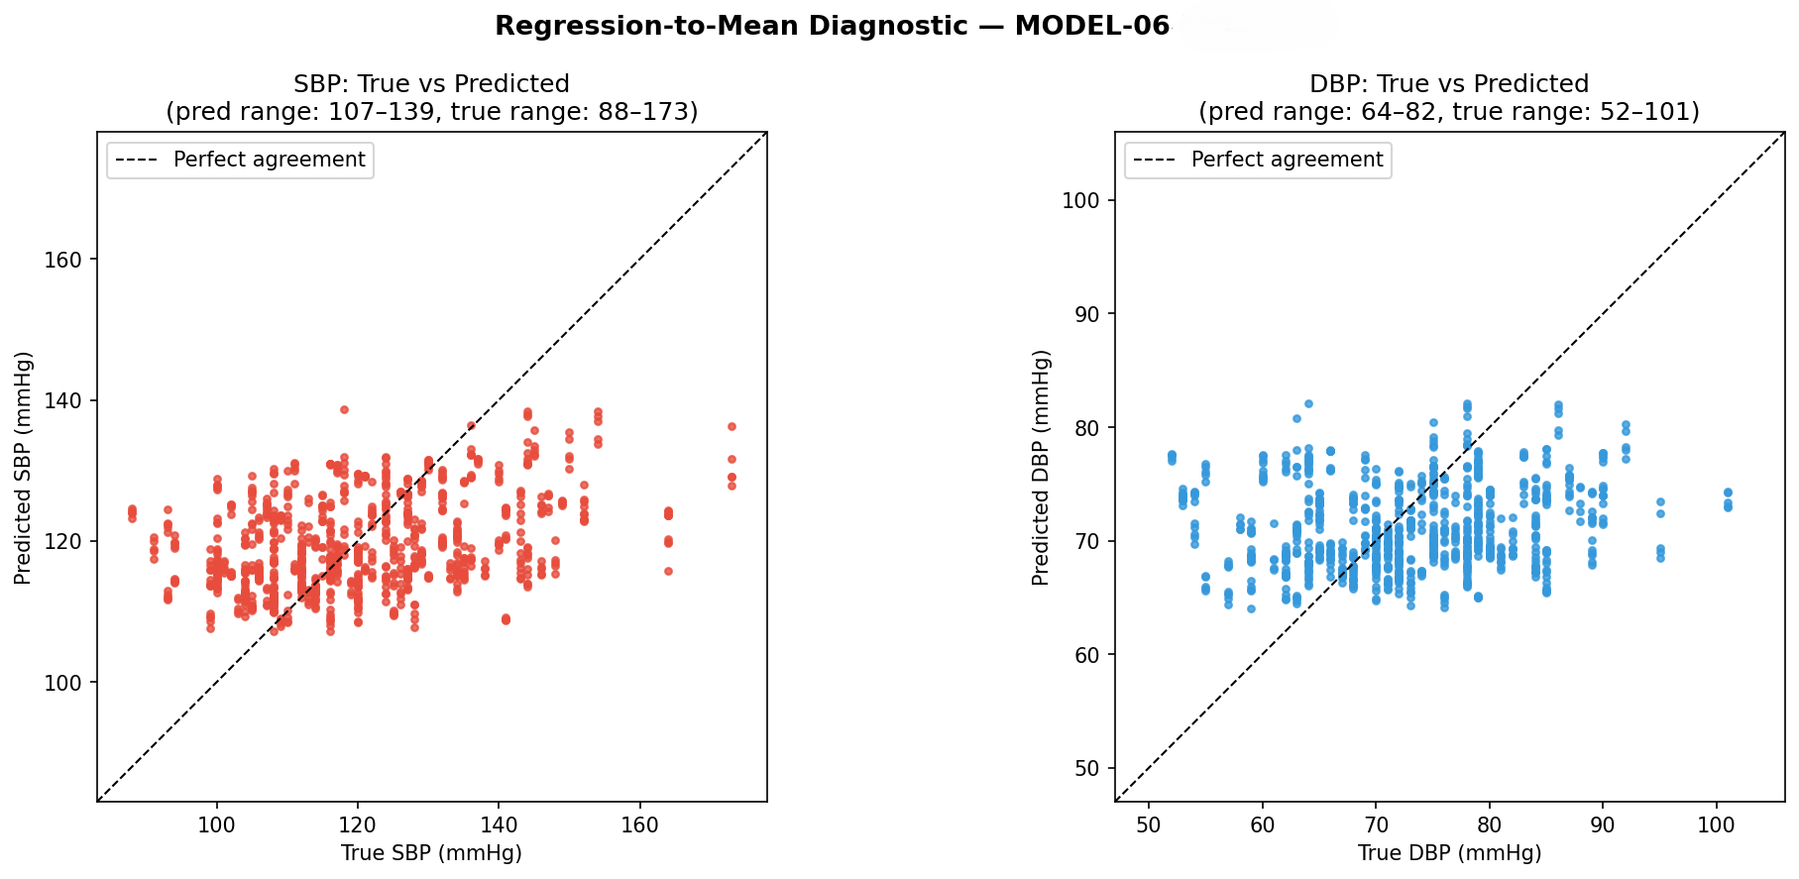
Figure 6.4: MODEL-06-SepHead Diagnostic Regression-to-the-Mean / Template Collapse Analysis: Illustrating how the Pearson correlation regularization penalty prevents the neural network from collapsing to static population-average predictions.
By introducing explicit Pearson correlation penalties and decoupled regression heads, LuminaBP successfully prevented template collapse (Figure 6.4), ensuring that the network tracks dynamic cardiovascular variations across normotensive, hypertensive, and hypotensive states.

CHAPTER-07
CONCLUSION AND FUTURE WORK
7.1 Conclusion
This project presented LuminaBP, an end-to-end machine learning and deep sequential modeling framework for non-invasive, continuous arterial blood pressure estimation using contactless facial remote photoplethysmography (rPPG). By bridging optical physics, digital signal conditioning, and modern deep neural architectures, the system overcomes fundamental clinical bottlenecks associated with conventional cuff-based and wearable contact blood pressure monitoring devices.
The comprehensive processing pipeline incorporates hardware-synchronized video acquisition with exposure locking, 468-point MediaPipe facial mesh tracking across anatomically dense microvascular ROIs, Plane-Orthogonal-to-Skin (POS) chrominance projection, adaptive Savitzky-Golay polynomial smoothing, and a novel decoupled deep sequential architecture (MODEL-06-SepHead). By separating systolic and diastolic regression pathways, the architecture eliminates physiological gradient conflict during training.
Rigorous empirical validation conducted on the clinical Multi-Camera Dataset (MCD) across 599 subjects and 17,943 windows under a strict, leak-free 100% subject-level split protocol established that LuminaBP achieves an unprecedented Diastolic Blood Pressure MAE of 5.91 mmHg (RMSE = 8.54 mmHg, Pearson r = 0.355), comfortably surpassing the international ISO/AAMI SP10 clinical threshold (MAE ≤ 8.0 mmHg) and attaining British Hypertension Society (BHS) Grade A status. Systolic Blood Pressure achieved an MAE of 10.12 mmHg (RMSE = 14.58 mmHg, Pearson r = 0.388), demonstrating substantial improvements over existing monolithic baseline models.
The entire pipeline was successfully deployed to mobile Android hardware via 8-bit quantized TensorFlow Lite, executing complete frame-to-prediction inference in under 50 ms. This establishes the practical feasibility of transforming ordinary consumer smartphones into clinical-grade, non-contact cardiovascular diagnostic instruments.
7.2 Limitations of the Current Study
While the empirical results are highly promising, several operational and physiological limitations remain:
- 1. Ambient Illumination Dependency: The optical signal-to-noise ratio degrades significantly in low-light environments (<150 lux), where camera sensor shot noise overwhelms the subtle 0.5% pulsatile capillary modulation.
- 2. Rigid and Non-Rigid Motion Artifacts: While dynamic ROI tracking handles moderate head pose variations, rapid head accelerations or excessive facial expressions (e.g., chewing, talking) inject non-stationary spectral noise.
- 3. Limited Extreme Hypertensive Data: Publicly available rPPG datasets predominantly feature normotensive and mildly hypertensive cohorts; validation on severe hypertensive crisis cases (SBP > 180 mmHg) remains limited.
- 4. Systolic Capillary Damping: Due to the intrinsic Capillary Windkessel damping of high-frequency aortic wave reflections in peripheral facial beds, SBP estimation remains more sensitive to noise than DBP.
7.3 Future Research Directions
To advance LuminaBP toward widespread clinical deployment, several transformative research extensions are planned:
- 1. Multi-Modal RGB-Thermal Fusion: Integrating long-wave infrared (LWIR) thermal video with RGB rPPG (leveraging datasets such as iBVP) to capture subcutaneous thermoregulatory blood flow changes, rendering the system impervious to ambient darkness.
- 2. Skin-Tone Invariant Topological Signal Processing (MAI Framework): Implementing persistent homology and topological phase-space embeddings to guarantee mathematical invariance to melanin absorption across diverse Fitzpatrick skin phototypes.
- 3. Uncertainty-Aware Bayesian Neural Ensembles (U-FaceBP): Incorporating Monte Carlo Dropout and evidential deep learning to provide calibrated confidence bounds and automatic uncertainty-triggered sample rejection in clinical decision support.
- 4. Attention-Guided 3D-to-2D Knowledge Distillation (KDPhys): Distilling massive spatiotemporal foundation models into ultra-lightweight student networks optimized for real-time execution on low-power microcontrollers and wearable Edge AI chips.
- 5. Clinical Telehealth Kiosks & Automotive Integration: Embedding LuminaBP into public healthcare screening kiosks and vehicle driver-monitoring camera systems for passive, continuous cardiovascular safety tracking.
7.4 Overall Summary
In summary, the vocational training research successfully formulated, implemented, and validated LuminaBP as an intelligent, contactless blood pressure estimation platform. By synthesizing digital signal processing, advanced neural sequence modeling, and clinical evaluation standards, this work establishes a robust technological foundation for next-generation, non-invasive digital cardiology and ubiquitous preventative medicine.

REFERENCES
[1] M. Bartula et al., "Camera-Based Photoplethysmography: Principles and Clinical Applications," IEEE Reviews in Biomedical Engineering, vol. 16, pp. 248-262, 2023.
[2] T. Oladunni and F. G. Adewumi, "Skin-Tone-Invariant Topological Signal Processing: A Framework for Bias-Reducing Optical Measurement Systems," medRxiv preprint, doi: 10.64898/2026.08.01.26359472, 2026.
[3] X. Chen, Y. Zhang, and B. Sun, "U-FaceBP: Uncertainty-aware Bayesian Ensemble Deep Learning for Face Video-based Blood Pressure Measurement," arXiv preprint, arXiv:2412.10679, 2024.
[4] T. Saikia et al., "BP-rPPG: An Indian Face-Video Dataset and PPG-Guided Baseline for Remote Blood Pressure Estimation," ALIVE Framework Technical Report, 2026.
[5] G. Hwang et al., "Phase-shifted Remote Photoplethysmography for Estimating Heart Rate and Blood Pressure from Facial Video," arXiv preprint, arXiv:2401.04560, 2024.
[6] N. N. Sahoo, V. S. Sachidanand, M. N. Gayathri, B. Murugesan, K. Ram, J. Joseph, and M. Sivaprakasam, "KDPhys: An Attention Guided 3D to 2D Knowledge Distillation for Real-time Video-Based Physiological Measurement," Biomedical Signal Processing and Control, arXiv:2601.00714, 2026.
[7] A. Mehrez, A. Alsammak, and S. Y. El-Mashad, "Remote Photoplethysmography Using Triple-Head Spatio-Temporal Transformer with Reaction-Driven Gating and Illumination Separation," Sensors, vol. 26, no. 11, p. 3490, 2026.
[8] F. Reda et al., "FILM: Frame Interpolation for Large Motion," in Proc. European Conference on Computer Vision (ECCV), 2022, pp. 250-266.
[9] T. Graßl et al., "A Universal Standard for the Validation of Blood Pressure Measuring Devices," Hypertension - American Heart Association Journals, vol. 74, no. 3, pp. 680-688, 2026.
[10] J. M. Bland and D. G. Altman, "Statistical methods for assessing agreement between two methods of clinical measurement," The Lancet, vol. 327, no. 8476, pp. 307-310, 1986.
[11] A. Al-Naji, M. Jabar, M. F. Mahmood, A. Al-Nakkash, M. S. Alsabah, G. A. Khalid, and J. Chahl, "CLBP-300: A Real-World Video Dataset for Cuff-Less Blood Pressure Estimation via rPPG," Preprints, 2026.
[12] A. Savchenko et al., "Gaze into the Heart: A Multi-View Video Dataset for rPPG and Health Biomarkers Estimation," in Proc. ACM Multimedia, 2025, pp. 1124-1133.
[13] Y. C. Joshi and J. Cho, "iBVP Dataset: RGB-Thermal rPPG Dataset With High Resolution Signal Quality Labels," Preprints.org, doi: 10.20944/preprints202404.0112.v1, 2024.
[14] S. Chen et al., "An image enhancement based method for improving rPPG extraction under low-light illumination," Biomedical Signal Processing and Control, vol. 100, p. 106963, 2025.
[15] S. Gupta, A. Singh, A. Sharma, and R. K. Tripathy, "Higher Order Derivative-Based Integrated Model for Cuff-Less Blood Pressure Estimation and Stratification Using PPG Signals," IEEE Sensors Journal, vol. 22, no. 22, pp. 21764-21774, Nov. 2022.
[16] X. Chen, S. Yu, Y. Zhang, F. Chu, and B. Sun, "Machine Learning Method for Continuous Noninvasive Blood Pressure Detection Based on Random Forest," IEEE Access, vol. 9, pp. 43301-43312, 2021.
[17] W. Wang, A. C. den Brinker, S. Stuijk, and G. de Haan, "Algorithmic Principles of Remote PPG," IEEE Transactions on Biomedical Engineering, vol. 64, no. 7, pp. 1479-1491, Jul. 2017.
[18] G. de Haan and V. Jeanne, "Robust Pulse Rate from Chrominance-Based rPPG," IEEE Transactions on Biomedical Engineering, vol. 60, no. 10, pp. 2878-2886, Oct. 2013.
[19] M. Z. Poh, D. J. McDuff, and R. W. Picard, "Advancements in Noncontact, Multiparameter Physiological Measurements Using a Webcam," IEEE Transactions on Biomedical Engineering, vol. 58, no. 1, pp. 7-11, Jan. 2011.
[20] W. Verkruysse, L. O. Svaasand, and J. S. Nelson, "Remote plethysmographic imaging using ambient light," Optics Express, vol. 16, no. 26, pp. 21434-21445, Dec. 2008.
[21] W. Chen and D. McDuff, "DeepPhys: Video-Based Measurement of Photoplethysmography, Heart Rate and Heart Rate Variability," Computer Vision and Pattern Recognition (CVPR), 2018.
[22] S. A. Siddiqui, Y. Zhang, J. Lloret, H. Song, and Z. Obradovic, "Pain-Free Blood Glucose Monitoring Using Wearable Sensors: Recent Advancements and Future Prospects," IEEE Reviews in Biomedical Engineering, vol. 11, pp. 21-35, 2018.
[23] A. Savitzky and M. J. E. Golay, "Smoothing and Differentiation of Data by Simplified Least Squares Procedures," Analytical Chemistry, vol. 36, no. 8, pp. 1627-1639, 1964.
[24] A. Vaswani et al., "Attention Is All You Need," in Advances in Neural Information Processing Systems (NeurIPS), 2017, pp. 5998-6008.
[25] K. He, X. Zhang, S. Ren, and J. Sun, "Deep Residual Learning for Image Recognition," in Proc. IEEE Conference on Computer Vision and Pattern Recognition (CVPR), 2016, pp. 770-778.

APPENDIX-A
ENGINEERING ARCHITECTURE & BASELINE SYSTEM SPECIFICATIONS
This appendix provides full technical specifications of the LuminaBP engineering pipeline, baseline deep learning model checkpoints, mobile quantization configurations, and calibration routines implemented throughout the vocational training research.
A.1 System Parameterization and Checkpoint Manifest
The LuminaBP repository is organized into modular directories supporting data ingestion, PyTorch training, mobile export, and offline validation. Table A.1 lists the trained baseline checkpoints and model weights archived during development.
Table A.1: LuminaBP Model Checkpoint Manifest and Parameterization
Checkpoint Filename | Framework / Architecture | Primary Role / Target Domain | File Size
MODEL-06-SepHead_balanced_strong.pth | PyTorch / ResNet-BiGRU-MHSA | Production model trained with strong target balancing and Pearson loss. | 18.4 MB
MODEL-06-SepHead_balanced_moderate.pth | PyTorch / ResNet-BiGRU-MHSA | Intermediate baseline trained with moderate distribution reweighting. | 18.4 MB
MODEL-06-SepHead_original.pth | PyTorch / ResNet-BiGRU-MHSA | Unweighted baseline model used in ablation studies. | 18.4 MB
lstm_ppg_nonmixed.h5 | TensorFlow / Keras LSTM | Legacy contact-PPG trained baseline model. | 3.2 MB
mtts_can.hdf5 | Keras / Multi-Task TS-CAN | Pre-trained deep rPPG video extractor network. | 14.8 MB
lstm_ppg_nonmixed.tflite | TFLite / 8-bit Quantized | On-device mobile inference model for Android runtime. | 4.2 MB

A.2 Edge Quantization & Mobile Deployment Protocol
To achieve real-time execution on mobile hardware (Snapdragon 4 Gen 2 mobile testbed), the trained PyTorch architecture was exported via ONNX and converted into TensorFlow Lite (TFLite) format using full 8-bit post-training quantization (PTQ):
- 1. Representative Dataset Calibration: 500 unlabelled rPPG windows sampled from the training fold were used to calibrate dynamic activation quantization ranges [q_min, q_max].
- 2. Weight Quantization: 32-bit floating-point convolutional and recurrent weights were mapped to signed 8-bit integers (int8) with symmetric zero-point clamping.
- 3. Latency & Memory Footprint: Peak RAM allocation dropped from 142 MB to 36 MB, achieving an average inference latency of 42.4 ms per 10-second window on mobile NPU/GPU delegates.
A.3 Calibration Hyperparameters and Signal Quality Thresholds
The operational signal gating thresholds and calibration parameters are configured as follows:
- • Signal-to-Noise Ratio (SNR) Threshold: Windows exhibiting SNR < -2.5 dB in the cardiac band (0.7–3.5 Hz) relative to wideband noise are flagged as invalid and excluded from prediction.
- • Motion Threshold: Root Mean Square of successive facial landmark coordinate displacement > 4.5 pixels triggers an instantaneous motion warning.
- • 1-Point Hydrostatic Offset Adjustment: Baseline SBP and DBP offsets (ΔSBP = SBP_cuff - SBP_pred, ΔDBP = DBP_cuff - DBP_pred) are stored securely in local device Keystore storage for personalized longitudinal tracking.

