**Code:**

1. **Linear Regression:**

clc

clear all

n = input('Enter number of samples: ');

d = input('Enter d: ');

coeffs = input('Enter Coeffs of Line for generating data: ');

v = input('range in which noise should vary (-a,a): ');

x = 1:d:n*d;

l = polyval(coeffs,x);

y = l -v + (2*v)*rand(1,n);

figure(1);

scatter(x,y,'filled'); hold on;

plot(x,l);

xlabel('x');

ylabel('y');

title('Original Data set');

legend('distributed data','original line');

hold off;

p=polyfit(x,y,1);

fitLine = polyval(p,x);

figure(2);

scatter(x,y,'filled'); hold on;

plot(x,fitLine);

xlabel('x');

ylabel('y');

title('Fitted Line');

legend('Data Set','Fitted Line');

hold off;

figure(3);

plot(x,fitLine);hold on;

plot(x,l);

xlabel('x');

ylabel('y');

title('Comparison of the two lines');

legend('Fitted Line','Original Line');

hold off;

MSE = sum((y-fitLine).^2)/length(y);

disp(['MSE: ',num2str(MSE)]);

**OUTPUTS:**

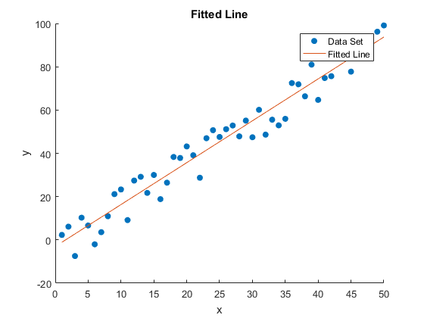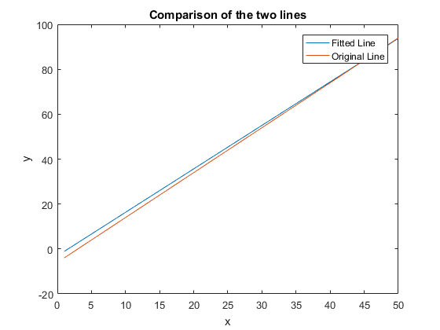

1. **Non-linear Regression:**

clc

clear all

n = input('Enter number of samples: ');

d = input('Enter interval spacing: ');

x = 0:d:(n-1)*d;

y = sin(0.5*x)+0.5*(-1+2*rand(1,n));

figure(1);

scatter(x,y,'filled');hold on;

plot(x,sin(0.5*x));

legend('data set','original function');

hold off;

newMSE = zeros(1,10);

figure(2);

for i=1:1:10

p=polyfit(x,y,i);

newY = polyval(p,x);

newMSE(i) = sum((y - polyval(p,x)).^2)/length(y);

subplot(2,5,i);

scatter(x,y,'filled');hold on;

plot(x,newY);

xlabel('x');

ylabel('y');

title(['Degree: ',num2str(i),', ','MSE: ',num2str(newMSE(i))]);

end

**OUTPUTS:**

