**Comparative analysis of solar radiation forecasting between LSTM and RF model using machine learning**

**Highlights**

* This study is a comparative analysis of the Solar radiation forecasting of a city using LSTM and RF models using the Machine Learning technique.
* The data used in this project will be based on hourly, daily, weekly, and monthly solar radiation data captured using a weather station. The available dataset varied in terms of its composition, as different percentages of the dataset were used as the training set for the models.
* The parameters R^2 and RMSE are calculated and compared for both models to find the best model.

**Abstract**

This paper is a comparative analysis of solar irradiation forecasting between LSTM and RF models using Machine Learning. Both models are employed and studied in this paper. The data used in this proposed work is for hourly, daily, weekly, and monthly solar irradiation data captured by a weather station. The R^2 and RMSE values for both models are computed and a comparative analysis is done. The result obtained using the LSTM (Long short-term memory) model is compared with the one obtained from the RF (Random Forest) model. This would further help in determining the most accurate model.

**Introduction**

The demand for electricity and worldwide energy consumption continues to rise as a result of population expansion and economic development [1,2]. Meanwhile, developing renewable power generating techniques is critical in the face of the rising depletion of fossil resources and demands for carbon emission reductions [2].

The production of solar plants has decreased dramatically due to the unpredictability of the weather. As a result, some predictable tools are necessary to overcome this disadvantage. This aids in maximizing the solar panel's output. By acquiring current and past information regarding irradiance, it is possible to estimate the amount of solar energy produced [2].

Solar power has been steadily improving over the years, with recent innovations allowing it to rival conventional power sources in many respects. PV cells have achieved higher efficiencies, lower costs, and lighter weight, making them a more attractive option for consumers [3]. However, solar power's unpredictability and the need for space-consuming installations have hindered its widespread adoption. Predictions of sunny weather have become increasingly accurate, and the industry is looking to translate those predictions into actionable intelligence [3,4].

PV technology has witnessed developments and improvements in the past decade. Today, rooftop solar power systems are an affordable and practical way to generate electricity for homes and businesses [1].

The LSTM architecture is a recurrent neural network (RNN). It can forecast a large amount of data. It helps in forecasting long-term and as well as short-term data that is days to years. Using the LSTM, the forecasting of time series models for future predictions based on previous values is done. LSTM works by sending an input sequence to a Neural Network with a hidden state, the hidden state containing the sequence's previous knowledge [5].

The information included in the hidden state of an LSTM is controlled by three gates: input, forget, and context gates. These gates enable the network to represent extended sequences without compromising on important information [6]. This model can keep the trend information included in the lengthy sequence due to its unique hidden layer unit structure, allowing it to overcome RNN difficulties and increase performance [6].

LSTM is a deep learning network that was built to solve the vanishing gradient problem in a traditional RNN. Deep learning has established its effectiveness in retrieving hierarchical information from the spatial-temporal data domain with tens of millions of parameters, having been confirmed and demonstrated as a very successful class of models for numerous tough learning tasks [6].

Overall, the LSTM model provides greater accuracy for demand forecasters to make better decisions in business.

The random forest (RF) is a model that is an ensemble of decisions. Bagging (or bootstrap aggregation) is the name of the sample that is picked through replacement. The term "replacement" refers to the fact that the identical observations may appear multiple times [7,8,9]. It can be handled by some datasets that contain variables. The thing is the datasets are to be converted into supervised learning. Here in this model regression and classification are done [10].

Solar irradiance projections in the future can help estimate how much energy can be created by solar power generators in days, weeks, or even months. This is useful for controlling the supply chains and power grids of power distribution firms [11,12]. Knowing that cloud cover is unlikely in the coming month, for example, allows a power distribution business to prepare ahead and guarantee that power generators are ready to produce as much power as feasible [13,14].

The square root of the variance of the residuals is the RMSE (Root Mean Square Error), which is a measure of the average departure of the estimated values from the observed values. However, R^2 is the percentage of the total sum of squares that the regression explains [15,16,17].

Normally, the R^2 ranges from 0 to 1. The RMSE, on the other hand, does not have a fixed range. The R^2 is less difficult to understand. The regression ratio is a straightforward way to express the model. In certain circumstances, we only need to consider the R^2, whereas, in others, we just need to consider the RMSE [18,19].

We can't notice anything about how much we change if we only look at RMSE since it doesn't add up to how many variables we have in the end. As a result, it is frequently beneficial to examine and remark on both [20,21]. Calculating R^2 and RMSE and doing a comparative analysis to find the best model in solar forecasting is used to predict and balance energy generation and demand [22,23,24].

As a result of the population increase and the industrial revolution, people have become more reliant on solar energy [25,26]. Renewable energy sources are commonly employed to address energy demands in addition to fossil fuels [27,28,29]. It is crucial to accurately estimate solar radiation to make optimal use of solar energy [30,31].

**Methodology**

In the proposed work an LSTM and Random Forest model is used for predicting solar irradiation. The dataset as well as the approach employed are thoroughly discussed in the proposed work. The open-source Python language is used to organize the study analysis process. The code snippets are entirely based on a python-based Jupyter notebook for the analysis. The proposed work includes libraries like NumPy, Matplotlib, Seaborn, sklearn, tqdm, and Pandas. A CSV file comprising 36720 records is used as a dataset. The original dataset is normalized with the Min-Max approach and mapped to values in the 0 to 1 range.

**LSTM**

Long Short-Term Memory (LSTM) is a Recurrent Neural Network (RNN)-based architecture used in natural language processing and time series forecasting. As shown in Figure 1 in the first stage solar irradiation data is collected. Then in the second stage raw data is prepared in a network-acceptable format which is pre-processed. In the third stage the data undergoes normalization, it is always necessary to normalize the input data and output data to improve the convergence and make the learning not fail the tests. In the fourth stage, the data undergoes pre-processing task for cleaning, to increase the accuracy and efficiency of the LSTM model.

In the fifth stage, the LSTM model is generated. In the sixth stage training and the testing process starts. If the data is trained well then moves to the seventh stage, else performance improvement of the LSTM model is done. In the eighth stage, predictions are done. In the ninth stage, R^2 and RMSE values are computed. To predict the irradiation value, two variables are utilized as inputs in the model namely Time (UTC) and Irradiation, which are then processed using the LSTM model on an hourly, daily, weekly, and monthly basis.

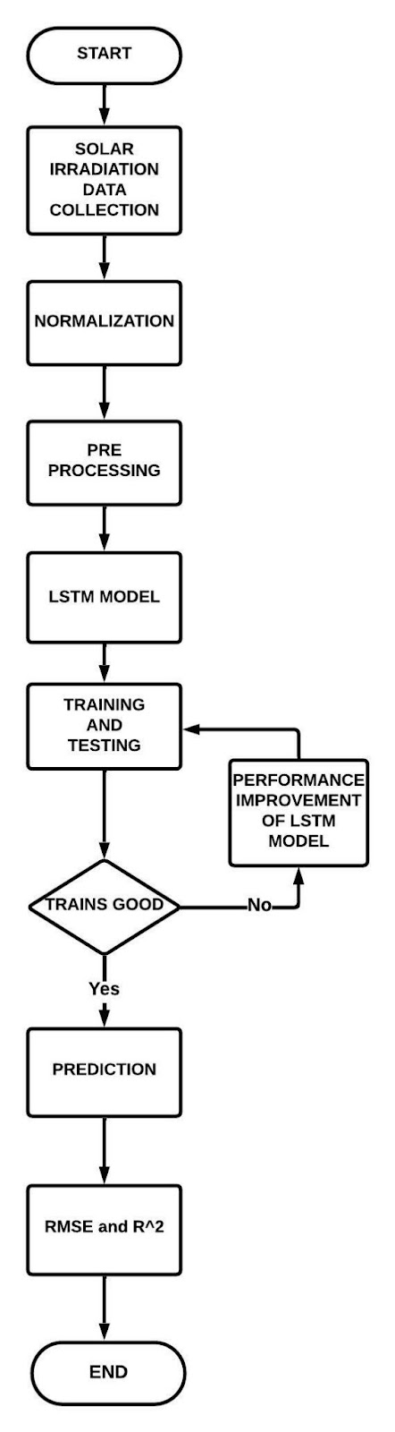

Figure 1: Flow diagram of LSTM in the proposed system

**Random forest**

In the proposed work a univariate feature extraction has been used to cope with a significant volume of irradiation data. The random forest tree's classifier is built using characteristics that impact irradiation, and the model's optimal parameters are chosen using OOB error analysis. The irradiation result has been examined and compared to the LSTM Model. The findings support the new method's validity; the root mean square error (RMSE) is lowered, and prediction precision is enhanced. This is important for predicting the amount of irradiation in a complicated environment and maximizing photovoltaic power generating efficiency.

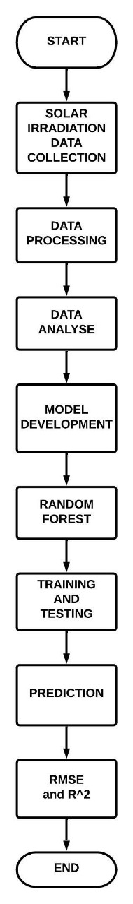

Figure 2: Flow diagram of Random Forest in the proposed system

The flow diagram of the RF model with intuitive steps to predict the RMSE and R ^2 values is shown in Figure 2.

The R^2 and RMSE values were used to compare the success rates of the LSTM and RF models. To predict the irradiation value, 2 variables were utilized as inputs in the model namely Time (UTC) and Irradiation, which were then processed using LSTM and RF models on an hourly, daily, weekly, and monthly basis.

**Results**

**Long-Short Term Memory (LSTM) Model**

Hour's data analysis contains a huge data with 36,720 records used for both training and testing. In Figure 3a date on the x-axis is plotted concerning irradiation on the y-axis, which tells how the irradiation data is varying concerning time(date). 90% of the data in 36,720 records are utilized for training, and 10% is utilized for testing. In Figure 3b the days on the x-axis from 01-01-2017 to 10-03-2021 at 5 intervals are plotted, the predicted values are in "blue" and actual values are in "red". The predicted values of hours data are very close to the actual values as shown in Figure 3b. In Figure 3c train and test data are plotted concerning loss on the y-axis and epoch on the x-axis from 0 to 100, the training data is "blue" color and the test data is "red". Loss in train data is less when compared to test data. In Figure 3d train and test data are plotted concerning accuracy on the y-axis and epoch on the x-axis from 0 to 100, the training data is "blue" color and the test data is "red". Also, the accuracy in test data is more when compared to train data because of proper training of data with a good number of hidden layers.

.

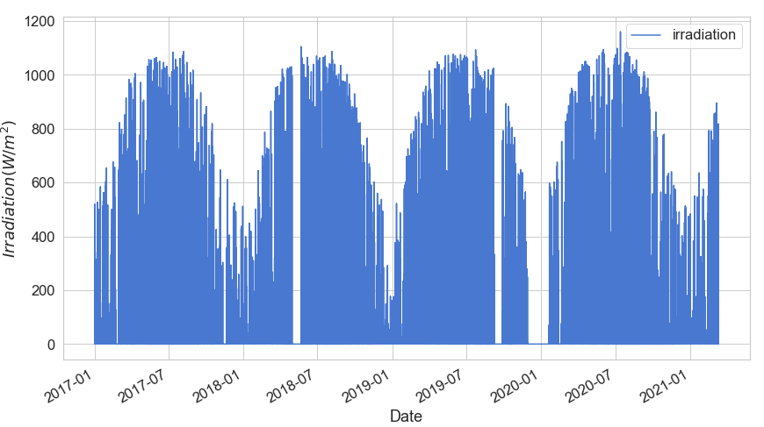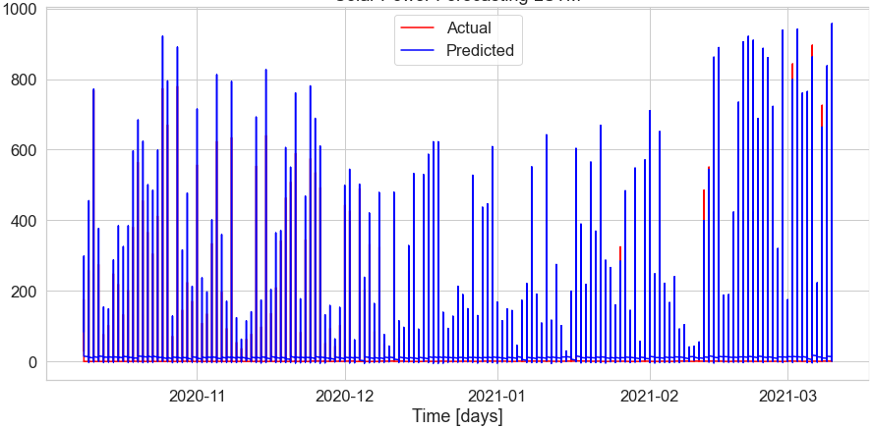

(a) (b)

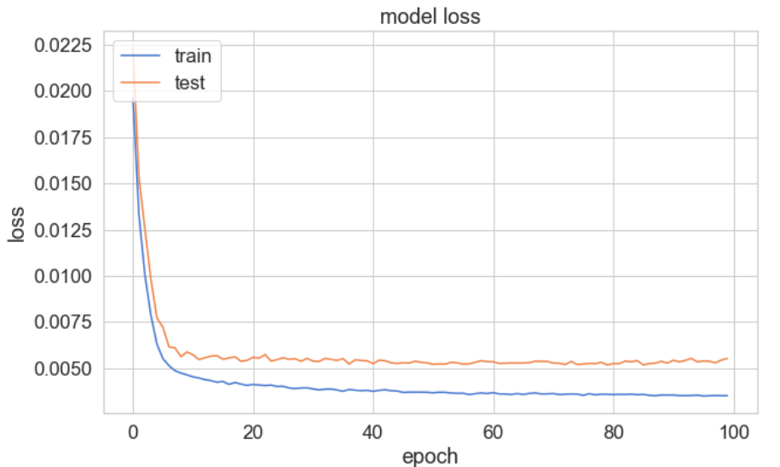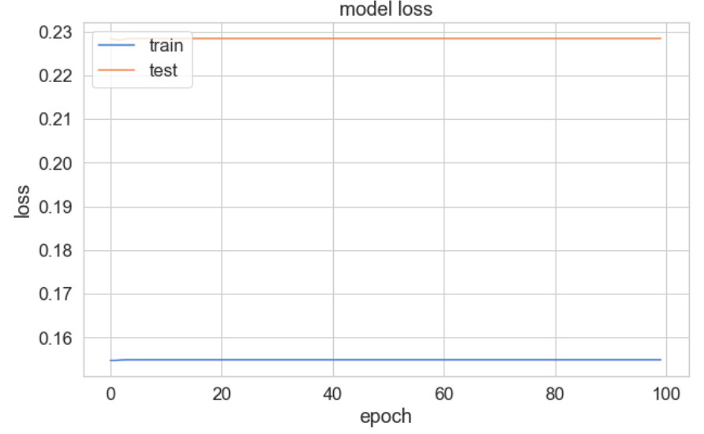

(c) (d)

Figure 3 Case-1: Hour’s data Analysis (a) Irradiation data used for hours analysis, (b) Graph between actual and predicted data for solar irradiation forecasting, (c) Graph between loss and epoch of train and test data and (d) Graph between accuracy and epoch of train and test data.

Days data contains 1530 irradiation records which are used for both training and testing. In Figure 4a the irradiation data on the y-axis is plotted concerning the date on the x-axis tells how the irradiation data is varying concerning time(date). 90% of the data in 1530 records are utilized for training, and 10% is utilized for testing. The irradiation data is plotted as a histogram concerning days on the y-axis and irradiation on the x-axis as shown in Figure 4b. In figure 4c train and test data are plotted concerning loss on the y-axis and epoch on the x-axis from 0 to 100, the training data is "blue" color and the test data is "red". Also, loss in train data is less when compared to test data.

In figure 4d train and test data are plotted concerning accuracy on the y-axis and epoch on the x-axis from 0 to 100, the training data is "blue" color and the test data is "red". The accuracy in test data is less when compared to train data because of the proper training of data with a good number of hidden layers. In Figure 4e the irradiance data on the y-axis is shown against time (days) on the x-axis. from 01-01-2017 to 10-03-2021 at 8 intervals, the predicted values are in "red" and actual values are in "green" color. The predicted values of hours data are very close to the actual values as shown in Figure 4e. In Figure 4f the error in predictions is represented in a red fill.

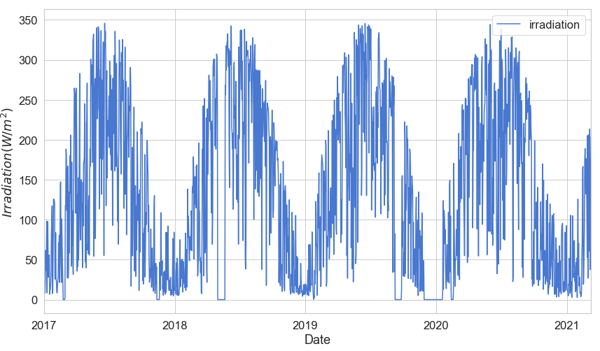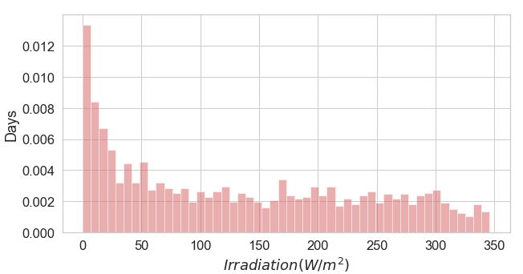

(a) (b)

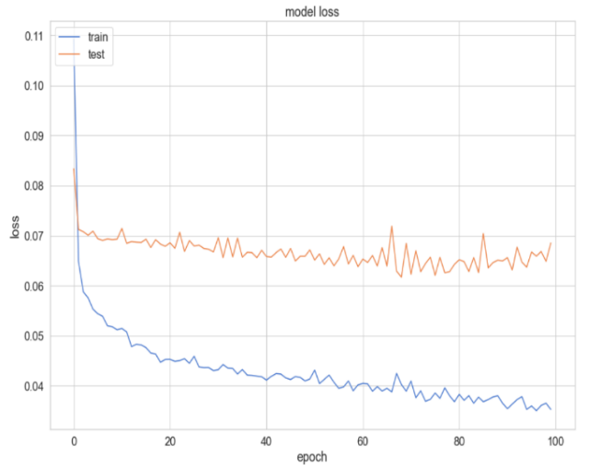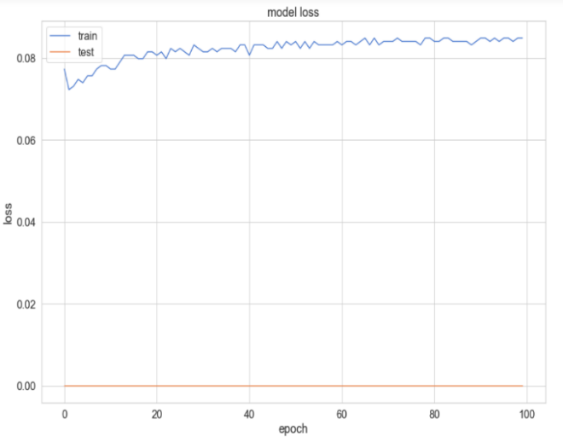

(c) (d)

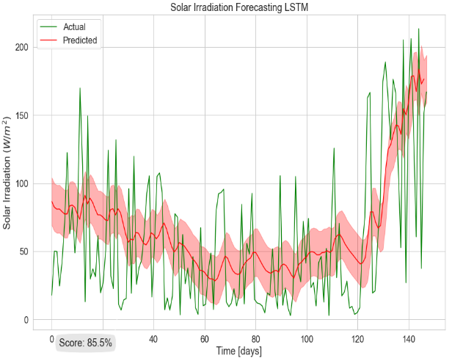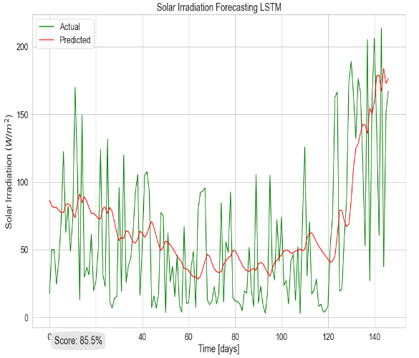

(e) (f)

Figure 4 Case-2: Data Analysis a) Irradiation data used for data analysis, b)Irradiation data in histogram representation used for days analysis, c) Graph between loss and epoch of train and test data, d) Graph between accuracy and epoch of train and test data, e)Graph between actual and predicted data for solar irradiation forecasting and f) Prediction with error.

Week's data contains 220 irradiation records which are used for both training and testing. In Figure 5a the irradiation data on the y-axis is plotted concerning the date on the x-axis tells how the irradiation data is varying concerning time(date). 90% of the data in 220 records are utilized for training, and 10% is utilized for testing. The irradiation data is plotted as a histogram concerning days on the y-axis and irradiation on the x-axis as shown in Figure 5b. In figure 5c train and test data are plotted concerning loss on the y-axis and epoch on the x-axis from 0 to 100, the training data is "blue" color and the test data is "red". Also, the loss in train data is less when compared to test data.

In figure 5d train and test data are plotted concerning accuracy on the y-axis and epoch on the x-axis from 0 to 100, the training data is "blue" color and the test data is "red". The accuracy in test data is less when compared to train data because of the proper training of data with a good number of hidden layers. In Figure 5e the irradiance data on the y-axis is shown against time(days) on the x-axis, the predicted values are in "red" and actual values are in "green" color. The predicted values of hours data are very close to the actual values as shown in Figure 5e. In Figure 5f the error in predictions is represented in a red fill.

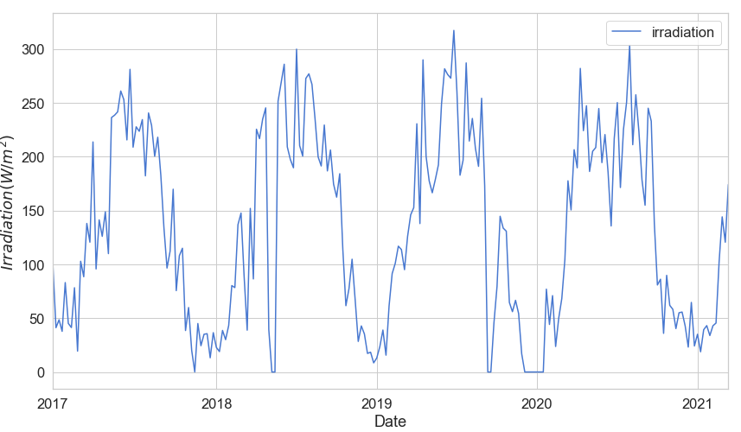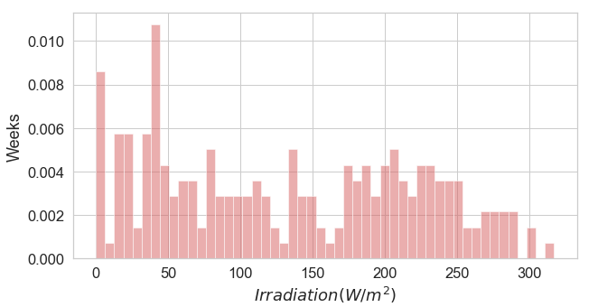

1. (b)

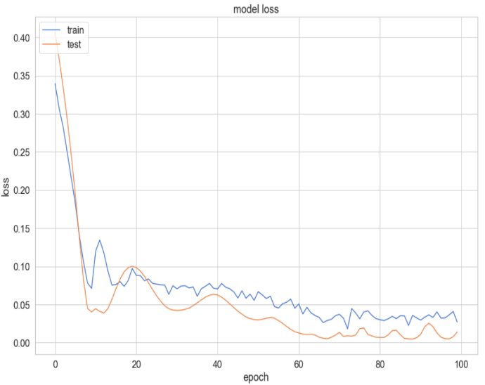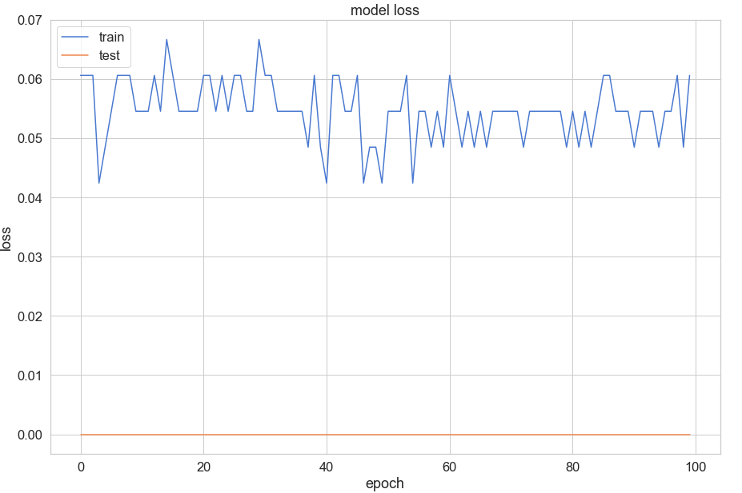

(c) (d)

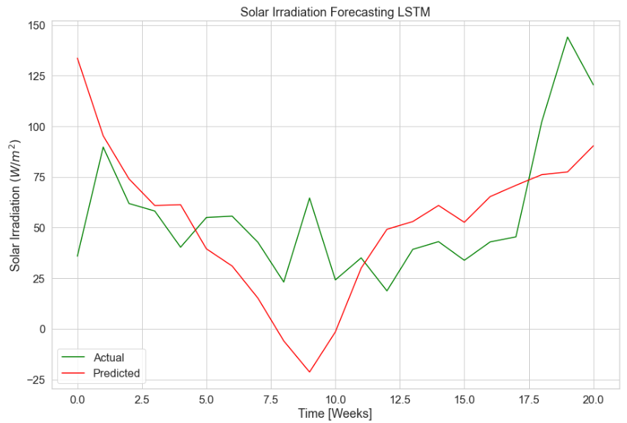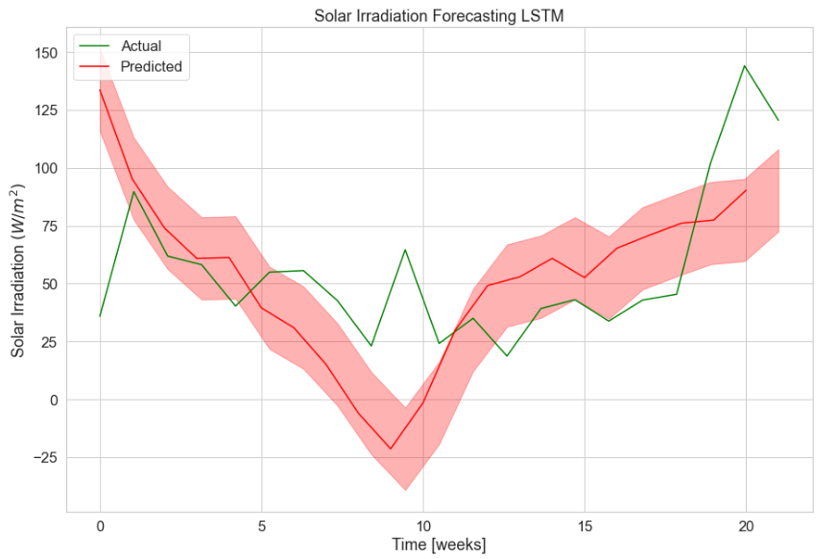

(e) (f)

Figure-5 Case-3: Weeks Analysis a) Irradiation data used for weeks analysis, b) Irradiation data in histogram representation used for weeks analysis, c) Graph between loss and epoch of train and test data, d) Graph between accuracy and epoch of train and test data, e) Graph between actual and predicted data for solar irradiation forecasting and f) Prediction with error.

Months data contains 51 irradiation records which are used for both training and testing. In Figure 6a the irradiation data on the y-axis is plotted concerning the date on the x-axis tells how the irradiation data is varying concerning time(date). 85% of the data in 51 records are utilized for training, and 15% is utilized for testing. The irradiation data is plotted as a histogram concerning days on the y-axis and irradiation on the x-axis as shown in Figure 6b. In figure 6c train and test data are plotted concerning loss on the y-axis and epoch on the x-axis from 0 to 100, the training data is "blue" color and the test data is "red". Also, loss in train data is less when compared to test data.

In figure 6d train and test data are plotted concerning accuracy on the y-axis and epoch on the x-axis from 0 to 100, the training data is "blue" color and the test data is "red". The accuracy in test data is less when compared to train data because of the proper training of data with a good number of hidden layers. In Figure 6e the irradiance data on the y-axis is shown against time(days) on the x-axis, the predicted values are in "red" and actual values are in "green" color. The predicted values of hours data are very close to the actual values as shown in Figure 6e. In Figure 6f the error in predictions is represented in a red fill.

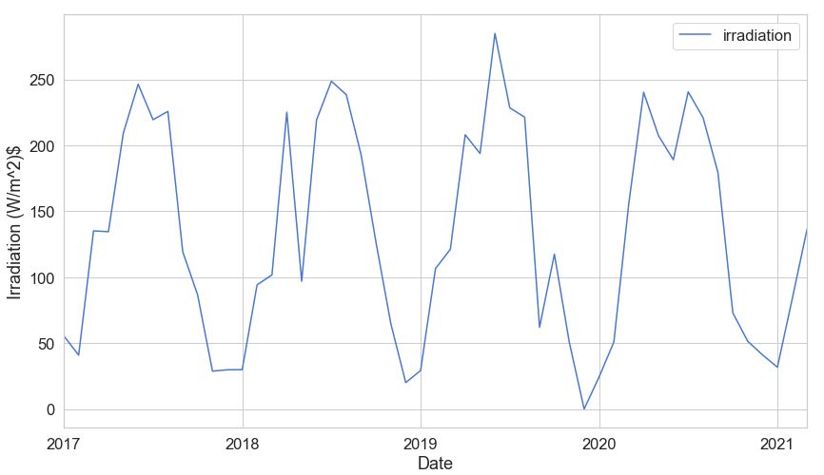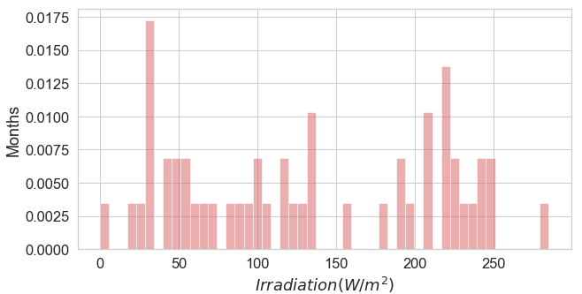

(a) (b)

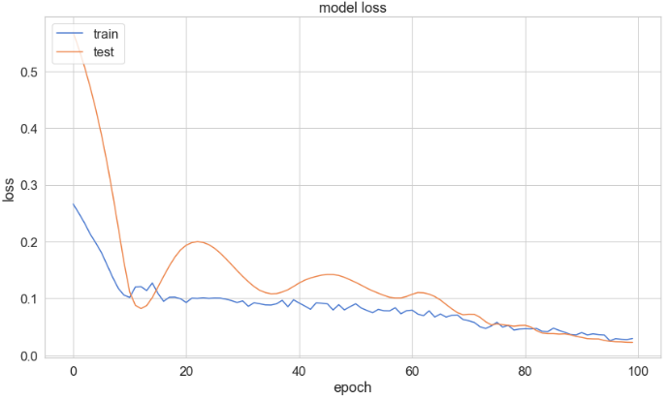 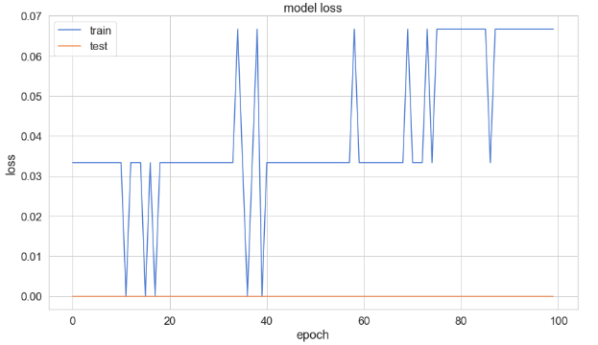

1. (d)

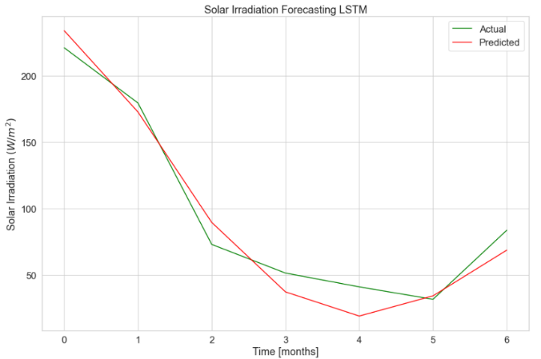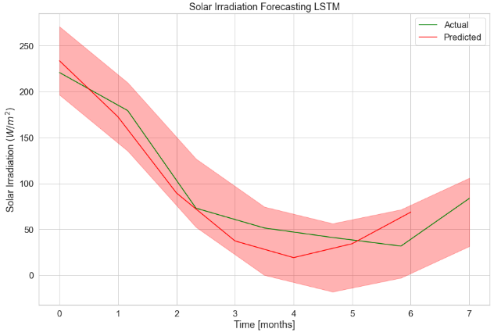

(e) (f)

Figure-6 Case-4: Months Analysis a) Irradiation data used for months analysis, b) Irradiation data in histogram representation used for months analysis, c) Graph between loss and epoch of train and test data, d) Graph between accuracy and epoch of train and test data, e) Graph between actual and predicted data for solar irradiation forecasting and f) Prediction with error.

**Random Forest (RF) Model**

Hour's data analysis contains a huge data with 36,720 records used for both training and testing. In Figure 7a the irradiation data on the y-axis is shown against the date on the x-axis tells how the irradiation data is varying concerning time(date). 90% of the data in 36,720 records are utilized for training, and 10% is utilized for testing. Days data contains 1530 irradiation records which are used for both training and testing. In Figure 7b the irradiation data on the y-axis is axis is shown against the date on the x-axis tells how the irradiation data is varying concerning time(date). 90% of the data in 1530 records are utilized for training, and 10% is utilized for testing.

Week's data contains 220 irradiation records which are used for both training and testing. In Figure 7c the irradiation data on the y-axis is shown against the date on the x-axis tells how the irradiation data is varying concerning time(date). 90% of the data in 220 records are utilized for training, and 10% is utilized for testing. Months data contains 51 irradiation records which are used for both training and testing. In Figure 7d the irradiation data on the y-axis is shown against the date on the x-axis tells how the irradiation data is varying concerning time(date). 85% of the data in 51 records are utilized for training, and 15% is utilized for testing.



(a) (b)



(c) (d)

Figure 7 Case-1: Irradiation data for Random Forest a) Hour’s analysis, b) Days analysis, c) Week analysis and d) Month analysis

Coefficient of Determination (R^2) values predictions are shown in Figure 8, the complete dataset is divided into five groups or five folds, each fold is represented with one color and for each fold, R^2 values are generated as shown in Figure 8. K-fold validation of hours, days, weeks, and months data is plotted concerning true values on the y-axis and predicted values on the x-axis as shown in Figure 8a, Figure 8b, Figure 8c, and Figure 8d respectively.

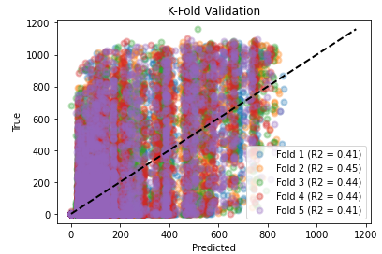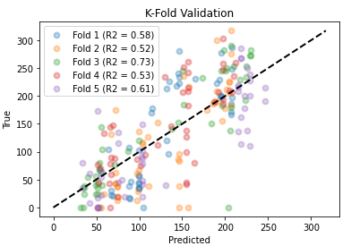

(a) (b)

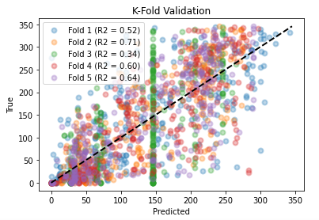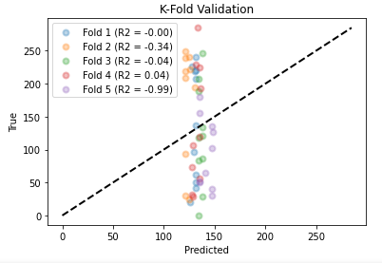

(c) (d)

Figure 8 Case-2: R^2 scores for each model a) Hour’s analysis, b) Days analysis, c) Week analysis and d) Month analysis

|  |  |  |  |  |
| --- | --- | --- | --- | --- |
|  | LSTM Model | | RF Model | |
| R^2 | RMSE | R^2 | RMSE |
| Hours | 0.7393 | 72.3239 | 0.4463 | 184.3875 |
| Days | 0.1960 | 47.0935 | 0.7149 | 57.5469 |
| Weeks | -0.3945 | 37.5850 | 0.7256 | 49.9040 |
| Months | 0.9567 | 14.1412 | 0.0387 | 85.3091 |

Table-1: R^2 and RMSE values of LSTM and RF model on hours, days, weeks, and months basis.

**Conclusion**

Long Short-Term Memory (LSTM) model is comparatively more accurate and faster when compared to Random Forest (RF) model. The Root Mean Square Error (RMSE) values of the LSTM model are less when compared to that of the RF model as shown in Table-1. If the RMSE value is high it reflects the poor ability of the model to accurately predict the data. Coefficient of Determination (R^2) values ranging from 0.6 to 1 is mostly good. From table 1 for hours and months data the R^2 values of the LSTM model are accurate when compared to that of the RF model. From Table-1 for days and weeks, the R^2 values of the RF model are accurate when compared to that of the LSTM model. Also, the training of large data is easy using the LSTM model when compared to that of the RF model. The time consumed for training the data in LSTM is less than compared to that of the RF model.

**References**

1. Fei Wang, Zhiming Xuan, Zhao Zhen, Kangping Li, Tieqiang Wang, Min Shi, "A day-ahead PV power forecasting method based on LSTM-RNN model and time correlation modification under partial daily pattern prediction framework", Energy Conversion and Management, Volume212,2020,112766, ISSN0196-8904.
2. R. Bachulkar, R. Bhatkande, A. Patil, and B. F. Telgi, "Machine Learning Algorithms for the Prediction of Daily Mean Solar Power," 2021 5th International Conference on Electronics, Communication, and Aerospace Technology (ICECA), 2021, pp. 860-866.
3. Y. -J. Zhong and Y. -K. Wu, "Short-Term Solar Power Forecasts Considering Various Weather Variables," 2020 International Symposium on Computer, Consumer and Control (IS3C), 2020, pp. 432-435.
4. N. Tosun, E. Sert, E. Ayaz, E. Yılmaz and M. Göl, "Solar Power Generation Analysis and Forecasting Real-World Data Using LSTM and Autoregressive CNN," 2020 International Conference on Smart Energy Systems and Technologies (SEST), 2020, pp. 1-6.
5. Y. Yu, J. Cao and J. Zhu, "An LSTM Short-Term Solar Irradiance Forecasting Under Complicated Weather Conditions," in *IEEE Access*, vol. 7, pp. 145651-145666, 2019.
6. C. N. Obiora, A. Ali and A. N. Hasan, "Forecasting Hourly Solar Irradiance Using Long Short-Term Memory (LSTM) Network," 2020 11th International Renewable Energy Congress (IREC), 2020, pp. 1-6.
7. A. Khalyasmaa *et al*., "Prediction of Solar Power Generation Based on Random Forest Regressor Model," *2019 International Multi-Conference on Engineering, Computer and Information Sciences (SIBIRCON)*, 2019, pp. 0780-0785.
8. S. Karasu and A. Altan, "Recognition Model for Solar Radiation Time Series based on Random Forest with Feature Selection Approach," *2019 11th International Conference on Electrical and Electronics Engineering (ELECO)*, 2019, pp. 8-11.
9. Rachit Srivastava, A.N. Tiwari, V.K. Giri, Solar radiation forecasting using MARS, CART, M5, and random forest model: A case study for India, Heliyon, Volume 5, Issue 10, 2019,e02692,ISSN 2405-8440.
10. Mumtaz Ali, Ramendra Prasad, Yong Xiang, Mohsin Khan, Aitazaz Ahsan Farooque, Tianrui Zong, Zaher Mundher Yaseen, Variational mode decomposition based random forest model for solar radiation forecasting: New emerging machine learning technology, Energy Reports, Volume 7, 2021, Pages 6700-6717, ISSN 2352-4847.
11. T. Mutavhatsindi, C. Sigauke, and R. Mbuvha, "Forecasting Hourly Global Horizontal Solar Irradiance in South Africa Using Machine Learning Models," in IEEE Access, vol. 8, pp. 198872-198885, 2020.
12. M. S. Hossain and H. Mahmood, "Short-Term Photovoltaic Power Forecasting Using an LSTM Neural Network and Synthetic Weather Forecast," in IEEE Access, vol. 8, pp. 172524-172533, 2020.M. S. Hossain and H. Mahmood, "Short-Term Photovoltaic Power Forecasting Using an LSTM Neural Network and Synthetic Weather Forecast," in *IEEE Access*, vol. 8, pp. 172524-172533, 2020.
13. Z. Zhen *et al*., "Deep Learning Based Surface Irradiance Mapping Model for Solar PV Power Forecasting Using Sky Image," in *IEEE Transactions on Industry Applications*, vol. 56, no. 4, pp. 3385-3396, July-Aug. 2020.
14. C. -J. Huang and P. -H. Kuo, "Multiple-Input Deep Convolutional Neural Network Model for Short-Term Photovoltaic Power Forecasting," in *IEEE Access*, vol. 7, pp. 74822-74834, 2019.
15. Utpal Kumar Das, Kok Soon Tey, Mehdi Seyedmahmoudian, Saad Mekhilef, Moh Yamani Idna Idris, Willem Van Deventer, Bend Horan, Alex Stojcevski, "Forecasting of photovoltaic power generation and model optimization: A review,Renewable and Sustainable Energy Reviews",Volume 81, Part 1,2018,Pages 912-928,ISSN 1364-0321.
16. F. A. Kraemer, D. Palma, A. E. Braten and D. Ammar, "Operationalizing Solar Energy Predictions for Sustainable, Autonomous IoT Device Management," in *IEEE Internet of Things Journal*, vol. 7, no. 12, pp. 11803-11814, Dec. 2020.
17. Y. Wang, Y. Shen, S. Mao, X. Chen and H. Zou, "LASSO and LSTM Integrated Temporal Model for Short-Term Solar Intensity Forecasting," in *IEEE Internet of Things Journal*, vol. 6, no. 2, pp. 2933-2944, April 2019.
18. L. Gigoni *et al*., "Day-Ahead Hourly Forecasting of Power Generation From Photovoltaic Plants," in *IEEE Transactions on Sustainable Energy*, vol. 9, no. 2, pp. 831-842, April 2018.
19. I. -I. Prado-Rujas, A. García-Dopico, E. Serrano and M. S. Pérez, "A Flexible and Robust Deep Learning-Based System for Solar Irradiance Forecasting," in *IEEE Access*, vol. 9, pp. 12348-12361, 2021.
20. Daniel Koster, Frank Minette, Christian Braun, Oliver O'Nagy, "Short-term and regionalized photovoltaic power forecasting, enhanced by reference systems, on the example of Luxembourg",Renewable Energy,Volume 132,2019,Pages 455-470,ISSN 0960-1481.
21. K. Bae, H. Jang, B. Jung, and D. Sung, “Effect of Prediction Error of Machine Learning Schemes on Photovoltaic Power Trading Based on Energy Storage Systems,” *Energies*, vol. 12, no. 7, p. 1249, Apr. 2019.
22. A. Nespoli *et al.*, “Day-Ahead Photovoltaic Forecasting: A Comparison of the Most Effective Techniques,” *Energies*, vol. 12, no. 9, p. 1621, Apr. 2019.
23. D. Lee and K. Kim, “Recurrent Neural Network-Based Hourly Prediction of Photovoltaic Power Output Using Meteorological Information,” *Energies*, vol. 12, no. 2, p. 215, Jan. 2019,
24. P.-H. Kuo and C.-J. Huang, “A Green Energy Application in Energy Management Systems by an Artificial Intelligence-Based Solar Radiation Forecasting Model,” *Energies*, vol. 11, no. 4, p. 819, Apr. 2018.
25. I. A. Ibrahim, M. J. Hossain and B. C. Duck, "An Optimized Offline Random Forests-Based Model for Ultra-Short-Term Prediction of PV Characteristics," in *IEEE Transactions on Industrial Informatics*, vol. 16, no. 1, pp. 202-214, Jan. 2020.
26. M. Golam, R. Akter, J. -M. Lee and D. -S. Kim, "A Long Short-Term Memory-Based Solar Irradiance Prediction Scheme Using Meteorological Data," in *IEEE Geoscience and Remote Sensing Letters*, vol. 19, pp. 1-5, 2022, Art no. 1003705.
27. H. Zhou, Y. Zhang, L. Yang, Q. Liu, K. Yan and Y. Du, "Short-Term Photovoltaic Power Forecasting Based on Long Short Term Memory Neural Network and AttentionMechanism," in *IEEE Access*, vol. 7, pp. 78063-78074, 2019.
28. Shikhar Srivastava, Stefan Lessmann,"A comparative study of LSTM neural networks in forecasting day-ahead global horizontal irradiance with satellite data ",Solar Energy,Volume 162,2018,Pages 232-247,ISSN 0038-092X.
29. S. M. J. Jalali, S. Ahmadian, A. Kavousi-Fard, A. Khosravi and S. Nahavandi, "Automated Deep CNN-LSTM Architecture Design for Solar Irradiance Forecasting," in *IEEE Transactions on Systems, Man, and Cybernetics: Systems*, vol. 52, no. 1, pp. 54-65, Jan. 2022.
30. E. D. Obando, S. X. Carvajal and J. Pineda Agudelo, "Solar Radiation Prediction Using Machine Learning Techniques: A Review," in *IEEE Latin America Transactions*, vol. 17, no. 04, pp. 684-697, April 2019.
31. B. Brahma and R. Wadhvani, “Solar Irradiance Forecasting Based on Deep Learning Methodologies and Multi-Site Data,” *Symmetry*, vol. 12, no. 11, p. 1830, Nov. 2020