

AI Predictor & Visualizer
A Machine Learning Project with Data Visualization

Project Report
Submitted in partial fulfillment of the requirements for
B.Tech – Computer Science & Engineering (AI & ML)

Name | Vedansh Singh Tomar
Registration No. | 25BAI11509
Course | B.Tech CSE (AI & ML)
Institution | VIT Bhopal University
Academic Year | 2025 – 2026

VIT Bhopal University | Kothri Kalan, Sehore, Madhya Pradesh – 466114

1. Overview
This project implements a simple automatic AI model using Linear Regression to learn relationships between input and output data. It not only performs predictions but also visualizes the learning process using both Matplotlib and Turtle Graphics, making it intuitive and interactive.

The goal is to bridge the gap between theoretical machine learning concepts and visual understanding.

2. Problem Statement
Understanding how AI models learn from data can be abstract and difficult for beginners. This project solves that by:
- Creating a simple predictive model
- Visualizing how the model fits data
- Simulating predictions in an interactive graphical way

3. Solution Approach
The system follows these steps:
- Data Input – Uses a sample dataset (e.g., study hours vs marks)
- Model Training – Applies Linear Regression using NumPy
- Prediction – Generates predicted values based on learned patterns
- Visualization – Matplotlib for graph representation; Turtle for animated coordinate plotting

4. Key Concepts Used
- Linear Regression (Supervised Learning)
- Data Visualization
- Model Prediction
- Coordinate Mapping
- Basic AI Workflow

5. Tech Stack
Language: Python

NumPy | Matplotlib | Turtle
Numerical computing & polynomial fitting | Static data visualization & regression line plotting | Animated coordinate plotting simulation

6. Project Structure
AI-Predictor-Visualizer/
├── main.py
├── outputs/
├── README.md
└── report.pdf

7. Source Code
main.py
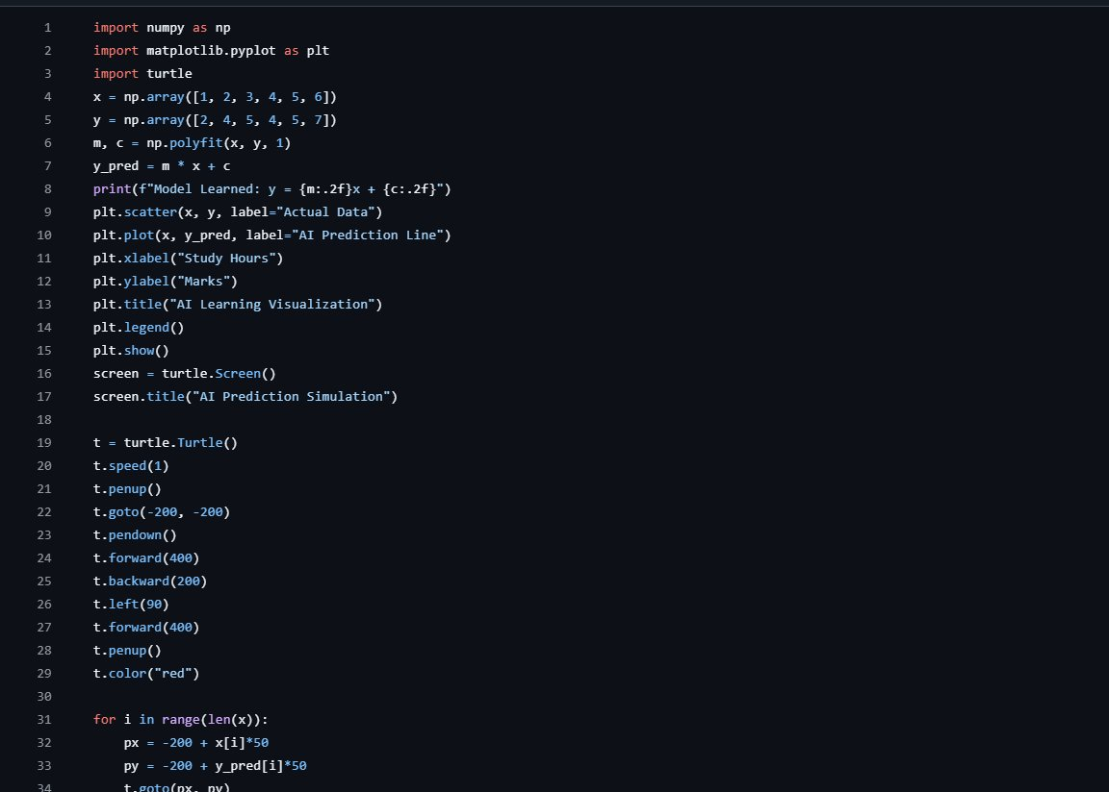
Figure 1: Python source code – Lines 1–34 (data, model, matplotlib, turtle setup)
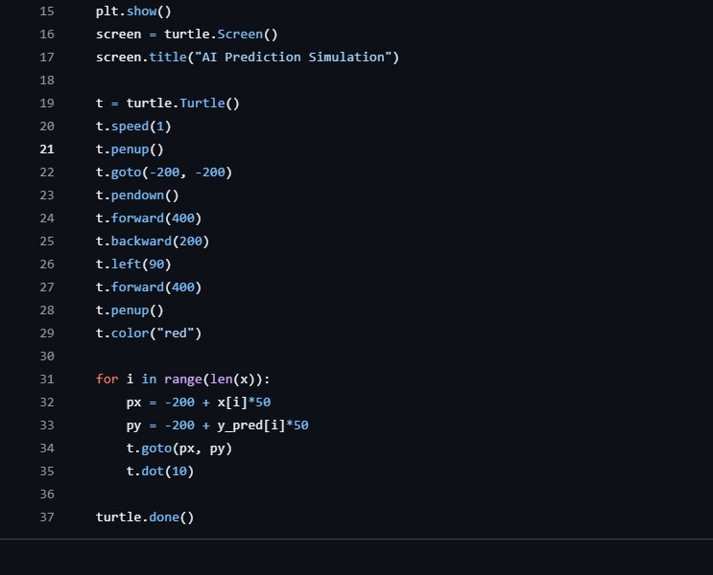
Figure 2: Python source code – Lines 15–37 (turtle simulation & turtle.done())

8. Output Description
8.1 Matplotlib Visualization
- Displays actual data points (scatter plot)
- Shows regression line (AI prediction)
- Labelled axes: Study Hours (X), Marks (Y)

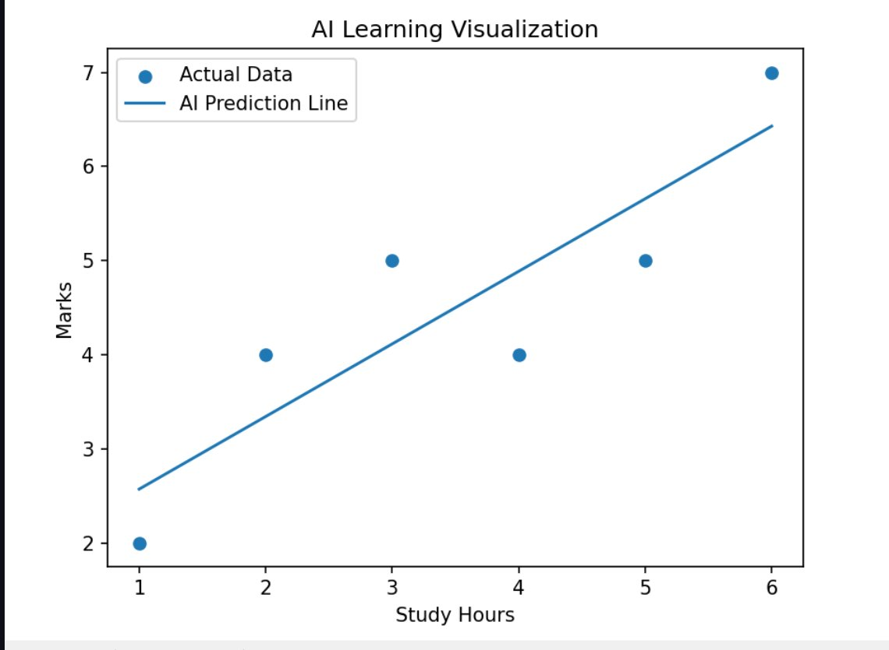
Figure 3: Matplotlib output – AI Learning Visualization (Study Hours vs Marks)
8.2 Turtle Simulation
- Draws coordinate axes dynamically
- Plots predicted data points as red dots in real-time
- Provides an animated and interactive view of the AI model's predictions

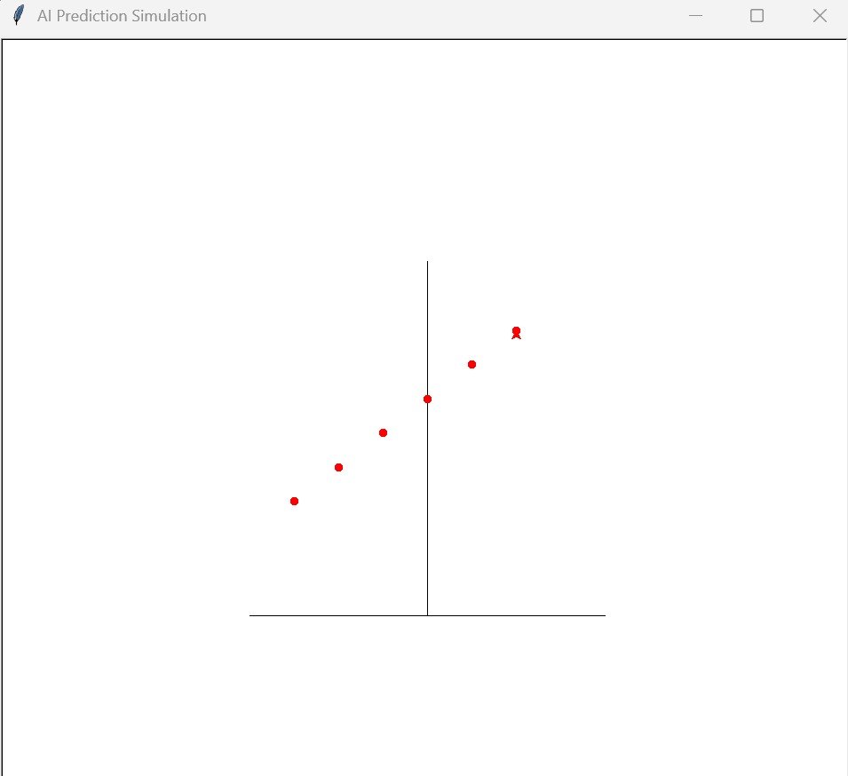
Figure 4: Turtle graphics output – AI Prediction Simulation window

9. Results
The model successfully learns trends from input data and produces accurate predictions for simple datasets. Visualization enhances interpretability and makes the learning process easier to understand.

10. Features
- Automatic model training using NumPy polyfit
- Dual visualization – static graph (Matplotlib) + animated simulation (Turtle)
- Beginner-friendly implementation with clean, modular code structure
- No external ML frameworks required – built with core Python libraries

11. Limitations
- Works on small/simple datasets only
- Uses basic linear regression (degree-1 polynomial fit)
- No real-time user input (can be extended in future versions)

12. Future Enhancements
- Add CSV dataset support for flexible data loading
- Implement advanced ML models (polynomial, decision tree, etc.)
- Build a GUI/web interface for user interaction
- Add accuracy metrics and model evaluation dashboard

13. Learning Outcomes
- Practical understanding of AI model training and testing
- Experience with data visualization tools (Matplotlib, Turtle)
- Ability to convert theoretical ML concepts into working projects
- Improved problem-solving and software implementation skills

14. Declaration
I hereby declare that the project "AI Predictor & Visualizer" submitted is my own original work and has been carried out under the academic guidelines of VIT Bhopal University. All references and resources used are duly acknowledged.

Student Signature  Vedansh Singh Tomar | Registration No.  25BAI11509

