MCA Semester – IV
Capstone Project – Cloud Computing
Interim Report

A study on "EchoMateLite: Design and Deployment of a Cloud-Based Lightweight Social Media Platform on Amazon Web Services (AWS)"

A Project submitted to Jain Online (Deemed-to-be University)
In partial fulfillment of the requirements for the award of:
Master of Computer Application

Name | Deepak Jain
USN | 241VMTR01377
Elective | Cloud Computing
Date of Submission | 01/07/2026

Under the guidance of:
Madhulika Praveen Dubey
(Faculty – JAIN Online)

Jain Online (Deemed-to-be University)
Bangalore
2025–26

DECLARATION

I, Deepak Jain, hereby declare that the Interim Project Report titled "EchoMateLite: Design and Deployment of a Cloud-Based Lightweight Social Media Platform on Amazon Web Services (AWS)" has been prepared by me under the guidance of Madhulika Praveen Dubey. I declare that this Project work is towards the partial fulfillment of the University Regulations for the award of the degree of Master of Computer Application by Jain University, Bengaluru. I have undergone a project for a period of Eight Weeks. I further declare that this Project is based on the original study undertaken by me and has not been submitted for the award of any degree/diploma from any other University / Institution.

Place: Bangalore ______________________
Date: 01/07/2026 Deepak Jain
USN: 241VMTR01377

EXECUTIVE SUMMARY

This Interim Report documents the progress, architectural decisions, and current implementation status of "EchoMateLite," a lightweight, cloud-based social media platform being developed as part of the MCA Semester IV Capstone Project in Cloud Computing at Jain Online (Deemed-to-be University). The project aims to design, develop, and deploy a fully functional social media web application on Amazon Web Services (AWS), demonstrating practical proficiency in full-stack MERN development and cloud infrastructure management.
EchoMateLite is built using the MERN stack — MongoDB for the database layer, Express.js as the backend framework, React.js for the frontend user interface, and Node.js as the server runtime. This technology combination was selected for its unified JavaScript ecosystem, high performance in handling concurrent requests, and strong alignment with modern web development industry standards. The application is designed to support core social media functionalities: secure user registration and authentication, user profile management with picture uploads, text-based post creation, and a chronological news feed.
At this interim stage, the project has successfully completed the backend foundation and the user authentication module. A production-ready Express.js server has been established following the Model-View-Controller (MVC) architectural pattern, with a clear separation into configuration, controllers, middleware, models, routes, and utility layers. The MongoDB Atlas database cluster has been provisioned on AWS infrastructure in the Mumbai (ap-south-1) region as a free M0 sandbox, and a successful connection has been verified. The User data model has been designed with Mongoose, incorporating field-level validation, email uniqueness constraints, and automatic password hashing using bcryptjs. Complete user registration and login APIs have been implemented with JSON Web Token (JWT) based authentication, along with a reusable authentication middleware for protecting private routes.
The project source code is version-controlled using Git and hosted on GitHub. All implemented features have been tested using Postman, confirming successful API responses including HTTP 201 (Created) for user registration and proper JWT token generation. The cloud architecture has been designed to leverage the AWS Free Tier, with the backend planned for Amazon EC2 (t2.micro), the React frontend for Amazon S3 with CloudFront distribution, and HTTPS enforcement through an Application Load Balancer with AWS Certificate Manager.
The remaining phases of the project include implementing the Post data model and associated APIs, building the React.js frontend application, and deploying the complete application stack on AWS. This report provides a comprehensive overview of the work completed thus far, the rationale behind the chosen technology stack and AWS services, and a detailed solution architecture with cost analysis.

TABLE OF CONTENTS

Executive Summary | i
Table of Contents | ii
List of Tables | iii
Chapter 1: Introduction | 1
1.1 Background Information of the Project | 1
1.2 Goals and Objectives | 2
1.3 Key Requirements of the Project | 3
Chapter 2: Literature Review | 5
2.1 Significance and Rationale for the Chosen Technology Stack | 5
2.2 Significance and Rationale for the Chosen AWS Services | 7
2.3 Problems Addressed by the Selected Stack | 10
Chapter 3: Solution Architecture | 12
3.1 Architecture Diagram | 12
3.2 Cost Analysis and Financial Implications | 14
References | 16
Annexures | 17

LIST OF TABLES

Table No. | Table Title | Page No.
Table 1.1 | Project Technology Stack Summary | 3
Table 1.2 | Key Functional Requirements | 4
Table 2.1 | MERN Stack Component Analysis | 6
Table 2.2 | AWS Services Selected for EchoMateLite | 8
Table 3.1 | AWS Free Tier Cost Analysis | 14
Table 3.2 | Estimated Monthly Cost Summary | 15

CHAPTER 1
INTRODUCTION

1.1 Background Information of the Project

Social media platforms have fundamentally transformed the way individuals communicate, share information, and build communities in the digital age. Platforms such as Facebook, Twitter, and Instagram serve billions of users worldwide, facilitating real-time interaction through profiles, posts, feeds, and messaging systems. However, these commercial platforms are built on massive, proprietary infrastructure stacks involving thousands of microservices, complex distributed systems, and hardware investments running into billions of dollars. This level of complexity makes them unsuitable as learning references or templates for academic cloud computing projects.
There exists a clear academic and practical need for a lightweight social media platform that demonstrates the core principles of modern web application development and cloud deployment without the overhead of commercial-scale complexity. Such a platform would serve as an ideal capstone project for a Master of Computer Application (MCA) program, combining full-stack web development with hands-on cloud infrastructure management.
"EchoMateLite" is designed to address this need. It is a lightweight, cloud-deployable social media platform that implements the essential functionalities of a social network — user authentication, profile management, post creation, and a public news feed — while remaining simple enough to be developed, tested, and deployed by a single developer within the constraints of a semester-long capstone project. The platform is built using the MERN stack (MongoDB, Express.js, React.js, Node.js) and is architected for deployment on Amazon Web Services (AWS), leveraging the AWS Free Tier to demonstrate cost-efficient cloud architecture.
This project is undertaken as part of the MCA Semester IV Capstone Project in Cloud Computing at Jain Online (Deemed-to-be University), Bangalore. The project provides practical, end-to-end exposure to the complete software development lifecycle: from requirement analysis and architectural design, through implementation and testing, to cloud deployment and documentation.

1.2 Goals and Objectives

The overarching goal of EchoMateLite is to design, develop, and successfully deploy a lightweight cloud-based social media platform on Amazon Web Services (AWS), demonstrating practical proficiency in full-stack MERN development, AWS cloud architecture design, and end-to-end cloud deployment.
The specific objectives of the project are:
1. To design and develop a fully functional MERN-stack web application (EchoMateLite) that supports user registration, login, profile management, post creation, and a dynamic news feed.
2. To design a scalable, cost-efficient AWS cloud architecture capable of hosting the EchoMateLite application with high availability and low latency.
3. To integrate relevant AWS services — including Amazon EC2, Amazon S3, MongoDB Atlas, Amazon CloudFront, and Elastic Load Balancing — to form a complete, production-grade cloud solution.
4. To implement fundamental security practices including HTTPS enforcement via AWS Certificate Manager, secure password hashing using bcryptjs, JWT-based authentication, and IAM-based access control following the principle of least privilege.
5. To evaluate the performance, cost, and scalability of the deployed AWS architecture and document the findings comprehensively with architecture diagrams and cost analysis.

Table 1.1: Project Technology Stack Summary
Layer | Technology | Purpose
Frontend | React.js | Single Page Application (SPA) for user interface
Backend | Node.js + Express.js | RESTful API server
Database | MongoDB Atlas | NoSQL cloud database (AWS Mumbai region)
Authentication | JWT + bcryptjs | Token-based auth with password hashing
Version Control | Git + GitHub | Source code management and collaboration
Cloud Platform | Amazon Web Services | EC2, S3, CloudFront, ALB, ACM, IAM
Dev Tools | Nodemon, Postman | Auto-restart server, API testing

1.3 Key Requirements of the Project

To meet its stated objectives, EchoMateLite must fulfill a set of essential features and functionalities. These requirements are derived directly from the university-assigned problem statement and have been elaborated upon in the project synopsis. The following table summarizes the key functional requirements:

Table 1.2: Key Functional Requirements
Requirement | Description | Priority
User Registration | Users must be able to create new accounts by providing their name, email address, and a password. The system must validate all inputs and reject duplicate email addresses. | High
User Login | Registered users must be able to log in using their email and password. The system must verify credentials against securely hashed passwords stored in the database. | High
JWT Authentication | Upon successful login or registration, the system must issue a JSON Web Token (JWT) that the client uses to authenticate subsequent API requests. A middleware layer must protect all private routes. | High
User Profile | Authenticated users must be able to view and edit their profile information, including their name, biography, and profile picture. | High
Profile Picture Upload | The system must allow users to upload profile pictures, which will be stored in Amazon S3 for scalable and durable object storage. | Medium
Post Creation | Authenticated users must be able to compose and publish text-based posts to the platform. | High
News Feed | The application must display a global news feed showing posts from all users in reverse chronological order. | High
Responsive UI | The React.js frontend must be responsive and compatible with both desktop and mobile browsers. | High
Cloud Deployment | The complete application stack must be deployed on AWS and accessible over the public internet via a secure HTTPS URL. | High
Security | The system must implement password hashing (bcrypt), HTTPS enforcement (ACM), and input validation to mitigate common vulnerabilities. | Medium

CHAPTER 2
LITERATURE REVIEW

2.1 Significance and Rationale for the Chosen Technology Stack

The technology stack for EchoMateLite was selected after careful evaluation of the project requirements, the university guidelines, and industry best practices. The MERN stack — MongoDB, Express.js, React.js, and Node.js — was chosen as the foundational technology due to several compelling advantages that directly align with the objectives of this capstone project.
Unified JavaScript Ecosystem:
The most significant advantage of the MERN stack is the use of JavaScript as the sole programming language across the entire application — from the frontend (React.js) to the backend (Node.js/Express.js) to the database query language (MongoDB). This eliminates the cognitive overhead of context-switching between different programming languages, accelerates development velocity, and reduces the learning curve. For a semester-constrained capstone project developed by a single student, this is a critical practical advantage.
Component-Based Frontend with React.js:
React.js was selected for the frontend layer because of its component-based architecture, which promotes code reusability and maintainability. React's Virtual DOM efficiently handles frequent UI updates — a critical capability for a social media application where the news feed must render and re-render dynamically as new posts arrive. React's declarative programming model makes the UI code predictable and easier to debug. Additionally, React's massive ecosystem of community libraries and tools (React Router for navigation, Axios for HTTP requests, Context API for state management) provides ready-made solutions for common frontend challenges.
Event-Driven Backend with Node.js and Express.js:
Node.js provides a lightweight, event-driven, non-blocking I/O runtime that is highly efficient for handling numerous concurrent connections — a typical pattern in social media applications where multiple users simultaneously fetch feeds, create posts, and update profiles. Express.js, built on top of Node.js, provides a minimal and flexible web application framework that simplifies the creation of RESTful APIs through its robust routing system and middleware architecture. The combination of Node.js and Express.js enables rapid API development while maintaining production-grade performance.
Flexible Data Layer with MongoDB:
MongoDB, a document-oriented NoSQL database, was chosen for its schema flexibility and natural compatibility with JavaScript objects. Unlike relational databases that enforce rigid table schemas, MongoDB stores data as JSON-like documents (BSON), making it ideal for the semi-structured nature of social media data — where user profiles may have varying fields and posts may evolve to include different content types over time. MongoDB Atlas, the fully managed cloud database service, was selected specifically because it can be hosted on AWS infrastructure, co-locating the database with the application server to minimize network latency.

Table 2.1: MERN Stack Component Analysis
Component | Technology | Role in EchoMateLite | Key Advantage
M – Database | MongoDB Atlas | Stores user profiles, posts, and session data as JSON documents | Schema flexibility, native JS compatibility
E – Backend Framework | Express.js | Handles HTTP requests, defines API routes, manages middleware pipeline | Minimal, fast, extensive middleware ecosystem
R – Frontend Library | React.js | Renders the user interface as a Single Page Application (SPA) | Virtual DOM, component reusability, large community
N – Runtime | Node.js | Executes JavaScript on the server, handles async I/O operations | Non-blocking I/O, event-driven, high concurrency

2.2 Significance and Rationale for the Chosen AWS Services

Amazon Web Services (AWS) was selected as the cloud platform for deploying EchoMateLite based on the university capstone project guidelines, which specifically mandate the use of AWS services. Beyond this requirement, AWS offers the most comprehensive set of cloud services globally, an extensive Free Tier program suitable for academic projects, and deep integration capabilities between its services. The following AWS services have been identified and selected based on preliminary research into the project requirements:

Amazon EC2 (Elastic Compute Cloud)
Amazon EC2 provides resizable compute capacity in the cloud through virtual server instances. For EchoMateLite, a t2.micro instance (1 vCPU, 1 GB RAM) running Ubuntu Server will host the Node.js/Express.js backend API. EC2 was chosen over serverless alternatives like AWS Lambda because the backend requires a persistent server process to handle WebSocket connections (for potential real-time features) and to maintain a continuous connection pool to MongoDB Atlas. The t2.micro instance is eligible for the AWS Free Tier, providing 750 hours of compute time per month at zero cost during the first 12 months.

Amazon S3 (Simple Storage Service)
Amazon S3 provides highly durable (99.999999999%) and available object storage. In EchoMateLite, S3 serves a dual purpose: (a) hosting the production build of the React.js frontend as a static website, and (b) storing user-uploaded profile pictures as objects. S3 was selected over alternatives like EBS or EFS because it is purpose-built for object storage, offers virtually unlimited capacity, integrates natively with CloudFront for content delivery, and provides 5 GB of standard storage under the Free Tier.

Amazon CloudFront
Amazon CloudFront is a Content Delivery Network (CDN) that caches and delivers content from edge locations worldwide. CloudFront will be placed in front of the S3-hosted React frontend to achieve two objectives: (a) reducing latency by serving static assets from the nearest edge location to the user, and (b) enforcing HTTPS for the frontend using an SSL/TLS certificate provisioned via AWS Certificate Manager. The Free Tier includes 1 TB of data transfer out per month, which is more than sufficient for this academic project.

MongoDB Atlas (Hosted on AWS)
While AWS offers managed database services such as Amazon RDS and Amazon DocumentDB, MongoDB Atlas was selected as the database layer because it provides a fully managed MongoDB service that is natively compatible with the Mongoose ODM library used in the MERN stack. The M0 Sandbox tier (free) offers 512 MB of storage and is hosted on AWS infrastructure in the Mumbai (ap-south-1) region, co-locating it with the EC2 backend instance to minimize cross-region latency. This selection prioritizes developer productivity and MERN stack alignment while still leveraging AWS infrastructure.

Elastic Load Balancer (ELB) + AWS Certificate Manager (ACM)
An Application Load Balancer (ALB) will be configured to distribute incoming HTTPS traffic to the EC2 backend instance. While load balancing across multiple instances is not required for this project's scale, the ALB serves a critical purpose: it enables SSL/TLS termination using a free certificate provisioned through AWS Certificate Manager (ACM). This enforces HTTPS for all API requests between the frontend and the backend, satisfying the security requirement outlined in the project synopsis.

AWS IAM (Identity and Access Management)
AWS IAM will be used to define roles and policies that govern access to all AWS resources. Following the principle of least privilege, each component will be granted only the permissions strictly necessary for its function. For example, the EC2 instance role will have permission to read and write objects in the designated S3 bucket but will not have access to other AWS services or resources. This approach minimizes the blast radius of any potential security compromise.

Table 2.2: AWS Services Selected for EchoMateLite
AWS Service | Purpose in EchoMateLite | Free Tier Allowance
Amazon EC2 | Host the Node.js/Express.js backend API server | 750 hours/month (t2.micro)
Amazon S3 | Host React frontend build + store profile pictures | 5 GB storage, 20,000 GET requests
Amazon CloudFront | CDN for frontend delivery + HTTPS enforcement | 1 TB data transfer out/month
MongoDB Atlas | Cloud-hosted NoSQL database for user and post data | 512 MB storage (M0 Sandbox)
AWS ALB + ACM | HTTPS load balancing + free SSL/TLS certificate | Free certificate provisioning
AWS IAM | Access control with least-privilege roles/policies | Always free

2.3 A Brief Overview of the Problems Addressed by Using the Selected Stack

The combined selection of the MERN stack and AWS cloud services directly addresses several significant challenges encountered in modern web application development and deployment:
Problem 1: Development Complexity and Context Switching
Traditional web development stacks (e.g., LAMP — Linux, Apache, MySQL, PHP) require developers to work with multiple programming languages across the frontend (HTML/CSS/JavaScript), backend (PHP, Python, or Java), and database (SQL). The MERN stack eliminates this fragmentation by using JavaScript throughout the entire application. This unified language approach significantly reduces development time, minimizes bugs caused by context-switching, and allows a single developer to be productive across all application layers — a critical advantage for a solo capstone project.
Problem 2: Dynamic UI Performance
Social media applications require frequent and efficient UI updates as users scroll through feeds, receive notifications, and interact with posts. Traditional server-rendered pages require full page reloads for every interaction, resulting in poor user experience. React.js solves this through its Virtual DOM mechanism, which computes the minimal set of changes needed and updates only those specific DOM elements. This results in a fluid, responsive user interface that feels native-like, even in a web browser.
Problem 3: Capital-Intensive Infrastructure
Hosting a web application on physical servers requires significant upfront capital expenditure for hardware procurement, networking equipment, physical security, and ongoing maintenance. AWS eliminates this barrier entirely through its pay-as-you-go pricing model and Free Tier program. For EchoMateLite, the entire deployment architecture falls within the AWS Free Tier, reducing the infrastructure cost to practically zero during the development and evaluation phases.
Problem 4: Authentication Security
Building a custom authentication system from scratch is notoriously error-prone and carries significant security risks, including plaintext password storage, session hijacking, and token forgery. EchoMateLite addresses this by implementing industry-standard security practices: passwords are hashed using bcryptjs with a cost factor of 10 before storage (making brute-force attacks computationally infeasible), user sessions are managed through cryptographically signed JWTs with configurable expiration periods, and the authentication middleware validates every request to protected routes. The architecture is also designed to be flexible enough to integrate Amazon Cognito for enterprise-grade identity management in future iterations.
Problem 5: Scalability and Global Availability
A self-hosted application is limited by the capacity of a single server and is only accessible with low latency to users geographically near the server. The AWS architecture designed for EchoMateLite addresses this through Amazon CloudFront (which caches and serves the frontend from 400+ edge locations worldwide), MongoDB Atlas (which supports horizontal scaling through sharding), and the architecture-ready design for Application Load Balancing (which can distribute traffic across multiple EC2 instances if demand increases). While horizontal scaling is not required for this academic project, the architecture is designed to support it without requiring fundamental redesign.

CHAPTER 3
SOLUTION ARCHITECTURE

3.1 Architecture Diagram

The architecture of EchoMateLite follows a decoupled, three-tier client-server model deployed across multiple AWS services. The architecture separates the presentation layer (React.js frontend), the business logic layer (Node.js/Express.js backend API), and the data layer (MongoDB Atlas) into independently deployable components connected through well-defined APIs and network configurations.

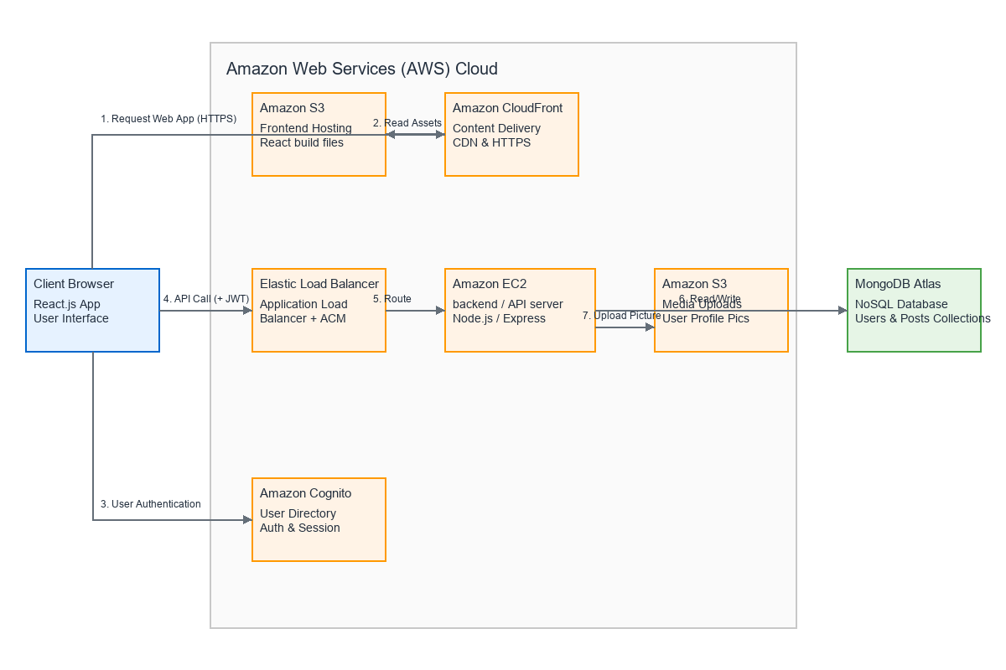
Figure 3.1: AWS Solution Architecture Diagram for EchoMateLite

Architecture Components and Data Flow:

Tier 1 – Presentation Layer (Frontend):
The user accesses EchoMateLite through a web browser. The React.js frontend is built into static HTML, CSS, and JavaScript files and hosted in an Amazon S3 bucket configured for static website hosting. Amazon CloudFront is placed in front of S3 as a Content Delivery Network (CDN), caching the static assets at edge locations globally. CloudFront also enforces HTTPS using an SSL/TLS certificate provisioned through AWS Certificate Manager (ACM). When a user navigates to the application URL, CloudFront serves the React application from the nearest edge location, ensuring minimal latency.
Tier 2 – Business Logic Layer (Backend API):
The React frontend communicates with the Node.js/Express.js backend API through RESTful HTTP requests. Each request from an authenticated user includes a JWT token in the Authorization header. The backend is hosted on an Amazon EC2 instance (t2.micro, Ubuntu Server) in the ap-south-1 (Mumbai) region. An Application Load Balancer (ALB) sits in front of the EC2 instance, handling SSL/TLS termination (via ACM) and routing HTTPS traffic to the backend. The Express.js server processes the request through its middleware pipeline (CORS validation, JSON parsing, JWT authentication), invokes the appropriate controller, interacts with the database through Mongoose models, and returns a JSON response.
Tier 3 – Data Layer (Database and Storage):
The data layer consists of two components: (a) MongoDB Atlas, a managed NoSQL database cluster hosted on AWS in the Mumbai region (M0 Sandbox, free tier), which stores all application data including user accounts, hashed passwords, profiles, and posts as JSON documents; and (b) Amazon S3, which stores binary objects such as user-uploaded profile pictures. The EC2 backend interacts with MongoDB Atlas over a secure connection string (using TLS) and with S3 through the AWS SDK using IAM role-based credentials.

Backend MVC Architecture (Implemented):
The backend follows the Model-View-Controller (MVC) architectural pattern with clear separation of concerns. The implemented folder structure is as follows:

Directory | Purpose | Current Contents
src/config/ | Database and environment configuration | db.js – MongoDB Atlas connection
src/models/ | Mongoose data schemas (the "Model" layer) | User.js – User schema with bcrypt hooks
src/controllers/ | Business logic (the "Controller" layer) | authController.js – Register and Login
src/routes/ | API endpoint definitions (URL mapping) | authRoutes.js – POST /register, /login
src/middleware/ | Request processing pipeline | authMiddleware.js – JWT token verification
src/utils/ | Reusable helper functions | generateToken.js – JWT signing utility
src/server.js | Application entry point | Express initialization, middleware, error handlers

3.2 Cost Analysis and Financial Implications of the Selected Services

A primary design constraint of this capstone project is to minimize financial expenditure while utilizing enterprise-grade cloud services. The architecture has been intentionally designed to leverage the AWS Free Tier, which provides new AWS accounts with 12 months of free access to a generous allocation of compute, storage, and networking resources. The following cost analysis demonstrates that the EchoMateLite deployment can be sustained at practically zero cost during the development and evaluation period.

Table 3.1: AWS Free Tier Cost Analysis
AWS Service | Free Tier Allocation | EchoMateLite Usage (Estimated) | Monthly Cost
Amazon EC2 (t2.micro) | 750 hours/month | ~720 hours (1 instance, always on) | $0.00
Amazon S3 | 5 GB storage, 20,000 GET, 2,000 PUT | ~50 MB (React build + images) | $0.00
Amazon CloudFront | 1 TB data transfer out | ~5 GB (academic testing traffic) | $0.00
MongoDB Atlas (M0) | 512 MB storage | ~20 MB (users + posts data) | $0.00
AWS ALB | Not included in Free Tier | 1 ALB (if used beyond free hours) | $0.00 – $16.20*
AWS ACM | Always free for public certificates | 1 SSL/TLS certificate | $0.00
AWS IAM | Always free | Roles and policies | $0.00

*Note: The Application Load Balancer is not covered under the standard Free Tier. However, new AWS accounts receive 750 hours of ALB usage in the first 12 months. If the ALB free hours are exhausted, the cost is approximately $0.0225 per ALB-hour ($16.20/month). An alternative approach is to skip the ALB and configure HTTPS directly on the EC2 instance using a free Let's Encrypt certificate, reducing the cost to $0.00.

Table 3.2: Estimated Monthly Cost Summary
Scenario | Estimated Monthly Cost
Development Phase (Free Tier, no ALB) | $0.00
Development Phase (Free Tier, with ALB within free hours) | $0.00
Post-Free Tier (minimal usage, EC2 + S3 + CloudFront) | ~$8.50 – $12.00
Post-Free Tier (with ALB) | ~$25.00 – $30.00

Conclusion: The financial implication of deploying EchoMateLite using this architecture is practically zero for the duration of the capstone project. The architecture leverages the AWS Free Tier strategically, selecting t2.micro for compute, M0 for database, and S3 for storage — all of which have generous free allocations. This demonstrates that production-grade cloud architectures can be designed and operated at minimal cost, making cloud deployment accessible for academic projects and startup prototypes alike.

REFERENCES

[1] Amazon Web Services. (2026). Amazon EC2 – Elastic Compute Cloud. Retrieved from https://aws.amazon.com/ec2/
[2] Amazon Web Services. (2026). Amazon S3 – Simple Storage Service. Retrieved from https://aws.amazon.com/s3/
[3] Amazon Web Services. (2026). Amazon CloudFront – Content Delivery Network. Retrieved from https://aws.amazon.com/cloudfront/
[4] Amazon Web Services. (2026). AWS Free Tier. Retrieved from https://aws.amazon.com/free/
[5] Amazon Web Services. (2026). AWS Identity and Access Management (IAM). Retrieved from https://aws.amazon.com/iam/
[6] Amazon Web Services. (2026). Elastic Load Balancing. Retrieved from https://aws.amazon.com/elasticloadbalancing/
[7] Express.js. (2026). Express – Node.js Web Application Framework. Retrieved from https://expressjs.com/
[8] Meta Platforms, Inc. (2026). React – A JavaScript Library for Building User Interfaces. Retrieved from https://react.dev/
[9] MongoDB, Inc. (2026). MongoDB Atlas – Database as a Service. Retrieved from https://www.mongodb.com/atlas
[10] MongoDB, Inc. (2026). MERN Stack Explained. Retrieved from https://www.mongodb.com/mern-stack
[11] Node.js Foundation. (2026). About Node.js. Retrieved from https://nodejs.org/en/about/
[12] Tilkov, S., & Vinoski, S. (2010). Node.js: Using JavaScript to Build High-Performance Network Programs. IEEE Internet Computing, 14(6), 80–83.

ANNEXURE

Annexure A: Screenshots of Project Implementation

The following screenshots provide concrete evidence of the project implementation progress at this interim stage. These screenshots are captured from the active project workspace.

Figure A.1: Project folder structure in VS Code showing the complete MVC backend architecture with config, controllers, middleware, models, routes, and utils directories.
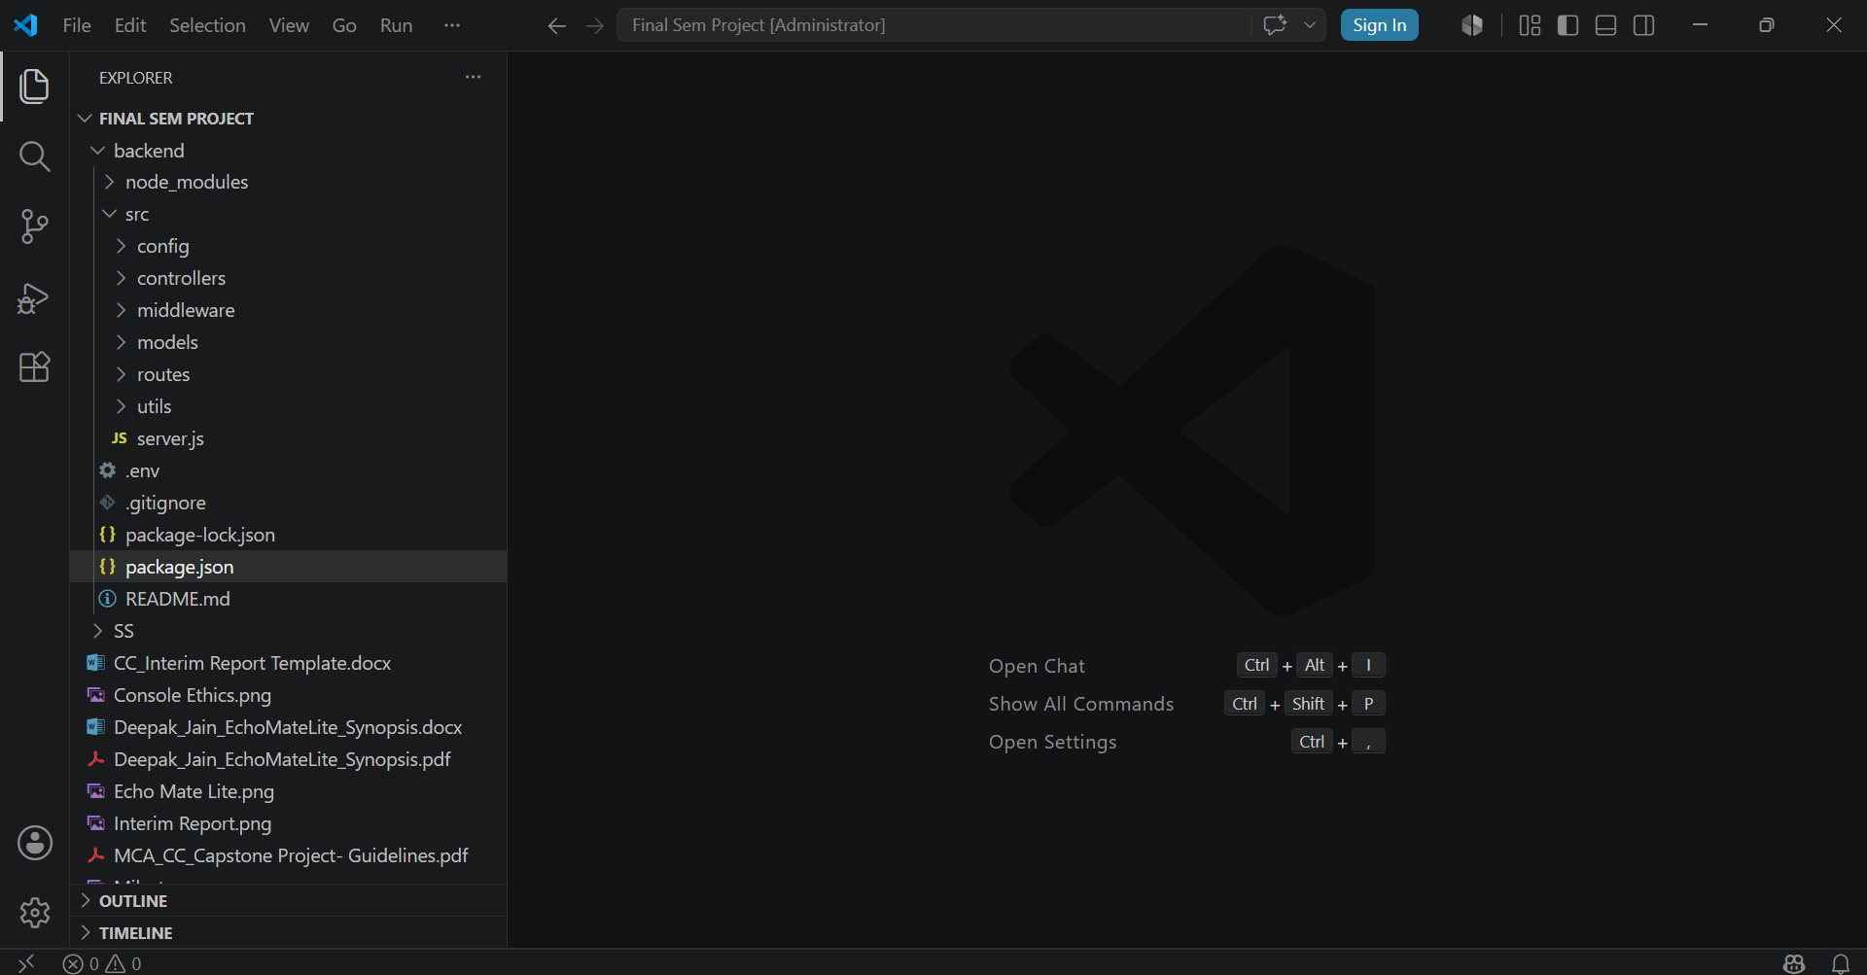

Figure A.2: GitHub repository (vedansh2806/EchoMateLite) after initial push, showing 3 commits and the complete project file listing.
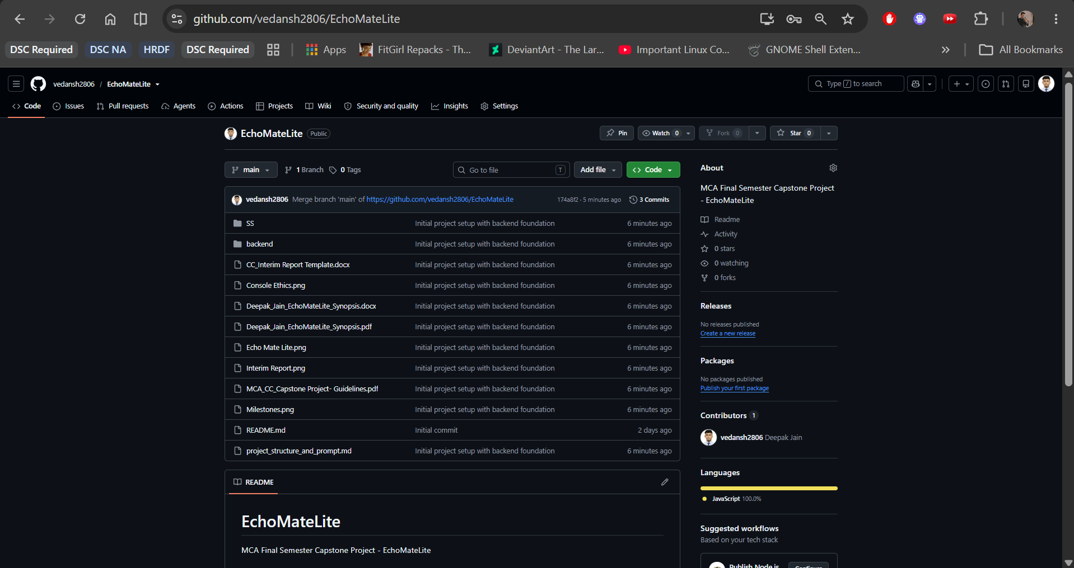

Figure A.3: MongoDB Atlas dashboard showing the "echomatelite-cluster" active on AWS Mumbai (ap-south-1) with M0 Free Tier, 142.72 MB / 512 MB usage, Replica Set with 3 nodes.
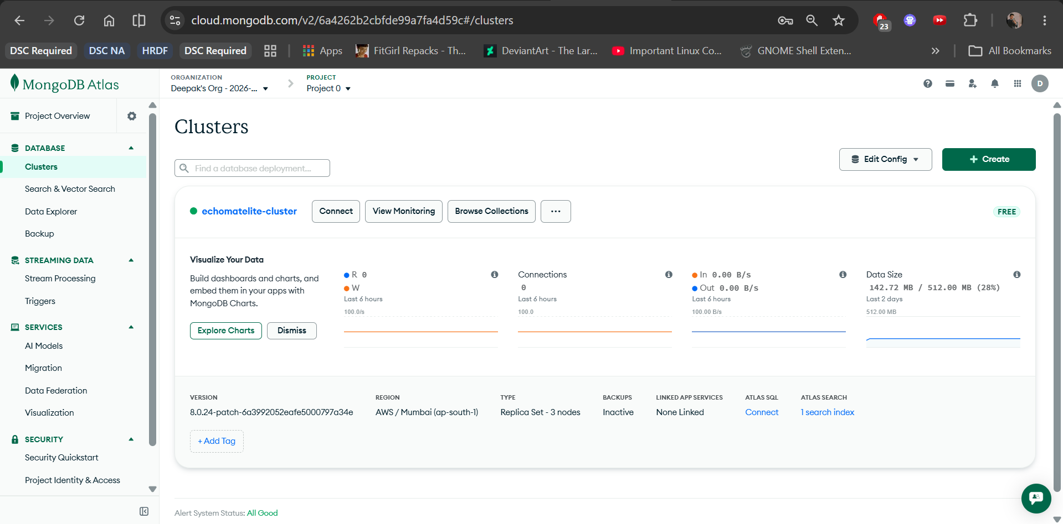

Figure A.4: VS Code explorer showing the complete User Authentication module: authController.js, authMiddleware.js, User.js model, authRoutes.js, and generateToken.js.
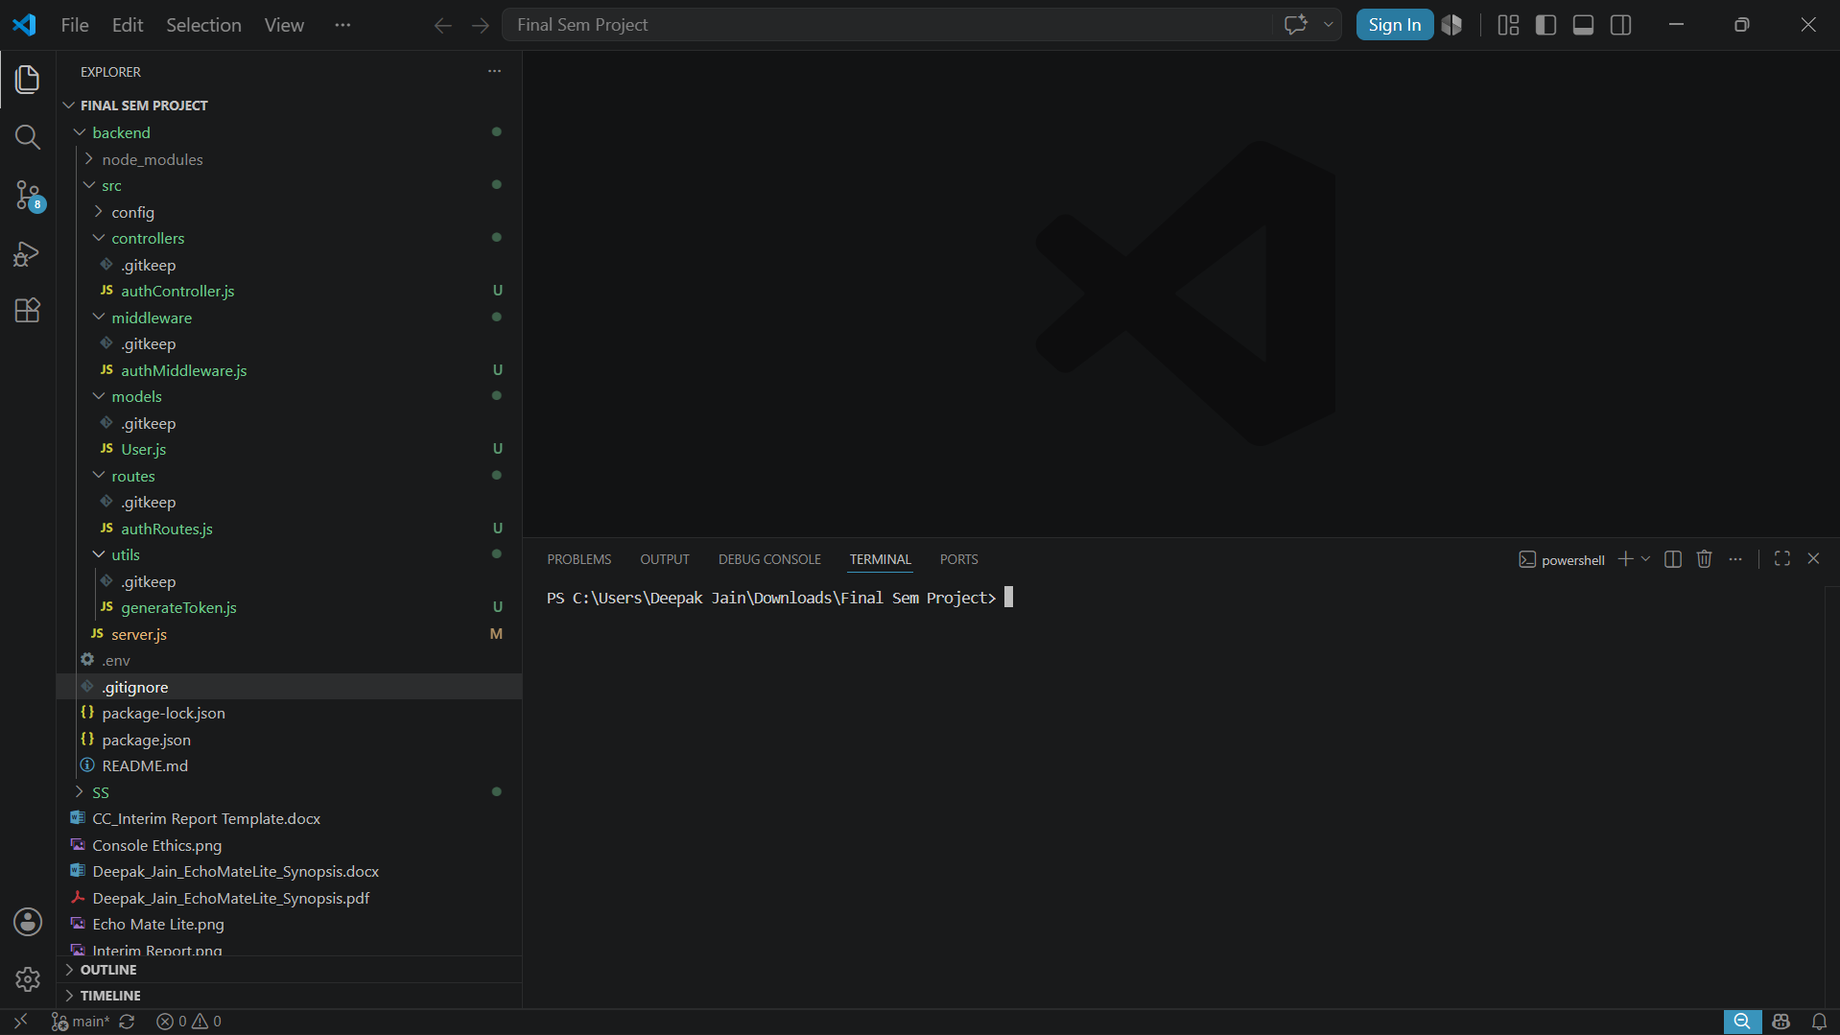

Figure A.5: Postman API test for POST /api/auth/register showing successful 201 Created response with JWT token, user object, and timestamp.
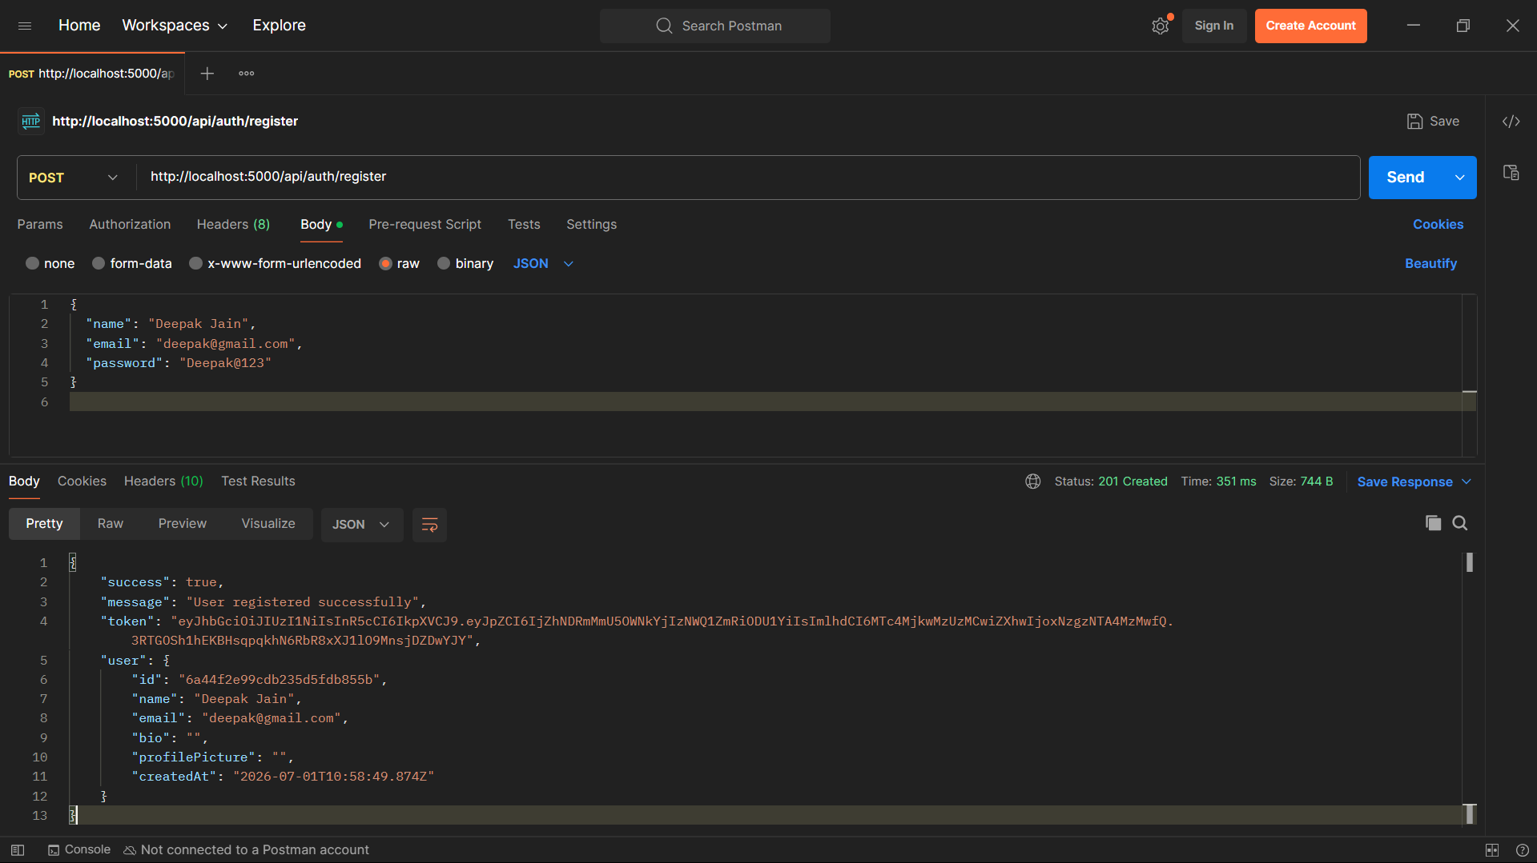

Figure A.6: VS Code terminal showing successful "npm run dev" execution with server startup banner and "MongoDB Connected" confirmation message.
