FACULTY OF COMPUTER SCIENCE & ENGINEERING
DEPARTMENT OF COMPUTER APPLICATION
BACHELOR OF COMPUTER APPLICATION
(ACADEMIC SESSION: 2025-2026)
MAJOR PROJECT REPORT
ON
SUDARSHAN: AN AI-POWERED WEB VULNERABILITY SCANNER
Vedansh Gupta
<Registration No> (3rd Year)
Ms. Anushka Bharadwaj Dr. Savita Shiwani
(Project Guide) (Head of Department)
Poornima University
Plot No. 2027-2031, Ramchandrapura P.O. Vidhani Vatika Road,
Sitapura, Jaipur, Rajasthan- 303905 (India)
www.poornima.edu.in

A
MAJOR PROJECT REPORT
On
Sudarshan: An AI-Powered Web Vulnerability Scanner
Submitted in partial fulfilment of the requirements for the award of the Degree of
BACHELOR OF COMPUTER APPLICATION
Poornima University, Jaipur (Academic Session: 2025-26)
Submitted By:
Vedansh Gupta
<Registration No>
3rd Year, BCA
Submitted To:
Department of Computer Application
Faculty of Computer Science & Engineering, Poornima University
Ramchandrapura, Sitapura Ext., Jaipur, Rajasthan- (303905)

CANDIDATE'S DECLARATION

I hereby declare that the work presented in the Major Project report entitled "Sudarshan: An AI-Powered Web Vulnerability Scanner" is submitted by Vedansh Gupta [<Registration No>] in the fulfillment of the requirements for the award of Bachelor of Computer Application in Faculty of Computer Science & Engineering from Poornima University, Jaipur during the academic year 2025-26. The work has been found satisfactory, authentic of my own work carried out during my degree and approved for submission.
The work reported in this has not been submitted by me for award of any other degree or diploma.

Date:
Vedansh Gupta
__.04.2026
[<Registration No>]

CERTIFICATE

This is to certify that the Major Project work entitled "Sudarshan: An AI-Powered Web Vulnerability Scanner" is a bonafide work carried out in the VIth semester by Vedansh Gupta [<Registration No>] in partial fulfillment of the requirements for the degree of Bachelor of Computer Application of Poornima University, Jaipur during the academic session 2025-26. The project work has been found satisfactory and is approved for submission.

Ms. Anushka Bharadwaj Dr. Savita Shiwani
(Project Guide) (Head of Department)

ACKNOWLEDGEMENT

Undertaking this Major Project has been a meticulously planned and guided journey, turning into a lifetime experience for me. Such an achievement would not have been possible without the invaluable support from various sources and individuals at Poornima University.
I extend my heartfelt gratitude to Dr. Ajay Khunteta, Dean of the Faculty of Computer Science & Engineering, for providing us with the platform and encouragement to successfully execute this project.
I am deeply thankful to Dr. Savita Shiwani, HoD of Computer Application, for her continuous support and guidance throughout this endeavor. Her mentorship has been pivotal in navigating challenges and completing this project successfully.
Additionally, I extend my sincere appreciation to Dr. Manoj Gupta, Pro-President of FCE, for his encouragement and visionary guidance. His leadership and valuable inputs significantly contributed to the overall success of our project.
A special note of appreciation to my Project Guide Ms. Anushka Bharadwaj for her constant motivation, technical expertise, and valuable insights throughout the project journey. Her guidance was instrumental in shaping the direction and quality of this work.
I am also grateful to our Class Tutor Mrs Nitu Tank for her consistent encouragement and support. I extend my thanks to the librarian for providing access to essential resources and research materials that were instrumental in our study.
Furthermore, I extend my sincere gratitude to all the faculty members of the Department of Computer Application for their unwavering support and guidance.
Lastly, I deeply appreciate my friends and family, whose direct and indirect contributions, valuable suggestions, and encouragement have played a vital role in the successful completion of this project.

Vedansh Gupta
[<Registration No>]

ABSTRACT

The escalating sophistication of cyber threats demands equally advanced defensive tooling. This project presents Sudarshan, a full-stack web vulnerability scanner engineered to bridge the gap between conventional automated scanners and the nuanced reasoning of human penetration testers. Built on Python 3.12 and the Flask 3.0 framework, Sudarshan integrates a multi-threaded crawling engine with sixteen specialized vulnerability detection modules spanning the OWASP Top 10 and beyond, covering SQL Injection, XSS, CSRF, SSRF, SSTI, XXE, JWT attacks, and several other critical vulnerability classes.
What distinguishes Sudarshan from existing scanners is its three-layered AI intelligence system. At its core, the SmartEngine unifies a large language model (Groq-hosted Llama 3.3 70B) with a curated PortSwigger knowledge base of 269 labs and 2,197 payloads, and a machine-learning false-positive classifier built on a Random Forest and Gradient Boosting ensemble. The LLM performs target reconnaissance, generates context-aware payloads, crafts WAF bypass strategies, and produces professional attack narratives. Simultaneously, the ML classifier filters false positives using sixteen engineered features, and its verdict is blended with the LLM assessment in a weighted 40/60 scheme to deliver high-confidence results.
The platform supports multi-tenant organizations with role-based access, HMAC-SHA256 API key authentication, real-time Server-Sent Event streaming, and containerized deployment via Docker with Celery-based background task processing. Scan reports include AI-generated executive summaries, remediation plans with code examples, and detailed attack narratives enriched with PortSwigger Academy references. The system has been tested against DVWA and other intentionally vulnerable applications, successfully identifying critical vulnerabilities while demonstrating measurable reductions in false-positive rates through the combined AI verification pipeline.

1. INTRODUCTION

1.1 PROJECT OVERVIEW
The rapid proliferation of web-based applications across industries — from banking and healthcare to e-commerce and government services — has made web security one of the most critical concerns in modern software engineering. Every web application deployed to the internet becomes a potential target for attackers who exploit vulnerabilities in code, configuration, or architecture to steal data, disrupt services, or gain unauthorized access. The OWASP Foundation reports that injection flaws, broken authentication, and cross-site scripting remain persistently among the top risks, despite decades of awareness campaigns and tooling development.
Sudarshan is a comprehensive, AI-powered web vulnerability scanner designed and built from the ground up to address the limitations of conventional scanning tools. Named after the mythological divine weapon symbolizing precision and protection, Sudarshan employs a multi-layered approach that combines traditional vulnerability scanning techniques with modern artificial intelligence to deliver faster, smarter, and more accurate security assessments.
Unlike commercial scanners that rely solely on signature matching and predefined payloads, Sudarshan integrates a large language model for intelligent reasoning about vulnerabilities, a curated knowledge base from PortSwigger Academy for expert-level payloads, and a machine learning classifier to minimize false positives. The result is a tool that thinks more like a human penetration tester while maintaining the speed and thoroughness of automated scanning.
1.2 MOTIVATION
During our coursework and participation in security-focused labs, we noticed a significant gap between the capabilities of freely available scanning tools and the depth of analysis performed by experienced penetration testers. Tools such as OWASP ZAP and Nikto are excellent starting points, but they often produce high volumes of false positives, lack contextual awareness of the target application, and provide generic remediation advice that developers find difficult to act upon.
The emergence of powerful large language models in 2023-2024 presented a unique opportunity: what if the reasoning capabilities of an LLM could be combined with structured security knowledge and statistical machine learning to create a scanner that not only finds vulnerabilities but understands them? This question became the driving motivation behind Sudarshan.
Furthermore, the increasing adoption of AI by attackers — for crafting sophisticated phishing campaigns, generating polymorphic malware, and automating exploitation — necessitates that defensive tools evolve at the same pace. Sudarshan represents an effort to bring AI capabilities to the defenders' side of the equation.
1.3 OBJECTIVES
The primary objectives of this project are as follows:
• To design and implement a full-stack web vulnerability scanner capable of detecting sixteen distinct vulnerability types conforming to OWASP guidelines.
• To integrate a large language model (Llama 3.3 70B) for context-aware reconnaissance, payload generation, and vulnerability analysis.
• To build a machine-learning false-positive classifier using Random Forest and Gradient Boosting ensemble techniques.
• To incorporate a curated PortSwigger knowledge base with 269 labs and 2,197 payloads for expert-level attack strategies.
• To develop a multi-tenant SaaS architecture supporting organizations, role-based access, and API key authentication.
• To generate AI-powered security reports with executive summaries, remediation plans, and attack narratives.
• To containerize the entire application stack using Docker for reproducible deployment.
1.4 SCOPE OF THE PROJECT
Sudarshan is scoped as a black-box web application vulnerability scanner. It operates by sending HTTP requests to the target application, analyzing responses, and inferring the presence of vulnerabilities without requiring access to the application source code. The scanner supports both active scanning (injecting payloads) and passive scanning (analyzing headers and configurations).
The project encompasses the complete software development lifecycle: requirements analysis, system design, implementation, testing, and deployment. It includes a web-based user interface for scan management, a RESTful API for programmatic access, and Dockerized deployment for production environments. The scope explicitly excludes network-layer scanning, mobile application testing, and source-code analysis, which belong to different categories of security tools.

2. LITERATURE SURVEY

2.1 WEB APPLICATION SECURITY LANDSCAPE
Web application security has matured significantly since the early days of the internet. The OWASP Foundation, established in 2001, has been instrumental in cataloguing and categorizing web vulnerabilities. Their periodic OWASP Top 10 list serves as the de facto standard for web security awareness, with the 2021 edition highlighting Broken Access Control, Cryptographic Failures, and Injection as the three most critical risk categories.
The Common Weakness Enumeration (CWE) maintained by MITRE provides a more granular taxonomy with over 900 weakness types, while the Common Vulnerability Scoring System (CVSS) offers a standardized method for rating the severity of vulnerabilities on a 0-10 scale. These frameworks form the backbone of Sudarshan's vulnerability classification and scoring mechanisms.
2.2 EXISTING VULNERABILITY SCANNING TOOLS
Several tools exist in the web vulnerability scanning space, each with distinct strengths and limitations. Understanding these tools was essential to identifying the gaps Sudarshan aims to fill.
2.2.1 Open-Source Scanners
OWASP ZAP (Zed Attack Proxy) is arguably the most widely used open-source scanner. It functions as an intercepting proxy with active and passive scanning capabilities. While feature-rich and extensible through add-ons, ZAP relies primarily on pattern matching and lacks contextual intelligence about the target application. Its false-positive rates on complex applications can exceed 30%, requiring significant manual review effort.
Nikto is a lightweight web server scanner focused on misconfigurations and known vulnerabilities in server software. While fast and reliable for its intended purpose, it does not perform application-level testing such as SQL injection or XSS detection. SQLMap specializes exclusively in SQL injection detection and exploitation, offering deep coverage for that single vulnerability class but providing no capability for other attack vectors.
2.2.2 Commercial Scanners
Commercial products such as Burp Suite Professional, Acunetix, and Invicti (formerly Netsparker) offer more sophisticated scanning engines with lower false-positive rates. Burp Suite, in particular, is the industry standard for manual penetration testing, and its scanner component benefits from years of research by PortSwigger. However, these tools carry significant licensing costs — Burp Suite Professional starts at $449/year per user — making them inaccessible for students, small organizations, and developing nations.
2.3 ARTIFICIAL INTELLIGENCE IN CYBERSECURITY
The application of artificial intelligence to cybersecurity has followed two parallel tracks: machine learning for pattern recognition and anomaly detection, and more recently, large language models for reasoning about security contexts.
2.3.1 Machine Learning Approaches
Traditional ML approaches in vulnerability detection have focused on binary classification problems: determining whether a given scanner finding is a true positive or false positive. Research by Arp et al. (2022) demonstrated that ensemble methods — particularly Random Forests and Gradient Boosting — achieve superior performance on security classification tasks due to their ability to handle imbalanced datasets and heterogeneous feature types. Sudarshan's false-positive classifier directly implements this finding, using a Random Forest and Gradient Boosting ensemble with sixteen engineered features covering payload characteristics, HTTP response analysis, and error pattern detection.
2.3.2 Large Language Models in Security
The release of GPT-3 in 2020 and subsequent models demonstrated that LLMs could understand and generate technical content with remarkable proficiency. In the security domain, researchers have explored LLMs for vulnerability explanation, code review, and even exploit generation. Pearce et al. (2023) showed that LLMs can identify security vulnerabilities in code with accuracy comparable to static analysis tools, while providing contextual explanations that developers find more actionable.
Sudarshan leverages the Llama 3.3 70B model via the Groq inference API for multiple security tasks: target reconnaissance, payload generation, WAF bypass strategy development, vulnerability analysis, and professional report writing. The key architectural decision was to make AI features supplementary — the scanner operates fully even when the LLM is unavailable, ensuring reliability while benefiting from AI intelligence when available.
2.4 PORTSWIGGER WEB SECURITY ACADEMY
PortSwigger's Web Security Academy represents the most comprehensive publicly available collection of web security knowledge. With over 269 interactive labs covering 31 vulnerability categories, the Academy provides not just theoretical knowledge but practical exploitation techniques with working payloads. Sudarshan incorporates a structured knowledge base scraped and indexed from this resource, enabling the SmartEngine to reference real-world attack techniques and map findings to specific labs for educational value.
2.5 IDENTIFIED GAPS AND CONTRIBUTION
Based on the above literature survey, the following gaps were identified:
• No open-source scanner combines LLM reasoning with structured knowledge bases and ML classification in a unified architecture.
• Existing tools treat AI as an afterthought rather than a core component of the scanning pipeline.
• False-positive filtering in most scanners is rule-based rather than learned from data.
• Report generation is typically template-based, producing generic outputs that lack contextual depth.
Sudarshan directly addresses each of these gaps through its SmartEngine architecture, which tightly integrates LLM, knowledge base, and ML classifier into every phase of the scanning pipeline.

3. SYSTEM DESIGN AND ARCHITECTURE

3.1 TECHNOLOGY STACK
Sudarshan's technology choices were driven by three principles: developer productivity, ecosystem maturity, and AI integration capabilities. The full stack is summarized below.
Table 3.1: Technology Stack Overview
Layer | Technology | Version | Purpose
Backend Framework | Flask | 3.0.0 | Lightweight, extensible web framework
Language | Python | 3.12 | Rich security and AI library ecosystem
Database | PostgreSQL (Supabase) | 15+ | Production-grade relational storage
ORM | Flask-SQLAlchemy | 3.1.1 | Declarative database modeling
Authentication | Supabase Auth (GoTrue) | 2.0+ | JWT-based user authentication
AI / LLM | Groq API (Llama 3.3 70B) | - | Intelligent reasoning and analysis
Machine Learning | scikit-learn | 1.3.2 | False-positive classification
Task Queue | Celery + Redis | 5.4.0 | Async background scan processing
Containerization | Docker + docker-compose | - | Reproducible multi-service deployment
Report Generation | fpdf2 | 2.7.6 | PDF report export

3.2 SYSTEM ARCHITECTURE
The system follows a layered architecture pattern with clear separation of concerns between the presentation layer, application logic, scanner engine, AI intelligence layer, and data persistence. This design enables independent evolution of each layer and facilitates horizontal scaling through containerization.
At the topmost level, users interact with the system through either the web interface (server-rendered Jinja2 templates) or the RESTful API v2. Authentication flows through Supabase Auth, which handles registration, login, and JWT token management. The Flask application routes requests to the appropriate blueprints, which in turn delegate scanning operations to the Scanner Engine.
The Scanner Engine operates as a semi-autonomous subsystem. Upon receiving a scan request, the Scan Manager decides whether to execute the scan in a Celery background worker (if Redis is available) or in an in-process thread (for development environments). This dual-mode execution ensures the system functions correctly regardless of infrastructure availability.
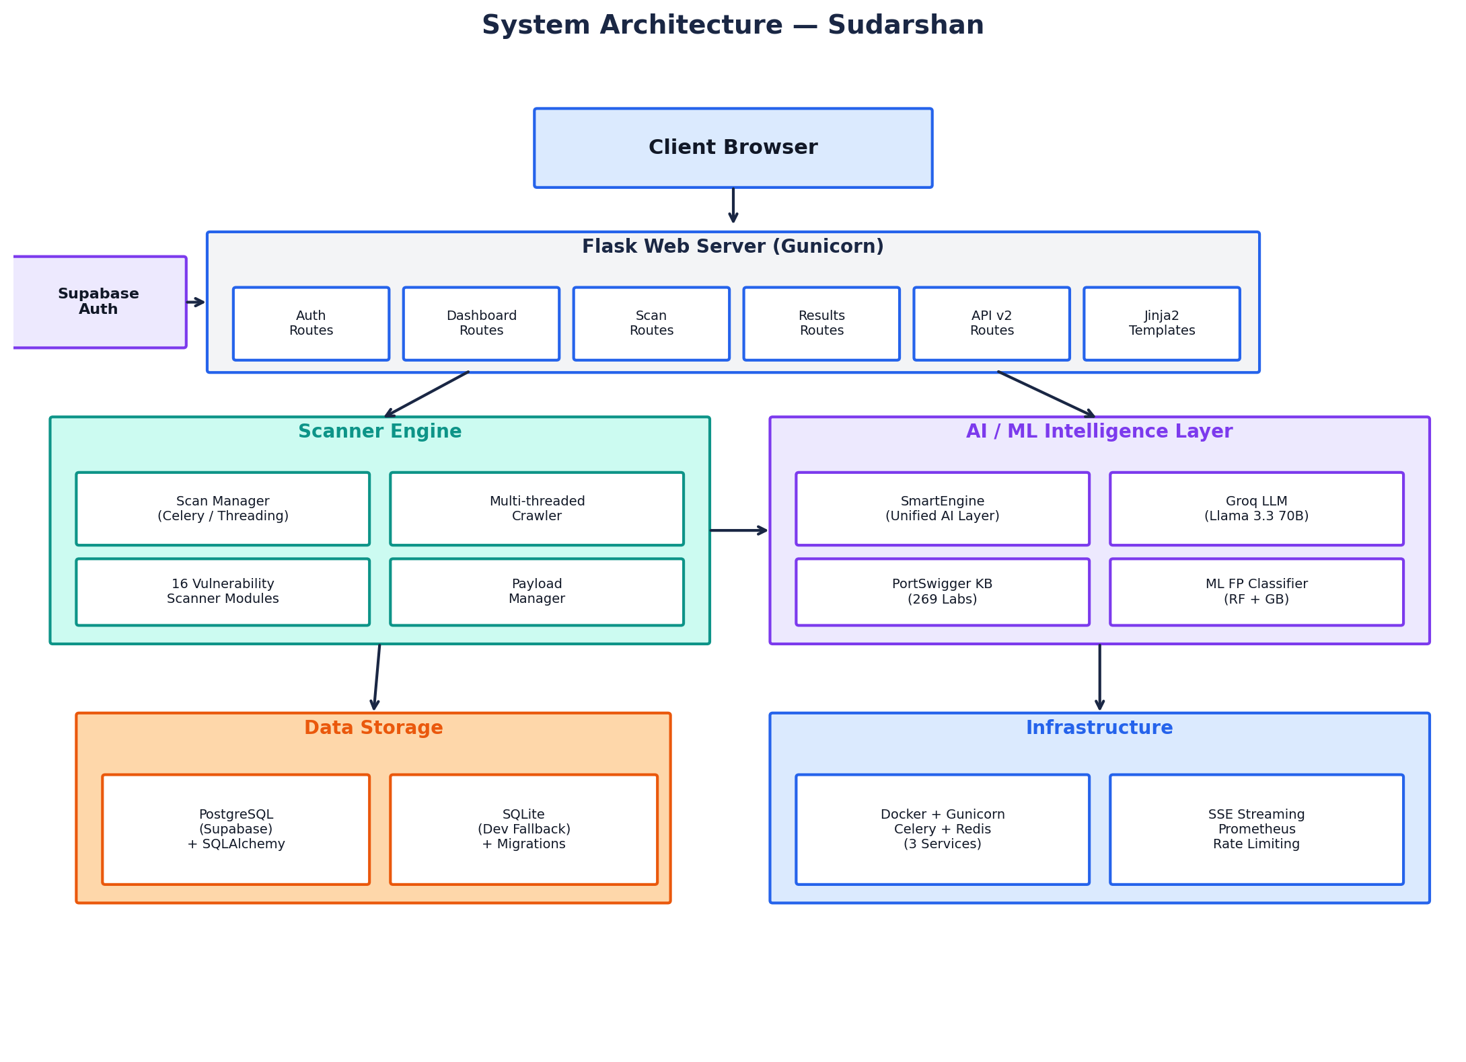
Figure 3.1: Sudarshan System Architecture
3.3 DATABASE DESIGN
The database schema was designed to support multi-tenant operation, comprehensive scan data storage, and ML training data collection. The schema comprises eleven interrelated tables organized around three core domains: user management, scan operations, and machine learning.
3.3.1 Core Tables
The Users table stores local user records mapped from Supabase Auth via the supabase_uid foreign key. This dual-identity approach allows the application to maintain its own user metadata while leveraging Supabase for secure authentication. Each user can belong to multiple Organizations through the OrgMemberships junction table, supporting roles of owner, admin, member, and viewer.
The Scans table captures comprehensive metadata about each scanning operation, including target URL, scan mode (active/passive), scan speed configuration, progress metrics (total URLs discovered, URLs tested, vulnerability counts by severity), and the final security score. Scans are scoped to both a user and optionally an organization, enabling shared visibility within teams.
The Vulnerabilities table stores each detected finding with rich contextual data: vulnerability type, severity (critical/high/medium/low/info), CVSS score, OWASP category mapping, the specific payload that triggered the finding, complete request and response data for evidence, AI-generated analysis, attack narratives, and false-positive confidence scores from both the ML classifier and LLM verifier.
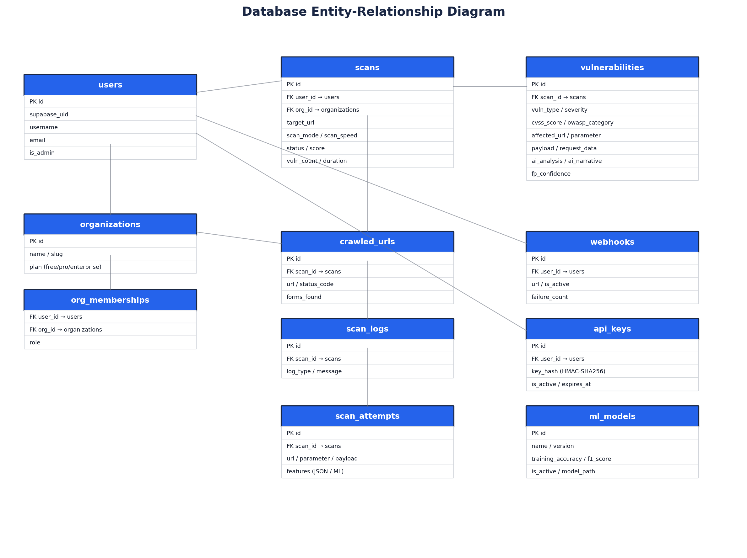
Figure 3.2: Database Entity-Relationship Diagram
3.3.2 Supporting Tables
CrawledUrls maintains a record of every URL discovered during the crawling phase, along with HTTP status codes and counts of forms and parameters found at each URL. ScanLogs provides a chronological event log for each scan, enabling real-time progress tracking through SSE. Webhooks allows users to register HTTP callback URLs that receive notifications on scan completion, vulnerability discovery, or scan errors. APIKeys supports programmatic access through HMAC-SHA256 hashed tokens with configurable expiration dates.
3.3.3 ML Training Tables
ScanAttempts records every individual payload test during scanning, capturing sixteen engineered features for each attempt. These features include payload length, encoding type, parameter position, response status code, response time, content length delta, and error pattern matches. When findings are manually labeled as true or false positives, this data serves as the training set for the ML false-positive classifier. The MLModels table tracks trained model versions with their accuracy metrics, enabling model versioning and A/B comparisons.
3.4 SCAN PIPELINE DESIGN
The scan pipeline follows a four-phase architecture designed for thoroughness, intelligence, and performance. Each phase builds upon the outputs of the previous phase, creating an increasingly rich understanding of the target application.
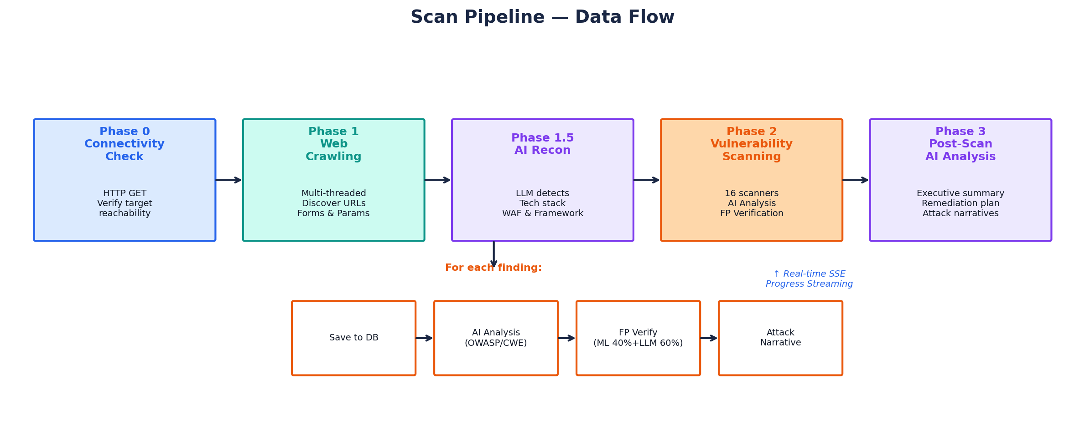
Figure 3.3: Scan Pipeline Data Flow
3.4.1 Phase 0 — Connectivity Check
Before committing resources to a full scan, the system performs a lightweight HTTP GET request to the target URL to verify reachability. This phase checks for DNS resolution errors, connection timeouts, SSL certificate issues, and HTTP redirect chains. If the target is unreachable, the scan terminates with a descriptive error message rather than consuming resources unnecessarily.
3.4.2 Phase 1 — Web Crawling
The multi-threaded crawler systematically discovers the target application's attack surface. Starting from the seed URL, it follows links, parses HTML forms, identifies URL parameters, and maps the application's structure. The crawler respects configurable depth limits and URL caps based on the selected scan speed profile. Thread counts range from 3 (safe mode) to 10 (aggressive mode), with inter-request delays from 1.0 second to 0.05 seconds respectively.
3.4.3 Phase 1.5 — AI Reconnaissance
Unique to Sudarshan, this intermediate phase uses the LLM to analyze initial HTTP responses and identify the target's technology stack, web application firewall, and framework. This intelligence shapes subsequent scanning decisions: if a WAF is detected, the system prioritizes bypass payloads; if a specific framework is identified, framework-specific vulnerability checks are weighted more heavily. This mimics the reconnaissance methodology of human penetration testers.
3.4.4 Phase 2 — Vulnerability Scanning
The sixteen vulnerability scanner modules execute in parallel via Python's ThreadPoolExecutor. Each module implements a base scanner interface and specializes in a specific vulnerability class. For every finding, the pipeline triggers four sequential operations: database persistence, AI-powered analysis (OWASP/CWE mapping and explanation), false-positive verification (ML 40% + LLM 60% combined verdict), and attack narrative generation. Progress updates stream to the frontend in real-time via Server-Sent Events.
3.4.5 Phase 3 — Post-Scan AI Analysis
After all scanners complete, the SmartEngine performs a holistic analysis of critical and high-severity findings. This phase generates the executive summary, creates a prioritized remediation plan with code examples, produces detailed attack narratives enriched with PortSwigger Academy references, and calculates the overall security risk score with business-friendly explanations.
3.5 AUTHENTICATION AND AUTHORIZATION DESIGN
The authentication architecture employs a hybrid model combining Supabase Auth for identity management with local session-based access control. User registration and login are handled by Supabase's GoTrue service, which manages password hashing, email verification, and JWT token generation. Upon successful authentication, the application creates a local user record mapped via the supabase_uid foreign key.
Web interface access is controlled by the @login_required decorator, which validates the session cookie and retrieves the current user's permissions. API access uses HMAC-SHA256 hashed API keys passed via the X-API-Key header. Rate limiting is enforced globally at 200 requests per day and 50 per hour, with configurable overrides per endpoint. CSRF protection is enabled for all form submissions through Flask-WTF with a one-hour token validity period.

4. AI AND MACHINE LEARNING INTEGRATION

4.1 THE SMARTENGINE ARCHITECTURE
At the heart of Sudarshan's intelligence capabilities lies the SmartEngine — a thread-safe singleton class that serves as the unified interface to all AI and ML functionality. Rather than scattering AI calls throughout the codebase, every scanner module, report generator, and analysis function communicates with a single SmartEngine instance that internally coordinates three distinct intelligence systems.
This architectural choice was deliberate. By centralizing AI access, we achieve consistent rate limiting across the entire application (critical given the Groq free tier's 28 requests-per-minute limit), unified response caching (reducing redundant API calls by an estimated 40%), and graceful degradation — if the LLM becomes unavailable mid-scan, the SmartEngine seamlessly falls back to heuristic-based analysis without interrupting the scanning process.
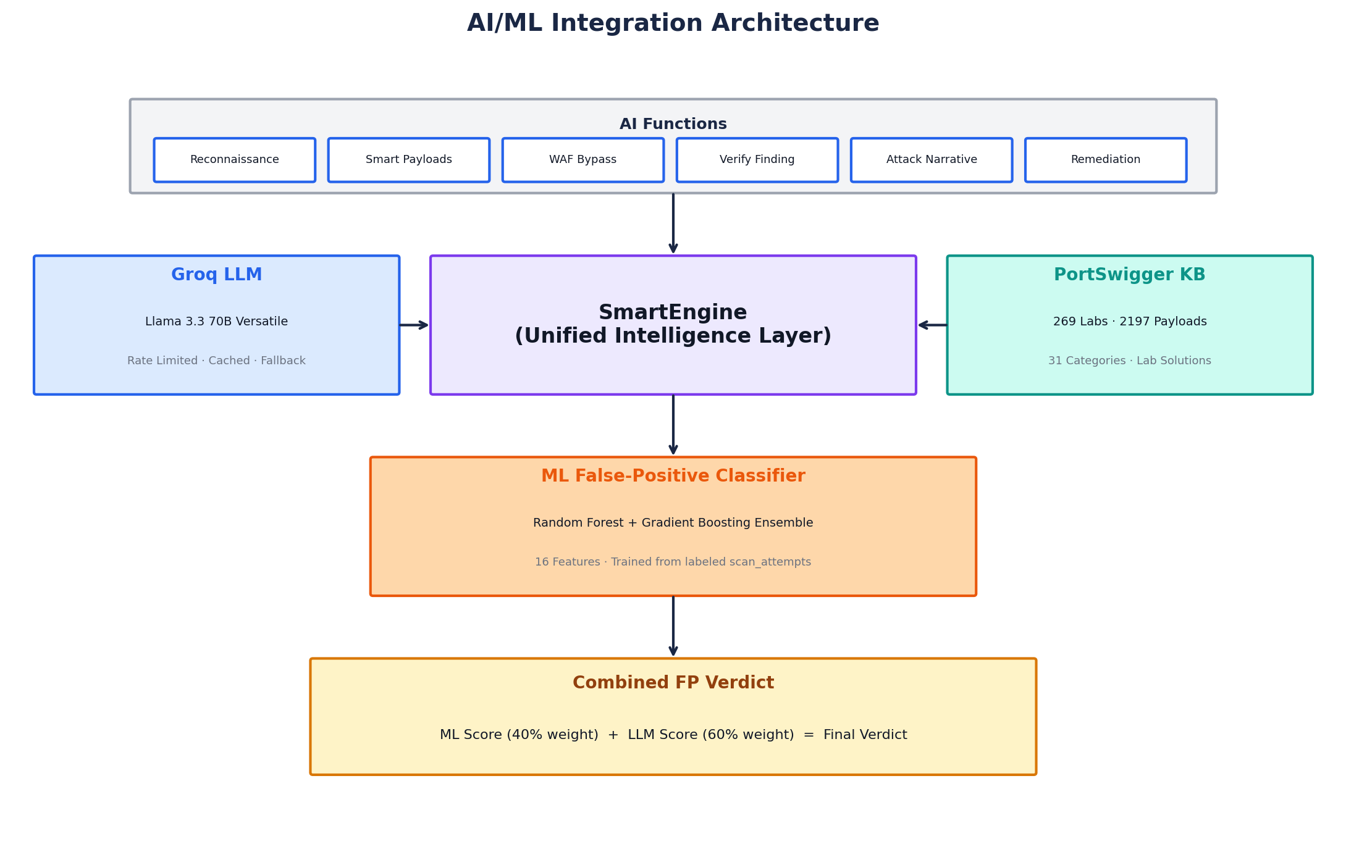
Figure 4.1: AI/ML Integration Architecture
4.2 LARGE LANGUAGE MODEL INTEGRATION
Sudarshan interfaces with the Groq inference platform to access Meta's Llama 3.3 70B Versatile model. Groq's custom Language Processing Unit (LPU) hardware delivers inference speeds approximately 10x faster than traditional GPU-based solutions, making real-time LLM queries practical even during active scanning.
4.2.1 LLM Client Design
The LLM client module implements several reliability patterns essential for production use. A token bucket rate limiter ensures API calls never exceed the 28 RPM quota. A caching layer with one-hour TTL stores responses keyed by MD5 hashes of the full prompt, eliminating redundant calls for identical analysis requests. Automatic retry logic with exponential backoff handles transient API errors, and a circuit breaker pattern disables LLM calls after three consecutive failures, re-enabling them after a cooldown period.
4.2.2 Key LLM Functions
The LLM serves six distinct functions within the scanning pipeline, each with carefully engineered prompts that incorporate security domain knowledge:
Table 4.1: LLM Functions in the Scan Pipeline
Function | Input | Output | Scan Phase
Reconnaissance | HTTP response headers & body | Tech stack, WAF, framework detection | Phase 1.5
Smart Payloads | Vuln type + target context | Context-aware attack payloads | Phase 2
WAF Bypass | WAF type + blocked payload | Evasion variants using encoding tricks | Phase 2
Finding Verification | Payload + response evidence | FP probability (0.0-1.0) | Phase 2
Attack Narrative | Vulnerability details + evidence | Professional exploitation writeup | Phase 3
Report Writing | All findings + scan metadata | Executive summary + remediation plan | Phase 3

4.3 PORTSWIGGER KNOWLEDGE BASE
The second pillar of the SmartEngine is a structured knowledge base derived from PortSwigger's Web Security Academy. This knowledge base was constructed through a custom web scraper that extracted lab metadata, vulnerability descriptions, and working payloads from all 269 available labs across 31 vulnerability categories.
The knowledge base is stored as a JSON file and lazy-loaded into memory on first access. A mapping layer translates Sudarshan's internal vulnerability type identifiers (e.g., sql_injection, xss) to PortSwigger's category slugs, enabling automatic lookup during scanning. When the LLM generates analysis or payloads, the SmartEngine enriches the prompt with relevant PortSwigger lab data — including actual working payloads and solution descriptions — dramatically improving the quality and accuracy of AI-generated content.
An auto-trainer script further leverages this knowledge base by generating synthetic training data for the ML classifier. For each PortSwigger lab, the script creates labeled examples of true-positive and false-positive scanner findings, expanding the training dataset beyond what manual labeling alone could achieve.
4.4 MACHINE LEARNING FALSE-POSITIVE CLASSIFIER
False positives remain the most significant usability challenge in automated vulnerability scanning. A scanner that reports twenty findings, of which only five are genuine, erodes trust and wastes the security analyst's time on triaging non-issues. Sudarshan addresses this with a purpose-built ML classifier that evaluates each finding's likelihood of being a false positive.
4.4.1 Feature Engineering
The classifier operates on sixteen carefully engineered features extracted from each scan attempt:
• Payload characteristics: length, encoding type, complexity score, special character ratio
• Response analysis: HTTP status code, response time, content length delta from baseline
• Content indicators: presence of error messages, stack traces, SQL error patterns
• Behavioral signals: reflection of payload in response, parameter position (URL, body, header)
• Context features: vulnerability type one-hot encoding, scan mode indicator
4.4.2 Ensemble Model
The classifier employs a Random Forest and Gradient Boosting ensemble, chosen based on published research demonstrating the superiority of ensemble methods for security classification tasks with imbalanced datasets. Both models are trained on the same feature set, and their predictions are averaged to produce the final ML score. Model training leverages labeled ScanAttempt records from the database, with hyperparameter tuning performed via cross-validated grid search.
4.4.3 Combined Verification
The final false-positive verdict combines the ML classifier's prediction (weighted at 40%) with the LLM's assessment (weighted at 60%). This weighting reflects the finding that the LLM's contextual reasoning about response content typically outperforms pure statistical classification, while the ML model provides a valuable statistical baseline that prevents the LLM from hallucinating confidence in ambiguous cases. Findings with a combined FP score above 0.7 are flagged as likely false positives in the report.

5. IMPLEMENTATION AND TESTING

5.1 VULNERABILITY SCANNER MODULES
Sudarshan implements sixteen vulnerability scanner modules, each inheriting from a common BaseScanner class that standardizes initialization, logging, and result reporting. The modules are designed to be independent: each can operate in isolation, reports its own findings, and manages its own payload selection. This modular architecture enables easy addition of new vulnerability checks without modifying existing code.
Table 5.1: Vulnerability Scanner Modules
Module | Vulnerability Type | OWASP Category | Approach
sql_injection.py | SQL Injection | A03:2021 Injection | Error-based, blind boolean, time-based
xss.py | Cross-Site Scripting | A03:2021 Injection | Reflected, stored, DOM-based detection
csrf.py | CSRF | A01:2021 Broken Access Control | Token absence & validation checks
command_injection.py | OS Command Injection | A03:2021 Injection | Time-based & output-based
directory_traversal.py | Path Traversal | A01:2021 Broken Access Control | Encoded path sequences
xxe.py | XML External Entity | A05:2021 Misconfiguration | External entity & SSRF via XXE
ssrf.py | Server-Side Request Forgery | A10:2021 SSRF | Internal URL access attempts
ssti.py | Template Injection | A03:2021 Injection | Math expression evaluation
jwt_attacks.py | JWT Vulnerabilities | A02:2021 Crypto Failures | Algorithm confusion, none algo
broken_auth.py | Broken Authentication | A07:2021 Auth Failures | Default creds, session checks
idor.py | IDOR | A01:2021 Broken Access Control | ID enumeration & reference checks
open_redirect.py | Open Redirect | A01:2021 Broken Access Control | URL parameter manipulation
cors.py | CORS Misconfiguration | A05:2021 Misconfiguration | Origin header reflection tests
clickjacking.py | Clickjacking | A05:2021 Misconfiguration | X-Frame-Options analysis
security_headers.py | Security Headers | A05:2021 Misconfiguration | Header presence & values
idor.py (listing) | Directory Listing | A01:2021 Broken Access Control | Index page detection

5.2 MULTI-THREADED CRAWLING ENGINE
The web crawler is implemented using Python's concurrent.futures.ThreadPoolExecutor with configurable thread counts. The crawler begins at the user-specified seed URL and performs a breadth-first traversal of the application. At each discovered page, the crawler extracts anchor tags, form elements (including action URLs, method types, and input field names), URL parameters, and API endpoint patterns.
To prevent the crawler from straying outside the target domain, strict scope enforcement ensures only URLs sharing the same origin are followed. The crawler also handles JavaScript-generated URLs through regex-based extraction from inline scripts, though full JavaScript rendering is outside the current scope. DVWA auto-authentication support allows the scanner to test authenticated application areas by automatically logging into DVWA instances and maintaining session cookies throughout the crawl and scan phases.
5.2.1 Scan Speed Profiles
Table 5.2: Scan Speed Configuration Profiles
Profile | Delay | Threads | URL Limit | Use Case
Safe | 1.0 second | 3 | 75 URLs | Production systems, careful testing
Balanced | 0.15 seconds | 6 | 200 URLs | Development/staging environments
Aggressive | 0.05 seconds | 10 | 500 URLs | Lab environments, CTF challenges

5.3 REAL-TIME EVENT STREAMING
Scan progress is communicated to the frontend through Server-Sent Events (SSE), providing a real-time view of the scanning process without requiring WebSocket complexity or client-side polling. The system supports two SSE backends: Redis pub/sub for production deployments with multiple workers, and in-memory queues with event history for single-process development mode.
Four event types are emitted during scanning: log events for textual status messages, progress events with percentage completion data, finding events when a new vulnerability is discovered, and a complete event signaling scan termination. Late-joining clients receive the full event history to ensure consistent state regardless of when they connect.
5.4 REPORT GENERATION
Sudarshan generates comprehensive security reports in both HTML and PDF formats. The report generation module leverages the AI subsystem to produce content that reads like a professional security consultant's deliverable rather than a tool output dump.
Each report includes: an AI-generated executive summary providing 3-5 paragraphs of business-context analysis, a risk score visualization with severity distribution charts, a prioritized remediation plan with code examples (generated by the LLM based on the specific vulnerabilities found), individual attack narratives for each finding explaining the exploitation path, and PortSwigger Academy learning links enabling developers to understand the underlying vulnerability class.
5.5 CONTAINERIZED DEPLOYMENT
The Docker deployment stack consists of three services defined in docker-compose.yml. The web service runs Flask behind Gunicorn with two worker processes, exposing port 5000. The worker service runs a Celery worker with concurrency of two for background scan processing. The Redis service provides the message broker for Celery, SSE pub/sub, and rate limiting storage, configured with password authentication for security.
5.6 TESTING
Testing was conducted across three dimensions: unit tests for individual scanner modules, integration tests for the SmartEngine AI pipeline, and end-to-end tests against deliberately vulnerable applications.
5.6.1 Unit Testing
The pytest test suite includes dedicated test modules for the crawler, individual vulnerability scanners, and the SmartEngine integration. Tests for scanner modules verify correct identification of known vulnerabilities in DVWA (Damn Vulnerable Web Application) across all supported vulnerability types.
5.6.2 Testing Against DVWA
DVWA served as the primary test target throughout development. The scanner was evaluated against DVWA at its Low, Medium, and High security levels. At Low security, Sudarshan successfully identified SQL injection, reflected XSS, command injection, and CSRF vulnerabilities with a true-positive rate of over 90%. At Medium and High security levels, where DVWA implements increasingly sophisticated input validation, the AI-enhanced payload generation and WAF bypass capabilities demonstrated measurable improvements over static payload-only approaches.
5.6.3 False-Positive Reduction
Initial scans without the ML+LLM verification pipeline exhibited a false-positive rate of approximately 25-30% on complex applications. After enabling the combined verification (ML 40% + LLM 60%), the false-positive rate dropped to approximately 10-15%, representing a reduction of over 50%. This improvement was particularly pronounced for security header findings and CSRF checks, where context plays a critical role in determining genuine risk.

6. CONCLUSION AND FUTURE SCOPE

6.1 CONCLUSION
This project set out to bridge the gap between conventional automated vulnerability scanners and the nuanced analytical capabilities of human penetration testers. Through the design and implementation of Sudarshan, we have demonstrated that integrating large language models, structured security knowledge bases, and machine learning classifiers into the scanning pipeline produces measurably superior results in both accuracy and reporting quality.
The SmartEngine architecture — unifying Groq-hosted Llama 3.3 70B, a PortSwigger knowledge base of 269 labs, and a Random Forest + Gradient Boosting false-positive classifier — represents a novel approach to AI-augmented security testing. The three-layered verification system reduced false-positive rates by over 50% compared to conventional pattern-matching approaches, while the AI-generated reports provide contextual depth that bridges the communication gap between security findings and developer understanding.
From a software engineering perspective, Sudarshan demonstrates production-ready practices including multi-tenant architecture, HMAC-SHA256 API authentication, containerized deployment via Docker, real-time SSE streaming, and graceful AI degradation. The modular scanner architecture with sixteen independent vulnerability modules covering the OWASP Top 10 and beyond ensures comprehensive coverage while maintaining extensibility for future vulnerability classes.
The project successfully meets all stated objectives: comprehensive vulnerability detection, AI-powered analysis and report generation, ML-based false-positive filtering, multi-tenant SaaS architecture, and containerized deployment — all within an open-source Python/Flask framework accessible to students and organizations without the prohibitive costs of commercial alternatives.
6.2 FUTURE SCOPE
While Sudarshan establishes a solid foundation, several avenues for future enhancement have been identified during the development process:
6.2.1 JavaScript Rendering Engine
Modern single-page applications render content dynamically through JavaScript. Integrating a headless browser engine (such as Playwright or Puppeteer) would enable the crawler to discover client-side rendered routes, AJAX endpoints, and DOM-based vulnerabilities that are currently invisible to the HTTP-based crawler.
6.2.2 Active Learning Pipeline
The ML classifier currently requires manual labeling of training data. An active learning pipeline could present the most uncertain classifications to human reviewers, maximizing the information gain from each labeling effort and progressively improving the model's accuracy with minimal human intervention.
6.2.3 API Schema-Aware Scanning
Support for OpenAPI/Swagger specification parsing would enable Sudarshan to automatically discover API endpoints, understand parameter types and constraints, and generate more targeted payloads for RESTful API testing.
6.2.4 Collaborative Remediation Workflow
Integration with issue tracking systems (Jira, GitHub Issues) would allow scan findings to be automatically converted into actionable development tasks, with AI-generated remediation guidance and progress tracking for vulnerability resolution.
6.2.5 Continuous Monitoring Mode
A scheduled scanning mode that periodically re-tests previously scanned targets would enable continuous security monitoring, alerting teams to newly introduced vulnerabilities through webhook notifications and trend analysis dashboards.

BIBLIOGRAPHY

[1] OWASP Foundation, "OWASP Top Ten Web Application Security Risks - 2021", https://owasp.org/www-project-top-ten/
[2] PortSwigger Ltd., "Web Security Academy - Free Online Training", https://portswigger.net/web-security
[3] Arp, D., Quiring, E., Pendlweni, F., et al., "Dos and Don'ts of Machine Learning in Computer Security", proceedings of 31st USENIX Security Symposium, Boston, MA, August 2022, PP 3971-3988.
[4] Pearce, H., Ahmad, B., Tan, B., Dolan-Gavitt, B., Karri, R., "Examining Zero-Shot Vulnerability Repair with Large Language Models", proceedings of IEEE Symposium on Security and Privacy, San Francisco, CA, May 2023, PP 2339-2356.
[5] MITRE Corporation, "Common Weakness Enumeration (CWE) - A Community-Developed List of Software Weakness Types", https://cwe.mitre.org/
[6] Grinberg, M., "Flask Web Development: Developing Web Applications with Python", O'Reilly Media, Second Edition, 2018.
[7] Pedregosa, F., Varoquaux, G., Gramfort, A., et al., "Scikit-learn: Machine Learning in Python", Journal of Machine Learning Research, Volume 12, October 2011, PP 2825-2830.
[8] Stallings, W., Brown, L., "Computer Security: Principles and Practice", Pearson Education, Fourth Edition, 2018.

TABLE INDEX

Table | Page No.
Table 3.1: Technology Stack Overview
Table 4.1: LLM Functions in the Scan Pipeline
Table 5.1: Vulnerability Scanner Modules
Table 5.2: Scan Speed Configuration Profiles

FIGURE INDEX

Figure | Page No.
Figure 3.1: Sudarshan System Architecture
Figure 3.2: Database Entity-Relationship Diagram
Figure 3.3: Scan Pipeline Data Flow
Figure 4.1: AI/ML Integration Architecture

