**ABSTRACT**

**AREA :** DEEP LEARNING

**SPECIALIZATION :** GENERATIVE ADVERSARIAL NETWORKS (GANs)

**IMPLEMENTATION :** IMAGE SYNTHESIZER USING GANs

**USE CASE :** SECURITY SYSTEMS AND MILITARY USAGE

**Overview of GANs**

Generative adversarial networks (GANs) are deep neural net architectures comprised of two nets, pitting one against the other (thus the “adversarial”). GANs’ potential is huge, because they can learn to mimic any distribution of data. That is, GANs can be taught to create worlds eerily similar to our own in any domain: images, music, speech, prose.

One neural network, called the *generator*, generates new data instances, while the other, the *discriminator*, evaluates them for authenticity; i.e. the discriminator decides whether each instance of data that it reviews belongs to the actual training dataset or not.

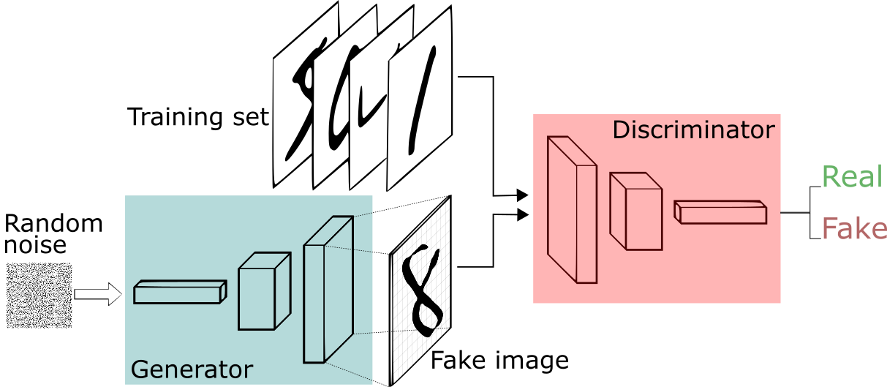

**Fig :** Architecture of a GAN

**TEAM MEMBERS :**

Vedansh Chandra Dwivedi. Ashish Ranjan

Shreya Krishna. Ayush Kasera

Ashish Kumar Mishra