Shri Ramdeobaba College of Engineering & Management, Nagpur
Department of Data Science
Session: 2025-26 [Even Semester]
VI Semester

Project Title: Intelligent Solar Energy Planning and Performance Forecasting System.

Problem Definition:
The growing demand for electricity and rising energy costs have increased the need for solar energy adoption. However, planning a solar power system is often difficult due to lack of technical knowledge, unclear cost and subsidy details, and absence of reliable energy forecasting tools. Existing solutions do not provide a complete and integrated approach, leading to inefficient planning and slower adoption. Therefore, a smart, data-driven system is needed to simplify solar planning and support better decision-making.
Project Objectives:
The objective of this project is to develop an intelligent solar energy planning system that assists users in designing efficient and scalable solar installations. The system aims to:
  - Estimate optimal solar capacity and number of panels based on available area and energy demand
  - Calculate installation cost, applicable government subsidies, and final investment value
  - Predict monthly and annual electricity generation
  - Analyze electricity bill reduction and long-term cost savings
  - Forecast future system performance using machine learning techniques
Proposed Plan of Work:
- Requirement Analysis and Study:
  - Study various solar panel technologies, efficiency levels, lifespan, and installation standards to define realistic system parameters.
  - Analyze government subsidy schemes, financial incentives, and current industry cost benchmarks to ensure accurate cost estimation.
  - Collect and analyze solar irradiance data and electricity consumption datasets required for energy calculation and machine learning model training.
- System Design:
  - Design the overall system architecture and functional workflow of the application.
  - Identify key input parameters such as rooftop area, geographical location, electricity tariff, and panel specifications.
  - Define output metrics including installed capacity, total cost, subsidy amount, expected energy generation, and bill savings.
- Module Development:
  - Develop an area-based solar capacity estimation module to calculate feasible installed capacity and number of solar panels.
  - Implement a cost estimation and subsidy calculation module to compute installation cost after applying applicable subsidies.
  - Create an energy generation and electricity bill reduction module to estimate annual power generation and savings.
- Machine Learning Integration:
  - Train regression-based machine learning models using historical or simulated solar energy datasets.
  - Use trained models to forecast future energy generation and long-term cost savings.
  - Improve prediction accuracy by validating models on unseen data.
- Interface Development:
  - Develop a web-based interactive user interface for user-friendly data input and result visualization.
  - Display system outputs such as cost breakdown, energy generation, and savings using tables and graphical representations.
- Testing and Validation:
  - Perform functional testing of each module to ensure correctness and reliability.
  - Validate machine learning model performance using appropriate evaluation metrics.
  - Compare system outputs with benchmark values to verify accuracy.
- Documentation and Final Deployment:
  - Prepare complete project documentation including system design, implementation details, and user manual.
  - Deploy the system for practical usage and future enhancements.
- Methodology:
The system follows a hybrid approach combining rule-based calculations and machine learning techniques:
  - User inputs include:
- Available installation area
- Average electricity consumption
  - Mathematical models and industry-standard formulas are applied to:
- Determine required solar capacity (kW)
- Estimate number of panels based on panel wattage and efficiency
  - Rule-based logic is used to:
- Compute installation cost
- Apply government subsidy rules
- Estimate final payable amount
  - A supervised machine learning regression model is implemented to:
- Forecast future energy generation
- Predict long-term cost savings and system performance
  - Results are presented using graphical visualizations and analytical reports for improved clarity and decision-making.

- System Flow Diagram & Architecture:
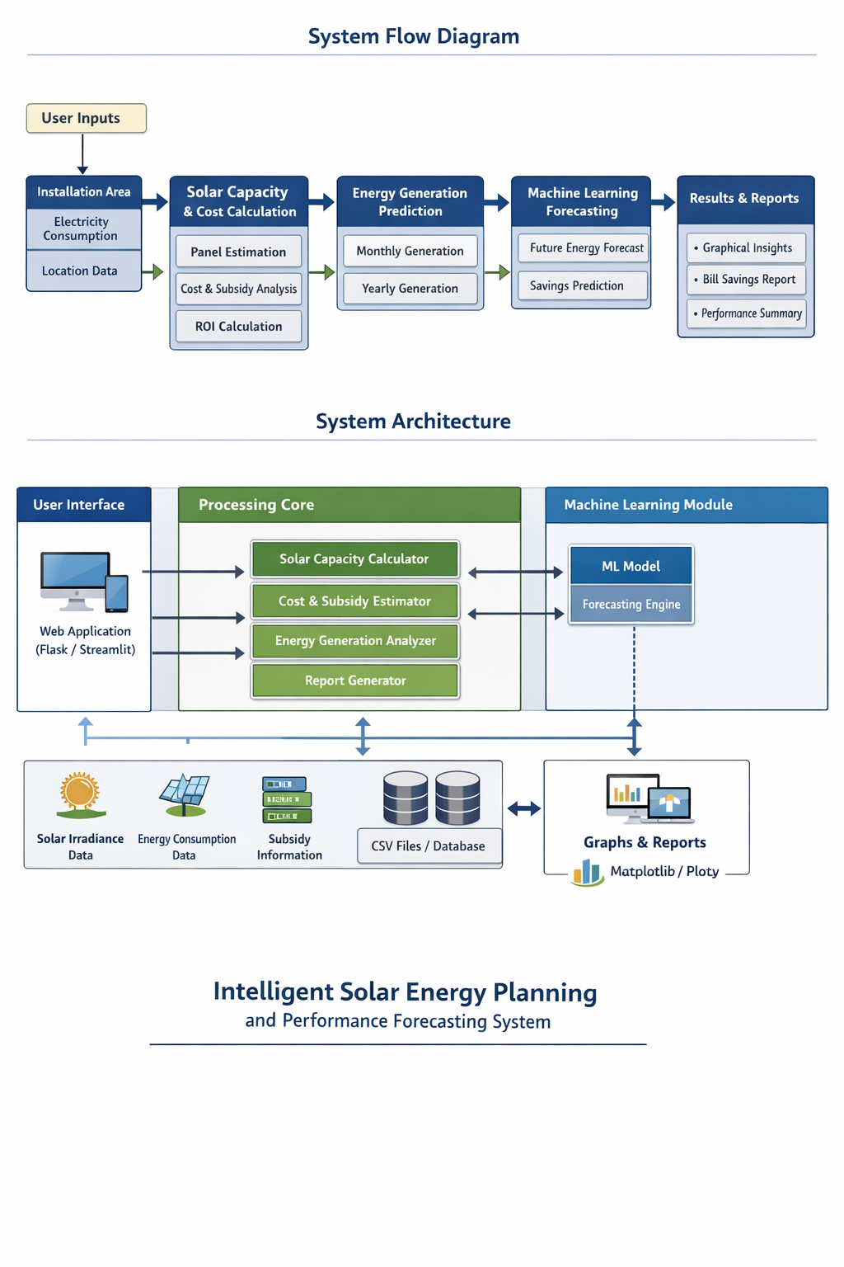
Figure 1. System Flow Diagram & Architecture

Technology:
- Programming Language: Python
- Data Processing: NumPy, Pandas
- Machine Learning: Scikit-learn
- Web Framework: Flask or Streamlit
- Visualization: Matplotlib, Plotly
- Data Storage: CSV files or lightweight database

- Functional Specifications [Deliverables]:
- User input interface for installation area and electricity consumption
- Solar capacity and panel requirement calculation
- Installation cost estimation with subsidy breakdown
- Monthly and annual energy generation prediction
- Electricity bill reduction and ROI analysis
- Machine learning-based future performance forecasting
- Graphical representation of energy output and savings
- Performance reports and basic maintenance guidelines

Project Scope:
- Covers planning and estimation for residential rooftop solar installations
- Supports industrial-scale solar power systems for commercial and manufacturing use
- Includes analysis for large-scale solar farms and utility-level solar projects
Future Enhancements:
- Integration of battery storage and energy storage system analysis
- Implementation of real-time weather-based energy forecasting
- Support for grid integration and net-metering analysis to evaluate power export benefits

Roll No. | Name of Student | Name of Guide
C-12 | Prince Maurya | Prof. Neha Tirpude
C-40 | Shubham Singh
C-59 | Vedansh Gupta
C-63 | Yash Rahane
C-64 | Yash Thakre

Suvik Rahane  Senior Software Engineer  (Fulcrum Developer) | Dr. A. M. Karandikar  HoD, Dept. of Data Science

