**System Requirement**

Recommended system requirements:

* Processor intel core i5
* Disc space: 2 to 4 GB
* RAM: 8GB or higher
* Operating system: Windows 10
* Python version: 3.7.9 or higher

Minimum system requirements:

* Processor intel core i3
* Disc space: 1GB
* RAM: 4GB
* Operating system: Windows 7 or 10
* Python version: 3.5

**FRONT END AND BACK END**

Front end:



Back end:



**INTRODUCTION**

This is a project-based on Bakery Management System. The program helps us to **view items**, **add item**, **update cost** of an item.

Moreover, the program also helps us to **view varieties** of cakes, **add variety**, **view workers**, **add workers** etc.

It is also includes a portion for customer where the customer can **see menu**, **place order** and **see bill.**

It includes various function programs to do the above-mentioned tasks.

**OBJECTIVE**

The main objective of Bakery Management System is to reduce time,

to provide the details related to various activities in the shop like:

viewing items, updating cost of items, adding items, viewing varieties of cake, adding varieties etc.

It manages all the information about the workers in the shop including their salaries, we can also add new workers.

**PROGRAM DISCRIPTION**

The program first asks the user whether he/she is an ADMIN or a CUSTOMER.

1. If the user is an admin, the program asks to enter username and password if the password is correct then the admin can access all the details related to the shop.
2. If the user is a customer, then the program can show menu, place order and show bill.

**MySQL**

MySQL is an open-source relational database management system. It allows users to interact directly with a MySQL database using SQL, but more often, MySQL is used with other programs to implement applications that need relational database management. MySQL also enables Python programs to access MySQL databases .



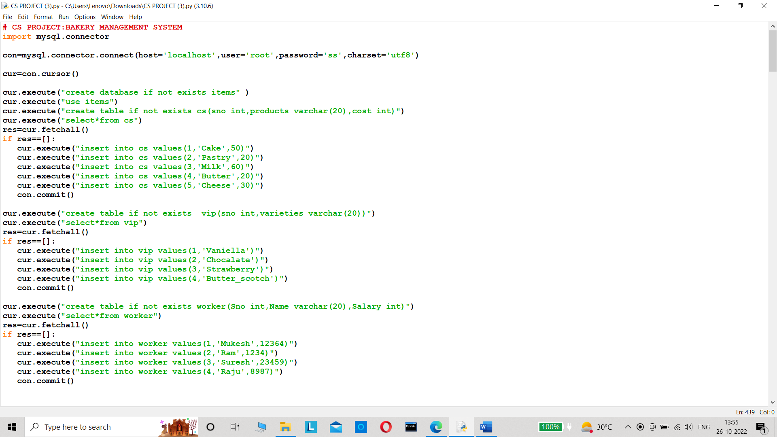

CODE

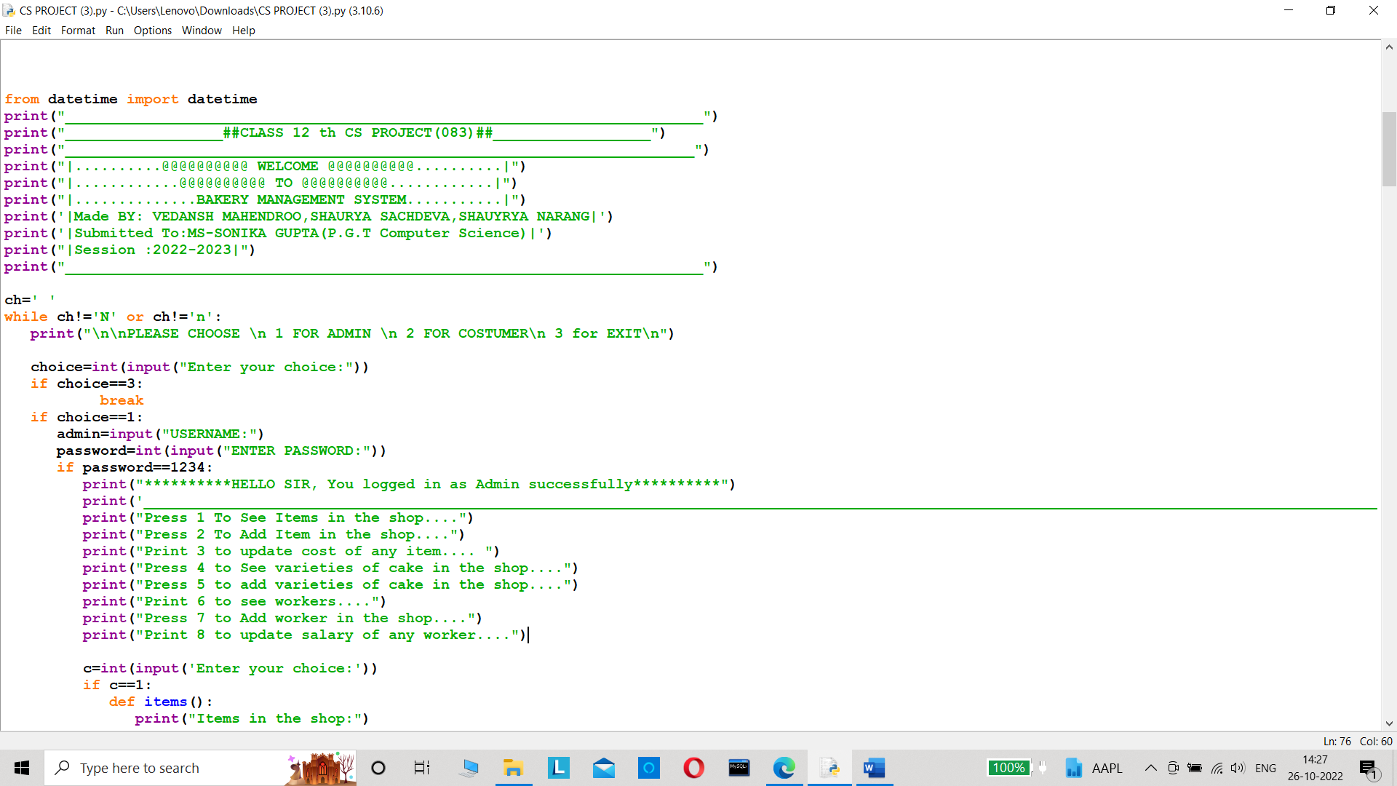

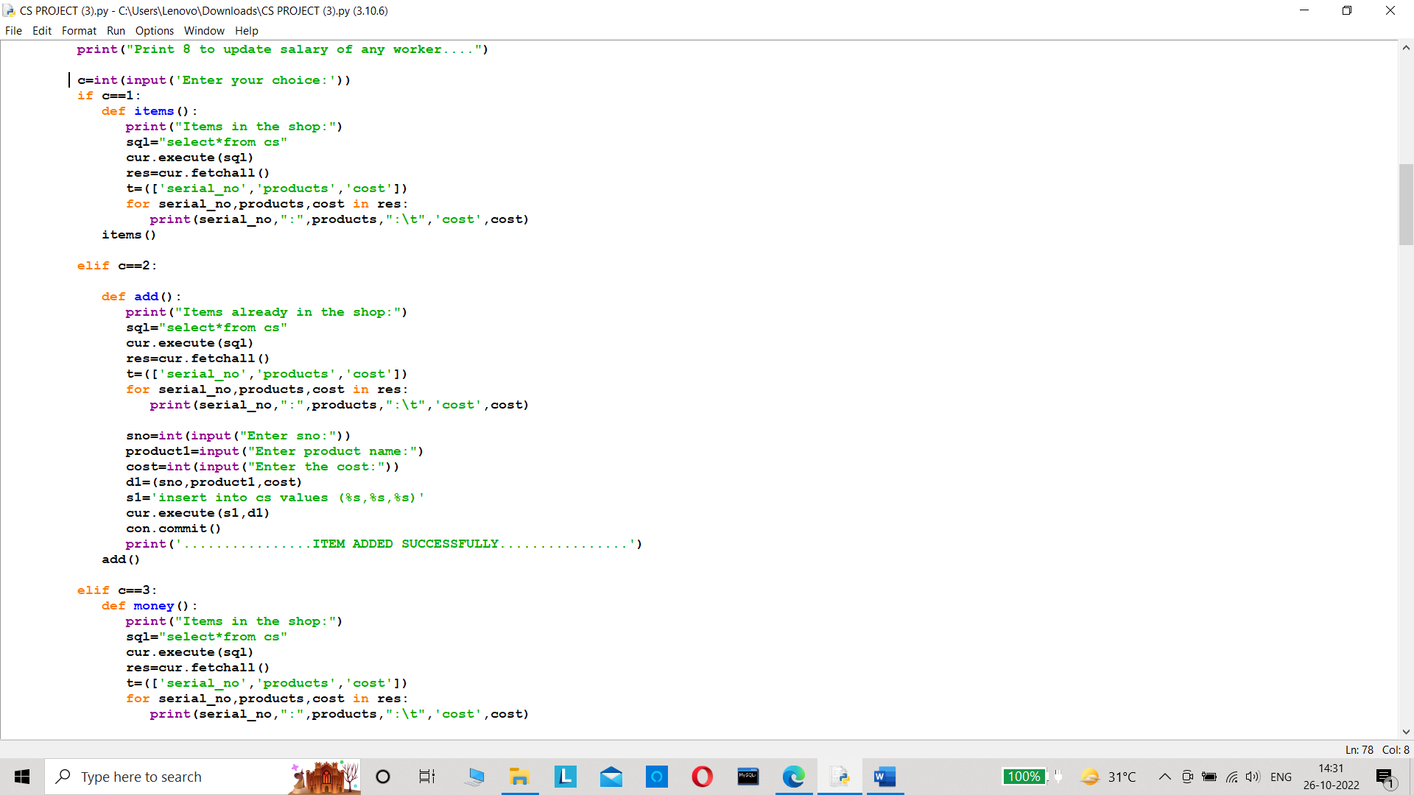

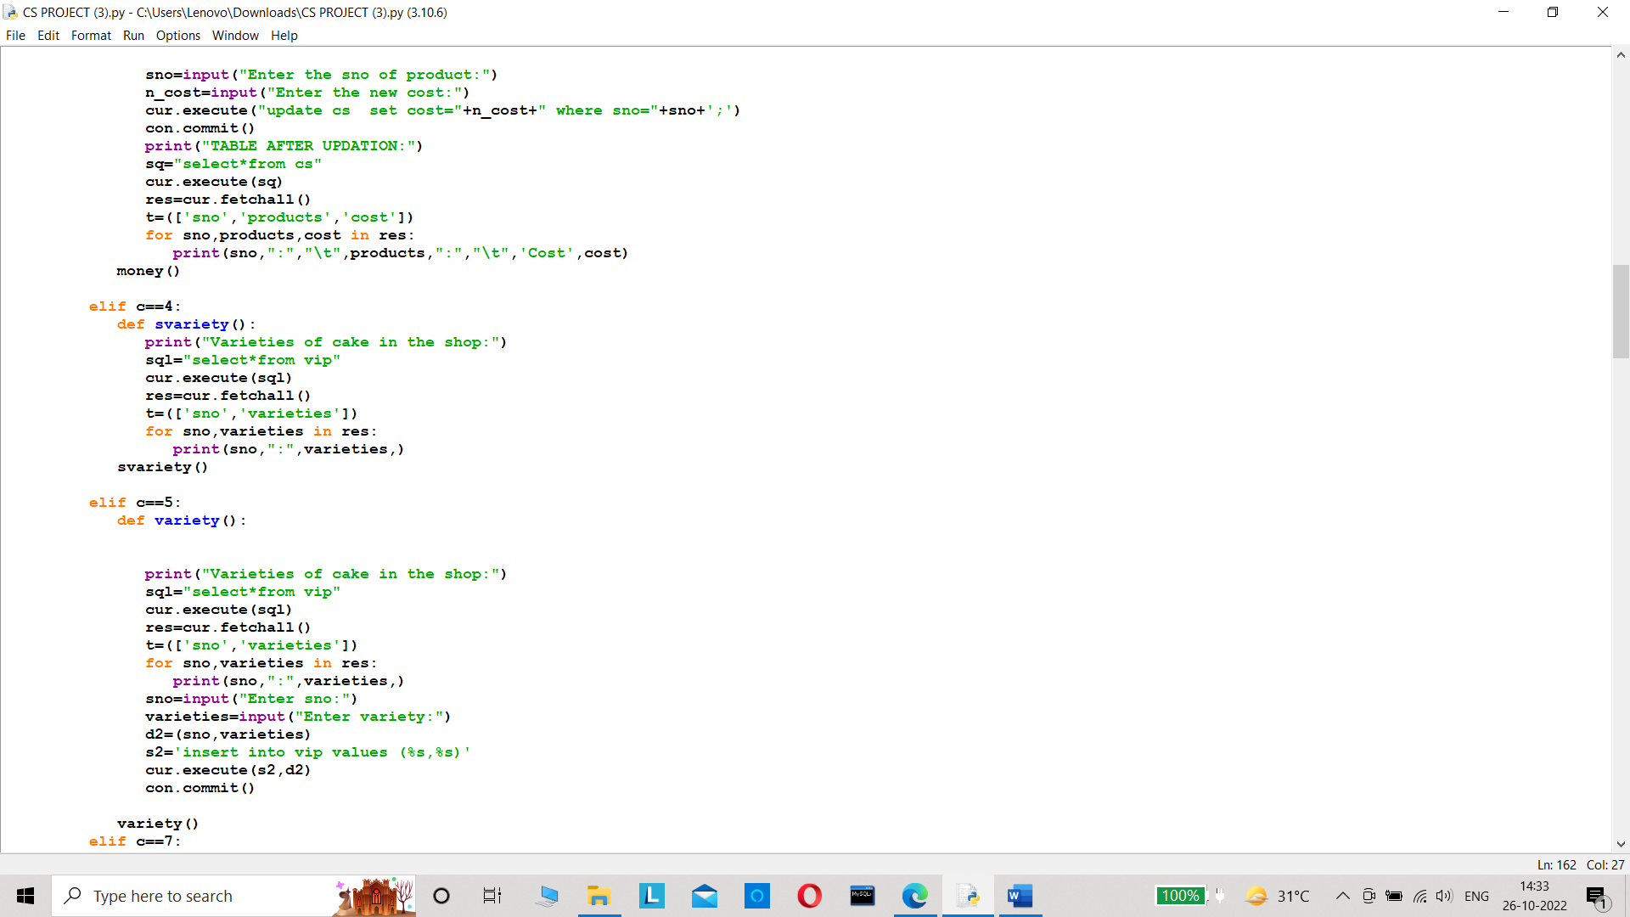

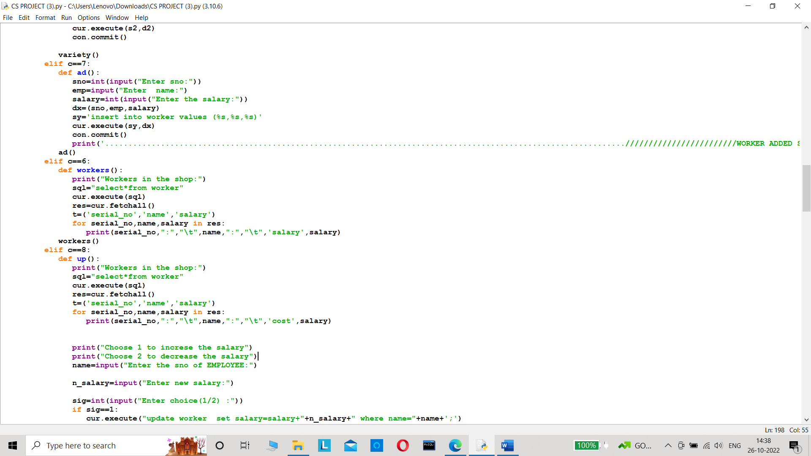

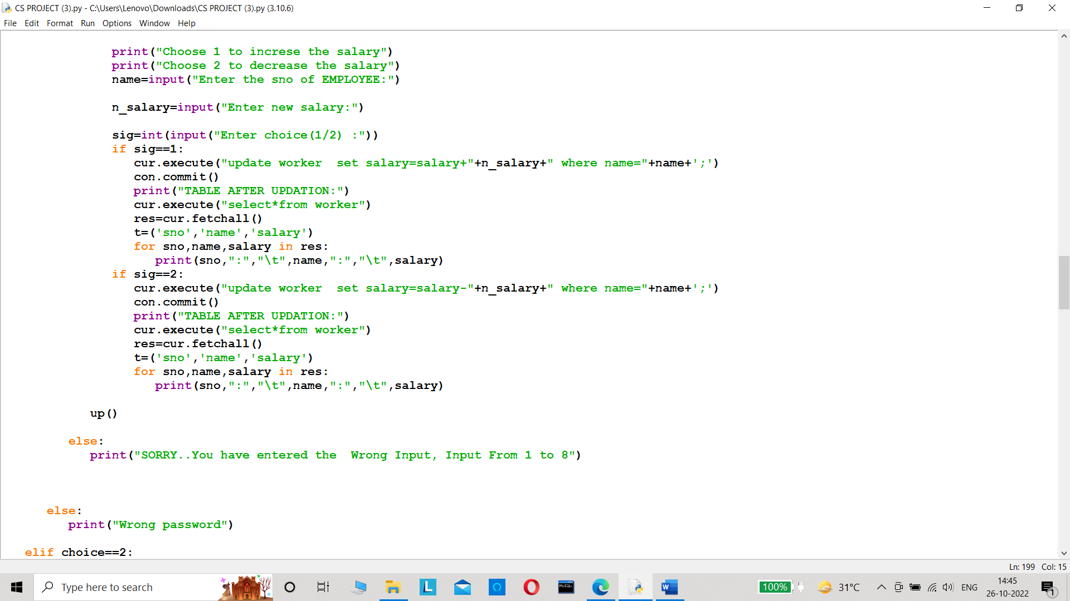

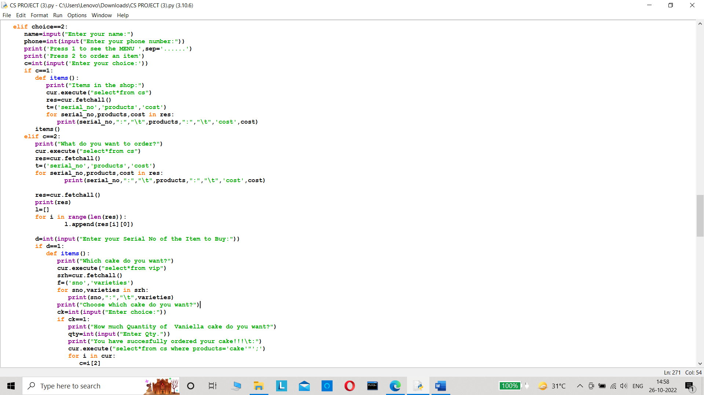

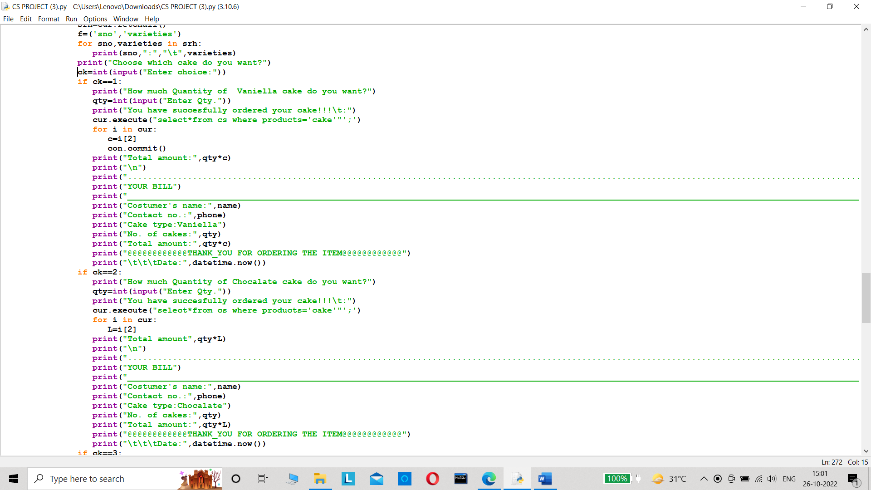

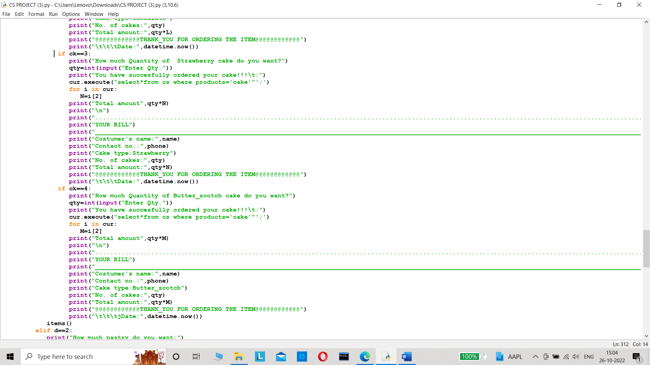

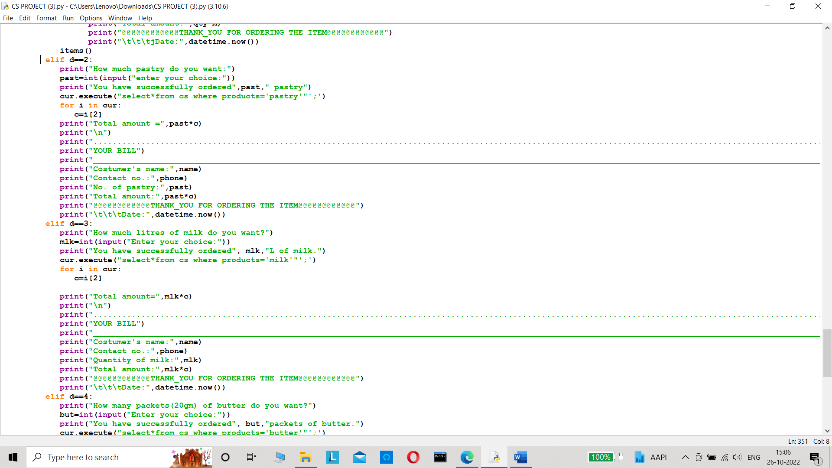

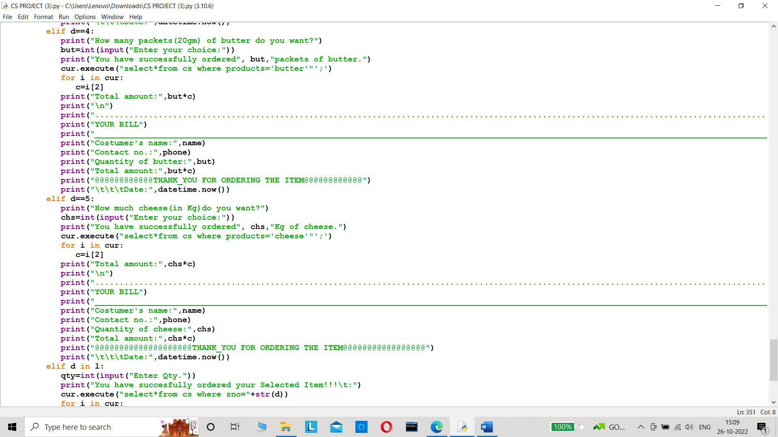

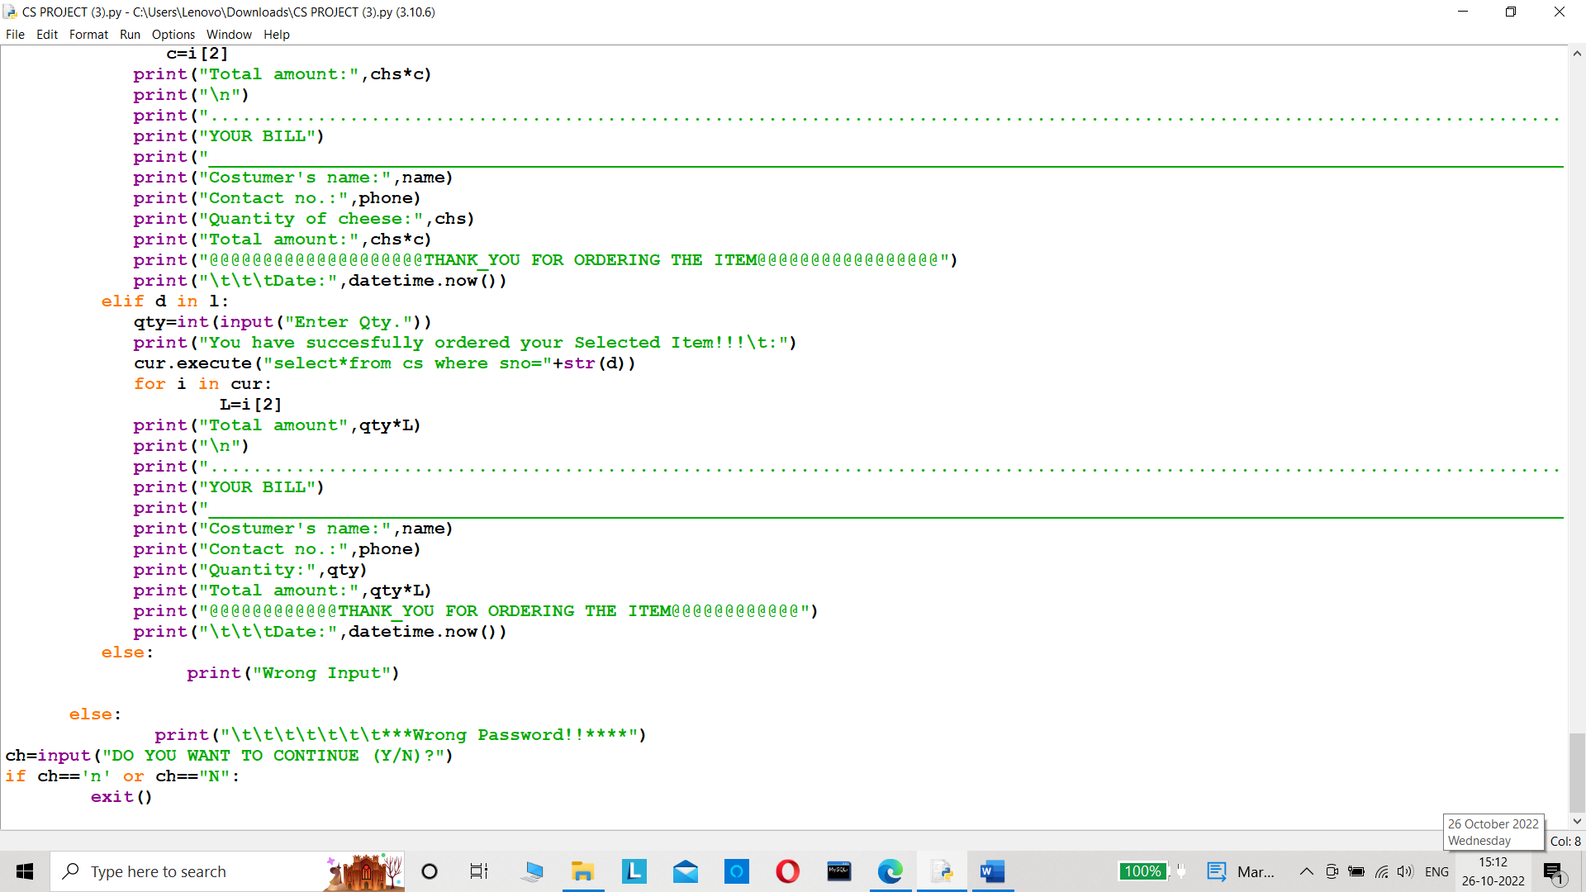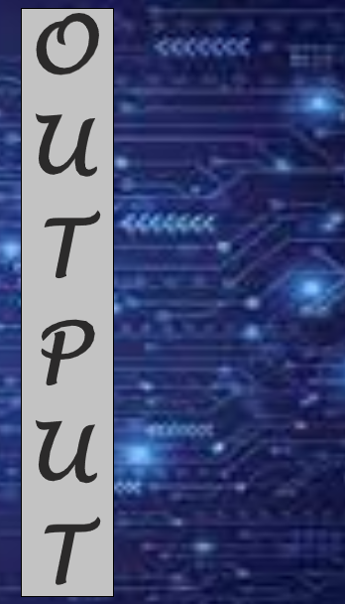

OUTPUT

ADMIN COMMANDS

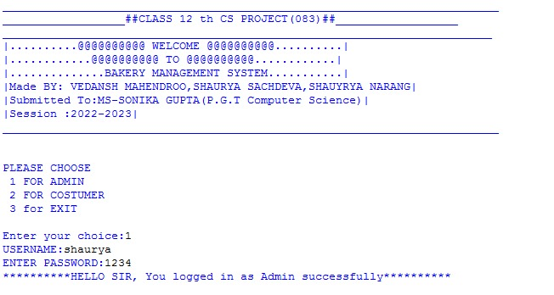

1)TO VIEW THE ITEMS

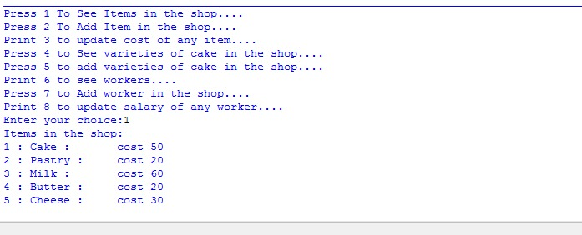

2)ADDING AN ITEM IN THE SHOP

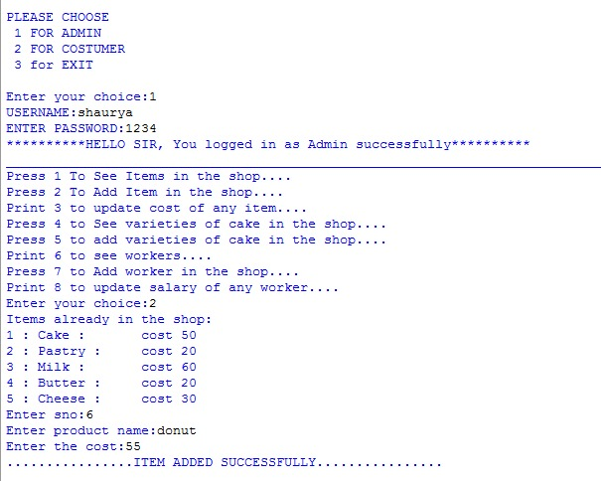

3)UPDATING THE COST OF AN ITEM

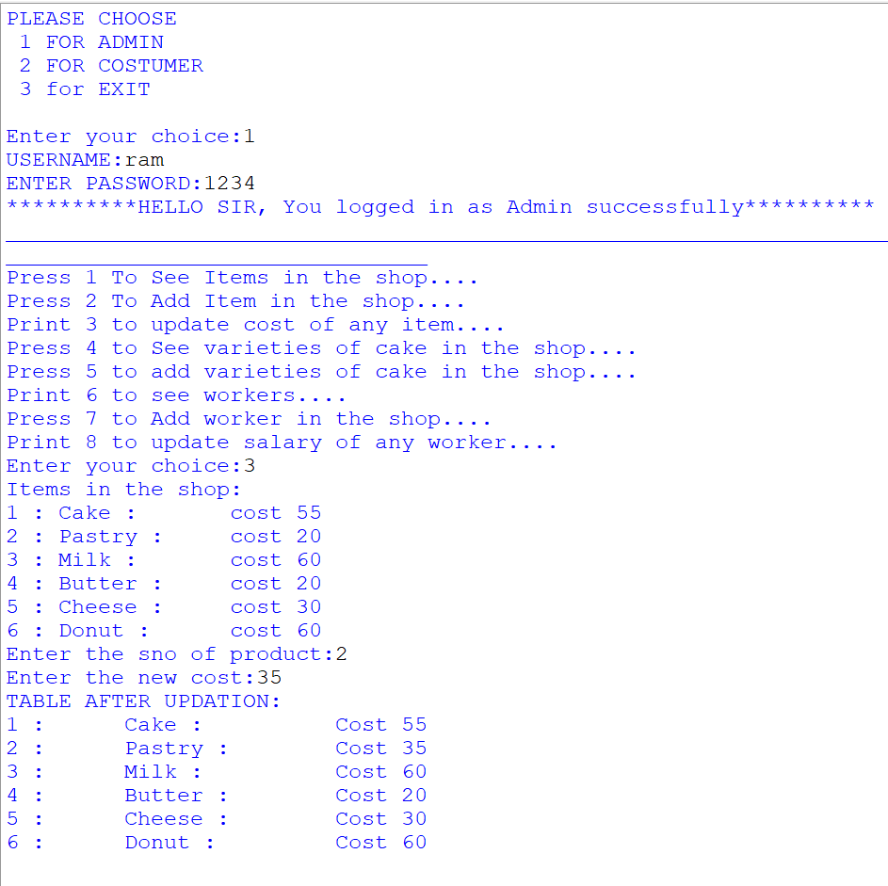

4)to see the varieties of cakes in the shop

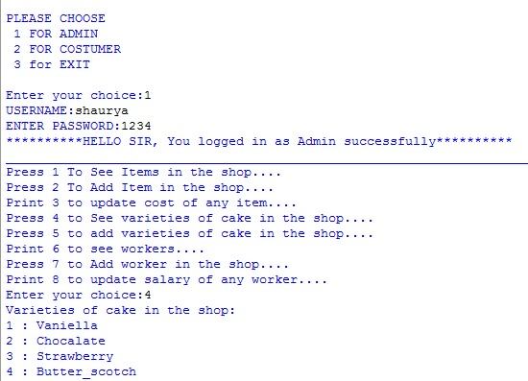

5)ADDING A VARIETY OF CAKE

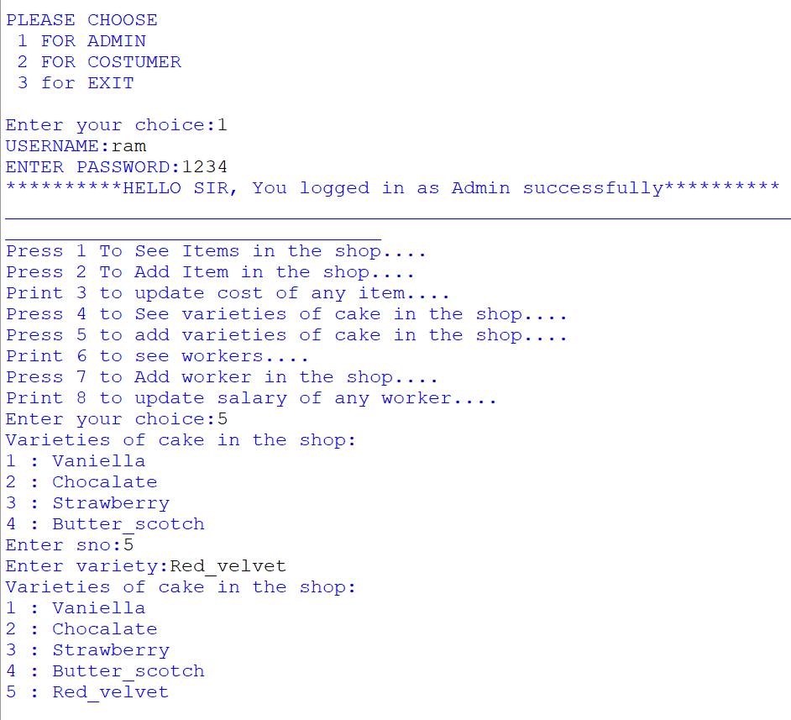

6) TO SEE THE LIST OF WORKERS WORKING AT SHOP

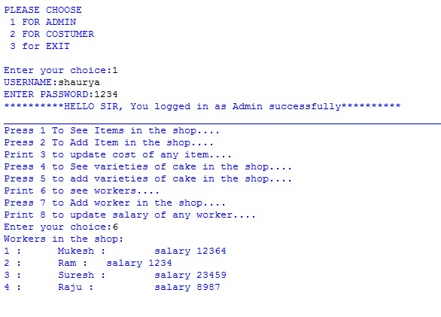

7)TO ADD A WORKER AT THE SHOP

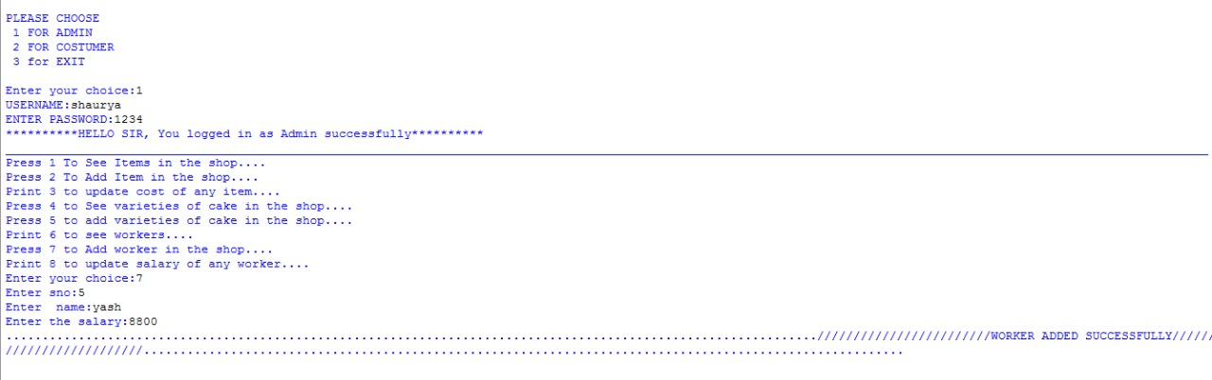

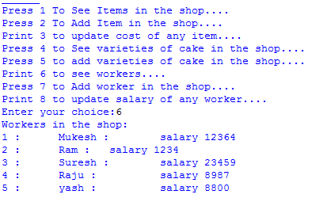

WORKER ADDED SUCCESSFULLY

8)updating the salary of a worker

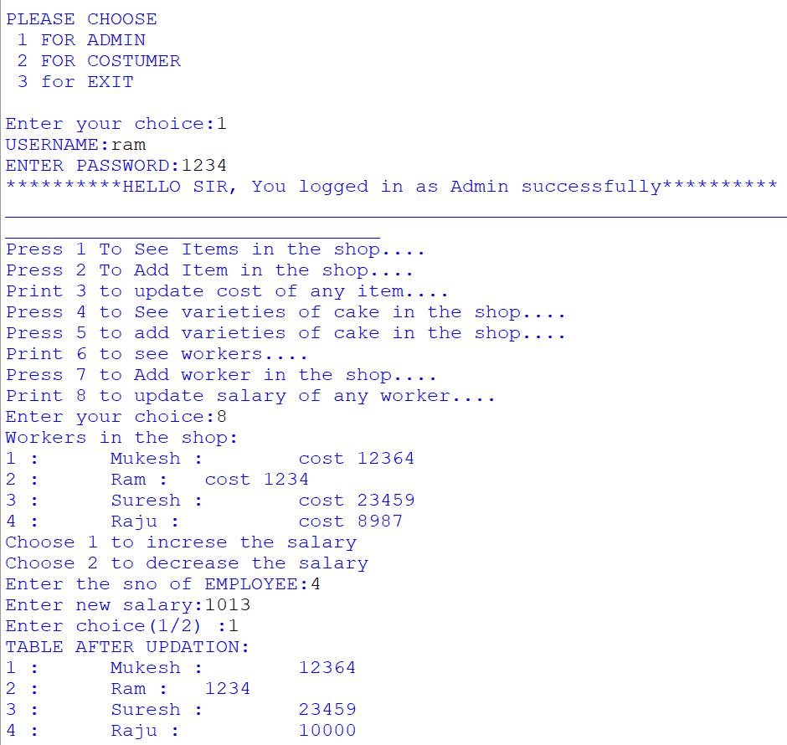

CUSTOMER COMMANDS

1)TO SEE THE MENU

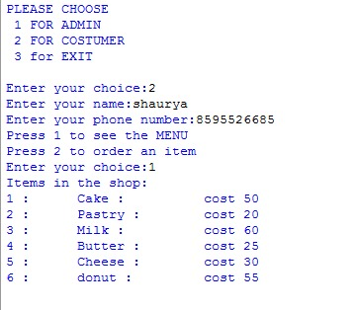

2)TO ORDER AN ITEM

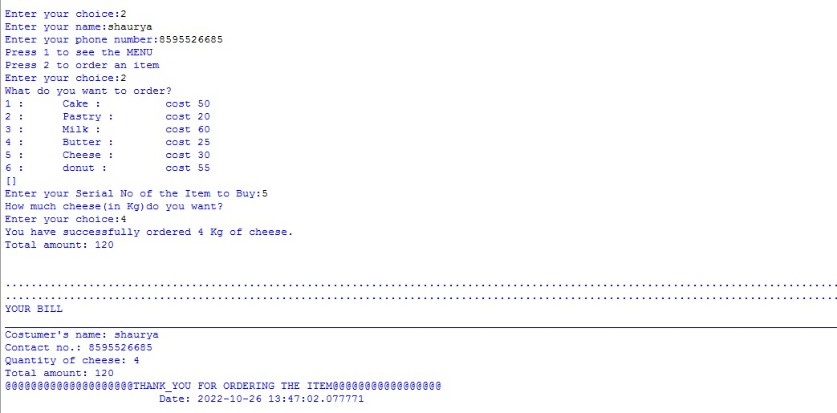



EXIT

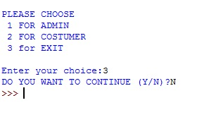

**Flow Chart**

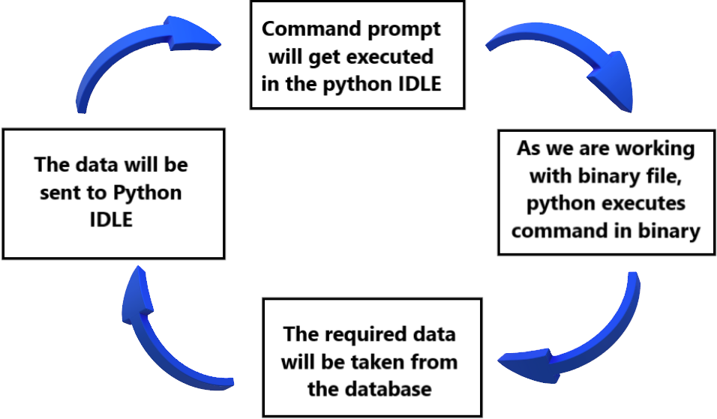

BIBLIOGRAPHY

BOOKS REFERRED: -

* Book: Sumita Arora by Sultan Chand Publications class XII

SITES REFERRED: -

* [www.tutorialspoint.com](http://www.tutorialspoint.com)
* [www.telusko.com](http://www.telusko.com)
* <https://csiplearinghub.com>
* [www.geeksforgeeks.org](http://www.geeksforgeeks.org)

