IU2541230060 – CPP39 – PROJECT REPORT

NGO Volunteer Management
Enrollment No.: IU2541230060
Student Name: VEDANSH PATEL
Semester: 3
Subject: C++ Guided Project
GitHub Repository: https://github.com/vedanshpatel25cse-INDUS/NGO-Volunteer-Management.git
1. Introduction
Non-governmental organizations depend on volunteers, yet many small NGOs still track volunteers, events and duties on paper or in scattered spreadsheets. This leads to forgotten contact details, double bookings and no clear picture of who is doing what. The NGO Volunteer Management system is a console-based application written in C++ that keeps this information in one place.
The project is built using Object-Oriented Programming. Volunteers, events, skills and assignments are modelled as classes derived from a common abstract base class. A system class (NGO) coordinates the work, a template container manages dynamic memory, and a FileManager class stores all data in text files so that records survive after the program is closed.

2. Problem Statement
NGOs need a simple and reliable way to record volunteers and their skills, plan events, and assign the right volunteers to events without clashes. Manual methods are error-prone, make searching slow, and lose data easily. The problem is to design and implement a menu-driven C++ program that stores volunteer, event, skill and assignment records, validates every input, prevents duplicate and conflicting assignments, produces reports, and saves all data permanently to files.

3. Objectives
- To apply Object-Oriented Programming concepts (classes, encapsulation, inheritance, runtime polymorphism) to a real-life problem.
- To manage volunteer, event, skill and assignment records using add, display, search, update and delete operations.
- To implement a main transaction that assigns a volunteer to an event while preventing duplicate assignments and same-date clashes.
- To use dynamic memory (new[] / delete[]) to store a growing number of records.
- To provide data persistence using file handling so that records are available after restarting the program.
- To validate user input and handle errors using exception handling.
- To generate a report summarising events, assigned volunteers and idle volunteers.

4. Functional Requirements
- FR1 – Add Record: add a volunteer (name, 10-digit phone, skills), an event (name, date) or a skill (name, level).
- FR2 – Display Records: list all volunteers, events, skills or assignments.
- FR3 – Search Record: search by ID or keyword (name, skill, phone, date, role).
- FR4 – Update Record: modify an existing volunteer, event, skill or assignment role.
- FR5 – Delete Record: delete any record; deleting a volunteer or event also removes its assignments.
- FR6 – Main Transaction: assign a volunteer to an event with a role; reject unknown IDs, duplicates and same-date clashes.
- FR7 – Report: show totals, volunteers per event and volunteers with no assignment.
- FR8 – Save / Load: save to and load from data files; data is loaded automatically at start and saved at exit.
- FR9 – Validation and error handling: reject invalid names, phone numbers, dates and menu choices without crashing.

5. System / Project Flow
The overall flow of the program is:
USER → MAIN MENU (main.cpp) → NGO SYSTEM CLASS → ENTITY CLASSES (Volunteer, Event, Skill, Assignment via Store<T>) → MAIN TRANSACTION (assignVolunteer) → FILE MANAGER → DATA FILES (Data/*.txt)
main.cpp only creates the NGO object and calls run(). At start-up, run() calls FileManager::load() to restore old records. The user then chooses menu options; each option is handled by an NGO member function that validates input, works on the Store<T> containers and prints the result. When the user chooses Exit, FileManager::save() writes all records back to the data files. The program follows the required cycle: START → Load existing records → Perform operations → Save updated records → EXIT.

6. Class Descriptions
Class | Data Members | Member Functions | Responsibility
Record (abstract) | id, name | Record(), Record(id,name), ~Record(), getId(), getName(), setName(), display()=0, serialize()=0, deserialize()=0, typeName()=0 | Abstract base class giving every entity a common id/name and a polymorphic interface.
Volunteer | phone, skills (+ inherited id, name) | Volunteer(), Volunteer(id,name,phone,skills), ~Volunteer(), getters/setters, display(), serialize(), deserialize() | Stores one volunteer's identity, contact number and skill list.
Event | date (+ id, name) | Event(), Event(id,name,date), ~Event(), getDate(), setDate(), display(), serialize(), deserialize() | Represents an NGO activity or campaign held on a particular date.
Skill | level (+ id, name) | Skill(), Skill(id,name,level), ~Skill(), getLevel(), setLevel(), levelName(), display(), serialize(), deserialize() | Master list of skills with a proficiency level (1-3).
Assignment | volunteerId, eventId, role (+ id) | Assignment(), Assignment(id,vId,eId,role), ~Assignment(), assign(), getters, setRole(), display(), serialize(), deserialize() | Links one volunteer to one event with a role; the result of the main transaction.
Store<T> (template) | items (T*), count, capacity | Store(cap), ~Store(), add(), at(), indexOfId(), removeAt(), nextId(), clear(), grow() | Dynamic array built with new[] / delete[]; grows automatically.
NGO (system class) | Store<Volunteer>, Store<Event>, Store<Skill>, Store<Assignment>, dirty | NGO(), ~NGO(), addVolunteer(), addEvent(), addSkill(), assignVolunteer(), delete*(), menuAdd/Display/Search/Update/Delete(), menuTransaction(), report(), saveAll(), loadAll(), run() | Controls the whole system: owns all data, implements every menu option and the main transaction.
FileManager | dir (data folder) | FileManager(), ~FileManager(), save(NGO&), load(NGO&) | Writes and reads the four data files; reports corrupt data with exceptions.
AppException, ValidationException, InputClosedException | (inherit std::runtime_error) | constructors | Exception hierarchy used for validation, logic and file errors.

7. OOP Concepts Used
- Classes & Objects: Volunteer, Event, Skill, Assignment, NGO and FileManager are classes; main() creates an NGO object.
- Encapsulation: Data members are private or protected and are accessed only through getters/setters, e.g. Volunteer::getPhone()/setPhone().
- Constructors (default + parameterized): Every entity has Class() and Class(id, …), e.g. Volunteer() and Volunteer(id, name, phone, skills); Store(cap) and FileManager(dir) are parameterized.
- Destructors: Virtual ~Record() and derived destructors; ~Store() calls delete[] items to release memory; ~NGO() lets its Stores clean up automatically.
- Inheritance: Volunteer, Event, Skill and Assignment inherit from Record; ValidationException and InputClosedException inherit from AppException, which inherits from std::runtime_error.
- Runtime Polymorphism: Record declares pure virtual display(), serialize(), deserialize() and typeName(). NGO::showAll() and FileManager::saveStore() call them through Record* pointers, so the correct derived version runs at runtime.
- Dynamic Memory: Store<T> allocates T* items = new T[capacity], doubles it with grow() when full and frees it with delete[]. Dynamic memory is needed because the number of records is not known in advance.
- File Handling: FileManager uses ifstream/ofstream to save and load volunteers.txt, events.txt, skills.txt and assignments.txt.
- Validation: validateName(), validatePhone(), validateDate(), validateText() and readInt() re-prompt until correct input is entered.
- Exception Handling: try/catch blocks handle AppException, ValidationException and InputClosedException in input helpers, NGO::run() and file operations; invalid IDs, duplicates and corrupt files are reported cleanly.

8. File Handling and Data Persistence
Data is stored in plain text files inside the Data/ folder, one record per line with fields separated by the '|' character:
- volunteers.txt – id|name|phone|skills
- events.txt – id|name|date
- skills.txt – id|name|level
- assignments.txt – id|volunteerId|eventId|role
On start-up, FileManager::load() reads every file line by line, splits it and calls the entity's deserialize() method. A missing file is treated as an empty list (first run). A corrupt line raises an AppException with the file name and line number. On exit (or through menu option 8), FileManager::save() rewrites all files. The '|' character is rejected during input so the file format can never be broken. Test T15 closes and reopens the program and confirms that old records are still available.

9. UML Diagrams
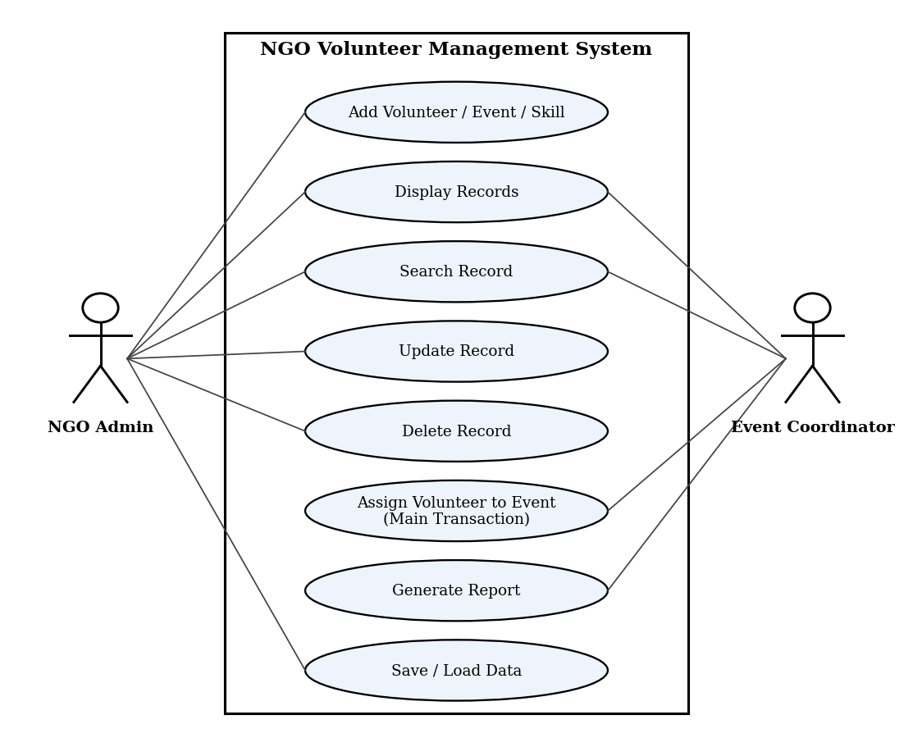
Figure 1: Use Case Diagram (2 actors, 8 use cases)
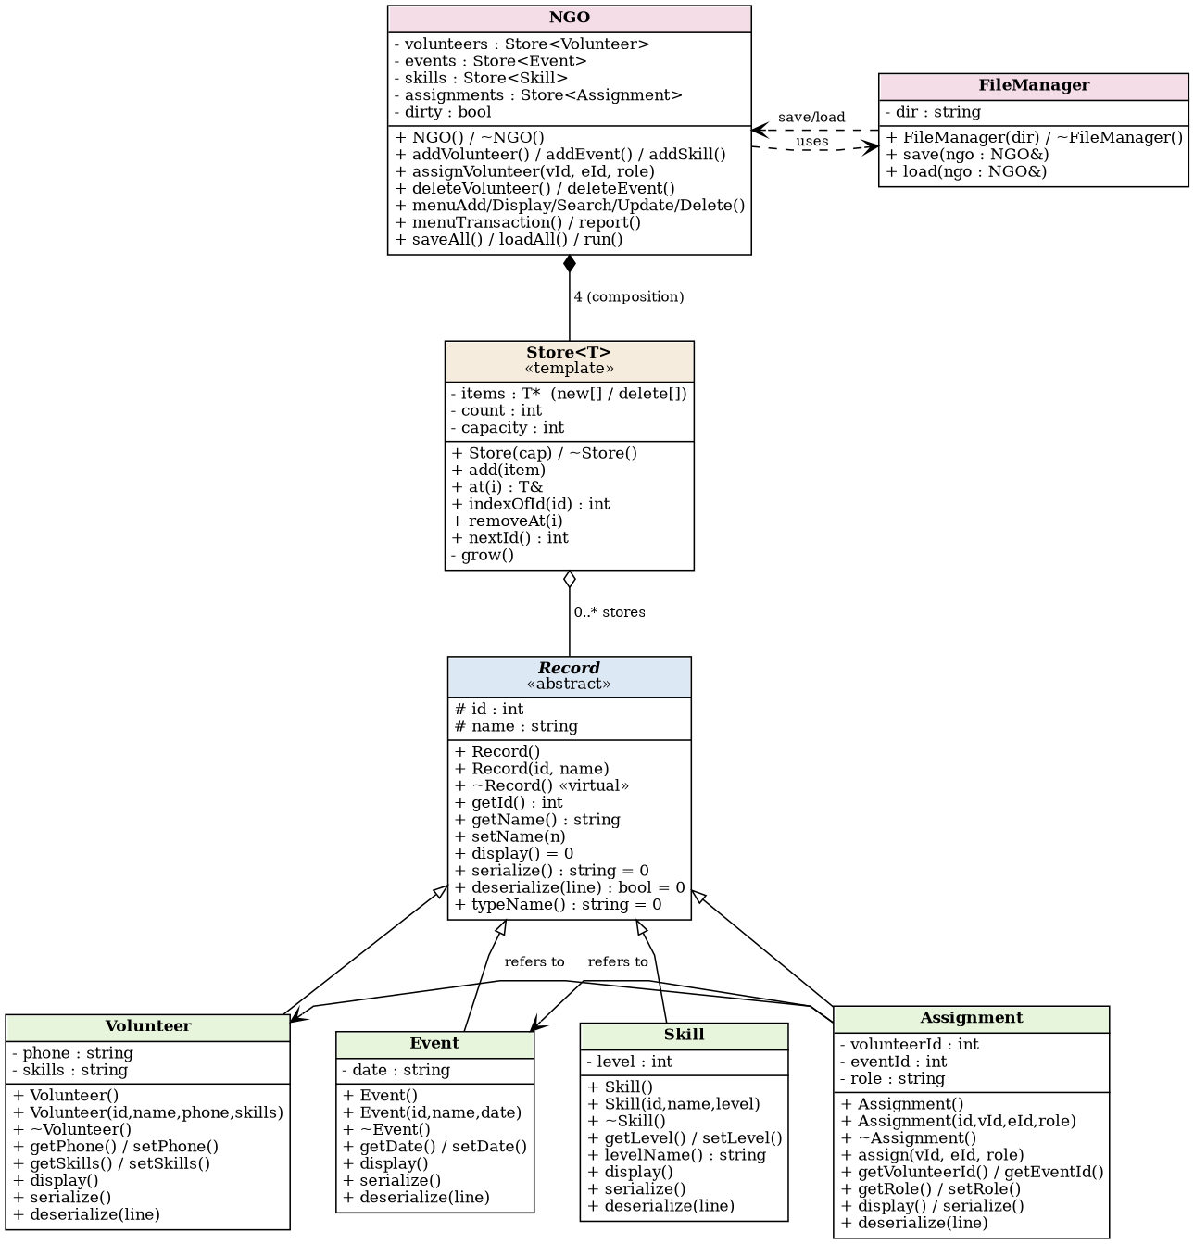
Figure 2: Class Diagram
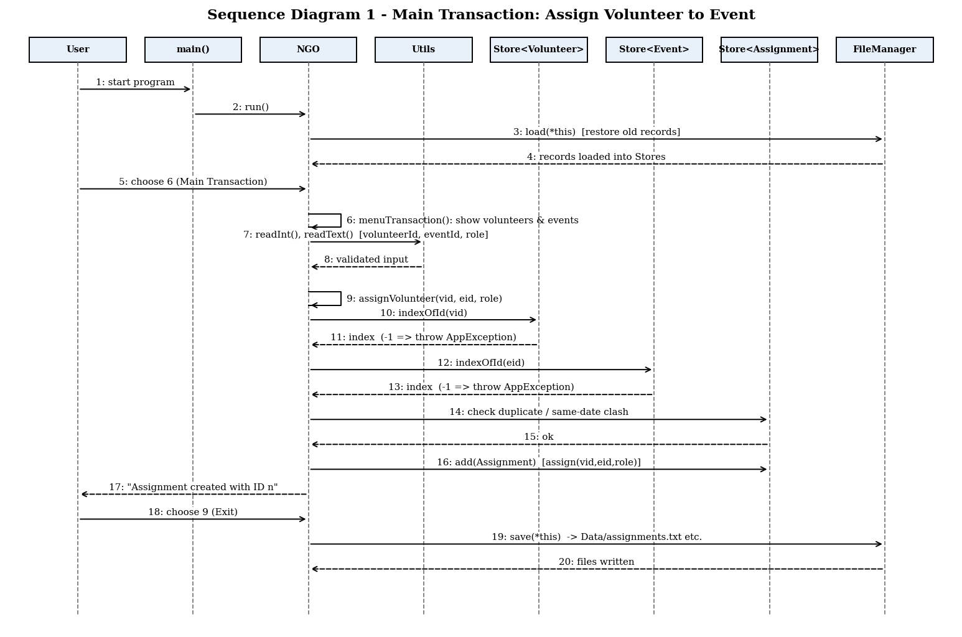
Figure 3: Sequence Diagram 1 – Main Transaction (Assign Volunteer to Event)
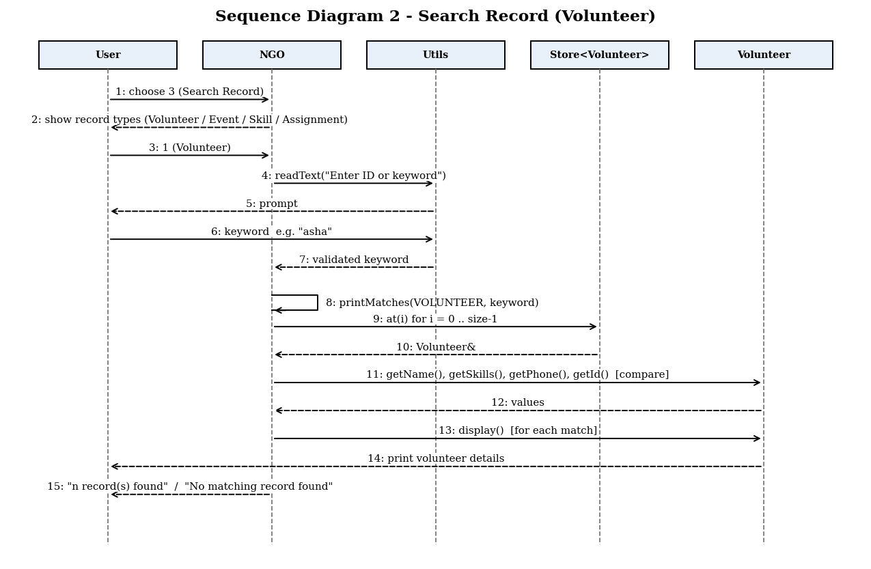
Figure 4: Sequence Diagram 2 – Search Record

10. Implementation Details
The program is written in C++11 and compiled with g++. The source is divided into one header/source pair per class, which keeps main.cpp very small:
- main.cpp – creates the NGO object and calls run().
- Record.h/.cpp – abstract base class.
- Volunteer, Event, Skill, Assignment (.h/.cpp) – entity classes.
- Store.h – template dynamic array.
- NGO.h/.cpp – system class with all menu logic and the main transaction.
- FileManager.h/.cpp – file save/load.
- Utils.h/.cpp – validation, input helpers and exception classes.
Main transaction logic (assignVolunteer): the function (1) validates the role text, (2) checks that the volunteer ID and event ID exist, (3) scans existing assignments of that volunteer to reject a duplicate assignment to the same event, (4) rejects a second event on the same date (a volunteer cannot be in two places at once), and (5) creates an Assignment object, calls assign(), and adds it to the Store<Assignment>. Failures throw AppException, which the menu loop catches and displays.
Memory safety: the program was also compiled with AddressSanitizer and UndefinedBehaviorSanitizer and all 15 tests were re-run; no memory leaks or errors were reported.
Compilation: g++ -std=c++11 main.cpp NGO.cpp FileManager.cpp Record.cpp Volunteer.cpp Event.cpp Skill.cpp Assignment.cpp Utils.cpp -o NGOVolunteer (or simply run make).

11. Testing and Results
Test ID | Input / Operation | Expected | Actual | Status
T01 | Add Volunteer – Name: Asha Patel, Phone: 9876543210, Skills: Cooking | Volunteer added with ID 1. | Matched: Volunteer added with ID 1. | Pass
T02 | Add Volunteer (validation) – Phone '12345' then valid 9876543211 | Phone must be exactly 10 digits.  Volunteer added with ID 1. | Matched: Phone must be exactly 10 digits.  Volunteer added with ID 1. | Pass
T03 | Add Event – Blood Donation Camp, 15/11/2026 | Event added with ID 1. | Matched: Event added with ID 1. | Pass
T04 | Add Event (invalid date) – Date 31/02/2026 then 20/11/2026 | Invalid date (day out of range for month).  Event added with ID 1. | Matched: Invalid date (day out of range for month).  Event added with ID 1. | Pass
T05 | Add Skill – First Aid, level 3 | Skill added with ID 1. | Matched: Skill added with ID 1. | Pass
T06 | Add Skill (duplicate) – First Aid twice (second as 'first aid') | Skill already exists. | Matched: Skill already exists. | Pass
T07 | Display Volunteers – Menu 2 > 1 after adding one volunteer | Volunteers (1)  Asha Patel | Matched: Volunteers (1)  Asha Patel | Pass
T08 | Search Volunteer – Keyword 'asha' | 1 record(s) found. | Matched: 1 record(s) found. | Pass
T09 | Search (no match) – Keyword 'xyz' | No matching record found. | Matched: No matching record found. | Pass
T10 | Update Volunteer – ID 1 -> Asha Mehta, 9876500000, Teaching | Record updated.  Asha Mehta | Matched: Record updated.  Asha Mehta | Pass
T11 | Main Transaction: Assign – Volunteer 1, Event 1, role Coordinator | Assignment created with ID 1. | Matched: Assignment created with ID 1. | Pass
T12 | Assign (duplicate) – Same volunteer + same event again | Volunteer is already assigned to this event. | Matched: Volunteer is already assigned to this event. | Pass
T13 | Assign (date clash) – Volunteer 1 to two events on 15/11/2026 | already booked for another event on this date. | Matched: already booked for another event on this date. | Pass
T14 | Delete Volunteer (cascade) – Delete volunteer 1 then Report | Record deleted.  Total assignments: 0 | Matched: Record deleted.  Total assignments: 0 | Pass
T15 | File persistence (restart) – Add data, Exit, reopen, Display + Report | Existing records loaded  Asha Patel  Total assignments: 1 | Matched: Existing records loaded  Asha Patel  Total assignments: 1 | Pass

All 15 test cases passed. An additional check confirmed that a corrupted data file is reported with a clear message instead of crashing the program.

12. Sample Screens / Output
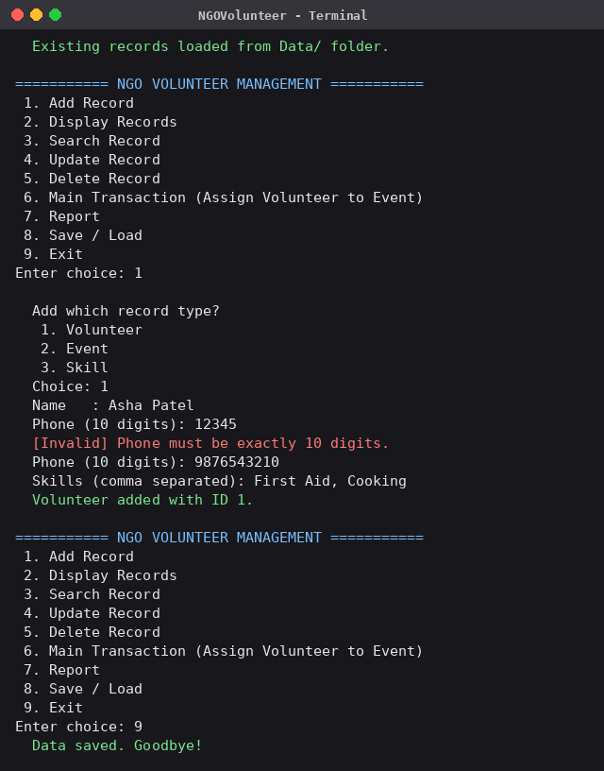
Screen 1: Adding a volunteer (invalid phone number rejected, then accepted)
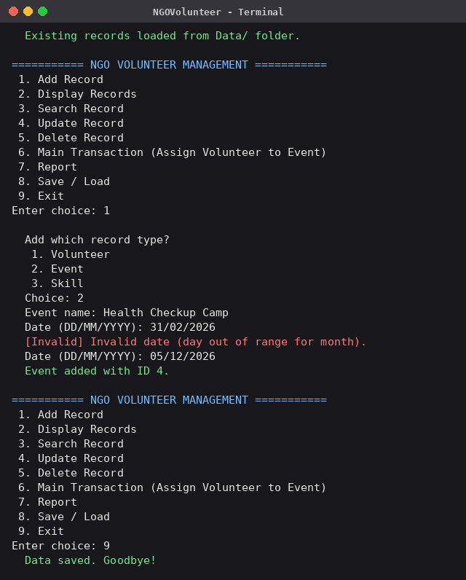
Screen 2: Adding an event (invalid date 31/02/2026 rejected)
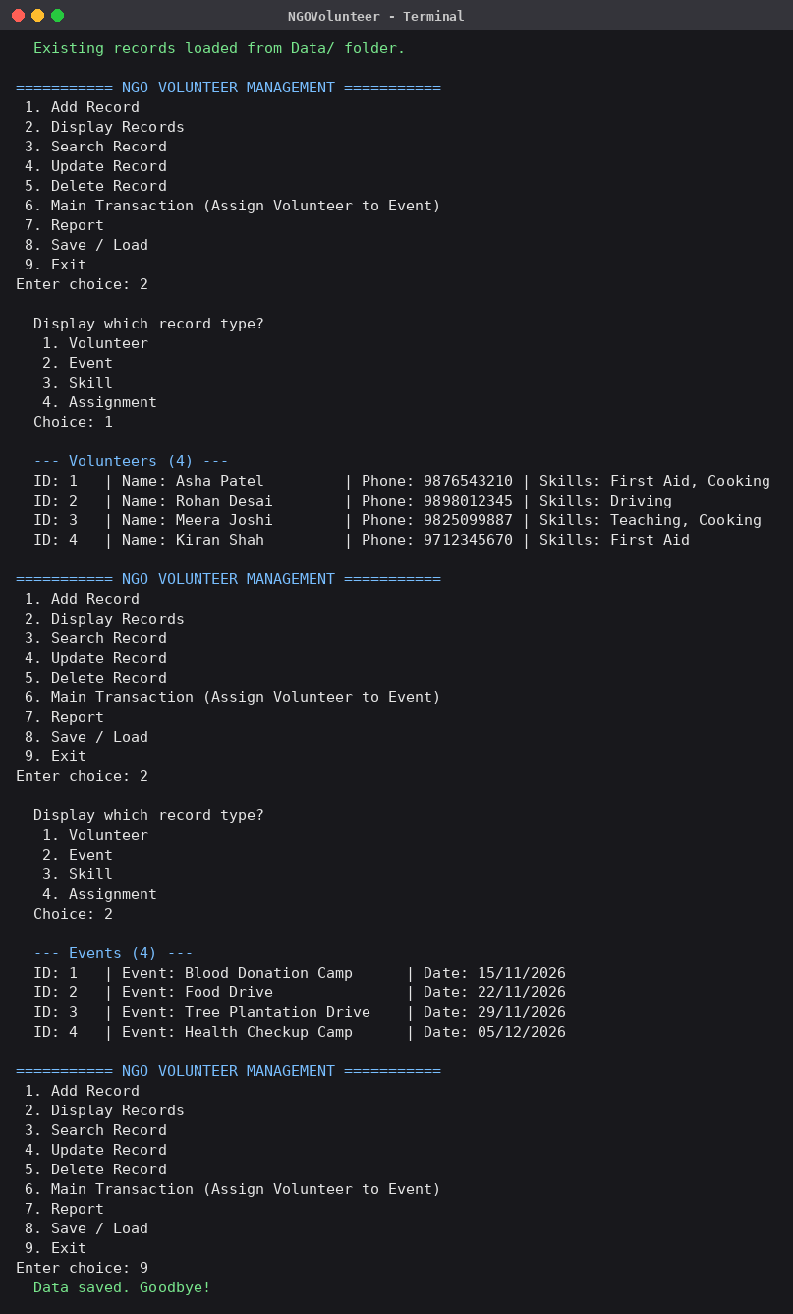
Screen 3: Displaying volunteers and events
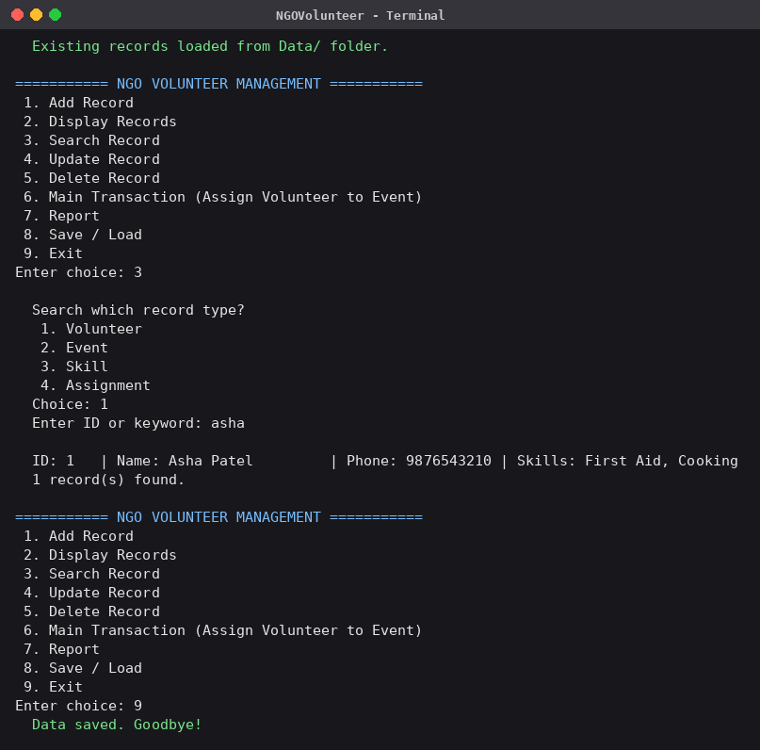
Screen 4: Searching for a volunteer by keyword
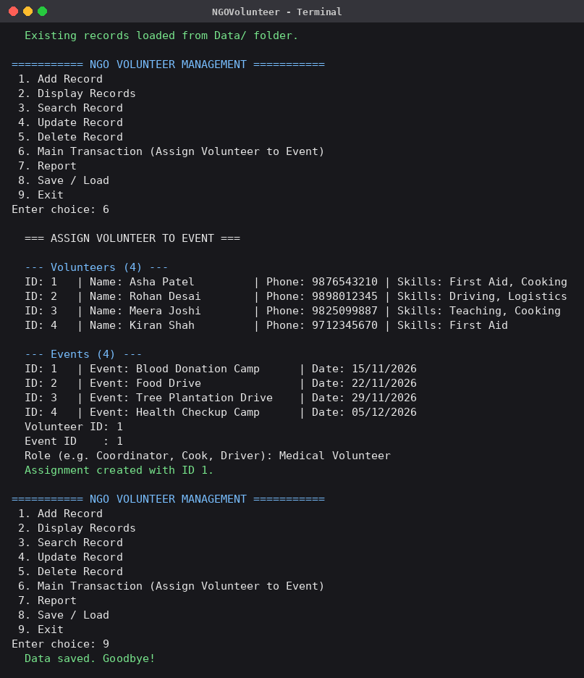
Screen 5: Main transaction – assigning a volunteer to an event
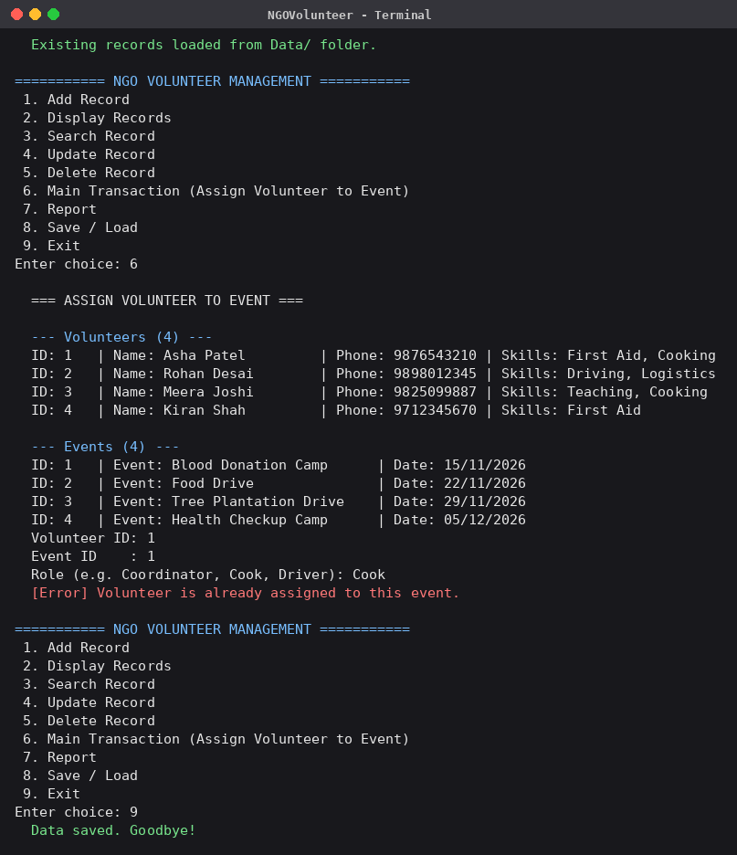
Screen 6: Duplicate assignment rejected
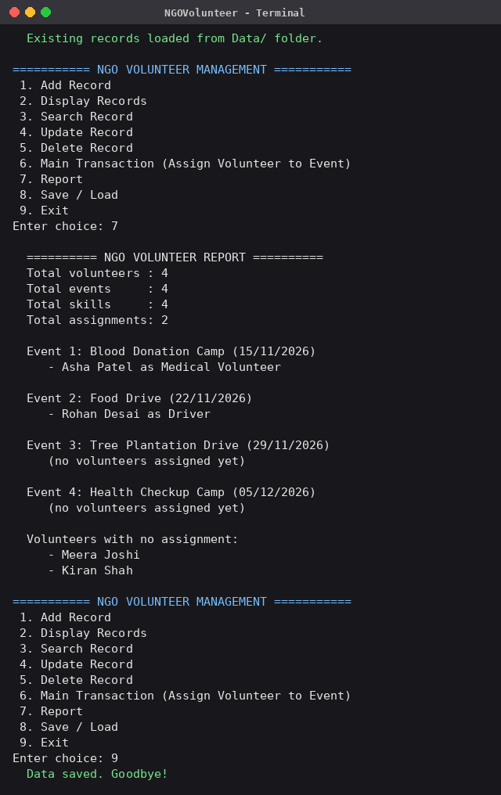
Screen 7: Report
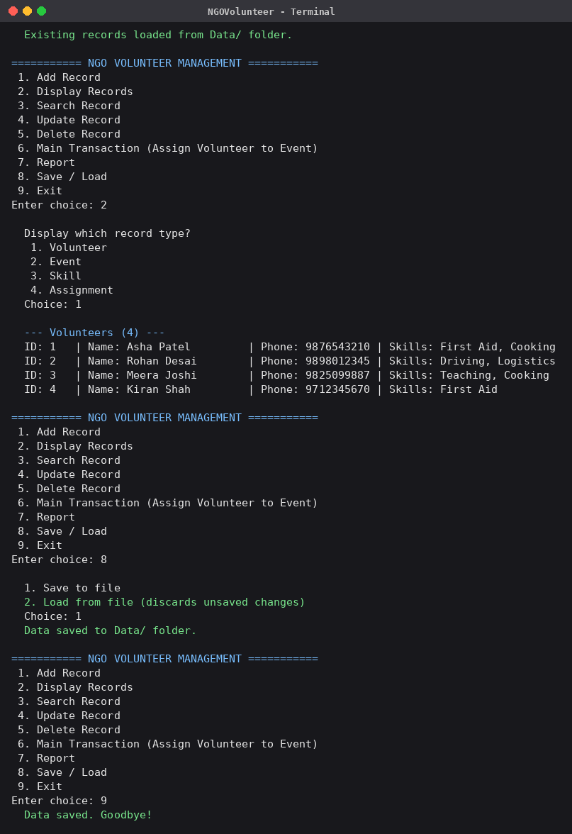
Screen 8: Program reopened – old records loaded from file

13. Limitations
- It is a console application without a graphical interface.
- Data is stored in plain text files; there is no database, encryption or multi-user access.
- Skills in a volunteer record are free text and are not linked by ID to the Skill list.
- Only one NGO and one administrator are supported; there is no login.
- Events are checked only by date, not by start and end time.

14. Future Scope
- Add a graphical interface (Qt) or a web front end.
- Move storage to a database such as SQLite or MySQL.
- Add login with admin and coordinator roles.
- Link volunteer skills to the Skill list and suggest suitable volunteers for each event.
- Send e-mail or SMS reminders and export reports to PDF/CSV.
- Track volunteer hours and generate certificates.

15. Conclusion
The NGO Volunteer Management system successfully meets the requirements of the guided project. It demonstrates classes and objects, encapsulation, constructors and destructors, inheritance, runtime polymorphism, dynamic memory, file handling, validation and exception handling in one working application. All 15 test cases pass, data persists between runs, and the code is organised so that new entity types or features can be added easily. The project gave practical experience in designing with UML, structuring a multi-file C++ program and testing it systematically.

