CUSTOMER SHOPPING BEHAVIOR ANALYSIS

Executive Summary
This report presents a comprehensive analysis of customer shopping behavior based on transactional data from 3,900 customer purchases across four product categories. The analysis was conducted using Python for data preparation, MySQL for business querying, and Power BI for interactive visualization.

The objective is to surface actionable insights across revenue performance, customer loyalty, product ratings, discount behavior, and demographic trends — equipping stakeholders with the intelligence needed to drive strategic decisions.

3,900  Total Customers | $233K  Total Revenue | $59.76  Avg. Purchase | 3.75 / 5  Avg. Rating

1. Business Context & Objectives
The retail organization sought to better understand the factors driving customer purchasing behavior, identify high-value segments, and evaluate the effectiveness of discount and subscription programs.

Key business questions addressed in this analysis:

- Which customer segments generate the most revenue?
- Which product categories perform best?
- Do subscribers spend more than non-subscribers?
- How do discounts influence purchasing behavior?
- Which products receive the highest customer satisfaction ratings?
- Which age groups contribute most significantly to overall revenue?

2. Dataset Overview
The dataset contains transactional records from 3,900 unique customers across 50 locations, covering 4 product categories and 18 attributes. Prior to analysis, data cleaning was performed in Python to ensure accuracy and consistency.

Attribute | Details
Total Records | 3,900
Product Categories | Clothing, Accessories, Footwear, Outerwear
Customer Locations | 50 US States
Missing Values Treated | 37 (Review Rating — imputed using category median)
Features Used | 18 variables including demographics, purchase, and behavior data

Data Preparation Highlights
- Column names standardized to snake_case for consistency across Python and SQL.
- Missing review ratings filled using category-level median to preserve segment-specific sentiment.
- Age groups engineered: Young Adult, Adult, Middle-aged, and Senior.
- Purchase frequency converted from categorical to numeric (days between purchases).
- Redundant column promo_code_used removed — identical to discount_applied across all records.

3. Revenue Analysis

3.1 Revenue by Product Category
Clothing emerged as the top-performing category, generating $104K in revenue — significantly ahead of all other categories.

Category | Revenue | Share of Total
Clothing | $104,000 | ~45%
Accessories | $74,000 | ~32%
Footwear | $36,000 | ~15%
Outerwear | $19,000 | ~8%

Business Implication
Clothing accounts for nearly half of total revenue. Prioritizing inventory depth, marketing investment, and promotional activity within this category is likely to yield the highest returns.

3.2 Revenue by Gender
Male customers were the dominant revenue contributors, accounting for approximately 68% of total sales. Female customers contributed the remaining 32%.

Gender | Revenue | Share
Male | $158,000 | 67.74%
Female | $75,000 | 32.26%

Business Implication
While male customers currently dominate revenue, there is a significant untapped opportunity to grow female customer spending through targeted campaigns, personalized offers, and product mix optimization.

3.3 Revenue by Age Group
Young Adults generated the highest total revenue at $62.14K, followed closely by the Middle-aged segment. All four age groups contributed meaningfully to overall performance.

Age Group | Revenue
Young Adult | $62,140
Middle-aged | $59,200
Adult | $55,980
Senior | $55,760

Business Implication
Young Adults are the highest-value demographic. Marketing campaigns, loyalty programs, and digital engagement strategies targeted at this group are likely to generate above-average returns.

4. Customer Segmentation & Loyalty

4.1 Customer Segments
Customers were segmented based on their number of previous purchases: New (1 purchase), Returning (2–10 purchases), and Loyal (more than 10 purchases).

Segment | Definition | Count
Loyal | More than 10 previous purchases | 2,300
Returning | 2 to 10 previous purchases | 1,100
New | 1 previous purchase | 500

Business Implication
Loyal customers form the backbone of the business, representing the majority of the customer base. Investing in retention programs, exclusive benefits, and recognition for this segment will protect and grow the most valuable revenue stream.

4.2 Subscription Status
Only 27% of customers are current subscribers, despite subscribers demonstrating comparable spending levels to non-subscribers. This represents a clear growth opportunity.

Status | Customers | Share
Non-Subscriber | 2,850 | 73%
Subscriber | 1,050 | 27%

Business Implication
Subscription adoption is low despite strong purchasing behavior from existing subscribers. Offering compelling incentives — such as free shipping, early access to new products, or exclusive discounts — could meaningfully increase subscriber conversion rates.

4.3 Repeat Buyers & Subscription Correlation
Among customers with more than 5 previous purchases, the majority remain non-subscribers. This highlights that repeat purchase behavior does not automatically translate into subscription adoption, suggesting a need for proactive subscription marketing targeted at frequent buyers.

5. Product Performance

5.1 Top-Rated Products
The following products achieved the highest average customer review ratings across the dataset, reflecting strong customer satisfaction:

Rank | Product | Avg. Rating
1 | Gloves | 3.85
2 | Sandals | 3.84
3 | Boots | 3.83
4 | Hats | 3.82
5 | Skirts | 3.81

Business Implication
These top-rated products should receive increased marketing visibility, enhanced product placement, and inventory prioritization. Featuring them in promotions and on landing pages is likely to improve conversion rates.

5.2 Discount-Dependent Products
Certain products display a high percentage of discounted purchases, indicating customers may be conditioned to wait for promotions before buying. This can erode margin if not managed strategically.

Rank | Product | Discount Rate
1 | Hats | Highest
2 | Sneakers | High
3 | Coats | High
4 | Sweaters | Moderate-High
5 | Pants | Moderate-High

Business Implication
Discount dependency can reduce perceived product value over time. Consider introducing value-added promotions (e.g., bundling, loyalty points) rather than blanket discounts to maintain margin while sustaining purchase volume.

6. Shipping Behavior

6.1 Shipping Type vs. Average Spend
Analysis of shipping preferences revealed that customers using premium shipping options tend to spend slightly more on average, suggesting a correlation between higher-value purchases and faster delivery expectations.

Shipping Type | Avg. Purchase Amount
2-Day Shipping | $60.73
Express | $60.48
Free Shipping | $60.41
Store Pickup | $59.89
Next Day Air | $58.63
Standard | $58.46

Business Implication
Customers who opt for faster or premium shipping tend to spend more per transaction. These customers may represent a higher-value segment worth targeting with tailored upsell or loyalty incentives.

7. Summary of Key Findings

Area | Key Finding
Top Revenue Category | Clothing generated $104K — approximately 45% of total revenue, outperforming all other categories.
Gender Split | Male customers contributed ~68% of total revenue; female customers represent a significant growth opportunity.
Highest-Value Demographic | Young Adults generated the most revenue at $62.14K, making them the priority marketing segment.
Customer Loyalty | Loyal customers (10+ purchases) form the largest segment at ~2,300 customers, indicating strong retention.
Subscription Gap | Only 27% of customers are subscribers, despite subscribers showing comparable spending patterns to non-subscribers.
Shipping & Spend | Customers using premium shipping options spend more on average, indicating higher transaction values.
Top-Rated Products | Gloves, Sandals, Boots, Hats, and Skirts achieved the highest customer satisfaction ratings.
Discount Dependency | Hats, Sneakers, Coats, Sweaters, and Pants showed the highest rates of discount-driven purchasing.

8. Strategic Recommendations
Based on the findings, the following five strategic actions are recommended for stakeholder consideration:
1 | Increase Subscription Adoption  Launch a targeted subscription conversion campaign aimed at frequent buyers (5+ previous purchases). Offer exclusive benefits such as free 2-day shipping, early product access, and members-only discounts to increase the 27% adoption rate.

2 | Strengthen Customer Loyalty Programs  Introduce tiered loyalty rewards for the Loyal customer segment. Recognize top spenders with premium status, exclusive offers, and personalized communications to reinforce retention and increase lifetime value.

3 | Focus Marketing on Young Adults & Female Customers  Allocate a larger share of marketing budget toward Young Adults, who represent the highest-revenue demographic. Simultaneously, develop targeted campaigns and product recommendations to grow engagement and spend among female customers.

4 | Optimize Discount Strategy  Replace blanket discounts on high-dependency products (Hats, Sneakers, Coats) with value-added promotions such as bundles, loyalty points, or limited-time gift-with-purchase offers. This protects margin while maintaining purchase motivation.

5 | Amplify Top-Performing Products  Feature highly rated products — Gloves, Sandals, Boots, Hats, and Skirts — prominently across marketing channels, homepage placements, and email campaigns. Prioritize their inventory availability ahead of peak seasons.

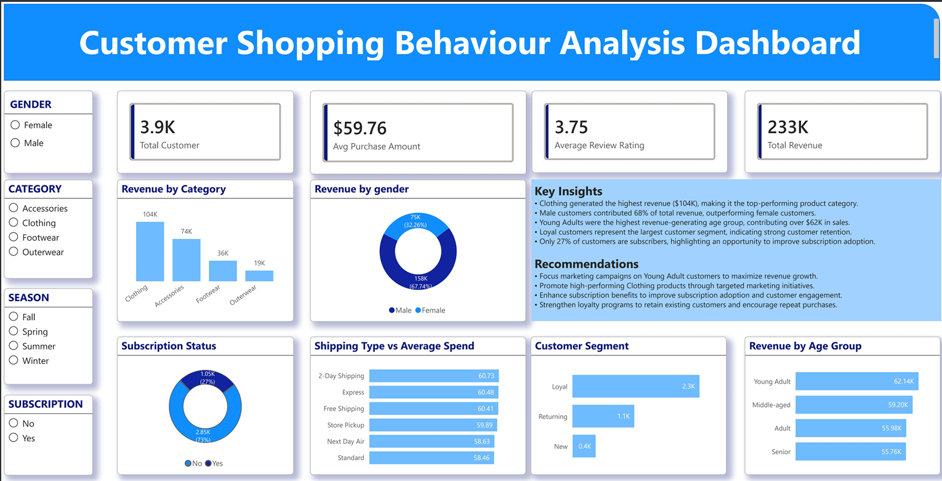

9. Conclusion
This analysis demonstrates how structured data analytics can transform raw transactional records into actionable business intelligence. By examining customer demographics, purchasing patterns, loyalty behavior, and product performance, the organization is well-positioned to make data-driven decisions that improve retention, optimize revenue, and strengthen competitive advantage.

The recommendations outlined in this report are prioritized to deliver near-term commercial impact while building the foundation for longer-term customer relationship management and growth.

Technologies Used
Python (Pandas, NumPy) • MySQL / SQLAlchemy • Power BI • Jupyter Notebook

