Iteration 1: Random forest preliminary

Panacea

Used random forest to predict Superbowl_Winner by using the entire dataset. Replaced missing values with -99999, split into 75-25 train test.

Where it went wrong: 1450 rows for losers, 50 rows for winners. This led to the model predicting everyone as losers because it has been trained too much on loser data.

Iteration 2: Logistic Regression

Removed pre 1990 data because too many missing columns. Ran Information value function to determine the top 40 variables which predict superbowl winner. Narrowed down to the below ones.

Wins

Losses

Offense_field_goals_XPM

Offense_scoring_Rk

Offense_touchdowns_Rk

Offense_field_goals_XP_Att

Offense_kicking_KO

Defense_scoring_Rk

Offense_touchdowns_Total

Offense_touchdowns_Rsh

Offense_game_stats_TO

Defense_rushing_Rk

Offense_game_stats_Rk

Defense_touchdowns_Rk

Defense_game_stats_1st.G

Offense_touchdowns_Rec

Offense_passing_Avg

Defense_scoring_XPM

Defense_touchdowns_Total

Offense_game_stats_3rd_Pct

Defense_game_stats_Pts.G

Defense_game_stats_4th_Att

Defense_game_stats_Yds.P

Offense_game_stats_Pts.G

Offense_rushing_Att.G

Defense_passing_1st.

Defense_rushing_Att.G

Defense_tackles_Sck

Defense_passing_Sck

Offense_rushing_1st

Defense_rushing_1st

Defense_interceptions_PDef

Offense_game_stats_3rd_Att

Offense_offensive_line_Exp

Defense_game_stats_Rk

Offense_game_stats_Yds.P

Defense_passing_Att.G

Offense_punting_Punts

Offense_punting_Rk

Offense_passing_1st

Created a correlation matrix to further reduce these 40 to 15 by removing the highly correlated variables, then removed the below ones,

temp$Losses <- NULL

temp$Offense_scoring_Rk <- NULL

temp$Offense_touchdowns_Rk <- NULL

temp$Offense_field_goals_XP_Att <- NULL

temp$Offense_kicking_KO <- NULL

temp$Offense_touchdowns_Total <- NULL

temp$Defense_touchdowns_Rk <- NULL

temp$Defense_scoring_XPM <- NULL

temp$Offense_game_stats_Rk <- NULL

temp$Defense_passing_Sck <- NULL

temp$Offense_game_stats_Pts.G <- NULL

Call:

glm(formula = Superbowl_Winner ~ ., family = binomial(link = "logit"),

data = dataset)

Deviance Residuals:

Min 1Q Median 3Q Max

-2.20086 -0.29786 -0.09632 -0.02257 2.58855

Coefficients:

Estimate Std. Error z value Pr(>|z|)

(Intercept) -13.985719 5.865483 -2.384 0.01711 *

Wins 0.889663 0.118935 7.480 7.42e-14 ***

Offense_touchdowns_Rsh 0.041990 0.045511 0.923 0.35620

Offense_touchdowns_Rec 0.035113 0.032223 1.090 0.27586

Offense_passing_Avg 0.563956 0.338847 1.664 0.09604 .

Defense_touchdowns_Total -0.035743 0.034799 -1.027 0.30436

Offense_game_stats_3rd_Pct -0.144582 0.055888 -2.587 0.00968 **

Defense_passing_1st. -0.077072 0.069686 -1.106 0.26873

Offense_rushing_1st 0.008057 0.010097 0.798 0.42488

Defense_rushing_1st 0.014474 0.010606 1.365 0.17233

Defense_interceptions_PDef -0.001124 0.001890 -0.595 0.55215

Offense_game_stats_3rd_Att 0.039309 0.016616 2.366 0.01799 *

Offense_punting_Punts -0.046917 0.021757 -2.156 0.03105 *

Call:

glm(formula = Superbowl_Winner ~ ., family = binomial(link = "logit"),

data = dataset)

Deviance Residuals:

Min 1Q Median 3Q Max

-2.15866 -0.29923 -0.09431 -0.02232 2.62156

Coefficients:

Estimate Std. Error z value Pr(>|z|)

(Intercept) -1.477e+01 5.815e+00 -2.539 0.0111 *

Wins 9.402e-01 1.109e-01 8.477 <2e-16 ***

Offense_touchdowns_Rsh 1.834e-02 3.984e-02 0.460 0.6453

Offense_passing_Avg 6.713e-01 3.244e-01 2.069 0.0385 *

Defense_touchdowns_Total -1.683e-02 3.004e-02 -0.560 0.5752

Offense_game_stats_3rd_Pct -1.205e-01 5.085e-02 -2.369 0.0178 *

Defense_passing_1st. -8.428e-02 6.921e-02 -1.218 0.2234

Offense_rushing_1st 8.170e-03 1.012e-02 0.808 0.4193

Defense_rushing_1st 1.263e-02 1.040e-02 1.215 0.2244

Defense_interceptions_PDef -8.773e-04 1.874e-03 -0.468 0.6397

Offense_game_stats_3rd_Att 3.583e-02 1.624e-02 2.206 0.0274 *

Offense_punting_Punts -4.448e-02 2.156e-02 -2.063 0.0391 *

FALSE TRUE

0 28 0

1 2 2

**POST 1990 DATA, LOGISTIC REGRESSION MODEL VARIABLE SIGNIFICANCE**

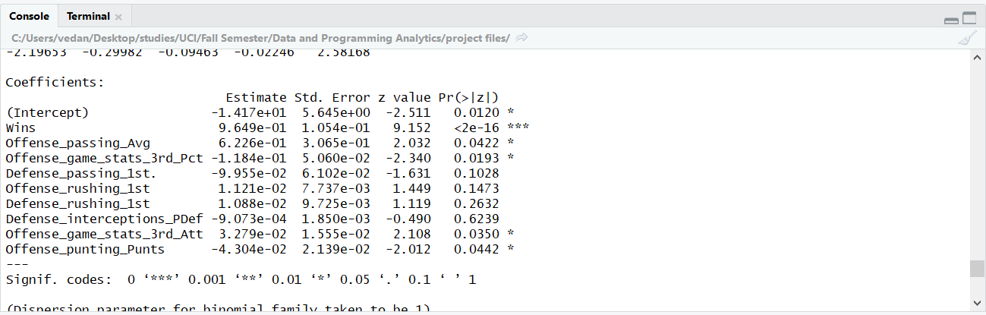

**1967 ONWARDS DATA LOGISTIC REGRESSION MODEL VARIABLE SIGNIFICANCE**

