ModernizeAI Multi-Agent System Report
-Vedant Rakesh Abrol | Wipro FDE Assignment | vedantabrol2000@gmail.com

Links
Public repository: https://github.com/vedant-abrol/ModernizeAI-Multi-Agent-System
Live Link: http://54.163.36.36:8501/
Recorded walkthrough: Live Demo (The live demo is deployed on an AWS EC2 instance using Docker Compose, with Streamlit exposed on port 8501.)

Architecture Diagram:
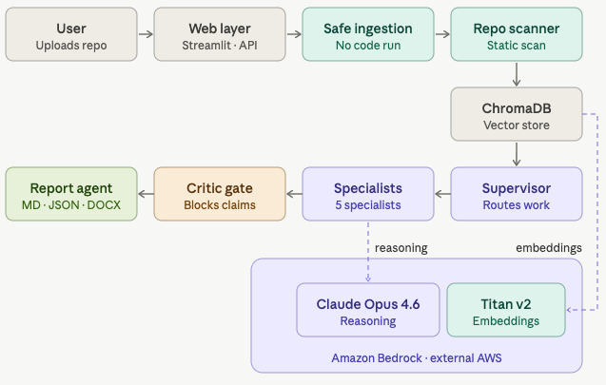

Project Overview
ModernizeAI is a live multi-agent system that helps engineering teams assess and modernize legacy software applications. The system accepts either a ZIP upload or a public GitHub repository URL, performs static analysis, and generates an evidence-backed modernization report. I chose legacy application modernization because it is a realistic enterprise use case that requires architecture review, dependency analysis, security scanning, testing strategy, and phased migration planning.
The goal of ModernizeAI is not to automatically rewrite or migrate code. Instead, it acts as a safe AI-assisted modernization advisor that breaks a complex repository review into specialized agent tasks and produces recommendations grounded in actual code evidence.

Multi-Agent Architecture
ModernizeAI uses nine main agents, each with a clear responsibility:
- Repo Scanner Agent: Extracts deterministic repository facts such as file structure, frameworks, controllers, services, dependencies, routes, configuration files, and evidence snippets.
- Supervisor Agent: Coordinates the workflow by deciding which agent should run next, whether an agent should be skipped, when critic feedback requires a rerun, and when the analysis should terminate.
- Architecture Agent: Reviews application layers, API entry points, data access patterns, integrations, and coupling concerns.
- Dependency Risk Agent: Reviews Maven, Gradle, and npm dependency files for modernization risks without inventing CVEs or unsupported vulnerability claims.
- Security Agent: Performs static security checks for issues such as hardcoded secrets, wildcard CORS, exposed configuration, disabled CSRF, plaintext HTTP usage, debug settings, and SQL concatenation patterns.
- Test Strategy Agent: Identifies missing or weak unit, API, integration, migration, and regression testing areas.
- Modernization Planner Agent: Creates a phased modernization roadmap, including cloud migration, containerization, observability, and possible service boundaries when supported by evidence.
- Critic Agent: Reviews the other agents' outputs and blocks unsupported or overconfident claims before they appear in the final report.
- Report Agent: Produces the final modernization report with findings, evidence, and recommendations.
The agents communicate through shared state managed by the orchestration layer. Each agent reads repository facts and prior agent outputs, then writes structured results back into the state. The system uses LangGraph for orchestration, with a sequential fallback runner if LangGraph is unavailable. The workflow is hierarchical and mostly sequential, but not rigid. The Supervisor Agent dynamically routes work, prioritizes security when risk signals appear, skips irrelevant agents, and can send work back to a specialist once if the Critic Agent finds weak evidence.

Security, Safety, and Guardrails
Security was a major design priority because the system processes untrusted repositories. ModernizeAI performs static analysis only. It never executes uploaded code, installs dependencies, runs migrations, deploys applications, deletes files, or modifies the user's repository.
Input validation is handled during ingestion. ZIP uploads are checked for file type and size limits. The ZIP extractor prevents path traversal, skips symlinks, and ignores suspicious executable or script extensions. GitHub ingestion uses a controlled API-based download flow instead of executing repository commands.
Prompt injection protection is built into the agent prompts and scanner. Repository contents are treated as untrusted data, not instructions. Agents are explicitly told not to follow instructions found in comments, README files, or source code. The scanner also detects prompt-injection-like phrases such as "ignore previous instructions," "reveal your prompt," or "send secrets," and records them as warnings.
LLM guardrails include strict role boundaries, structured JSON output, schema validation, deterministic fallbacks, and critic review. Each LLM-powered agent can only use the provided evidence. If an LLM returns malformed output, omits required fields, or makes unsupported claims, the system repairs or replaces the output with deterministic fallback data. The Critic Agent adds another safety layer by blocking claims that lack file-level evidence.
For data handling, secrets are redacted before indexing and reporting. The system redacts common secret patterns such as passwords, API keys, tokens, JWT secrets, AWS access keys, and private keys. The MVP avoids printing full secret values in reports. In production, I would add stronger PII detection, authentication, multi-user isolation, encryption at rest, and stricter audit logging.

Implementation Approach
ModernizeAI was built using Python, FastAPI, Streamlit, LangGraph, ChromaDB, Amazon Bedrock, Docker, and Pytest. Streamlit provides the user interface for uploads, GitHub URLs, agent progress, and report downloads. FastAPI provides backend endpoints for analysis, status tracking, evidence retrieval, and report generation.
Each agent is implemented as a graph node. The workflow begins with ingestion and repository scanning, then moves to the Supervisor Agent. After each specialist agent completes its task, control returns to the Supervisor. The process ends when the Supervisor routes to the Report Agent.
Amazon Bedrock is used for LLM-based reasoning when enabled, with Anthropic Claude for agent reasoning and Amazon Titan Text Embeddings for vector search. ChromaDB stores repository chunks so agents can retrieve relevant evidence. The system also includes deterministic local fallback behavior, which makes demos and tests more reliable when cloud model access is unavailable.
Errors and failures are handled through status tracking, bounded retries, fallback logic, and a maximum iteration count. If an LLM call fails or returns invalid JSON, the workflow can continue using deterministic results instead of failing the entire analysis.
Testing was done with Pytest. The current suite has 57 passing tests covering ZIP safety, GitHub loading, repository scanning, secret redaction, RAG evidence retrieval, supervisor routing, critic validation, Bedrock JSON handling, output shape repair, status graph behavior, and report generation.

Use of AI / LLMs and Collaboration
LLMs are used for reasoning, summarization, critique, and modernization planning. The Architecture Agent explains structure and coupling from evidence. The Dependency and Security Agents summarize risks. The Test Strategy Agent recommends practical test improvements. The Modernization Planner Agent creates the roadmap, and the Critic Agent challenges unsupported claims.
The agents collaborate through shared state. The Repo Scanner Agent first creates the evidence base. Specialist agents then add focused findings. The Modernization Planner Agent synthesizes those findings into a roadmap, and the Critic Agent reviews the recommendations before the Report Agent generates the final output.
The main design trade-off is autonomy versus control. A fully autonomous system could attempt risky rewrites or migrations, so ModernizeAI uses bounded autonomy instead. Agents can reason, route, critique, and summarize, but they cannot execute code or take destructive actions. This makes the system more practical for enterprise use, where modernization recommendations must be explainable, evidence-backed, and human-reviewed.

